Ryan Hopkins (2221956)
2221956@student.uwtsd.ac.uk
Abstract
This report covers the use of pathfinding algorithms inside of a program, and the general discussion of them with examples of how it works.
Advanced Software Development
ACCB5011

Contents
Task – 1 discussion on pathfinding algorithms 2
Pathfinding algorithms 2
What is Dijkstra's Algorithm? 2
What is A Algorithm? 3
Task 2 – Implementing code to sort through a maze 3
My approach 3
Conclusion 4
Bibliography 4

Task – 1 discussion on pathfinding algorithms

Pathfinding algorithms
Alexander Gillis described algorithms as [1]” a procedure used for solving a problem or performing a computation. Algorithms act as an exact list of instructions that conduct specified actions step by step in either hardware- or software-based routines.”. The main reason to use pathfinding in software engineering is the optimised resource allocation, this is only applicable when the dataset is massive, as it might cost more for in resources and a higher time complexity than just running a simple sorting algorithm, however the efficiency cost is negligible on modern day computers, the only time when this would be necessary is when developing a program for a system on a chip where memory onboard memory is incredibly low.

What is Dijkstra's Algorithm?
Dijkstra’s algorithm, is a pathfinding algorithm which finds the shortest path in a graph, it will determine find the shortest path to all nodes from the starting point, when applied to computer science it is typically used in networking, where network packets are split up to reduce network latency, however can have some applications in software engineering, such as finding the shortest path to each entry in a data structure. The formula for Dijkstra’s algorithm is f(n) = g(n)
The process starts with designating a start point for this example its designated number is 0, this would, and ever other node has been set to an unvisited class. Dijkstra’s algorithm will pick from the smallest path and traverse it, until it cannot continue, when all possible nodes have been traversed then the data has been sorted for the shortest path to each node, using a priority queue to dictate the sorting done, whether its high to low or vice versa.
When sorting dijkstra’s algorithm, it searches from lowest to highest, for example, in figure 1 we have a 7 nodes, the algorithm would go 0 -> 0| 1 -> 2| 2 -> 6| 3 -> 7| 4 -> 17| 5 -> 22| 6 -> 19, the reason for this path is due to the traversal length being shortest to highest, however step 5 needs to be checked just incase step 6 has a cheaper path than 5-> 6, from 4->6.
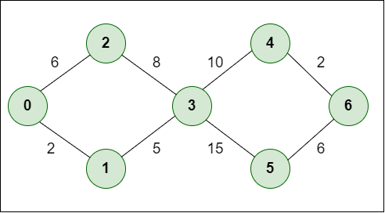
Figure 1 Dijkstra nodes, from geeks for geeks [1]

What is A Algorithm?
The a* algorithm is an extension of Dijkstra’s algorithm g or the distance travelled in Dijkstra has a heuristic function is added to guess the shortest route without calculating all the nodes in the set. The full equation is: f(n)= g(n)+h(n). f in this equation is the total distance to a node, g is the total distance travelled, and h is the heuristic is the estimated distance to future nodes.
Mahattan distance, is the distance traversed without diagonal representation, this is the shortest distance without using a diagonal node, this means that to turn you must go through a node, and then take that turn.
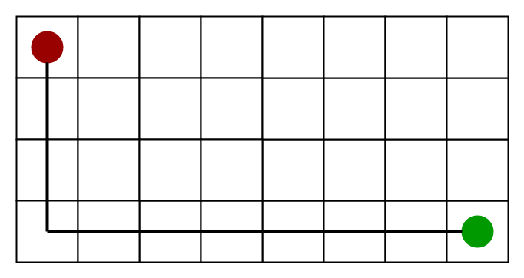
Figure 2 a* algorithm from geeks for geeks [2]

Task 2 – Implementing code to sort through a maze

My approach
The approach I intended to use was Dijkstra’s, I believed that I could comfortably apply it to my program with my understanding of the theory and , however I struggled to understand and comprehend the provided code, after this I decided to do a random int this approach greatly increased the minimum and maximum checks or moves made in comparison to the theorised Dijkstra’s algorithm, to limit the moves made I tried to keep the previous random number generated and throw away duplicates, this would stop the program from making the same move twice, even if the move was correct and in the best direction. See figure 3 for the code of this
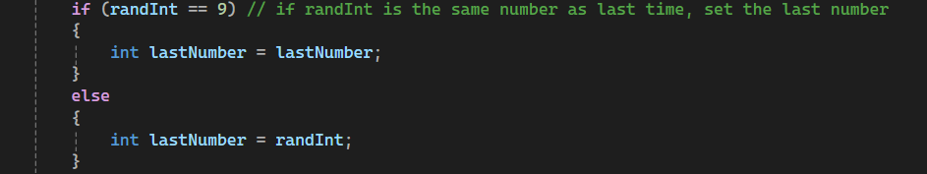
Figure: 3 ensuring that rand int cannot be the same as the previous number
When defining the variables used i tried to keep to one paradigm for future-proofing the code, ensuring that all variable names were camalcased, which is using capital letters to show a different word, for example RandInt or LastNumber

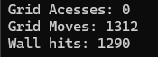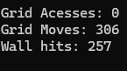
Figure 4&5 showing a range of responses from the result
the results printed, show the code struggling to find the wall, this is seen with the player hitting the wall almost the same amount as the total grid moves. In the future I could use a Breadth first search, to define where the wall is and stop reduce the wall hits to 0 and the grid access to 250, however it was incredibly efficient when it did find the exit, with only 500-2000 moves being done, even without a dedicated a* or Dijkstra algorithm included.
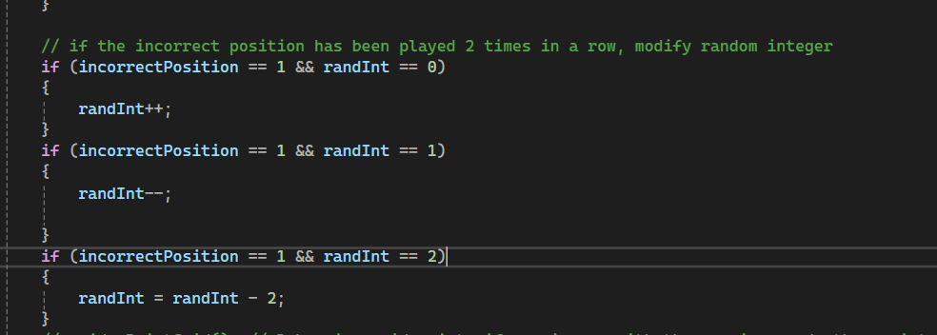
Figure 6 this shows the check for the incorrect position.
When the incorrect position has been calculated. If the user keeps getting the incorrect position, the code will try to force them to increase the value of randint, the aim of which is to move the player out of the corner or the problem the player has got into.

Conclusion
While my approach was not the most efficient, as the code randomly generates a number this could take 15000 searches or 300. As there is no part of the maze that required to go down, I removed the down element as this reduced the potential amount of as it continues to search up whilst moving right or left. With this task I struggled reading the provided code, as limited comments were provided on the code, which I struggled to comprehend

Bibliography

[1] | geeks for geeks, “ What is Dijkstra’s Algorithm? | Introduction to Dijkstra’s Shortest Path Algorithm,” Geeks for geeks, 24 Dec 2024. [Online]. Available: https://www.geeksforgeeks.org/introduction-to-dijkstras-shortest-path-algorithm/. [Accessed 14 Jan 2025].
[2] | Geeksforgeeks, “ A* Search Algorithm,” Geeksforgeeks, 30 Jul 2024. [Online]. Available: https://www.geeksforgeeks.org/a-search-algorithm/. [Accessed 1 Jan 2025].

