Activity Two
Understand the range of HR roles and behavioural requirements of HR professional.

The HR profession often operates by principles deemed as ‘best practise’, many do not question if it is the best for the business which could lead to bad decisions making. CIPD have a profession map, this is to show how value-based decision making creates more of an impact than generic best practices, this will help to create a positive workplace (Mac Court).

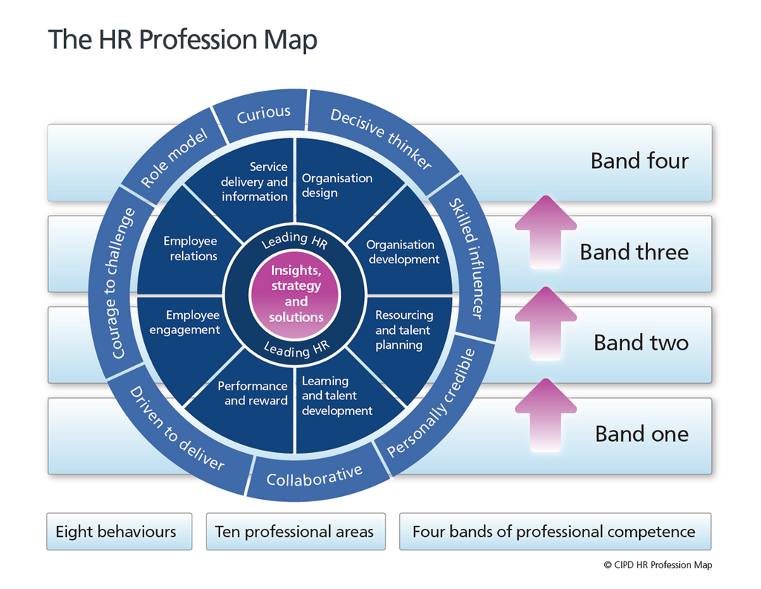

There are three main sections to the profession map – Professional areas, Bands and Transitions.

Professional Areas
There are ten professional areas within the profession map. The two core areas are insights, strategy and solutions and leading HR, these are at the heart of the of all professions and are important regardless of the HR role, location of the role or stage in a HR career. The two core areas underpin the map together. The map describes what you need to do and what you need to know, as well as the predominant behaviours you need to successfully carry out required activities (CIPD).
Insights, strategy, and solutions.
Human resources can only deliver its business purpose and performance if it works from deep within the business looking at contextual and organisational understanding to develop. This allows us to create prioritised and situational HR strategies that will make a difference and build a case for change (CIPD 2020).
Leading HR
Professionals are active and insight led people. They are not just facilitating and observing you, they need to be driven and own and shape a business. They develop across three main areas – personal leadership, leading others, and leading issues.
Organisation Design.
This ensures the business is designed to have a short term and long-term impact.
Organisation Development.
It looks at capability requirements and aligns strategy, people, and processes to achieve. It drives appropriate culture, skills, performance, and behaviours and helps with change strategy planning and implementation.
Resource and talent planning.
This ensures your business has the right capability, talent, and resource to achieve strategic ambitions now and in the future.
Learning and Development.
This builds organisational and personal capability and knowledge to meet requirements and creating a learning culture to embed performance.
Performance and reward.
Create and maintain a high achieving organisational culture by delivering programmes that recognise and reward behaviours, skills, experience, and performance and ensure the system is cost effective, fair and market relevant.

Employee Relations.
Ensures collective and individual relationships with employees are managed correctly within a framework, underpinned by culture, practises, policies and law.
Service, delivery, and information.
Ensures customer focused HR service is delivered across the entire employee life cycle. Using exceptional process and project management to enable cost efficient and effective HR services and provide the business with analytics to aid improvements.
(CIPD 2020).

The profession map behaviours describe the competences a HR professional needs to have to perform in a HR role. To reach the required professionalism the HR role requires specific competencies to be proven at each band level throughout the HR path.

The four bands of the profession map define the contribution that you make at every stage of your career and incorporates the relationship a HR professional has with others. It looks at activities performed by a HR professional, where you would spend your time, what service you would provide and how contribution and success is measured.

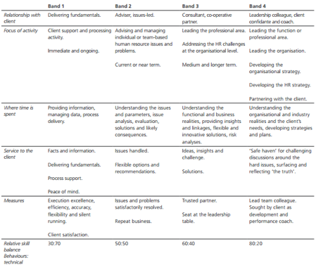
Band one
Band one is supporting and processing activities. You provide information, manage data and deliver process by giving facts and information and delivering fundamentals giving peace of mind. It is measured by efficiency, accuracy, and client satisfaction.
Band two.
Band two is managing and advising teams or an individual’s issues and problems. Your time is spent understanding issues and parameters, analysing issues, evaluation, likely consequences, and solutions. It is measured by any issues and the problems are resolved.
Band three.
Band three is leading the professional areas and addressing HR challenges at organisational level. It is about understanding the business realities and providing insightful innovative solutions and completing risk analysis. You generally are a trusted partner or at a leadership level.
Band four.
Band four is leading the function, developing the organisation and developing strategies for the business and the HR function. You would be in a business partner role understanding the business realities and the client’s needs, developing plans and strategies. You would lead teams’ colleagues and be a development and performance coach.

The profession map describes the behaviours and competencies a HR professional needs to perform in a HR role.

Curious
Curious behaviour is inquisitive and open minded, seeking innovative ways to add value. If you don’t have this behaviour you would fail to ask questions and take things at face value, reject ideas quickly without reflection and would be very focused on the past and present and not the future.
Decisive Thinker
A decisive thinker can analyse and understand data quickly with the use of information and knowledge in a structured way to identify options and make robust, defendable solutions.
Skilled influencer
A skilled influencer can gain the commitment and support from diverse stakeholders by influencing in a value led way.
Personally Credible
To build and deliver professionalism through combining commercial and expertise to add value to the business, stakeholders, and peers.
Collaborative
Works effectively with whoever is required, both within and outside a business.

Driven to deliver
You are determined to deliver using resourcefulness and purpose to give the best results for the business.
Courage to challenge.
To show confidence and courage to challenge others even when there is resistance, or it is an unfamiliar situation.
Role Model.
Leads by example, acts with integrity, acts impartially and balances personal, legal, and organisational parameters.

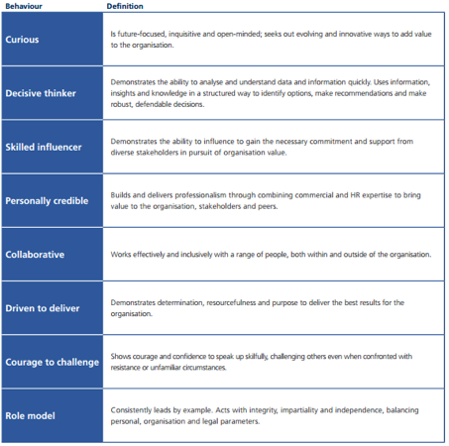

The world of HR is creating new opportunities and challenges, so it needs to be adapted and shape the approach and gain solutions to match the fast shift in the HR profession. CIPD needed to update the 2013 profession map to reflect this and adapt to the future. In 2015 CIPD completed a significant research process about real experiences and this became the foundation for the ‘profession for the future’ thinking. It became the start of defining the heart of the new map (Cheese 2018). The 2013 map that I have used remains a robust and relevant point of reference as the CIPD transitions to the new map in 2021 (CIPD 2020).
Words 1062

Reference

CIPD 2020 https://www.cipd.co.uk/learn/profession-map/2013-profession-map
CIPD profession map 2013 https://www.cipd.co.uk/learn/profession-map/2013-profession-map
Peter Cheese 2018 https://www.cipd.co.uk/Community/blogs/b/peter_cheese/posts/our-new-profession-m
Siobhan Mac Court July 2020 https://community.dpgplc.co.uk/blog/the-cipd-profession-map#

Activity Four.

Be able to work collaboratively with others, as a member of a team or working group.

HR professionals need teamwork skills to help businesses thrive. They can support to build a diverse team who bring individual ideas to the table. Teamwork helps solve issues and brainstorming is a great way for ideas to be exchanged to come up with ‘out of the box thinking’ to find solutions that work the best for the business (schoultz).

‘’ A team is a group of people with complementary skills who are committed to a common purpose performance goals and approach for which they hold themselves mutually accountable. ‘’

Clear direction – Without a clear sense of direction, what is to be accomplished and how outcome will be defined it is impossible to assemble the right group to get there (spoon 2013). So, the goals and outcomes are divided first.

Open and honest communication is a key characteristic in any team. The more openly communication happens between team members the more comfortable you and the team are in sharing ideas. Listening is the most important part of communication it is a way of finding things out and it is also a sign of respect.

Risk taking – Great teams support risk taking and look at first time mistakes as opportunities to learn.

Defined Roles – The skill set can determine the roles. These roles may shift once the team is in place, once all the roles have been determined the strongest team member could be the leader.

Mutually Accountable – Team members accept responsibility as a team and individuals team members do not blame one another for team mistakes.

Common goals are a key characteristic; team members should place common goals above individual interests. Encouraging difference of opinions and agreeing is essential, however it should not be at a cost of pursuing different ideas and opinions. Diverse opinions enlighten new thoughts and ideas. Collaboration is simply the more you communicate, then the more can be created.

Team trust - Team members who cannot trust or believe in a process and goal seldom succeed. Effective teams are focused, trust goes closely alongside communication. Team members can trust each other if they have adult to adult conversations to air views.

(Harvard)(Schoutlz)

Working as part of a team is an integral aspect of business. If we work successfully as a team, we maximise our chances of being successful.

‘’The whole is greater than the sums of its parts’’ Arisotle

The difference between a group and a team is the interaction between the members who depend on each other to achieve a goal. A group could be a football supporters’ group and a team could be the football team.

Psychologist Bruce Tuckman in 1965 came up with memorable phase ‘Forming-Storming-Norming-Performing’. It describes the path that teams follow to high performance. Tuckman adapted a fifth stage ‘Adjourning’ (also known as ‘’Mourning’’) to mark the end of the journey (Mindtools). If you are fully aware of the characteristics of each stage you can implement strategies so the team can more quickly through each stage, this will get you closer to the pinnacle performance giving the best chance of success.

Forming.

The forming stage is when the team first meet, they will compare themselves against each other and assess strengths and weaknesses. Individuals will identify their roles and interpersonal relationships will form.

Storming.

This is the resistance stage; this occurs when team members fight team rules. During this stage communication is key, it needs to be open and objective about the expectations and responsibilities and come up with strategies to decrease friction and stress.

Norming.

During this stage, the storming is replaced with cooperation and unity. Individuals work closely towards goals. The roles in the team are stabilised and everyone is comfortable with the part they play. It is at this point that leaders should reinforce performance and efforts and reward outstanding performance.

Performing.

This is the stage where the team channel energies to succeed and achieve. The roles in the team are defined, the relationships are stable, individual success does not go unrecognised and the team’s success is the primary goal.

Adjourning (Mourning).

This is reached naturally; it could be the project has come to an end or maybe people have been redeployed. Potentially if it involves people that like routine or have developed close working relationships with others, they may find this stage hard.

The Tuckman theory is not a one-way street, you can go back and forth between the stages. Once the team is at the performing stage, the teams performance and progression need monitoring in case it slips. Re-evaluation can happen at any point.

In the HR profession good political influencing is essential. Winning hearts and minds can be difficult if your views are discounted. As a HR professional you must be willing to deploy a range of political strategies and tactics, in line with ensuring moral and ethics are used.
Common tactics include networking, building your own support systems and getting ideas from different levels. A common strategy used is to have a strong business plan and presenting a strong argument, along with adapting your behaviour to the situation.

Learn to be positive this can benefit an organisation and the individual. People tend to learn from observing others, positive politics depends on having a clear agenda and a strategy for achieving. The best agendas take other peoples’ agendas into account, in particular those belonging to the people wanting to succeed.

‘’In order to be a successful arm twister one needs to know which arm to twist and how’’(Pfeffer).

The channel of communication is key to hear and be heard, then identify who is politically influenced and what motivates them. You could maximise your chance of the success of your ideas by mixing other’s needs with your own.

The key drivers of a political climate that can impact the HR function could include union laws, work contracts, job descriptions, recruitment, performance management, talent management and pay.

During my career I have faced many scenarios where I have worked in a team. I can honestly say that the majority of teams I have worked with have been successful. The main reason it may not have worked is usually due to the team not singing from the same hymn sheet. This would be recognised during the forming, storming, norming and performing stages, therefore they were easily rectified.

Words 1066

Reference.

Arisotle

Bruce Tuckman

Chris Adams https://www.modernanalyst.com/

Harvard business school

Jeffery Pfeffer

Mike Scholtz 2017 https://mikeschoultz.medium.com

Mind tools https://www.mindtools.com/pages/article/newLDR_86.htm

Richard Spoon 2013 Old man publishing 2013 Team Renaissance: The Art, Science Politics of Great Teams

Smart goals https://www.professionalacademy.com/

