

BMSW4002: Effective Team Work and Communication

Student name: Viktoriya Racheva

Student ID:2030292

Table of Contents
Introduction 2
Discussion on models of communication 2
Discussion on the communication skills 4
Real-life examples of the application of communication models and skills 5
Examples of poor communication in my workplace 7
Recommendations on how it could be improved 8
Conclusion 9
References 10

Introduction
This report will analyse the different models of communication that are applicable in modern workplaces. This report will also highlight the personal skills one has to possess to deliver a high level of communication efficiency. Furthermore, this report will analyse the real-life case studies that exemplify the applications of communication theories in practical organisational situations. Moreover, this report will evaluate my personal experience regarding the usage and application of communication theories in my previous workplace. Finally, this report will develop recommended strategies to improve such situations and enhance organisational communication.

Discussion on models of communication
According to Seguin et al. (2020), communication models are various concepts that depict the optimal integration of both the internal and external communication channels in professional and personal settings. The focus of the communication model is to understand its usability and applicability in the given contexts.
Transceiver model
The Transceiver Model or Transmitter-Receiver Model is one of the best applicable models used in the field of researching and creating communication entities. The model was developed in the 1940s and was then known as Shannon Weaver Model after its propagator Warren Weaver and Claude E Shannon (Liu et al., 2017). The model proposes that messages primarily have the elements that affect the language of both the sender and receiver and provisions a solution for the optimisation. The model implies that communication is a process that involves both sender and receiver. The sender and receiver are responsible for decoding the codes of the communication (Oguntunde et al., 2019). The code may sometimes differ from verbal and non-verbal aspects giving rise to conflicts and misunderstandings. The model is sometimes criticised for being less flexible as it lacks social aspects such as interpersonal relationships, recipient feedback and motivation. However, the core idea of communication is transferrable.
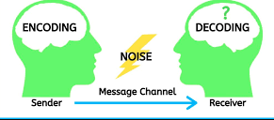
Figure 1: Transceiver Model of Communication
(Source: Oguntunde et al., 2019)
Schramm’s model of communication
Schramm’s model is an improvement over the Transceiver Model (Shannon Weaver model). Schramm has dictated that unlike the Shannon Weaver model that indicates that communication involves simply a transmitter sending a message to the receiver, in reality, communication is a two-way process that involves the sender receiving a feedback from the receiver. Lin and Lin (2020) argued that according to this model, it is highly important for a message receiver to decode the message and send a feedback to the sender, so that the sender can confirm that the message has indeed been decoded. Elleström (2018) stated that according to this model, even through the sender has managed to encode and sent the message to receiver successfully, the communication process remains incomplete as long as the sender does not receive a reply from the receiver regarding it. The communication process is thus comprised of the communication message and its reply together. This ensures that both the sender and receiver have managed to understand each other, and have come to mutual agreement regarding the content of the message, thus making the communication process successful.
Berlo's SMCR communication model
Berlo's SMCR communication model is related to the communication process that involves four stages, which are Sender, Message, Channel and Receiver. For instance, the initiation of the communication process is done by the sender, who designs the message and prepares for sending. Muyanga and Phiri (2020) stated that the skills necessary for the sender at this stage include communication skills, attitude, and knowledge of the communicated subject, social aptitude and a good level of cultural background. The message itself has to meet certain criteria, which are a good level of content, inclusion of the necessary elements, an understandable structure and an easy-to-understand system of code. Labudović (2019) argued that the channel of communication is also highly important, as it determines the speed and accuracy of the message being sent. The channel must have certain criteria, such as being accessible through at least one of the human senses. Finally, the receiver has to understand the communication message received. For this, the receiver must have some particular skills, such as communication, attitudes, knowledge, social system and culture.

Discussion on the communication skills
Claro et al. (2018) stated that communicating effectively is considered one of the integral facets of professional and academic settings. The business management and the leadership are based on impeccable communication skills where the goals of the companies should be conveyed along with the expected outcomes. Communicating effectively must possess the following resultant outcomes:
Listening: The first and foremost aspects of a good communicator are to become a good listener. Practising active listening is important for paying close attention to the communicator (Binbin, 2020). Listening clarifies the ambiguity in the communication through rephrasing the words within the understanding level in a meticulous manner.
Conciseness: Ilie et al. (2019) stated that conveying the message in a few possible words is another important communication skill that is prevalent in the corporate business setting. It involves not using the filler words and getting straight to the point that requires to be communicated. Avoiding rambling would cause the listener unsure about the facts.
Body language: Good body language while communicating is one of the integral parts of the corporate setting. Claro et al. (2018) pointed out that tone of the voice must be maintained while communicating with the listener. Minimally utilising hand gestures is important. It is also important to maintain eye contact
Confidence: Communicating with confidence is equally important for maintaining the ability in the communication framework. Ilie et al. (2019) stated that ability to exhibit confidence could be beneficial for maintaining eye contact and creating a relaxed body disposition while maintaining communication.

Real-life examples of the application of communication models and skills
The communication models and skills are the integral aspects of communicating in professional and personal life. The communication helps obtain the professional consent that is one of the methodological in approaching the listener for the one way or multiple ways of the communication. Prominent communication models are used in the meetings of the corporate setting as well as reducing the conflict in the workplace.
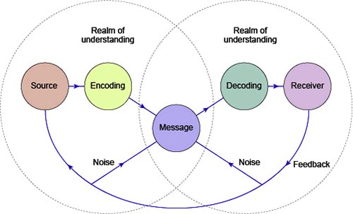
Figure 2: Scramm’s Model of Communication
(Source: Lin and Lin, 2020)
The Schramm’s model of communication can be exemplified with the case study of “The Professor and the Village People”. It can be argued that the sole reason that the professor failed to make the people in the village to understand that his house is on fire, which needs to be extinguished immediately. This is because the Schramm’s model indicates that the communication can only be successful if the sender sends a message to the receiver. According to Lin and Lin (2020), the overall effectiveness of the communication process is only increased if the receiver acknowledges the communicated message and sends a feedback to the sender. However, in this case, no such thing happened. When the professor went to the village while asking for help, no person in the village acknowledged that communicated message and replied with a feedback. This is because the professor communication in a language that they could not understand.
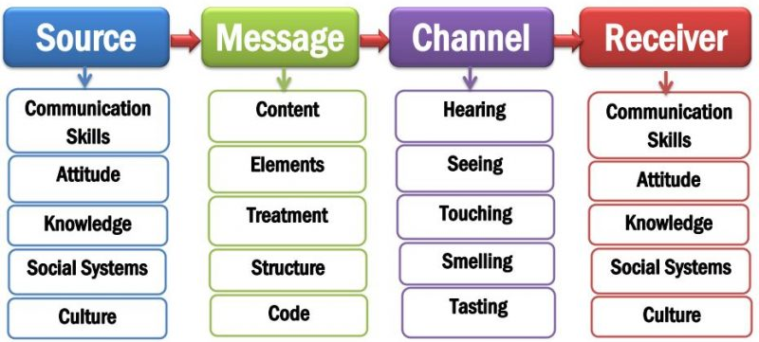
Figure 3: Berlo's SMCR Model of Communication
(Source: Muyanga and Phiri, 2020)
This can be related with Berlo's SMCR communication model, as this model indicates that the overall effectiveness of the communication process is depended on the channel and encoding process of the message (Muyanga and Phiri, 2020). In this case, the professor encoded his message in a language that was not possible for the villagers to decode. This is why they ignored the message of the professor. Thus, it indicates that to ensure a high level of success in the communication process, one has to ensure that the message is encoded in a language that the receiver can understand, and wait till the sender gets a feedback message from the receiver, to make sure that the communication has been successful.
The transceiver model can also be linked with this case. For instance, it has been seen that the communication between the professor and the villagers were incomplete, as the message did not reach the understanding of the villagers (Oguntunde et al., 2019). According to the transceiver model, this count as a failure in communication, as the professor could not send the message across, thus resulting in the burning of his house.

Examples of poor communication in my workplace
I have realised that Schramm’s model of communication can be used for explaining my workplace experiences as well. For instance, in my workplace, a project experienced a sudden halt due to the lack of approval from the end of the partnered company. Later, it was found that due to the lag in paperwork at the end of the partnered company, they could not send their approval of the procedure on time. Thus, the activities in our end were halted, which resulted in monetary loss of the project, which the partnered company had to compensate out of obligation. This can be related to Schramm’s model of communication, as this communication failed due to lack of feedback message from receiver’s end. Furthermore, we also faced an incident where one of the foreign business delegates in one of our corporate events misunderstood the schedule due to the difference in language, which resulted in miscommunication. This can be explained with Berlo's SMCR communication model, as it states that communication can never be successful without ensuring that both the sender and the receiver understands the language of the message.
Another example of poor communication in my workplace was due to the mismatch in language among the employees. For instance, during the recruitment session in the previous season, some of the employees hired in my previous workplace were from native locations from Scotland and Ireland. Furthermore, some of the other employees were from different Asian countries, including India and China. Naturally, they were accustomed to different accents of English. This disrupted the communication among them, which resulted in the lack of business performance in the projects of the organisations. For instance, in the coordinated jobs, the strategic measures were not communicated between an employee from Scotland and an employee from China, which was due to the difference in the language among them. This caused a significant loss in that project at my workplace. This can be explained through the transceiver model of communication, where the communication between two people is hampered due to the difference in their languages. Due to the differences in English accent, my new Scottish and Chinese colleagues could not communicate with each other. This type of situation is undesirable in any organisation and should be prevented with proper recruitment and training measures.

Recommendations on how it could be improved
The situation about the poor communication in workplaces due to the lack of understanding among each other could be tackled with the help of employee training and team coordination development among each other. For instance, the higher management of an organisation could deploy the training sessions and activities to increase the bonding among the employees. Andersson (2019) stated that this might include carrying out probationary periods of the employees while assigning them to work to do together so that they can form better bonding among each other. Furthermore, it may also involve assigning them to the same departments while recruiting them permanently. This would ensure that they could utilise the personal understanding between them, and deliver a high level of job performance through excellent coordination among each other. Men and Yue (2019) stated that this would ensure that they have a high level of communication efficiency, which would allow them to carry out business activities within the organisational working environment with a high level of job efficiency.
Another measure that could be used to minimise the poor communication in the workplace is to modify the recruitment policies to ensure that the communication among the employees is not hampered due to the lack of understanding each other's language. For instance, according to Lee and Kim (2021), this could be done by the recruitment policy focusing on the proficiency of the English language in the standard British accent. It could also be done through the enforcement of the rule that the employees while working in the office, must communicate with their colleagues in a British accent and not their colloquial accent. Li et al. (2021) stated that this would ensure that no barriers related to the difference in language can remain, and the job efficiency of the employees is increased due to better coordination.
Another measure to be taken is to maintain written records of the job activities in each stage. While this is done for important jobs, this could be done for minor job operations as well. According to Andersson (2019), as written communication is much more effective due to its better understanding generally, it could help to enhance the overall business efficiency of the organisation.

Conclusion
The report concludes that communication in the workplace is extremely important, and its effectiveness affects the overall efficiency of the job operations and projects greatly. I have realised that the models of communication, such as the transceiver model, Schramm’s model and Berlo's SMCR model, are applicable in real business situations. Alongside the existing cases, I have also experienced them in my previous workplace. In the end, the best strategies to maintain a high level of communication efficiency is to implement proper recruitment measures to ensure that the employees have proficiency in the official working language of the organisation. Furthermore, deploying optimal job delegation strategies also ensures that they form a good level of understanding among them, thus increasing overall organisational efficiency.

References
Andersson, R. (2019). Employee communication responsibility: its antecedents and implications for strategic communication management. International Journal of Strategic Communication, 13(1), pp.60-75.
Binbin, H.U.A.N.G. (2020). Research on the Importance of Explicit Quality to Innovative and Entrepreneurial Talents——Competency Construction of College Students' Innovation and Entrepreneurship Competition based on Iceberg Model. The Theory and Practice of Innovation and Enntrepreneurship, 3(5), p.12.
Claro, M., Salinas, Á., Cabello-Hutt, T., San Martín, E., Preiss, D.D., Valenzuela, S. and Jara, I. (2018). Teaching in a Digital Environment (TIDE): Defining and measuring teachers' capacity to develop students' digital information and communication skills. Computers & Education, 121, pp.162-174.
Elleström, L. (2018). A medium-centered model of communication. Semiotica, 2018(224), pp.269-293.
Ilie, O.A. (2019). The intercultural competence. Developing effective intercultural communication skills. In International conference Knowledge-based organization (Vol. 25, No. 2, pp. 264-268).
Labudović, B. (2019). Communication: Analytical unity of two selections and two constructions. CM: Communication and Media, 14(45), pp.87-108.
Lee, Y. and Kim, J. (2021). Cultivating employee creativity through strategic internal communication: The role of leadership, symmetry, and feedback seeking behaviors. Public Relations Review, 47(1), p.101998.
Li, J.Y., Sun, R., Tao, W. and Lee, Y. (2021). Employee coping with organizational change in the face of a pandemic: The role of transparent internal communication. Public Relations Review, 47(1), p.101984.
Lin, X. and Lin, C. (2020). Communication theories applied in mentimeter to improve educational communication and teaching effectiveness. In 4th International Conference on Culture, Education and Economic Development of Modern Society (ICCESE 2020) (pp. 870-875). Atlantis Press.
Liu, Y., Roblin, P., Quan, X., Pan, W., Shao, S. and Tang, Y. (2017). A full-duplex transceiver with two-stage analog cancellations for multipath self-interference. IEEE Transactions on Microwave Theory and Techniques, 65(12), pp.5263-5273.
Men, L.R. and Yue, C.A. (2019). Creating a positive emotional culture: Effect of internal communication and impact on employee supportive behaviors. Public relations review, 45(3), p.101764.
Muyanga, C.C. and Phiri, J. (2020). Assessment of Effective Communication in International Schools in Developing Countries Based on the Berlo’s SMCR Model. Open Journal of Business and Management, 9(1), pp.448-459.
Oguntunde, P.E., Khaleel, M.A., Okagbue, H.I. and Odetunmibi, O.A. (2019). The Topp–Leone Lomax (TLLo) distribution with applications to airbone communication transceiver dataset. Wireless Personal Communications, 109(1), pp.349-360.
Seguin, C., Tian, Y. and Zalesky, A. (2020). Network communication models improve the behavioral and functional predictive utility of the human structural connectome. Network Neuroscience, 4(4), pp.980-1006.

