Student Name: Tyrell Graver
Student ID: 2027780
Module code: BMSW 4004
Assignment title: Report on absenteeism in mid Cheshire NHS
Lecturer’s name: Tayo Korede
Table of contents:

- Introduction *
- Define the problem
- Its scope and impact (Pestle)
- Analysis of the organisation and problem (Fishbone)
- Propose alternative solutions (PMI)
- Evaluation
- Plan implementing solution, monitoring, and review process/system
- Conclusion
- References

Introduction
Absenteeism is the tendency of skipping work or school on a regular basis for no apparent cause. (Oxford Languages, 2022)
This report will discuss the rising issue effecting many businesses, in particular the Mid Cheshire Hospitals NHS Foundation Trust. This reoccurring dilemma is staff absenteeism. It is causing an annual loss of over £1 million for the trust, in addition to this, there has been a decrease of service quality as a result of the increased employment of temporary and agency workers. In this report the issue will be solved using problem solving tools/ models to establish the problem's root cause, by identifying the cause, prioritising, and selecting different solutions for a solution; and putting the solution into action.
Decision-making tools, such as the PMI strategy, will be used to obtain information and evaluate potential solutions, by arranging pertinent data and creating alternatives, to make more informed decisions. This method improves the likelihood that you will select the most pleasing option to prevent elevated levels of absenteeism.
- A research-informed discussion on the nature and impact of the complex problem on employees and their organisations.

Defining the problem
The problem that continues to shun the mid Cheshire hospital NHS foundation trust, is the augmentation of absenteeism from 2007 to 2012, causing a significant impact on the trust. Revenue statement show quantitative data alluding to the trust suffering a loss of over £1 million per percentage point. Absenteeism not only effects the trusts annual (), but also has led to under par services due to upsurge in temporary/ agency staff being employed. Low customer service could also lead to further equity losses. The reasons of absenteeism could be due poor management, bad communication between employees and employer and/or staff motivation.
(Cotton, 2019)

Scope and impact
Absenteeism is a global problem that effects all businesses around the world, profit wise, some more than others. This issue is ongoing and has been a long-term problem that gets worse each year showing little to no improvement. It also affects businesses in diverse ways, for example: Individual productivity can be harmed by absenteeism. Broadly stated, if someone works less hours, they are less likely to be effective. Root factors, such as burnout and disengagement, including those that may necessitate modifications, such as childcare or illness, should be considered by employers. Employees at the office are left to make up for work not done by absent employees as the amount of time spent away from work grows, so absenteeism has a significant impact on team performance leading to inferior quality of service. (Cushard, 2017)
Absenteeism can have both beneficial and negative implications for a company. They also include the impact of lost output and a drop in job quality on the harmful impact; on the plus side, they emphasize the value which can be received from an exhausted employee's absence when their job role demands mental alertness. (Robbins and Judge 2004, p.28)

Pestle analysis
A PESTLE analysis is a process of gaining a broad view of an industry's environment. (PESTLE) elements are acronyms for Political, Economic, Social, Technological, Legal, and Environmental aspects. It enables a business to understand the variables that may influence a business or trade. This will be used to examine the macro factors that could be the potential causes of absenteeism.
Political determinates that have an impact and could cause employee absenteeism things such as, global pandemics which could cause high demand hours for staff to come and work, changes in government sectors and policy's such as Brexit has impacted the level of absenteeism due to elevated levels of staff fatigue. (Cotton, 2019). plus, nationwide strikes where staff are refusing to work because of low pay rates.
Economic elements that can alter staff attendance could potential be in inflation which has a long-term effect on staff home life, this relates to disposable income where staff might not be able to afford to attend work because they cannot afford to get to work. Another, would be economic growth, involving 4 factors being land labour, capital, and entrepreneurship, this would increase the amount of stress in a workplace for example due to the trust not having the funding to buy new equipment the staff are forced to perform tasks that could be completed quicker and more efficiently with the right equipment, potentially making there shifts longer, then eventually leading to staff fatigue. (Ross, 2021)
Social influences which could deter staff from wanting to attend work might be political disagreements for example if someone is views and beliefs in a political area my cloud another's judgement on that person's character, causing ongoing arguments during work hours, or worst-case scenario but possible, bullying and harassment can make a member of staff feel sceptical about coming to work because of fear.
Technological, this can include automation where technology application where human input is minimised. Research and Deveolpment may also hinder employee attendance, because if staff are not up to date with new practices and/or new pharmaceuticals then they are not going to be able to provide good Quilty services, alternatively causes increasing stress levels throughout the staff.
Legal reasons for not attending work must be taken into consideration when dealing with staff absenteeism, these reasons could include staff members currently undergoing divorce proceedings and/or maternity/parental leave. Staff members may have to attend court as a witness, preventing them from attending work.
Environmental aspects which affect staff absenteeism would be elements such as weather being too harsh for traveling, for example excessive rainfall or snow fall can be a cause of temporary absence (Spencer and Urquhart, 2021). Another could be mass outbreaks of the flu.

Analysis of the organisation and problem
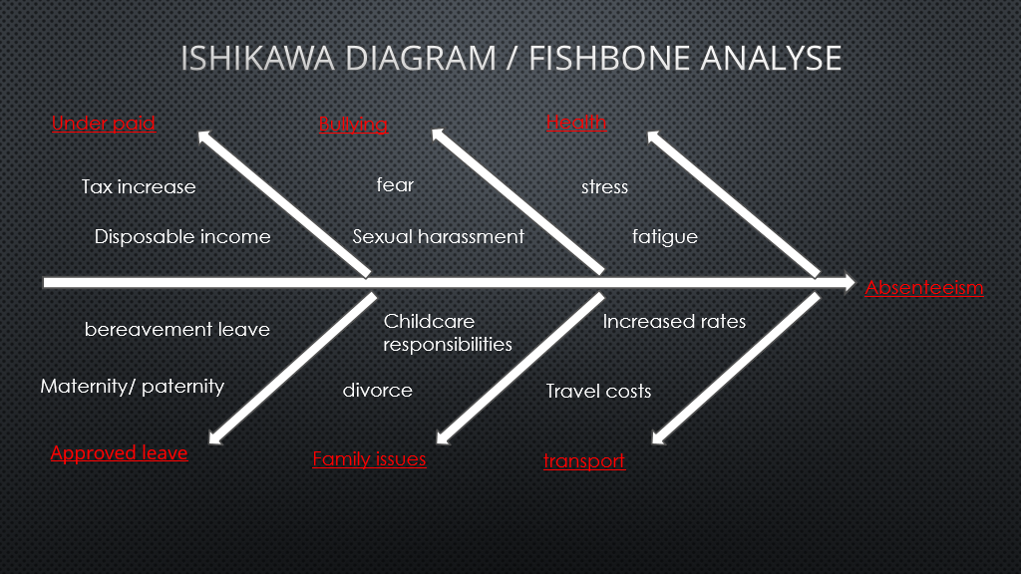
(Tyrell graver, presentation slide, 2022)
Here is an Ishikawa diagram also known as a fishbone diagram. A tool created in the 1960s, Kaoru Ishikawa created the Ishikawa diagram to measure quality control operations in the shipbuilding sector. An Ishikawa diagram depicts the causes of an event and is frequently used in manufacturing and product innovation to define the many sequences of events, highlight where quality control concerns may arise, and identify which requirements are needed at pivotal moments. (Hayes, 2021)
As seen on the diagram the words in red are the some of the major causes leading to absenteeism as shown six in total. Each major cause has 2 reasons that fall under the categories. The diagram shows how each cause i.e., bullying, health, transport, family issues, approved leave and being under paid can lead to a decrease in staff attendance. By finding these root causes it is easier to identify workable solutions absenteeism such as increased wages for the under paid section.

Proposed solutions
- New management – new management can lead to an improvement is staff satisfaction, for multiple reasons such as if previous management were bulling and harassing staff the staff would feel safe to attend work, so if new management takes over then staff would feel intimidated or scared to come into work because new management could be kinder to them and less stressful.
- Fresh staff guideline and requirements this could be something as simple as fewer demanding hours of work, so staff do not fell fatigue and get plenty of rest require to performed high quality service.
- Attractive offers are always great motivators to attend work and perform to a high standard, attractive offers could include things like, pay rises and/or bonuses, staff discounts or free access leisure facilities/membership.
- Communication plans to improve communication, alluding back to staff feeling threatened/ intimidated to come into work, there should be a plan and/or system the can go though to communicate the situation outside the management, that could provide them with the information or help they need such as relocation and replacement plans that could be implemented. If staff feel as if they have a voice within the workplace, they are more likely to attend because the weel respected and appreciated.

Evaluation
See below an evaluation of the solutions found and the final decision to be implemented this is done by gathering the Plus, Minus and interesting, (PMI tool), factors of each solution to congregate information on all areas and conclude on which will have the most impact for the trust absenteeism level.
^{Decisions} | ^{Plus} | ^{Minus} | ^{Interesting} | ^{Total}
^{Attractive offer} | ^{Increased pay /Bonuses +2}  ^{Motivation to work+2}  ^{Better quality work+3}  ^{Higher disposable income+3} | ^{Increased tax -7}  ^{Irresponsible}  ^{Spending -3}  ^{Mental fatigue –4}  ^{behavioural changes –2} | ^{Tax return +4}  ^{More holidays+3}  ^{Aid and assistance+5}  ^{Fitness and wellbeing+3}  ^{chance +2}  ^{Stress –3} | ⁺⁸
^{New Management} | ^{Higher motivation +2}  ^{Innovative ideas+2}  ^{Professionalism+1}  ^{Prevent bullying+2}  ^{Staff appreciation +2} | ^{Inexperience -3}  ^{Adjustments -2}  ^{Room for mistakes -2} | ^{New work environment +2}  ^{Potential friendships+2} | ⁺⁶
Improved communication/ communication plans | ^{joyful +4}  ^{improved relationship +3}  ^{enthusiam+3}  ^{Teamwork +4}  ^{maturity +2} | ^{group activities -2}  ^{Sleep deprived –2}  ^{susceptibility-5}  ^{dispute-6}  ^{Tattle tailing -3} | ^{Shop talk +2}  ^{Small talk +2}  ^{Debates+2}  ^{Work dianamics+2} | ⁺⁶
Fresh staff requirement/ guidelines | ^{Higher quality performance+2}  ^{Professionalism +1}  ^{Clear understandings +1} | ^{Staff strikes-3}  ^{Harsher rules -1}  ^{Staff fatigue-2} | ^{Less hours+ 3}  ^{Refusals-1}  ^{Smooth workflow+2}
(T.Graver, presentation slide 5, 2022)
As illustrated above, the outcome is clear and the winning solution to minimising absenteeism is Attractive offer.

Action plan
actions | Description | Period | Who is responsible
Calculate what the trust can afford | Communicate to head of department and the finance and budget team |  | HR
Ask staff which theyd prefer to have bonuses a pay rise | Communicate with HR on how to increase pay
Success indicators
Bibliography
Cotton, B., 2019. NHS Absenteeism: The crisis months are here - Business Leader News. [online] Business Leader. Available at: <https://www.businessleader.co.uk/nhs-absenteeism-the-crisis-months-are-here/> [Accessed 15 April 2022].
Cushard, B., 2017. The Impact of Absenteeism. [online] Spark. Available at: <https://www.adp.com/spark/articles/2017/01/the-impact-of-absenteeism.aspx> [Accessed 12 April 2022].
Graver, T., 2022. Problem solving and decision making for NHS absenteeism [online] Power point presentation available at: Presentation2.pptx
Hayes, A., 2021. Ishikawa Diagram Definition. [online] Investopedia. Available at: <https://www.investopedia.com/terms/i/ishikawa-diagram.asp> [Accessed 13 April 2022].
Languages.oup.com. 2022. Oxford Languages and Google - English | Oxford Languages. [online] Available at: <https://languages.oup.com/google-dictionary-en/> [Accessed 12 April 2022].
Ross, S., 2021. Why Factors of Production are Important to Economic Activity. [online] Investopedia. Available at: <https://www.investopedia.com/ask/answers/040715/why-are-factors-production-important-economic-growth.asp> [Accessed 14 April 2022].
Spencer, N. and Urquhart, M., 2021. Extreme Climate and Absence from Work: Evidence from Jamaica. [online] springer link. Available at: <https://link.springer.com/article/10.1007/s13753-020-00327-1> [Accessed 14 April 2022].

