

Programme: Master of Business Administration
Module: Strategic Management
Module code: LCMB7003

Title: A Report Strategic Management of Amazon

Student Name: Almahender singh
Student ID: 2504913

Table of Contents
Section 1: Strategic Analysis Report 3
Organisational Context and Overview 3
External and Internal Environment Analysis 4
PESTLE Analysis 4
CSFs and Challenges in External Environment 7
Internal Environment and Key Resources 8
VRIO Analysis 10
Critically discussion on internal strengths 11
CSR and Sustainability objectives 12
Comprehensive and holistic view of Amazon 12
Balanced Scorecard Analysis of Amazon 12
Critical Integration 15
Strategic Choices and Implementation 15
Strategic Choices 15
Analysis of Corporate Level Strategies 16
Change management and Strategic Implementation 17
Strategic Evaluation and Recommendations 17
SWOT Analysis 17
Ansoff Matrix 18
Recommendations 19
Justification 19
Section 2: Reflection 19
References 24

Section 1: Strategic Analysis Report

Organisational Context and Overview
Established in 1994, Amazon has evolved from just an online book store named as “Cadabra” to a globally dominant and diversified digital conglomerate (Abdeen, 2024). Since its journey with the hands of Jeff Bezos, Amazon website as a bookselling site has delivered books to all 45 countries and 59 US states. In 1998, it extended the product lines beyond book and generated its first profitable revenue USD 35 million 2003 (MJE, 2023). The strategic trajectory demonstrates a consistent focus on operational scalability, customer-centric innovation and long-term value creation. The mission of Amazon is to continuously raise the bar of customer experience using technology to help customers discover, and buy anything empowering content creators and businesses. The vision of Amazon is to be the most customer-centric company on the earth (Amazon, 2018). Amazon to pursue its mission and vision is continuously investing in the digital ecosystem, logistics infrastructure and data-driven decision-making. The business model of Amazon is multifaceted combining the third-party marketplace services, first-party retail and subscription-based offerings like high margin cloud computing and Prime services through Amazon Web Services or AWS enabling ecosystem lock-in and cross-subsidisation (AWS, 2025). Its business model is characterised as a highly integrated customer-centric digital ecosystem.
Amazon is operating within the highly competitive cloud-computing industry and e-commerce sector characterised by low switching cost and rapid technological disruption. Amazon has captured 37.6% market share among all the online retailers in the United States in 2024 followed by Walmart with 6.4% and Apple with 3.6% (Statista, 2024). In cloud computing, AWS maintains a leading global position competing with Google Cloud and Microsoft Azure (Alkhatib, Shaheen and Albustanji, 2025). The competitive advantage of Amazon is reinforced by the advanced data analytics capabilities, logistic networks and strong brand equity which enhance the operational efficiency and customer retention collectively. However, the scale of Amazon exposed the intensified regulatory scrutiny with increasing fulfilment costs and societal expectations about labour practices and sustainability. Consequently, although Amazon has retailed dominant market position, the strategic context is defined by the requirement to balance aggressive growth with responsible business conduct and regulatory compliance.
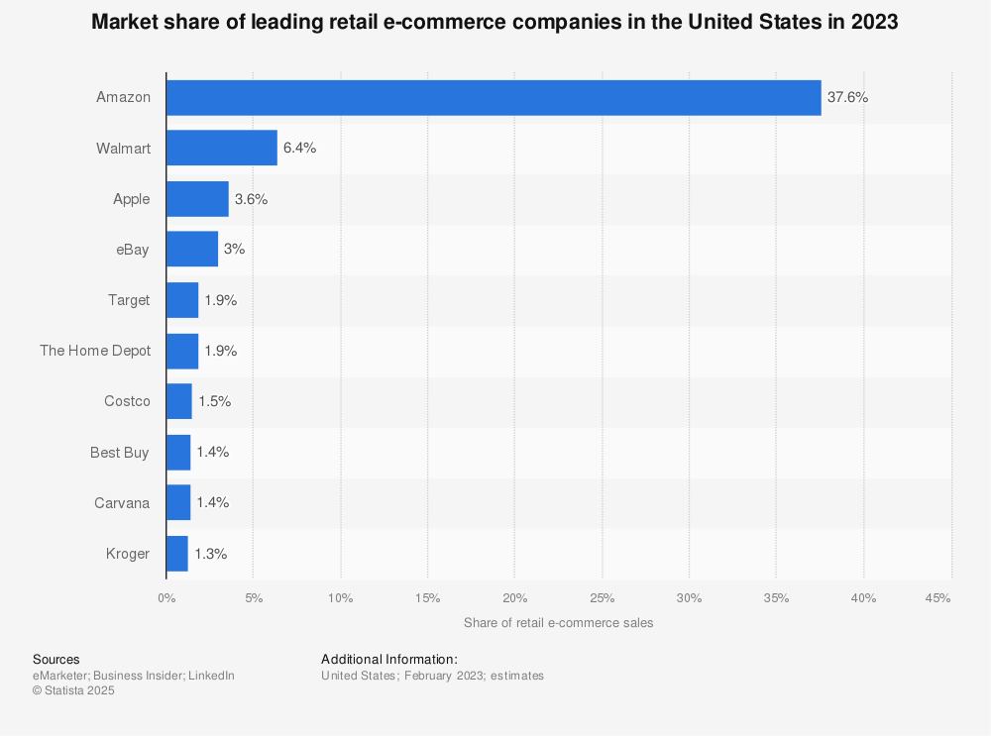
Figure 01: Leading Market Share of Amazon
(Source: Statista, 2024)
This report is going to analyse the external and internal environment of Amazon, its sustainability and CSR activities and financial and non-financial analysis to identify its holistic perspectives. This paper will analyse the strategic business choices suitable for Anacon to offer significant evidence-based recommendations.

External and Internal Environment Analysis

PESTLE Analysis
Political: The UK Competition and market authority CMA has caused active intervention in Amazon. Competition Act 1998 and the subsequent commitment of Marketplace practices on Amazon has ensured fair competition specifically regarding “Buy Box” and the third-party seller data which has forced structured adjustments to platform governance (International Center for Law & Economics, 2024). In addition, the Digital Markets, Competition and Consumers Act 2014 has strengthened the enforcement power influencing Amazon to address the issues like fake reviews.
Economic: The UK has remained the second largest European market for Amazon as it has generated nearly USD 43.2 billion in net sales which is supported by more than 27 distribution centres in the UK and 345.4 million website visits (‌Statista, 2025). However, the macroeconomic pressure has persisted with the inflation rate in the UK which caused cost-of-living pressure, real wage stagnation. This has constrained customer spending directly affecting the discretionary demand in e-commerce.
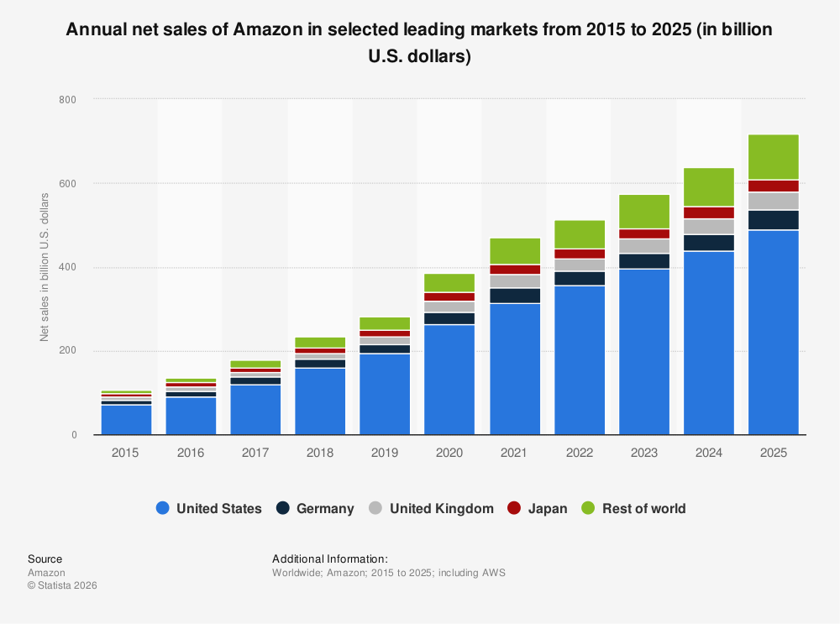
Figure 02: Net Sales in the UK and other countries
(Source: Statista, 2025)
Social: The consumer behaviour of Britishers is embedded in products and services as 82% of UK customers purchase through Amazon (Statista, 2019). However, certain reputational issues persist around the unionisation efforts like Coventry fulfillment centre and labour practices require increased investment in stakeholder engagement and employee welfare.
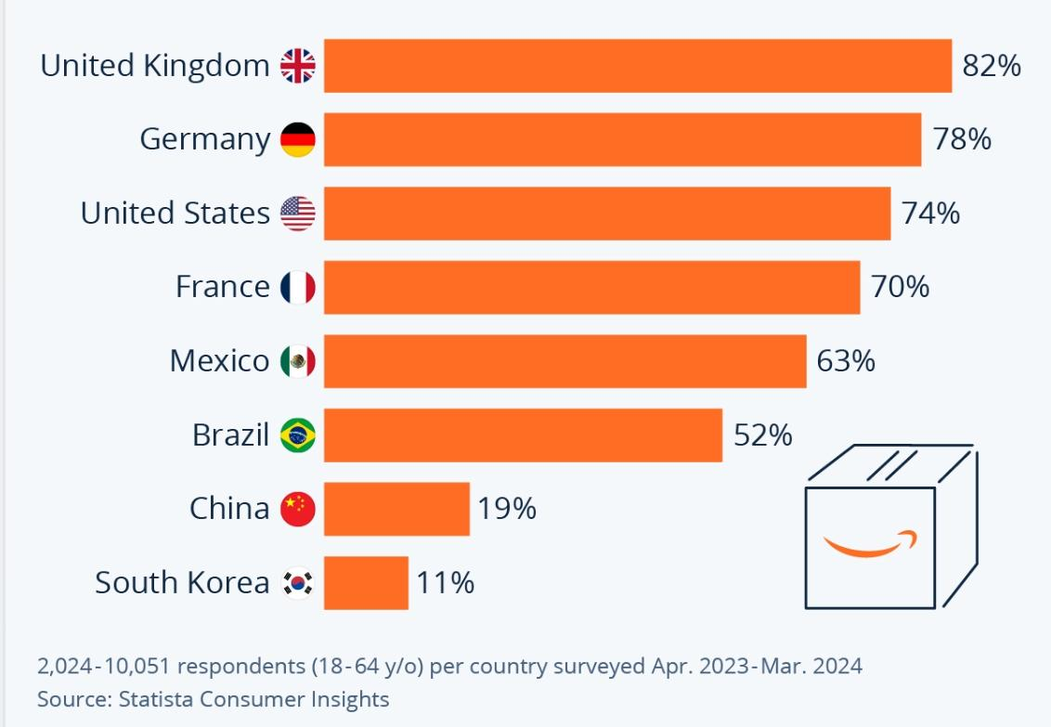
Figure 03: Britishers like Amazon
(Source: Statista, 2019)
Technological: Amazon has benefited from advanced digital infrastructure and a growing cloud market which is valued at £7.6 billion. AWS remains the dominant provider with 28% market share alongside Microsoft Azure with 21% share (Statista, 2024). Continued investment in cloud computing and AI-driven logistics reinforced market leadership and operational efficiency.
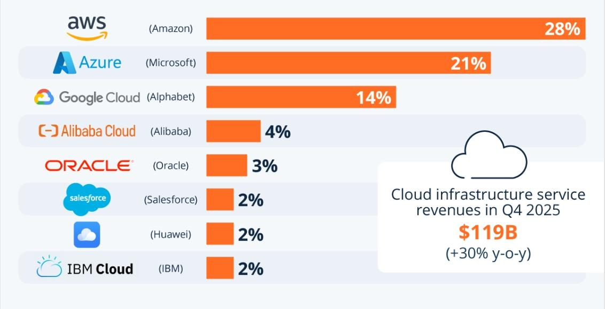
Figure 04: AWS is the dominant market player in the cloyd computing market
(Source: Statista, 2024)
Legal: Legal factors are highly intensified due to binding with CMA on the consumer protection and ongoing litigation from the British retailers. The cloud computing services and integration of Big Data infrastructure has posed cybersecurity challenges under UK GDPR and Data Protection Act 2018 and Telecommunication Security Act 2021 (Prather, 2026). These UK-based Britishers have alleged anti-competitive behaviours which indicate litigation of risks and rising compliance.
Environmental: Amazon has faced pressure aligned to the net zero target of the UK. USD 1 billion investment on electrification and renewable energy has highlighted Amazon's commitment to sustainability (L, 2025). Emission in logistics networks across the UK remains a critical challenge demonstrating tension between the environmental sustainability and rapid delivery models.

CSFs and Challenges in External Environment
Critical Success Factors
Logistics ecosystem: The "Last Mile” infrastructure of Amazon has spanned over 400 million square feet in the fulfillment spaces which ensured the unrivalled delivery speed (Logistics Management, 2018). It has driven 90% prime retention rate. Delivery speed has reinforced the brand preferences among UK customers.
AWS Market Dominance: Holding 28% in the global cloud market share, AWS has provided high-margin capital which has subsidised R&D operation and retail expansion (Statista, 2024).
Data-driven Flywheel: The “Network Effect” is identified through proprietary AI which has converted billions of customer data into the personalised co version (Gregory et al. 2020). It had driven a huge market share and customer base in the UK.
Economies of scale: Currently, in the UK, the net revenue of Amazon is USD 6.92 billion in 2023 (Statista, 2023). Massive volume of procurement further allows Amazon to dictate the terms and standards for vendors and maintains a low-cost leadership position which creates significant barriers in the entry.
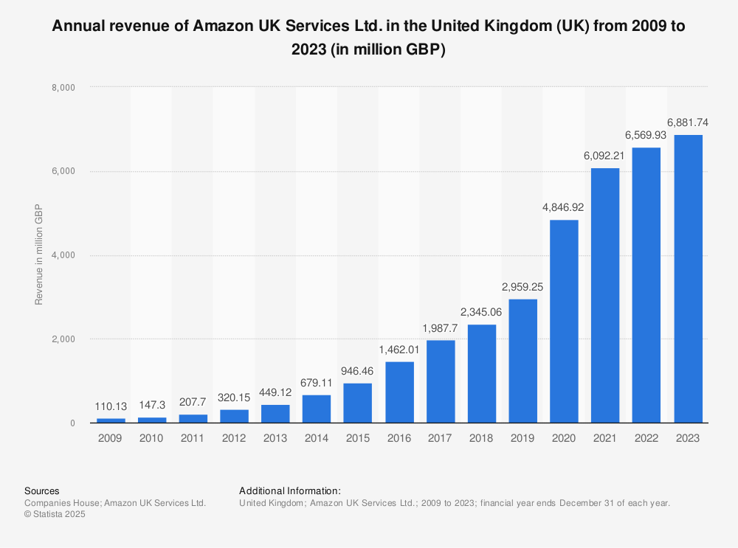
Figure 05: Annual Revenue of Amazon in the UK
(Source, Statista, 2023)
Strategic Challenges
- Despite the scale, Amazon is facing intensified external constraints in the UK. Regulatory pressure from CMA or Competition and Market Authority and the digital Markets Competition and Consumers Act 2025 has restricted marketplace practices (Peter, 2025). These standards are essential to maintain algorithmic transparency and third-party seller data.
- In addition, labour market pressure and the cost inflation has continued to erode the retail margins with increasing fulfilment expenses and wage expectations that have challenged the operational efficiency.
- Sustainability expectations have created structural tension whereas Amazon has committed to net-zero commitment by 2040 (Yu, Hassan and Adhikariparajuli, 2022). The logistics intensive model has generated significant emissions exposing the firm to reputational risks and strict environmental compliance requirements.

Internal Environment and Key Resources
Key tangible and intangible resources: A critical tangible resource is the global fulfilment and logistics infrastructure of Amazon supported by the automation technologies and transportation networks. The firm has extended the same-day delivery capability and has optimised the inventory placements reducing the fulfilment costs and enhancing delivery speed. The financial strength of this brand is reflected through European revenue of €54 billion in 2020 which is more than combined eCommerce competitive brands like Tesco, Zalandi, Apple, Argos and so on (Statista, 2022). Intangible resources are equally decisive in the Amazon with the data ecosystem which has been generated through millions of daily transactions. It has facilitated personalisation, advanced analytics and demand forecasting (Keshavarz et al. 2021). Customer trust and brand equity further reinforce the stickiness to platforms specifically through subscription-based services like Amazon Prime.
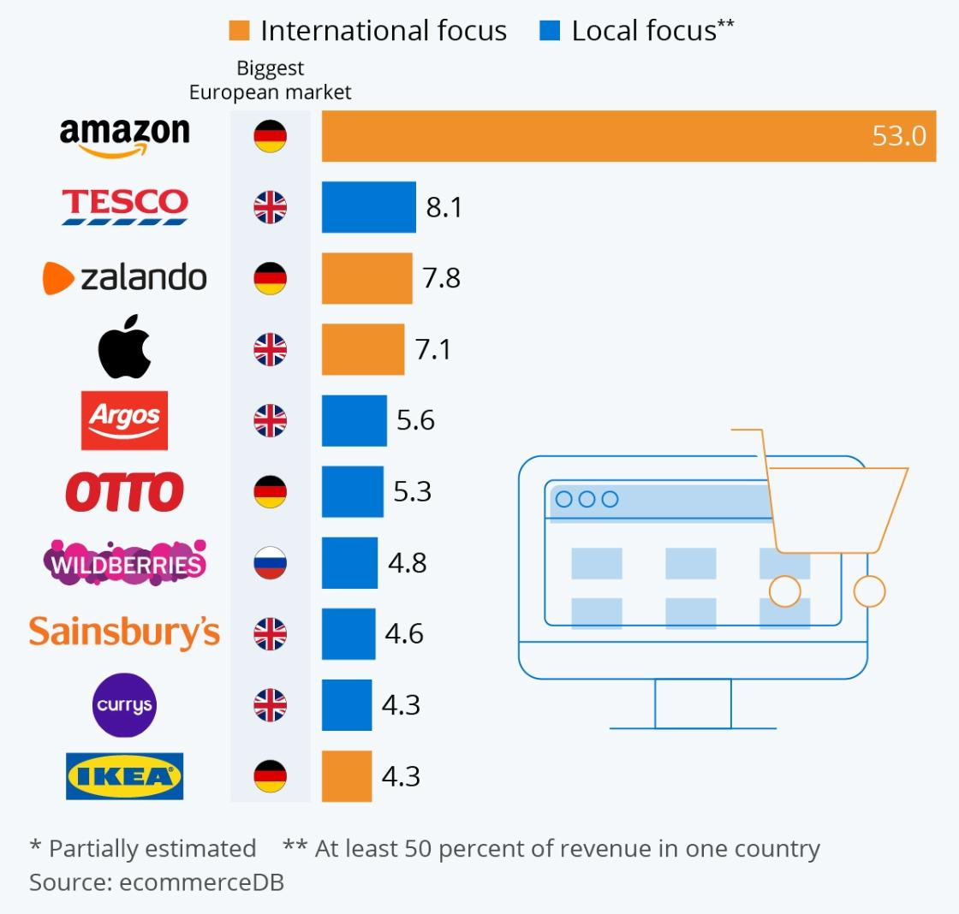
Figure 06: Top leading e-commerce retailer in the UK
(Source: Statista, 2022)
Organisational capabilities: The tangible and non-tangible resources of Amazon is operationalised through organisational capabilities. Amazon has hired 60,000 of skilled UK-based staff in its human resources. AWS or Amazon Web Services has generated more than 62% of the total operational profit and 13% of the net sales with USD 9.0 billion revenue (Statista, 2019). AWS functions as the high margin capability which has underpinned the wider ecosystem of the firm by funding low-margin retail expansion. In addition, the capability of Amazon in AI-driven optimisation included predictive analytics, robotics and generative AI integration. It enhances both customer experience and operational efficiency.
Core competencies: Collectively these elements create the core competencies in Amazon. The integration of the platform ecosystem, large-scale logistics orchestration and technological innovation has created its core competencies which are not isolated rather mutually reinforcing. AWS financed the logistics ecosystem expansion while data from retail operations may strengthen the AI capabilities (Li, 2024). This systemic interdependence has created high barrier ti imitation positioning internal environment of Amazon as the sustained source of competitive advantage rather than merely operational efficiency.

VRIO Analysis
Fulfilment and Logistics network: The fulfilment network and logistics infrastructure, growing in-house transportation fleet and last-mile delivery stations has created substantial value through cost efficiencies and delivery times. Continuous optimisation of regional fulfilment has improved delivery speed and has lowered cost-to-serve (Shuaibu, Mahmoud and Sheltami, 2025). However, although organisationally embedded and valuable, such infrastructure is not entirely rare, the major competitors have invested in similar organisational capabilities which have limited competitive parity.
AWS or Amazon Web Services: AWS constitutes a core significant asset. AWS has accounted for 62% of the share despite a smaller share in net sales margin (Novet, 2024). In the global proprietary chips like Trainium and Graviton and footprint in data centers alongside the integrated AI services has created e tey barriers making it rare, valuable and difficult to imitate.
Platform integration and data ecosystems: The data ecosystem and the platform integration have further reinforced the operational advantage. The firm had processed large-scale behavioural and transactional data across the advertising, retail and cloud services enabling demand forecasting and sophisticated personalisation (Toorajipour, Oghazi and Palmié, 2024). The organisational capability to embed the data across the multiple business units has constituted the inimitable and rare elements.
Organisational structure and capital allocation: The organisational structure of Amazon was multifaceted and the brand had reinvested in AI, automation and sustainability initiatives like renewable energy projects. It ensures that these sources are exploited effectively.
VRIO Table
Resources | Valuable | Rare | Inimitable | Organised | Competitive implications
Fulfilment and logistics networks | ✓ | × | × | ✓ | Competitive parity
AWS cloud infrastructure | ✓ | ✓ | ✓ | ✓ | Sustained advantage
Data integration ability | ✓ | ✓ | ✓ | ✓ | Sustained advantage
Brand trust and reputation | ✓ | ✓ | × | ✓ | Temporary advantage
Platform ecosystem | ✓ | ✓ | ✓ | ✓ | Sustained advantage

Critically discussion on internal strengths
The competitive advantages of Amazon are not derived from the isolated resources but from the systemic integration of high-value organisational capabilities. The critical strength of this brand lies in AWS which has generated USD 9.0 billion revenue only whereas accounted for the majority of total operating profit in Amazon (‌Klebnikov, 2020). This asymmetry has enabled Amazon to cross-subsidise the low-margin retail operations sustaining aggressive pricing strategies which competitors struggle to replicate.
Equality significant service is the logistics and fulfilment capability of Amazon which is restructured through the regionalised network for reducing the delivery cost and times. While this infrastructure is replicable, the capital intensity and the infrastructure has created substantial barriers to entry (Setiadi and Muharam, 2024). However, the contribution is primarily effocldmch drive rather than uniquely differentiation indicating any conditional rather than absolute advantage. More strategically, the platform ecosystem and data integration linking the cloud, retail and advertising has reinforced the feedback loop in Amazon (Carreno, 2024). Data generated from the marketplace transaction has enhanced AI driven demand forecasting and AI recommendations. It has improved the seller participation and customer retention in turn. This interconnectedness has increased the switching cost and embed users within ecosystems.

CSR and Sustainability objectives
The CSR approach of Amazon demonstrated a structured alignment between business objectives which is evaluated through TBL or Triple Bottomline model integrating the 3Ps like environmental (planet), societal (people) and economic (profit) performances.
From the environmental perspectives, the Climate Pledge of Amazon targets net-zero carbon emissions by 2040 supported by measurable operational processes. 100% of electricity consumption is generated with renewable energy and is achieved through investment of 600 renewable energy projects globally (Amazon, 2025). In addition, Amazon has deployed 31,400 electric delivery vans in 2025 reflecting the integration of decarbonisation within logistics systems (Amazon, 2024). However, this progress is partially offset by the structural changes as Scope 3 emission accounted for nearly 74% of the total emission and increased by 6% in 2025 due to expansion of data centres and third-party logistics (Amazon, 2024). It reflects the tension between environmental commitment and technological growth.
From social perspectives, the scale of Amazon as an employer is central to its CSR impact. The company has reported nearly 1.56 million employees globally in 2024 supported by programmes like Career Choice with more than 240,000 employees participating in skill development and educational programmes (Statista, 2022). This reflects investment on human capital aligned to long-term productivity. However, intense competition on rising wage pressure and accessing labour indicates structural challenges in maintaining workforce satisfaction and stability.
From economic perspectives, the CSR strategy of Amazon is closely embedded within its operational model. This firm has generated USD 637.9 billion in net sales and USD 68.6 billion as operating income in 2025 demonstrating a strong financial capability in investing in sustainability initiatives (About Amazon, 2020). The AWS has enabled cross-subsidisation on low-margin retail operations and enables the firm to fund on infrastructural and sustainability investments.

Comprehensive and holistic view of Amazon

Balanced Scorecard Analysis of Amazon
The Balanced Scorecard offers multidimensional teamwork to analyse how Amazon translates its customer-centric strategy into measurable performance across the non-financial and financial domains. The mission of Amazon is based on long-term value creation and customer obsession which are operationalised through interlinked objectives across the following four perspectives.
Financial: The primary financial objectives are margin expansion with sustainable revenue growth specifically across the high-margin segments. In 2024, the firm reported net sales of USD 574.8 billion and USD 30.4 billion as net operating income in 2023 demonstrating a strong financial capability (Statista, 2024). The key KPIs are the operating income, growth in net sales and segment profitability. Targeted are implicitly based on advertising revenues and scaling cloud while enhancing retail cost efficiency. Strategic initiatives involve AI-driven cost optimisation and regionalised fulfilment which enhanced margins and reduced fulfilment expenses (Wolniak, Stecuła and Aydın, 2024). This reflects a shift towards disciplined financial performance and growth-at-all-cost.
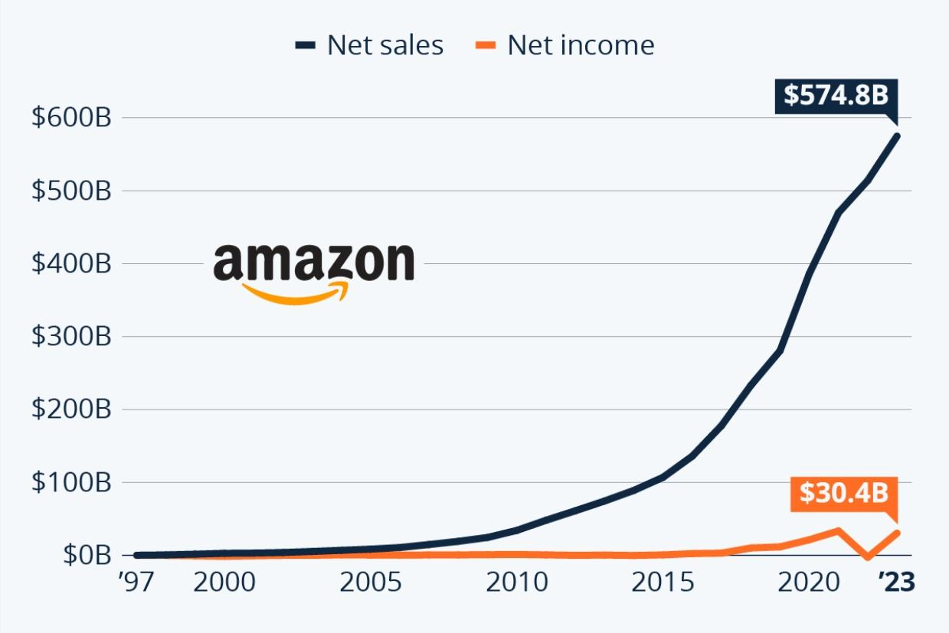
Figure 07: Net sales and Net income of Amazon
(Source: Statista, 2024)
Customer perspectives: The strategic objective of Amazon is to maximise customer lifetime value through price competitiveness, convenience and ecosystem integration. KPIs include the delivery speed, membership engagement and customer retention metrics (Ali and Shabn, 2024). Amazon maintains dominant traffic share across its core markets reflecting strong customer loyalty. Initiatives like personalised recommendations and same-day delivery directly support this aim. The initiative like Prime integration with the features like bundling delivery and service increases switching costs reinforcing the long-term customer retention aligned to customer-centric mission of Amazon. These initiatives have caused customer retention with the operations over 185 countries and sales over 400 million products (Ekene et al. 2024). It helps maintaining surplus inventory levels for every product is cost-prohibitive.
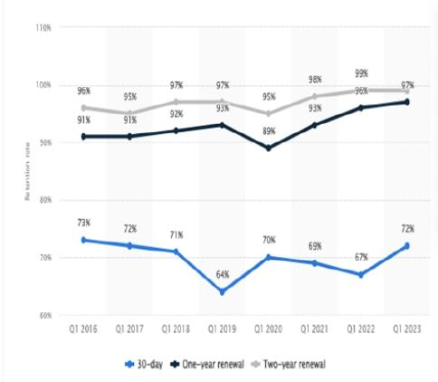
Figure 08: Retention Rate of Amazon
(Source: Ekene et al. 2024)
Internal Business Processes: Operational excellence is the central to strategy of Amazon as its objectives are focused on scalability, efficiency and innovation on cloud infrastructure and fulfilment. KPIs involve the cost-to-serve, fulfilment speed and AWS service reliability. Automation technologies and regional fulfilment models have improved delivery to lower unit costs. The strategic target of Amazon involved reduced fulfilment cost per unit and improving delivery speed through regionalisation (Rodrigue, 2020). In parallel, AWS has focused on uptime performance and data centre efficiency which are critical for the enterprise clients. These initiatives reflect how the process of innovation underpins both service differentiation and cost leadership.
Learning and growth: The long-term competitiveness of Amazon is sustained through technological innovation and human capital development. The company has reported over 1.5 million employees globally and their participation in upskilling programmes like Career Choice (Statista, 2022). KPIs involve retention, employee productivity and innovation outputs like new services and AI deployment. The company targets an upskilling workforce for AI and digital capabilities and enhances the innovation capacity across the logistics and AWS. Strategic initiatives involve the investment on the workforce training and AI technologies like generative AI within AWS (. The productivity improvements and workforce safety through Career Choice Programme are strategic initiatives in this case.
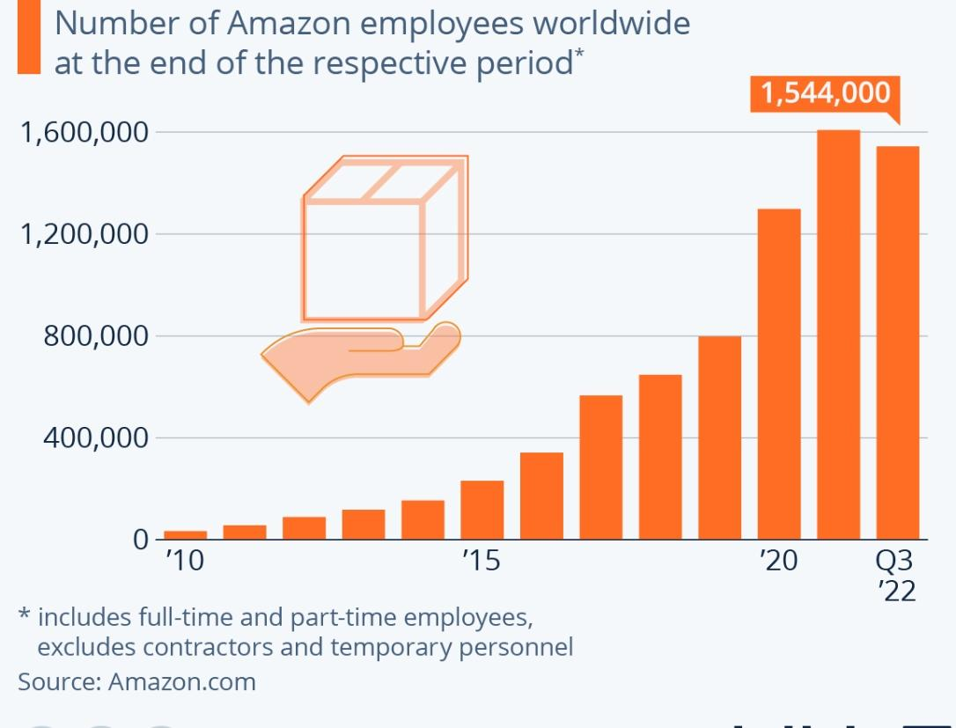
Figure 09: Employee Growth on Amazon
(Source: Statista, 2022)

Critical Integration
The four perspectives are highly interdependent. Financial performance of Amazon is increasingly influenced by AWS whereas customer satisfaction is dependent on logistics efficiency. Internal processes are reliant on technological innovation and the investment on learning sustain future capabilities (Braga et al. 2023). However, tensions persist due to workforce conditions, cost efficiency and sustainability commitments indicating although the balanced scorecard of Amazon is strategically aligned, execution needs continuous balance of competing priorities like workforce conditions, cost efficiency and sustainability.

Strategic Choices and Implementation

Strategic Choices
Cost Leadership: Cost leadership focuses on becoming the lowest-cost driver within the entire industry for achieving given quality. The key drivers of cost leadership are achieving proprietary technologies, preferential access to raw material and economics of scale (Jerab and Mabrouk, 2023). Amazon pursues a cost leadership approach through automation, scale economies and optimisation of supply chain. A shift to a regionalised fulfilment network has reduced the transportation distance and lowered the per-unit costs. In addition, continuous investment in AI-driven inventory management and robotics has enhanced operational efficiency (Raina et al. 2025). However, the rising inflationary pressure and labour cost across the key markets like the UK has constrained the margin improvement indicating cost leadership which is increasingly dependent on the technological optimisation rather than purely scaling benefits.
Differentiation: Differentiation strategy aims to offer the products and services perceived as the unique sector-based approach which allows the premium pricing. Differentiation strategy helps building brand image through customer orientation and unique value (Jerab and Mabrouk, 2023). Amazon has simultaneously adopted a differentiation strategy through technological innovation. Services including the AWS, Prime Membership and personalised recommendations has created a value proposition beyond the price competition. In particular, AWS delivered the advanced AI and cloud capabilities differentiating Amazon in high-potential growth markets (Challa, Devineni and Karangara, 2022). However, this differentiation is partially imitable in the segments like retail and streaming where competitors may replicate features. Therefore, the differentiation advantage of Amazon is strongest when derived from ecosystem integration.

Analysis of Corporate Level Strategies
Diversification: Diversification strategy is defined as the entry level approach of a firm which helps entering new markets with new products. Diversification is the initiative to widen a business portfolio outside the engaged activities which often requires the significant changes in technical and managerial competences (Buzhymska et al., 2024). Expansion into areas which share common features of the current value chain as it allows transfer to core competencies. Unreleased dissatisfaction reinforces new industries with no connection to current business. The diversification strategy of Amazon is spanned across cloud computing, e-commerce, subscription services and digital advertising (Sandhya and Srinivasa, 2023). These related diversification has reduced risk concentration enabling cross-subsidisation. AWS has generated a substantial share of operating income. However, diversification has increased capital intensity and organisational complexities.
International expansion: It is geographical diversification as it focuses on expansion of operations across the national borders. It aims to exploit the seasonal opportunity and new customer bases. The international expansion approach of Amazon focuses on scaling its logistics infrastructure and marketplace across Asia, Europe and emerging markets (Lu, 2024). In this regard, the UK is the key market of revenue extraction. The geographic market expansion has enabled economies of scale and growth of market share but exposed Amazon to currency fluctuations and regulatory volatility. Moreover, differing compliance requirements and customer behaviour has limited full standardisation which necessitates adaptive approaches which increase operational complexities.
Amazon needs to prioritise hybrid strategy combining ecosystem-based differentiation and cost leadership supported by continued investment on AI capabilities and AWS. At the corporate level, focused differentiation through technology enabled strategy rather than expansion will be priorosrf rmdronh sunetgitd regulatory rcpisure operational complexities.

Change management and Strategic Implementation
Amazon has reflected a strong capability in managing large-scale strategic change specifically on transitioning to a regionalised fulfilment model from centralised operation enhancing the cost efficiency and delivery speed. In addition, rapid integration of AI across logistics and AWS reflects organisational agility. However, the strategic integration shows significant friction with rising operational costs, workforce restructuring and regulatory interventions (Dharmananda et al. 2024). The pace and scale of change often may create internal strain in labour management. Consequently, although change management in Amazon is effective in driving innovation, its implications remain ineffective. It may require improved alignment between workforce stability, operational efficiency and regulatory compliance.

Strategic Evaluation and Recommendations

SWOT Analysis
Strengths | Weaknesses
- Strong profitability in AWS (Amazon Web Service, 2022)  - Integrated digital ecosystem with marketplace and Prime  - Advanced logistics networks | - Lower retail margins  - Increasing regulatory exposure  - High labour costs and operating costs
Opportunities | Threats
- Cloud and AI expansion  - Advertising growth  - Emerging markets for e-commerce services and AI-based personalisation | - Antitrust regulations like EU DMA and UK CMA (Whitecase, 2025)  - Competition from Walmart and Microsoft  - Rising pressure for sustainability
Discussion: The SWOT analysis has indicated that the competitive advantage of Amazon is increasingly driven by the ecosystem and AWS integration. Although strengths in logistics, data and cloud computing have created scalability, its strategic weaknesses in regulatory exposure and cost structure constrains the performance in Amazon (Chen, 2024). Opportunities in digital advertising and AI-driven personalisation have reinforced growth potentials. However, intensified competition and legal scrutiny has highlighted that Amazon's strategy needs to evolve towards efficiency, value optimisation and regulatory compliance from just expansion-driven growth.

Ansoff Matrix
Market Penetration: Amazon has continued to deepen its presence across the existing market through faster delivery services and prime ecosystem expansion. The core markets are the United Kingdom and the United States. Initiatives like prime subscription and same-day delivery along with increased purchase frequency has extended its customer base in Amazon (Brue, 2025). However, marginal profit is diminished which requires the continuous investment in pricing and logistics which places pressure on profitability despite stronger customer retention.
Market Development: Geographic expansion into the emerging markets has remained the strategic priority. Amazon has leveraged its marketplace model to enter into new regions with comparatively lower intensity in assets in Brazil, India, Mexico and Australia (HECHT et al. 2024). However these markets experience increased e-commerce adoption but needs localisation strategy due to the local competition and regulatory differences constrains scalability. It reduces efficiency in global integration approaches and increases operational complexities.
Product Development: The investment of Amazon in cloud services like AWS, AI and advertising technology demonstrate stronger product development strategies (AWS, 2024). This dimension has represented the most suitable growth potential within stronger demand and high margins for the digital transformation across the industry.
Diversification: The diversification of Amazon includes digital advertising, cloyd computing through AWS, healthcare through One Medical and satellite internet lilt Project Kuiper (Leo, 2025). Although the diversification strategy in Amazon has reduced dependence on retail, it has increased regular exposure and capital expenditure across the multiple industries. Therefore, although diversification strategy enhances the brand resilience, it needs strategic focus in avoiding the dilution of core competencies and avoidance of overextension.

Recommendations
Amazon needs to prioritize technology-driven and high-margin growth through AI advertising and AWS while restructuring its retail operations for cost efficiency. Investment on automation and sustainable logistics needs to be accelerated to address environmental pressure and cost (Nagy and Szentesi, 2024). In addition, proactive regulatory compliance strategies are essential in mitigating legal risks and maintaining market legitimacy specifically in the EU and UK.

Justification
Focusing on high-margin segments will enhance financial resilience as evidenced with the disproportionate contribution of AWS to operating income (Nigar et al. 2025). It is evidenced as AWS and the data ecosystem of Amazon has sustained the competitive advantage.
Prioritising product development over the market penetration will enable Amazon to mitigate diminishing returns on saturated markets capitalising global demands for the cloud services and AI products. Microsoft has structurally shifted to cloud-driven growth through Azure enhancing strategic focus and profitability (Hirning, 2025).
Moreover, investment on sustainable logistics aligned with the Triple Bottomline mode balancing environmental responsibility and economic efficiency. This is critical as the stakeholder and regulatory pressure is intensified.

Section 2: Reflection
Gibbs Reflective Cycle

Figure 10: Gibbs Reflective Cycle
(Source: Dutta, He and Tsang, 2023)
Description
My research and preparation of this strategic analysis report on Amazon has involved iterative and structured processes based on both empirical evidence and academic theory. I have used credible primary sources like Sustainability Report and Annual Report 2024 of Amazon to ensure data reliability and strict alignment to assessment criteria. These data sources are supplemented with industry-specific days and insights from Statista reports and different industry reports to contextualise the market performance and share of the brand. I have systematically applied strategic models like VRIO, PESTLE, SWOT and Balanced Scorecard alongside Ansoff Matrix. Each of these models require selective generation of relevant information and I have avoided descriptive application of these tools subsequently. For instance, I have prioritised operational metrics and specific data and information in structuring balanced scorecards whereas macroeconomic and regulatory information are crafted in PESTLE analysis. This process was iterative as my initial draft revealed my tendency towards generalisation which requires refinement to incorporate critical analysis and precise data points. Cross-referencing between the reports has ensured the academic consistency particularly when I have analysed the logistics efficiency, AWS performance and sustainability commitments. Finally, I have synthesised the findings across the sections to maintain academic coherence which will ensure the internal capabilities identified through VRIO are aligned to performance outcomes and strategic choices identified in Balanced Scorecard. This integration is essential to move beyond fragmented analysis towards evidence-based and holistic strategic evaluation.
Feelings
At the outset, I have experienced uncertainty about the depth of analysis necessitated to meet the high-fisticyopnncroteria. I have faced less confidence while balancing the theoretical models with the empirical evidence. The extensive volume of days within the corporate reports have created an overwhelming situation for me making it challenging to detect the most relevant information to the theories and concepts I have applied. However, as the process proceeded, my confidence increased as I developed a systematic approach to interpret and filter data. Engaging directly to the primary sources has enhanced my understanding on how strategic decisions are demonstrated in real organisational settings. There was also increasing awareness of the importance of critical analysis rather than description. Although this required initial efforts, ultimately improved the quality of assessment. In the final stages, I felt assured in my ability to implement theory into practice. Although I have identified the requirement for further enhancement on efficiency and precision while managing larger data sets.
Evaluation
The research process has demonstrated several core strengths such as consistent usage of verifiable and credible sources specifically from the official website of Amazon. It has enhanced the academic integrity and reliability of this assessment. This belonged to the scholarly article which encompasses the importance of high-quality data in strategic research (Bernardi et al. 2023). In addition, the structured application of multiple models enabled comprehensive analysis of strategy of Amazon from different perspectives. For instance, integrating VRIO with the Balanced Scorecard offers performance-based and capability-based insights to strengthen the analytical depth. However, there are several limitations too. Initially several sections relied on generic interpretation of models which has reduced critical depth. This necessitated revision to incorporate organisation-specific evidence. Moreover, managing large volumes of data was time consuming and I faced challenges on maintaining consciousness while ensuring the analytical rigour. Another limitation is the complexity in aligning the financial performance and sustainability data as disclosures were presented in different forms. This has required additional effort to make meaningful connections. Overall the process was effective in producing detailed assessment and it highlighted the requirements for improved data management and more effective synthesis strategies.
Analysis
The experience in this strategic analysis has reflected principles of experiential learning theory where knowledge is integrated through iterative cycles of reflection and actions. The transition from the descriptive to critical assessment demonstrates movement from the surface-level understanding to in-depth cognitive processing. It is essential for strategic analysis. I have applied multiple frameworks which have further illustrated the concept of methodological triangulation that enhances validity analysing the organisation from different perspectives (Valencia, 2022). For example, the PESTLE model has offered macro-economic contexts as VRIO has reinforced assessing internal capabilities and Balanced Scorecard linked to the overall performance outcomes. This multi-layered approach has reduced the risk of incomplete or biased assessment. Moreover, the challenges encountered in managing larger datasets highlighted the importance of prioritisation of information and filtering. The requirement to identify days points has influenced me to maintain analytical selectivity principles which is crucial in strategic management research. This process has also revealed the importance of descriptive reporting and critical thinking. High order skills like synthesis and evaluation are required for advanced academic performance. This transition is essential in achieving more insightful and rigorous analysis.
Conclusion
The reflective process has demonstrated that effective strategic evaluation needs evidence-based support with theoretical application. It depends on the ability to embed credible data with the critical synthesis. Although the research approach was successful in generating the evidence-based and comprehensive analysis, it highlighted areas for improvement specifically on analytical efficiency and data management. My experience throughout this report has enhanced my ability to interpret the complex organisational data and apply the strategic models within practical contexts. Moving forwards more structured solutions in data synthesis and selection will strengthen the analysis clarity and quality.
Action Plan
Areas of development | Action | Evidences | Timeline
Data Selection | Using structured note taking to generate only relevant information | Creating my summary table for each models | Immediate
Critical Analysis | Practice linking theory directly to the evidence in each paragraph (Shoghi et al. 2019) | Reviewing the journal articles on strategic management from Google Scholar and university library | Ongoing
Time management | Allocating fixed time for the each section to avoid over assessment | Using weekly planning schedules | Next assignment
Source credibility | Prioritising corporate reports and statistical databases. | Maintaining the reference log  (Murali, 2019) | Continuous
Writing precision | Reducing descriptive content and increased analysis | Self-review and peer review against the grading criteria | Before submission

References
About Amazon. (2020). Amazon.com Announces Fourth Quarter Results. [online] Available at: https://ir.aboutamazon.com/news-release/news-release-details/2026/Amazon-com-Announces-Fourth-Quarter-Results/.
Alkhatib, A., Shaheen, A. and Albustanji, R.N. (2025). A Comparative Analysis of Cloud Computing Services: AWS, Azure, and GCP. International Journal of Computing and Digital Systems, 18(1), pp.1–15. doi:https://doi.org/10.12785/ijcds/1571111846.
Ali, N. and Shabn, O.S. (2024). Customer lifetime value (CLV) insights for strategic marketing success and its impact on organizational financial performance. Cogent business & management, 11(1). doi:https://doi.org/10.1080/23311975.2024.2361321.‌
Amazon (2018). Our Mission. [online] About Amazon. Available at: https://www.aboutamazon.eu/news/how-amazon-works/our-mission.
AWS (2024). Behind the scenes look at generative AI infrastructure at Amazon. [online] Available at: https://aws.amazon.com/ai/machine-learning/trainium/.
Amazon Web Services. (2022). AWS Partner Profitability Framework: Deepen and Diversify Your Offerings | Amazon Web Services. [online] Available at: https://aws.amazon.com/blogs/apn/aws-partner-profitability-framework-deepen-and-diversify-your-offerings/.‌
Amazon (2024). Amazon Sustainability Report . [online] Available at: https://sustainability.aboutamazon.com/2024-amazon-sustainability-report.pdf.
‌Amazon (2025). Carbon-Free Energy. [online] Sustainability (US). Available at: https://sustainability.aboutamazon.com/climate-solutions/carbon-free-energy.
AWS (2025). Accelerating Innovation in Retail | Industry Overview. ‌Amazon Web Services, Inc. [online] Available at: https://aws.amazon.com/retail/.
Abdeen, Z.U. (2024). Jeff Bezos: The Visionary Behind Amazon’s Global Empire. [online] Medium. Available at: https://medium.com/@zain_ul_abdeen/jeff-bezos-the-visionary-behind-amazons-global-empire-a85ccf2cab2f.
Bernardi, F.A., Alves, D., Crepaldi, N.Y., Yamada, D.B., Lima, V. and Rijo, R. (2023). Data quality in health research: An integrative literature review. Journal of Medical Internet Research, [online] 25(25), pp.e41446–e41446. doi:https://doi.org/10.2196/41446.
Braga, T., Flávio Hourneaux, Cristiana Lara-Cunha, Patricia Taeko Kaetsu and Torres, G. (2023). Technology and Innovation: A Systematic Literature Review on Sustainability Research in the Amazon. Bar. Brazilian Administration Review, 20(4). doi:https://doi.org/10.1590/1807-7692bar2023220020.
Brue, M. (2025). Will Amazon’s Prime Model Drive Growth In Same-Day Grocery Delivery? Forbes. [online] 5 Sep. Available at: https://www.forbes.com/sites/moorinsights/2025/09/05/will-amazons-prime-model-drive-growth-in-same-day-grocery-delivery/.
Buzhymska, K., Tsaruk, I., Biriuchenko, S., Pashchenko, O. and Svitlyshyn, I. (2024). Impact of diversification on strategic business management. Scientific Bulletin of Mukachevo State University Series ‘Economics’, 11(3), pp.34–46. doi:https://doi.org/10.52566/msu-econ3.2024.34.
‌Carreno, A.M. (2024). Analyzing Amazon’s Evolution from an Online Bookstore to a Global Tech Giant. [online] Researchgate. doi:https://doi.org/10.5281/zenodo.14261927.
Challa, N., Devineni, S.K. and Karangara, R. (2022). A Deep Dive into Amazon Web Services: Unlocking the Potential. Journal of artificial intelligence & cloud computing, 1(2), pp.1–2. doi:https://doi.org/10.47363/jaicc/2022(1)179.‌
Chen, Y. (2024). Research on Supply Chain Optimization at Amazon. Advances in Economics, Management and Political Sciences, [online] 105(1), pp.257–261. doi:https://doi.org/10.54254/2754-1169/105/20241983.
Dharmananda M, Mahmod, B., Purohit, N., Shailendra Kumar Singh, Joseph, B., Mohanadasan T, Mittal, M. and Vyas, P. (2024). Strategic integration: Exploring the intersection of technology, finance, and management in today’s business environment. Journal of Infrastructure Policy and Development, [online] 8(8), pp.4871–4871. doi:https://doi.org/10.24294/jipd.v8i8.4871.
Dutta, S., He, M. and Tsang, D. (2023). Reflection and peer assessment to promote self-directed learning in higher education. [online] ResearchGate. Available at: https://www.researchgate.net/publication/371536633_Reflection_and_peer_assessment_to_promote_self-directed_learning_in_higher_education.
Ekene, M.C., Ekaete, O.O., Chukwudi, O.M., Temitope, A.O., John, O.B. and Adetola, A.T. (2024). The Role of Predictive Analytics in Enhancing Customer Retention Strategies in E-commerce. Path of Science, [online] 10(12), pp.3001–3007. doi:https://doi.org/10.22178/pos.112-6.
Gregory, R.W., Henfridsson, O., Kaganer, E. and Kyriakou, H. (2020). The Role of Artificial Intelligence and Data Network Effects for Creating User Value. Academy of Management Review, [online] 46(3). doi:https://doi.org/10.5465/amr.2019.0178.
HECHT, S., SCHMINK, M., ABERS, R.N., ASSAD, E., BEBBINGTON, D.H., BRONDIZIO, E., Francisco, María, A., FEARNSIDE, P., GARRETT, R., HEILPERN, S., MCGRATH, D., Gustavo, PEREIRA, H. and PINEDO-VAZQUEZ, M. (2024). Amazonia in motion: Changing politics, development strategies, peoples, landscapes and livelihoods. Acta Amazonica, [online] 54(spe1). doi:https://doi.org/10.1590/1809-4392202203060.‌
Hirning, D. (2025). Modernizing IT Infrastructure at Microsoft: A cloud-native journey with Azure - Inside Track Blog. [online] Inside Track Blog. Available at: https://www.microsoft.com/insidetrack/blog/modernizing-it-infrastructure-at-microsoft-a-cloud-native-journey-with-azure/.
International Center for Law & Economics. (2024). A Competition Law & Economics Analysis of Sherlocking. [online] Available at: https://laweconcenter.org/resources/a-competition-law-economics-analysis-of-sherlocking/.‌
Jerab, D.A. and Mabrouk, T. (2023). Achieving Competitive Advantage through Cost Leadership Strategy: Strategies for Sustainable Success. [online] ResearchGate. Available at: https://www.researchgate.net/publication/374000449_Achieving_Competitive_Advantage_through_Cost_Leadership_Strategy_Strategies_for_Sustainable_Success.‌
Keshavarz, H., Mahdzir, A.M., Talebian, H., Jalaliyoon, N. and Ohshima, N. (2021). The Value of Big Data Analytics Pillars in Telecommunication Industry. Sustainability, [online] 13(13), p.7160. Available at: https://www.mdpi.com/2071-1050/13/13/7160.
‌Klebnikov, S. (2020). Microsoft Is Winning The ‘Cloud War’ Against Amazon: Report. [online] Forbes. Available at: https://www.forbes.com/sites/sergeiklebnikov/2020/01/07/microsoft-is-winning-the-cloud-war-against-amazon-report/.
L, J. (2025). Amazon’s $1 Billion Move Towards Net Zero: Logistics Electrification Across Europe. [online] Carbon Credits. Available at: https://carboncredits.com/amazons-1-billion-move-towards-net-zero-logistics-electrification-across-europe/.
Leo (2025). Amazon rebrands Project Kuiper as Amazon Leo: What to know. [online] Aboutamazon.com. Available at: https://www.aboutamazon.com/news/amazon-leo/project-kuiper-becomes-amazon-leo.‌
Li, Z. (2024). Review of Application of AI in Amazon Warehouse Management. Advances in Economics Management and Political Sciences, [online] 144(1), pp.1–8. doi:https://doi.org/10.54254/2754-1169/2024.ga18980.
‌Lu, Y. (2024). Mastering Complexity: Amazon’s Innovative Approach to Global Supply Chain Challenges. Advances in Social Science, Education and Humanities Research, pp.752–762. doi:https://doi.org/10.2991/978-2-38476-297-2_92.
Logistics Management (2018). Buyers’ Guide. Peerless Media LLC 2017. Available at: https://scg-lm.s3.amazonaws.com/pdfs/LM_DEC_2017.pdf [Accessed 27 Mar. 2026].
‌MJE. (2023). The History of Amazon and its Rise to Success – Michigan Journal of Economics. [online] Available at: https://share.google/7WM91bp0E5uYZE2Un [Accessed 24 Mar. 2026].
Murali, R. (2019). Usage of References and Its Management in Research: Breakthroughs in Research and Practice. [online] doi:https://doi.org/10.4018/978-1-5225-8057-7.ch041.
Nagy, G. and Szentesi, S. (2024). Green logistics: Transforming Supply Chains for a Sustainable Future. Advanced Logistic Systems - Theory and Practice, [online] 18(3), pp.29–42. doi:https://doi.org/10.32971/als.2024.026.
Nigar, M., Juli, J.F., Golder, U., Alam, M.J. and Hossain, M.K. (2025). Artificial intelligence and technological unemployment: Understanding trends, technology’s adverse roles, and current mitigation guidelines. Journal of Open Innovation: Technology, Market, and Complexity, [online] p.100607. doi:https://doi.org/10.1016/j.joitmc.2025.100607.
‌Novet, J. (2024). Amazon’s cloud margin widens on accelerating revenue growth. [online] CNBC. Available at: https://www.cnbc.com/2024/04/30/aws-q1-earnings-report-2024.html.
Peter (2025). Reinforcing data protection and competition through art. 6(2) of the Digital Markets Act. International Review of Law and Economics, pp.106265–106265. doi:https://doi.org/10.1016/j.irle.2025.106265.‌
Prather, R.D. (2026). UK Competition and Market Authority Provides New Green Marketing Guidance for All Supply Chain Actors. [online] The National Law Review. Available at: https://natlawreview.com/article/uk-competition-and-market-authority-provides-new-green-marketing-guidance-all [Accessed 27 Mar. 2026].
Raina, K., Sharma, G.D., Taheri, B., Dev, D. and Chavriya, S. (2025). Artificial intelligence-driven management: Bridging innovation, knowledge creation, and sustainable business practices. Journal of Innovation & Knowledge, [online] 11, p.100860. doi:https://doi.org/10.1016/j.jik.2025.100860.‌
Rodrigue, J.P. (2020). The distribution network of Amazon and the footprint of freight digitalization. Journal of Transport Geography, [online] 88(102825), p.102825. doi:https://doi.org/10.1016/j.jtrangeo.2020.102825.‌
Sandhya, C. and Srinivasa (2023). Competitive Digital Strategic Model of Amazon - A Case Study Analysis. International Journal of Case Studies in Business IT and Education, pp.198–213. doi:https://doi.org/10.47992/ijcsbe.2581.6942.0268.
Setiadi and Muharam, H. (2024). Logistics Innovation in Developing Economies: Integrating Digital Solutions in E-Commerce Supply Chains. Sinergi International Journal of Logistics, 2(4), pp.239–251. doi:https://doi.org/10.61194/sijl.v2i4.733.‌
‌Shoghi, M., Sajadi, M., Oskuie, F., Dehnad, A. and Borimnejad, L. (2019). Strategies for bridging the theory-practice gap from the perspective of nursing experts. Heliyon, [online] 5(9), pp.1–6. doi:https://doi.org/10.1016/j.heliyon.2019.e02503.
Shuaibu, A.S., Mahmoud, A.S. and Sheltami, T.R. (2025). A Review of Last-Mile Delivery Optimization: Strategies, Technologies, Drone Integration, and Future Trends. Drones, [online] 9(3), p.158. doi:https://doi.org/10.3390/drones9030158.‌
Statista (2019). Brits Love Amazon. [online] Statista Daily Data. Available at: https://www.statista.com/chart/amp/18611/share-ordering-from-amazon-gcs/.
Statista (2019). The Blockbuster Growth of Amazon’s Cloud Business. [online] Statista Daily Data. Available at: https://www.statista.com/chart/amp/18822/amazon-web-services-revenue/ [Accessed 25 Mar. 2026].
Statista (2022). Infographic: No Match for Amazon. [online] Statista Daily Data. Available at: https://www.statista.com/chart/26846/ecommerce-brands-by-revenue-europe/?srsltid=AfmBOoquM7um2E3fV0O2Iacqg8Qx7oB37OQTeUvXpj76tcqGdOHox9Jn [Accessed 25 Mar. 2026].
Statista (2022). Infographic: Layoffs Reach Amazon After Years of Unabashed Growth. [online] Available at: https://www.statista.com/chart/amp/7581/amazons-global-workforce/.‌
Statista. (2023). Amazon UK Services revenue 2023| Statista. [online] Available at: https://www.statista.com/statistics/1050066/amazon-uk-services-turnover/?srsltid=AfmBOopW_c2ysVXI4gh6pIh8q5KnXz27SoNQHAc4NlsEOUAoySsUw9Oh [Accessed 25 Mar. 2026].
‌Statista (2024). Infographic: Amazon Maintains Cloud Lead as Microsoft Edges Closer. [online] Available at: https://www.statista.com/chart/amp/18819/worldwide-market-share-of-leading-cloud-infrastructure-service-providers/.
Statista (2024). Infographic: Amazon at 30: All Grown Up. [online] Statista Daily Data. Available at: https://www.statista.com/chart/4298/amazons-long-term-growth/?srsltid=AfmBOoqHMPsXLsnTkacTpXjVdhHqFVcfmetSkuVw5uH44UxebTr20cbN [Accessed 27 Mar. 2026].
‌Statista (2024). Market share of leading retail e-commerce companies in the United States in 2023. [online] Statista. Available at: https://www.statista.com/statistics/274255/market-share-of-the-leading-retailers-in-us-e-commerce/.
‌Statista. (2025). Amazon top markets net sales 2025| Statista. [online] Available at: https://www.statista.com/statistics/672782/net-sales-of-amazon-leading-markets/?srsltid=AfmBOooND8Xy4Zgk3xR8sEDF88QwdOncw4EYsBFwNIhqcORJ__juQHUR [Accessed 25 Mar. 2026].
Toorajipour, R. Oghazi, P. and Palmié, M. (2024). Data ecosystem business models: Value propositions and value capture with Artificial Intelligence of Things. International journal of information management, 78, pp.102804–102804. doi:https://doi.org/10.1016/j.ijinfomgt.2024.102804.
‌
Valencia, M.M.A. (2022). Principles, scope, and limitations of the methodological triangulation. Investigacion Y Educacion En Enfermeria, 40(2), pp.1–14. doi:https://doi.org/10.17533/udea.iee.v40n2e03.
Wolniak, R., Stecuła, K. and Aydın, B. (2024). Digital Transformation of Grocery In-Store Shopping-Scanners, Artificial Intelligence, Augmented Reality and Beyond: a Review. Foods, 13(18), p.2948. doi:https://doi.org/10.3390/foods13182948.‌Whitecase. (2025). Navigating the new UK antitrust landscape | White & Case LLP. [online] Available at: https://www.whitecase.com/insight-alert/navigating-new-uk-antitrust-landscape.‌
Yu, W., Hassan, A. and Adhikariparajuli, M. (2022). How Did Amazon Achieve CSR and Some Sustainable Development Goals (SDGs)—Climate Change, Circular Economy, Water Resources and Employee Rights during COVID-19? Journal of Risk and Financial Management, 15(8), p.364. doi:https://doi.org/10.3390/jrfm15080364.
‌
‌

