Programming in C++
Software Development
Correy Heard (1901709)
2020
Table of Contents
Exercise 1 2
Problem-Solving 2
Screenshots 3
Exercise 2 5
Problem Solving 5
Screenshots 6
Exercise 3 9
Problem-solving 9
Screenshots 10
Exercise 4 13
Problem-solving 13
Screenshots 14
Appendix 17
Code listing 17
Exercise 1 17
Exercise 2 18
Exercise 3 20
Exercise 4 21

Exercise 1

Problem-Solving
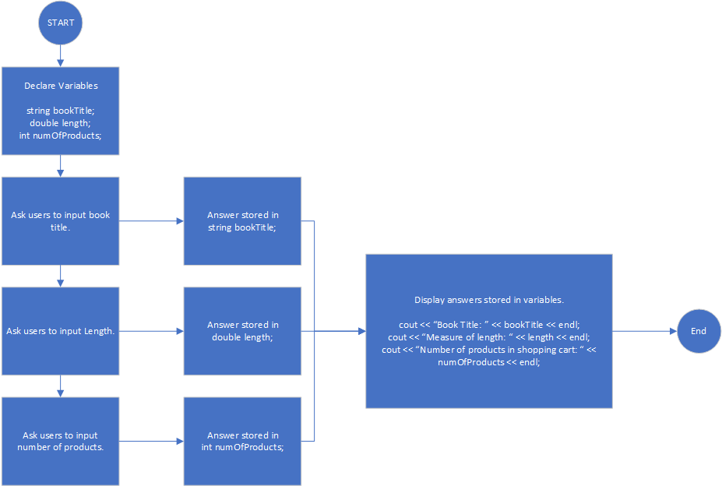
During this stage I worked out how I’d set up the program before starting it I decided to start with declaring the potential variables such as bookTitle, length and numOfProducts since they would be related on storing the data I’d of achieving from the user once I’ve started with that I prompted the user with a question to enter the value for these variables they’d give a value which then would be stored in the variable that represents it, finally when I’ve achieved all the answers to my questions I’d display the answers that was inputted into the system.

Screenshots
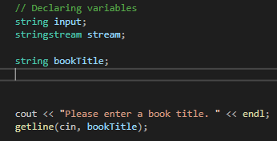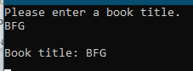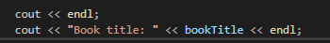
Firstly, I started with adding the variables for bookTitle and then started to add the Question using cout, to get the answer from the questions I’ve asked I used getline() function to get the information and for it to be stored in “bookTitle” once I’ve achieved the information I have made it so it can be displayed to the user at the end of the questions.
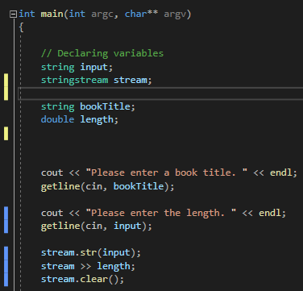 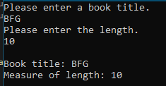
After making the bookTitle one I went on further to implement the Length this was the same process as making the one before but I needed to make the variable a double because someone could have a size of 4.2 cm, When typing the number into the console it gave a string instead of a double/int so I had to use stream to be able to convert the string into a double so I can use it to be put into the correct variable once that was finished I then added it to be displayed the same way as the book title.
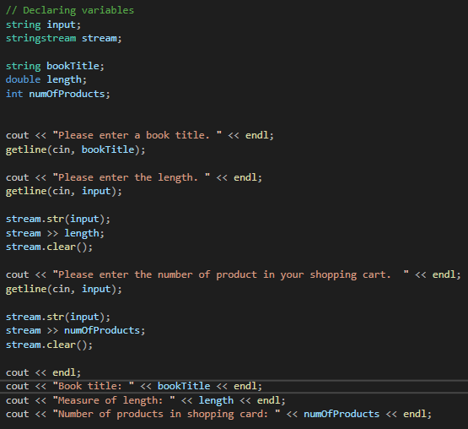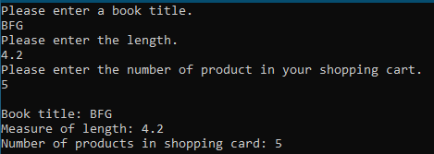
Finally, after I test and made sure the other two questions were working and displaying the correct answers I implemented the next part of the program which allows for the users to enter the number of products in the shopping cart, once I was able to enter the number I made sure that it would display the correct number once that was finished I did tests to make sure that the program worked correctly.

Exercise 2

Problem Solving
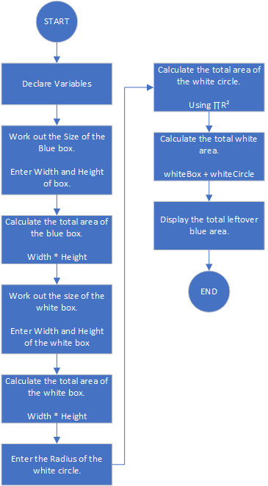
Firstly I started by making the variables that were needed such as String input and stringstream stream once I’ve made these variables I needed to advance into working out the total area of the blue box so I used a simple maths equation width * height to be able to work out the total area of the blue, once I’ve got the total area of the blue box I needed to work out the total white area to do this I first needed to work out the white box using the same equation after I got the results I then needed to proceed and work out the total area of the circle within the blue box which I used another equation ∏R² to be able to work out the area (Within the program I used 3.14 as ∏ which is Pi rounded to 2 decimal places), this gave me the total of the white circle I then added both the white circle and box to give me the total white area within the blue box then I subtracted the white area to give the final results of the blue box.

Screenshots
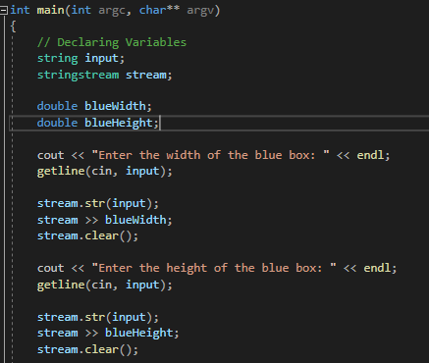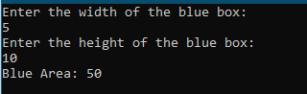
First I started by making it let the user enter blue box height and width then it would calculate the total area of the blue box by multiplying the height and width, to test I get the correct results I added a temporary cout to allow for it to be displayed for me to check the correct calculation.

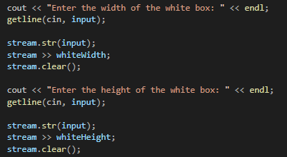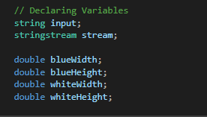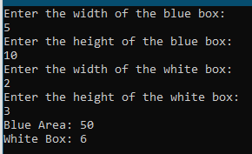
After the test of the blue box, I proceeded to work on the program by adding the next step of adding the equations for the white box to do this I used the same process that I calculated the blue box and displayed the white box area temporary for me to make sure the calculations was correct during the testing.
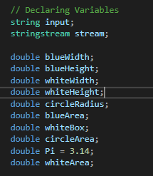
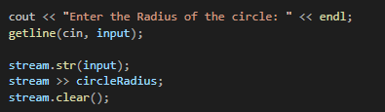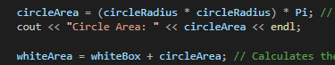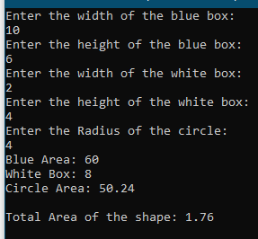
Finally, I added the area of the circle I done this by creating a variable called Pi which has the value of Pi rounded to 2 decimal places, and when the user inputted the radius of the circle then I used ∏R² to calculate the area of the white circle once I’ve done that I added both the white box and the circle together to make the total white area which then I could subtract from the blue area to give me the total blue area leftover.

Exercise 3

Problem-solving
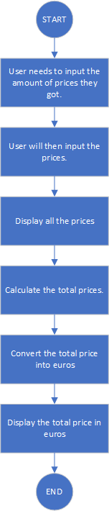
First, the user will need to input the total number of prices they have once they inputted that then the program will ask them to input every price they got, afterwards it will then display the prices they have inputted into the system and calculate the total price of the prices then it will convert them prices into euros and display them to the user.

Screenshots
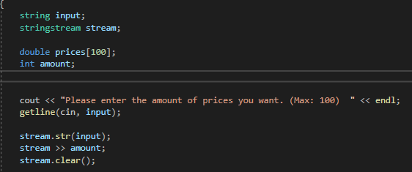
When the user starts the program it will then give them a question on the number of prices they want to submit to the system with a maximum of 100, this is to make sure that the user doesn’t go over the array if they were to do that the data wouldn’t be stored.
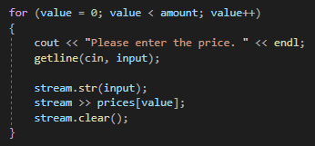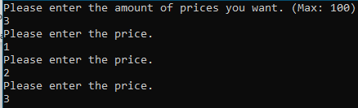
After the user entered the number of prices they want to enter then the system will prompt them to enter the prices into the system this will then store the prices into the array while for the data to be used for the end calculations.
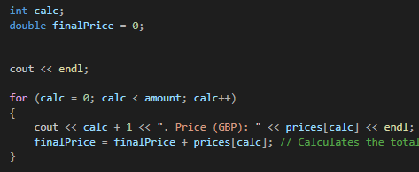
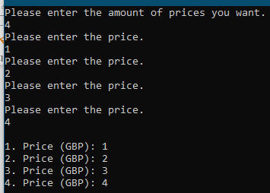
After entering the prices they will be displayed to the user to show what prices they have entered into the system for the calculations during this process the calculation for the final price is getting calculated.

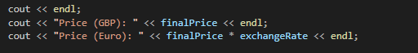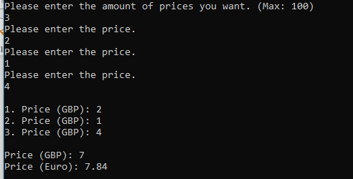
After the process of the calculations are done and the prices have been displayed and tested it will then display the total price in GBP and the total price in EUROs.

Exercise 4

Problem-solving
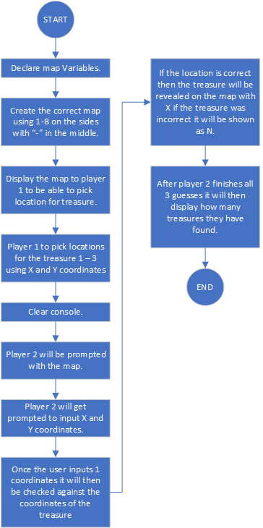
Firstly I’d start off setting up the map as a visual map for the user to be able to see the coordiantes, I done this by first making the array and inputting the numbers 1-8 so if we was to display the map it would show the correct coordinates, after correctly doing the map id need to make player 1 be able to input X and Y coordinates so they could hide the treasure on the map, once player 1 have hidden all the treasures on the map I would need to make the console clear so that player 2 wouldn’t see the inputted data from player 1, after that Id need to prompt the player 2 with where they’d want to guess the coordinates of the treasure once they enter the coordinates I’d need to check these coordiantes against the coordiantes of the treasure that player 1 inputted I’d do this with a if statement, if the player 2 was to find the treasure it would display Found the treasure and add a X marker on the map to show that a treasure have been found but if the player was to not find the treasure it would display a N on the map to show that none treasure was found, after the player has used all guesses the game will be finished and it would display the amount of treasure they have found.

Screenshots
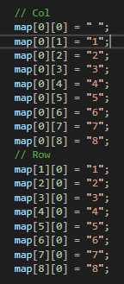
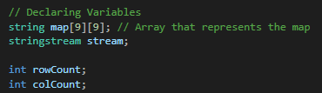
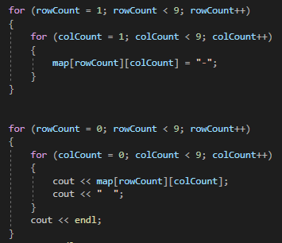

I first started by making the map structure so it showed coordinates of the map and had – to act like empty spots so the players would be able to visualise the map before placing the treasure this allowed for them to know what the coordinates are to give X and Y values.

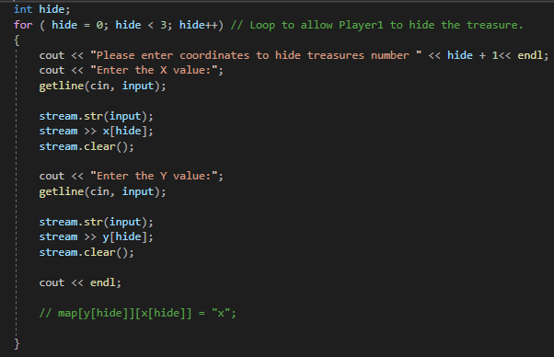
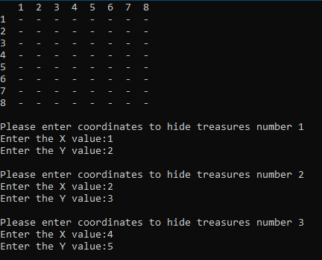
Afterwards, I made a loop for the player 1 to be able to enter the coordinates for the treasures once the player enters the coordinates it is then put into an array so it can be used to compare against players 2 answers.
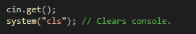
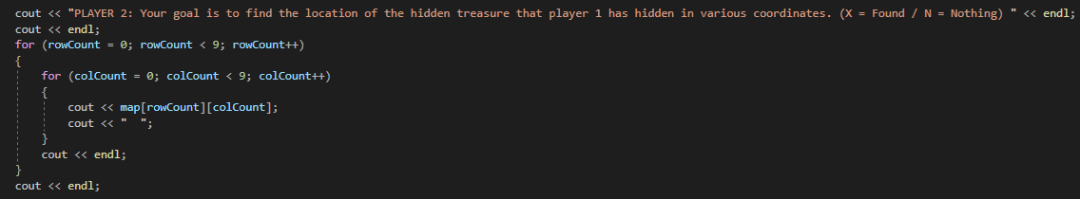
Once the player 1 has finished entering the coordinates for the treasures I have made the console clear so that player 2 can’t easily get the locations of the treasures, and to help out player 2 I have the map of the coordinates in the console so they can easily try and guess the coordinates of the hidden treasure.

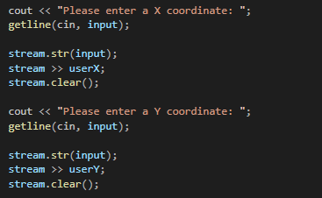
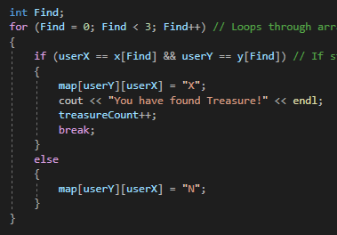
Player 2 will get prompted with entering X and Y coordinates these are put into a loop so it will be running 3 times, once the player 2 enters the coordinates it will then run the find loop this goes through the treasure X and Y coordinates to see if they both match if they were to match it will display an X to ensure you have found the treasure but if you haven't found the treasure it will show an N which represents no treasure found in the coordinates once you found a treasure it adds 1 to the treasure count.
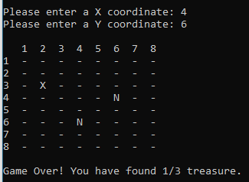 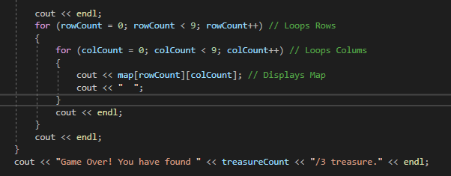
After the player uses all their turns the game will display Game Over and reveal how many treasures they found in total.

Appendix

Code listing

Exercise 1
#include <sstream>
#include <iostream>
#include <string>

using namespace std;

int main(int argc, char** argv)
{

// Declaring variables
string input;
stringstream stream;
string bookTitle;
double length;
int numOfProducts;

cout << "Please enter a book title. " << endl;
getline(cin, bookTitle);

cout << "Please enter the length. " << endl;
getline(cin, input);

stream.str(input);
stream >> length;
stream.clear();

cout << "Please enter the number of product in your shopping cart. " << endl;
getline(cin, input);

stream.str(input);
stream >> numOfProducts;
stream.clear();

cout << endl;
cout << "Book title: " << bookTitle << endl;
cout << "Number of products in shopping card: " << numOfProducts << endl;

cin.get(); // Pause
return 0;
}

Exercise 2
#include <string>
#include <iostream>
#include <sstream>

using namespace std;

int main(int argc, char** argv)
{
// Declaring Variables
string input;
stringstream stream;
double blueWidth;
double blueHeight;
double whiteWidth;
double whiteHeight;
double circleRadius;
double blueArea;
double whiteBox;
double circleArea;
double Pi = 3.14;
double whiteArea;

cout << "Enter the width of the blue box: " << endl;
getline(cin, input);

stream.str(input);
stream >> blueWidth;
stream.clear();

cout << "Enter the height of the blue box: " << endl;
getline(cin, input);

stream.str(input);
stream >> blueHeight;
stream.clear();

cout << "Enter the width of the white box: " << endl;
getline(cin, input);

stream.str(input);
stream >> whiteWidth;
stream.clear();

cout << "Enter the height of the white box: " << endl;
getline(cin, input);

stream.str(input);
stream >> whiteHeight;
stream.clear();

cout << "Enter the Radius of the circle: " << endl;
getline(cin, input);

stream.str(input);
stream >> circleRadius;
stream.clear();

blueArea = blueWidth * blueHeight; // Calculates the total blue area.
whiteBox = whiteHeight * whiteWidth; // Calculates the total area of the white box.
circleArea = (circleRadius * circleRadius) * Pi; // Calculates the area of the circle using Pi R squared.
whiteArea = whiteBox + circleArea; // Calculates the total white area.

cout << endl;

if (blueArea > whiteArea) // Validation to make sure that the white area aint bigger than the blue area.
{
cout << "Total Area of the shape: " << blueArea - whiteArea << endl;
}
else
{
cout << "ERROR: Area can not be calculated. " << endl; // Displays a error to the user.
}

cin.get(); // Pause
return 0;
}

Exercise 3
#include <sstream>
#include <iostream>
#include <string>

using namespace std;

int main(int argc, char** argv)
{
string input;
stringstream stream;

double prices[100];
int amount;
int value;
double exchangeRate = 1.12;

cout << "Please enter the amount of prices you want. (Max: 100) " << endl;
getline(cin, input);

stream.str(input);
stream >> amount;
stream.clear();

for (value = 0; value < amount; value++)
{
cout << "Please enter the price. " << endl;
getline(cin, input);

stream.str(input);
stream >> prices[value];
stream.clear();
}

int calc;
double finalPrice = 0;

cout << endl;

for (calc = 0; calc < amount; calc++)
{
cout << calc + 1 << ". Price (GBP): " << prices[calc] << endl; // Displays the prices that have been submitted.
finalPrice = finalPrice + prices[calc]; // Calculates the total price.
}

cout << endl;
cout << "Price (GBP): " << finalPrice << endl;
cout << "Price (Euro): " << finalPrice * exchangeRate << endl;

cin.get(); // Pause
return 0;
}

Exercise 4
#include <sstream>
#include <iostream>
#include <string>

using namespace std;

int main(int argc, char** argv)
{
// Declaring Variables
string map[9][9]; // Array that represents the map
stringstream stream;

int rowCount;
int colCount;

string input;

int x[3]; // Array that represents x treasure positions
int y[3]; // Array that represents y treasure positions

int userX;
int userY;

int treasureCount = 0;

// Col
map[0][0] = " ";
map[0][1] = "1";
map[0][2] = "2";
map[0][3] = "3";
map[0][4] = "4";
map[0][5] = "5";
map[0][6] = "6";
map[0][7] = "7";
map[0][8] = "8";
// Row
map[1][0] = "1";
map[2][0] = "2";
map[3][0] = "3";
map[4][0] = "4";
map[5][0] = "5";
map[6][0] = "6";
map[7][0] = "7";
map[8][0] = "8";

for (rowCount = 1; rowCount < 9; rowCount++)
{
for (colCount = 1; colCount < 9; colCount++)
{
map[rowCount][colCount] = "-";
}
}

for (rowCount = 0; rowCount < 9; rowCount++)
{
for (colCount = 0; colCount < 9; colCount++)
{
cout << map[rowCount][colCount];
cout << " ";
}
cout << endl;
}
cout << endl;

int hide;
for ( hide = 0; hide < 3; hide++) // Loop to allow Player1 to hide the treasure.
{
cout << "Please enter coordinates to hide treasures number " << hide + 1<< endl;
cout << "Enter the X value:";
getline(cin, input);

stream.str(input);
stream >> x[hide];
stream.clear();

cout << "Enter the Y value:";
getline(cin, input);

stream.str(input);
stream >> y[hide];
stream.clear();

cout << endl;

// map[y[hide]][x[hide]] = "x";

}

int clear;
for ( clear = 0; clear < 30; clear++)
{
cout << endl;
}

cout << "PLAYER 2: Your goal is to find the location of the hidden treasure that player 1 has hidden in various coordinates. (X = Found / N = Nothing) " << endl;
cout << endl;
for (rowCount = 0; rowCount < 9; rowCount++)
{
for (colCount = 0; colCount < 9; colCount++)
{
cout << map[rowCount][colCount];
cout << " ";
}
cout << endl;
}
cout << endl;

int Game;
for ( Game = 0; Game < 3; Game++) // Game loop this allows for the user to attempt finding the treasure 3 times.
{
cout << "Please enter a X coordinate: ";
getline(cin, input);

stream.str(input);
stream >> userX;
stream.clear();

cout << "Please enter a Y coordinate: ";
getline(cin, input);

stream.str(input);
stream >> userY;
stream.clear();

int Find;
for (Find = 0; Find < 3; Find++) // Loops through array.
{
if (userX == x[Find] && userY == y[Find]) // If statement to check the player 2s X / Y compared to the treasure locations
{
map[userY][userX] = "X";
cout << "You have found Treasure!" << endl;
treasureCount++;
break;
}
else
{
map[userY][userX] = "N";
}
}

cout << endl;
for (rowCount = 0; rowCount < 9; rowCount++) // Loops Rows
{
for (colCount = 0; colCount < 9; colCount++) // Loops Colums
{
cout << map[rowCount][colCount]; // Displays Map
cout << " ";
}
cout << endl;
}
cout << endl;
}
cout << "Game Over! You have found " << treasureCount << "/3 treasure." << endl;

cin.get(); // Pause
return 0;
}

