Tsvetomila Metodieva
1808619

Managing project in the organization
(BMSW5104_LON)
Dr Kenny Tang

BBC Worldwide

Contents
Executive Summary 3
Introduction 3
Different project methodologies 4
Risk Management 4
Time project management 5
Benefits of project management 5
Project communication method 6
Different change management project model 7
Kotter's 8-stage change model 7
Greiner’s Stages of Growth 9
ADKAR Successful change management model 10
Changes error fail by John Kotter 11
Implementing the project change management for BBC Worldwide 12
Create and design need of change 12
Techniques for building understanding: new themes on building commitment to change, engaging 15
Management of transformation process, implementing 18
Stakeholders 19
Stakeholders mapping -Power and interest 20
Project manager quality 21
Gibbs model – reflecting on project manager skills 21
Belbin’s team model - reflecting on project manager skills 23
Personal development plan (PDP) 24
Conclusion 25
References 25

Executive Summary

In acknowledgement of the difficulty of transformational reform, BBC's global initiative explored some of the new research and creative concepts in the area of change management that can help to transform property. The study aimed to bridge the often-quoted distance between the current research on change management and its execution in organizations. The second step of the Landing Transformation Research aims to investigate how the established concepts are implemented. The goal is to encourage practitioners to explore fresh and creative solutions to change management and to help them render land reform more successful. The emphasis is on presenting concrete explanations of how companies have implemented transformational change. This work consists of three parts. In the first section, the main defined in the BBC Worldwide project about how to convert land or various project methodologies, the second component is how to execute a change initiative, and the third aspect is the consistency of the project manager with reflection on skills using Gibbs model, Belbin model and PDP.

Introduction

Forcing cultural transformation became a key concern for organizational growth programs of organizations. This indicated that, as the economy begins to recover from the crisis, companies are transitioning from a time of accelerated transition to a phase of more proactively orchestrated reform opportunities (Badewi, 2015).
BBC Worldwide is a Royal Charter and its aim being to inform, educate and entertain the public. BBC Worldwide is the largest corporate arm of the BBC which earns revenues in relation to the license charge. This is the biggest TV show producer, outside U.S. studios. BBC Enterprises invests in quality programming, markets the BBC brand globally and improves its multimedia services. In 2014–15 BBC Worldwide gross receipts for public service broadcasting (PSB) contributed to GBP 226.5 million. It aims to substantially improve the collection of revenues for the BBC Public Sector. They discuss their plan of transition from 2012 to 2015, including: a sustainable regionalization structure; explanation of the strategy; a large cultural conversation; and progressing towards diverse research (BBC Worldwide, 2015).

Different project methodologies

Project management is mainly divided into different categories or domains that contribute to the life cycle of projects. Some of the stages that cover some or all the business finance services processes. For example, the usage of the PMBOK method, which is known as the most common project management guidelines, is defined by the Institute of Project Management (PMI). The lifecycle of a business management project is described as the duration from first project proposal to the full removal of the time of the business finance project. As every sort of project during its lifespan, the company project passes through the different phases and levels that need to be handled (Charvat, 2003). Many may consider the impetus behind the project management cycle incomprehensible, particularly if they are not informed of the multiple methodologies that have been built to coordinate complicated plans. But there's a law that controls all good programs. Nonetheless, this method is not the same with any project. Project management approach is also a nice term to explain the program used to accomplish it. At the outset of every project, it takes project management resources, a strong staff, and how to execute the project (Charvat, 2003).

Risk Management

Project risk management is a continuous method to define, assess, evaluate and minimize threats that endanger the project's chances of completion in terms of expense, scheduling, efficiency, safety and technological results. Organizations and managers often find project risk reduction practices to be a "positive thing" for a business rather than a central component of business controls (Chapman & Stephen, 1996). The goal of project risk management is to identify project and system threats, reduce the probability of adverse incidents and increase the possibility of successful occurrences on tasks and plan results. A compressive project risk control is a continual cycle that starts during the design phase and finishes after the construction is effectively completed and transitioned to operations. the following components:
1. Strategy and planning.
2. Risk identification.
3. Analysis (quantitative and qualitative).
4. Response planning; and
5. Monitoring and control.
BBC's approach to risk control is well understood and offers reliable and comprehensive market support; in this respect, they conclude that the BBC's output is online with the median results shown by FTSE 100 firms. The BBC has done especially well in recognizing and determining how best to react to danger and in enforcing related management measures to minimize the probability or effect of danger happening (Alvarez & Marsal, 2015).

Time project management

Time management begins from the very beginning of the launch of the project by defining the length of the project and its goals, until a comprehensive timeline can be set up during the design process. There are other methods and strategies used to build timeframes such as: task breakdown layout, project network, calculation, essential route analysis, and scheduling (Knudson, 1991).
The BBC Worldwide CEO aims to foster societal transformation over three years. Months of training have taken place behind the scenes to encourage the company to demonstrate different habits and help it, the CEO of BBC Worldwide has begun a cycle of cultural change with the executive team leaders. They were granted time to get on board the need for a culture drive, and to work together to find an consensus on the need for a culture drive strategy (BBC Worldwide, 2015).

Benefits of project management

Project management offers a "roadmap" that is quickly followed that contributes to the success of the job. Whenever a proposal is done on schedule and on budget, the company is happy. And the satisfied customer is one that it can be seen again. Smart project management offers resources to allow this client / manager partnership to continue. Many advantages as good outcomes not only demand appreciation, but more frequently than not motivate the employees to start searching for opportunities to work more effectively. Greater Reputation and Strategic Advantage is not only a positive gain for project management in the office, but even beyond it; news spreads rapidly and there is nothing like superior results to ensure your spot in the market. Probably one of the biggest advantages of project management is that it requires versatility. Sure, project management helps you to plan out the approach that you intend to follow to see the project finished. But the advantage of having an enterprise is that if you see a better path to go, you will pursue it. This alone is worth the entry price for several small-to-medium-sized businesses (Badewi, 2015).
BBC CEO's learning to walk the speak, led by case, and rewrite the meaning. Structures and control mechanisms play a comparatively minor role in transformational progress, as compared to the massive and substantial expenditure required in softer approaches linked to connectivity (in several various forms), schooling, preparation and symbolic action. Although another benefit of project change management for BBC is changing actions around the enterprise by moving tactics to the front line is key to transformational progress. New techniques need to be driven down the front line, to others in customer-facing positions, if they want to create a difference in the way a company competes to maintain or reclaim competitive edge. Clear comprehension of how business jargon around society can be transformed into concrete consequences for individuals. There is also a function to play in transmitting openness and proximity – thus the value of modern structures in putting together the top and bottom of the organizations (BBC Worldwide, 2015)

Project communication method

Communication is more than a message exchange, but a means for project managers to establish the foundation for a project. A communication-related initiative contributes to uncertainties, misunderstandings, disappointment, organizational tension and inconsistency of stakeholder perceptions. The usage of appropriate contact techniques is also important to ensure the progress of the project. There are Interactive Communication, Push Communication and Pull Communication. For collaborative communication, all parties participating in the conversation will respond to each other in real time. Examples of digital contact include face-to-face sessions, video conferencing, phone calls, and conversation talks. These forms of communication are frequently utilised in programmes and are more efficient than other types of communication. In the sense of social interactions, face-to-face meetings are the most successful as they enable you to display the vocabulary of the body and the facial gestures of the contact partners. Push contact is one of the effective correspondence systems through which information is transmitted without any input from the receivers. For starters, during a brainstorming session, you should give meeting notes to others. Pull mode of contact is suitable for a broad group who wants to retain exposure to knowledge at their disposal. Suppose you did a training for a group of developers in a broad project. After practising, in order to encourage developers to re-enter the training material, you should upload the slides and other supporting content material through the corporate intranet (Ziek & Anderson, 2015).
Consistent and ongoing funding at the top of the transformation initiatives lets the BBC retain traction. People make room doing something on a crowded day (BBC Worldwide, 2015).

Different change management project model

There are different styles of change management systems and change management modes Some of the change management models include ADKAR (Awareness, Want, Experience, Capacity, Reinforce) model, Lewin's three-stage change management model, Kotter's 8-stage change model, and Jick's 10-stage change model, Greiner’s Stages of Growth (Tang, 2019).

Kotter's 8-stage change model

A dream of transformation should be structured to inspire people to consciously challenge and attempt and make sense of their circumstance in order to establish a split between past and current thought. In turning the environment of a company into something better conducive to creativity, we will need to adjust our mindset and behavior. Changing society includes the implementation of such behaviors that are more favorable to stimulating, introducing and rewarding technologies. John P. Kotter has identified the cycle of driving transformation, allowing managers to recognize, motivate, and implement initiatives to build culture of innovation (Kotter, 1996).
Figure 1. Kotter’s 8 steps of changing model
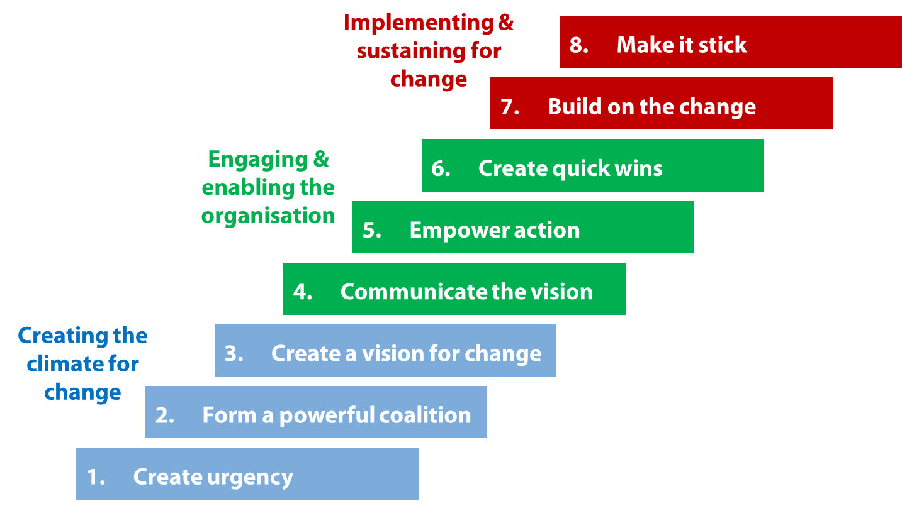
Source: Kotter’s 8 steps of changing model,1996
Rising a sense of urgency is the first and most important phase towards a positive attempt to reform. With weak ambition and complacency, attempts to reform cannot get off the ground. It is crucial to bring in position the best people in Phase 2 who are completely dedicated to the reform agenda, well regarded within the organization, and have the power and authority to push progress initiatives at their level. Having a Vision Correct is Phase 3, although generating a common desire, and the motivation for progress will drive citizens into action, it is the vision that will lead us in a new path. When a vision and plan has been established, it will be presented to the company in phase 4 in order to achieve awareness and buy-in. Sending straightforward, accurate and sincere announcements on the course of progress produces a real intestinal buy-in that sets the tone for the next step: bringing people to act. Phase 5 encouraging intervention is increasing obstacles of all who wish to further move further reform initiatives. Removing hurdles will empower, promote creativity and create trust in reform efforts. Short-term wins foster confidence in reform initiatives, personally praise diligent jobs, hold opponents at bay, and create traction in move 6. By generating short-term gains and being truthful about reviews, change is being created and people are being motivated. In productive initiatives, citizens draw on this energy to make the dream a reality by keeping up with the pace of next phase 7, minimizing repetitive, stressful labor and not claiming victory prematurely. Last phase 8 is to make change last by establishing a fresh, welcoming and adequately powerful corporate culture, which will stay the same. A tradition of encouragement has given birth to different forms of working (Kotter, 1995).

Greiner’s Stages of Growth

The Greiner Development Model explains the various processes that companies are experiencing as they develop in scale. Such steps are agnostic to the form of entity – they relate to all organizations in all industries. The model is basically a method that organizations may use to identify the root causes behind the issues that an increasing enterprise is likely to face. It makes it easier to predict these issues when they arise, and therefore to take measures to prevent them entirely. The model comprises of six development stages. It also indicates which root issues are likely to arise at the end of growing step (Greiner, 1998).
The founders operated the business in the first step. They are ambitious and concentrated on putting goods into the market. The promoters are underscored and disagreements over crucial choices proceed, bringing the organization to a crisis in leadership. The natural first move as that occurs is to set up an operationally oriented company manager. If the business manager has been successfully hired, the organization begins its second phase of development. Here the company has a hierarchical framework and correspondence is beginning to get more organized. As the enterprise begins to expand, the executive committee is no longer willing to personally oversee all operational operations, so to do so, the corporation utilizes delegation to motivate lower-level managers. The next step is the rotation, where the business members are still running by default and decision-making is focused on regular evaluations. Cost centers can begin to be developed. In four steps, the enterprise transitions away from organizational divisions and into commodity categories. Horizontal support roles shall be defined inside the company during this process. In step five, the company is a matrix of product-focused teams distributed through numerous departments to allow development once again. Eventually, the company is facing an internal development challenge – the business is growing increasingly smaller and unwilling to respond effectively to evolving consumer demands. The corporation tries to resolve internal development problems by entering into partnerships, such as mergers, or by making a management firm manage the various companies independently (Greiner, 1998).
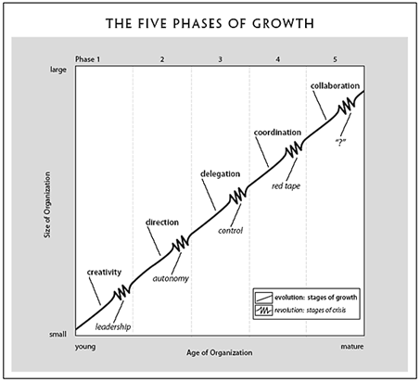
Figure.2 Greiner’s Stages of Growth

Source: Greiner (1998) Evolution and Revolution as Organizations Grow

ADKAR Successful change management model

Fig.3 ADKAR Successful change management
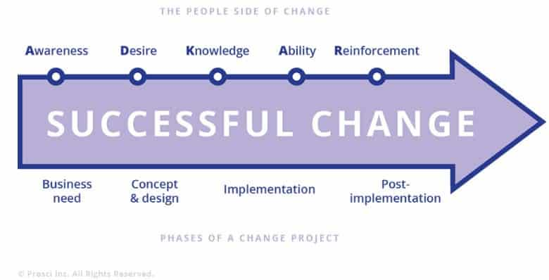

Source: https://www.google.co.uk/search?q=change+manage+implement&tbm=isch&ved=2ahUKEwi7jfqss_roAhXk2OAKHWTeDkYQ2-cCegQIABAA&oq=change+manage+implement&gs_lcp=CgNpbWcQAzoICAAQCBAHEB46BAgjECc6AggAOgQIABAeOgYIABAIEB46BggAEAoQGFC3igJY8-ECYPznAmgAcAB4AIABogGIAc4TkgEFMTIuMTKYAQCgAQGqAQtnd3Mtd2l6LWltZw&sclient=img&ei=UF2fXrulIuSxgwfkvLuwBA&bih=646&biw=1421&hl=en#imgrc=VW8CLdfjPXy83M
The mechanism of transition in an enterprise may be analyzed across several change management methods. ADKAR was created by Jeff Hiatt of Prosci Research in 1998 and was originally used as a method to evaluate if change management practices have the expected effects through organizational transition. Prosci (2008) clarified that successful management of the human aspect of transition involves the management of five main goals that shape the foundation of the ADKAR model: understanding of the need for transition, desire to initiate and promote change, knowledge of how to improve (and what the change looks like), capacity to execute improve on a day-to-day foundation, motivation to hold progress in place (Prosci, 2008).

Changes error fail by John Kotter

Fig.4. Changes 8 error fail by John Kotter
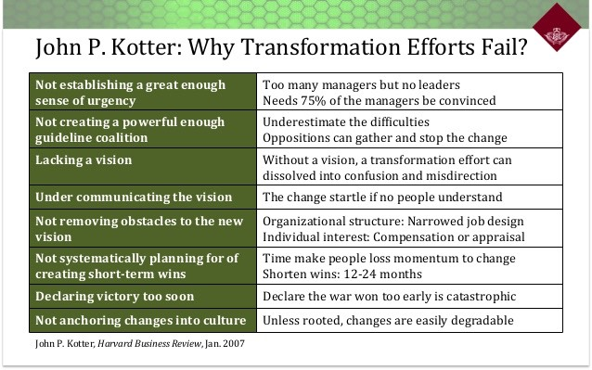
Kotter's model deals with this easily by suggesting the opposition is attributed to fear of work cuts. Every person would like to be part of the winning team, so if a fast victory is achieved in a reform effort, even those who were originally opposing progress will be associated with the reform leadership team. Whatever factors encourage businesses to feel the need for reform, corporate leaders tend to strive to retain or improve their corporations' competitive edge, while dramatic shifts take place in both the external and internal contexts. The guiding factors for organizational reform are the outcome of the need to consistently increase profitability and performance (Rajan & Ganesan, 2017).

Implementing the project change management for BBC Worldwide

Create and design need of change
Fig.5 John Kotter 8 steps process for leading change
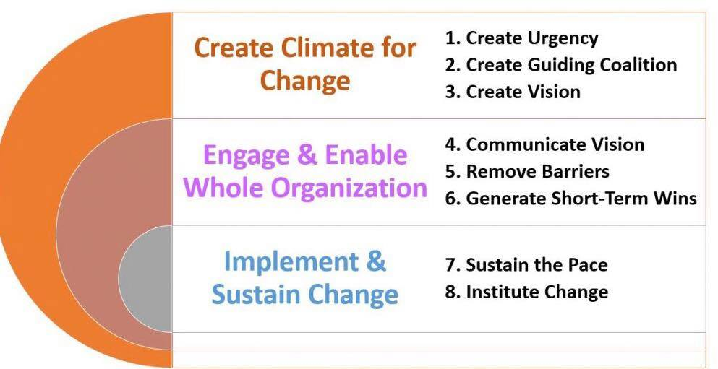
BBC Worldwide is implementing the project management change following * Kotter’s step model.
Figure6. The ten change transformations themes
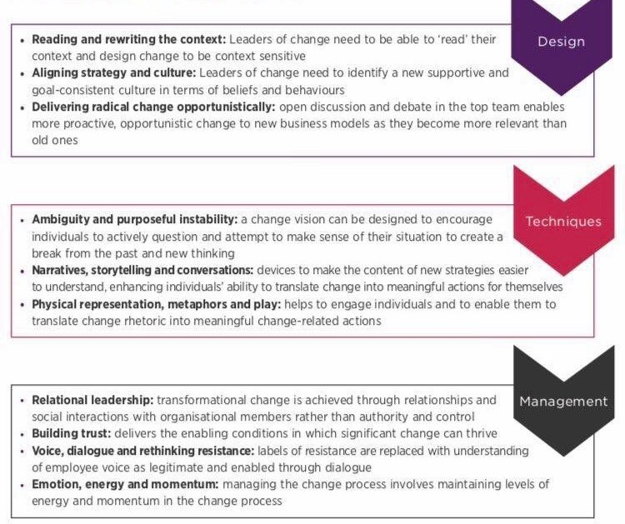
Source: https://www.cipd.asia/Images/landing-transformation-change_2015-case-study-bbc-worldwide_tcm23-9055.pdf
In August 2014, a new global director of organization development started with BBC Worldwide.
The BBC conducted a large dialogue with 1,800 employees, which started with the management and top executives, and eventually extended into squad members and managers, in the shape of a forum that told all what they liked about BBC Worldwide and what could be changed. The aim of the dialogue was to make people more culture-focused and enthusiastic about their jobs at BBC Worldwide – to 'turn up' the community, while at the same time to question what must be modified. These activities have encouraged people to catch amazing stories about their most motivational moments at BBC Worldwide, which could then be circulated. Such seminars are based around the idea that other people operate around the UK and they are strongly about the BBC (BBC Worldwide, 2015).
Transformational progress is caused by positive experience and changed partnerships, not by pushing toward concrete results. Revolutionary acts are revolutionary mainly since they are interrelated. Information in partnership unlocks a particular type of knowledge: a 'dispositional' awareness, rather than a propositional knowledge, one that taps into a hidden aspect (Polanyi, 1996).
Fig.7
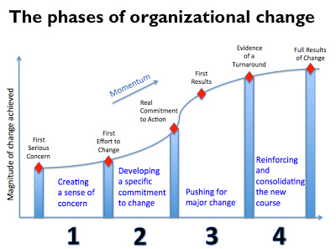
Source: https://www.google.co.uk/search?q=techniques+for+change+management&sxsrf=ALeKk01QOS91NHBD8kyv8aXhkcWdzm5LVQ:1587502654574&source=lnms&tbm=isch&sa=X&ved=2ahUKEwjG7LietProAhWdQkEAHSA0CDUQ_AUoAXoECBMQAw&biw=1438&bih=646
A crucial feature of positive transition is the responsiveness of the environment in the implementation of transition – the adaptation of the concept of change to the nature of the enterprise by members and designers of change. Another element of changing the background is that reform advocates utilize their own actions to do so, by demonstrating the shift they expect most of the organization to create. To order for transition to thrive, shift planners need to match their technical and cultural goals. When part of this, the increasing structures and procedures that are strongly stereotypical of the past have an significant symbolic consistency, such as modern buildings with dramatically revamped office spaces (Seneque, 2017). There have been separate and very specific strategic projects aiming into the ideal emerging community of BBC Worldwide. Although cultural transition needs consideration of initiatives within institutions and processes, as shown by BBC – with modernization seen as the beginning point and not the end point of reform – the shifting ingrained frameworks symbolic of the old community were also important here (BBC Worldwide, 2015).
Time, rationality and obligation have been critical in forming executive teams that embrace the transformational improvement goals of the CEO / business leader and the direction for their company. The philosophy of transformation is evolving in a collaborative mechanism of free debate and discussion. Participants can have diverse viewpoints and experiences, but they will express a common dedication to progress. The more the party represents the interests of all the members, the better the conversation is likely to be. The cycle starts with a group of key personnel and representatives of the company come together for a facilitator who can picture a dream of performance (Burke, 2017).
BBC has a future-oriented outlook about how companies had to adapt in order to continue to be competitive in highly difficult markets. At BBC Worldwide, several people associate the current CEOs for making progress possible and being influential in the performance of the changes of the organizations. The BBC Worldwide CEO aims to foster societal transformation over three years. Months of training have taken place behind the scenes to encourage the company to demonstrate different habits and help it, the CEO of BBC Worldwide has begun a cycle of cultural change with the executive team leaders. They were granted time to get on board the need for a culture drive, and to work together to find an consensus on the need for a culture drive strategy (BBC Worldwide, 2015).
Organizations utilize myths and tales to improve the willingness of people to turn progress into concrete practice within themselves. Those are especially common methods in the sense of social media events. At BBC Worldwide, they had a huge discussion around documenting the experiences of people regarding their most inspirational times at BBC Worldwide, which could then be posted. Engaging people and encouraging them to turn signs and messages into concrete change-related acts. At BBC Worldwide, personal experiences of BBC research from the major dialogue sessions were exchanged around the organization on the intranet in text, photos, images, and even one album. Throughout fact, BBC Worldwide has reiterated the value of BBC coverage in the new house. Further displays show videos and conference spaces, for example around EastEnders and Doctor Who (BBC Worldwide, 2015).

Techniques for building understanding: new themes on building commitment to change, engaging

Change management is a vital aspect of every initiative that guides, oversees and encourages individuals to implement different methods, technology, frameworks, institutions and principles. This is a series of behaviors that makes people transition from their present way of working to the ideal way of working (Bamford & Forrester, 2003). The BBC organized a collective dialogue with 1,800 employees, which started with the management and senior executives, and eventually extended into department members and managers, in the form of a forum that told all what they liked about BBC Worldwide and what could be changed. The aim of the discussion was to make people more culture-oriented and enthusiastic about BBC Worldwide. These events have encouraged people to catch amazing stories about their most inspirational moments at BBC Worldwide, which could then be circulated. These workshops is based around the idea that many people operate in the community and they are very strongly about the BBC (BBC Worldwide, 2015).
Fig.8 Change management tools and techniques
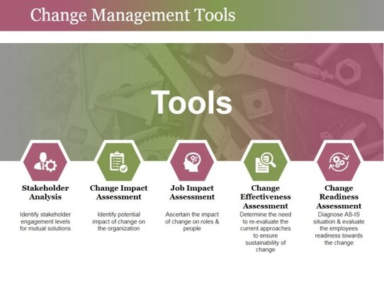

Source: https://www.google.co.uk/search?q=techniques+for+change+management&sxsrf=ALeKk01QOS91NHBD8kyv8aXhkcWdzm5LVQ:1587502654574&source=lnms&tbm=isch&sa=X&ved=2ahUKEwjG7LietProAhWdQkEAHSA0CDUQ_AUoAXoECBMQAw&biw=1438&bih=646
Tools for creating a collaborative area of consciousness, like dialogue (Bohm, 1996) and conversation-based strategies, are essential to transformational change research (Isaacs, 1990). In order to bring about transformational progress, all people in an organization need to alter their actions in every way. Techniques for transforming the story of corporate reform into specifics about individual improvement included: visioning seminars, tasking individual administrators with drawing up action plans on the items they should do to promote improve, encouraging people to join mass events / seminars Identifying the one aspect they'd achieve, then collaborating with a group of employees in considerable depth about whether they'd like to improve as persons, then eventually getting them back into the company to implement improvement from the ground up (Carnall, 2003). Within BBC Worldwide, the transformation of the futuristic dream into human progress started at the top and was only introduced to general management before being accessible to anyone. Time was taken to meet senior leaders at each level to enable them to plan and own the transition (BBC Worldwide, 2015).
For society to shift, existing, ingrained habits will also alter. That involves adjustments at the corporate level in terms of procedures, structures, operating practices and metrics for free workers to modify their actions – or perhaps compel others more unwilling to let go of old forms of modifying their behavior. Throughout fact, the breaking of seemingly insoluble challenges marked out by workers as obstacles to progress often helps employees conscious of them. Members are beginning to accept the married transition is truly feasible this time (Hughes, 2007). At BBC Worldwide, the elimination of hierarchical structures became more systemic. There has been a consolidation of regional divisions rather than market sectors, which has rendered it possible for the management committee to be more unified (BBC Worldwide, 2015).
Transformational reform, by nature, includes shifts in thought and performing. Around the same period, improvements to such instances also involved IT services. However, the most important 'hardware' of cultural shifts through case study organizations that enabled the requisite improvements in patterns of contact across various levels and divisions was the procurement of new buildings. These new buildings facilitate and allow various connections in line with the expected course of transition. They also have greater consistency across all levels of managers and employees, allow role modelling and lead by example (BALOGUN, et al., 2015). BBC Worldwide relocated to a new building in London, where the bulk of BBC Worldwide employees are based, moving them together to a central office built to promote collaborative collaboration and greater exposure to information. Workers enjoy getting a building of their own and living together in one location. News UK also has all its names in one strong-profile, business park, with complete titles on single floors to encourage cohesion between label, and all titles within one building to facilitate synergy between titles and encourage common corporate identity. The co-location of visual and paper citizens facilitates the convergence of the two (BBC Worldwide, 2015).

Management of transformation process, implementing

Relationship leadership is one in which the leadership's strength rests in the presence of solid, permanent, trustworthy partnerships with both employees and external shareholders. Because leadership styles set the tone for what matters in an organization, individual members may accomplish a great deal by becoming a role model for others through their specific actions and attitudes (Sharma & Jain, 2013). High rates of confidence can create supporting conditions in which meaningful reform will flourish. Change leaders need to demonstrate their trustworthiness by showing their ability to plan transition intelligently and their benevolence and honesty in the way they react to the interests of companies, workers and the broader society in the phase of transformation (Dietz & Gillespie, 2015). BBC Worldwide has discussed faith explicitly into the 'Commitment.' HR outlined the topics of the Senior Leaders' Meeting and Workers Sessions in the 'Commitment,' which was a type of quasi-contract between members and those in the organization, detailing what to expect from the Senior Management, but what to expect from those in response (BBC Worldwide, 2015).
This is by HR mechanisms that facilitate discussion and direct two-way dialogue with staff, such as town hall meetings and focus groups, that policy planners can learn fresh thoughts on adoption, encourage workers to make more sense of progress around them and thereby render more dedication to policy feasible. Company leaders should be encouraged to lead by example, by genuinely embodying the principles and actions of their organizations, and by interacting and connecting with stakeholders in a way that is not only open, but actual. Without a phrase, credibility would be the order of the day (Dietz & Gillespie, 2015). The public communication activities mentioned above – the collective discussion at BBC Worldwide offered the most clear medium of expression and debate (BBC Worldwide, 2015).
Change is a mental roller coaster that produces both powerful positive and negative reactions. Emotions felt influence the way individuals react and can contribute to the substance of the shift, but also the essence of the interaction with those overseeing the shift. Transformational reform is often a lengthy march rather than a fast jog, allowing all driving progress to retain commitment and support towards improvement in the enterprise. Commitment and emphasis on the cycle of transformation by the CEOs / business leaders, and see improvement in the company as a core feature of their position (Smollan & Sayers , 2009). At BBC Worldwide, HR specifically speaks of the ability to sustain traction through current campaigns, such as the accelerated roll-out of the updated People Management Intranet to prove that progress is really taking shape (BBC Worldwide, 2015).
Leadership in the organizations of CEO / market leaders and management teams has been complemented by the emergence of reform champions employed in the sector to support the transition phase. These people have played a vital function, offering role models and inspiring many to improve, helping to build awareness and compassion for many. In this context, constructive communication contributed to the elimination of obstacles and the development of resources to promote transition rather than to place criticism as opposition. The CEO remembered the value of the small daily annoyances. They claimed that the participation of workers was impacted by this. And what may look like grooming. Organizations associated with utilizing metrics, such as pulse tests and interaction polls, also uncomfortable with referring to bad ratings. The roles of administrators are influenced to a degree by the findings of the previous study. Switch systems have been updated to adapt to issues (Odor, 2018). BBC Worldwide heard as people claimed the printers have constantly broken down – slowing down their jobs – then replaced them (BBC Worldwide, 2015).

Stakeholders

According to R. Edward Freeman, the (grand)father of stakeholder theory, is "any community or person that may or may be influenced by the achievement of the goals of the organization." (Freeman, 2010). Stakeholders can be split into various classes. There are three different categories of stakeholders in the company as follows:
- Internal stakeholders
- Connected stakeholders
- External stakeholders
Examples of internal owners are staff and administrators. Customers, manufacturers, lenders, fans and employees are representations of associated stakeholders. Finally, the society, the administration, the advocacy groups and so on are examples of external stakeholders (Walley, 2013).
Internal stakeholders for BBC are owner, employee. BBC CEO and people director were very effective at sharing dream and taking people on a trip by storytelling. The CEO has demonstrated passion and sincerity. He is a perfect communicator. The BBC workers survey was performed in November 2014. The findings given a starting place of 72% of the relationship (top quartile of the IPSOS MORI commitment survey). WEx and HR are trying to build on this ranking (BBC Worldwide, 2015)

Stakeholders mapping -Power and interest

Analysis of stakeholders is the method of recognizing stakeholders. This recognizes stakeholder interests and influence and allows market leaders to consider government goals (Johnson, et al., 2006).
Fig. 8. Power and interest
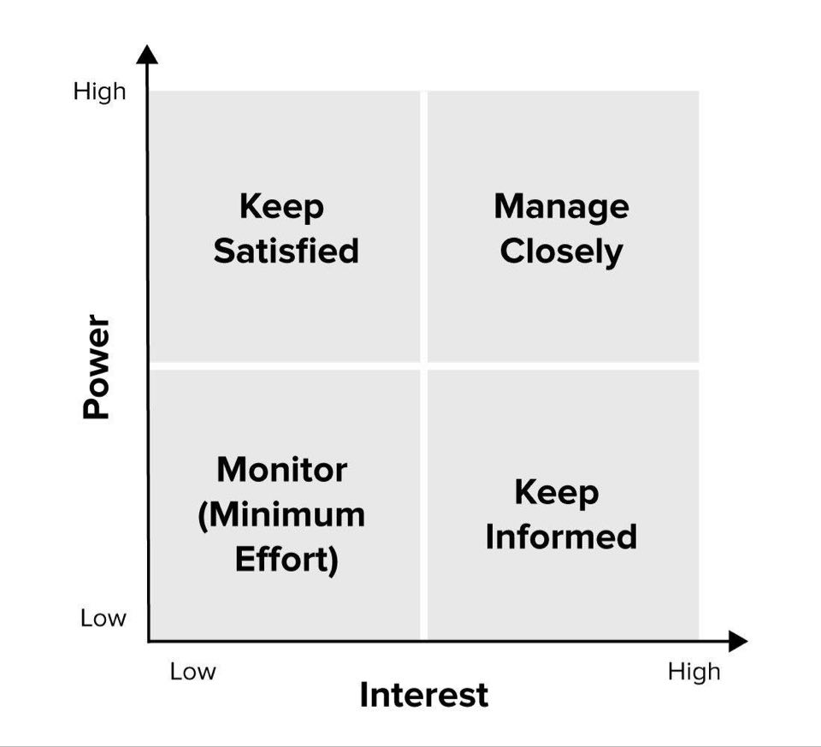
Source: Mendelow, 1991 cited in Johnson, Scholes, and Whittington, 2006

As mentioned above, in terms of control and value, not all actors are the same. Organizations will also establish a range of contact approaches in accordance with the influence and desire of their stakeholders. Indeed, stakeholder engagement supports companies in a variety of areas. For example, companies may recognize the most and least relevant stakeholders with a stakeholder review. They may also classify harmful actors and their possible detrimental effects on the project by research. Different parties have specific perceptions of each other. For e.g., shareholders are interested in income and dividends, whereas workers are interested in healthcare, high wages and promotion. The surrounding community would likely be involved in the job prospects provided by the business for residents. This is necessary for companies to recognize stakeholders and their aspirations. Stakeholders' perceptions often clash with each other. A stakeholder research is also very beneficial for all organizations (Rahman, 2017).
It can allow project managers and their staff to recognize, assess significance, influence and then priorities project stakeholders. Knowing the expectations of stakeholders and the degree of project engagement is essential to the implementation of the stakeholder policy and management plan (Forman & Discenza, 2012).
Table1. BBC Stakeholders
BBC Stakeholders | internal | external | Which quadrant? | How to manage
CEO | Internal |  | Manage closely | High motivation
Employees | internal |  | Keep satisfied | Medium motivation
Government |  | External | Keep informed | High motivation
Creditors |  | External | monitor | Medium motivation

Figure 9. BBC Power Interest

High

Power | Keep satisfied | Manage Closely
 | Monitor | Keep informed
Low | Interest |  | High

Source: Mendelow,1991 and Tsvetomila’s own work

Project manager quality

Manager’s job of transition would be to help and inspire your workers during each process. This is necessary to note that the process is not continuous and that those impacted often find themselves going back and forth between the phases. With this probability, you may need to predict and foresee that individuals may experience a transformation phase height and in various directions. Your teamwork, listening and counselling capabilities can be critical when understanding how to help the employees, both as people and as a group, so that they will progress through the processes as efficiently and easily as possible (Kotter & Cohen, 2002).

Gibbs model – reflecting on project manager skills

The Gibbs Reflective Process was created by Graham Gibbs in 1988 to provide a framework for learning from practice. It offers a structure for the analysis of interactions and, despite its cyclical existence, lends itself especially well to recurring encounters, helping you to understand and prepare events that either went well or did not go well. It is covering six phases (Gibbs, 1988).
Fig.9 Gibbs Model
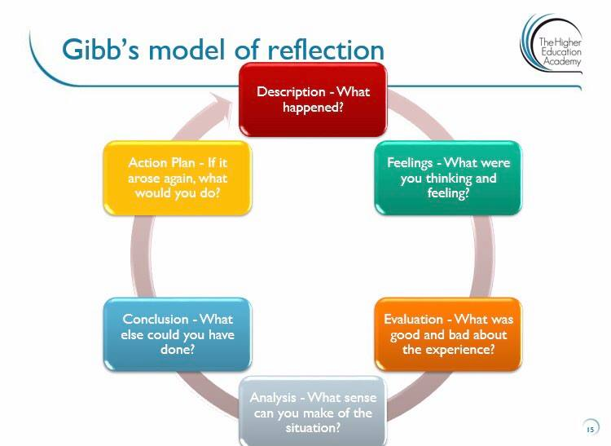
Source: Gibb’s Model, 1988
A good project manager needs to have leadership skills, negotiation, scheduling, time management skills, communication skills, risk management skills, critical thinking skills for being able to make a good decision making (Knudson, 1991). In order a project manager to be able to succeed with the project there is need of constant improving skills and knowledge.
I have learned many skills as communication, decision making, time management, self-motivation, team player, leadership, adaptability, analytical and critical thinking, and technical skills. Although, there are still skills I need to improve to gain better project management success. These skills are negotiation, risk management, project recovery, coaching, contract management. There is an action plan for that purpose, where I can gain more confidence in showing missing skills by reading more books, participate in voluntary project to gain more experience. The process of improving those skills will be explain more in details in personal development plan below.
Fig.10 Gibbs Reflective Model

Skills I have learned during my study

Action plan for expanding knowledge and experience
Practicing and keep learning is key for improving
Reflective model

Positive – I have skills
Negative- there are not enough
I have learned skills, but it needs go gain more skills

Source: Gibbs,1988 and Tsvetomila’s own work

Belbin’s team model - reflecting on project manager skills

Fig.9 Belbin’s model
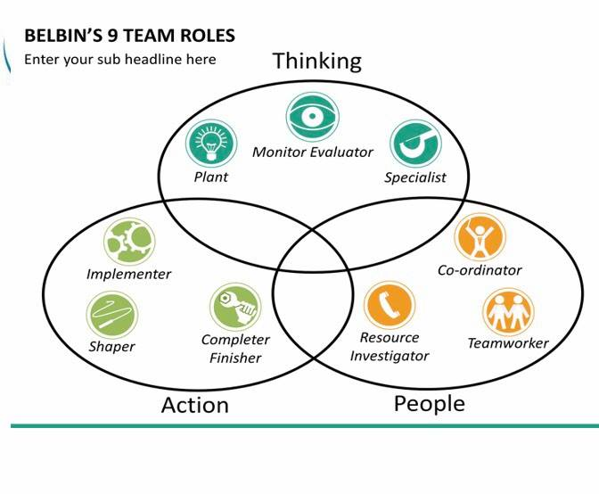
Source: Belbin (1981) Team roles
Plant, Monitor Evaluator and Specialist are brain or thought functions. Plants are both innovative and free-thinking. We will also work a way into complicated situations and come up with ideas that no one else has ever thought. Control Evaluators, on the other hand, are highly rational and good at critical reasoning. They take an idea down and investigate it from any conceivable perspective. Specialists tend to learn and research the topic in detail. We appear to be specialists in one topic and are committed to the advancement of expertise in this area (Belbin, 1981).
It will be more helpful for me if I gain more experience with planning, coordinating and implementing as I am a good team player, but I need to increase my effort in implementing the ideas.
Resource Manager, Team worker and Coordinator are social or 'contact' positions, yet again, each is distinct within this group. Outgoing and engaging, Asset Investigators prefer to operate beyond the organization, networking and developing different connections and networks that will create potential resources and offer the organization useful insights into the industry. Team workers are internal communicators, maintaining team unity that keeps things going smoothly. Diplomatic are perceptive, are strong listeners, they think for the emotions of others and aspire for a harmonious working atmosphere. Coordinators – who can recognize and exploit specific abilities – collaborate to inspire others, foster unity and help direct the team through its goals. Mature and cool, they encourage gatherings and debates, insure that everybody gets their say and provide guidance and support as appropriate (Belbin, 1981).
I might be a good team player, but I need to improve my resource investigator skills in order to gain better results in achieving projects in future. I have good coordinator skills as I can easily inspire the others and help them by guiding and motivate them.
Implementer, Completer Finisher and Shaper are the three positions in operation associated with the job at hand. Implementers are structured and productive and excel on the system – they aim to ensure the work is done on schedule and in an orderly manner. If Implementers want it to be finished easily, Completer Finishers want it to be done properly. They insist on information, meaning that no errors are permitted to sneak in and ruin the outcome. Shapers, on the other side, keep deadlines first and foremost on their heads. Competitive and vocal, they are the guiding power of the organization, pressing us to insure that goals are achieved and tasks completed on schedule (Belbin, 1981).
To have a sharper skill there is a need of good practice, which I am doing at my workplace by leading a team to ensure goals are targeted and achieved. However, Implementer and Completer finisher is where I could do more to improve the results related to those skills.
Thinking
Me in 2020
I have thinking skills, but I need to improve them in order to be a better project manager

Action
Me in 2025
Increased my people skills and gained better results in achieving projects.
Me in 2023
I have gained good practice, leading a team and ensure goals are targeted and achieved.
People

Source: Belbin, 1981 + Tsvetomila’s own work

Source: Belbin, 1981, and Tsvetomila’s own work

Personal development plan (PDP)

Personal development plan
 | Skill | Current ability | Target ability | Development opportunity | Criteria to judge success | Time frame | Evidence
1st priority | Communication | have | Could improve more | Practicing with a project | To be able to connect, deal, manage | 3 months | Books  Conversation  Nonverbal communication
2nd priority | Planning | Not enough | To reach to confidence level | Start to plan personal project | To be able to plan well | 6 months | Well-structured project
3rd priority | Implementing | Not satisfied | To reach to confidence level | Implement personal project | To be able to achieve planned goals or a project | 8 months | Good outcome of the project

Creating personal development plan is very important part of my career progression. In order to become a great project manager, I must develop further communication skills, planning as a second priority and implementing as a third priority. However, the basic knowledge of those skills I have, but it needs an effort to increase those knowledges.

Conclusion

BBC News has displayed a great deal of maturity in its transformational development initiatives. They incorporated most of the information outlined in the project management change, indicating that the CEO / business executives and the HR staff members helping them were well educated and willing to translate their awareness into practice (BBC Worldwide, 2015). The current wave of CEOs / business executives appears to have a stronger idea of how to improve land transition. Such capacity is underpinned by a series of understandings of the essence of transformational change (Balogun & Hailey, 2009).

References

Alvarez & Marsal, 2015. BBc review of risk management, s.l.: s.n.
Badewi, A., 2015. The impact of project management and benefits management practices on project success:Towards developing a project benefits governance framework. International jurnal of project management.
BALOGUN, J., HOPE HAILEY, V. and GUSTAFSSON, S. (2015) Exploring strategic change. 4th edition. London: Prentice Hall.BALOGUN, Exploring strategic change. 4th ed. London: Prentice Hall.
Balogun, J. & Hailey, V., 2009. Final report of the Change Management Consortium. London: CASS Business School.
Bamford, D. R. & Forrester, P. L., 2003. Managing planned and emergent change within an operations management environment. International Journal of Operations & Production Management, Volume 23(5), pp. pp. 546–564..
BBC Worldwide (2015) CIPD.
Belbin, M., 1981. Management Teams, Why They Succeed or Fail. London: Heinemann.
Bohm, D., 1996. On Dialogue. Abingdon, UK.: Routledge.
Burke, W., 2017. Organization Change : Theory & Practice. 5th ed. Thousand Oaks, Ca: Business, Accounting & Vocational: Textbooks & Study Guides.
Carnall, C., 2003. Managing Change in Organizations. 4th ed. Harlow: Prentice Hall.
Chapman, C. & Stephen, W., 1996. Project risk management:processes, techniques and insights. Chichester,UK: Jonh Wiley.
Charvat, J., 2003. The Project management methodologies: Selecting, implementing and supporting methodologies and processes for projects.. Hoboken: John Wiley & Sons Inc..
Dietz, G. & Gillespie, N., 2015. Building and Restoring Organisational Trust. London: The Institute of Business Ethic.
Freeman, R., 2010. Strategic Management: A Stakeholder Approach. Cambridge: Cambridge University Press.
Gibbs, G., 1988. Gibbs G (1988) Learning by Doing: A guide to teaching and learning methods. Further Education Unit. Oxford Polytechnic: Oxford.. Oxford: Further Education Unit. Oxford Polytechnic.
Greiner, L., 1998. “Evolution and Revolution as Organizations Grow”. s.l.:Harvard Business Review.
Hughes, M., 2007. The Tools and Techniques of Change Management. Journal of Change Management, Volume 7(1), pp. 37-49.
Isaacs, W., 1990. Dialogue and the Art of Thinking Together. New York: Doubleday.
Johnson, G., Scholes, K. & Whittington, R., 2006. Johnson, G., Scholes, K. and Whittington, R. (2006) Exploring Corporate Strategy: Text and Cases. 7th ed. UK: Prentice hall.
Knudson, J., 1991. Project Management. s.l.: AMACOM Books.
Kotter, J., 1995. Why Transformation Efforts Fail, Harvard Business Review, March-April 199. Massachusetts: Harvard Business Review.
Kotter, J., 1996. Leading Change. s.l.: Kotter, John P., Leading Change, Harvard Business Press, 1996.
Kotter, J. & Cohen, D. S., 2002. The Heart of Change. s.l.:s.n.
Odor, H., 2018. Organizations associated with utilising metrics, such as pulse tests and interaction polls, also uncomfortable with referring to bad ratings. The roles of administrators are influenced to an degree by the findings of the previous study. Switch systems hav. Journal of Business and Management , Volume 10.
Polanyi, P., 1996. The Tacit Dimension. Chicago: The University of Chicago Press.
Prosci, 2008. A Guide for Managers and Supervisors. [Online]
Available at: Prosci (2008) A Guide for Mana http://www.change-management.com/tutorial-adkar-overview.htm
[Accessed 24 4 20].
Rahman, M., 2017. Stakeholder mapping – stakeholder analysis. [Online]
Available at: https://www.howandwhat.net/stakeholder-mapping-stakeholder-analysis/
[Accessed 24 4 2020].
Rajan, R. & Ganesan, D. R., 2017. A Critical Analysis of John P. Kotter‟s Change Management Framework. Journal of Research in Business Economics and Management, Volume 7.
Seneque, M., 2017. Enabling transformational change: transforming the relational dimension. London, Susanna Wesley Foundation, Roehampton University.
Sharma, K. & Jain, S., 2013. Leadership Management: Principles, Models and Theories. Global Journal of Management and Business Studies., Volume 3, pp. 309-318.
Smollan, R. & Sayers , J., 2009. Organizational Culture, Change and Emotions: A Qualitative Study. Journal of change management, 9(4), pp. 435-457.
Tang, K. N., 2019. Change Management. In: Leadership and Change Management. Singapore: SpringerBriefs in Business.
Walley, P., 2013. Stakeholder management: the sociodynamic approach. International Journal of Managing Projects in Business, Volume 6, pp. 485-504.
Ziek, P. & Anderson, J., 2015. Communication, dialogue and project management. International Journal of Managing Projects in Business, Volume 8, pp. 788-803.

