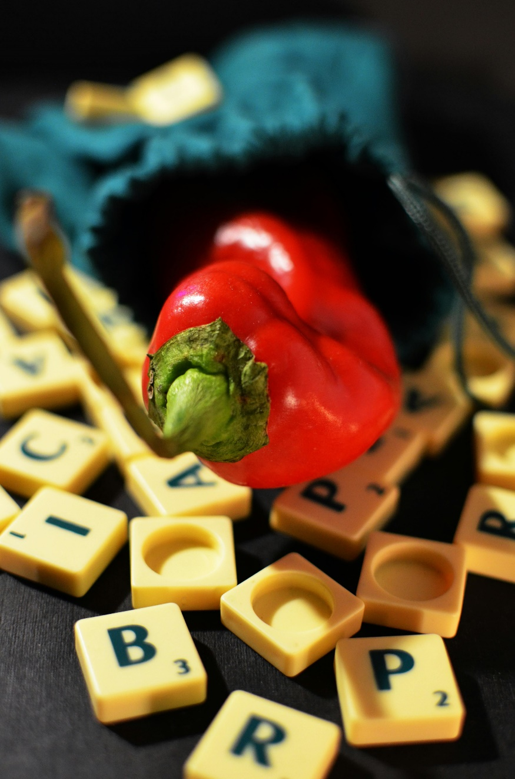

The unique “Scrabble Game”
  - & THE Algorithm of the game

  - STUDENT NAME: Anamaria-Cristina Finta
  - Tutor: Dr Redhwan Al-amri
  - Module: Problem Solving Techniques (ACMA4027)

Contents
Introduction 2
Scrabble Rules 2
Setup: 2
Starting the game: 2
Scoring: 3
End of Game: 3
Requirements Analysis MoSCoW 4
Must Have: 4
Should Have: 4
Could Have: 5
Won’t Have: 5
Variables and Constants: 5
Example Flowchart Outline: 6
Pseudocode for Sub Processes 6
Example Game Scenario 9
Conclusion 10
References 11

Introduction
I wrote this assessment, to tell you everything you need to know about the unique game called “Scrabble” and about the algorithm of the game, and of course, how it was invented by the unemployed American & architect on his name Alfred Mosher Butts.
In the beginning, I am going to present you a quick intro about the game, Scrabble is a fun two to four player board game where players try to score the most points by playing words in a strategically way on the board.
The game was invented by Alfred M.B. in the year of 1938, it was use as a distraction in the Great depression & during the economic times.

Scrabble Rules
The object of the game is to score the most points when the game ends. The game ends when one of the players has emptied their rack of all letters when the bag is empty or if all the players pass twice successive turns.

Setup:
Place the board on the table, or on a flat surface, you will get a small bag where you will have to store all your 100 pieces of letters, which you will use for the entire time, until the end of the game, make sure that you will have your rack that will help you to position your letters during the game, make sure you don’t let anyone see your tiles. Each player must be positioned in front of the one of the sides of the board, depending on how many players will be.
The points can be written on a paper, to keep the track of each players points, or you can use your own notebook.

Starting the game:
Firstly, each player needs to take one letter out of their bags, without looking. The one who has the letter closer to letter “A”, will be the one who starts the game, or if you get a blank tile, that one beats any letter, so the person who gets that tile, goes first.
Each player takes a turn first by drawing seven tiles from the Scrabble bag. Following each turn, a player can either place a word, exchange tiles for new ones, or pass, which is quite rare. Since the other two options lead to no score, most players opt for placing a word. If a player decides to exchange tiles, they can do so for just one tile or of their current tiles. After exchanging tiles, the turn will end, and a player will have to wait until their next turn to play a word on the board.
Whenever, the players would like to, can pass. The one passing would lose every point’s collected in that turn and, let’s hope, hope to play the next. All odds end if, 2 passes in a row follow each other and, in this case, the one with the highest score will be the winner.

Scoring:
Special squares, such as double letter score and triple letter score, are only counted the first time a letter is played on them. The light blue double letter square doubles the point value of the tile played on it, while the blue triple letter square triples the value. If a blank tile is played on these squares, it does not contribute to the total word score as blank tiles have a score of zero.
On the other hand, pink double word squares double the entire word value, and red triple word squares triple the entire word value. This rule applies even if a blank tile covers these special squares. The pink square in the middle of the board, used to start the game, is a double word score.
First, double letter and triple letter squares are counted to calculate the initial word score. Then, any double word score or triple word score squares are counted.
If a player uses all seven letters in their rack, they gain a bonus of 50 points after counting all other special squares. However, these bonus points do not contribute to double and triple word scores.
In case two or more words are formed on a single turn, each word is scored individually. This means that special scoring squares are counted for each word.
At the end of the game, all tiles remaining in a player's rack are subtracted from their score. The player with the highest score wins. In the event of a tie, the player with the fewest points subtracted from their score is declared the winner.

End of Game:
To be successful in a Scrabble game, your objective should be to earn as many points as you can. Every player selects letter tiles from a set of 100 at random to form words and place them on a game board that resembles a grid. The game will come to an end when a player has played all their tiles and there are no more tiles to draw. The winner is ultimately determined by a player's total points and their scores for each word.
As per the official rules of Scrabble, the game concludes when all letters from the bag are drawn, either when a player uses all their tiles or all possible plays on the board are made. In the latter scenario, either there is no more room on the board to form new words or the remaining letters cannot be used to create any words. The scoring process starts after the game finishes so they can decide who the champion.
Interestingly, although the regulations for concluding a game of Scrabble appear to be widely agreed upon, the correct way to calculate points, which determines the game's victor, varies depending on the rule set you adhere to. The scoring rules set by Hasbro, the game manufacturer, are not the same as those of the North American Scrabble Players Association, which hosts the yearly National Scrabble Championship and is the top organization for Scrabble fans worldwide.

Requirements Analysis MoSCoW

Must Have:
Standard Scrabble game board with letter and point values.
Tile rack for each player to hold their letters.
Dictionary or word checker to validate word plays.
Scoring system to track player points.
Turn-based gameplay with pass option.
Game over conditions and winner determination.

Should Have:
Multiplayer mode (local or online).
Timer for each turn.
Challenging AI opponent.
Undo/Redo functionality.
Customizable game settings (e.g., dictionary, board size).
Save and load game progress.

Could Have:
Statistics tracking (e.g., win/loss ratio, average score).
Tutorial or help system.
Voice commands.
Social features (e.g., friend invites, leaderboards).
Different game modes (e.g., speed round, word ladder).

Won’t Have:
Integration with external language learning tools.
Augmented reality features.
To note: This MoSCoW analysis is a starting point and can be adjusted based on specific project goals, target audience, and available resources.

Variables and Constants:
Player names: Strings to store the names of the players.
Current player: Integer to indicate whose turn it is.
Player racks: Lists or arrays to hold the tiles each player has.
Tile bag: A list or array of characters representing the available tiles.
Turn count: Integer to keep track of the number of turns played.
Player scores: Integers to store the scores of each player.
Game board: A 2D array of characters to represent the game board.
Dictionary: A data structure (e.g., a trie, hash table) to store valid words.
BOARD_SIZE: Integer representing the dimensions of the game board (e.g., 15x15).
TILE_VALUES: A dictionary or array mapping letters to their point values.
BONUS_SQUARES: A list or array of tuples representing the positions and types of bonus squares.
MAX_TURN_TIME: Integer representing the maximum time allowed for a turn.
TILE_BAG_SIZE: Integer representing the initial number of tiles in the bag.

Example Flowchart Outline:
START:
Initialize game board, tile bag, and player information.
Determine starting player.
While game not over:
Display game board and player information.
Current player draws tiles.
Current player makes a move:
Choose tiles to play.
Place tiles on the board.
Validate word.
Calculate score.
Update game state.
Switch to next player.
Determine winner.
Display final scores.
END.

Pseudocode for Sub Processes
Here are some potential subprocesses for a Scrabble game:
1. InitializeGame()
InitializeGame()
Create game board
Create tile bag
Create player objects
Shuffle tile bag
Deal initial tiles to players
2. DisplayGameBoard()
DisplayGameBoard(gameBoard)
For each row in gameBoard
For each column in row
Display tile or empty space
3. DrawTiles()
DrawTiles(player, tileBag, numTiles)
For i = 1 to numTiles
If tileBag is not empty
Remove a random tile from tileBag
Add tile to player's rack
4. IsValidWord()
IsValidWord(word, dictionary)
If word is in dictionary
Return true
Else
Return false
5. CalculateScore()
CalculateScore(word, positions, board)
score = 0
For each letter and position in word and positions
letterScore = getLetterValue(letter)
bonusMultiplier = getBonusMultiplier(position, board)
score += letterScore * bonusMultiplier
Return score
6. PlaceTiles()
PlaceTiles(player, tiles, positions, board)
For each tile and position in tiles and positions
Place tile on board at position
Remove tile from player's rack
7. CheckForBingo()
CheckForBingo(player)
If player's rack is empty
Return true
Else
Return false
How to Use Subprocesses
These subprocesses can be called from the main game loop or other subprocesses as needed. For example:
MainGameLoop()
InitializeGame()
While game not over
DisplayGameBoard()
CurrentPlayerDrawsTiles()
PlayerMakesMove()
CheckForGameOver()
DetermineWinner()
DisplayFinalScores()
Additional Considerations
Parameters: Subprocesses often take parameters (inputs) and may return values (outputs). For example, IsValidWord takes a word and a dictionary as input and returns a boolean.
Modularity: Break down complex processes into smaller, more manageable subprocesses.
Reusability: Aim to create subprocesses that can be used in different parts of the program.

Example Game Scenario
Nick vs. Josef
Round 1
Nick draws his tiles: A, E, I, L, M, O, R
Josef draws his tiles: B, C, F, G, N, S, T
Nick’s Turn:
Nick places the word "REAL" horizontally across the center star (a double word score).
Score: 8 points (4 letters x 2 points each) * 2 (double word score) = 16 points
Josef’s Turn:
Josef places the word "BEST" vertically below "REAL", with the "B" on the double letter score square.
Score: 13 points (B=3*2 + E+S+T=10) = 16 points
Round 2
Nick draws a new tile: S
Josef draws a new tile: U
Nick’s Turn:
Nick plays "SIRE" vertically to the right of "BEST", forming the word "BESIRE".
Score: 11 points (S+I+R+E=10) + 2 (double letter score for B) = 13 points
Josef’s Turn:
Josef plays "CAGE" horizontally above "REAL", forming the word "GRACE".
Score: 11 points (G+R+A+C+E=11) + 2 (double letter score for C) = 13 points
Round 3
Nick draws a new tile: T
Josef draws a new tile: Y
Nick’s Turn:
Nick plays "STIR" vertically below "SIRE", forming the word "STIRES".
Score: 10 points (S+T+I+R=8) + 2 (double letter score for S) = 12 points
Josef’s Turn:
Josef plays "FUN" horizontally to the right of "CAGE", forming the word "FUNNY".
Score: 10 points (F+U+N+N+Y=10) + 2 (double letter score for N) = 12 points
Game Continues...
The game would continue with players taking turns, forming words, and scoring points. The game would end when one player runs out of tiles, or both players pass consecutively twice. The player with the highest score at the end of the game wins.

Conclusion
Scrabble is a classic word game that challenges players to strategically form words using letter tiles on a game board. By combining skill, vocabulary, and a bit of luck, players compete to earn the highest score through clever word placement and bonus tile utilization. With its engaging gameplay and competitive nature, Scrabble has captivated players of all ages for generations.

While the core rules and objectives remain consistent, variations in scoring and gameplay can add depth and complexity to the game. Whether enjoyed casually with friends or competitively in tournaments, Scrabble continues to be a beloved pastime for word enthusiasts around the world.

References
SETUP
https://www.wikihow.com/Play-Scrabble

Scrabble rules
https://www.youtube.com/watch?v=A9fJT13NT6g&t=16s

Starting the game
https://www.scrabblepages.com/scrabble/rules/

Scoring & End of the game
https://www.thesprucecrafts.com/how-to-score-scrabble-plays-410932

