LITERATURE NOTES AND WORK IN PROGRESS.

From the early 1940s following the relaxation of post-war censorship in the media, BDSM has slowly crept into the media through ‘raunchy’ images, stories and articles in magazines such as the ‘Bizarre’ in 1946 which depicted images of women in corsets, wearing leather gloves and restrained with chains and ropes, including images of women wearing a scold’s bridle and being punished for menial tasks such as pedalling a bike too slow. The popularity of the magazine reflected the growing interest and intrigue with BDSM-related activities (Stein, 2021)
The fascination and interest in BDSM continued to grow, mirroring the broader shifts in society in the attitudes towards sexuality (Stone & Weinberg, 2015).
Over the ensuing decades, the once-marginalized interest gained traction, mirroring broader societal shifts in attitudes towards sexuality (Weinberg, 2013). As societal taboos waned, BDSM transitioned into mainstream consciousness, facilitated by evolving cultural perspectives (Mulhall, 2016). This evolution in media portrayal, from sensationalized narratives to more nuanced representations, is exemplified in television series such as "BDSM: Behind Closed Doors" and cinematic endeavors like "Secretary," contributing significantly to the destigmatization of BDSM practices (Sullivan, 2018).
Contemporary media landscapes are characterized by the inclusion of diverse and respectful portrayals of BDSM, acknowledging the spectrum of consensual activities (Weinberg, 2013). This paradigm shift aligns with broader societal acceptance, emphasizing informed consent and challenging pervasive stereotypes associated with BDSM (Stein, 2021). In the present milieu, BDSM stands as a testament to the evolving and inclusive nature of media representations of sexuality.

sex has become more visible on TV shows, in films and books, and the growth of the interest has led to a reduction in the perception of sex being a taboo topic. This has led to people feeling more sexually confident in themselves and viewing sex as less of an activity restricted to only married couples, and more of an activity that if it is safe and consensual between two or more people, is okay and ‘normal’ to have multiple sexual partners (Mergenthaler & Yasseri, 2022). BDSM has also seen a rise in exposure with the release of popular books and films such as ’50 Shades of Grey’, the three-book and film series, and ‘365 Days’ on Netflix (Khan, 2017), but has not seen the same level of acceptance as sex in general. BDSM still has a level of stigmatism against the activity even with the Worldwide popularity of BDSM-themed films and books. There has, however, been an increase in people researching and a general interest in things ‘kinky’ and to do with BDSM (REFERENCE!). With people being open to the idea of BDSM and some potentially practising BDSM at home, it should be noted that the popular media coverage of BDSM and ‘kinky’ activities do not give an honest representation of what BDSM practises include, such as consent and safety procedures (REFERENCE!)
With this increase in media coverage over the last decade, it can be assumed that there is a high potential that some may begin to practise BDSM at home or similar aspects of it, but there are no studies to date to measure whether this is an accurate assumption. It can also be assumed that people who may be practising BDSM or similar from watching or reading the previously stated popular media, may not have researched the safe and consensual

practises of true BDSM and may just assume the rough sex and non-consensual play they have been exposed to, is the right way, which can be very dangerous if this trend continues of the growth of BDSM in the world media.

AIM OF THE STUDY ADD AT THE END!
There is very little evidence to suggest that there could also potentially be a generational gap in the attitudes towards BDSM, with older generations who have been brought up with sex and BDSM being a taboo subject still having a negative attitude towards people who practise BDSM, with younger generations who have been brought up and exposed to sex-positive media and BDSM being shown instead of hidden away, have a more positive attitude and opinion toward people who practise BDSM.
Recognising there is a potential gap in the research as to whether the increase in popularity and media exposure of BDSM has created a link in the popularity of people participating in the practice of BDSM is important. This is due to the media portrayal of BDSM being inaccurate suggesting and promoting the idea that BDSM is just rough sex and no acknowledgement of safety procedures and more importantly, consent. Unfortunately, a study of that magnitude for an undergraduate student raises a lot of ethical factors, so I will look into whether there is a more positive attitude towards BDSM from younger generations than older, which, if the results reflect that hypothesis, further studies in the future can be conducted to explore this link further.

KRAXENBERGER ET AL WRITE ABOUT FEMALES READING EROTIC NOVELS, LINKING FEMALES BEING MORE ACCEPTING OF BDSM AND MORE KNOWLEDGE THAN MALES.

Notes, rewrite this!!:
Research can also inform the field of mental health counseling by exploring: sexual and marital satisfaction of partners (Meyer 2016), growth-oriented vs. self-destructive aspects of BDSM, how clinicians react to “perverse” material and transference-countertransference, and how practitioners experience healing through BDSM (Matthews 2005). Research on why D/s partners break up and how they separate from their dynamic can also help counselors to provide better service for clients (Dancer et al 2006)

Stein, S. K. (2021). Sadomasochism and the BDSM Community in the United States: Kinky People Unite. Routledge.
Stone, A. L., & Weinberg, J. D. (2015). Sexualities and Social Movements: Three Decades of Sex and Social Change. In Handbooks of sociology and social research (pp. 453–465). https://doi.org/10.1007/978-3-319-17341-2_25

Kraxenberger, M., Knoop, C. A., & Menninghaus, W. (2021). Who reads contemporary erotic novels and why? Humanities and Social Sciences Communications, 8(1). https://doi.org/10.1057/s41599-021-00764-3

CHAPTER 3: Results
Three independent sample T-tests were conducted through the program SPSS to analyse the data collected through EMS. The data collected was separated into three categories to discover whether the data supported or rejected each hypothesis. These groups were labelled as; Gender, Age and Knowledge. A T-test analysis was chosen for this study to determine whether there was a significant difference between the two sets of data’s mean scores in each group, thus meaning the data is either significant (supports hypothesis) or not significant (rejects hypothesis). The results for each group are as follows:
1. Gender. – “Females will have a more positive attitude towards BDSM than men”.
 | MEAN | S.D | N
MALE | 27.30 | 4.24 | 10
FEMALE | 26.56 | 6.57 | 39

t (47) = .34, p > .37
Results show that in regards to the first group of data, there is no significant result between males and females in response to their attitude towards people who practise BDSM. This rejects the first hypothesis that females have a more positive attitude towards BDSM than men.
2. Age. – “Young adults will have a more positive attitude towards BDSM than older adults”.
 | MEAN | S.D | N
YOUNG (18-23) | 27.88 | 4.81 | 25
OLDER (24+) | 25.50 | 7.16 | 24

t (47) = 1.37, p > .09
The second T-test sample shows no significant result between age groups in regard to attitudes towards BDSM, rejecting the hypothesis that a younger age group will have a more positive attitude than older age groups.
3. Awareness. – “People with previous awareness of BDSM will have a more positive attitude towards BDSM than those who do not”.
 | MEAN | S.D | N
YES | 26.22 | 6.19 | 41
NO | 29.25 | 5.50 | 8

t (47) = 1.29, p > .20
The third data set too, shows no significant result Regarding awareness of BDSM affecting attitudes. These results reject the hypothesis that people with previous knowledge of BDSM will have a more positive attitude towards people who practise BDSM than those who do not.

CHAPTER 4: Discussion.

This study aimed to discover whether there was a correlation between positive attitudes towards people who practise BDSM and gender, age, and previous knowledge of BDSM. Through the evaluation of previous literature and studies based on the topic of attitudes towards BDSM as an activity, it was hypothesised that positive attitudes would be more likely to be found amongst younger age groups, females, and people with previous knowledge of BDSM. However, the results from this study found no significant correlation between these groups and displaying more positive attitudes than those who were older, male or had no previous knowledge of BDSM. Therefore, the results did not support any of the three hypotheses made.

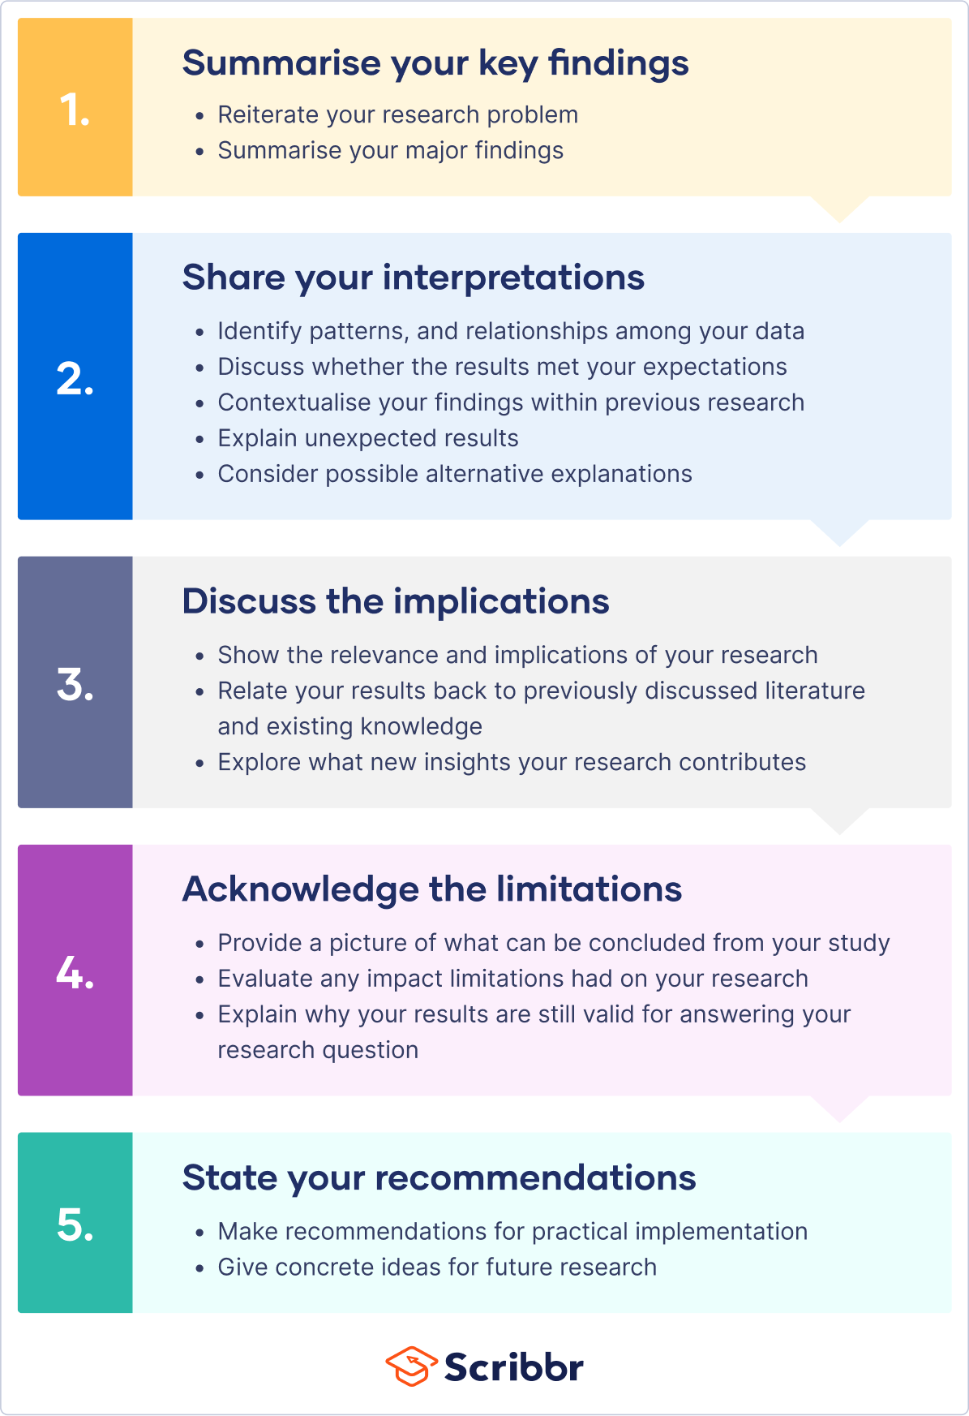
DISSCUSSION NOTES AND WORK IN PROGRESS.
- Research summary
- Interpretation of findings
- Comparison with literature
- Implications of your work
- Limitations
- Future work
The age 22 had the most participants with 7p’s. Largest range/mix of attitudes, with the lower scores being from this age. But this could be just 1 person who did not have any knowledge? Attitudes towards BDSM otherwise as a whole is very positive which can only be seen as a good thing, but with the obviously small sample there were no significant results which is the biggest limitation of this study.
AGE GROUPS hypothesis rejected, the age groups created for the analysis of the data collected, did not reflect the age groups that were originally intended for this study. To determine whether attitudes towards BDSM differed between age groups, two age groups 18-35 and 35+ years old were ideally aspired to obtain, taken from the study Pitagora (2013). This would support the literature that sex and sex-related topics were taboo for older generations (Boyd-Rogers, 2022) with it being less so in recent years due to media coverage (Stone & Weinburg, 2015). The limitation of the study was a small sample size with a limited age range. Future research is to be done externally to gather a large number of participants with a broader range of ages to represent the population over the age of 35 years old and potentially 50+ to see whether there is a generational implication on attitudes toward BDSM.
GENDER Hypothesis rejected. Sample size not equal enough between the 2 genders. Similar to the study by Kraxenberger et al., 2021 who had to change their study after recruitment due to 98% of the participants being female over male, can assume that more females read exotic novels over males hence the small percentage of males signing up. Kraxenberger et al, with more female participants enjoying reading erotic novels, and shows as well as reporting to be enjoying and seeking out erotic-themed media over other, non-sexual, topics. From the literature, a common theme was There is little research and that further research could be conducted into the difference between genders and BDSM, which is why this hypothesis was created, although the results were not significant it did show that females did have an overall positive attitude to BDSM. In this case there are more female to male students studying psychology in the UWTSD which is the reasoning behind the unbalanced gender samples. Further research to widen to outside the university to gather a better and more balanced sample size of males to females.
KNOWLEDGE Hypothesis rejected, not enough of a sample size to see any differences or correlations. The majority of the participants were 30 years old and under, which reflected the knowledge of BDSM is very high compared to no knowledge which would be supported by the literature with the increase of BDSM in the media over the last 50 years (Stein, 2021), can also be supported by Kraxenberger et al., 2021 with females seeking erotic and BDSM themed literature may thus know more about BDSM through reading. however, due to the low age groups created to run the analysis, there was no significant result between knowledge and having a positive attitude towards BDSM. Further research could be to carried out with a larger sample size to determine whether females have more knowledge than males, and whether this affects attitudes towards BDSM practitioners.
Overall results show that participants have a positive attitude towards BDSM rather than a negative attitude, which when considering the high percentage of participants under the age of 30 years old would support the literature that younger age groups would reflect these results REFERENCE.
Future research, outside recruitment from uni to collect larger range of ages and males. Qualitative study or aspect (mixed methods) to collect data on WHERE they have learnt about BDSM, WHAT their attitudes are and WHY they feel that way. Be good to gather information on what they believe BDSM is or entails and where this knowledge has come from as the media and popular books such as ’50 shades of grey’ false image and information of BDSM, which is dangerous to anyone who may be interested in participating in BDSM activites due to consent and power exchange (find reference? Im sure there's one in lit review). Maybe see how many have participated in BDSM and how they feel they are portrayed, how they feel others may judge them or positive/negative experiences from others?

