ACEA 6002

Barrie John

1811176

Applying Lean Techniques

Andrew Thorn

Contents

- Figure and tables list........................................................................................................
- Introduction......................................................................................................................
- What is lean manufacturing.............................................................................................
- Reduction of waste...........................................................................................................
- Scope of the project.........................................................................................................
- Current process investigation..........................................................................................
- Investigation outcome.....................................................................................................
- Process improvement......................................................................................................
- Outcome..........................................................................................................................
- Conclusion.......................................................................................................................
- Achknowledgements.......................................................................................................
- References.......................................................................................................................

1.Figure and tables list.
- Principles of lean manufacturing.
- Eight wastes of lean manufacturing.
- Image of an LTR.
- LTR process flow chart.
- LTR end capping machine.
- New location for LTR end capping machine.
- New LTR process flow chart.

2.Introduction.
This report prepared by Barrie John looks at lean techniques and how they can be used to improve a manufacturing process. This will then be demonstrated by analysing a manufacturing process and implementing lean processes to make improvements.

3.What is lean manufacturing?
Lean manufacturing is a production method that is aimed at maximising value for the customer by ensuring the least amount of waste to a manufacturing process.

This is a method that has been around since the 20th century. Manufacturers realised there was a need to find efficiencies in their processes.

Toyota are a leading company in lean manufacturing, they developed the Toyota Production System, which looks at the overall management approach. The term ‘lean’ has been used since the 1990’s.

Lean manufacturing and just in time manufacturing often work hand in hand. Although lean manufacturing is a more wide-ranging term that can be used in all sorts of the business.

Key principles include continuous improvement (kaizen), eliminating waste and being able to define customer value.

Lean manufacturing focuses on....
Being people-focused – employees are encouraged to be customer focused. This focus is on ensuring that anything that doesn’t create value for the customer is waste. This also allows the employee to develop their lean skills.
long-term – not all improvements are quick fixes, lean manufacturing looks at the long-term and ensuring the improvements are robust.
continuous improvement – to avoid making repeat mistakes, lean manufacturing is about problem solving, becoming more efficient and helping the business to grow. (Bromley, 2022)
Below figure 1 is a diagram of the five principles of lean manufacturing.
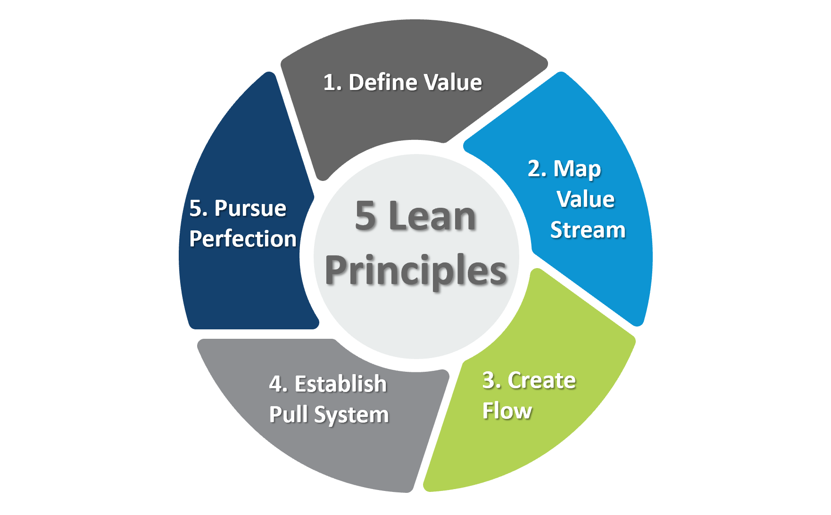
Figure 1. (Planettogether, 21)

4.Reduction of waste.
The scope of the project will be to remove waste from a manufacturing process. What is waste?
Modern Lean Manufacturing models recognise that there are eight types of waste. There are the traditional seven that were developed by the Toyota production system and then the eighth waste which is linked to a manager’s ability to utilise personnel.
The 8 wastes are:
- Defects.
- Over processing.
- Overproduction
- Waiting.
- Inventory
- Transportation.
- Motion.
- Non-Utilized Talent.
(Christina Gay, 2016)

Below Figure 2 shows the eight wastes of lean manufacturing.

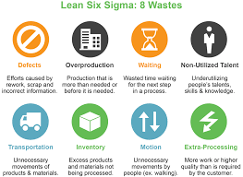
Figure 2. ( John O’Kelly, 2017)

5.Scope of the project.

The waste this report will be looking to reduce will be the waste of motion.

In this project we will look to reduce the amount of movement needed in the end capping process on the L462 LTR.

The L462 LTR is a low temperature radiator that is supplied to JLR. An LTR is a low temperature radiator which is used as a backup to the main radiator in a vehicle. The LTR is built on a core build using raw aluminium materials and they are then stored on a trolley before being transported to the end cap machine. From here it is then transported to the braze furnace and then onto the testing facility. This report looks at the potential waste of transporting the parts between the core build and the end capping process.

Figure 3 below shows a standard LTR.

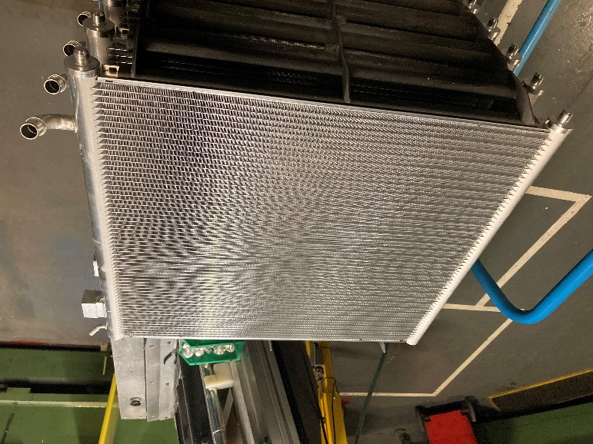
Figure 3.

6.Current process investigation.

Below Figure 4 shows the process flow chart of the current endcap process.

Figure 4.

Figure 5 below shows the current location of the LTR endcap machine.

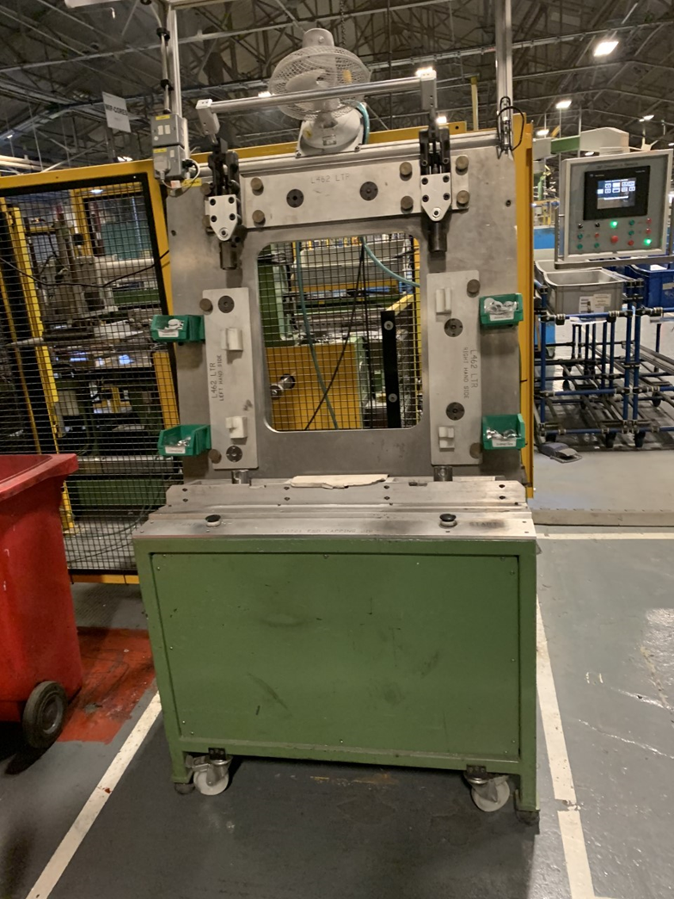
Figure 5.

It is clear that the current layout is not ideal for a good flow of parts as there is a disconnect between the corebuild and the end capping jig, causing the need for extra movement and extra handling of the components. This also requires a second operator to complete the process.
A brainstorming session was held with a cross functional team made up from manufacturing, engineering, quality, and operators to see how to best improve the process. This was started with value stream mapping the current process.

What is value stream mapping?
(VSM) Value stream mapping is a lean manufacturing tool that documents all the steps in a process and looks to identify waste. This is then used to reduce or eliminate the waste by implementing process improvements.
Value stream mapping helps to maximise resources by creating a plan to ensure that time and materials are used as efficiently as possible.
It is important to start by "walking the flow," this allows the team to gather high-value information from employees, including:
- Cycle time or processing time
- Changeover time
- Reliability of equipment
- First pass yield
- Quantities
- Number of operators and shifts
- Hard copy information
- Electronic information
- Inventory levels
- Queue or waiting times

When all the information is gathered it can provide a clear picture of the major issues in the process. From here the team build a lean process map. (American Society for Quality, 2022)

7.Investigation outcome.

From the investigation and brainstorming sessions carried out by the team it was discovered that there was spare process time in the core build cycle time. It was then decided that this could be investigated further to see if the end capping role could be combined.

It was noted that there was 84.2 seconds of process time during the build process where the operator was left waiting for the machine to complete its cycle. The next step was to take a timing of the end cap process to see if it would fit. The end cap process was timed at 30 seconds to complete proving there was plenty of time within the build cycle time to carry out the end capping cycle.

The next steps were to investigate if the layout could be improved to accommodate the end capping process into the build.

Why is it essential to get the right layout?

When designing a manufacturing layout, it should look to optimise the facilities to help reduce the material handling and material movement.
A dynamic approach to layouts looks for flexibility and a robust layout which can be used on a range of products and cope with various volumes. (Arimond J, 1993)

The team tried several different layouts around the core build looking to see if the end cap machine would fit and what would be the best for process flow.
It was found that the endcap jig could be placed next to the build In a suitable position that would allow for the operator to complete the endcap task while the core build completes the cycle.

Figure 6 below shows the new layout of the end capping machine next to the build that allows for the end capping to be completed during the cycle.

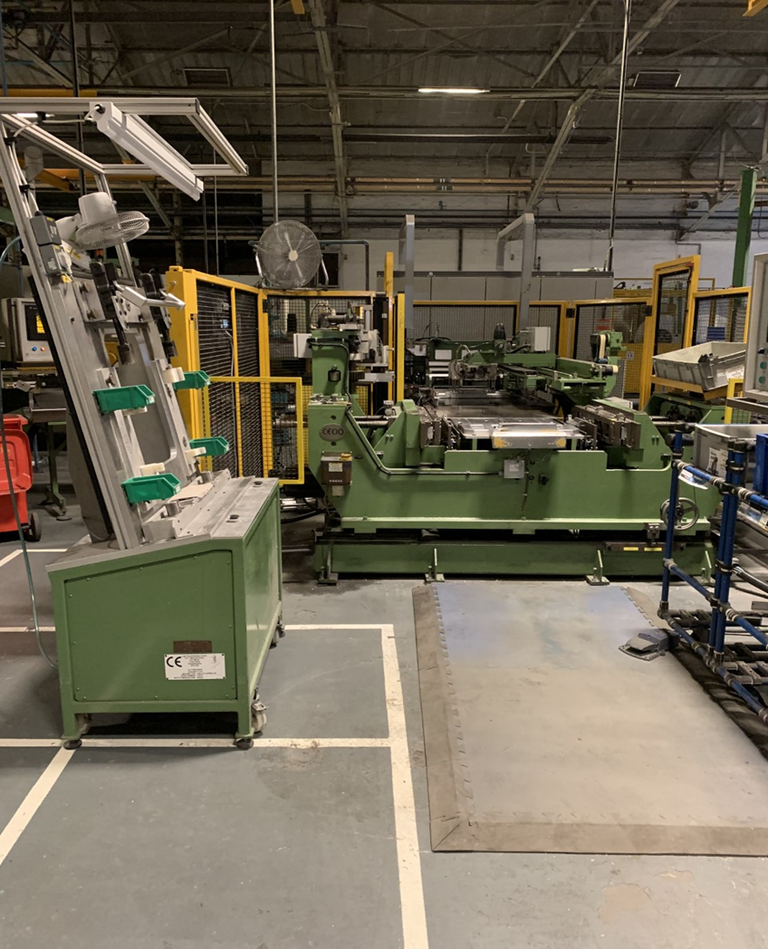
Figure 6.

8.Process Improvement.
With the new layout in place, it is possible to measure if any improvements had been achieved.
Firstly, there was not the need for the second operator to carry out the end capping task as this was now being carried out by the core build operator.
This is a reduction in movement as the parts are travelling less. And this is also a reduction in Non – utilization as this allows the second operator to complete another task.
Secondly, there was the reduction in waiting time as the operator now had a task to complete during the build cycle.
This is a reduction in waiting time as the operator is completing the second task while the build process is on-going.

Figure 7 below shows the new process flow.

Figure 7.

This new process eliminates one operation by combining the end capping into the cycle of the core build.

9.Outcome.
Several outcomes have been achieved from this activity these include time, movement, and manning savings. It has generated a saving of 0.600 SMV which means the tac time for the product is reduced allowing for a greater output. Also, there is the saving of the need for a second operator which equates to a possible saving of up to £23,400 per annum.

10.Conclusion.
In Conclusion the main aim of the project was to reduce the movement of the part and eliminate this waste. This was achieved by combining the task into the core build cycle, however, there has been further improvements in that there has been an improvement in efficiency as well as a reduction in waiting time and a reduction in manpower needed for the operation.

Overall, this has been a very successful lean activity as it has managed to not only reduce waste of movement but also reduce the overall cost of manufacturing a part.
I believe this is a good example of how following the lean manufacturing principles can lead to a reduction in waste and an improvement in a manufacturing process to help reduce costs and improve profitability.
11.Acknowledgements.

I would like to thank the following people for their support in this lean activity.
Rowan Burgess – Coordinator, Rowan played a key role in trialling the different layouts for the end capping machine.
Roger Mosley – Operator, Roger was the operator who assisted with the different trials to see If the end capping could be done during the build cycle.
Adam Evans – senior quality engineer, Adam ensured that any changes to the process had no adverse effects to the quality of the product.
Rob Folland – MTM engineer, Rob carried out several timings of different methods to see what would be the best fit to achieve the ability to combine tasks.
Andrew Thorn – lecturer, I would like to thank Andrew for his teachings in lean activities which help inspire the ideas to improve a process.

12.References.
John O’Kelly. (2017, Dec 30). wastes of Lean and how to eliminate them. Retrieved from automationmag.com: https://www.automationmag.com/7872-seven-wastes-of-lean-and-how-to-eliminate-them/
American Society for Quality. (2022). Value stream mapping. Retrieved from asq.org: https://asq.org/quality-resources/lean/value-stream-mapping
Arimond J, A. W. (1993). Phenolics creep up on engine application. Retrieved from link.springer.com: https://link.springer.com/chapter/10.1007/978-1-84996-017-5_10
Bromley, S. (2022, Feb 17). What is lean manufacturing? Retrieved from simplybusiness.co.uk: https://www.simplybusiness.co.uk/knowledge/articles/2022/02/what-is-lean-manufacturing/
Christina Gay. (2016, 01 25). Machine Metrics. Retrieved from machinemetrics.com: https://www.machinemetrics.com/blog/8-wastes-of-lean-manufacturing
Planettogether. (21, 8 3). Five Principles of Lean Manufacturing. Retrieved from planettogether.com: https://www.planettogether.com/blog/five-principles-of-lean-manufacturing

