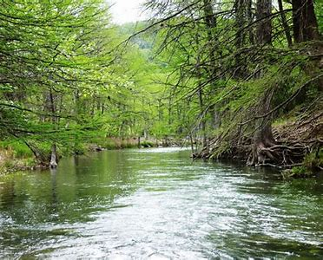  Riparian Shade Mapping in Wales | Abstract  This research proposal seeks to understand the methods of the existing riparian shade map in England, evaluate its successes to analyse the potential to replicate the map to Welsh Rivers with the River Tawe as a starting point.  Catherine Parnaby  2412703

Contents
Title 1
Introduction 1
Aims 1
Objectives 1
Research question 1
Literature Review 3
River Temperatures 3
Keystone Species Salmon & Trout 3
Riparian Trees Planting 4
GIS Mapping 4
Methods 4
Mapping the shade. 4
Testing the map 5
Analysis of data 5
Results 5
Evaluation 6
References 7

Figure 1 Temperature Ranges for Atlantic Salmon (Calado, Mota and Leal, 2021) 2

Title
Creating a map to show riparian shade index on the River Tawe based on the Keeping Rivers Cool Project and testing its effectiveness in reducing river temperature.

Introduction

Aims
To create a riparian shade map for ease of identifying areas that would benefit from planting trees and to test it to show if it is representative of different river temperature using and comparing the riparian shade map from the Keeping Rivers Cool project (KRC).

Objectives
- Use GIS and LiDAR to identify tree canopy along the River Tawe and create a shade map with a percentage of cover index.
- Test the temperature of shaded areas compared to open areas for both River Tawe and a river that the KRC map uses, likely the Usk.
- Analyse data to test hypothesis that a tree canopy map can effectively show shade and therefore reduced river temperature for use in the wider field to support land managers with riparian tree planting.

Research question
Does the existing map form the Environment Agency offer an accurate description of shade that correlates to a reduction in temperature, and can a shade index provide better results?

Climate change is considered a key threat to biodiversity and the increase in global temperature is impacting the health of our rivers and their ecosystems. River health is important as they provide drinking water, crop irrigation, food and transport and are often used for recreation. Temperature rises are posing a threat to fish in all levels of biological organization (Graham and Harrod, 2009).
Temperature of flowing water in streams and rivers has a significant impact on the ecosystem and organisms within it (Webb et al., 2008). Higher temperatures are often associated with eutrophication and lower dissolved oxygen and, as many aquatic species such as fish are cold blooded or ectothermic, meaning that their physiological processes and behaviour is dependent on its environment (Johnson et al., 2024) it is essential that the temperature remains within the optimal range, especially for species that are particularly vulnerable to such changes as the Atlantic Salmon (Salmo Salar and Brown Trout (Salmo Trutta).
Figure 1 shows the temperature ranges including the optimal temperature for different stages of an Atlantic Salmon’s life cycle. The optimal range in temperatures for juvenile salmon is much lower temperatures than that of an adult.
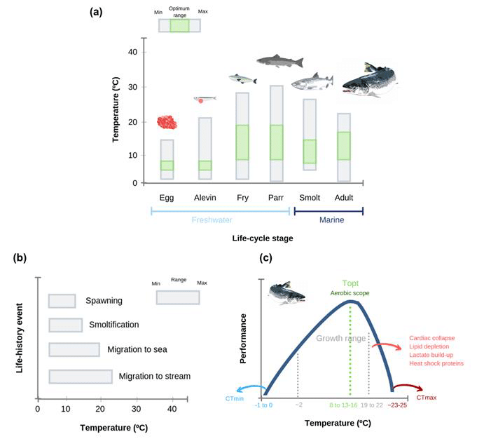
Figure 1 Temperature Ranges for Atlantic Salmon (Calado, Mota and Leal, 2021)

Riparian shade in the head waters of rivers can help mitigate these risks and increase biodiversity and flood management. Headwater streams are particularly sensitive to temperature fluctuations. Riparian vegetation provides shade that helps maintain cooler water temperatures as it flows downstream (Correll, 2005).
The Environment Agency created a shade map and provides funds to a projects on some rivers in England to enable land managers, river and wildlife trusts to identify areas that would benefit from tree planting. Since the project began, 300,000 trees have been planted (JNCC, 2021). It uses a gradient colour scale of red to blue where red shows most shading and blue shows least shading.
There is no such map that exists for rivers in Wales. This research seeks to understand how effective the gradient shade map from the Keeping Rivers Cool project is and to create a map that has a percentage cover index instead. Temperature readings from rivers on both maps can show which map would be most beneficial to organisations such as Natural Resources Wales and the various Rivers Trusts of Wales and place a foundation for tree planting.

Literature Review

River Temperatures
There have been many studies on freshwater temperatures, and it is understood that temperature is a key element to freshwater species as it can affect such factors as distribution, growth rates and life history events (Hannah and Garner, 2015).
As the climate is changing and the air temperature is increasing, it is expected that temperatures in streams and rivers will increase too. A study by (Orr et al., 2015) looked at 2773 sites in England and Wales where they looked at 231 ‘subsites’ in 63 catchments as they were thought to have fewer anthropological impacts. The study looked at temperature changes between 1990 and 2006 and found that there was an overall increase of 0.52°C which gave a rise of 0.03°C per year. While this data is almost 20 years old, could it be assumed that river temperatures in the UK could have risen a further 0.57°C by 2025?
The drawbacks of the literature are that while there has been a mass study, it is difficult to find data that looks at temperatures at different depths. This is an important aspect for spawning fish especially as river bed temperatures are crucial to understanding the success rates of juvenile salmon and trout. However, ultimately, it can be concluded that the temperatures of rivers are increasing which will have an impact on their survival.

Keystone Species Salmon & Trout
The focus on Atlantic Salmon and Brown trout is based on that they are both keystone species, these are identified species that are crucial to the biodiversity and functioning of an ecosystem, attracting conservation efforts as their loss would accelerate the extinction of other species in the ecosystem (Mills and Doak, 1993).
The two fish belong to the same Salmonid family and have overlapping habitat requirements. They are anadromous which means they spawn in rivers in clean gravel where it is relatively low risk before migrating out to sea to feed and grow (Hendry and Cragg-Hine, 2003).
Salmonids have specific temperature thresholds that influence their ability to spawn, migrate, and survive and water temperature also plays a crucial role in fish growth rates, which can impact their size, alter the timing of salmon migration to the sea, and potentially affect population numbers (Orr et al., 2015).
A study in Norway found that Salmon eggs that developed and hatched in warmer waters led to the adult Salmon ‘homing’ back to the rivers from sea came back later in the year than those that hatched in cooler water which indicated that the warmer incubated Salmon fed longer at sea. (Jonsson and Jonsson, 2018). This shows that Salmon can adapt to changes in the environment for example higher water temperature. However, the study doesn’t show the implications of feeding and subsequent growth rates of Salmon who have consequently spawned later in the year.
The time between Salmon eggs being spawned and later hatching is dependent on temperature, the warmer the water, the earlier they eggs will hatch and likely with a lower body weight. (Solomon and Lightfoot, 2008). Salmon eggs have a high mortality rate once at 16°C and while alevins (hatched Salmon eggs) can endure higher temperatures than at egg stage, they can survive temperatures up to 22°C (Ojanguren, Reyes-Gavilán and Rodríguez Muñoz, 1999). The optimal thermal ranges for Salmon and Brown Trout are 6-20°C and 4-19°C respectively according to (Elliot, 1981). His study also states that temperatures above these ranges the fish are likely to display stress responses such as reluctance to feed and short bursts of activity with collisions to the side of the tank. While this study was laboratory based, it can be expected for the behaviour of fish in rivers to be similar in similar temperatures.

Riparian Trees Planting
Changes in land use over time and activities such as livestock grazing and trampling are some of the reasons for the degradation of riparian wooded areas (Bowler et al., 2012)..
Riparian tree planting plays an important role in maintaining lower temperatures in streams, through providing shade and transpiration cooling (Correll, 2005).
Tree planting would be most effective in the head waters and streams so that it reduces the maximum temperatures rather than the mean (Bowler et al., 2012) as these waters are more responsive to shading (Lenane, 2016)

GIS Mapping
Graphic Information Systems (GIS) are computer based tools that capture and store and analyse data to present it in visual format to understand the dynamics of objects and activities on Earth (Parent, 2024)

Methods

A quantitative methodology will be used to identify areas of shading and the effectiveness of the shading maps on river temperatures.

Mapping the shade.
Using Datamaps Wales it is possible to access imagery for the whole of Wales. While a whole Wales map isn’t required, it is useful to track the river Tawe from its head waters to its estuary. Using the LIDAR viewer function it is then possible to toggle the layers so that all layers are switched off with exception to the Digital Surface Model (DSM) to highlight natural and built features in the landscape such as trees, hedgerows and buildings (datamapswales 2025). This can offer insights into the level of riparian vegetation however it is difficult to assess a percentage of tree canopy as such.
Further research is needed to more accurately identify canopy. The Environment Agency created a shade map so contacting them for more information on their methods may be necessary.

Testing the map
At least 6 sites will be identified on the map with a balance between assumed shade and open areas to test how the level of tree canopy relates to water temperature. An index of canopy in percentage over a 200m can offer a more detailed picture of the shade that is over the river at that site.
Water temperature and dissolved oxygen should be tested if it is safe to do so with a minimum of three samples from each site need to be recorded.
As the shading map that the Environmental Agency created covers part of the River Wye it is not too far to travel to identify sites and test those for comparison.

Analysis of data
Data from all of the sites covered by my map and also the sites covered by the riparian shade and entered into a table for analysis.
The key dependant variable is the temperature of the water, with the key independent variable is the shade provided by tree canopy. The test should be able to ascertain that $x$ % shade results in $x$°C cooler than open river.
There will be an expected reduction in temperature between shaded areas and open areas, however, it is expected that an assumption from the indexed areas to correlate to a certain degree in reduction.

Results
The index of tree cover for the map on the Tawe will be discrete data in that it will be an index of 0-20% coverage, 20-40% coverage and so on. The temperature from each site will be continuous as it will have an infinite number of potential values. An independent t-test would be effective in identifying if there was any statistical difference in the two data groups.
It is expected that the shaded areas reduce river temperatures by 2-4°C (JNCC, 2021), however it is unclear what temperature reduction would be expected using a ‘most shade to least’ gradient. It would be expected that a reduction of >4°C from >60% shade and >2°C from 40% shade.
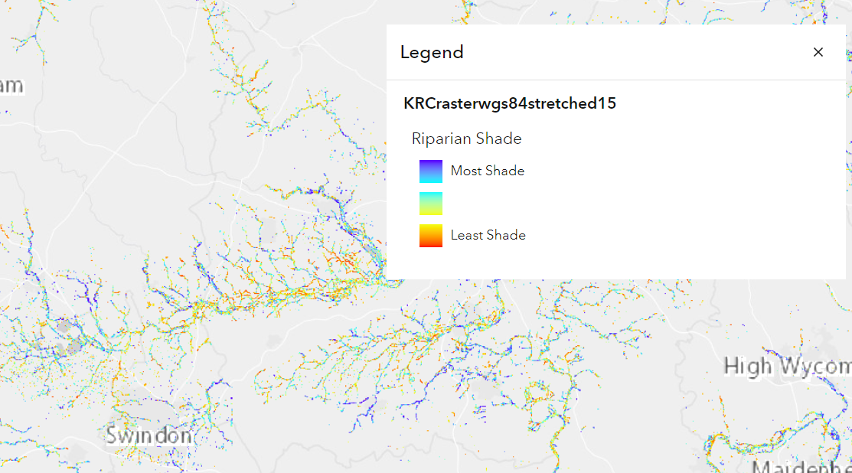

Evaluation
As the climate is warming there is evidence to show that our rivers are warming too (Liu et al., 2020). Warm rivers can have negative if not catastrophic impacts on freshwater organisms and there is a growing knowledgebase that riparian shading can help mitigate these impacts by reducing the warming effect from solar radiation (Johnson et al., 2024).
There is an existing map that covers England that highlights levels of riparian shading highlighting areas with most shade and least shade (Walker, 2015).
My proposal is to create a similar map using LiDAR along the upper reaches of the River Tawe with a percentage index and test if the map can accurately show shading which is representative of the difference in water temperature. The Keeping Rivers Cool Project will be used as a controlled variable and the results analysed and shared with organisations such as The West Wales Rivers Trust, and Natural Resources Wales.
This research proposal has the potential to easily highlight areas that would benefit from riparian tree planting. It is expected that there will be a strong correlation between shade and river temperature as previous studies have shown and with more accuracy for depicting shade coverage. However, the development of the map may need a lot of work and it will then need to be thoroughly tested geographically as well as periodical monitoring to ensure its up to date.

References

Bowler, D.E. et al. (2012) ‘What are the effects of wooded riparian zones on stream temperature?’, Environmental Evidence, 1(1), p. 3. Available at: https://doi.org/10.1186/2047-2382-1-3.
Calado, R., Mota, V. and Leal, M. (2021) ‘Summer Is Coming! Tackling Ocean Warming in Atlantic Salmon Cage Farming’, Animals, 11, p. 1800. Available at: https://doi.org/10.3390/ani11061800.
Correll, D.L. (2005) ‘Principles of planning and establishment of buffer zones’, Ecological Engineering, 24(5), pp. 433–439. Available at: https://doi.org/10.1016/j.ecoleng.2005.01.007.
Datamapswales (2025) lidar viewer – website unavailable at time of referencing.
Graham, C.T. and Harrod, C. (2009) ‘Implications of climate change for the fishes of the British Isles’, Journal of Fish Biology, 74(6), pp. 1143–1205. Available at: https://doi.org/10.1111/j.1095-8649.2009.02180.x.
Hannah, D.M. and Garner, G. (2015) ‘River water temperature in the United Kingdom’, Progress in Physical Geography: Earth and Environment, 39(1), pp. 68–92. Available at: https://doi.org/10.1177/0309133314550669.
Hendry, K. and Cragg-Hine, D. (2003) ‘Ecology of the Atlantic Salmon Conserving Natura 2000 Rivers Ecology Series No’. Available at: www.riverlife.org.uk. (Accessed: 6 February 2025).
JNCC (2021) Keeping Rivers Cool. Available at: https://jncc.gov.uk/our-work/keeping-rivers-cool/ (Accessed: 8 February 2025).
Johnson, M.F. et al. (2024) ‘Rising water temperature in rivers: Ecological impacts and future resilience’, WIREs Water, 11(4). Available at: https://doi.org/10.1002/wat2.1724.
Jonsson, B. and Jonsson, N. (2018) ‘Egg incubation temperature affects the timing of the Atlantic salmon Salmo salar homing migration’, Journal of Fish Biology, 93(5), pp. 1016–1020. Available at: https://doi.org/10.1111/jfb.13817.
Liu, S. et al. (2020) ‘Global river water warming due to climate change and anthropogenic heat emission’, Global and Planetary Change, 193, p. 103289. Available at: https://doi.org/10.1016/j.gloplacha.2020.103289.
Mills, L.S. and Doak, D.F. (1993) ‘The Keystone-Species Concept in Ecology and Conservation’, BioScience, 43(4), pp. 219–224. Available at: https://doi.org/10.2307/1312122.
Ojanguren, A.F., Reyes-Gavilán, F.G. and Rodríguez Muñoz, R.R. (1999) ‘Effects of temperature on growth and efficiency of yolk utilisation in eggs and pre-feeding larval stages of Atlantic salmon’, Aquaculture International, 7(2), pp. 81–87. Available at: https://doi.org/10.1023/A:1009214804949/METRICS.
Orr, H.G. et al. (2015) ‘Detecting changing river temperatures in England and Wales’, Hydrological Processes, 29(5), pp. 752–766. Available at: https://doi.org/10.1002/hyp.10181.
Lenane, R. (2016) ‘Keeping Rivers Cool: A Guidance Manual Creating riparian shade for climate change adaptation’. Available at: https://www.woodlandtrust.org.uk/media/1761/keeping-rivers-cool.pdf (Accessed: 7 February 2025).
Solomon, D.J. and Lightfoot, G.W. (2008) ‘The thermal biology of brown trout and Atlantic salmon’. Available at: www.environment-agency.gov.uk (Accessed: 6 February 2025).
Walker, M. (2015) Riparian Shade (England) | ArcGIS Hub. Available at: https://hub.arcgis.com/maps/theriverstrust::riparian-shade-england/about (Accessed: 8 February 2025).
Webb, B.W. et al. (2008) ‘Recent advances in stream and river temperature research’, Hydrological Processes, 22(7), pp. 902–918. Available at: https://doi.org/10.1002/HYP.6994.
Parent, R. (2024) What is GIS? Available at: https://www.korem.com/what-is-gis/ (Accessed: 8 February 2025).

