Report

Subject: Primark Internal and External Marketing Analysis

Student Name/ ID: Deena Palanchoke 2221001
Module: MBA Marketing Management
Lecturer: Tushara Balendran

Contents
1. Introduction 3
2. PESTLE analysis 3
2.1 Political Factors 3
2.2 Economical Factors: 4
2.3 Social/Cultural Forces 4
2.4 Technological Factors 5
2.5 Legal Factors: 5
2.6 Environmental Factors 6
2.7 Advantages and Disadvantages of PESTLE analysis 7
3. Porter’s Five Forces analysis at Primark 7
3.1 Competitive Rivalry: 8
3.2 Threat of New Entrants: 8
3.3 Bargaining Power of Supplier 8
3.4 Bargaining Power of Buyer 8
3.5 Threat of Substitute 8
4. SWOT Analysis 9
5. STP Strategy 9
6. Marketing Mix Strategies 11
6.1 Product 11
6.2 Price 12
6.3 Place 12
6.4 Promotion 12
7. Recommendation 13
8. Conclusion 15
Reference 17

Introduction
The apparel business hosts some of the world’s most rapidly growing companies. Fashion co-operates today with different other factors like culture, entertainment, capital and information’s. Primark operated since 1969 is leading international clothing retail. The author plays role to determine Primark’s internal and external environmental analysis which is one of the significant apparel business in its market. The author will looks after some of the major forces such as PESTLE analysis where, the report basically deal in favourable and unfavourable factors for the company. Secondly, in Porter’s Five Force Model analysis it deals with High, Medium and Low forces that impacts the company. Whereas, SWOT analysis describes Primark’s Strength, Weakness, Opportunities, and Threats. Similarly, the author talks about Primark’s segmentation, targeting and it’s positioning that relates to its values. Further, the author will recommend future marketing strategy to the company considering Ansoff matrix for institutional betterment.

PESTLE analysis
The external environment of the Primark can be analyse through the PESTLE analysis which assesses the external macro-environment factors affecting a business.
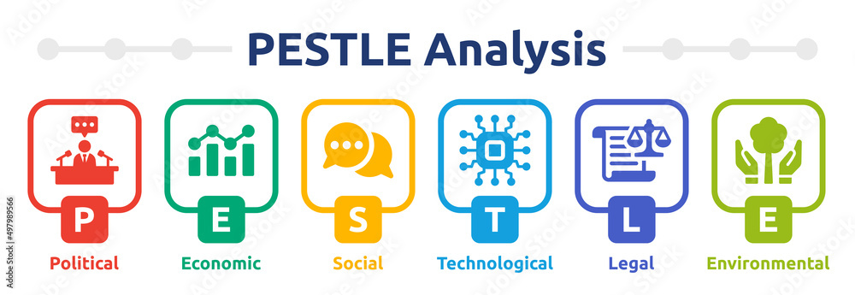
(The, 2023)

2.1 Political Factors
Government rules and regulations, policies and law affect the business environment of Primark.
- Trade Policies: Change in trade policies, trade agreements and traffics will affect the Primark’s supply chain, profitability and Cost of goods sold. This will create an unfavourable situation to the company.
- Brexit: Primark had to restructure its supply chain and pricing strategies due to the trade barrier and higher tariffs between the UK and EU countries. Brexit has an unfavourable impact on the company’s operations.
- Environmental regulations: Primark is committed to make sustainable products, reducing its impact on the planet and improving the lives of workers. This has created a favourable impact to the company.

2.2 Economical Factors:
- Inflation: Inflation has lead Primark to increase in the cost of goods sold and decrease in the company’s profit margin. This has also result to decrease in demand of Primark’s non essential products and got an unfavourable impact on company’s sales and revenue. However Primark being is known for the affordability, inflation has less impact on company’s sales comparing to other clothing retailer.

- Exchange rates: Primark operates in multiple countries and fluctuation foreign exchange rate can impact the cost of goods, transportation and production. This results an unfavourable situation to the company.

- Consumer Purchasing Power: Recession has declined the consumer purchasing power which has impacted the Primark’s revenue and profitability which will be unfavourable to the company.

More than one third (almost 35%) people are worried about the cost-of-living crisis which will prevent them from shopping more sustainably in UK consumers who are facing a crisis, shows in latest research carried out by Primark. Amongst 18-34-year-olds it has increased to 45%. (Squeezed young shoppers worry they can’t afford to dress more sustainably anymore | Primark Cares (UK), 2021)

2.3 Social/Cultural Forces
Social cultural forces are important consideration for the company like Primark. Overall, Primark’s social/cultural forces are favourable and give a positive impact on company’s revenue and profit.
- Changing Fashion Trends: The changing fashion trend can be both favourable and unfavourable to the company. Knowing the new trending fashion/style and fulfilling the demand of the customer creates a favourable environment for the Primark. However, Primark may be left with excess inventory, which could be unfavourable.

- Demographic Changes: Primark is a multi generational clothing retail company and is able to satisfy a diverse range of consumers and remain competitive in a market. Primark can easily change the situation to favourable by monitoring the demographic trend.

- Social Influencer: Fashion influencer Laura Byrnes is collaborating with Primark to raise awareness of its Primark Cares Label and has motivate people to build a extra sustainable capsule wardrobe for less, by styling up its Primark Cares essentials with the items they have in their closet. This will creates favourable environment to the company by influence the people.

(Squeezed young shoppers worry they can’t afford to dress more sustainably anymore | Primark Cares (UK), 2021). This creates an favourable results to the company.

Technological Factors
The technological factors have a favourable impact on Primark.
- E-commerce: After fully entering to online sales after Covid-19 Pandemic the sales of Primark has been increased. Online and mobile platforms have offered an easy and seamless shopping experience to customer. Hence, e-commerce has become favourable to the company.

- Social Media: Primark is well known for offering affordable clothing options to its customers; one of the main reasons behind this is its low advertising cost. Primark does not invest heavily in traditional advertising, but it does have a strong social media presence to promote its products, share customer stories and interact with customers. Hence, it has created favourable impact to the company.

Legal Factors:
Compliance with labour, health and safety, and environmental protection rules and regulations is essential for Primark because it operates in a highly regulated sector of the economy. Any legal conflicts or infractions could hurt the business's reputation and financial performance, which would be both favourable and unfavourable to the company.

- Labour Laws: It operates under United Nations Guiding Principles on Business and Human Rights and the OCED Due Diligence Guidance for Responsible Supply Chains. It is so serious on preventing and addressing today’s slavery risks as well as respect human rights. This results favourable situation to the Primark and its labour.

- Environmental Regulations: By 2030 Primark aimed to make 100% clothes out of sustainable sourced materials. As of now it has almost 40% of clothes made of recycled materials. It has committed in making better environmental for everyone and complies with policy related to waste disposal, energy use and carbon emissions. (Squeezed young shoppers worry they can’t afford to dress more sustainably anymore | Primark Cares (UK), 2021). This has been favourable to Primark Company as it will reduce the cost of goods sold.

Similarly, all Primark’s cosmetic and personal care products are Leaping Bunny approved. They are protecting the environment as well as animal habitats. (Cruelty Free International | Primark, 2023).

- Consumer Protection Laws: Consumer data protections, product safety, advertising and marketing practices are some of the consumer protection laws that Primark is adhering. It is favourable to Primark because it increases the trust of customer towards Primark and leads them to become a loyal customer.

- International Trade Laws: Primark must comply with trade laws and regulations like import and export regulations, trade restrictions. Violation on regulations or failure to comply these laws can create an unfavourable environment to the company.

2.6 Environmental Factors
- Recycling: Primark has made efforts to recycle the cardboards to paper bags. Similarly, Primark has launched a clothes recycling program where customer can bring their old clothes for recycle or repurposed.
Primark has partnered with material innovators Unifi, Inc to bring their REPREVE Our Ocean® fibre to its newest denim style. (From throwaway plastic to denim fantastic: Primark launches new skinny jeans in partnership with REPREVE Our Ocean® | Primark Cares (UK), 2022). This represents favourable condition to the company.

- Sustainability: Primark has set out three pillars with nine commitments which will help them to become more sustainable business.
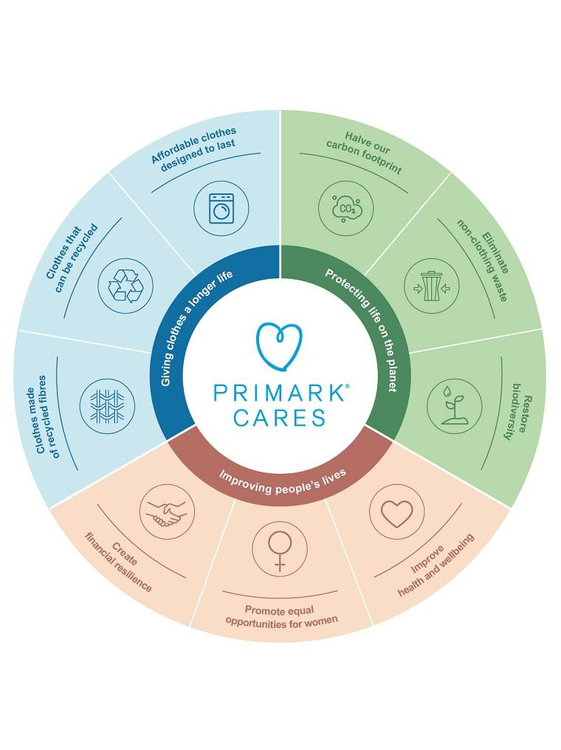
(Our Commitments | Primark Cares (UK), 2023)
Hence, Sustainability creates a favourable environment to the company.

- Eco-Friendly Environment: Primark heavily engage with organization like Zero Discharge of Hazardous Chemicals (ZDHC Foundation) for improving the way in which chemicals are used to make the products and Sustainable Apparel Coalition (SAC) for positive social and environmental transformation and change. Primark has also sets strategy for reducing carbon emission. These all represent a favourable environment to the company.

2.7 Advantages and Disadvantages of PESTLE analysis
The PESTLE analysis is a tool to evaluate the macroeconomic environment and its potential impact on their organization. Although some variables may be interdependent, the classification helps to sort and compare information. According to (EpubReader, 2023) The PESTLE analysis is useful for launching new businesses, developing new products, questioning the organization of the company, and decision-making in marketing strategy. The collected variables will be interpreted differently by experts from different backgrounds, and working with the right people is essential. However, it has limitations too. It can overwhelm managers with information and scenarios, making it difficult to identify important variables. The tool also lacks reliability, objectivity, and the ability to quantify specific impacts on the sector. To develop a relevant strategy, PESTLE analysis must be complemented by other tools that study the organization's close environment such as industry, direct competitors, and Porter's five forces analysis and SWOT analysis.

3. Porter’s Five Forces analysis at Primark
Porter’s five forces model identifies and analyzes five competitive forces which shape every industry and helps determine an industry’s strengths and weaknesses. It analyze company’s competitive environment. This model will be used to explain how the environments in which the companies operate condition their pricing strategy in the equilibrium. This model includes Competitive Rivalry, Threat of new entrants, bargaining power of buyers, bargaining power of suppliers and threat of substitute which helps to understand the level of competition within the Primark and enhance its long term profitability.

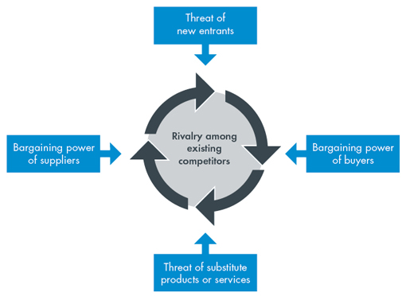
(Porter’s Five Forces of Competitive Position Analysis, 2013)

3.1 Competitive Rivalry:
Competitive rivalry is ‘high’ for Primark as there are multiplayer offering similar products like Zara, H & M, Next, T & K etc and there is high cost in exit.

3.2 Threat of New Entrants:
Customers are always attracted by cost effective products. Primark need to think about the risk of new entrants which will affect its sales and profitability and which would make difficult to reach goals and objectives set. New entrance of any other small company can be easily archived in the market and may perform great in retail clothing industry on the basis of cost, variety, new trends, location, convenience, speciality etc because they can operate in low cost with the innovative ideas and the barriers to entry for the new entrants are low. However, new entrants will have difficulty to compete with brand image of Primark. Therefore, the threat of new entrants is ‘medium’ for Primark.

3.3 Bargaining Power of Supplier
Primark does not only rely on one big supplier. They deal with numbers of small suppliers. They supply the raw material like cotton from India, Pakistan, Bangaladesh. Therefore, bargaining power of suppliers is ‘low’ for Primark.

3.4 Bargaining Power of Buyer
There are numbers of retail clothing company in market and customers are more sensitive towards the price so they visit every store and make a buying decision. There are many attractive substitutes available in market. Therefore, bargaining power of buyer is ‘high’ for Primark. However, there are customers who are brand loyal to Primark.

3.5 Threat of Substitute
Nowadays, many other companies are also focusing on cost effective products and are offering similar products with low price which leads customer to switch from one product to another. Therefore, threat of substitute is ‘high’ for Primark.

Porter’s five forces analysis has highlighted various elements which impact Primark competitive environment and helped to determine Primark’s strengths and weakness. It has determined that, Primark has the risk on ‘threat of substitute’ but ‘bargaining power of supplier’ of Primark is impressive and even though the ‘threat of entrants’ is high, they can’t compete with brand image of Primark. The high buying power of buyer may affect the quality of the product. Primark have high rivalry power which may leads downfall in profitability of the company.

4. SWOT Analysis
Strength | Weakness
Primark has expanded its business across 15 countries and growing in Europe and US and has aim of reaching 530 stores by the end of 2026. It has been successful to locate its store in high street which attracts the customer attention. | Although Primark is excessively active in social media, Primark does not have an online store, which limits its reach to customers who prefer to shop online. This weakness force customer to switch the company.
Primark provides clothing for children, men and women of all ages, it also provide some home accessories with a high street quality at affordable and competitive prices. | Primark does not invest heavily in marketing, which can limit its brand awareness and customer acquisition efforts. Also this gives their competitors the advantage over them.
Primark offers a range of job opportunities and employees more than 72,000 people in 15 countries. | Primark has faced criticism for exploiting the employees, abuse on labour force and child labour.
Primark has 28 days refund or exchange policies

Opportunities | Threats
Primark can explore opportunities to expand into new markets, such as Asia, to reach new customers and increase its brand presence. | Primark are in great competition with other fast- fashion retailers companies which can impact its market share and sales.
Primark can grab large customer by promoting e-commerce in their business and can improve convenience for customer using digital platform. | Changing customer preferences can impact Primark’s sales and requires it to adapt to new trends and preferences.
Primark can explore partnerships with other brands or retailers to expand its reach and offer customers new products. | Primark may face legal and regulatory issues, such as lawsuits or fines for ethical concerns, which can negatively impact its brand image and sales.

In conclusion, SWOT analysis highlights that, Primark has a strong brand image and efficient supply chain but faces challenges like e-commerce. To continue to succeed in the fast-fashion industry, Primark should consider opportunities such as expanding into new markets and explore new partnerships for new products.

5. STP Strategy
STP strategy for Primark is essential for developing strong marketing skills. It is a three-step model marketing technique which contains segmentation, targeting and positioning techniques that will help Primark to examine its product and services and communicate the benefits of these products or services to specific, segmented audiences.
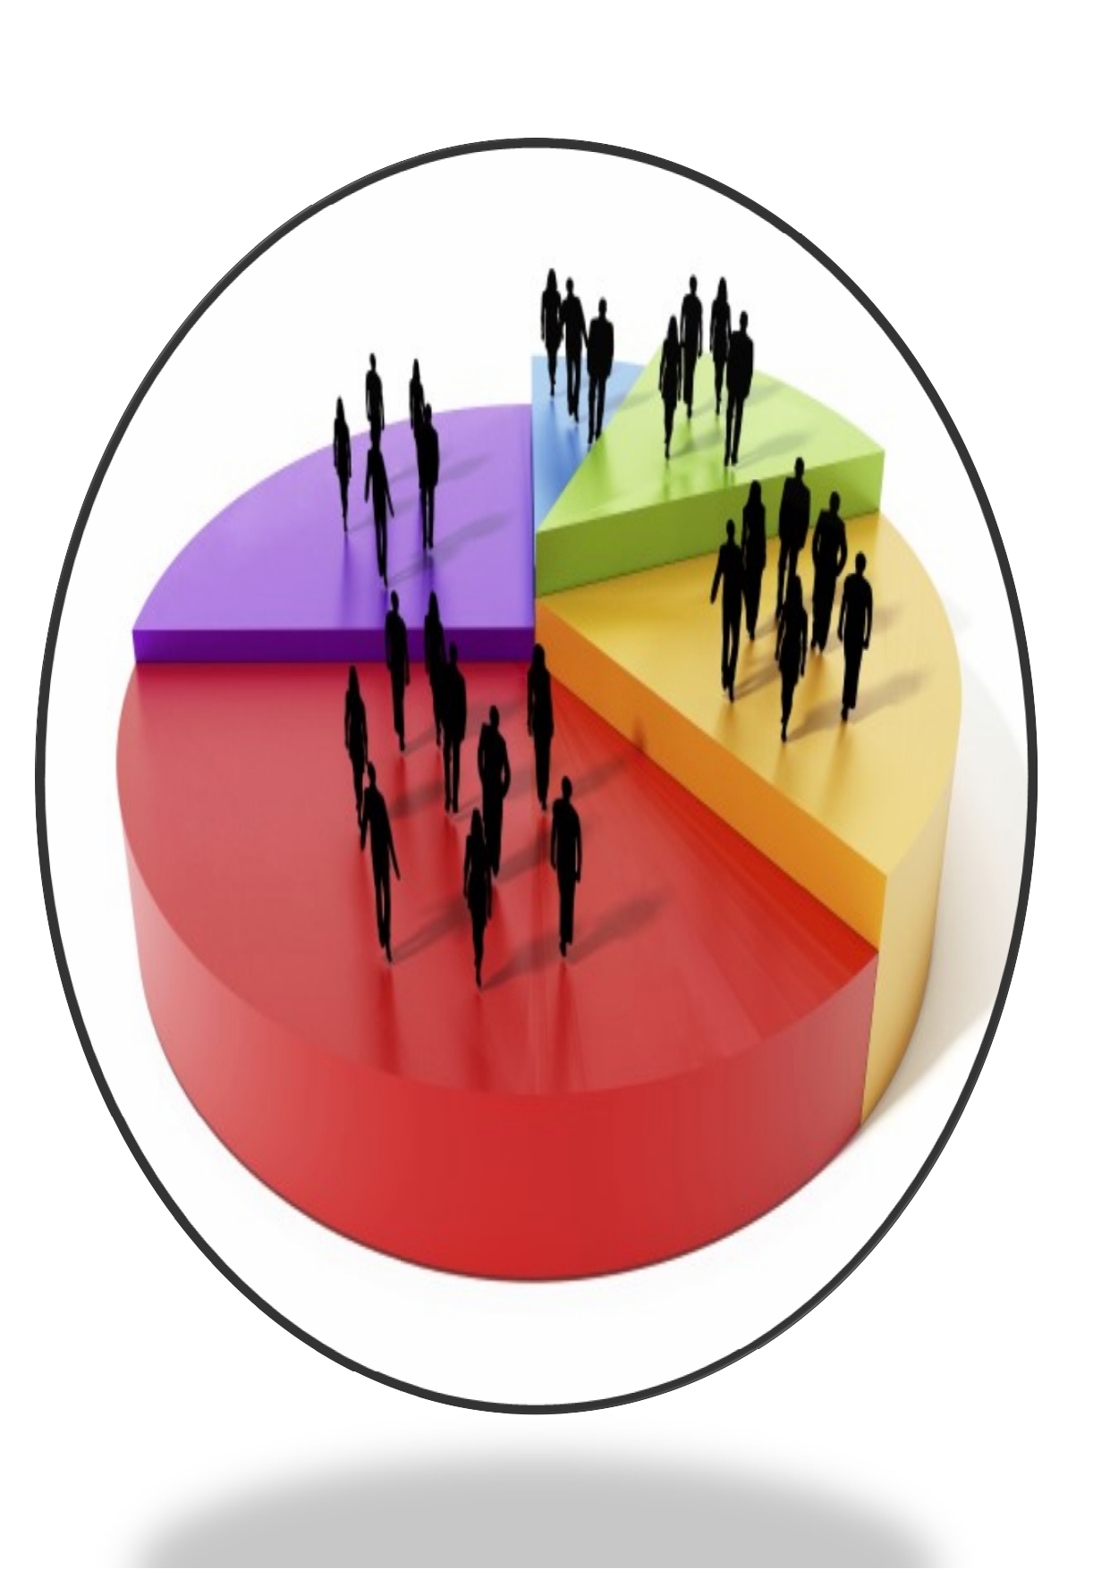
- Demographic
- Age: Multigenerational
- Gender: Children, Men, women
- Income: Low income groups
- Geographic
- Country: Europe and US
- City: Urban areas
- Psychographic
-Social class: Middle and lower class
-Buying habit: Brand loyalty
-Perception: Sustainable fashion for everyone
-Personality: Profit conscious
4. Behavioural
-Volume: Heavy users
-Loyalty: Brand-loyal
- Benefit: Quality and sustainable product in affordable price

SEGMENTATION
TARGETING
Differentiated Marketing:
-Targeted multiple market segments with different products and strategy with its benefit.

- First choice for high quality clothing and accessories in affordable price.
- On-trend fashion items without breaking the bank
- Brand image
Positioning
The STP marketing strategy is an effective framework including guidance for company’s marketing plan’s implementation. This framework makes sure that company are communicating the right content to the right audience, via right channels, at the right time to accomplish company’s business goals. It enables company to boost sales by determining a specific target market and positioning products right at these segments. Company can also spot gaps in the market. With the help of STP marketing strategy, successful and innovation business model in fashion retail industry have surprising. To become one of the leading giant in global apparel it has been gradually increasing its market share.
The STP marketing strategy has some limitation that, if we targeted to manufacture various strategy of product or service, then production costs will increase. They need to create different promotional campaign for each segment. Different marketing campaign, distribution channel should be developed, which will raise the company’s cost.

6. Marketing Mix Strategies
Marketing mix describes the set of tools that management can use to influence sales. The traditional formulation is called the 4Ps- Product, Price, Place and Promotion (Kotler, 2003). Jerome McCarthy introduced 4Ps which explains that, the businessman needs to:
(a) produce or manufacture the product according to customer’s need;
(b) make available it at a price that the consumers’ find reasonable;
(c) supply the product to the customers at different outlets they can conveniently approach; and
(d) inform the customers about the product and its characteristics through the media they have access to (UoP, 2022). This framework aims to create a comprehensive plan to distinguish a product or service from competitors that creates value for the customer. For marketing to work, company must manage the marketing mix in integrated fashion.
Marketing Mix

6.1 Product
Primark is applying range branding product strategy. It is offering wide range of products which includes clothing, footwear for all age and gender, home ware, accessories, cosmetics and many more. Without compromising on quality the company focuses on providing fashionable, seasonable and on-trend clothing items at an affordable price. Primark has also applied line filling and brand extension strategy. The company offers variety of product to same target market and has extended its offering into unrelated brand extension like home goods and beauty products. Primark’s logo has helped to differentiate Primark from its competitors in the retail industry. Proper sanitized, well organized and ease navigation are mainly focused to provide seamless shopping experience to its customers. The company’s store associates are trained to provide friendly and helpful customer service to assist shoppers with their purchase and any question they may have. The company’s team managers and line managers are always on the floor to maintain, organize, and solve the unforeseen problems. In terms of after sales service, within 28 days of purchase it happily refunds/exchange any items that has an original receipt and needs to be in saleable condition. (Refund & Exchanges | Primark, 2023). Primark also offers a customer service helpline and an online customer service form where customer can reach out with any queries or concerns they may have regarding their products and purchases or the shopping experience.

6.2 Price
Primark applies penetration pricing strategy and offers its products in low prices to its customer. It uses economies of scale and efficient supply chain management to keep its prices low while maintaining a high level of quality. As per resource, almost half (45%) of all the clothes are from Primark are made out of sustainably source or recycled materials and 40% of Primark clothes are made with cotton from Primark Sustainable Cotton Programme (PSCP) – set up in 2013. Primark does not pass any price increases to customers from PSCP cotton product. (FAQs | Primark Cares (UK), 2013)

6.3 Place
Primark has entered in global market across 15 countries in Europe and the US. ‘It has extended its global presence since 2008, and doubly by now. In 2022, there were 408 Primark stores location worldwide. It has expanded its market share between 2016-2017, which was one of the biggest in Primark History, adding 30 stores to its portfolio including new locations in new markets such as the United States.’ (Primark number of stores 2008-2022 | Statista, 2022). The biggest Primark store was established in Birmingham, UK in 2019 having five floors across 160,000 ft of retail space. ‘Primark continues to expand across new and existing markets with the aim of reaching 530 stores by the end of 2026, including upcoming new markets of Slovakia and Hungary’ (About Us, 2013). Company prioritizes creating a positive customer experience through its stores, associates, and after-sales policies, to ensure customer feel satisfied with their purchases and continue to shop at Primark. In addition, the company’s stores are typically located in high footfall areas such as shopping centre and high streets. Further, Primark has also launched click and collect trial in 25 stores in the UK, where customer can purchase an extended products from online and collect in stores.

6.4 Promotion
Primark promotion strategy focuses on creating a buzz around its products through social media and digital marketing. Primark is active on Twitter, Pinterest, Facebook, Instagram, Youtube and Tiktok. The company also uses in-stores displays and visual merchandising to showcase its products and attract customers. Primark also uses public relation and celebrity endorsement as a promotion strategy. Until July 2022, UK fashion online shop users had heard about Primark on social media or in advertising over the past three months by just 17%. Among 95% who know the brand, that's 18%, meaning at the time of the survey there's little buzz around Primark in the UK. (Primark brand profile UK 2022 | Statista, 2022)Primark has collaborated with YouTuber, Saffron Barker, for a new home ware range. (Primark Launches Range With Saffron Barker - Celebrity Group, 2017). Additionally, Primark uses offers and discounts to encourage customers to make purchase.
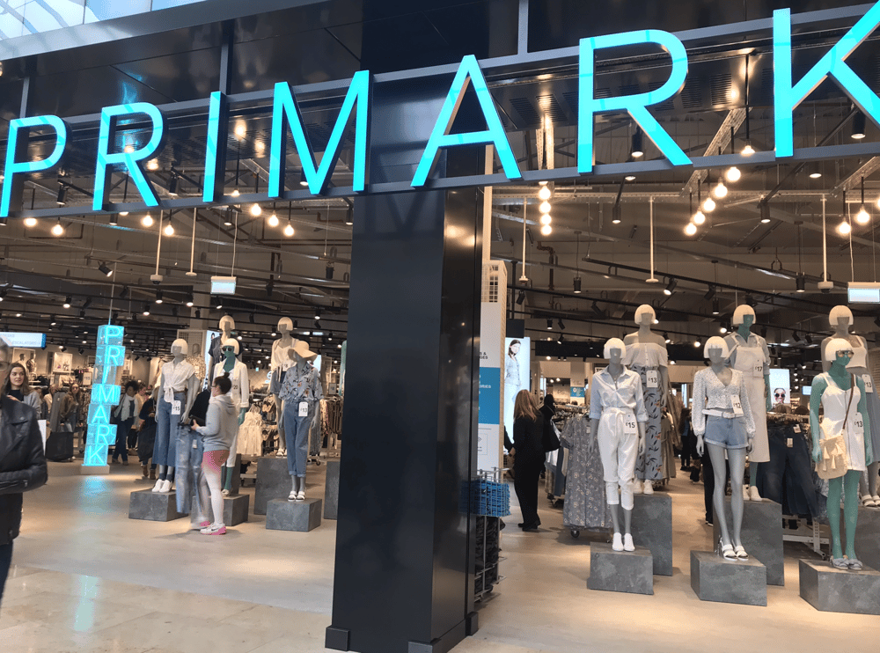
(FashionNetwork.com WW, 2022)
In June 2011 and again in June 2012, Primark was pleased to be awarded ‘Leader’ status by the ETI (Associated British Foods plc - Responsibility - Responsibility in action - Primark Ethical Trade Team, 2015)

7. Recommendation
Primark, being a leading international clothing retailer with the brand awareness of 94%, still needs to embrace on its e-commerce and invest more in technology. In fast-changing, increasingly digital and social marketplace, today’s marketing is all about creating customer value and engagement. (Kotler et al. 2019). Only after understanding the customers and marketplace, marketing management can design a customer value-driven marketing strategy. A marketing planning tool ‘Ansoff Matrix’ aids a business in determining its product and market growth. This is usually determined by focusing on whether the products are new or existing and whether the market is new or existing. (Ansoff Matrix – A Guide to the Ansoff Product Market Growth Matrix, 2023)
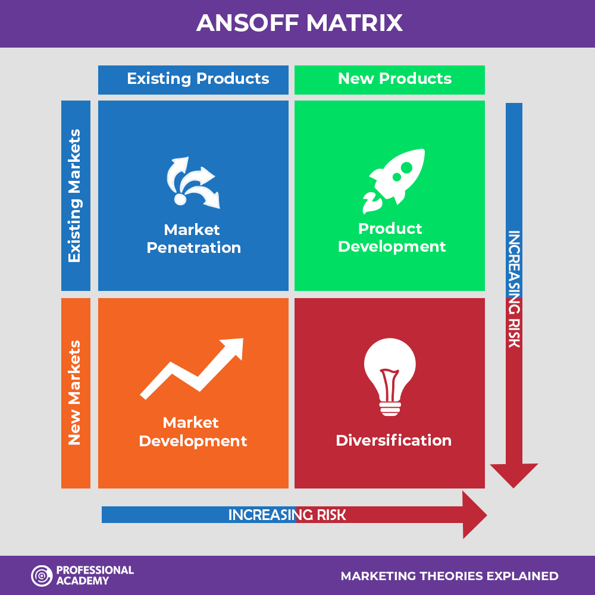
(Marketing Theories - Explaining The Ansoff Matrix, 2023)
Primark is using market penetration and market development for creating customer value and to determine product and market growth.

- Market Penetration
Although Primark has launched ‘Click+ Collect’ in 57 stores, Primark’s customer still are not able to enjoy an exact online shopping. They have to collect their purchase from the stores. Online shopping is gaining popularity as there have been significant advances in technology in last couple of decades. Online shopping provides numerous benefits to consumers as compared to the traditional offline shopping channels. Offering an e-commerce to Primark’s customer will definitely helps to boost the sales in Primark.
Similarly, introducing loyalty program and loyalty card will encourage Primark’s customer to repurchase. Offering loyalty program and card will help to increase the sales as well as customer loyalty.

- Market Development
Primark needs to expand its product beside Europe and the US. Expanding Primark’s market in Asia can be the new marketing strategy under Market development strategy. Primark can reach a wide range of target audience and explore new countries and regions in Asia. By exploring a new target market, Primark can research and understand the customer preference and behaviour and can increase brand awareness.
In addition, Primark could consider offering customization options for its products, such as personalized embroidery or printing. This would appeal to customers who are looking for unique and personalized items and could differentiate Primark from other fast fashion brands.

8. Conclusion
In conclusion the internal and external environment analysis of Primark, the author provides some of recommendations that help out Primark to gain competitive advantages. Further, this will motivates consumers to make better purchasing decision. The company should be aware of micro-environment, as the market is fragile and impact could be worst in scenario. Continuous study of market in different aspect will help to identify potential opportunities for growth and to keep other factors intact to gain more competitive advantages over others. This information will certainly help to prepare the appropriate strategy to meet its objectives and goals. Regarding to information in internal and external environment it should focus on that are ease on controlling and focus on sales, marketing and others. For smooth and better performance it needs to make decisions on basis of all models we have mentioned in this report.

Reference
About Us (2013) Primark Corporate. Available at: https://corporate.primark.com/en-gb/a/about-us/who-we-are (Accessed: 5 April 2023).

Ansoff Matrix – A Guide to the Ansoff Product Market Growth
Matrix (2023) Ansoffmatrix.com. Available at: https://www.ansoffmatrix.com/ (Accessed: 5 April 2023).
‌
Associated British Foods plc - Responsibility - Responsibility in action - Primark Ethical Trade Team (2015) Archive.org. Available at: https://web.archive.org/web/20150502100506/http://www.abf.co.uk/responsibility/our-actions/primark_ethical_trade_team (Accessed: 5 April 2023).

Cruelty Free International | Primark (2023) Primark.com. Available at: https://www.primark.com/en-gb/cruelty-free-international (Accessed: 22 March 2023).

FashionNetwork.com WW (2022) Primark names 25 stores for click & collect trial, FashionNetwork.com. Available at: https://ww.fashionnetwork.com/news/Primark-names-25-stores-for-click-collect-trial,1448918.html (Accessed: 5 April 2023).
‌(Primark Launches Range With Saffron Barker - Celebrity Group, 2017)

FAQs | Primark Cares (UK) (2013) Primark.com. Available at: https://corporate.primark.com/en-gb/primark-cares/resources/faqs (Accessed: 5 April 2023).

From throwaway plastic to denim fantastic: Primark launches new skinny jeans in partnership with REPREVE Our Ocean® | Primark Cares (UK) (2022) Primark Corporate. Available at: https://corporate.primark.com/en-gb/a/news/primark-cares/from-throwaway-plastic-to-denim-fantastic-primark-launches-new-skinny-jeans-in-partnership-with-repreve-our-ocean (Accessed: 25 March 2023).
‌
Kotler, PT, Armstrong, G, Harris, LC, & He, H 2019, Principles of Marketing, Pearson Education Limited, Harlow, United Kingdom. Available from: ProQuest Ebook Central. [5 April 2023].

Kotler. (2003). Marketing insights from A to Z 80 concepts every manager needs to know. John Wiley & Sons.
UoP, C. (2022) University of Peshawar, University of Peshawar. Available at: http://www.uop.edu.pk/ocontents/marketing%20mix.pdf.

Marketing Theories - Explaining The Ansoff Matrix (2023) Professionalacademy.com. Available at: https://www.professionalacademy.com/blogs/marketing-theories-explaining-the-ansoff-matrix/ (Accessed: 5 April 2023).

Our Commitments | Primark Cares (UK) (2023) Primark Corporate. Available at: https://corporate.primark.com/en-gb/a/primark-cares/our-approach/our-commitments (Accessed: 15 March 2023).

Primark brand profile UK 2022 | Statista (2022) Statista. Statista. Available at: https://www.statista.com/forecasts/1252287/primark-fashion-online-shops-brand-profile-in-the-uk (Accessed: 5 April 2023).
‌
Primark number of stores 2008-2022 | Statista (2022) Statista. Statista. Available at: https://www.statista.com/statistics/383890/primark-store-numbers-europe/ (Accessed: 5 April 2023).

Porter’s Five Forces of Competitive Position Analysis (2013) CGMA. Available at: https://www.cgma.org/resources/tools/essential-tools/porters-five-forces.html (Accessed: 29 March 2023).
‌
Refund & Exchanges | Primark (2023) Primark.com. Available at: https://www.primark.com/en-gb/help/refund-and-exchanges (Accessed: 5 April 2023).

Squeezed young shoppers worry they can’t afford to dress more sustainably anymore | Primark Cares (UK) (2021) Primark Corporate. Available at: https://corporate.primark.com/en-gb/a/news/primark-cares/squeezed-young-shoppers-worry-they-cant-afford-to-dress-more-sustainably-anymore (Accessed: 15 March 2023).
‌
The (2023) Pestle Analysis Images – Browse 1,698,572 Stock Photos, Vectors, and Video, Adobe Stock. Available at: https://stock.adobe.com/uk/search?k=pestle+analysis&asset_id=497989566 (Accessed: 15 March 2023).
‌

