Cae Felin Habitat Management Plan

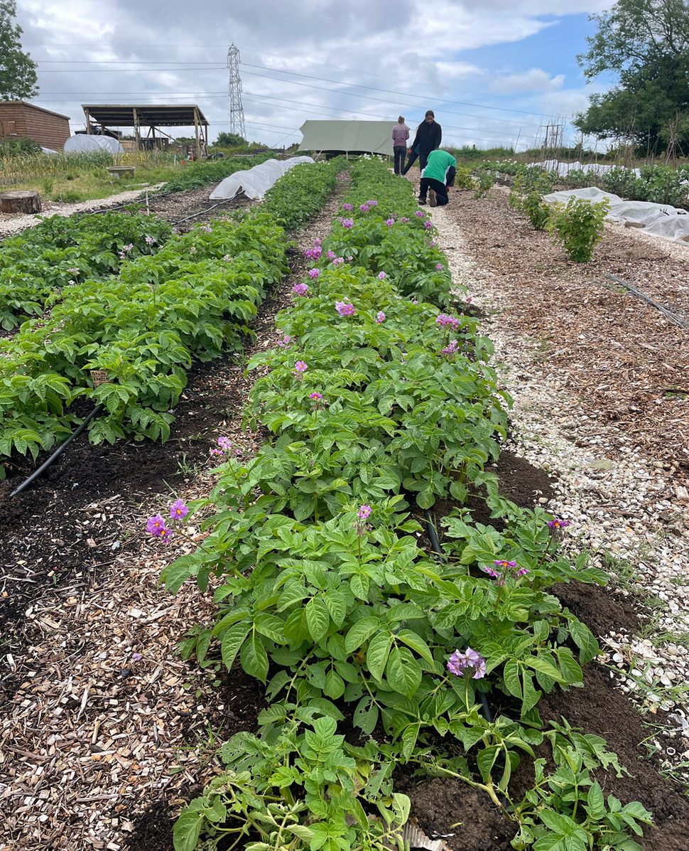

"It's surely our responsibility to do everything within our power to create a planet that provides a home not just for us, but for all life on Earth.”

Sir David Attenborough

Contents

- Introduction to the Habitat Management Plan for Cae Felin
- Site Vision
- Site Description
3.1 Summary of Phase 1
- Habitat Type Key and Condition
4.1 Site Plan Continued
- Habitat Management Plan
  - Hedgerow Habitat Management
5.1.1. Best Practices: Conservation Methods Over Traditional Hedgerow Maintenance
  - Unlined Pond Habitat Management
    - Threats to Pond Ecosystems from Monocultures of Native Vegetation
  - Orchard and Hazel Wood Current Status
    - Orchard Management Objectives and Actions
    - Hazel Woodland Management Objectives and Actions
- Pond Management (Two Lined Ponds)
- Financing and Budget
- Conclusion
- References

- Introduction to the Habitat Management Plan for Cae Felin
This habitat management plan outlines a basis to help inform the long-term ecological strategy for Cae Felin, a 7.6-acre site located on loan from Morriston Hospital in Swansea. Once a degraded and polluted grazing pasture, Cae Felin is now at the heart of a visionary transformation. In partnership with Swansea Bay University Health Board, it is being reimagined as a regenerative Community Supported Agriculture (CSA) project, integrating ecological restoration with food production, community wellbeing, and education.
Initially informed by a Preliminary Ecological Assessment conducted in August 2022, the site was identified by Ecologist Simon Peacock as containing valuable yet degraded habitats, including semi-improved grassland, native hedgerows, patches of marshy/fen habitat, mature trees, and a brook. Since then, significant progress has been made adding essential infrastructure and habitat creation such as a greenhouse, compostable toilet, water catchment system and three ponds. These additions not only support food cultivation but also serve ecological functions contributing to habitat restoration and biodiversity enhancement.
- Site Vision
(https://www.caefelincsa.com)
Cae Felin aims to go beyond food production. It envisions a future where the land is not only restored but becomes a hub for social and ecological wellbeing, providing local, sustainable food through a CSA box scheme, while offering surplus produce to charities and food banks. The site engages local people through volunteering, nature-based education, rehabilitation, and therapeutic programmes, particularly through its growing relationship with Morriston Hospital.

- Site Description
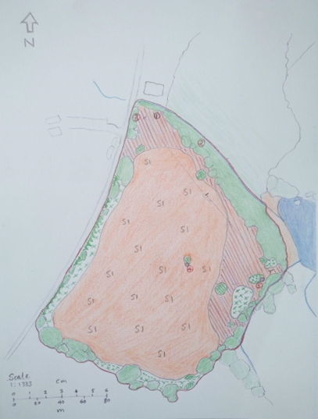
Cae Felin is situated near Rhydypandy Road, SA6 6NX. Rhydypandy Road defines the western boundary of the site. To the south and east, the site is bordered by additional agricultural land. A brook delineates the northern boundary, beyond which a few residential properties are situated. It is approximately 0.8 miles from Morriston Hospital and encompasses a variety of habitats, including broadleaved woodland within the riparian zone of a small brook, hedgerows, scrub, and marshy grassland. Notably, the site has been impacted by polluted water courses, coppiced hedgerows, and exposure to wind, as well as being close to the road.

  - Summary of Phase 1
The Phase 1 survey provided a strong indication of the site's current ecological state under prolonged grazing. While the land is degraded, with compacted pasture and a dominance of ephemeral weedy species, there remain pockets of ecological value, particularly in the riparian zone and marshy meadow to the north. These areas, despite the overall poor condition of the site, hold potential for ecological improvement. However, as noted in the (JNCC Handbook), Phase 1 surveys typically have a validity of 2-3 years, meaning Simon Peacocks 2022 assessment is now outdated. Given that the site is still undergoing development, new habitats are forming and have yet to fully establish themselves within the ecosystem. This presents a critical decision: whether to conduct a Phase 2 survey now or transition to the UKHAB classification system for a more comprehensive understanding of the site's evolving ecology. This system offers a more detailed and adaptable framework, better suited to capturing the complexities of emerging habitats (ECOSA). Unlike Phase 1, which relies on broad categories such as ‘semi-improved grassland’ and ‘scattered trees,’ UKHAB refines habitat classification with essential and additional secondary codes, like green infrastructure and environmental qualifiers, providing greater accuracy in assessing biodiversity and land use. As ECOSA highlights, this system is increasingly being used by different projects in ecological surveys to meet new biodiversity and development requirements. Given the site's transitional nature, implementing UKHAB now could enhance long-term monitoring, ensuring that conservation efforts align with biodiversity net gain objectives while allowing time for newly forming habitats to mature before reassessment. Since then, the site has been enhanced including three new standing water ponds and the planting of hazelwood and orchard wood.

Habitat Type | Key | Condition | Notes
Ponds | B2
Hazel Wood | W8/9?
Orchard | W24

4. Site Plan

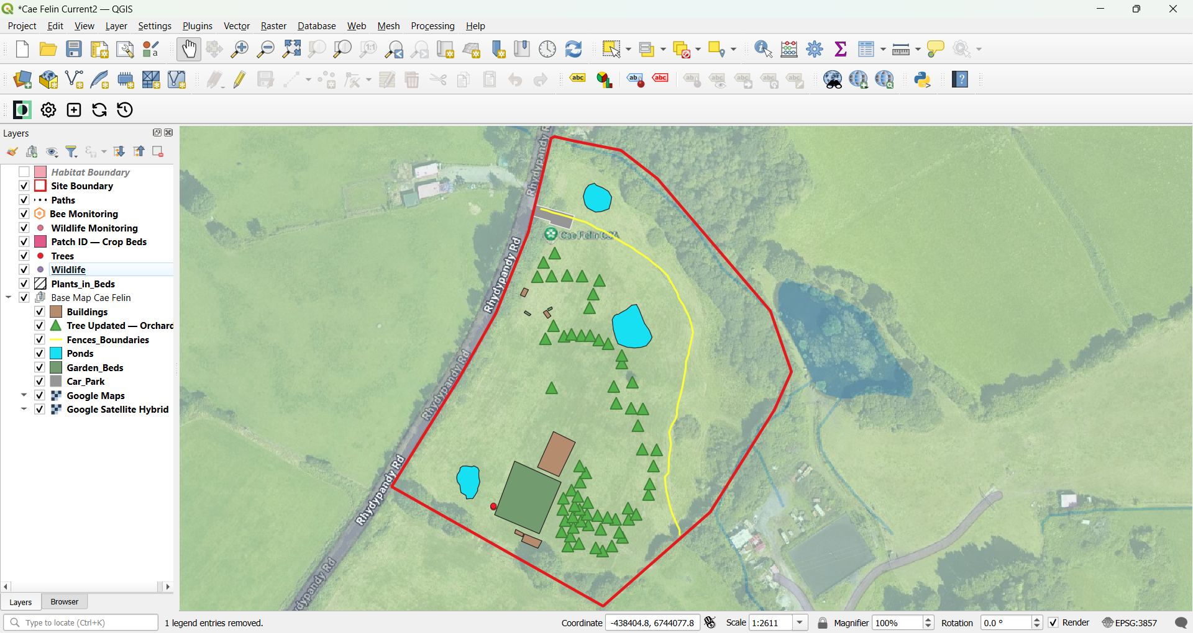
The first two images provide an overview of the site’s current state from different technological perspectives. The first, a satellite image from Google Earth, reflects the site as it was during the Phase 1 Habitat Survey (see Phase 1 summary). This highlights how outdated publicly available data can be, often failing to capture ongoing ecological changes. In contrast, the second image is a detailed site structure map created using Mergin Maps and QGIS. This map, developed by myself, documents recent modifications including new structures, fence boundaries, the car park, volunteer buildings, and planted hazel and orchard trees. The use of free mapping technology, especially for non-profit organizations, allows the continuous monitoring of small areas that might otherwise go unnoticed. By keeping track of changes in real time, such tools can inform decisions regarding climate resilience, plant health, and wildlife activity. Additionally, they serve as a valuable resource for engaging the wider community, showcasing the progress of volunteer-led projects, and encouraging greater participation in ecological restoration efforts.

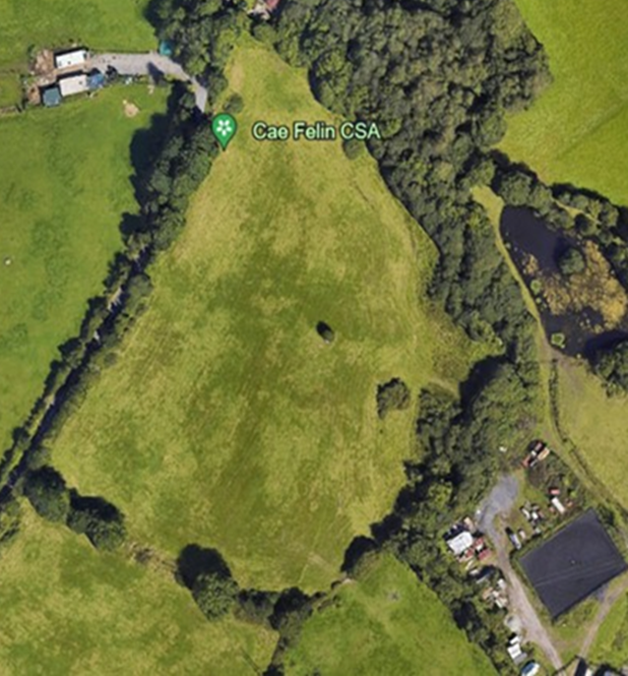

4.1 Site Plan Continued

The final two images, created by site lead Will Beasley, offer a broader perspective on both current conditions and future aspirations. The first is a site map showing the biodiversity zone vs the cultivation zone created using a different application. The second is a visionary layout depicting the site’s potential future, illustrating plans for habitat creation and enhancement. The ability to visualize data this way is crucial for making complex ecological information more accessible and actionable. It helps stakeholders—whether volunteers, conservationists, or policymakers—understand the site’s trajectory and recognize the role of nature in promoting health, well-being, and community engagement. Furthermore, such forward-thinking mapping can serve as a blueprint for other urban and rural projects, inspiring sustainable land management practices both locally and globally.
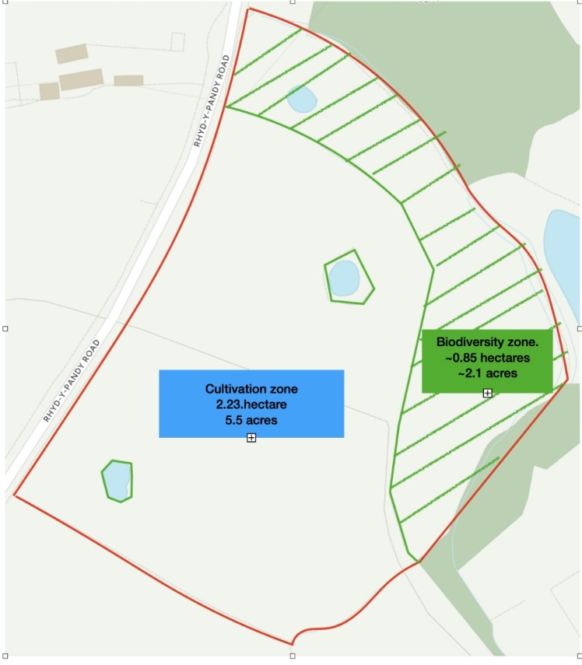

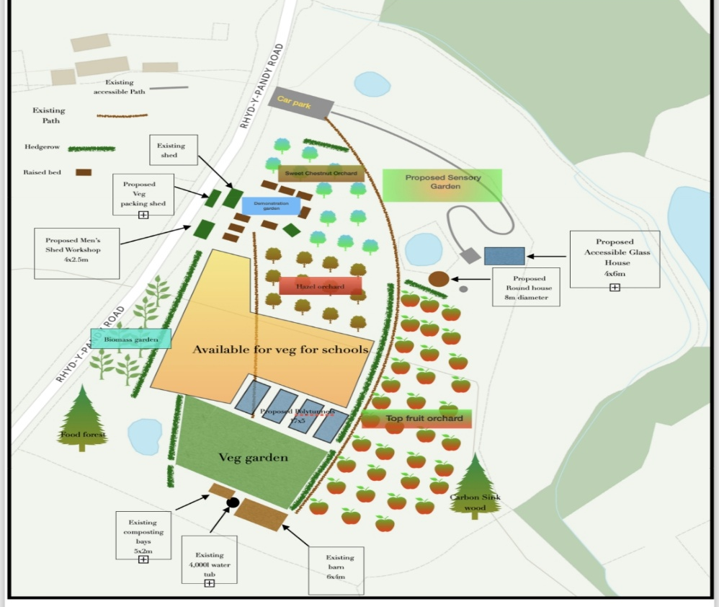

  - . Habitat Management
5.1 Hedgerow Habitat Management
Hedgerows play a crucial role in habitat management, acting as more than simple boundary features—they are essential ecological corridors connecting fragmented landscapes and supporting a wide range of wildlife. “A hedge becomes a hedgerow when it includes other features within it, such as trees, walls, fences, or gates” (Woodlands.co.uk). These structures provide food, shelter, and nesting grounds for birds, mammals, and invertebrates, making them indispensable for maintaining biodiversity. Their ecological value is recognised through legal protections such as the Hedgerow Regulations (1997) and their classification as a priority habitat under the UK Biodiversity Action Plan (1994). To prevent disruption to breeding species, UK government guidelines recommend trimming hedgerows no more than once every 2–3 years, and outside of the spring and summer nesting seasons (Gov.uk). Nationally, the importance of hedgerows is further underlined by Defra’s target to restore 45,000 miles of hedgerow by 2050 (People’s Trust for Endangered Species), placing them at the forefront of sustainable land-use strategies.
Hedgerows also offer significant soil-related benefits. The absence of tillage within hedgerow zones helps maintain soil structure supporting both above and below ground biodiversity. Notably, hedgerows have been shown to increase the richness and diversity of arbuscular mycorrhizal fungi—organisms critical for nutrient cycling and plant health ("Hedgerows increase diversity and modifies composition of arbuscular mycorrhizal fungi in Mediterranean agricultural landscapes", 2022) (González, n.d.). The belowground benefits highlight the multifunctionality of hedgerows in modern land management, reinforcing the need for conservation-led practices that safeguard their structural complexity and ecological functions over the long term.
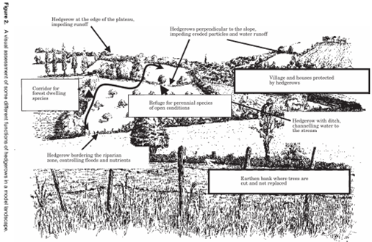
.

5.1.2 Best Practices: Conservation Methods Over Traditional Hedgerow Maintenance
Traditional hedgerow management practices, such as routine mechanical trimming, can gradually degrade habitat quality—leading to reduced berry production, loss of structural complexity, and declines in associated wildlife. In contrast, conservation techniques like hedge laying and coppicing are increasingly recognised for their ecological benefits. “Coppicing and Hedge laying: These traditional practices have been shown to positively influence biodiversity by maintaining hedgerow structure and promoting habitat complexity” (Tresise et al., 2021). These methods encourage natural regrowth from the base, extending the life of the hedge and enhancing its ecological function. “Hedge Laying is the only hedgerow maintenance method currently available which promotes regrowth from ground level, and which will ensure the health and longevity of the hedgerow” (National Hedge Society). However, hedgerow management also presents ongoing challenges, particularly the labour-intensive nature of traditional methods and the need for further research into how hedge age affects biodiversity over time (Tresise et al., 2021).
For Cae Felin, conservation hedging offers an ideal solution that reflects the site’s biodiversity-led values. This approach avoids excessive cutting, allowing the hedge to retain its layered structure whilst still undergoing necessary rejuvenation. Research supports its effectiveness: “Three years after rejuvenation, hedge structure and rates of woody re-growth were traditional hedge-laying in improving hedge condition. Berry provision for overwintering wildlife was slightly better than for traditional hedge-laying” (Hedgerow Rejuvenation Research Project). By adopting these methods, Cae Felin enhances habitat connectivity, supports diverse species including pollinators and small mammals, and contributes to broader ecological restoration objectives. Conservation hedging ensures that hedgerows remain resilient and capable of delivering vital ecosystem services well into the future.

5.2 Unlined Pond Habitat Management
5.2.1 Evaluating the Role of Pondscapes in Biodiversity and Climate Resilience near Urban Areas
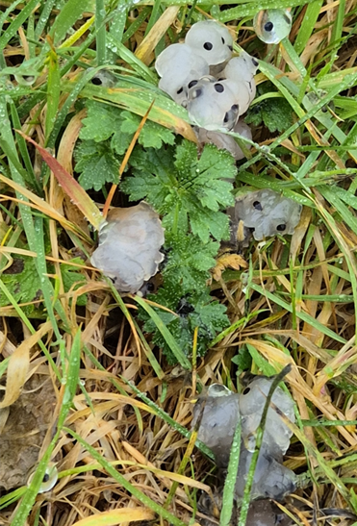
The unlined pond in the biodiversity zone at Cae Felin represents a commitment to naturalistic, low-intervention habitat creation. Left unlined to reduce costs and encourage natural hydrological processes, it is also a key feature in enhancing ecological connectivity across the site, linking with additional ponds in the cultivation area. This strategy aligns with Cae Felin’s holistic, biodiversity-focused management ethos. However, while unlined ponds offer many benefits, especially in nature-based and urban-adjacent settings, they also present challenges that must be carefully considered. Ponds and Pondscapes are increasingly recognised as powerful Nature-Based Solutions (NbS) contributing to climate resilience and sustainable development. Their ecological functions are numerous: regulating water flow, mitigating flooding, retaining water during droughts, and helping to preserve microclimates by buffering temperature fluctuations. Importantly, they also act as critical habitats for amphibians, invertebrates, and birds, according to (Bartrons et al., 2024). These functions are especially valuable in the context of climate change, providing resilience in both rural and urban-fringe landscapes. Additionally, ponds support aquatic-terrestrial interactions enhancing local biodiversity. For instance, the emergence of aquatic invertebrates provides key food sources for nesting birds, especially in agricultural and urban-edge habitats (Lewis-Phillips et al., 2018; Baxter et al., 2005). For community-focused projects like Cae Felin, ponds offer educational, recreational, and mental well-being benefits, connecting people with nature through visible, functional water features.
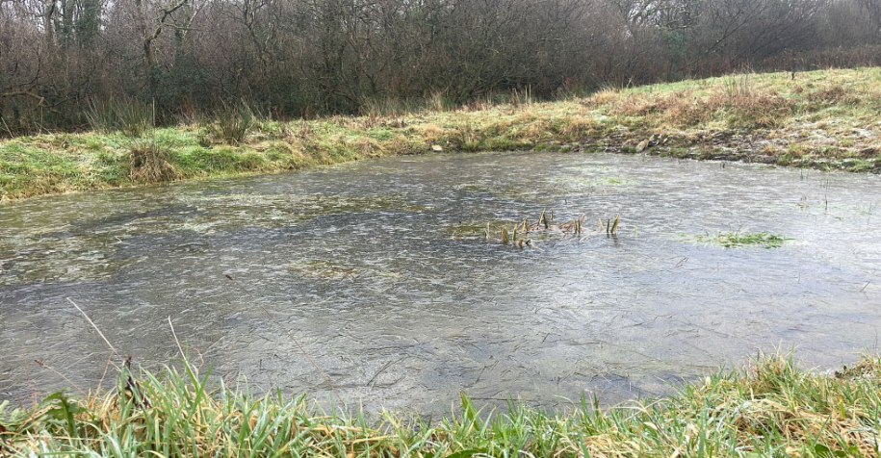
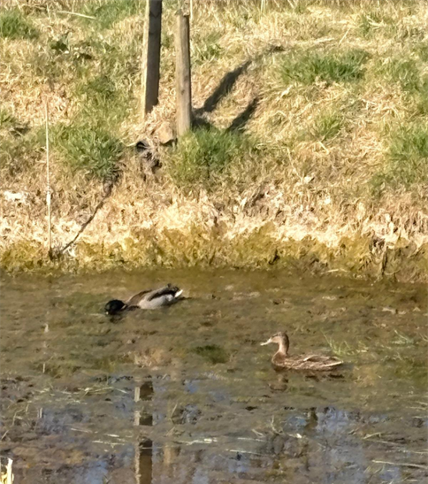
Despite these strengths, pond creation—particularly in or near urban areas—poses specific ecological and practical challenges. A study of 21 urban ponds in northern England found that biodiversity levels were significantly lower than expected due to urban pressures such as pollution, invasive species, and fragmented connectivity (Urban Ecosystems, 2015). Over time, without management, ponds may undergo territorialisation, where excessive shading, nutrient input, or lack of disturbance leads to loss of aquatic plant cover and habitat complexity (Sayer et al., 2013; Janssen et al., 2018). Moreover, unmanaged ponds may provide fewer benefits to key species groups. Research has shown that open-canopy, actively managed ponds support higher bird abundance and species richness than overgrown, neglected ponds (Lewis-Phillips et al., 2018). In the context of Cae Felin, while allowing the pond to vegetate naturally aligns with a low-impact ethos, light-touch monitoring and periodic management may be necessary to prevent ecological decline and maintain the pond's biodiversity potential.

5.2.2 Threats to Pond Ecosystems from Monocultures of Native Vegetation
While native aquatic plants like Typha latifolia (commonly known as reedmace or bulrush) are essential components of wetland ecosystems, their unchecked dominance can lead to significant ecological imbalances. Though often associated with healthy freshwater margins, species like reedmace can become overly dominant in ponds and lakes, creating dense monocultures that suppress biodiversity and disrupt the ecological functioning of aquatic environments. A primary threat from these monocultures is loss of plant diversity. As native species such as reedmace or certain types of rushes expand unchecked, they can outcompete other aquatic plants, leading to a uniform vegetative structure. This reduces the availability of varied food sources and microhabitats for a range of species, including invertebrates, amphibians, fish, and birds. “Uncontrolled growth of reeds and bulrush can lead to the formation of dense monocultures that outcompete native plants... which are vital for supporting a diverse range of wildlife” (Simply Aquatic). The result is a simplification of the habitat, which can diminish ecosystem resilience and reduce the number of ecological niches available.
Research comparing monoculture and mixed plant wetlands has shown clear ecological disadvantages to monocultures. In a study by Liang et al. (2010), monoculture wetlands displayed lower plant heights and density over time compared to mixed-species systems, which consistently supported more vigorous and complex plant communities. These findings highlight that mixed vegetation wetlands provide more structural diversity and ecological benefits, including improved nutrient cycling and habitat provision, than single-species systems (Ecological Engineering, https://doi.org/10.1016/j.ecoleng.2010.11.018). From a management perspective, dense stands of reedmace and rushes can also impede water flow, contribute to excess organic matter accumulation, and accelerate territorialisation—the process by which aquatic habitats gradually fill in and become more terrestrial in nature. Over time, this can lead to the degradation or complete loss of open water habitat, especially in smaller or shallow ponds. As the literature notes, effective NBS Pondscapes depend on strategic planning, spatial distribution, and adequate resourcing (Bartrons et al., 2024). At Cae Felin, embracing this complexity by combining naturalistic design with thoughtful, conservation-led monitoring ensures that the unlined pond remains ecologically functional and serves as a living example of climate-conscious land management.

5.3 Orchard and Hazel Wood Current Status
The orchard and hazel grove at Cae Felin represent an emerging, ecologically focused landscape designed for both productivity and biodiversity. The orchard contains around 40 young fruit trees—including apple, pear, plum, and cherry—spaced to optimise light, airflow, and future understorey planting to benefit pollinators. Managed without synthetic inputs, the orchard follows organic, low-input principles that enhance soil health and ecosystem resilience (Simon et al., 2010). Adjacent to this, a 0.3-acre hazel grove in the sapling stage has been planted in a semi-formal layout with plans for future coppicing to support habitat complexity and provide shelter for wildlife. Together, these integrated systems align with regenerative agriculture and contribute to national goals in woodland creation, biodiversity enhancement, and climate resilience (van der Meer et al., 2020; Natural Resources Wales, 2024; Senedd Research, 2024), reflecting Cae Felin’s role as a demonstration site for multifunctional, sustainable land use.

5.3.1 Orchard Management Objectives and Actions
The orchard is designed to align with agroecological principles, promoting biodiversity while producing fruit through organic methods. Research shows that traditional and organically managed orchards can support high levels of plant and invertebrate diversity, particularly when pesticides are avoided and floral resources are maximised (Simon et al., 2010). Cae Felin explicitly avoids synthetic chemical inputs, supporting a growing movement toward functionally biodiverse systems that favour long-term soil health and ecosystem integrity over short-term yield (van der Meer et al., 2020). To maintain healthy, productive trees, young saplings will undergo formative pruning during the first 3–5 years, establishing strong branch structures capable of supporting fruit loads without breakage. This early intervention is essential to avoid structural weakness and the need for corrective pruning in later years (Natural England, 2010). Pruning will take place in winter, alongside mulching with compost and woodchip to conserve soil moisture, suppress weeds, and feed soil microbiota.
The future management of the orchard understorey could be enhanced with wildflower strips and ground cover plants to support solitary bees and other pollinators. Research shows that the floral density of non-crop forage plants within orchards is directly correlated with pollinator abundance and reproductive success (Carvell et al., 2022). These floral zones offer nectar and pollen resources for natural pest predators, forming the basis of an Integrated Pest Management (IPM) strategy reducing pest pressure without synthetic inputs (McKercher et al., 2020). Such habitat interventions, though sometimes constrained in commercial systems, are critical to developing multifunctional, low-input orchard systems (Granatstein & Sánchez, 2009; Bugg & Waddington, 1994). Companion planting with herbs and native perennials will further enhance pollinator activity, deter pests, and build plant-soil relationships that support orchard resilience

5.3.2 Hazel Woodland Management Objectives and Actions
The hazel grove at Cae Felin has been established to serve both productive and ecological functions, with plans to initiate a rotational coppicing regime beginning in year seven. Coppicing provides a sustainable source of poles, fencing material, and craft wood, and enhances habitat heterogeneity. The cyclical nature of coppicing creates open, sunny glades alongside denser thickets, supporting a range of flora and fauna across successional stages (Woodland Trust, 2016).
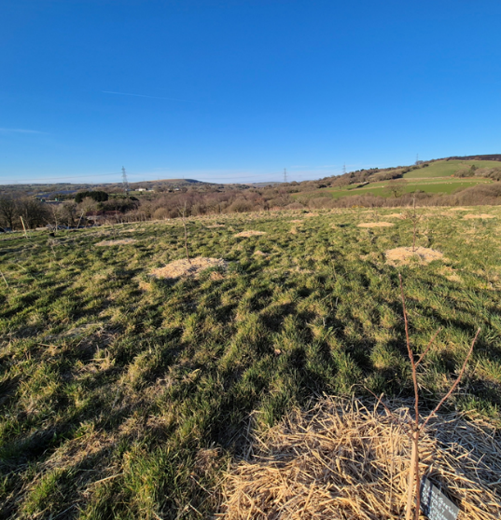
Management practices in the future should prioritise understorey diversification and wildlife support. Access paths will be kept open, and invasive bramble domination will be periodically cut back to allow the establishment of shade-tolerant native herbs and grasses. Hazel prefers well-drained loamy soils in sheltered areas and will thrive in the conditions present, though extreme cold may impact nut yields (Glut, 2024).
Habitat features such as log piles and insect hotels will be installed to attract invertebrates, while uncut hedgerow margins will support nesting birds and small mammals. The grove also has potential to contribute to local efforts in dormouse conservation (Muscardinus avellanarius), a species whose UK population has declined by over 50% between 2009 and 2018 due to habitat fragmentation and the loss of connected woodland and hedgerows (Woodland Trust, 2024). By managing the grove to promote structural diversity and maintain connectivity with surrounding habitats, Cae Felin supports the ecological requirements of this and other woodland edge species. Monitoring efforts will track orchard productivity and ecological function through annual yield logs (by variety), pollinator observations during spring and summer, and seasonal assessments of tree health. In the hazel grove, coppice regrowth will be monitored post-harvest, while nesting activity and small mammal signs will be recorded regularly. Both areas will be subject to annual vegetation surveys to evaluate ground flora diversity and the success of understorey establishment.
Together, the orchard and hazel woodland demonstrate how productive land can be managed in harmony with nature. By applying best practices informed by contemporary ecological research, Cae Felin’s land-use model exemplifies the role that small-scale, community-led sites can play in addressing systemic challenges in food production, biodiversity loss, and climate change.

  - Pond Management (Two Lined Ponds)

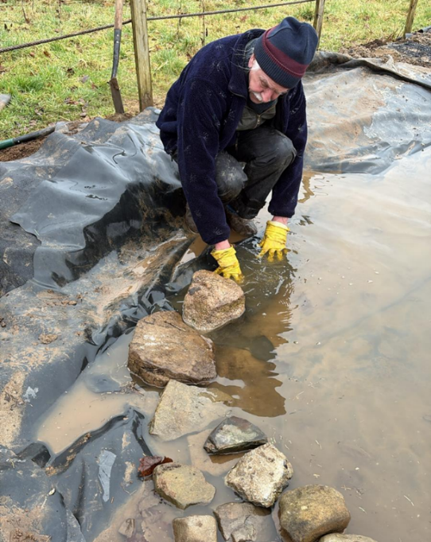
The two lined ponds situated in the cultivation zone at Cae Felin have been purposefully constructed to support both habitat creation and community engagement. Each measures approximately 4x6 metres and include shallow and deep zones accommodating a variety of aquatic species. Aquatic planting, featuring water mint, yellow flag iris, and pond sedge was intentionally introduced to encourage biodiversity and establish structurally diverse habitats. Unlike the unlined pond in the biodiversity zone, which is designed to rewild with minimal human intervention, these ponds require more intensive monitoring and maintenance. Their ecological success is dependent on environmental conditions and the outcomes of intentional planting, making data collection critical for tracking development and adjusting management strategies accordingly.
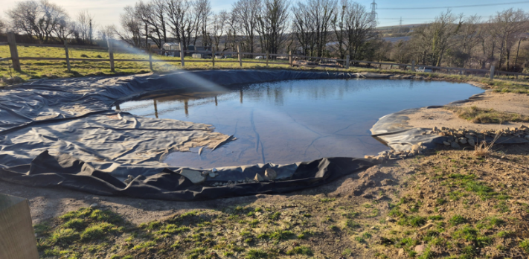
Due to the artificial nature of their design and planting, regular ecological monitoring is essential to ensure long-term health and resilience. Key actions include seasonal thinning of fast-growing vegetation, manual removal of invasive species, and maintaining at least 30% open water to prevent dominance by a single species. Marginal planting along the edges helps stabilise the banks and improve habitat complexity, while features like basking stones and gentle slopes allow access for small mammals. Amphibian surveys will be conducted in spring using guidance from the Freshwater Habitats Trust: “The aim is to visit each pond in a 1km square in March or April, and see if frogs, toads or their spawn is present. An average sized pond will take around 45 min to survey” (Freshwater Habitats Trust, https://freshwaterhabitats.org.uk/advice-resources/survey-methods-hub/amphibian-surveys/). These findings can also contribute to national records via the Amphibian and Reptile Conservation Trust: “By taking part in this survey, you can help ARC improve the information available for conservation assessments at different spatial scales and for informing conservation activity” (National Amphibian Survey, https://amphibian-survey.arc-trust.org/). Additional monitoring will include twice-yearly macroinvertebrate sampling, annual vegetation assessments, and regular water quality checks for turbidity and algal presence. Together, these methods ensure that the lined ponds remain ecologically balanced and resilient in a cultivated setting, providing learning opportunities and biodiversity value within a managed agricultural zone.
  - Financing and Budget

Financing and budgeting are essential components in the long-term success of Cae Felin, especially given its foundation as a Community Supported Agriculture (CSA) site. While the project relies heavily on volunteer support, the presence of a permanent team of growers is critical for maintaining core infrastructure and guiding volunteers in practical land management tasks. Government funding can play a pivotal role. Schemes like Natural England’s Environmental Stewardship and DEFRA’s Tree Planting Grants provide opportunities to support activities like orchard establishment, infrastructure development, and habitat creation. Around 25% of DEFRA grant applications have been for community orchards, indicating strong potential for sites like Cae Felin to access similar funding streams (www.naturalengland.org.uk; www.defra.gov.uk/news/2010/12/02/tree-plant/). Additional funding is available through platforms such as The Big Tree Plant and Greenspace Funding (www.communities.gov.uk/publications/communities/greenspacefunding).

The site has already made progress in maintaining sustainability and minimising costs by creatively reusing materials such as pallets, cockle shells, and woodchip. Tools and equipment can be sourced through grants or community donations, reducing the need for new purchases. Furthermore, Mergin Maps, a free tool for non-profits, has provided vital support in site planning and biodiversity monitoring. One future logistical challenge involves transport access. The site is currently not well-served by vehicle access, and while an open pathway from Morriston Hospital is planned, interim transport solutions may be necessary. Investing in a small minibus to shuttle volunteers from nearby public bus routes (e.g., the No. 4 and X6) could reduce on-site traffic and improve accessibility for individuals without private transport—an important step toward inclusive participation.
Looking ahead, expanding the team to include a biodiversity officer or ecological education lead could significantly enhance the ability to record, report, and evidence biodiversity gains, further supporting future funding applications. In the short term, this role could be fulfilled through student placements, internships, or grant-funded positions. A modest investment in social media outreach and marketing could grow the site’s volunteer network, increase awareness of Cae Felin’s mission, and engage a broader cross-section of the local community. Together, these financial strategies reflect a commitment not just to ecological integrity, but also to social inclusion, education, and long-term community resilience.

  - . Conclusion

Cae Felin represents a forward-thinking approach to land stewardship, where ecological restoration, community involvement, and low-impact food production converge. Through the development of interconnected habitats the site demonstrates how multifunctional landscapes can deliver both ecological integrity and social value. By prioritising biodiversity, climate resilience, and organic management, it serves as a model for how small-scale land use can address environmental and societal challenges in a meaningful way. As a community-supported agriculture site, it serves as a productive space and a living experiment in regenerative practice. Its holistic ethos explores how food systems can be rooted in ecological harmony while remaining affordable, accessible, and locally driven. The site's ongoing evolution offers practical insight into the viability of low-cost, nature-based land management within semi-urban and community contexts, where land-use pressures are often complex. Cae Felin encourages positive human interaction with nature, reinforcing the mental health and wellbeing benefits of accessible green spaces, and strengthening the emotional and cultural connection between people and the landscapes they help steward.

Most importantly, Cae Felin contributes to the growing recognition that there is no one-size-fits-all approach to habitat management. While there are established guidelines that help distinguish between practices likely to support ecological health and those that may cause harm, effective management must be context-specific. Each site operates within a unique set of ecological, social, and economic conditions that influence its needs and potential. Guidance and ecological theory provide a valuable framework, but long-term success depends on adaptive management, ongoing monitoring, and place-based learning. In this regard, Cae Felin plays a critical role in addressing gaps in both research and practice by generating real-world insights into community-led, integrative land use. Its continued development will not only inform site-specific outcomes but also contribute to broader understandings of sustainable, inclusive, and climate-resilient landscape management at a time when such models are urgently needed.

REFERENCES AND SOURCES

Balmford, A., Green, R.E. and Jenkins, M., 2003. Measuring the changing state of nature. Trends in Ecology & Evolution, 18(7), pp.326–330. (Accessed 12th March 2025)
Bartrons, M., Trochine, C., Blicharska, M., Oertli, B., Lago, M. and Brucet, S., 2024. Unlocking the potential of ponds and pondscapes as nature-based solutions for climate resilience and beyond: Hundred evidences. Journal of Environmental Management. [online] Available at: https://doi.org/10.1016/j.jenvman.2024.120992. (Accessed 10th March 2025)
Baxter, C., Fausch, K.D. and Saunders, W.C., 2005. Tangled webs: reciprocal flows of invertebrate prey link streams and riparian zones. Freshwater Biology, 50(2), pp.201-220. (Accessed 10th March 2025)
Bradbury, R.B. and Kirby, W.B., 2006. Farmland birds and resource protection in the UK: Future perspectives. Journal of Applied Ecology, 43(1), pp.1–3. (Accessed )
Bugg, R.L. and Waddington, C., 1994. Using cover crops to manage arthropod pests of orchards: A review. Agriculture, Ecosystems & Environment, 50(1), pp.11-28.
Cae Felin CSA CIC | Regenerative horticulture https://www.caefelincsa.com/
Cae Tan CSA | Community Supported Agriculture http://www.caetancsa.org/en/
Carvell, C., Bourke, A.F.G., Dreier, S., Freeman, S.N., Hulmes, S., Jordan, W.C., Redhead, J.W. and Heard, M.S., 2022. Establishment and management of wildflower areas for insect pollinators in commercial orchards. Basic and Applied Ecology, 58, pp.2–14.
Chartered Institute of Ecology and Environmental Management (CIEEM), 2021. Good practice guidance for habitats and species: Version 3, May 2021. [pdf] Winchester: CIEEM. Available at: https://cieem.net/resource/good-practice-guidance-for-habitats-and-species/ [Accessed 20th March. 2025].
Community-Supported Agriculture in Wales: Caring for the Land and the People - Institute of Welsh Affairs 1st November 2022 Dr Angelina Sanderson Bellamy , Barbora Adlerova , Heather Birnie - https://www.iwa.wales/agenda/2022/11/community-supported-agriculture-in-wales-caring-for-the-land-and-the-people/
Croxton, P.J., Franssen, W., Myhill, D.G. and Sparks, T.H., 2004. The restoration of neglected hedges: a comparison of management treatments. Biological Conservation, 117(1), pp.19–23.
de Necker, L., Brendonck, L., Vanschoenwinkel, B., Florencio, M., Rhazi, L. and Gołdyn, B. (2024) Lessons from pond creation and restoration projects in Europe, Restoration Ecology, Wiley.
Declerck, S., et al., 2006. Biodiversity in isolated pond systems. Nature, 361(6407), pp.467–470.
DEFRA, 2010. Tree Planting Grants. [online] Available at: https://www.defra.gov.uk/news/2010/12/02/tree-plant/. [Accessed 19th March. 2025].
Demestihas, C., Plénet, D., Génard, M. et al. Ecosystem services in orchards. A review. Agron. Sustain. Dev. 37, 12 (2017). https://doi.org/10.1007/s13593-017-0422-1 , Accepted 21 March 2017, Published 04 April 2017 DOIhttps://doi.org/10.1007/s13593-017-0422-1
Department for Communities and Local Government, n.d. Community Orchards: How to guide – setting up your own community orchard. [online] Available at: https://assets.publishing.service.gov.uk/media/5a78d20ae5274a2acd18a0ac/1973262.pdf [Accessed 2nd March. 2025].
Department for Environment, Food & Rural Affairs (DEFRA), 2023. Creating a habitat management and monitoring plan for biodiversity net gain. [online] GOV.UK. Available at: https://www.gov.uk/guidance/creating-a-habitat-management-and-monitoring-plan-for-biodiversity-net-gain [Accessed 15th March. 2025].
Department for Environment, Food & Rural Affairs and Animal and Plant Health Agency, 2012. Honey bees: protecting them from pests and diseases – How to spot and report bee pests and diseases. [online] Last updated 21 August 2024. Available at: https://www.gov.uk/guidance/bee-health [Accessed 20th March. 2025].
Duru, M., Therond, O. and Fares, M., 2015. Designing agroecological transitions; a review. Agronomy for Sustainable Development, 35, pp.1237–1257.
ECOSA, n.d. UK Habitat Classification System. [online] Available at: https://www.ecosa.co.uk.
Fehlinger, L., Misteli, B., Morant, D., Juvigny‐Khenafou, N. P. D., Cunillera-Montcusí, D., Chaguaceda, F., Stamenković, O., Fahy, J., Kolar, V., Halabowski, D., Nash, L. N., Jakobsson, E., Nava, V., Tirozzi, P., Urrutia Cordero, P., Mocq, J., Camacho Santamans, A., Zamora-Marín, J. M., Marle, P., … Rimcheska, B. (2022). The ecological role of permanent ponds in Europe: a review of dietary linkages to terrestrial ecosystems via emerging insects. Inland Waters, 13, 30–46. https://doi.org/10.1080/20442041.2022.2111180
Food with the Farmers Face on It | What is Community Supported Agriculture? — Glasbren | Permaculture in Wales https://www.glasbren.org.uk/blog/what-is-csa
Foster, D.R., Aber, J.D., Melillo, J.M., Bowden, R.D. and Bazzaz, F.A., 1997. Forest response to disturbance and anthropogenic stress. BioScience, 47(7), pp.437–445.
Freshwater Habitats Trust, 2024. Amphibian Surveys. [online] Available at: https://freshwaterhabitats.org.uk/advice-resources/survey-methods-hub/amphibian-surveys/.
Glut, 2024. Hazel Tree Plant Care Guide. [online] Available at: https://glut.co.uk/care-guides/hazel-tree/.
González, J.M., 2022. Hedgerows increase diversity and modify composition of arbuscular mycorrhizal fungi in Mediterranean agricultural landscapes. Fungal Ecology.
Greenway, M. (2010) Wetlands and Ponds for Stormwater Treatment in Subtropical Australia: Their Effectiveness in Enhancing Biodiversity and Improving Water Quality?, Journal of Contemporary Water Research & Education, Blackwell Publishing Ltd, 146(1), pp. 22–38, [online] Available at: https://research-repository.griffith.edu.au/handle/10072/38105.
Hansson, L. Traditional management of forests: plant and bird community responses to alternative restoration of oak–hazel woodland in Sweden. Biodiversity and Conservation 10, 1865–1873 (2001). https://doi.org/10.1023/A:1013125611492
Harvard Forest, 2010. Wildlands and Woodlands: A Vision for the Forests of Massachusetts. [online] Harvard Forest. Available at: https://harvardforest1.fas.harvard.edu/publications/pdfs/HF_WandW.pdf [Accessed 17th March 2025].
Hossain, Md. M. and Patra, K. K. (2024) Watershed Management for Sustainable Livelihoods: Integrating Local Pond Ecosystems in Malda, West Bengal, International Journal For Multidisciplinary Research, [online] Available at: https://www.ijfmr.com/papers/2024/1/12017.pdf.
International Association for Landscape Ecology UK (ialeUK), n.d. Mapping and the benefits of QGIS. [online] Available at: https://iale.uk/mapping-and-benefits-qgis [Accessed 16th March. 2025].
Janssen, M., Hunger, S., Konold, W., Pufal, G. and Staab, M., 2018. Terrestrialisation of farmland ponds—causes and consequences for aquatic and terrestrial biodiversity. Landscape and Urban Planning, 170, pp.43–51.
Lewis-Phillips, J., Brooks, S., Sayer, C.D., McCrea, R.S., Siriwardena, G. and Axmacher, J.C., 2018. Pond management enhances the local abundance and species richness of farmland bird communities. Agriculture, Ecosystems & Environment, 267, pp.1–9.
Liang, M.Q., Zhang, C.F., Peng, C.L., Lai, Z.L., Chen, D.F. and Chen, Z.H., 2010. Plant growth, community structure, and nutrient removal in monoculture and mixed constructed wetlands. Ecological Engineering, 36(9), pp.1227–1235.
Lindenmayer, D.B. and Franklin, J.F., 2002. Conserving forest biodiversity: a comprehensive multiscaled approach. Washington, DC: Island Press.
Maudsley, M.J., 2000. A review of the ecology and conservation of hedgerow invertebrates in Britain. Journal of Environmental Management, 60(1), pp.65–76.
McKerchar, M., et al., 2020. The potential for wildflower interventions to enhance natural enemies and pollinators in commercial apple orchards is limited by other management practices. Agriculture, Ecosystems & Environment, 295, p.107034.
Morandin, L. A. and Kremen, C. (2013) Hedgerow restoration promotes pollinator populations and exports native bees to adjacent fields., Ecological Applications, John Wiley & Sons, Ltd, 23(4), pp. 829–839, [online] Available at: https://escholarship.org/content/qt4tr1z08r/qt4tr1z08r.pdf.
Morris, P., 1984. Field Guide to the Animals of Britain. 1st ed. London: Reader's Digest Association Limited.
National Hedge Laying Society, n.d. Hedgelaying Information and Guidance. [online] Available at: https://www.hedgelaying.org.uk.
Natural England, 2010. Traditional Orchards: Formative Pruning of Young Trees (TIN016). 2nd ed. [online] Available at: https://www.naturalengland.org.uk.
Natural Resources Wales, 2024. Benefits to Planting Trees and Creating Woodland. [online] Available at: https://naturalresources.wales/guidance-and-advice/environmental-topics/trees-woodlands-and-forests/benefits-to-planting-trees-and-creating-woodland/.
Oertli, B. and Parris, K. M. (2019) Review: Toward management of urban ponds for freshwater biodiversity, Ecosphere, John Wiley & Sons, Ltd, 10(7), [online] Available at: https://esajournals.onlinelibrary.wiley.com/doi/full/10.1002/ecs2.2810.
People’s Trust for Endangered Species, 2020. Planting and restoring 45,000 miles of Britain’s hedgerows. [online] Available at: https://ptes.org/planting-and-restoring-45000-miles-of-britains-hedgerows/.
Rose, S., 2022. The regenerative garden: 80 practical projects for creating a self-sustaining garden ecosystem. 1st ed. Beverly, MA: Cool Springs Press.
Sayer, C.D., Andrews, K., Shilland, E., Edmonds, N., Edmonds-Brown, V. and Patmore, I.R., 2013. The role of pond management for biodiversity conservation in an agricultural landscape. Biological Conservation, 165, pp.104–112.
Senedd Research, 2024. National Forest: The Challenge of Woodland Creation in Wales. [online] Available at: https://research.senedd.wales.
Sharma, P. and Thakur, N., 2024. Sustainable farming practices and soil health: a pathway to achieving SDGs and future prospects. Discover Sustainability, 5, p.250. [online] Available at: https://doi.org/10.1007/s43621-024-00447-4 [Accessed 18th March . 2025].
Simon, S., Bouvier, J.C., Debras, J.F. and Sauphanor, B., 2010. Biodiversity and pest management in orchard systems. Agronomy for Sustainable Development, 30(1), pp.139–152.
Simply Aquatic, 2023. Why is it Important to Control Reeds and Bulrush? [online] Available at: https://www.simplyaquatic.co.uk/post/why-is-it-important-to-control-reeds-and-bulrush.
Social Farms and Gardens Wales https://www.farmgarden.org.uk/wales
The Big Tree Plant, 2010. Funding Application Guidance. [online] Available at: https://thebigtreeplant.direct.gov.uk/funding.html.
Tilman, D., Cassman, K.G., Matson, P.A., Naylor, R. and Polasky, S., 2002. Agricultural sustainability and intensive production practices. Nature, 418(6898), pp.671–677.
Tresise, B., et al., 2021. Effects of traditional hedge laying and coppicing on biodiversity. Journal of Applied Ecology, 58(2), pp.240–251.
Tresise, M. E., Reed, M. and Chapman, P. J. (2021) Effects of hedgerow enhancement as a net zero strategy on farmland biodiversity: a rapid review, Emerald Publishing Ltd, 3, p. 23, [online] Available at: https://emeraldopenresearch.com/articles/3-23.
Trout, R.C., Brooks, S.E., Rudlin, P. et al. The effects of restoring a conifer Plantation on an Ancient Woodland Site (PAWS) in the UK on the habitat and local population of the Hazel Dormouse (Muscardinus avellanarius). Eur J Wildl Res 58, 635–643 (2012). https://doi.org/10.1007/s10344-012-0611-9
U.S. Geological Survey (USGS), 2021. Integrated hierarchical models to inform management of transitional habitat and the recovery of a habitat specialist. [online] 28 Jan. Available at: https://www.usgs.gov/publications/integrated-hierarchical-models-inform-management-transitional-habitat-and-recovery-a [Accessed 3rd March. 2025].
Urban Ecosystems, 2015. Poor ecological quality of urban ponds in northern England: causes and consequences. Urban Ecosystems, 18(2), pp.649–662.
van der Meer, M., Kay, S., Lüscher, G. and Jeanneret, P., 2020. What evidence exists on the impact of agricultural practices in fruit orchards on biodiversity? A systematic map. Environmental Evidence, 9(2).
Volunteers - https://communitysupportedagriculture.org.uk/wp-content/uploads/2018/06/V.pdf
Wildlife Trusts, n.d. Great Reedmace (Typha latifolia). [online] Available at: https://www.wildlifetrusts.org/wildlife-explorer/grasses-sedges-and-rushes/great-reedmace.
Woodland Trust, 2016. Hazel Wood Management Plan 2016–2021. [online] Available at: https://www.woodlandtrust.org.uk/media/47401/5175-hazel-wood.pdf.
Woodland Trust, 2024. Hazel Dormouse (Muscardinus avellanarius). [online] Available at: https://www.woodlandtrust.org.uk/trees-woods-and-wildlife/animals/mammals/hazel-dormouse/.
Woodlands.co.uk, n.d. Hedges and Hedgerows. [online] Available at: https://www.woodlands.co.uk/blog/practical-guides/hedges-and-hedgerows/.

Image Sources
Hedgerows Ireland, 2019. Hedgerows: An international perspective [pdf]. Available at: https://hedgerows.ie/wp-content/uploads/2019/12/Hedgerows_An_international_perspective.pdf [Accessed 13th March. 2025].
Natural England, 2015. Hedgerow Rejuvenation Research Project: Summary Leaflet, June 2015 [pdf]. Available at: https://hedgelink.org.uk/wp-content/uploads/2019/10/HedgerowRejuvenationResearchProject_SummaryLeaflet_June15.pdf [Accessed 20th March. 2025].
Betson, R., 2023 - 2025. Photographs taken at Cae Felin, Swansea.
Beasley, W. (n.d.) Two Part Habitat and Future of Cae Felin.

