b Customising the Table View Cell (continuation of handout 4a)

While the Basic Cell works fine for our cafes, it only allows one text label and one image. It would be nice to do some customisation, for example:

- Change height of cell
- Make image bigger
- Show more info about the café
- Change font type and size

etc

1. Instead of using a Basic Cell, we’ll now change to Custom.

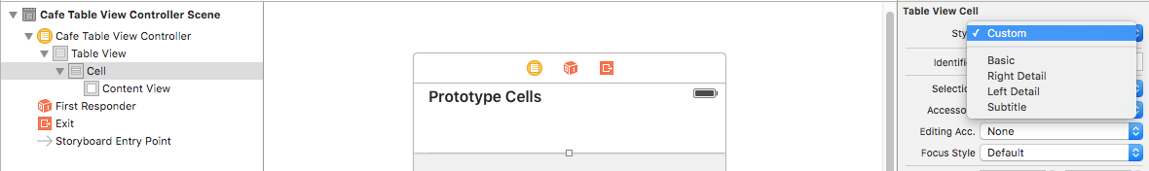

2. Let’s change the height of the cell to make a bit more room. Click on the wider Table View and use the Size Inspector:

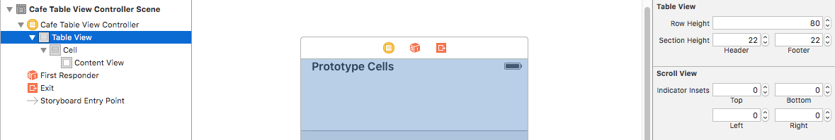

Also, let’s change the height of the cell itself to match the height of the row. Click on "Cell" and use the Size Inspector:

3. Let's start customising the cell. Put an Image View on to the cell:

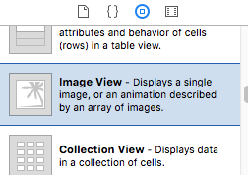

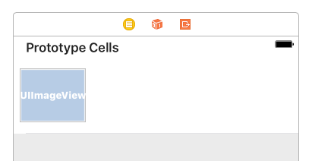

You can change the size of the Image View by dragging the corners with the mouse, or to be more exact, using the Size Inspector:

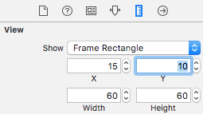

XCode will help you to position exactly too.

4. Let’s add three labels, for Name, Location, and Price band

First, add a label to the cell:

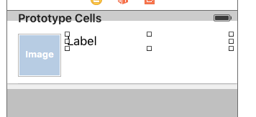

Change the text to “Name” in the Attributes Inspector:

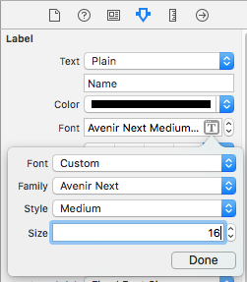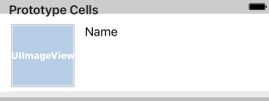

Repeat the process for Location and Price Band. Change the font size/colours as required:

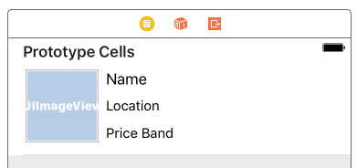

5. Since we want to use a custom cell, we need to override the default cell (UITableViewCell) which only has one text label and one image view, and create our own.

Create a new Cocoa Touch Class file called CustomTableViewCell. This time, make the class a subclass of UITableViewCell.

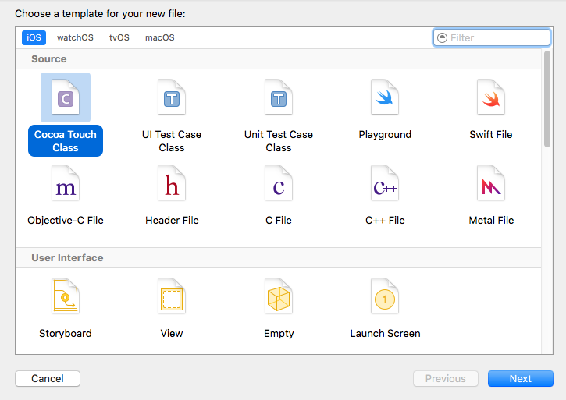

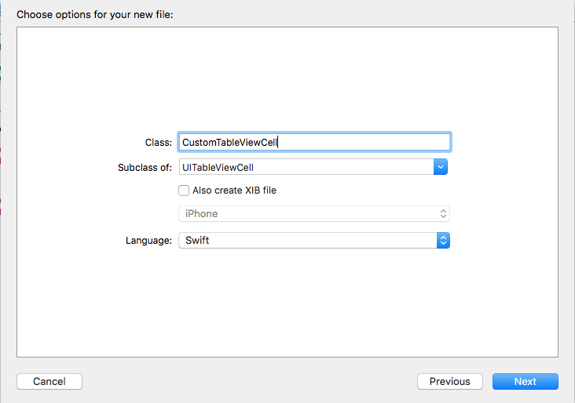

We now have CustomTableViewCell.swift in our project.

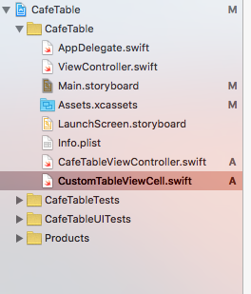

6. Set CustomTableViewCell to be the controller for our customised cell. Make sure that "Cell" is selected, and select the new class CustomTableViewCell in the Identity Inspector.

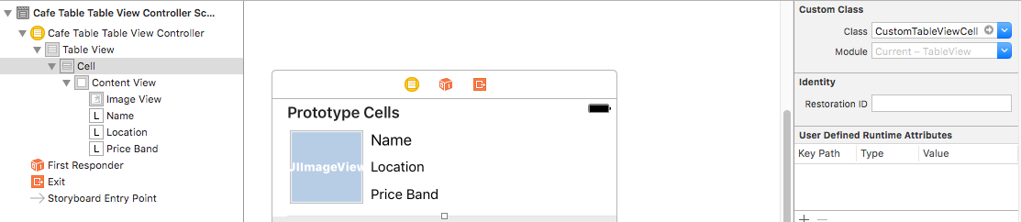

7. We will now link our customised labels and image view as Outlets to CustomTableViewCell. (Click-drag or Right-click Drag as usual) Note: You may need to select them first.

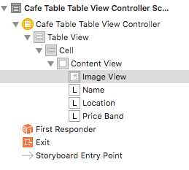

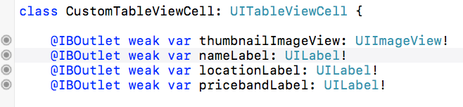

When we look at Cell, all four should be linked as Outlets:

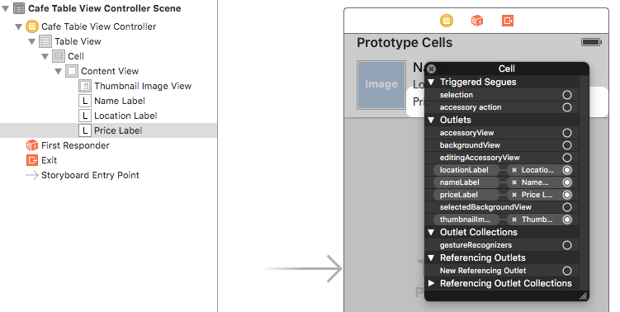

8. Next, we need to tell CafeTableViewController.swift that we’re using a custom cell layout for the reusable cell:

Currently we have this:

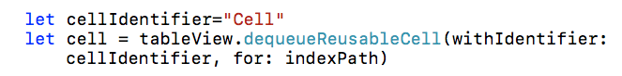

Now we’ll change it to:

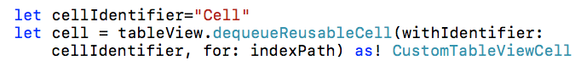

This reflects that the cell is going to use CustomTableViewCell as its class when drawing the cells.

We also need to change the bit that writes the text and images from our arrays as follows:

Before we had:

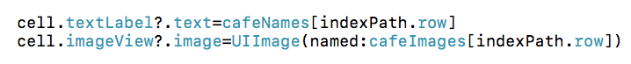

Now we going to link the data to our customised labels and picture. Let's deal with nameLabel and the image first. Change textLabel and imageView to the name of our customised label and image:

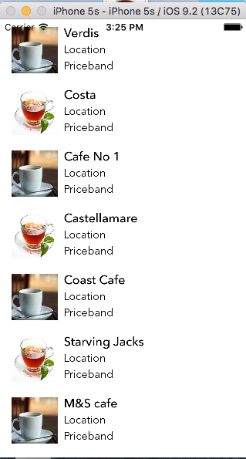

Exercise: We don’t have Location and Priceband in yet, so add in arrays for them too and get them working.

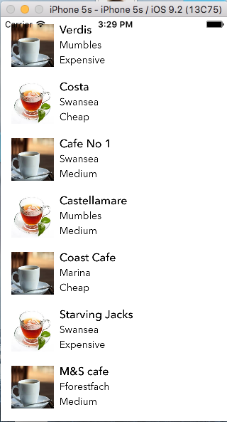

We can also change the layout of the app easily using Main.storyboard.

For example:

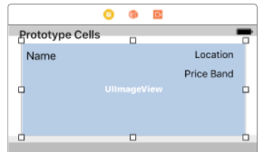

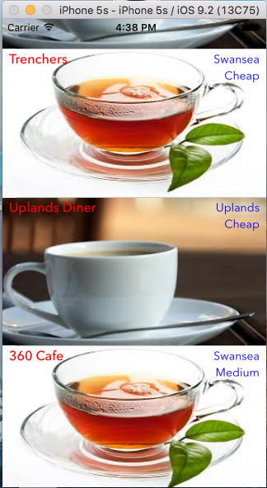

Try it on your app.

Exercise: Add a Tab View Controller so that you have two screens: one is the cafes and the other is general introductory information about Swansea.
Add some custom icons (a good website for this is icons8.com). Note that pictures have to be transparent (as they are on icons8.com) otherwise they’ll show up as a blank square.
(Don’t forget to click on the tab in the destination window, rather than in the Tab View Controller.)
I used 50x50. Although the icon looks big in the xCode window, it looks the correct size in the simulator.
Create something like the following:


