Welcome to Heddlu Gwent Police

- Operate through two Local Policing Areas aligned to five local authorities
- Covers an area of15542 km with a population of over 576,700 people
- Chief Constable- Julian Williams

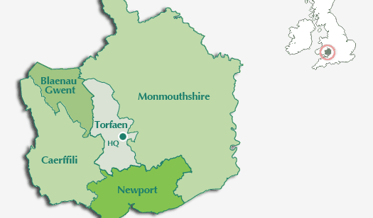

The Police and Crime Priorities for Gwent
The Police and Crime Priorities for Gwent are driven by the issues you told the Police and Crime Commissioner are important to you. They form the basis of his Police and Crime Plan for Gwent.
1. Crime Prevention
Taking action to prevent crime by working with partner organisations and communities to tackle crimes that present the greatest threat, risk and harm and especially those crimes committed against the most vulnerable.
2. Supporting Victims
Provide excellent support for all victims of crime with a particular focus on preventing further serious harm.
3. Community Cohesion
Ensure that the Police, partners and the Office of the Police and Crime Commissioner engage with communities to encourage, help and support them to work together to keep themselves safe.
4. Tackling Anti-Social Behaviour (ASB)
Ensuring the Police work closely with partner organisations to tackle ASB effectively.
Ensuring the Police work closely with partner organisations to tackle ASB effectively.

5. Efficient and Effective Service Delivery
Ensuring that Gwent Police and the Office of the Police and Crime Commissioner are high performing organisations which value and invest in our staff to achieve value for money in delivering impressive services that meet the needs of all our communities.

Please see before for copy of Force Structure.

https://www.gwent.police.uk/en/about-us/gwent-police/our-structure/

Gwent Police Staffing Establishment
The below figures represent the authorised establishment of staffing levels of Gwent Police in various areas. Figures as per 2017
 | Authorised Establishment (WTE)
Police Officers | 1,203
Police Staff | 528.4
Community Support Officers | 131
Special Constables | 92 (Not Budgeted Posts)

