BSC Sports and Exercise Science
Module: BMHN4002
Module Lead: Alison Connaughton

Richard Bakewell (2204367)
Date submitted: 04/12/2022

laboratory report: to compare the mood state of students before and after an exercise session lasting at least 20 minutes.
Laboratory Report: To compare the mood state of students before and after an exercise session lasting at least 20 minutes.
- INTRODUCTION
Mood states are conditions we experience daily, such as anger or tension. Still, they differ from emotions which are consequences of specific situations (Biddle, Fox and Boutcher, 2000, p. 66) and can strongly affect the ability to function (Porta and Last, 2018). A positive mood enhances neural paths and improves cognitive processes (Buckworth and Dishman, 2002, p. 93). Mental Health is not the lack of mental illness but a state where the individual can cope with the stresses of everyday life and is the basis for well-being (World Health Organization, 2004). In 2017 10.7% of the global population suffered from a mental health condition (Terry and Parsons-Smith, 2021). A 2014 survey showed that each week in the UK, one in six adults experienced mental health issues and one in five contemplated suicide. There has been an increase in people seeking assistance with mental health issues but around a third have not sought any help (Mental Health Foundation, 2016). A 2014 survey of England showed an increase of 24% in the number of adults receiving treatment (NHS Digital, 2014). In Wales, one in four adults experienced mental health issues, with half of those problems occurring before the age of fourteen. In 2019, 330 registered deaths were recorded from suicide, and mental health problems were the most significant single cause of disability in the UK (Senedd Cymru, Senedd Research, 2019).
UK universities have faced high rises in students requiring counselling services due to mental health issues and are high compared to the general population (Institute for Public Policy Research, 2017). A 2015 survey of American Freshmen showed high levels of depression and anxiety among college students (Rakow and Eells, 2019, pp. 4-16). First-year students suffer psychological impacts because of workload and assessment demands (Coutts et al., 2011).
The benefits of physical activity consist of sustaining a healthy weight and enhancing the quality of life (Department of Health & Social Care, 2019). A National Survey for Wales concerning everyday adult life showed that 56% were physically active for 150 minutes in the previous week. Guidelines suggest two and a half hours of moderate activity, an hour and a quarter of vigorous exercise or a mixture of the two (Gov.Wales, 2022).
The benefits of being physically active and reducing stress are well-researched and agreed upon (Buckworth and Dishman, 2002, pp. 79-80). Active people who maintain exercise suffer less from depression (Weir, 2011). The frequency of an exercise regime requires at least two sessions per week to improve mood states (Matsouka et al., 2016). The gains for an individual’s mood state when conducting an exercise of a moderate level are well recognised and provide a positive effect regarding cognitive task solving (Stolarska et al., 2019). Exercise is beneficial to mental health and overall well-being regardless of whether it is conducted in an indoor or outdoor environment (Scott, 2022).
Comparisons of indoor or outdoor environments for exercise suggest that results regarding mood states were higher for outdoors than indoors. Social interaction, enjoyment and intention for further or future practice were associated more with outdoor activity (Rogerson et al., 2016). Increased reactions of revitalisation, decreases in mood states and boosts in energy (Thompson Coon et al., 2011). Social support is an essential factor in exercise. Group exercise, support and cohesion increase commitment (Taylor, 2015, p. 66). Parkrun is an example of this promotion of personal well-being and social interaction leading to continued healthy habits (Grunseit et al., 2017). Outdoor environments were considered more calming and stress-reducing (Klaperski et al., 2019). The positive effects of physical exercise on mood states are evident, and how that person feels after the activity is essential in their motivation on whether they continue (Biddle et al., 2000, p.66).
This study's purpose was to compare students' mood states before and after an exercise session of at least 20 minutes. One session in an indoor environment and one outdoors would be conducted, and any differences in mood states would be examined. The hypotheses were that (1) the effects of the exercise session would improve the six mood states examined and (2) the outdoor exercise session would produce more significant results and benefits.

- RESULTS
The results show data collected (Appendix 5.1 and 5.2) from 19 first-year undergraduate students at the University of Wales Trinity St David before and after indoor and outdoor exercise sessions utilising the Brunel Mood Scale (BRUMS). Both male and female participants were of varying ages, between 18 and 53 and had varying fitness levels. Their medical history was unknown.

Indoor exercise session
Figure 2.1 Column chart showing Mean BRUMS scores for all participants of the Indoor exercise session.

Figure 2.1 shows there were reductions in Anger (61.64%), Confusion (46.73%), Depression (63.64%), Fatigue (13.76%) and Tension (64.94%).
In contrast, there was an increase in Vigour (40.94%).

Figure 2.2 Radar chart showing Mean BRUMS scores for all participants of the Indoor exercise session.

The increase in Vigour is more evident in Figure 2.2

Indoor Standard Deviations
Figure 2.3 Column chart showing Mean BRUMS scores for all participants of the Indoor exercise session and includes Standard Deviation figures.
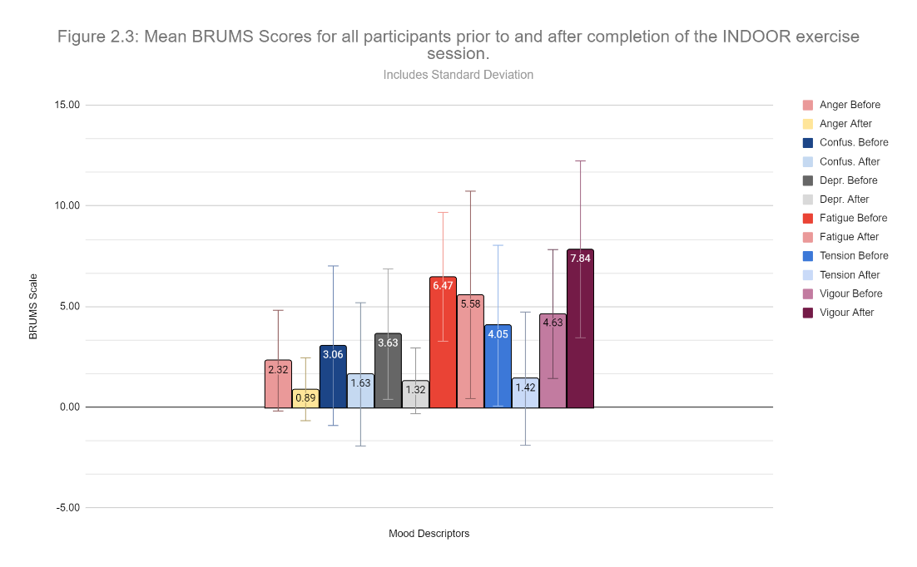
Figure 2.3: Anger before 2.32 & after 0.89, Confusion before 3.06 & after 1.63, Depression before 3.63 & after 1.32, Fatigue before 6.47 & after 5.58, Tension before 4.05 & after 1.42 and Vigour before 4.63 & after 7.84.

Outdoor exercise session
Figure 2.4 Column chart showing Mean BRUMS scores for all participants of the Outdoor exercise session.

Figure 2.4 shows there were reductions in Anger (73.13%), Confusion (59.49%), Depression (78.65%), Fatigue (25.81%) and Tension (74.31%).
In contrast, there was one increase in Vigour (48.86%).

Figure 2.5 Radar chart showing Mean BRUMS scores for all participants of the Outdoor exercise session.

The increase in Vigour is more evident in Figure 2.5

Outdoor Standard Deviations
Figure 2.6 Column chart showing Mean BRUMS scores for all participants of the Outdoor exercise session and includes Standard Deviation figures.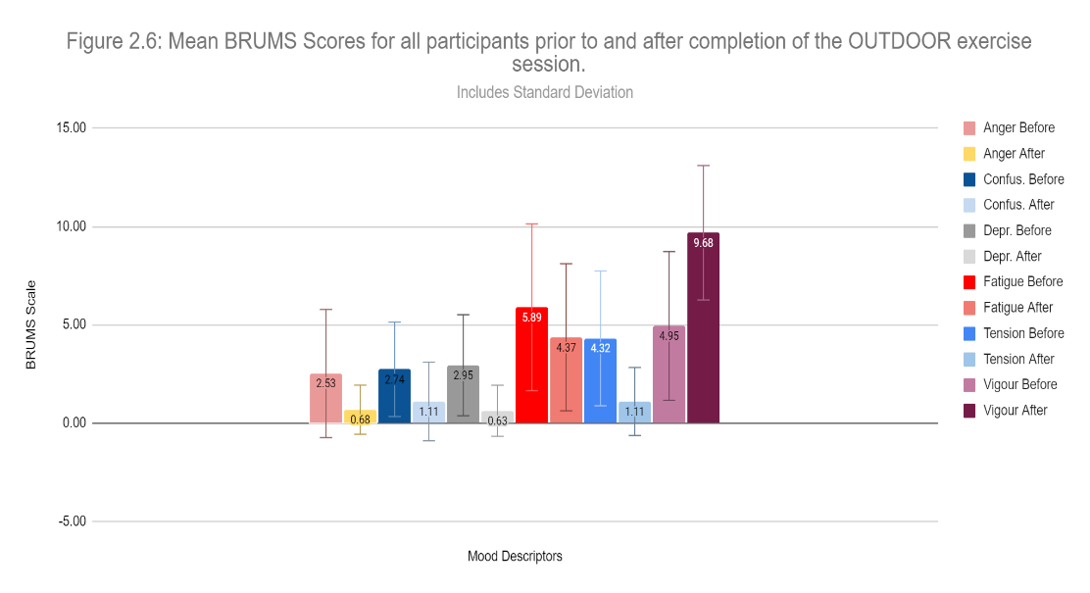
Figure 2.6: Anger before 2.53 & after 0.68, Confusion before 2.74 & after 1.11, Depression before 2.95 & after 0.63, Fatigue before 5.89 & after 4.37, Tension before 4.32 & after 1.11, Vigour before 4.95 & after 9.68.

Comparison Table
Figure 2.7 A comparison table of mean BRUMS scores for indoor and outdoor exercise sessions.

- DISCUSSION
This study examined students' mood states before and after an exercise session of at least 20 minutes. It was hypothesised that the effects of exercise would improve mood states and that the outdoor session would produce more significant results.
The scale of this study was small, with data collected from only 19 subjects over single bouts of exercise, and it was not a prolonged study. The study does not adequately reflect the student population, so results are limited and must be considered cautiously (Buckworth and Dishman, 2002, pp. 111-112). Despite a small sample size, the study supports the hypotheses and other research in that mood states are improved following exercise and more when training is conducted outside (Rogerson et al., 2015).
The findings suggest that in both indoor and outdoor exercise sessions, there were positive results across all Mood states, with substantial reductions in anger, confusion and depression, with fatigue having the lowest drop. Vigour increased following indoor exercise by 40.94% (Figure 2.1) and outdoor activity (Figure 2.4) by 48.86%, suggesting that this mood is enhanced more by the outdoor environment.
As hypothesised, outdoor exercise produced more significant results, which support previous research outlined in the Introduction of this report (Rogerson et al., 2016). Being in and exposed to natural environments includes various physiological benefits such as lower all-cause of mortality and diabetes 2 (Natural England, 2016).
Standard deviations show similarities for most mood states in indoor (Figure 2.3) and outdoor (Figure 2.6) data showing relative consistency but were more significant in Fatigue and Vigour, offering less reliability. Completing the mood questionnaires was problematic for participants when they were aware of the study and the exercise stimulus needed to be standardised too by time or nature (Buckworth and Dishman, 2002, p. 112).
During the indoor sessions, participants carried out various exercises on different days in various locations for up to one hour. Exercises included Treadmill runs and walks, Elliptical machines, weight training, general gym workouts, Indoor cycling, Yoga and Crossfit high-intensity sessions. Issues arise with analysing the indoor exercise data as mood states can alter between high and low-intensity exercise (Kerr and Wollenberg, 2007).
In contrast, with the outdoor session, most participants conducted a twenty-minute walk at the same time in the same location. Therefore, the data for the outdoor session can be considered more accurate for this report.
A more extensive survey was conducted in 2019/2020 by the UK Active Research Institute with 9,013 students from 101 Institutions, where 84% were undergraduates. Personal well-being scores for before and after physical activity show slight increases in happiness, life satisfaction, feeling worthwhile and anxiety reduction. Mental well-being, loneliness and social trust were also higher following exercise (UK Active Research Institute, 2020).
The importance of physical activity for students’ mental health and well-being cannot be underestimated (Weinberg and Gould, 2015, pp.405-418). Stress and depression symptoms can be lessened by short-term, aerobic exercise regimes and can be more effective than other cognitive methods. Participants who take up regular low to moderate exercise increase their chances of continuing this activity long-term (Herbert et al., 2020).
Providing students with opportunities for physical exercise provides them with all the benefits of a healthy lifestyle both physically and improves their mental health and well-being (Grasdalsmoen et al., 2020). Education establishments should consider that students who regularly participate in physical activity and sports have higher self-esteem and states of mind. This leads to more positive mood states, being more engaged and focused on their academic work (Haoran, 2021).

- REFERENCES
Biddle, S., Fox, K. and Boutcher, S. (2000) Physical Activity and Psychological Well-Being. London: Routledge.
Buckworth, J., and Dishman, R. K. (2002) Exercise Psychology. USA: Human Kinetics.
Coutts, R., Gilleard, W, and Baglin, R. (2011) ‘Evidence for the impact of assessment on mood and motivation in first-year students,’ Studies in Higher Education, 36(3), pp. 291-300. Available at: https://doi.org/10.1080/03075079.2010.523892
Department of Health & Social Care (2019) UK Chief Medical Officers' Physical Activity Guidelines. Available at: https://assets.publishing.service.gov.uk/government/uploads/system/uploads/attachment_data/file/832868/uk-chief-medical-officers-physical-activity-guidelines.pdf (Accessed: 3 December 2022).
GOV.WALES. (2022) Adult lifestyle (National Survey for Wales): April 2021 to March 2022. Available at: https://gov.wales/adult-lifestyle-national-survey-wales-april-2021-march-2022 (Accessed: 3 December 2022).
Grasdalsmoen, M., Eriksen, H. R., Lønning, K. J., and Sivertsen, B. (2020) ‘Physical exercise, mental health problems, and suicide attempts in university students’, BMC Psychiatry, 20(1), pp. 1–11. Available at: https://doi.org/10.1186/s12888-020-02583-3
Grunseit, A., Richards, J., & Merom, D. (2017) ‘Running on a high: Parkrun and personal well-being’, BMC Public Health, 18(1), pp. 1–11. Available at: https://doi.org/10.1186/s12889-017-4620-1
Haoran, X. (2021) ‘A Study of Emotions in Sport Psychology Based on The Mood State Inventory’, Revista de psicología del deporte, 30(2), p. 11. Available at: https://www.proquest.com/scholarly-journals/study-emotions-sport-psychology-based-on-mood/docview/2730387318/se-2 (Accessed: 3 December 2022).
Herbert, C., Meixner, F., Wiebking, C, Gilg, V. (2020) ‘Regular physical activity, short-term exercise, mental health, and well-being among university students: The results of an online and a laboratory study’, Frontiers in Psychology, 11, pp. 509–509. Available at: https://doi.org/10.3389/fpsyg.2020.00509 (Accessed: 3 December 2022).
Institute for Public Policy Research (2017) Improving student mental health in the UK’s universities 60-second summary. Available at: www.ippr.org/publications/not-by-degrees (Accessed: 2 December 2022).
Kerr, J. A., and Van den Wollenberg, A. (1997) ‘High and low intensity exercise and psychological mood states’, Psychology & Health, 12(5), pp. 603-618. Available at: https://doi.org/10.1080/08870449708407409
Klaperski, S., Koch, E., Hewel, D., Schempp, A., & Müller, J. (2019) 'Optimising mental health benefits of exercise: The influence of the exercise environment on acute stress levels and wellbeing', Mental Health & Prevention, 15. Available at: https://doi.org/10.1016/J.MHP.2019.200173
Matsouka, O., Kabitsis, C., Harahousou, Y, and Trigonis, I. (2016) ‘Mood Alterations following an Indoor and Outdoor Exercise Program in Healthy Elderly Women’, SAGE Journals, 100(3), pp. 707-715. Available at: https://doi-org.ezproxy.uwtsd.ac.uk/10.2466/pms.100.3.707-715
Mental Health Foundation (2016) Fundamental Facts About Mental Health. Available at: https://www.mentalhealth.org.uk/sites/default/files/2022-06/The-Fundamental-facts-about-mental-health-2016.pdf (Accessed: 2 December 2022).
Natural England (2016) Links between natural environments and mental health: evidence briefing. Available at: http://publications.naturalengland.org.uk/publication/5748047200387072 (Accessed 3 December 2022).
NHS Digital (2014) Adult Psychiatric Morbidity Survey: Survey of Mental Health and Wellbeing, England. Available at: https://webarchive.nationalarchives.gov.uk/ukgwa/20180328140249/http:/digital.nhs.uk/catalogue/PUB21748 (Accessed: 2 December 2022).
Porta, M., & Last, J. M. (2018). A Dictionary of Public Health. Available at: https://www.oxfordreference.com/view/10.1093/acref/9780191844386.001.0001/acref-9780191844386 (Accessed: 2 December 2022).
Rakow, D.A. and Eells, G.T. (2019) Nature Rx : improving college-student mental health. Ithaca: Cornell University Press. Available at: https://doi.org/10.7591/9781501715303 (Accessed: 2 December 2022).
Rogerson, M., Brown, D. K., Sandercock, G., Wooller J-J, Barton J. A. (2015) ‘Comparison of four typical green exercise environments and prediction of psychological health outcomes’, Perspectives in Public Health. 136(3), pp. 171-180. Available at: https://doi:.org/10.1177/1757913915589845
Rogerson, M., Gladwell, V. F., Gallagher, D. J., and Barton, J. L. (2016) ‘Influences of Green Outdoors versus Indoors Environmental Settings on Psychological and Social Outcomes of Controlled Exercise’, International Journal of Environmental Research and Public Health 2016, 13(4), p. 363. Available at: https://doi.org/10.3390/IJERPH13040363
Scott, L. (2022) ‘Green exercise for well-being: an exploration of psychological responses to physical activity in outdoor and indoor environments’, European Journal of Public Health, 32(2). Available at: https://doi.org/10.1093/EURPUB/CKAC095.034
Senedd Cymru, Senedd Research (2019) A mentally well Wales. Available at: https://research.senedd.wales/research-articles/a-mentally-well-wales/ (Accessed: 2 December 2022).
Stolarska, B., Stolarski, M., and Matthews, G. (2019) ‘A Comparison of the Effects of 45-minute Aerobic Training and Cognitive Task Solving on Transient Mood States in a Female Student Sample’, Applied Psychology: Health and Well-Being, 11(3), pp. 499-521. Available at: https://doi.org/10.1111/aphw.12165
Taylor, S. E. (2015) Health Psychology. 9th edn. New York: McGraw-Hill Education.
Terry, P. C., and Parsons-Smith, R. L. (2021). ‘Mood Profiling for Sustainable Mental Health among Athletes’, Sustainability 2021, 13(11), p. 6116. Available at: https://doi.org/10.3390/SU13116116
Thompson Coon, J., Boddy, K., Stein, K., Whear, R., Barton, J., and Depledge, M. H. (2011) ‘Does Participating in Physical Activity in Outdoor Natural Environments Have a Greater Effect on Physical and Mental Wellbeing than Physical Activity Indoors? A Systematic Review’, Environmental Science and Technology, 45(5), pp. 1761–1772. Available at: https://doi.org/10.1021/ES102947T
UK Active Research Institute (2020) British Active Student Survey 2019-2020. Available at: https://www.bucs.org.uk/resources-page/bass-2019.html (Accessed: 3 December 2022).
Weinberg, R. S. and Gould, D. (2015) Foundations of Sport and Exercise Psychology. USA: Human Kinetics.
Weir, K. (2011) ‘The exercise effect’, American Psychological Association42(11), p. 48. Available at: https://www.apa.org/monitor/2011/12/exercise (Accessed: 2 December 2022).
World Health Organization (2004) Promoting Mental Health. Available at: https://apps.who.int/iris/bitstream/handle/10665/42940/9241591595.pdf (Accessed: 2 December 2022).

- APPENDIX
Appendix 5.1: BRUMS raw data collated for indoor exercise session.
Participant | Anger Before | Confus. Before | Depr. Before | Fatigue Before | Tension Before | Vigour Before | Anger After | Confus. After | Depr. After | Fatigue After | Tension After | Vigour After
1 | 7 | 7 | 14 | 11 | 11 | 7 | 4 | 6 | 6 | 13 | 5 | 11
2 | 1 | 9 | 4 | 5 | 6 | 7 | 0 | 2 | 1 | 4 | 2 | 13
3 | 6 | 1 | 3 | 8 | 5 | 2 | 0 | 0 | 0 | 3 | 1 | 8
4 | 0 | 5 | 0 | 5 | 1 | 7 | 0 | 0 | 0 | 3 | 0 | 12
5 | 0 | 0 | 0 | 0 | 2 | 5 | 0 | 0 | 0 | 0 | 0 | 7
6 | 0 | 8 | 4 | 6 | 7 | 5 | 0 | 0 | 2 | 2 | 0 | 7
7 | 1 | 0 | 3 | 4 | 2 | 1 | 0 | 0 | 0 | 0 | 0 | 1
8 | 2 | 0 | 0 | 9 | 1 | 0 | 0 | 0 | 0 | 3 | 0 | 1
9 | 1 | 5 | 6 | 10 | 5 | 3 | 0 | 0 | 3 | 5 | 0 | 10
10 | 8 | 4 | 5 | 12 | 4 | 2 | 0 | 2 | 0 | 9 | 0 | 16
11 | 5 | 13 | 3 | 5 | 15 | 3 | 4 | 15 | 2 | 1 | 14 | 2
12 | 1 | 0 | 4 | 4 | 0 | 4 | 0 | 2 | 0 | 1 | 0 | 4
13 | 0 | 0 | 5 | 7 | 0 | 9 | 1 | 2 | 2 | 11 | 1 | 10
14 | 0 | 0 | 0 | 3 | 1 | 10 | 0 | 0 | 0 | 5 | 0 | 5
15 | 2 | 1 | 2 | 4 | 0 | 0 | 0 | 0 | 0 | 0 | 0 | 11
16 | 1 | o | 5 | 5 | 1 | 4 | 0 | 1 | 2 | 6 | 0 | 9
17 | 3 | 0 | 6 | 7 | 7 | 5 | 1 | 1 | 3 | 9 | 2 | 13
18 | 3 | 2 | 1 | 12 | 4 | 3 | 3 | 0 | 3 | 16 | 2 | 3
19 | 3 | 0 | 4 | 6 | 5 | 11 | 4 | 0 | 1 | 15 | 0 | 6
Mean | 2.32 | 3.06 | 3.63 | 6.47 | 4.05 | 4.63 | 0.89 | 1.63 | 1.32 | 5.58 | 1.42 | 7.84
Standard Deviation | 2.50 | 3.96 | 3.24 | 3.20 | 3.99 | 3.20 | 1.56 | 3.56 | 1.63 | 5.15 | 3.31 | 4.39

Appendix 5.2: BRUMS raw data collated for outdoor exercise session.
Participant | Anger Before | Confus. Before | Depr. Before | Fatigue Before | Tension Before | Vigour Before | Anger After | Confus. After | Depr. After | Fatigue After | Tension After | Vigour After
1 | 5 | 8 | 4 | 13 | 10 | 6 | 4 | 5 | 5 | 11 | 7 | 10
2 | 0 | 5 | 3 | 3 | 0 | 1 | 0 | 2 | 1 | 4 | 2 | 13
3 | 1 | 2 | 0 | 11 | 4 | 3 | 0 | 0 | 0 | 4 | 1 | 7
4 | 0 | 4 | 0 | 5 | 1 | 7 | 0 | 0 | 0 | 1 | 0 | 12
5 | 0 | 0 | 0 | 3 | 0 | 3 | 0 | 0 | 0 | 2 | 0 | 7
6 | 0 | 3 | 4 | 16 | 11 | 1 | 0 | 0 | 2 | 4 | 2 | 7
7 | 3 | 4 | 2 | 8 | 2 | 1 | 0 | 0 | 0 | 0 | 0 | 8
8 | 0 | 0 | 2 | 10 | 4 | 0 | 0 | 0 | 0 | 0 | 0 | 8
9 | 2 | 1 | 3 | 1 | 4 | 12 | 0 | 0 | 0 | 2 | 0 | 15
10 | 0 | 0 | 0 | 4 | 1 | 5 | 0 | 0 | 0 | 5 | 1 | 14
11 | 9 | 6 | 8 | 9 | 6 | 7 | 3 | 5 | 0 | 10 | 2 | 14
12 | 9 | 6 | 7 | 2 | 9 | 6 | 1 | 6 | 2 | 10 | 2 | 10
13 | 4 | 2 | 5 | 6 | 7 | 4 | 1 | 1 | 0 | 4 | 1 | 8
14 | 2 | 0 | 1 | 1 | 4 | 14 | 1 | 0 | 0 | 12 | 0 | 2
15 | 0 | 1 | 1 | 1 | 3 | 9 | 0 | 0 | 0 | 1 | 0 | 7
16 | 0 | 2 | 3 | 4 | 3 | 1 | 0 | 0 | 0 | 3 | 0 | 6
17 | 1 | 1 | 3 | 5 | 1 | 4 | 0 | 0 | 0 | 4 | 0 | 11
18 | 3 | 2 | 2 | 5 | 3 | 6 | 0 | 0 | 0 | 5 | 0 | 13
19 | 9 | 5 | 8 | 5 | 9 | 4 | 3 | 2 | 2 | 1 | 3 | 12
Mean | 2.53 | 2.74 | 2.95 | 5.89 | 4.32 | 4.95 | 0.68 | 1.11 | 0.63 | 4.37 | 1.11 | 9.68
Standard Deviation | 3.26 | 2.40 | 2.57 | 4.24 | 3.43 | 3.78 | 1.25 | 2.00 | 1.30 | 3.74 | 1.73 | 3.42

