Lewis Gray
2224230

Electronics

Contents

  - Task One……………………………………………………………………………………………………………………………………p3
  - Aim……………………………………………………………………………………………………………………………………………p3
  - Theory…………………………………………………………………………………………………………………………………….…p3
  - Method……………..………………………………………………………………………………………………………………………p4
  - Results………………………………………………………………………………………………………………………………………p5
  - Conclusion…………………………………………………………………………………………………………………………………p6

  - Task Two……………………………………………………………………………………………………………………………………p7
  - Aim……………………………………………………………………………………………………………………………………………p7
  - Theory……………………………………………………….………………………………………………………………………………p7
  - Method………………………………………………………………..……………………………………………………………………p8
  - Results………………………………………………………………………………………………………………………………………p8
  - Conclusion…………………………………………………………………………………………………………………………………p9

3.1 References…………………………………………………………………………………………………………………………………p9

1.1 Task One

1.2 Aim
To use a simulation software to determine the internal resistance of a circuit using Thevenin’s theorem and the maximum power theorem.

1.3 Theory
An electrical circuit is defined by Embibe as “a closed path of wires and electrical components which allows a current through it on the application of potential difference between two points in the path.”
When a circuit is complete, a current flows through the wires and components that make up the circuit. Current is the rate of flow in a circuit and can be measured in amps.
Resistance in a circuit is directly proportional to the voltage supplied. This relationship is known as Ohms law and can be written as V=IR, where V is the voltage measured in volts, I is the current measured in amps and R is the resistance measured in ohms. Ohms law specifically states that the resistance in the relation is constant and that if the resistance is not constant, the states equation cannot be referred to as Ohms law. However, V=IR can still be used as a relationship for DC resistance.
A circuit has two different types of current flow, AC and DC. DC, also known as direct current , is a monodirectional flow of charged particles through a circuit. Direct current has many practical uses such as in batteries or power supplies for large circuits. Powerful high voltage direct current systems are used to transport large quantities of electricity from remote generation sites.
AC, or alternating current, is different from direct current in that it flows in both directions as opposed to single directional flow. It reverses it’s directional flow at intervals and continuously changes magnitude. Alternating current is the type of current that is delivered to residences and businesses. The normal waveform of an alternating current is a sine wave, it’s half positive half negative period equates to the positive and negative direction of flow within the circuit.
Thevenin’s theorem states that any two terminals of a circuit network comprising of a number of active and inactive elements can be substituted by an equivalent source of potential difference and equivalent resistance in series. The source of potential difference is the open circuit voltage caused between the circuit across the terminal. The resistance in series is also the equivalent resistance. By removing the load resistor, the circuit can be opened and an open circuit voltage can be obtained which can then be used to deduce the equivalent resistance of the circuit. A Thevenin’s equivalent circuit can then be constructed which can be used to calculate the current through the load resistor.
Maximum power theorem states that in a direct current circuit, maximum power will be consumed by the load or maximum power will be transferred from the source to the load, when the load resistance of the load equates to the internal resistance of the circuit as viewed from the load terminal. Thevenin’s equivalent resistance must be deduced as the theorem states that the maximum power will be transferred to the load only when the load resistance is equal to the internal resistance of the circuit. In order to do this, the load resistor of which the current is to be determined must be removed to open a gap across the circuit. The open circuit voltage must then be calculated, followed by a calculation of the equivalent resistance after substituting the voltage sources with their internal resistance by short-circuiting it. The current source must then be removed in order to open-circuit the network. The current across the load can then be calculated using the formula: $I=\frac{V_{th}}{R_{eq}+R_{L}}$ Where I is the current measured in amps, V_{th} is Thevenin’s voltage, R_{eq} is the equivalent resistance or Thevenin’s resistance which is measured in Ohms and R_{L} which is also measured in Ohms.

1.4 Method
The following circuit was constructed using the simulation software Proteus.
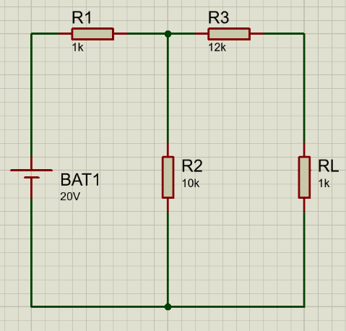

[Figure 1.1 – Task One circuit]

The values for R_{L} were set to values from 1k to 20k.
In order to apply the maximum power transfer theorem, the load resistor (R_{L}) was removed to create an open circuit. A voltmetre was installed to the gap between the terminals created by removing the load resistor to record Thevenin’s voltage.
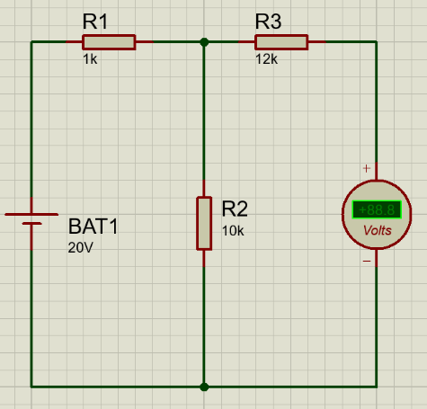

[Figure 1.2 - Task One circuit with added voltmetre]

The reading on the voltmetre was recorded as V_{th}. Following the deduction of Thevenin’s voltage, the equivalent resistance was recorded by removing the DC power supply and adding an ohmmetre where R_{eq} = R_{L}.

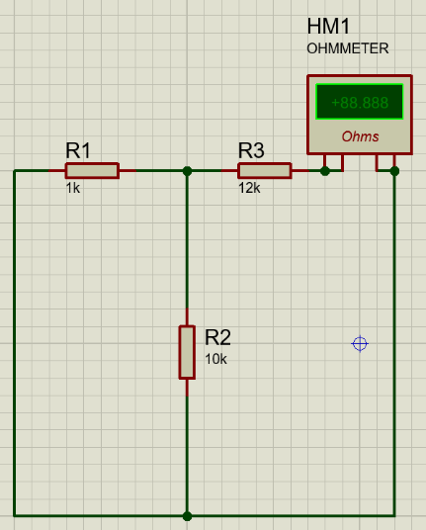

[Figure 1.3 – Addition of ohmmetre]

An equivalent circuit was then created using the software. The presence of a DC battery is in place of V_{th} which was calculated to be 18.2V and Thevenin’s resistance was calculated to be 12.91kΩ. An ammetre was included to measure the flow of current across the load resistor.

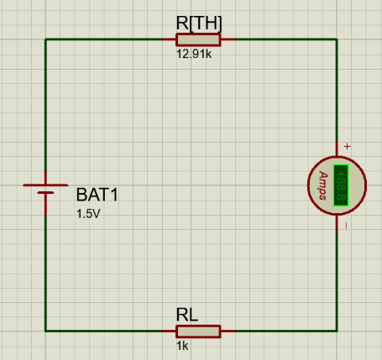

[Figure 1.4 – Thevenin’s equivalent circuit]

The readings from the ammetre for the values of R_{L} ranging from 1k to 20k were recorded and the results placed in a table. As the current was too small to be recorded in amps, it was recorded in milliamps (mA).

The power of the circuit was calculated using the equation: P = I²R_{L}.

1.5 Results
The table of results for task one is shown below:
Resistance (kΩ) | Current (mA) | Power (mW)
1 | 1.31 | 1.72
2 | 1.22 | 2.98
3 | 1.14 | 3.9
4 | 1.08 | 4.67
5 | 1.02 | 5.2
6 | 0.96 | 5.53
7 | 0.91 | 5.8
8 | 0.87 | 6.06
9 | 0.83 | 6.2
10 | 0.79 | 6.24
11 | 0.76 | 6.35
12 | 0.73 | 6.39
13 | 0.7 | 6.37
14 | 0.68 | 6.47
15 | 0.65 | 6.34
16 | 0.63 | 6.35
17 | 0.61 | 6.33
18 | 0.59 | 6.27
19 | 0.57 | 6.17
20 | 0.55 | 6.05
[Figure 1.5 – Task one table of results]

A graph was produced showing the relationship between Power and Resistance

[Figure 1.6 – graph of power against resistance]

1.6 Conclusion
The internal resistance of the circuit was determined to be 14.65kΩ. According to the maximum energy theorem, the maximum power will be consumed when the load resistance equals the internal resistance of the circuit. Therefore, as the power peaked at 14.657kΩ, that is the internal resistance of the circuit.
A theoretical value was obtained alongside the simulation value. The theoretical value was found to be higher than the simulation value. This could be for a number of reasons, such as the internal resistance of the copper wire not being taken into account in the theoretical calculations as well as rounding error being carried through the stages of the calculations. Rounding to two decimal placed would have resulted in an overall higher number for the internal resistance.

2.1 Task Two

2.2 Aim
To determine the resonant frequency of an AC circuit using an oscilloscope.

2.3 Theory
Capacitance is the measurement of a materials ability to store an electric charge. It is a result of a difference in potential between the two plates. Capacitance is measured in Farads and the energy stored within the component equates to the energy required to charge it.
Inductance is the habit of an electrical conductor to resist an alteration of the electrical current flowing through the component. The flow of this current creates an electromagnetic force around the conductor due to a coiled wire within the component. The strength of this force is directly proportional to the rate of the change of the current through the inductor. Faraday’s law states that: “the magnitude of the emf induced in a circuit is proportional to the rate of change with time t of the magnetic flux Φ that cuts across the circuit: $emf=\frac{-dϕ}{dt.}$”.
Reactance in an AC circuit is the resistive electromagnetic force faced by the current of the circuit by capacitance and inductance. It is one of the two elements of impedance, along with resistance, which is the opposition to an AC current via the combined force of resistance and reactance in a network. Unlike impedance, no energy is lost as heat in reactance as the stored charge is returned to the circuit after a period of a quarter cycle.
Reactance can either be capacitive or inductive.
The formula for inductive reactance is: $X_{L}=2πfL$, Where X_{L} is the inductive reactance measured in ohms, f is the frequency measured in Hertz and L is the inductance which is measured in Henry.
Capacitive reactance is: $X_{L}=\frac{1}{2πfC}$ , where X_{L} is the capacitive reactance measured in ohms, f is the frequency and C is the capacitance measured in Farads.
Resonance is an occurrence where wavelengths oscillate with the same frequencies, meaning they are in phase. This creates constructive interference which gives the maximum output from the electrical signal. When $X_{L}=X_{c}$, the supply voltage and current of the circuit are in phase which creates an effect known as series resonance.
Since $X_{L}=X_{c}$ , this means that $\frac{1}{2πfC}=2πfL$ and the frequency at which resonance occurs at can be written as $f_{r}=\frac{1}{2π\sqrt{LC}}$.
The resonant series circuit is also referred to as an acceptor circuit as it has minimum impedance and peak current at the resonant frequency.

2.3 Method
A circuit was constructed using a signal generator and an oscilloscope to measure the voltages across the resistor, inductor and capacitor.
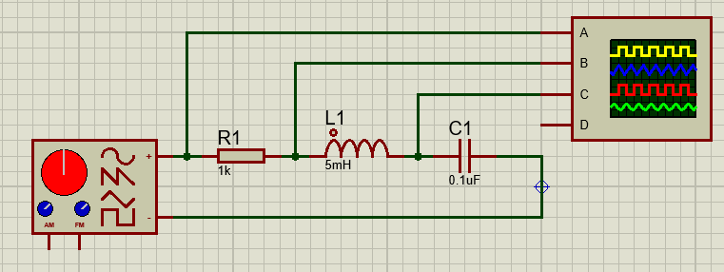

[Figure 2.1 – Task Two Circuit]

The frequency output from the signal generator was increased from 1kΩ to 20kΩ. The voltages of the resistor, capacitor and inductor were recorded at each incremental increase and put into a table.

2.4 – Results

Frequency (Hz) | Resistor Voltage (V) | Inductor Voltage (V) | Capacitor Voltage (V)
1000 | 10 | 10 | 10.26
2000 | 10 | 10 | 10.76
3000 | 10 | 9.76 | 12
4000 | 10 | 9.26 | 13.76
5000 | 10 | 8.26 | 17
6000 | 10 | 5.76 | 21.26
7000 | 10 | 0.15 | 22.26
8000 | 10 | 5 | 16.76
9000 | 10 | 7.5 | 11.5
10000 | 10 | 8.5 | 8.26
11000 | 10 | 9 | 6.2
12000 | 10 | 9.26 | 4.8
13000 | 10 | 9.4 | 3.9
14000 | 10 | 9.6 | 3.2
15000 | 10 | 9.6 | 2.7
16000 | 10 | 9.7 | 2.3
17000 | 10 | 9.8 | 2
18000 | 10 | 9.8 | 1.75
19000 | 10 | 9.8 | 1.55
20000 | 10 | 9.8 | 1.4
[Figure 2.2 – Task Two results table]

A semi-log graph of frequency against capacitor voltage was plotted in order to obtain the resonant frequency.

[Figure 2.3 – Frequency, Voltage graph]

2.5 – Conclusion
In conclusion, the resonant frequency was found to be around 7000Hz. Due to the number of increments of recorded frequency, the highest point on the graph is not given as a number. This could be fixed by increasing the number of recorded frequencies around the 7000Hz mark to provide a more accurate answer.
A theoretical value was obtained alongside the simulation value. The theoretical value was found to be higher than the simulation value. This could be for a number of reasons, such as the internal resistance of the copper wire not being taken into account in the theoretical calculations as well as rounding error being carried through the stages of the calculations. Rounding to two decimal placed would have resulted in an overall higher number for the internal resistance.

3.1 – References.
“Electric Circuit – Definition, Components & Symbols Used, Types & Analysis,” Embibe Exams, Jan. 11, 2022. Available: https://www.embibe.com/exams/electric-circuit/

The Physics Classroom, “Electric Current,” Physicsclassroom.com, 2019. https://www.physicsclassroom.com/class/circuits/Lesson-2/Electric-Current

The Editors of Encyclopedia Britannica, “Faraday’s law of induction | physics,” Encyclopædia Britannica. Sep. 06, 2013. Available: https://www.britannica.com/science/Faradays-law-of-induction
“What is Resonant Frequency?,” resources.pcb.cadence.com. https://resources.pcb.cadence.com/blog/2021-what-is-resonant-frequency
‌

‌

‌

