
Module Name: Financial Management for the Hotel Industry
Module Code: BMIH5007
Liviu Zaharia;2122725
Table of Contents
1 Introduction 3
2 Overview of the Seacrest Lodge 3
3 Financial Analysis 3
3.1 Income Statement 3
3.2 Balance Sheet 4
3.3 Key Financial Ratios 4
3.4 SWOT Analysis 5
3.4.1 Strengths 5
3.4.2 Weaknesses 5
3.4.3 Opportunities 5
3.4.4 Threats 5
4 Market Analysis 5
5 Turnaround Strategy 400 6
6 Financial Projections 300 6
7 Risk Assessment 200 6
7.1 Conclusion 100 6
8 References 6

Introduction
The Seacrest Lodge used to be a famous place for rich people and peace and quiet to get away. But in the last few years, income, rental rates, and customer happiness have all gone down in an unexpected way. The report will analyse The Seacrest Lodge's financial success over the last three years. The report will also identify the key reasons for the drop in profits and come up with a way to get it back on track financially so that it can be a popular holiday spot once more.

Overview of the Seacrest Lodge
The Seacrest Lodge, which is on a beautiful beach, used to be the perfect place for people looking for peace and comfort (The Seacrest Lodge, 2024). The resort is having a hard time because of the economic downturn, which means less money going in, fewer people staying, and unhappy customers. The owner of the lodge is worried about the financial position and intends to evaluate the situation and reasons for the declination. The main objectives of the lodge are to assess the financial performance as well as create a potential turnaround strategy to boost the profits and growth of the lodge.

Financial Analysis

Income Statement
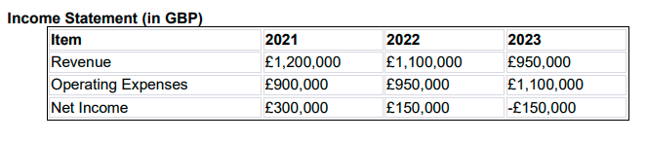
Concerningly, the financial condition of the Seacrest Lodge it has been analysed that the hotel has deteriorated during the last three years. Revenue saw a slow drop, decreasing from £1.2 million in 2021 to £950,000 in 2023. Simultaneously, operating expenditures surged, reaching £1.1 million in 2023, intensifying the financial problem. The most unfavourable aspect is the abrupt and significant decrease in net income, dropping from a commendable £300,000 in 2021 to a catastrophic loss of £150,000 in the following year. The current decrease in trend emphasizes the urgent need to promptly analyze operational efficiency, explore supplementary sources of income, and evaluate cost structures (Papadopoulos et al., 2021). A complexly strategized turnaround is necessary to counteract the prevailing decline and reinstate the fiscal well-being of the lodge.

Balance Sheet
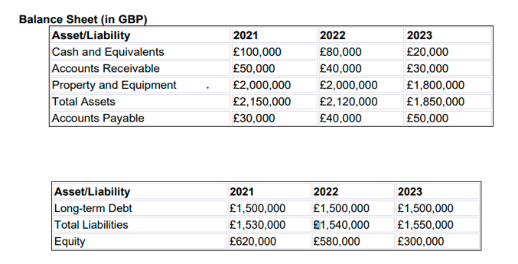
The financial records for the Seacrest Lodge show a concerning trend over those three years. A sharp drop in cash and equivalents from £100,000 in 2021 to £20,000 in 2023, along with a rise in accounts receivable and a fall in the value of property and equipment, are all signs of problems with liquidity and asset value. Even though accounts due went up, the large amount of constant long-term debt of £1,500,000 points to possible financial trouble. The falling wealth from £620,000 in 2021 to £300,000 in 2023 shows how bad things are getting financially. To deal with problems with cash flow, lower debt levels, and bring back general financial security, a complete turnaround plan is needed,

Key Financial Ratios
Return on Equity
2021 | 2022 | 2023
48.39% | 25.86% | 50%

Return on Assets
2021 | 2022 | 2023
14.04% | 7.08% | 8.16%

Return of Debt to Equity
2021 | 2022 | 2023
2.47 | 2.66 | 5.17

SWOT Analysis

Strengths
Being right on the beach, the Seacrest Lodge is in a great spot and has a unique and appealing setting for guests (Revell, 2020). The restaurant, bar, and event rooms on the site have all been well taken care of, which adds to its historic charm. The image of the lodge is high as a high-class vacation spot has helped spread the word about it and, hopefully, keep customers coming back.

Weaknesses
A big drop in cash, wealth, and property value are all signs of financial insecurity. Lower rental rates and the possibility of customer unhappiness show that customer experiences and services need to be better. In addition, facilities that are too old can cause problems for the lodge if they aren't up to date with modern service standards.

Opportunities
At first, spending on property fixes and new features can bring in new customers and keep old ones interested before start modernizing and renovating. The lodge could become a famous getaway and get more customers if it runs effective advertising campaigns (Zhang et al., 2020). In addition, the hotel needs to try to be diverse. The Seacrest Lodge can improve the general tourist experience by adding extra services or forming relationships, like exercise programs or nearby sites.

Threats
It is possible that people will spend less on expensive trips and adventures if the economy gets worse. The lodge needs to come up with ways to stand out from its competitors if it wants to do well in the very competitive hotel industry. Changes to rules, including those about health and safety can also make it hard for the resort to run its business.

Market Analysis
In the market of the UK, there is quite a competitive environment for the hotel businesses. Even places with a lot of experience, like The Seacrest, are having tough competition from new businesses. The Seacrest Lodge could use customer reviews as critical indicators of why profits are decreasing. However, it seems that people who visit The Seacrest Lodge are not satisfied with the level of service and amenities provided. Today, online reviews are very important in how people decide to spend their money and hence criticism could damage the lodge’s reputation as well as discourage potential customers (Tan and Despotis, 2021). If the lodge wants to regain the trust and love of its clients, it should act fast in solving these issues. The economic situation and incidents taking place in the world also contribute to a more severe fall. The willingness of customers to pay for the hotel services can vary depending on economic changes, global disasters and holiday seasons. However, it is also possible that the lodge's profits will decrease because fewer people can decide to visit due to confusion and disruption caused by these incidents.
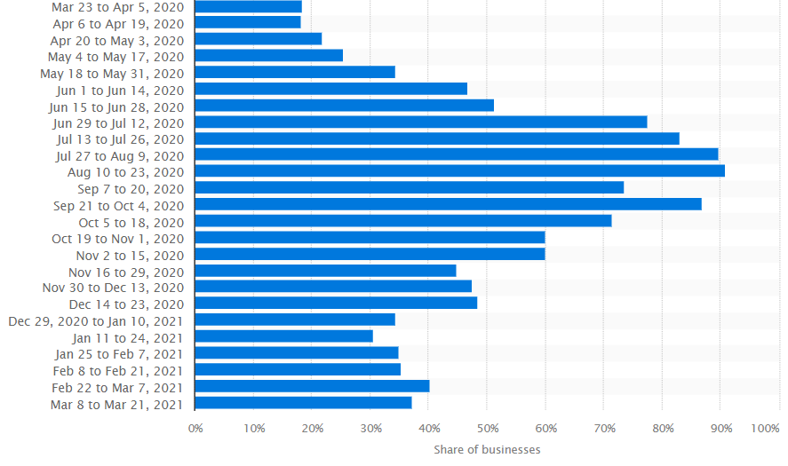
Figure 1: Foodservice businesses trading during the coronavirus pandemic in the United Kingdom (UK) from March 2020 to March 2021
(Statista, 2021)
The spread of COVID-19 has had a significant impact on various sectors, including the hotel and tourism industry (Duric and Potočnik Topler, 2021). The adoption of lockdowns, travel restrictions and health concerns has altered customer behaviour. All these issues are likely to aggravate the drop in income that has been witnessed by Seacrest Lodge. The lodge should have a clear plan to alter this pathway. In order to differentiate itself in a competitive market, this strategy should incorporate modernizing existing infrastructure, increasing the quality of service delivery and undertaking targeted marketing initiatives. The Seacrest Lodge has to regain the top position in the coastal hotel industry by ensuring that it can stay afloat through modern services, keeping up with trends and having a strong online presence.

Turnaround Strategy 400

Financial Projections 300

Risk Assessment 200

Conclusion 100

References
Duric, Z. and Potočnik Topler, J., 2021. The role of performance and environmental sustainability indicators in hotel competitiveness. Sustainability, 13(12), p.6574.
Papadopoulos, O., Lopez‐Andreu, M. and Jamalian, M., 2021. Violation and lack of awareness of employment rights in the United Kingdom's hotel industry: Isolation, fragmentation and barriers to labour enforcement. Industrial Relations Journal, 52(4), pp.315-330.
Revell, K.D., 2020. Luxury Hotels and Urban Hostels: Carl Fisher, Resort Architecture, and the Contrasting Worlds of Miami Beach's Pre-Depression-Era Lodging. Journal of the Society of Architectural Historians, 79(1), pp.39-60.
Statista, 2021. Food service businesses trading during the coronavirus pandemic in the United Kingdom (UK) from March 2020 to March 2021. [Online] Available at < https://www.statista.com/statistics/1168552/share-of-hospitality-businesses-trading-in-the-uk/> [Accessed on 22nd January 2024].
Tan, Y. and Despotis, D., 2021. Investigation of efficiency in the UK hotel industry: a network data envelopment analysis approach. International Journal of Contemporary Hospitality Management, 33(3), pp.1080-1104.
The Seacrest Lodge, 2024. About us. [Online] Available at < https://www.sykescottages.co.uk/cottage/North-York-Moors-Coast-Eastfield/Seacrest-Lodge-931230.html> [Accessed on 22nd January 2024].
Zhang, F., Xiao, Q., Law, R. and Lee, S., 2020. Mergers and acquisitions in the hotel industry: A comprehensive review. International Journal of Hospitality Management, 91, p.102418.

