Course: BSc (Hons) Health and Social Care
Module: Independent Project (BMHP6020_BIRM)

Dissertation: - Introduction and background methodology.

Student ID: 2221995

Student Name: Marjorie Hardware Simmonds

Chapter 1 Introduction

1.1 Introduction
In the United Kingdom (UK), adults are allowed to drink alcohol. When alcohol consumption causes an impact that is negative it is called alcohol misuse. Every-year there are primary research projects to identify and measure impacts of alcohol misuse.
This systematic review will look at what impact there is on children’s mental health as a result of parental alcohol misuse in the United Kingdom (UK).
To achieve this aim, we will:
- Identify any long-term mental health impacts for a child of parents who misuse alcohol.
- Explore a classification of mental health impact for children.
- Analysis information.
- Identify actions that might be taken to mitigate harm to the child’s mental health.
- Explore what recommendations could be based on current evidence, for policies and guidance for health care providers.
These reviews are important. They will support policies and direct or indirect help that might be given to a child.

1.2 Key definitions
Within this dissertation the following definitions are used:
- Mental Health: "A state of well-being in which an individual realises their abilities, can cope with life’s stresses, work productively, and contribute to their community." (World Health Organisation, 2022)
- Impact according to online dictionary Merriam-webster, It is ‘the force of impression of one thing on another: a significant or major effect’.
- Misuse according to online dictionary Merriam-webster, is Abuse.
- Alcohol:’ Is a toxic and psychoactive substance with dependence producing properties’ World Health Organisation (WHO). In British Law, Licensing Act (2003) ‘alcohol’ means: spirits, wine, beer, cider or any other fermented, distilled or spirituous liquor. It does not include any liquor of 0.5% strength or below’.
- Alcohol misuse is ‘defined as drinking in a manner, situation, amount, or frequency that could cause harm to the person who drinks or to those around them’ (National Institute on Alcohol Abuse and Alcoholism 2025).
- Parents According to Education Act 1996 Section 576 The Meaning of “parent”. Is a parent or some who has parental responsibility. This is also the same as the Children Act 1989.
- Child For this work the United Nations Convention on the Rights of the Child (‘UNCRC’), Article 1 states, “(Definition of A child) Everyone under the age of 18 yrs‘
- Systematic is to approach a subject in a repeatable way. Repeat a process of literature review. It will allow comparison. Changes and trends to be seen and identified. Systematic is an approach that it methodical in applying a procedure or plan. It is expected to be thorough and regular. It often relating to or concerned with classification according to the online Merriam webster dictionary.
- Classification from the Online dictionary Merriam Webster is the act or process of classifying. That is classifying to arrange information into classes A class is a group, set, or kind, sharing common attributes:

1.3 Background and current Context
The impact of parental alcohol misuse on mental health outcomes of children in the United Kingdom (UK), is widely accepted as an issue.
World Health Organisation highlights the social harms associated with alcohol consumption.
The Children's Society state’ It is important to understand and address the impact of alcohol harm, not only on the individual drinker, but to those around them especially children.’
The extent of the impact on children’s mental health is to be explored.

1.4 Using Statistics as Evidence.
The Children's Society website home page Headlines that
' 1 in 3 children aged 10-17 experience negative consequences
as a result of their parents drinking.'
The National Association for Children of Alcoholics website home page Headlines
1 in 5 people in the UK are affected by a parent's drinking'
Both are indications of a large problem.
- But what do the numbers mean?
- Are they both correct?
- Are they evidence?

The answer to all the questions is we do not know. This information cannot be used to allocate government budgets or make recommendations. They can only indicate a need for research.
If we do not know what it is, we cannot use the figures as evidence. Only clear systematic methods can give clear evidence.

1.5 Rationale for Research
A Current systematic review is required because:
- Alcohol use and impacts change over time
- Primary research is on-going.
- Government will update policy.
- A need for current Evidence.
Alcohol use and impacts change over time The Nuffield trust (2024) publish figures for alcohol-specific mortality rates. It states that,’ in 2010 mortality rates was 10 deaths per 100,000 population. In 2020 it was 13 and by 2022. it was 14.5. The trend is increasing. This demonstrates change.
Primary research is on-going. A search on the springer nature database for the last 6 years shows 752 published articles including key words. alcohol misuse child wellbeing between. Springer nature link (2025).
Child mental health with parental alcohol misuse impacts. requires identification in Government guidance (Gov.UK, 2021) to provide support services. The care act (2014) says a child will need an assessment.
We need careful analysis that give evidential numbers. This is the rational for ongoing research.
1.6 Objectives
The systematic Review will be conducted carefully, ethically for a meaningful exploration of the objectives outlined below.
- Explore the impact of parental alcohol misuse on the mental health of a child.
- A classification of mental health impact.
- What are the long term impacts for a child of parents who misuse alcohol and what actions might be taken to mitigate harm to the child’s mental health.
- Explore what recommendations could be based on current evidence, for health care providers.
1.7 Conclusion
Only a current systematic review will give evidence.
This is needed to understand:
- Change by comparison with previous reviews.
- Need current and updated recommendations.

Chapter 2 Background Information & Analysis Introduction

2.1 Historic Background
For a big problems that effect populations, we need an overview of the population, change and evolving behaviours.
A Systematic reviews, is a way of collecting lots of primary research in a way to help look at big problems and the prevalences they show.
This type of review is useful to form policy around health and social care practice.

2.1.1 Definitions
- Primary research is measuring and recording results from the original source. Bhandari (2025).

- Secondary research: collecting existing data Bhandari (2025).

- Qualitative research is interpreting data. Bhandari (2025), Not just recording numbers but ‘focus on retaining rich meaning when interpreting data’.

- Quantitative research is using numerical data for statistical analysis.

- Prevalence according to online dictionary Merriam-webster it is the degree to which something is prevalent, that is the amount of a population that is affected.

- Population. according to online dictionary Merriam-webster this is the whole number of people or inhabitants in a country or region

- A credible source is free from bias and backed up with evidence. It is written by a trustworthy author or organization. It is published and peer reviewed. George (2021)

2.2 Theoretical Background
A systematic review is a way to analyse a current area of research and compare with previous area research.
- We need all Information (selection of literature) to be considered in a systematic way.
- Applying classification and identifying attributes will allow comparisons.
- If a review is systematic, it can be used as evidence.
- Ethical and credible literature. This is found by only using credible sources. These will be published work that is ethical, and peer reviewed.
2.3 Systematic process for selection from a source

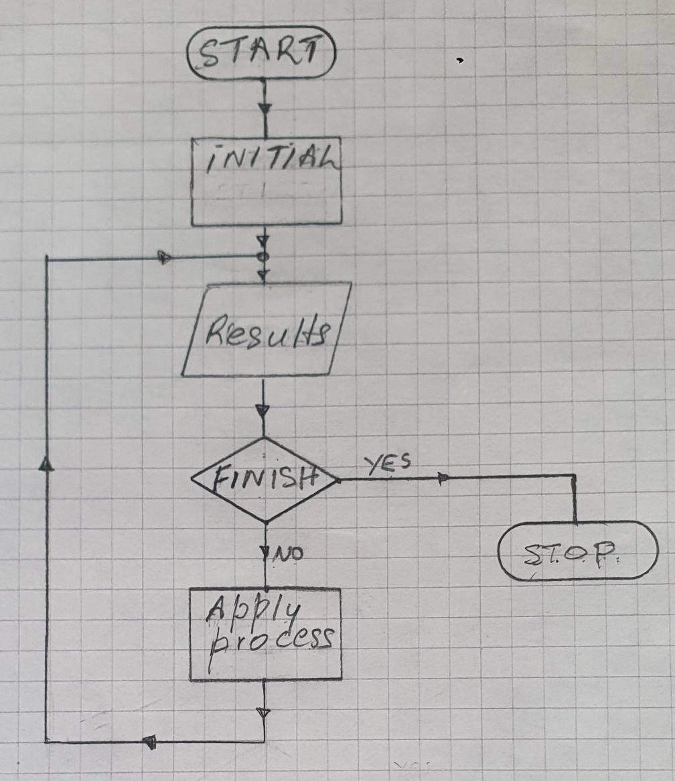

Figure I Method to creating the list of literature to review

Selection of Literature.
Literature will be selected from searches of credible sources using a systematic approach as outlined in Figure 1.
- Start.
Identify a journal database that is an ethical and credible source.
- Initial List
Access the source to create an initial list of literature to review by a search on all literature using keywords. Most databases will allow you to select several key words to search against. The ethical principle here is to collect all the relevant information, All literature must be included and then excluded in a systematic way.
- Result ‘an Initial List.’
- Finish?

YES, review of results,  - stop. | NO, review of results more processing is needed.  - Apply Process to Exclude articles in the review list.  - Exclude duplicates  - Exclude NOT COMPLETE. publication is not available: an abstract or partial publication will not be accepted. Any literature requiring payment for access will not be excluded.  - Exclude other secondary reviews  - Exclude published outside set dates.  - Exclude research with no data
- Result ‘new List.

- Finish?

YES, review of results,  - stop. | NO, review of results more processing is needed.  - Apply Process  Processing on electronic database can be with filtering. But for different databases all filtering may not be available. Filter manually
- Result ‘new List.

- Finish?

YES, review of results,  - stop. | NO, review of results more processing is needed.  - Apply more Process
- Result ‘new List.

- Finish?

YES, review of results,
- stop.

- stop. list added to The systematic review list.

2.4 The Systematic review List
Once all credible sources are reviewed, the systematic literature review list will be carefully worked through. Further exclusions may be done using the process outlined above. On reading an article it may be decided it is to be excluded. If it is not clear a second opinion will be sought.
Thematic Table: All literature will be reviewed and have attributes identified. All of this will be included in a table.

Classification
A Class has shared attributes.
Using the attributes identified in the table a class will be allocated. This classification will be used to compare changes over time for systematic reviews of literature,
- Comparison between like classes in the current and historical review.
- Examination of other characteristics in the classifications to see if there are finding for the current and historical review.

2.5 International Context
The World Health Organisation has recently announced a new collaborating centre on Alcohol Policy and Public Health Research (World Health Organisation 2025)
This is to launch as a partnership to generate information for public health policy and protect of communities from harms associated with alcohol. It is an internation endeavour. Alcohol consumption is a problem worldwide. But Just as there are differences in population from country to country there are differences in approaches needed.
This study is aimed at the UK to minimise these differences.

2.6 National/ local/ UK Context
For the systematic review to be useful their needs as much commonality with reviews it is compared with.
This review is UK based.
That means it will have common:
- British Law, Licensing Act (2003) The Care Act (2014) The Children’s Act (1998)
- Alcoholic products and regulation.
- Cultural norms.
- Population makes up and continuity.

2.7 Conclusions.
This systematic review is secondary research to summarise the current evidence from the body of primary literature It could be used to produce.
- Evidence by comparison with previous reviews.
- Evidence of current position
- Evidence for recommendations.

References
Bhandari, P. (2025) Scribbr What is Qualitative Research? | Methods & Examples Available at: What Is Qualitative Research? | Methods & Examples (scribbr.com) (accessed 07 July 2025)
Care Act (2014) Available at: Care Act 2014 (accessed: 8 June 2025)
Children Act 1989 Available at: Children Act 1989 (accessed: 27 July 2025).
Education Act 1996 Available at: Education Act 1996 (accessed: 27 July 2025).
George,T. (2021) What Are Credible Sources & How to Spot Them | Examples Available at: What Are Credible Sources & How to Spot Them | Examples (Accessed: August 2 2025).
Gov.UK (2021) Public Health Guidance Parents with alcohol and drug problems: adult treatment and children and family services. Available at: Parents with alcohol and drug problems: adult treatment and children and family services - GOV.UK (accessed: 17 June 2025).
Licensing Act 2003 Explanatory Notes Available at Licensing Act 2003 - Explanatory Notes (accessed : 27 July 2025).
Mckibbin, J,and Waton, (2012) A. Leadership & Management in Health & Social Care and Children & Young People’s Service. 2nd edn, Gosport Pearson:
Merriam-webster dictionary Classification Available at CLASSIFICATION Synonyms: 40 Similar Words | Merriam-Webster Thesaurus . (accessed: July 28 2025).
Merriam-webster dictionary Impact Available at: IMPACT Definition & Meaning - Merriam-Webster (accessed: July 28 2025).
Merriam-webster dictionary population Available at: POPULATION Definition & Meaning - Merriam-Webster (accessed: July 28 2025).
Merriam-webster dictionary prevalence Available at: PREVALENCE Definition & Meaning - Merriam-Webster (accessed: July 28 2025).
Merriam - Webster dictionary Systematic Available at SYSTEMATIC Definition & Meaning - Merriam-Webster (accessed: 31 July 2025).
National Institute on Alcohol Abuse and Alcoholism. (NIAAA) (2025) Understanding Alcoholic Use Disorder available Understanding Alcohol Use Disorder | National Institute on Alcohol Abuse and Alcoholism (NIAAA) (accessed: 17 June 2025).
Nkobi,M. and Kingan,M. (2025) The Impact of Parental Alcohol Misuse on Children: A systematic Review available at: Example of systemic review The Impact of Parental Alcohol Misuse on Children: <italic>A Systematic Review</italic>. - EBSCO Acessed (3 august 2025)
Rudestam, K. & Newton, R. (2001) Surviving Your Dissertation, A comprehensive Guide to content and process, 2nd edition. USA; Sage Publications, Inc.
Springer Nature Link (2025) available at Search research articles and books | Springer Nature Link (accessed: June 20 2025).
The Children's Society(2025) Headlines Available at Parental Alcohol (Use | Young Carers | The Children's Society ( Accessed: 21 June 2025).
The National Association for Children of Alcoholics (2025) [NACOA] Website available at: Nacoa: Helping everyone affected by their parent's drinking - Nacoa (Accessed: 22 June 2025).
The Nuffield trust (2024) Alcohol-related harm and drinking behaviour available at Alcohol-related harm and drinking behaviour | Nuffield Trust (Accessed: June 23 2025).
The United Nations International Children’s Emergency Fund, A summary of The United Nations Convention on the Rights of the Child (UNCRC), Article 1 available at: UNCRC_summary-1_1.pdf ( Accessed: 1 August 2025).
World Health Organisation, 2022 Alcohol Available at: Alcohol (accessed: 27July 2025).
World Health ORGANISATION (2025) launches new collaborating centre on Alcohol Policy and Public Health Research. Available at: WHO launches new Collaborating Centre on Alcohol Policy and Public Health Research (accessed: July 28 2025)

