Student: Florin-Ciprian Bucur
Lecturer: Maria Heffernan
Module: Leading and Implementing Workplace Change

Leading and Implementing
Workplace Change

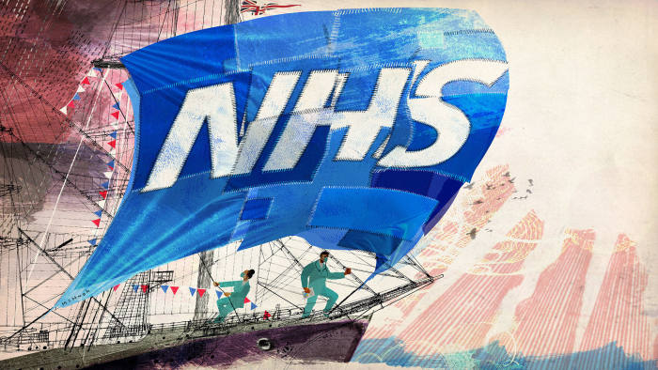

University of Wales, Trinity Saint David
26/03/2021
Executive summary

The response to the Covid-19 pandemic and Brexit has brought numerous changes to the organisation in how health and care services are used and delivered. These include a vital redesign in changes, with thoughtful implication financially and human resources. While the prime mechanism for change has been the urgent need for infection control, NHS is suffering from the loss of numerous non-UK staff. As it stands 13.1% staff that are working for NHS are non-British citizenship, recent year the number of nurses arriving from EU has decreased drastically. A study from Open Edition Journals predicts that due to Brexit, NHS will short the staff with 9.854 nurses only in 2021.
Although Brexit does not bring good news on the human resources side, the new financial year looks promising. 1.3 million extras will be added to the NHS wallet for investing in new staff to meet the new challenges. Also, the UK government allows 20.9 billion for COVID-19 extra founding for 2021/2022; more funding will be allocated as the cost for responding to the pandemic.

Page content

Executive summary……………………………………………………………….
Introduction……………………………………………………………………….
Findings…………………………………………………………………………..

1.0 Introduction

The fallowing assignment describes the issues that NHS (National Health System) is confronting due to Brexit and Covid-19 pandemic. The research is based on many journals and official site, providing the latest and updated information’s regarding the change the NHS has done to adapt to the new system.
The assignment is written by Florin Ciprian Bucur and is devoted to Maria Heffernan being due on 26/03/2021. I would like to thank to my lecturer for the great guidance and patience with us, to my wife for support and to my colleagues for assistance.

2.0 Findings

According to BBC (2008), NHS (National Health System), was created on 5 of July 1948, celebrating this year 73 years of decades of transformations beyond all recognition. The creation of NHS was the product of hard work and motivation from various individuals who belief that the health system was insufficient and needed to be transformed.
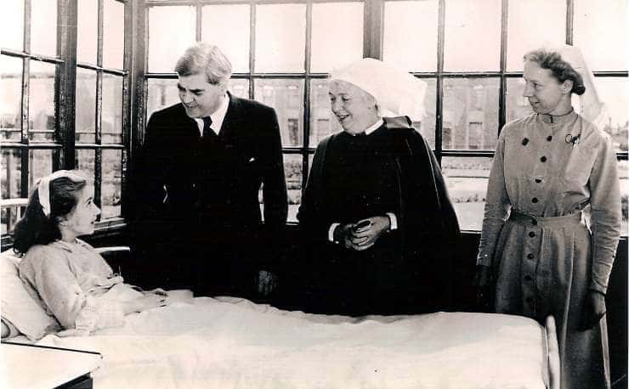
*Aneurin Bevan, Minister of Health, on the first day of the National Health Service, 5 July 1948 at Park Hospital
Before the creation of NHS or anything like that, people were forced to pay for all medical facilities, furthermore the local authorities in was running the hospitals only for the local ratepayers, an approach origination with the Poor Low. Starting from 1929, the local Authorities announce that medical services are providing medical facilities for everyone and on 1st of April 1930 took responsibilities for 140 hospitals, medical schools, and other medical institutions.
The first issues of health provision appeared during the 2nd World War when Great Britain was forced to build Emergency Hospital Services to take care of the wounded, all expenses being on the government. By 1941 the Ministry of Health created a policy where all services should be available to all public, and three years later the Cabinet endorsed “The White Paper” creating the first guidelines for NHS.
The finalised project took hold when Clement Attlee came to power and Aneurin Bevan became the Health Minister. The form that we are familiar now, was embarked by Bevan and it was based on three ideas: firstly, the services provided, secondly healthcare was free and last the care will be provided based on need rather than money. (Brain, 2018)
Dr Roger Henderson(2019) says that in NHS were introduced large reform since 2012, dividing the NHS into two organisations, both working at national and local level. The structure of NHS is now that The Department of State is in charge with for healthcare and funding in the UK and the Secretary of State for Health set policies such as: waiting time and staff target.
As medicine advances, health is on continuous change and the society develops, the NHS must continually move forward so that in the next 10-15 years the service to be tailored for the future. The organisation came up with a plan called “The NHS Long Term Plan” conceived in 2020, drowned up by patients’ group, frontline workers and national experts. The plan is an opportunity for the NHS to consider how to provide tailored care for patients, responsible for their personal needs, and to ensure that NHS is sustainable into future and to continue to offer the same care for future generations. (NHS Plan, 2020)
1.2 Coronavirus has required exceptional things from the NHS and all Health Services across Europe. Now, on 31st of December 2020, the United Kingdom has faced one of the biggest changes on domestic and international legal system in the last 50 years and was the most difficult period of containment. There will be a lot of operational details to sort out, to make the disruption of the UK/EU as smooth as possible, resulting new customer procedures, at a time when NHS is already stretched by COVID-19. The NHS Confederation will support throughout the Brexit process, listening and offering support to frontline workers, reporting directly to the government, issuing information and practice guidelines. (I. Bosch, 2020)
Task 2
In today unpredictable environment, the rate of organisational change is increasing. In the last two years, NHS has suffered not just from Brexit, due to low headcount, but recently from the pandemic and a huge impact on financial and human resources. The 2020 Budget has announced radical financial changes in the NHS, and the Government is forced to set aside additional money to fight the pandemic. Because of these changes, the budget for 2020/2021 will increase for NHS with £20.9 billion of extra funding because of Covid-19 and £394 million a week because of Brexit (Walker, 2020). As covid-19 means less money, Brexit means a double challenge for NHS to keep the skilled staff and to attract sufficient workforce to fill the vacancies. Independent report suggested that more than 22.000 EU staff has already left increasing to 21% from 2015.
2.1 The concept of change management is familiar in today business, but how business manage change depends on the people, the actual change, and the business. A key part on this depends on how well people understand the process of change.
One of the most foundation model for change management is developed by Kurt Lewin back in 1940 and it is still used today. His model is based on three stage process: Unfreeze- Change- Refreeze. (Mindtools.com, 2020)
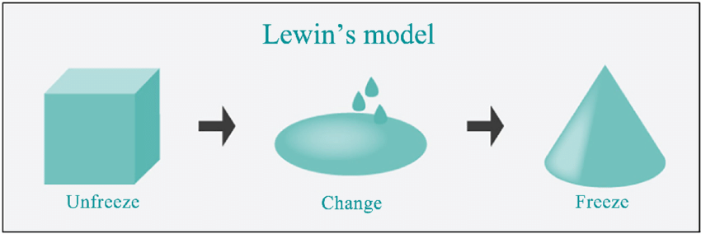

Unfreeze: the first stage of the process prepares the organisation to accept the change, as a necessary.
Pandemics are clearly unpredictable, in 2018/2019 there were 26.000 of unplanned admissions in the UK Hospitals, the number of Covid-19 were double. A more immediate concern is to be seen in the emergency departments were most of the individual present themselves for testing, instead of following the advices from 111. In the event of Covid-19 will be declared pandemic, the NHS will prioritize the patients, will delay admissions and non-emergency care will be postpone ensuring that hospitals have appropriate accommodation to isolate the patients with the highly infectious disease. (H. Buckingham, 2020)
Change: after the uncertainty created by the first stage, in the second stage of Lewin theory, people begin the resolve the uncertainty and to find new way to do things.
In the second stage, NHS focused more on staff health and wellbeing, focusing on the career and practitioner’s safety. The Government has shared the plan to combat the pandemic, which has helped many people to feel empowered to implement changes that will help the patients.
Flexible working- the number of virtual meeting has increased considerably from 13,521 to 90,253 in the first 8 week of pandemic, allowing authorities to find a plan of combat. Consultations have become online, including the option to work from home. There has also been a huge surge in people for volunteering. Thousands of people have sign up; this brought great opportunities but also challenges in making sure all volunteers are working in a safe environment. Where new approaches have worked well have been implemented as rules. In order to innovate the measures are carefully measured, this ensures a new NHS to rebuild better than before. (NHS England, 2021)
Refreeze: when changes are taking shapes, and everyone has embraced the new way, organisation is ready to refreeze. This stage helps organisations and people to internalize or institutionalize the changes.
NHS Confederations declares today, 03/03/2021 that the because of the current lockdown and the COVID-19 vaccine, the infections rate is 6.391 people positive, 343 deaths in the last month and 20.478.619 people have received the first dose of vaccine. (NHS Confederation, 2021)
2.2 Organisational change management has evolved during the last decades, firstly being used for training and communication. Today, in the times disturbance, change management is used as a tool to keep ahead of competition or to survive. Organizations set out multiple programmes and guidelines that need to be implemented to meet customer requirement and use new technology. To use the new technology, employees need to change and improve the way of working. (Gallagher, 2019)
Organisational change benefits:
- The benefits of change management serve as motivators and assessment of progress.
- The organisation can respond faster to customer demand.
- Employees feel supported and motivation is increasing.
- Provides a way of anticipating challenges and to respond quickly.
- Creates an opportunity for the development of leadership and team development. (Connelly, 2021)
Benefits of using model!
Forecasting
Change model anticipate the process change and help people to be prepared. The change model provides a structure and increase employee performance when they feel more supported and understand the change process.
Measure results
Change models require objectives, schedules, and budgets. Once created, the change model provides standards against which can be measured.
NHS Swot and Pestle!
Swot Analysis
Strengths:
- Autonomous- being part of the EU, the UK did not have the full control of borders and dealings. The UK had given part control of the border due to the exchange trade and other security benefits with the EU. While is still bounded by the membership with NATO, leaving EU contributes on gaining more control on over own sovereignty.
- More jobs- now there are 1.7m European workers and 2.3 m International workers in the UK. The increasing numbers of immigrants will be led to difficulties to housing and services. Even though the immigration will not stop after Brexit, the UK government will have full control over borders and immigration policy.
- Embedding public health on a local level- the advantages and strengths of bringing public health at a local level has been raised repeatedly. In some cases, being positioned locally within NHS include being able to influence local partners, having direct access to data and developing the local understanding of the national issue. (Public Health Review, 2016)
Weaknesses:
- Finding talented workers- one of the most significant challenge that NHS is facing is to retain qualified staff. The NHS relies quite heavily on foreign workers to make up for the shortfall. The NHS is currently suffering from staff shortage and Brexit accentuate the problem. Overall, the NHS workforce is fragmented more than ever with high rate of staff turnover and low morale. (Dalingwater, 2019)
- Surviving COVID-19- Health care workers have been the central of the pandemic and have been up by the UK public as national symbol of hope. Many of the healthcare staff have gone above and beyond to provide health services for covid-19 patients, putting themselves at risk. Some of the NHS staff have face stressful environments that effect their mental health. (The Health Foundation, 2020)
Opportunities:
- Cost saving- The divorce between EU/UK is likely to mean more money direct to NHS system, by directly stopping the contribution to the EU. Considering the formula of founding, the government is guaranteed around 100m each week for NHS. (Dayan, 2018)
Threats:
- Recruitment- Brexit already pushed the Sterling to collapse and will push the price up for the imported equipment and medication. Staff cost will also increase. The NHS system is completely dependent on the cheap foreign labour who are prepared to work harder. If freedom of movement is barred, NHS will face problems on recruiting more staff.
- Mental health and wellbeing of staff and patients- The COVID-19 pandemic has retained many of the NHS staff under pressure. They need it to balance the commitment between considering the risk of infection to themselves or family and their duties for patients. This situation has put the NHS staff under pressure and forced to make difficult decisions, and to take actions that are morally changing. (Wilson, 2020)

Pestle Analysis
The PESTLE analysis is a tool used by organisations, having as purpose the evaluation of external business environment. Even more PESTLE analysis forms the basis of recognition of opportunities and threats, that helps in the SWOT analysis. The model shows key aspects of the external environment, that indicates industry attractiveness, potential market or key success factors that helps organisations onto future growth and success. (Perera, 2017)
PESTLE analysis comes from Political, Economic, Sociocultural, Technological, Legal, and Environmental factors that affect the business or organisation. The PESTLE analysis is used onto report to show the numerous struggles that the NHS faces during BREXIT and pandemic. The most critical factors are POLITICAL and ECONOMICAL.
Political factors that affect NHS:
The biggest question mark in the present-day UK politics is that of BREXIT. Leaving the EU decision is has spread numerous consequences on the society, and that is includes community culture like NHS. Brexit comes with uncertainties surrounding medication and equipment is delivered from EU.
Perhaps the most stressful situation is about the staff: a numerous number of staff comes from European Union countries, there are concerns that NHS workers will take a hit, resulting a less positive living condition for foreigners. (Bush, 2019). A report stated by BBC (2018) says that even though that the UK Government created a skill migrants’ system, lower paid nurses, and non-clinical staff such as care nurses will not be covered because of the earnings less than £30.000 a year.
Economic factors that affect NHS:
Chancellor Rishi Sunak, announced at BBC (2020) that extra £3bn for NHS, but he also warns people that “economic shock laid bare” as country faces COVID-19 pandemic. The £3bn will help HNS deal with accumulations in the health service, with thousands of treatments delayed because of pandemic.
Charities also play an important role in helping relief the increasing worry on mental services during pandemic. The need of social distancing and infection control has reduced the number that NHS hospitals can do and the health service already acquiring the substantial number of essential services on the private sector.
Task 3
NHS Leadership during Covid-19
Based on the R.N.J. Graham (2021) NHS has invested a lot in developing the leaders, so they can provide efficient, effective, and suitable person-cantered services. This year (2020) has been a significant accelerator of these activities. In order to adapt with the new change, NHS leaders have used What’s UP as a tool to of sharing any new diseases that acquire during pandemic period, collaboration with different organisations or shareholders or developing new/more equipment, change and innovation are working at accelerating pace.
NHS frameworks adapt their leader to approach and adapt quickly to different situations, that will matter to the years ahead:
- Leaders are equipped to develop high quality health and care.
- Leaders have knowledge of how to practice effective leadership:
- develop and practice support for all staff,
During pandemic, the ways of working has been modified, many teams needed to work at speed, learning from where has been necessary and adapting to a new and better way. The use of positive thinking and relationship building allows an improvement for the team, and with wider support for the future. Once the initial phase of Covid-19 was over, it was vital the NHS leaders to keep the beneficial changes that developed and create a “new normal”.
Leadership has a number of timeless and general caracteristics. Leardeship means building a clear vision and achive it. In today’s NHS, staff at all levels are asked to maximise the outcomes, while minimising NHS costs. The term of leadership in NHS illustrates the various style, belief and attitudes adopted by staff and organsiation when faced whith complex situations. (Evans, 2021)
Currently, NHS have an transactional leadership style. As the name suggest, it view the relationship between healthcare executives and staff as transactional. Acceptiong their positions, staff members obey to leaders, completing their orders. In this leadership style, rewards and punishments serve as motivational tools which healthcare leaders use to encourage their staff. But not always this transactional style is applied, situational (transformational) style is various used when situation ask. Healthcare leaders evaluate the situation and determine which type of leadership makes the most sense. For exemple, when a new staff is learning new tasks, healthcare leaders give orders but in the same time they offer their support. NHS leaders find great advantage this leadership styles that offers flexibility in addressing complex situations. (AHU Online, 2020)
Leadership style plays an important role in enhancing measures in healthcare. Impact on health-related outcomes differs from the leadership style it is applied to. The transactional and transformational leadership style that NHS adopted ensure technical and professional expertise, building capacity, and organisational culture while balancing leadership style and existing skills to improve quality factors in health. (Sfantou et al., 2017)
The NHS is a massive and complex organisation and managing is a difficult task. Based on what Sir Gerry Robinson says, there is a huge influence from NHS managers against the leaders. NHS managers are seen as bureaucrats dressed in grey, that only give orders and push the hardworking frontline staff. Middle managers and leaders are often disempowered and need more support. (Robinson, 2021)

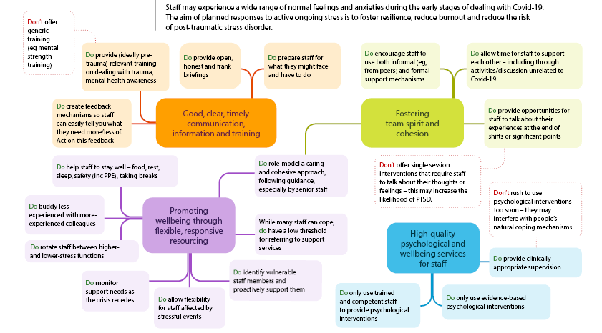

3.2 William Bridges a psychologist the work most of the time with NHS staff explains what psychology transition means and what stages are. She explains that current transition is an internal process, and our heads are catching up with the reality that happens. In responding to COVID-19 many of the NHS staff have changed role and accepted different responsibilities. This is where anxiety arises and motivation falls. Team can divide, people can not adapt to change and other might go to the old ways. Leaders play an important role on maintaining the staff motivated. NHS leaders maintain a clears communication regarding future plans in the combat against the virus, creates short goals, reviewing the process daily so everyone can deal with the current change and develop ideas constantly. (S. Hulks, 2020)
The Covid-19 pandemic is placing a huge pressure on the NHS to deliver safe and high-quality care. Leaders have sharpened their focus on meeting the core needs of staff, ensuring their safety and wellbeing, sustain motivation and help the staff to deal with the current change. During the crisis period, managing emergency response is based around clear coordination, communication, and control, alongside guidance and structures. The main objective of NHS leaders is to ensure a regular break due to high workload, staff not to get sick or patience care to suffer.
3.3 Leaders are facing multiple challenges and anxieties, now, with more than a year (February 2020) since the first wave of Coronavirus install in the UK and the fact that from 1 of January 2021 the deal between the UK and EU has ended. Although the deal is in negation for a while, pandemic crisis is still on, affecting millions of citizens. As a result, many of the most vulnerable citizens are rising since fear, loneliness, and isolation established. The divorce from EU did not happened suddenly, NHS leaders asking the Prime Minister Boris Johnson to delay with another month, as the exit might risk the health of patients during Covig-19 crisis stated by The Guardian (2020).
While the new agreement provides welcome trades, will introduce some new changes, that will have implication on health services, the public and medicines and medical devices and to the scientific research community. Based on different research, 13.1% of the NHS staff have non-British nationality and 5.7% are from EU countries. The key role of nursing in the NHS has dropped drastically since the referendum, and more are leaving the NHS system. The new system that started from 1st of January allow worker from EU and non-EU countries to be subject of some immigration rules. In February 2021, have been announces that the new plan will be a point-based immigration system. (Holmes, 2021) Custom changes and any fluctuation in sterling are likely to result an additional cost on medicines suppliers and an increase in price. Due to the current situation, NHS leaders have negotiated with the Prime Minister and NHS will receive an additional £315 million in the first year alone. The extra money will help NHS to fight against the crisis. (Dayan, 2020)

Task 4
4.1 Change agent is an individual or a group that assumes the task of initiating or controlling the change into an organisation. Change agent can be internal (managers or employees) or external (consultants, government, people). (Lunenburg, 2010)

External: Government:
The Coronavirus pandemic has delivered a profound shock to the UK. The measures to stop the spreading has reached deep into everyone life’s, effecting jobs, income, and salary. The government has intervened with a medium and long impact which will restrict the curve of movement of COVID-19. The UK government plan to combat the pandemic set out a plan based on 4 stages: contain, delay, research and mitigate. It is also foreseen that new legislation is necessary for people to understand the severity of the virus.
The Prime Minister, Boris Johnson has announced during a press conference that regulation will be recommended as:
- Households with any symptoms will be self-isolate for 14 days.
- All citizens will practice social distance, including where possible to work from home.
- Group meeting to be post-pone for at least 12 weeks.
- Mass gathering such as sporting events are suspended.
- The NHS app, the fastest way to see if you are at risk from coronavirus,
- Offer the opportunity for citizens to get free testing (GOV, 2020)
An article from The Guardian (2020) criticises the UK government claiming that mind where too focused on the Brexit and that the pandemic could be ended more quickly if measurement were taken on the time being. With 11 weeks from beginning of pandemic and 14.000 cases, the UK government has announced lockdown. Since March 2020, the UK government has updated daily the GOV.uk sites with guidelines for people to follow, and the latest data.
https://www.gov.uk/government/publications/covid-19-stay-at-home-guidance
In spring 2021, the Prime Minister has announced that the first dose of vaccine has arrived in the UK, available first for those vulnerable, for those above 70 years and for serious heath problem related to COVID-19. The success of vaccination rollout along with the number of infections, is paving way for restrictions to be lifted, guided by the data, in order to avoid putting more unsustainable pressure on the NHS. (Government, 2021)
External- Citizens
Recently, the Kübler-Ross model has been modified and adapted to interpret the reaction from COVID-19 pandemic. Although is a change management tool, the model can be applied in the daily life, and the current problem: how people accept the change.
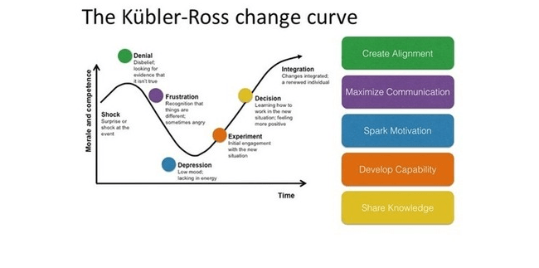
Stage1- Denial: at this stage, people do not understand or accept the need of change. Beginning of pandemic, lots of people denied the existence of the virus, many people sustaining an Conspiration theory, such as “know it all” or “apathetic” people. The Kings College London (2020), based on a recent study shows that people that get their information’s from social media platforms such as Facebook or YouTube, tend to belief more on conspiracy theory, influencing others.
Stage2- Frustration: once people realised that the bad news is real, their response if often resulted with anger. The anger period begins with new government regulations: social distance, mask wearing and lockdown.
Stage3- Depression: at this stage, lockdown was on, people are scared and concern about their loved ones, and depression and negative thoughts are installing, showing more cases of suicide, job lost. (incubators)
Stage4- Acceptance: eventually people have learned to accept that the virus is among us, and they are the only one that can stop it by respecting government regulations.

Task 5
NHS culture!
5.1The culture of an organisation is usually build based on wisdom accumulated on years of practice and the assumption of people working there and meeting challenges. From this assumption, which might be comatose, are determined the values and behaviours. The current NHS culture is no longer based on beliefs and it fails to provide motivation. A motivated staff does not fail in improving the NHS by behaving professionally and in a learning culture. These disadvantages can be avoided by adopting a professional culture, which intrinsic motivation arising from work content and recognition of accomplishment. Stevenson, Robin D, and Donald E Moore (2019)
According to Charles Handy (1932) there are four types of which the organisations use:
- Power- when power remains in the hand of one person.
- Task culture- teams are formed to achieve the organisational goal.
- Person culture- employees feel that are more important than organisation.
- Role culture- employees is delegated based on their experience and specialization.
Before the pandemic, NHS culture was the fourth type of Charles Handy theory called the role culture. The NHS staff have a connection and an understanding of their values and are critical for NHS culture. The following values are designed to support the organisation and to meet the workforce challenges.
The Covid-19 pandemic has magnified the multitude of challenges in the healthcare section. The NHS culture has change, involving leaders more to use their power, influence the workplace culture and thrive positivity. The challenges are greater than before, but the evidence shows that leaders' involvement in the workplace culture influenced a significant change. The significant change that came with the pandemic, shows that the NHS culture has changes, becoming task culture, where all NHS staff are working together to achieve the goal which is dropping the Covid-19 patients and ensuring a better care.
The Guardian presents a set of changes that NHS health system has implemented and the opportunities that arise. Due to pandemic situation, NHS leadership has come out with different changes, the most important one being the culture change. A new and kinder workplace has been created, allowing more life-work balance to staff, treating them with more compassion, and improving the whistleblowing practices. Pay rise is also not ignored, the chancellor Rishi Sunak relating that more money will be available for NHS staff to feel more valued for their work. (Schamroth, 2020)
5.2 The coronavirus has amplified the myriad of challenges in multitudes of challenges in healthcare sector. Although the magic cure has not been invented, a change in culture can deliver miraculous benefits including staff burnout, higher quality, and more productivity.
For a little more over a decade NHS has been wrestling with the shift in culture needed to sustain continuous improvement. Through the current crisis, it has been observed thru social media, a change in behaviour and focus, that staff, not just from the NHS but worldwide, has adapted to support the COVID-19 efforts. The Covid-19 response has highlighted the agility and willingness of staff to collaborate and improve their working habits. Reducing the barriers to change around organisation and government has allowed improvement to thrive.
The culture of frontline workers has been tested during covid-19; in many cases, motivation has strengthened, value for selflessness, care for colleagues, kindness, and creativity has been shone through. Rotas have changed quickly with minimal rules and regulations, putting system interest first. A rising positive mindset has been the biggest driver of innovation, and common objective, with willingness to try new things and the lowering the rank of professional and institutional silos.
The poor level of knowledge of covid-19 has driven an upsurge in research, the NHS working together with private companies and universities (Oxford and AstraZeneca) in developing a vaccine, showing that NHS can be a translational platform of research, competing with a world-class science base. (West, 2020)

Conclusion

In conclusion, the assignment has discussed two main changes that NHS is facing due to Brexit and Covid-19 that will affect all aspects of its operation. The challenges identified in the assignment show that NHS has limitation from the government financially speaking, and it is crucial to be addressed.
For more than a decade, NHS has suffered from a slowdown in funding growth, while there was a huge demand for services. Brexit and covid-19 costs have been massive that added further pressure. Workforce shortages and the finances for NHS have deteriorated rapidly. With more than 10.000 less staff, 40,000 only nurses underlined the fragile state of service delivered.
NHS People Plan is a project that start from 2021 and focus on people, create a culture of inclusion and belongings, as well a future growth in the workforce. The arrival of Brexit and Covid-19 has brought an incredible scale and transformation, showing the contribution of all people. The NHS must build on this momentum and continue to transform.

Appendices

- SWOT Analysis
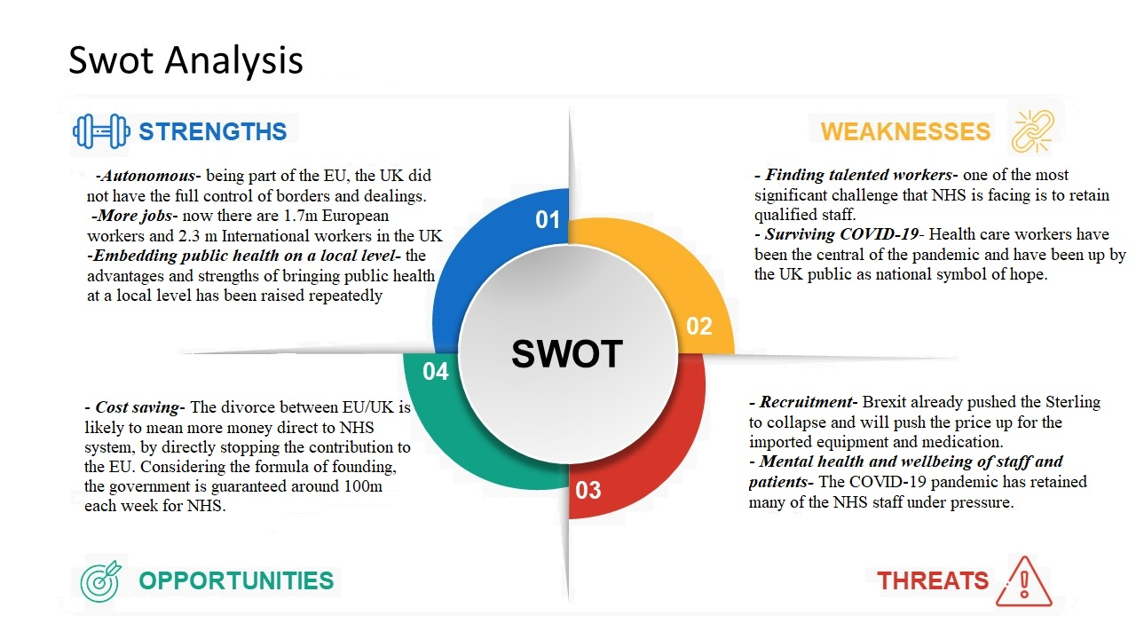

Recommendation

References

- Ahmed, A., 2020. What Are the Benefits of Managing Change in Organizations? [online] Small Business - Chron.com. Available at: <https://smallbusiness.chron.com/benefits-managing-change-organizations-108.html> [Accessed 3 February 2021].
- AHU Online. 2020. 5 Types of Leadership Styles in Healthcare | AHU Online. [online] Available at: <https://online.ahu.edu/blog/leadership-styles-in-healthcare/#> [Accessed 22 March 2021].
- BBC, 2020. Coronavirus: £3bn for NHS but Sunak warns of 'economic shock' to come. [online] Available at: <https://www.bbc.co.uk/news/uk-55032782> [Accessed 9 February 2021].
- BBC, News, 2008. Timeline of the history of the NHS. [online] Available at: <http://news.bbc.co.uk/1/hi/health/7462013.stm> [Accessed 2 February 2021].
- Bosch, I., 2020. What the Brexit deal means for the NHS. [online] Nhsconfed.org. Available at: <https://www.nhsconfed.org/news/2020/12/what-the-brexit-deal-means-for-the-nhs> [Accessed 3 February 2021].
- Brain, J., 2018. The Birth of the NHS - Historic UK. [online] Historic UK. Available at: <https://www.historic-uk.com/HistoryUK/HistoryofBritain/Birth-of-the-NHS/> [Accessed 2 February 2021].
- Brexit, N., 2021. Latest Brexit Updates. [online] Nhsconfed.org. Available at: <https://www.nhsconfed.org/regions-and-eu/nhs-european-office/brexit-and-the-nhs/latest-brexit-updates> [Accessed 3 February 2021].
- Buckingham, H., 2020. Coronavirus: how will the NHS cope. [online] The Nuffield Trust. Available at: <https://www.nuffieldtrust.org.uk/news-item/coronavirus-how-will-the-nhs-cope> [Accessed 3 March 2021].
- Bush, T., 2019. PESTLE Analysis of the NHS. [online] PESTLE Analysis. Available at: <https://pestleanalysis.com/nhs-pestle-analysis/> [Accessed 9 February 2021].
- Confederation, N., 2021. Latest developments. [online] Nhsconfed.org. Available at: <https://www.nhsconfed.org/supporting-members/covid19/latest-developments> [Accessed 3 March 2021].
- Connelly, M., 2021. Benefits Of Change Management. [online] Change Management Coach. Available at: <https://www.change-management-coach.com/benefits-of-change-management.html> [Accessed 3 March 2021].
- Dalingwater, L., 2019. NHS staffing shortages and the Brexit effect. Observatoire de la société britannique, (24), pp.67-86.
- Dayan, M., 2018. NHS planning to safeguard medicines supply in case of no-deal Brexit. The Pharmaceutical Journal,
- Dayan, M., 2020. [online] Nuffieldtrust.org.uk. Available at: <https://www.nuffieldtrust.org.uk/files/2020-10/coronavirus-brexit-briefing-3.pdf> [Accessed 4 March 2021].
- England, NHS., 2021. NHS England » Responding to new challenges and opportunities. [online] England.nhs.uk. Available at: <https://www.england.nhs.uk/ournhspeople/online-version/challenges-and-opportunities/> [Accessed 3 March 2021].
- Evans, N., 2021. NHS Leadership. [online] Improvement.nhs.uk. Available at: <https://improvement.nhs.uk/documents/3438/NHS_Mental_Health_Improvement_Chpter_4.pdf> [Accessed 22 March 2021].
- Gallagher, P., 2019. Change Management- Leadership of change. 1st ed. PFG Publishing.
- GOV.org 2016. Public Health Review: Analysis of responses to the engagement paper - gov. scot. [online] Available at: <https://www.gov.scot/publications/public-health-review-analysis-responses-engagement-paper/pages/4/> [Accessed 4 February 2021].
- GOV.UK. 2021. UK takes drastic measures to tackle COVID-19. [online] Available at: <https://www.gov.uk/government/news/uk-takes-drastic-measures-to-tackle-covid-19> [Accessed 23 March 2021].
- Government, H., 2021. [online] Assets.publishing.service.gov.uk. Available at: <https://assets.publishing.service.gov.uk/government/uploads/system/uploads/attachment_data/file/963491/COVID-19_Response_-_Spring_2021.pdf> [Accessed 23 March 2021].
- Handy, C., 2009. Gods of management. London: Souvenir.
- Helm, T., Harrison, E. and McKie, R., 2020. How did Britain get its coronavirus response so wrong. The Guardian, [online] Available at: <https://www.theguardian.com/world/2020/apr/18/how-did-britain-get-its-response-to-coronavirus-so-wrong> [Accessed 23 March 2021].
- Henderson, R., 2019. What is the NHS and how does it work? [online] Net doctor. Available at: <https://www.netdoctor.co.uk/health-services/nhs/a4489/what-is-the-nhs/> [Accessed 2 February 2021].
- Holmes, J., 2021. Brexit and the end of the transition period. [online] The King's Fund. Available at: <https://www.kingsfund.org.uk/publications/articles/brexit-end-of-transition-period-impact-health-care-system> [Accessed 3 February 2021].
- Hulks, S., 2020. Maintaining motivation in uncertain times. [online] The King's Fund. Available at: <https://www.kingsfund.org.uk/publications/maintaining-motivation-uncertain-times> [Accessed 4 March 2021].
- Kcl.ac.uk. 2020. Social media use linked to belief in Covid-19 conspiracies and breaking lockdown rules. [online] Available at: <https://www.kcl.ac.uk/news/social-media-use-linked-to-belief-in-covid-19-conspiracies-and-breaking-lockdown-rules> [Accessed 23 March 2021].
- Kübler-Ross E. On Death and Dying (Routledge, 1969).
- Lunenburg, F., 2010. Managing Change: The Role of the Change Agent. INTERNATIONAL JOURNAL OF MANAGEMENT, BUSINESS, AND ADMINISTRATION, 13(1).
- Mindtools.com. 2021. Lewin's Change Management Model: Understanding the Three Stages of Change. [online] Available at: <https://www.mindtools.com/pages/article/newPPM_94.htm> [Accessed 3 March 2021].
- Perera, R., 2017. The PESTLE Analysis. 1st ed. Nerdynaut.
- Plan, N., 2020. NHS Long Term Plan. [online] NHS Long Term Plan. Available at: <https://www.longtermplan.nhs.uk/> [Accessed 3 February 2021].
- R.N.J, G. and T, W., 2020. Leadership for continuous improvement in healthcare during the time of COVID-19. Clinical Radiology, 10.1136(76), pp.67-72.
- Robinson, S., 2021. [online] Nhsconfed.org. Available at: <https://www.nhsconfed.org/-/media/Confederation/Files/Publications/Documents/The-challenges-of-leadership-in-the-NHS.pdf?dl=1> [Accessed 22 March 2021].
- Schamroth, J., 2020. Covid-19 has shown the NHS can change. Let's turn that to our advantage. The Guardian, [online] Available at: <https://www.theguardian.com/commentisfree/2020/may/03/covid-19-nhs-change-radically-future-patients-staff> [Accessed 10 March 2021].
- Sfantou, D., 2017. Importance of Leadership Style towards Quality-of-Care Measures in Healthcare Settings: A Systematic Review. Healthcare, 5(4), p.73.
- Stevenson, Robin D, and Donald E Moore (2019) “A Culture of Learning for the NHS.” Journal of European CME vol. 8,1 1613862. 28 May. 2019, doi:10.1080/21614083.2019.1613862
- The Guardian, 2020. NHS chiefs urge PM to extend Brexit transition by a month. [online] Available at: <https://www.theguardian.com/society/2020/dec/23/nhs-chiefs-urge-pm-to-extend-brexit-transition-by-a-month> [Accessed 4 March 2021].
- The Health Foundation. 2020. Surviving COVID: The impact of the pandemic on the mental health of NHS workers | The Health Foundation. [online] Available at: <https://www.health.org.uk/what-we-do/responding-to-covid-19/surviving-covid/surviving-covid-impact-on-the-mental-health-of-NHS-workers> [Accessed 4 February 2021].
- Triggle, N., 2018. Six key questions Brexit poses for the NHS. BBC, [online] Available at: <https://www.bbc.co.uk/news/health-46350966> [Accessed 9 February 2021].
- Walker, J., 2020. The Brexit promises that are being kept. [online] ChronicleLive. Available at: <https://www.chroniclelive.co.uk/news/north-east-news/blue-passports-nhs-funding-brexit-17649663> [Accessed 15 March 2021].
- Warraich, S. and Olabi, B., 2020. Medical leadership in the NHS during the COVID-19 pandemic. Hospital Medicine, [online] 81(6). Available at: <https://www.magonlinelibrary.com/doi/pdf/10.12968/hmed.2020.0250> [Accessed 9 February 2021].
- West, P., 2020. The challenge of culture change in the NHS | HSR UK. [online] Hsruk.org. Available at: <https://hsruk.org/conference-2020/sessions/challenge-culture-change-nhs> [Accessed 24 March 2021].
- Wilson, C., 2020. Mental health impacts of COVID-19 on NHS healthcare staff. [online] POST. Available at: <https://post.parliament.uk/mental-health-impacts-of-covid-19-on-nhs-healthcare-staff/> [Accessed 4 February 2021].

