ORGANISATIONAL CONSULTANCY REPORT
(BMIH6005)

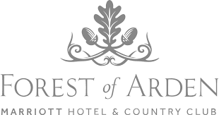

Professional: Talida Raducan(2013549)

Representant of: PHC- Professional Hotelier Consultancy

Date report delivered: 05/12/2022

EXECUTIVE SUMMARY

INK Hotelier Consultancy IHC communicates with Maryam Jennifer, Director of Woods of Arden Marriott Inns and Nation Club, on the goals and scope of addressing the hotel's remaining problems - those that are hindering the development and creation of inns. I received

The manager's girlfriend, Maryam Jennifer, told INK Hotelier Consultancy IHC that the immediate problem is that hotel staff are not doing their jobs properly, as described in "Staff Impact on Guest Satisfaction". said that was the reason. In addition, the managing director requested an organizational consulting report from the company.

The company began working on the project and discovered that the hotel was actually a very sophisticated her four-star hotel. This indicates that the hotel is trying to appeal to a specific group of people: those who are well-earned, educated, and who can actually enjoy and live a luxurious lifestyle. Large enough to accommodate quite a few rooms. In addition, the hotel offers guests a complete experience including pools, hot tubs, golf, tennis clubs, fitness centers, and many other amenities such as room service and bars.

However, the hotel gets a bad review because the staff doesn't do enough to provide a range of services such as: B. It takes too long to clean the room if necessary and when the guest orders something from the 24 hour room service.

In a consulting report describing the hotel and looking at both the micro and macro environment, the poor management style of the hotel he manager was responsible for the low engagement of his employees with guest satisfaction. understood.

As a result, it was demonstrated that the managers are approaching authoritarian management, which is not appreciated by the staff, necessitating some adjustments for the hotel to function properly. In addition, the authoritarian style of leadership implies that managers are only responsible for ensuring that workers complete their tasks and are not personally or physically involved in them.

After that, it was suggested that the authoritarian form of management be completely replaced with the participative form. The participative approach to management implies that the supervisor is actually collaborating with the workforce, providing assistance as well as direction and supervision.

The analysis demonstrated that the participative approach may be the most suitable for this kind of environment, despite the fact that these two types of management are opposites of one another. The Forest of Arden Marriott Hotel & Country Club exemplifies the significance of the management style chosen because it has the potential to affect an employee's well-being.

The employees' mental health has been negatively impacted as a result of inappropriate management, resulting in lower levels of motivation and severe loss of self-esteem. Since managers are responsible for ensuring the well-being of their employees, a change in approach is urgently required.

However, it is strongly believed that if a change in management style is implemented, staff members will have a greater impact on guest satisfaction because they will be motivated to work, resulting in the primary goal of increasing customer satisfaction, which can be measured in a variety of ways, including online reviews. There are a lot of bad reviews right now, but if the suggestions are taken into consideration, it is likely that the good ones will outnumber the bad ones, making the hotel more successful and able to expand and improve itself..

Table of Contents
The introduction 5
The aims and analysis 6
The PESTLE analysis 8
The SWOT analysis 10
MAIN BODY 12
FINDINGS – THE ACTION PLAN 15
RECOMMENDATIONS 16
CONCLUSION 16
REFERENCE LIST 17

The introduction

This report is written to provide a solid understanding of the organizational consulting module currently in operation. As the name already suggests, it's worth noting that a specific hotel with a specific problem was chosen to fix that specific problem. The hotel chosen is the Forest of Arden Marriott Hotel & Country Club in Birmingham, Coventry. This hotel has some issues. In other words, they don't know enough to improve overall customer satisfaction. For example, the main issue is interpreted as 'staff impact on guest satisfaction'. A key takeaway from this is the need to increase employee engagement to improve customer satisfaction. However, this requires performing a series of analyses. As a result, hotels are now being extensively researched using two well-known analyses, in order to improve their deficiencies and turn them into strengths. The hotel's internal environment is explored in detail using a SWOT (Strengths, Weaknesses, Opportunities, Threats) analysis. For the hotel's external environment, we carry out a detailed PESTLE analysis (political, economic, social, technological, legal/legal, environmental factors) to help solve the problem.

It is important to remember that the term 'internal environment' of a hotel refers to the aspects of hotel management that actually take place inside the hotel itself, including members, staff, staff and culture. All of these are closely related to this particular environment. Organizational consulting report. Each of the components mentioned has limitations that affect body selection at the inn, including how the human faculty behaves. Let's move on to another type of environment. The external environment consists of what is seen outside an organization rather than inside it, but still influences how the organization operates. According to Petersen (2019), the external environment actually consists of economic, demographic, political and sociocultural factors.
Moreover, the report has a very clear structure and uses many necessary headings and subheadings to facilitate comprehension. B h y t g f r t e w s x z a q w e r t y u h g d s c B h y t g f r t e w s x z a q w e r t y u h g d s c v B h y t g f r t e w s x z a q w e r t y u h g d s c v B h y t g f r t e w s x z a q w e r t y u h g d s c v B h y t g f r t e w s x z a q w e r t y u h g d s c v B h y t g f r t e w s x z a q w e r t y u h g d s c v B h y t g f r t e w s x z a q w e r t y u h g d s c v B h y t g f r t e w s x z a q w e r t y u h g d s c v B h y t g f r t e w s x z a q w e r t y u h g d s c v B h y t g f r t e w s x z a q w e r t y u h g d s c v B h y t g f r t e w s x z a q w e r t y u h g d s c v B h y t g f r t e w s x z a q w e r t y u h g d s c v B h y t g f r t e w s x z a q w e r t y u h g d s c v B h y t g f r t e w s x z a q w e r t y u h g d s c v B h y t g f r t e w s x z a q w e r t y u h g d s c v B h y t g f r t e w s x z a q w e r t y u h g d s c v B h y t g f r t e w s x z a q w e r t y u h g d s c v h y t g f r t e w s x z a q w e r t y u h g d s c B h y t g f r t e w s x z a q w e r t y u h g d s c v B h y t g f r t e w s x z a q w e r t y u h g d s c v B h y t g f r t e w s x z a q w e r t y u h g d s c v B h y t g f r t e w s x z a q w e r t y u h g d s c v B h y t g f r t e w s x z a q w e r t y u h g d s c v B h y t g f r t e w s x z a q w e r t y u h g d s c v B h y t g f r t e w s x z a q w e r t y u h g d s c v B h y t g f r t e w s x z a q w e r t y u h g d s c v B h y t g f r t e w s x z a q w e r t y u h g d s c v B h y t g f r t e w s x z a q w e r t y u h g d s c v B h y t g f r t e w s x z a q w e r t y u h g d s c v B h y t g f r t e w s x z a q w e r t y u h g d s c v B h y t g f r t e w s x z a q w e r t y u h g d s c v B h y t g f r t e w s x z a q w e r t y u h g d s c v B h y t g f r t e w s x z a q w e r t y u h g d s c v B h y t g f r t e w s x z a q w e r t y u h g d s c v h y t g f r t e w s x z a q w e r t y u h g d s c B h y t g f r t e w s x z a q w e r t y u h g d s c v B h y t g f r t e w s x z a q w e r t y u h g d s c v B h y t g f r t e w s x z a q w e r t y u h g d s c v B h y t g f r t e w s x z a q w e r t y u h g d s c v B h y t g f r t e w s x z a q w e r t y u h g d s c v B h y t g f r t e w s x z a q w e r t y u h g d s c v B h y t g f r t e w s x z a q w e r t y u h g d s c v B h y t g f r t e w s x z a q w e r t y u h g d s c v B h y t g f r t e w s x z a q w e r t y u h g d s c v B h y t g f r t e w s x z a q w e r t y u h g d s c v B h y t g f r t e w s x z a q w e r t y u h g d s c v B h y t g f r t e w s x z a q w e r t y u h g d s c v B h y t g f r t e w s x z a q w e r t y u h g d s c v B h y t g f r t e w s x z a q w e r t y u h g d s c v B h y t g f r t e w s x z a q w e r t y u h g d s c v B h y t g f r t e w s x z a q w e r t y u h g d s c v

The aims and analysis

A related history and brief research of the Forest of Arden Marriott Hotel is provided in a separate section of the Organizational Advisory Report. By providing a brief history of the hotel, it becomes possible to study the hotel scientifically and strategically using appropriate analytical tools and techniques. This section is specifically designed for hotel internal environments where the SWOT method applies and external environments where the PESTLE analysis applies.

The Forest of Arden Marriott Hotel and Country Club was first established in the late 1930s after Marriott was founded in Washington, D.C., USA in 1927 (Marriott, 2021).

The resort or hotel is located in Birmingham, Coventry, in a green area as the name suggests. As for the hotel's location, website sources say it lies between Birmingham and Coventry and is within 16 kilometers (16 miles) of Coventry Cathedral, one of the world's most famous cathedrals, and within 16 miles of the National Exhibition Centre. closer than that. Over 6 miles away. The National Exhibition Center is worth mentioning as it is even closer to other attractions such as shopping malls and Birmingham Airport once guests arrive there. In this case, travelers often prefer hotels that are close to their means of transport, which can be seen as a significant advantage for hotels, especially for travelers from other countries wishing to visit the UK (Cohen, 2021).
In addition, the hotel is actually surrounded by rice fields and nature, giving a sense of tranquility despite being in the countryside. A closer look at the location reveals that the hotel pays more attention to the surrounding nature, which can be seen as an advantage of the overall result.Forest of Arden Marriott Hotel has its own nature conservation There is a ward, which shows that it is environmentally friendly and eco-friendly. The hotel also provides for electric vehicle drivers by providing charging stations. This part of the hotel description is especially important. Because today people are willing to pay more to stay in such hotels. Looking at the stars given to the different departments of the hotel, we can see that the place itself - the environment - got a very high score of 4.6. Performer. This is because today people are always in a hurry and are always in a toxic environment.So when you go on vacation, you want a beautiful private property where you can relax, bloom flowers and clean the air. We are willing to pay more for nature reserves (Hydrinity, 2018).

The customer's inn he ranks similarly to the four-star inns, offering visitors a very sophisticated choice. From here, if you take a closer look at the star rating, the hotel's service rating is below 4.2 stars, which is not bad at all. This is a few percentage points lower than the score the hotel location got in Google reviews (Google – Forest of Arden Marriott Hotel and Country Club Birmingham).

The Forest of Arden offers guests a wide range of amenities typical of a luxury four-star hotel. In addition to the bar, guests wishing to spend time at the hotel will have the following amenities at their disposal:

• Fitness center for sports fans.
• Spa benefits to unwind after a long day.
• Sauna
• A cafe with a wide variety of ingredients and dishes.
• Buffet breakfast is available for an additional fee and is not included in the room rate.
• Swimming pool • Tennis lessons or games

Additionally, if you have any questions or concerns, please contact our 24/7 front desk. The hotel also has free parking for guests. Specialist children's programs add another service to the list.

If you want to stay overnight, you can choose a room. However, guests do not have access to air conditioning or private bathrooms in all rooms, which is a major problem, especially in the summer, when heat waves are at their strongest. Hotels can also offer event services to their guests. However, the history of the hotel does not provide much detail, giving the impression that the hotel is not well known for hosting events.Many people use the tennis and golf courses in Arden Woods. , with multiple playgrounds.

The PESTLE analysis
For a better overview of the positive aspects of the hotel and the negative aspects of the hotel for both of the environments, the examination will be conducted:

A tool called PESTLE analysis is being used to learn as much as possible about the macroenvironment (external environment). This strategic approach gives a better picture of a situation, which helps with making decisions (Oxford, 2020).

Factors political:
• Because the Forest of Arden Marriott Hotel is a part of the hospitality sector, any decision made in this area will have a direct impact on the hotel.
• Because the hotel is governed by the government, it must act in accordance with both governmental and parliamentary decisions (NDML, 2015);
• On the other hand, the hospitality industry is always subject to government pressure, and Arden is no exception. This is especially true in recent years as a result of restrictions imposed to stop the spread of the deadly virus (GOV.UK, 2021).

Economic Issues:
• It comes as no surprise that the economy as a whole is in serious danger, and the virus COVID-19's global spread is the primary cause of this. In point of fact, this aspect is extremely broad, but in a brief period of time, the industry to which the Forest of Arden belongs – the hospitality sector – has been severely impacted by the suspension of events. If the events weren't allowed, there wouldn't be any profits or money made, which would leave gaps in the economy (IMF, 2021).
• The Forest of Arden is directly impacted by the aforementioned gaps in the economy because it lacks the funds to benefit from government assistance, such as support programs.
• When it comes to losses in the economy, nearly everyone is suffering to some extent (AI, 2020).

Social Factors: The hotel industry and the society as a whole are greatly benefited by the fact that the society is the one who determines whether a hotel is worth visiting, for example, through feedback. In essence, industries are attempting to meet the demands and requirements of society in order for society to utilize the services they provide, thereby generating profits for industries. As a result, it's important to mention the self-regulatory process model known as Corporate Social Responsibility (CSR), which ensures that a company acts fairly and is transparent with its customers, stakeholders, and the general public. A positive aspect of this is the fact that a company that adheres to corporate social responsibility is actually making even greater contributions to the economy and the environment by participating in social activities (Fernando, 2021). In addition, one conclusion that was to be drawn from the hotel's description was that Arden is a part of the CSR program.

Technological Factors:
• The hospitality industry is benefiting from one of the world's most influential factors: technology.
• Innovation has expanded significantly over the past few years and, if harnessed appropriately, shelters can take very valuable steps to build it (Robinson, 2021).
• In relation to its hotels, Forest of Arden uses technology for a variety of tasks, including departmental and staff communication. Hotels are using technology differently, allowing potential customers to book services online. It's faster than a phone call.

Legal Factors:
• In this way, everything is critical for the working of the inn, the law some portion of the full scale climate is much more to be viewed as along the political angles - these two are cooperating to safeguard both the buyer and the supplier. The hotel industry must be aware of any new laws that are enacted in order to comply with them (Assetsure, 2021); this means that the hotel industry must comply with any new laws that are enacted.
• If you don't follow the law, you might get sued, which could hurt the hotel's reputation and cost a lot of money;
• Knowledge is essential for the hotel or any other business to function properly;
• It should be noted that an escalating lawsuit against the hotel may even result in its closure (Thompson, 2018).
• Forest of Arden Marriott has not been sued to this point.

Environment Factors:
• The hotel is making significant contributions to the environment, as mentioned, as part of CSR;
• The hotel may be negatively impacted by a number of environmental issues, such as the extreme climate change and global heat that the world has experienced over the past few years;
• Additionally, the hotel's wastes, such as water, energy, gas, and electricity consumption, are included in the environmental aspects. On the other hand, hotels can take steps to try to reduce wasteful consumption, such as food waste (Advantaged Hospitality Technologies, 2019);
• When discussing the effects that the environment has on the Forest of Arden, it is important to note that the weather can either be the hotel's friend or foe. A sunny day is an advantage, while a heavy downpour could be a disadvantage.

The SWOT analysis

The SWOT analysis is a tool used to learn as much as possible about the internal environment (microenvironment). This strategic approach gives a better picture of a situation, which helps with making decisions in the future.

STRENGTHS:
• Looking inside the hotel, it is a 4-star luxury hotel and has some strengths, including long arrival times.
• His second strength of the hotel is its location. This may be one of the reasons people choose this hotel for its clean air and lush vegetation.
• Another attribute is the playground that the property offers to its visitors. This includes a uniquely organized space for children and dedicated games for children. Additionally, Woods of Arden provides lifeguards with the opportunity to watch children register. For programs consisting of intuitive and educational games.

WEAKNESSES:
• This is the most offensive section of the advisory report. This outlines the hotel's issues, including the manager's main complaint regarding 'the impact of staff on guest satisfaction'. Since this is the main issue, we will address it first. However, research has revealed that there are other less important issues to discuss.
• Continuing from the previous point, there were complaints that the hotel did not meet expectations for food, especially breakfast. However, this issue is actually related to the hotel's main problem: the impact on the staff.

OPPORTUNITIES:
• The actual meaning of the opportunity applies.
• A meeting with all employees can make a difference. • Arden Marriott Hotel's best opportunity is to focus on employee satisfaction first. A lot of employee health knowledge is required here. An unsatisfied employee cannot satisfy a guest.
• Doing a 360-degree review definitely benefits hotels. - A 360-degree performance review is a process that gives everyone in your organization the opportunity to provide feedback to all other employees and see what other employees are saying about you. This includes everyone in the hotel and is completely anonymous (Custom Insight, 2021).

THREATS:
• As expected, the biggest threat to the Forest of Arden Marriott Hotel & Country Club is the hotel's current problems, especially its employees' inability to address customer service. Note that employees' contribution to customer satisfaction is directly proportional to their own job satisfaction (Employee Benefits, 2018).
• The list of threats can be expanded to include threats that have always existed (such as hotel competition for the best hotel). This may seem strange, but it is a positive sign because competition not only reflects a sense of fear, but also shows that other companies are afraid of certain companies (Myers, 2016).

MAIN BODY
This issue, raised by the hotel manager, turned out to be a major issue for the Forest of Arden Marriott Hotel & Country Club after a thorough examination of the hotel's micro- and macro-environment.

After numerous complaints related to the service provided by staff, especially customer service, the problem was identified as staff impacting guest satisfaction, including extremely slow food delivery. rice field. For this reason, the rating is aimed specifically at the hotel's catering department and waitresses.

Also, problem departments have been identified and the first phase has been completed. Therefore, presenting a solution to the problem is the next important step. But before we do that, we should put forward some theories that could positively impact the hotel. Knowledge is the key to everything (Malek, 2015).

It's all about the chosen type of leadership, starting with employee satisfaction and ending with managers.

Theory X and Theory Y, put forward by McGregor in one of his books, The Human Side of Enterprise, are the most important theories that need to be mentioned, and are the ones that help HR managers rethink their decisions, decisions, decisions. help you to action. The basic premise of this theory is that his two different management approaches are:

1. X is an authoritarian leadership style.
2. Y is a participatory management approach.

These two different leadership styles are known to have different effects on delegates. Opportunity for the boss to become a tyrant - also called a terrifying method. According to the X strategy, managers are more laissez-faire, meaning they only manage and direct work.

On the other hand, if you look at the meaning of Theory Y, it means exactly the opposite.
If employees seem enthusiastic and proud of their work, the management approach is her Y-type, participatory management that actually works with employees rather than just giving directions.

Reviews found on various booking websites indicate that the manager is authoritative as the management style is X-theory.

Please see the attached images below

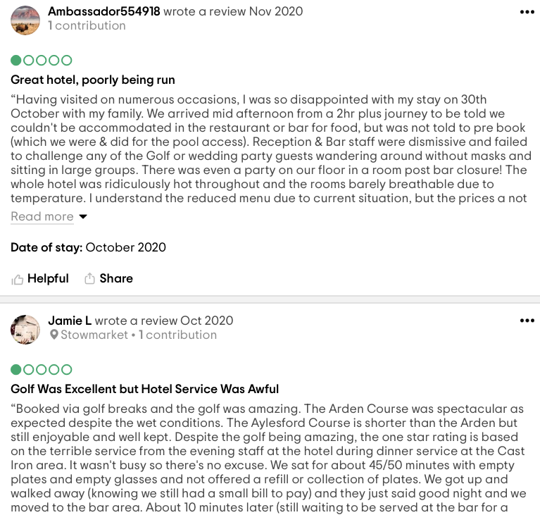
B h y t g f r t e w s x z a q w e r t y u h g d s c B h y t g f r t e w s x z a q w e r t y u h g d s c v B h y t g f r t e w s x z a q w e r t y u h g d s c v B h y t g f r t e w s x z a q w e r t y u h g d s c v B h y t g f r t e w s x z a q w e r t y u h g d s c v B h y t g f r t e w s x z a q w e r t y u h g d s c v B h y t g f r t e w s x z a q w e r t y u h g d s c v B h y t g f r t e w s x z a q w e r t y u h g d s c v B h y t g f r t e w s x z a q w e r t y u h g d s c v B h y t g f r t e w s x z a q w e r t y u h g d s c v B h y t g f r t e w s x z a q w e r t y u h g d s c v B h y t g f r t e w s x z a q w e r t y u h g d s c v B h y t g f r t e w s x z a q w e r t y u h g d s c v B h y t g f r t e w s x z a q w e r t y u h g d s c v B h y t g f r t e w s x z a q w e r t y u h g d s c v B h y t g f r t e w s x z a q w e r t y u h g d s c v B h y t g f r t e w s x z a q w e r t y u h g d s c v h y t g f r t e w s x z a q w e r t y u h g d s c B h y t g f r t e w s x z a q w e r t y u h g d s c v B h y t g f r t e w s x z a q w e r t y u h g d s c v B h y t g f r t e w s x z a q w e r t y u h g d s c v B h y t g f r t e w s x z a q w e r t y u h g d s c v B h y t g f r t e w s x z a q w e r t y u h g d s c v B h y t g f r t e w s x z a q w e r t y u h g d s c v B h y t g f r t e w s x z a q w e r t y u h g d s c v B h y t g f r t e w s x z a q w e r t y u h g d s c v B h y t g f r t e w s x z a q w e r t y u h g d s c v B h y t g f r t e w s x z a q w e r t y u h g d s c v B h y t g f r t e w s x z a q w e r t y u h g d s c v B h y t g f r t e w s x z a q w e r t y u h g d s c v B h y t g f r t e w s x z a q w e r t y u h g d s c v B h y t g f r t e w s x z a q w e r t y u h g d s c v B h y t g f r t e w s x z a q w e r t y u h g d s c v B h y t g f r t e w s x z a q w e r t y u h g d s c v h y t g f r t e w s x z a q w e r t y u h g d s c B h y t g f r t e w s x z a q w e r t y u h g d s c v B h y t g f r t e w s x z a q w e r t y u h g d s c v B h y t g f r t e w s x z a q w e r t y u h g d s c v B h y t g f r t e w s x z a q w e r t y u h g d s c v B h y t g f r t e w s x z a q w e r t y u h g d s c v B h y t g f r t e w s x z a q w e r t y u h g d s c v B h y t g f r t e w s x z a q w e r t y u h g d s c v B h y t g f r t e w s x z a q w e r t y u h g d s c v B h y t g f r t e w s x z a q w e r t y u h g d s c v B h y t g f r t e w s x z a q w e r t y u h g d s c v B h y t g f r t e w s x z a q w e r t y u h g d s c v B h y t g f r t e w s x z a q w e r t y u h g d s c v B h y t g f r t e w s x z a q w e r t y u h g d s c v B h y t g f r t e w s x z a q w e r t y u h g d s c v B h y t g f r t e w s x z a q w e r t y u h g d s c v B h y t g f r t e w s x z a q w e r t y u h g d s c v

v

The success of the hotel and the growth of the Forest of Arden Marriott Hotel depends on the happiness of its employees. In addition, promoting well-being prevents future misunderstandings, leads to positive work environments, and promotes health and well-being for the benefit of all, including employee engagement and company performance ( CIPD, 2021).

It's fair to say that the hotel has many positive aspects such as: B. The location and staff are good, but lack of services such as room service, problems in the food and beverage department, etc. B. Serving Cold Meals and Postponing Serving Times.
Note that these issues can be easily resolved with the right approach.

Chief importance refers to the individual skills and abilities necessary to lead an association as well as support a group of people, also called workers (Reh, 2020). The hotel's problem lies in the behavior of the manager. As mentioned earlier, Forest of Arden managers are more likely to adopt an authoritarian style that is detrimental to employee well-being and self-esteem.

If we change our leadership style from the actual current model, known as Theory X, employee happiness will improve and employees will start performing their jobs perfectly. We are proud to be part of a strong workplace, view all difficult tasks as constructive challenges (Smarp, 2021), and know that hard work pays off. In fact, the point here is that managers need to motivate their employees.

Some of the most common employee motivation strategies include:

1. Financial Compensation
2. award;
3. Increase.
4. Paid vacation
5. 6. Promotion Small gestures like: B. Congratulate your employees and tell them they are doing a great job (Vantage Circle Blog, 2021). Technically, the problem is caused by leadership style, so if this is addressed and managers treat their employees differently, they will clearly see that things are changing for the better. increase. Employees are then more likely to perform as expected and do only what is necessary to meet customer expectations. B. Don't be late for dinner because most complaints are food related.

However, the chef may also regret the dish, so the food and beverage department may also be to blame. As a result, this part of the hotel is in the same situation as the rest of the resort. As a result, cooks should be treated as well, resulting in improvements. Hotel food departments, on the other hand, are not as fluid as other departments such as housekeeping and require a different approach. This may mean that the manager will visit the hotel kitchen in person to talk to you. However, this is only an option. We recommend meeting with all hotel departments to finalize everything. Another benefit is that employees see transparency in management procedures (Salem, 2021) and gain the confidence they need to help the organization succeed (EOA, 2021).

FINDINGS – THE ACTION PLAN
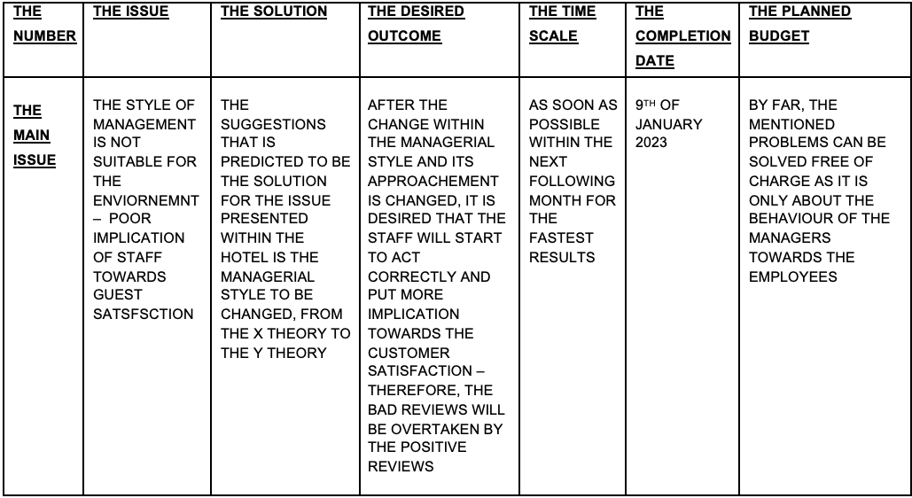
- 1. The first step in actually extending what the table shows is recognizing that the behavior managers are modeling for their employees is not the right one.
- 2. As a result, we should be aware of the presented theory, called "Theory X and Theory Y", and be able to easily understand what this means.
- 3. After accepting the theory, the situation as a whole should be considered to determine the appropriate treatment.
- 4. Before doing this it is important to understand the scope of the situation. In short, the Forest of Arden Marriott Hotel claims that due to a lack of staff engagement, you are not getting the treatment you need. Leadership behavior must change to address this issue and help organizations achieve maximum success.
- 5. After that, the majority of reviews will be positive, and even fewer negative reviews, so the desired outcome is much more likely to be observed.
- 6. However, although there is a deadline, we recommend that all necessary changes be made within one month. This should give him the desired result by the end of July at the latest.
- 7. When it comes to budgets, we don't have budgets because money can't solve our problems. It's all about employee well-being and motivation, including management style, which is the main issue.

RECOMMENDATIONS
- This consulting report can make the following recommendations following all examinations:
- • A change in management style: the personnel's low well-being, mental health, and motivation make the current management style unsuitable for this environment. The customers are dissatisfied, and even more so, they are expressing their displeasure with the services as a result of the implication of the employees; Last but not least, the hotel as a whole, which isn't up to the 4-star standard;
- • The implementation of the 360-degree evaluation so that everyone can provide and receive feedback for managerial purposes and the hotel's benefit;
- • Hold more staff meetings as frequently as possible to stay up to date on everything going on at the company.
- • Additionally, if the hotel's social media platforms are better managed, it could really improve, so it's also recommended to take better care of the social media aspect of the business.

CONCLUSION
The poor management provided by the hotel's managers was shown to be the primary issue at stake. It is supported that a difference in the style the board to be the arrangement of the both the central concern of the lodging, as well as different issues which are really a development of the main point of contention.

We, the INK Hotelier Consultancy IHC, are pleased that you have chosen to use our services, and we hope that this consulting report will assist in resolving the issues that have been brought up at the Forest of Arden Marriott Hotel & Country Club! Please don't hesitate to get in touch with us if you have any additional questions or concerns.

REFERENCE LIST



