EFFECTIVE TEAM WORKING AND COMMUNICATION
MODELS OF COMUNICATION
BY

IOAN-LAURENTIU ENACHE 2011896
LECTURER: ZAINAB ATTA
MODULE CODE:BMSW4002-LON

Communication is the way we express information such as emotions, ideas, thoughts. Communication may occur with spoken words, non-verbal gestures (also known as body language), signs and symbols. Communication can be understood as transmission, exchange, meaning and discourse.
Every so often, we use media to communicate, especially nowadays, due to the pandemic. We found ourselves unable to meet our families, co-workers, and friends due to legal restrictions in place, and we use media to make contact with them or see them. For me, media has been ever so presented even before. I am a foreigner in England, and my family lives in Romania still. All these years I have been away, I felt grateful for having the opportunity to use media because this made me feel somehow home by giving me the chance to see my family with no extra financial costs and in real-time. I also use media for social and leisure purposes, and I have all sort of socializing platforms accounts where I am pretty active. Media is fantastic; I got to meet so many people from different cultures and backgrounds, share experiences and emotions, and again, in real-time and not costly. Media also gave me a great opportunity to information and knowledge, especially now when again, Covid-19 made everything that was normal almost impossible and I was determined to start higher education last year; thanks to media, I can attend online courses and become a graduate after a year of studying online. I also work from home, the fact that would be impossible without the media as one of my jobs is the office where I should meet more than four team members.
Media can be: technical (audio, computers, phones, etc.) or broader definition ( our eyes, hands, ideas, etc.); however, the working media is frequently used only for the technical media.
Although media has many benefits and is easing our lives, I have experienced many difficulties and errors while using media. Media is impressive and easy to access, but it can make communication difficult if not used effectively. There are "tools "and theories in making communication effective, but I never taught that communication is hard to be effective if there is no basic knowledge about it. I did not have much knowledge of it, and as much as I observed, many people lack the ability to communicate effectively. Communication seems easy; everybody can share. There are no restrictions on this, but because of the excessive use of media and unskilled people in this sector, communication errors occur. People can't examine where and how this happens in many cases. People end up blaming each other for poor communication. We are just not following a systematic way of communicating to make this effective; everybody is rushing and is distracted by day-to-day life.
I can see improvements ineffective communication since I have studied communication models. The numbers of communication errors are much smaller before these models of communication were preset to me within the class by the lecturer.

MODELS OF COMMUNICATION

- SHANNON AND WEAVER

In 1948 Claude Elwood Shannon wrote an article "A Mathematical Theory of Communication" in Bell System Technical Journal with Warren Weaver.
Shannon was an American mathematician, and Weaver was a scientist.
Later on, the "mathematical theory" become the Shannon and Weaver Model of Communication, also known as: "the mother of all models". The model is the most technological of all the linear models.

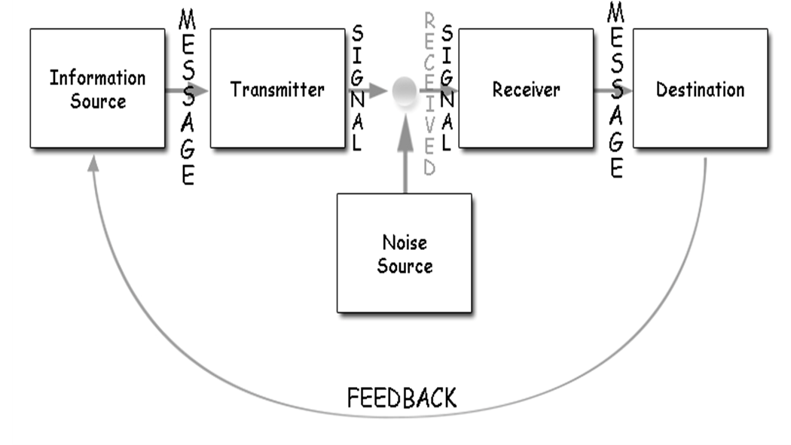

This model is based on six concepts: SENDER, ENCODER, CHANNEL, DECODER, RECEIVER, NOISE;
SENDER(information source)= person that initiates the message and chooses the channel
- ENCODER (transmitter)= sender that uses a machine, converts messages into data or signal
- CHANNEL= medium the messages are being sent by
- DECODER (receiver) = machine used to convert signals or data into a message or the receiver which translates the message from signals
- RECEIVER (destination) – gets the message or the place the message must reach. The receiver provides feedback according to the statement.
- NOISE= is the physical disturbance created by the environment and people etc.

The sender encodes the message and sends it to a receiver by a chose technological channel (telephone). The sender converts the message into codes understandable by the machine sent in information through a medium. The receiver has to decode the message before understanding it and interpreting it. The channel can have noise, and the receiver might not have the capacity to solve it, which might cause problems in the communication process.
This model can be understood as communication by transmission. This communication model is used to deliver messages, assuming that communication will take place at some period. The properties of this model and that is linear and simplistic—As simple as that this model of communication becomes problematic when it comes to transmitting full complex communication.
Shannon and Weaver model of communication has advantages and disadvantages:
- Disadvantages:
Technical problems- how a channel causes a problem
Semantic- is the meaning of the message sent and received differently.
Effectiveness problem-how effective does the message cause reaction
- Advantages:
The Concept of noises helps the communication by removing the noise or any factor causing the noise.
The Concept is based on a two-way process, which makes the model suitable in general communication and is taken and quantifiable.

- Criticism of the model:

It is more suitable for interpersonal communication than group or mass media communication.
The sender plays the primary role, and the receiver is the passive part of the communication.
The feedback is less important than the message initiate by the sender
Another criticism taken by the model is that human communication is no mathematical.
"misleading misinterpretation of the nature of human communication."

A case study from in-class activity with Zainab Atta

Pedro works on a building site, and Maria is his wife.
One day Maria phoned Pedro.
'Hello, Pedro, when you're coming home, see if you can get me a chicken.'
'Okay,' replied Pedro.
When he got home, Pedro took off his boots and coat and went into the kitchen.
'Maria, where are you?' He said.
'Here – in the sitting room,' she said.
When Pedro went into the sitting room, Maria said, 'Where is the chicken?'
'What Chicken?' Asked Pedro.
The one I asked you to get on your way home.'
Oh, no! I thought you said when I come home, I will see you in the kitchen!

Pedro and maria's misunderstanding could be avoided by choosing another type of media/ channel due to Pedro working on a building site. A message would be more effective as I could read instead ten trying to hear a word that sounds quite similar to another. This communication error could be avoided by choosing the channel/media wiser. Or they are making sure the physical noise does not interfere with the meaning of the conversation.
I also experienced these issues during the online courses; due to the physical noise created in the channel, I was marked as absent or consed with another student. My name is Ioan Enache. His name is Ivan( I won't disclose the surname due to GDPR). When lecturers take attendance, er are called one after another, and I always seem rude or not paying attention because I can hear my name while he is called or he does this. Of course, this could be avoided if the noise in the channel would be minimized but studying online within a group of 30 students is not easy for any of us. Another way would be to have attendance in writing, but this is the protocol within the University, and I understand.

SCHRAMM'S MODEL OF COMMUNICATION

This model of communication was created in 1954.
Schramm strongly agrees that communication is of no use until the message is carefully put into words and conveyed to others. Encoder here plays an essential role because he initiated the contact by getting the data into content. When the information reaches the recipient, his prime responsibility is to understand what the speaker intends to convey. Only when the second party can understand or decode the information that the sender wants to communicate, communication takes place.
The encoded and decoding make it possible for the information to flow between two individuals.
And those are the principle of Schramm's model of communication. Coding and Decoding. He claims these two components are essential in creating effective communication.
Unlike the Shannon and Weaver model of communication, Schramm strongly agrees that effective communication can only occur if feedback is being sent from the receiver back to the sender. ( find the diagram below).
Sender
M↓ ↑M= message
Receiver

Case study Maria and Pedro:
To avoid miscommunication between Pedro and Maria, Pedro could have sent feedback to Maria and check the meaning of the conversation.

BERLO'S MODEL COMMUNICATION

In 1940 developed the sender-messenger-channel-receiver (SMRC) model of communication from Shannon and Weaver model of communication 1949). He describes factors affecting the individual components in the decision making. The module focuses on encoding and decoding, which happens before the sender sends the message and the receiver receives the message, respectively.
Berlo's model focuses on components to describe the communication process.
SENDER, MESSENGER, CHANNEL, RECEIVER. Each component can be affected by many factors.

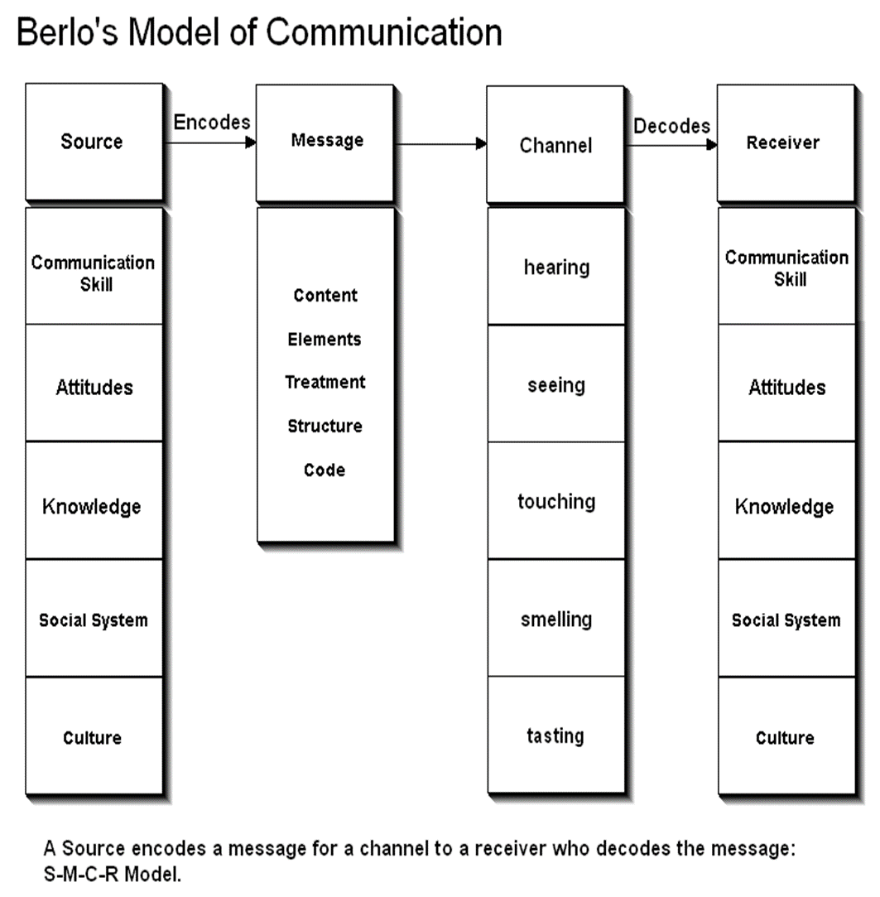

As you we can see, each component is affected by other factors:
The source can be affected by:
Communication skills. I f the sender has good communication skills, the message communicated is way better than if the communication skills of the ender require improvements.
Similarly, if the receiver an't grasp the message, than it would not be communicated effectively.
Attitude. This creates the effect of the message and together with he sender and environment can change the effect of the message.
Knowledge. Being familiar with the topic helps to communicate the message better.
Social system. Values, beliefs, culture, law, rules and other social factors. A person from a different culture might find something offensive; something might be expected for you, but others can take that as offensive.

Message can be affected by:

Content is the thing that is in the message. The complete statement from beginning to end is the content.
Elements are the non-verbal things that tag along with the content like gestures, signs, language, etc.
Treatment is how the message is conveyed to the receiver. Medicine also affects the feedback of the receiver.
The structure of the message or the way it has been structured or arranged affects the effectiveness of the message.
Code is the form in which the message is sent. It might be in the form of language, text, video, etc.

Channel can be affected by:

Hearing: We receive the message through hearing.
Seeing: We perceive through seeing. We also get non-verbal messages by visiting.
Touching: Many of the non-verbal communication happens from feeling like holding hands.
Smelling: We collect information from smelling.
Tasting – provides the information.

The receiver can be affected by:

Communication skills
Attitudes
Knowledge
Social Systems
Culture

Criticisms of Berlo's SMCR Model
Both of the people must be similar according to all the factors mentioned above.
Criticism of Berlo's SMCR model of communication:
1. No feedback / don't know about the effect
2. Does not mention barriers to communication
3. No room for noise
4. Complex model
5. It is a linear model of communication
6. Needs people to be on the same level for communication to occur but not true in real life
7. The main drawback of the model is that the model omits sixth sense usage as a channel that is a gift to human beings (thinking, understanding, analyzing, etc.).

THE PROFESSOR and THE VILLAGE PEOPLE
Lloyd b. 7/19

A Professor of English at a well-known Welsh University lived in a large house not far from a village. He never went into the town; bur shopped in the city near the University because he had nothing in common with the village people, who were largely uneducated and did manual jobs.
One night, the Professor fell asleep while smoking his pipe, and the pipe fell onto the carpet and started a fire.
When the Professor awoke and saw the house on fire, he rushed into the village, screaming:
'The edifice is being consumed by a great conflagration!'
'The edifice is being consumed by a great conflagration!'
The village people looked at him and continued doing what they were doing
'Don't you understand?' He said. "The edifice is being consumed by a great conflagration!'
They ignored him.
When the Professor returned home, he saw that his house had been completely destroyed. He sat down on the ground and wept.
The next day, he went into the village crying. 'Why, oh, why didn't you help me? The fire has destroyed my home. I came and begged you last night.' He wept.
'But Professor, why didn't you say that your house was on fire? We would have helped.'

Because of the lack of similarities and the fact that the Professor assumed the village people would understand his academic speech and approach. The receiver could not understand the information due to the massive difference in communication skills and education.

REFERENCES
- A case study from in-class activity with Zainab Atta
- In class case study - THE PROFESSOR and THE VILLAGE PEOPLE
Lloyd b. 7/19
- Moodle theory models of communication
- In class theory by Zainab Ata

