“A MANAGER CAN BE A LEADER, BUT A LEADER CANNOT BE A MANAGER”

  - COURSEWORK: ESSAY
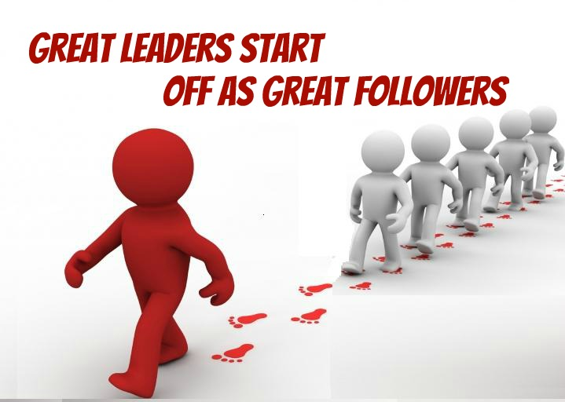
This Photo by Unknown Author is licensed under CC BY
Programme: BA Business Management
Module: Leadership and management, theory, and practice
Module code: LCBB6003
Lecturer/Module Leader: Mushfiqur Rahman/Tanja Nathan

Student Name: Momchil Kostadinov
Student Number: 2028013

CONTENTS
INTRODUCTION 3
TASK 1 3
EXAMPLE 1 4
EXAMPLE 2 5
EXAMPLE 3 5
EXAMPLE 4 5
TASK 2 5
CONCLUSION 8
REFERENCES 9

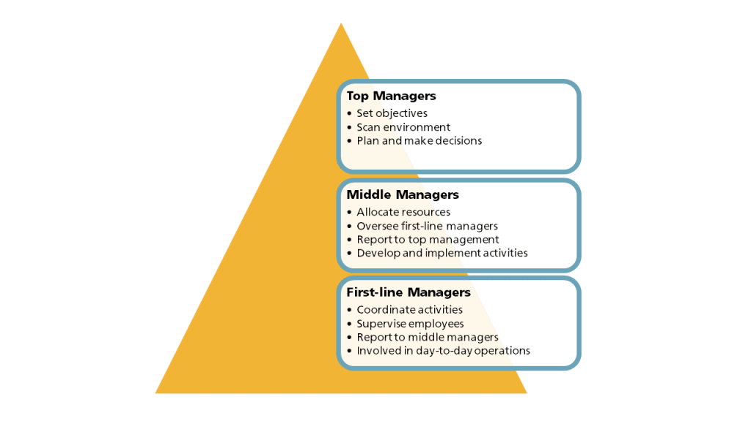
This Photo by Unknown Author is licensed under CC BY-SA-NC

INTRODUCTION
This study focuses on the aspects of leadership and management. How they are different, and one can overtake the role of other. The study is an interesting analysis of concepts of leadership and managements (Hewitt and et.al., 2021). Both these roles can be classified distinctively based on certain terms like qualities, roles, and responsibilities. The study will also justify the statement “a manager can be a leader, but a leader cannot be a manager”, along with-it discussion will also be done on the fact that how leadership and management skill improve the performance of an individual and organisation.

TASK 1
Leaders are those who have the potency to guide, direct, and influence the behaviour of those peoples who are following them to attain any aim or goal. Leaders make a vision and then they transfer it to their followers and keep on motivating them to achieve the desired goals. Leaders are proactive, premeditated, and creative in their approaches. Mostly they focus on persons and the relationship and encourage changes and innovations. A leader leads by inspiring and by virtue of their personal traits they govern an informal authority (Rehman and Iqbal, 2020). They develop a surrounding of influence and strive for effectiveness.
While a manager is an individual who with some effectives and mind-blowing plans, directions, coordination, and control manage an organisation or project. Managers farm out the task, meet the goals, and ensure that all the operations run smoothly and resourcefully. In their approaches managers are reflex, compliant, and organisational. The focus of the manager is on processes and systems, and they respond to the changes and avoid arguments or controversies. Because of their roles and position they govern a formal authority, and they lead by these formal authorities. They build a circle of power and command and strive for the efficiency. With introduction of these two terms and roles it can be said that “a manager can be a leader, but a leader cannot be a manager”.
A Manager might develop the skills own by a leader like, vision, communication, motivation, innovation, and can use it all impact fully to influence and inspire their followers. A manager can also acquire the transformational ability of leadership, which might involves developing a shared vision, making their followers powerful and encouraging creativity and changes. An individual who is manager as well a leader can positively impact the performance and satisfaction of their followers, and the overall growth and accomplishment of the organisation or projects. Conversely, a leader can never be a manager, unless they develop the essential and compulsory managerial skills and understanding like, the art of planning, organizing, staffing, directing, and controlling.
A leader might own a marvellous vision and magnetism, however, without the ability of planning and executing the actions necessary to achieve the vision, they may never be able to produce the desired results. A leader might counter the hurdles and challenges in occurred while managing the resources, processes, and system of the association or venture, as well as can deal with the external environments or stakeholders (Xu and et.al., 2022). But a leader who is only a leader and not a manager may not have the authority and authenticity to lead or manipulate others, and especially in a formal executive setting. To some extent I agree with the statement that “a manager can be a leader, but a leader cannot be a manager”.
An individual who is a manager may have the potential of becoming a leader, however a leader needs to develop and acquire some managerial skills and knowledges to become a manager (Bush, 2019). A person, who governs the qualities, roles, and responsibilities of leadership and management both, may be very effective and efficient for any organisation or association to achieve the goals and objectives.

EXAMPLE 1
To justify the statement, take the case of the Pakistani activist Malala Yousafzai, she is a successful leader who inspires more than millions of people all over the globe with her vision, bravery, and advocacy for females’ rights of education (Baldersheim and et.al., 2019). However, she is not a manager as she does not have any formal position or authority in any association or institution. She is not supposed to plan, organize, or control the actions or supplies of others or need not to follow rules, guidelines or procedures of any system or processes, she just is a leader bringing change and innovation by her voice and influences them to challenge the quo and ask for actions from global communities. She aligns people with her through her vision and motivates them to connect with her cause. She is a leader striving for effect and impact, rather than efficiency or results.

EXAMPLE 2
Take another example of the CEO of Microsoft, Satya Nadela. He is the managing person responsible for the inclusive or comprehensive strategy, performance, and success of the organization. All the activities and resources of the organization are planned, organized, directed, and the activities and resources are controlled by him. He governs the formal authority and legitimacy because of his positional role (Bush, Middlewood and Bell, 2019). And he also is a leader who is responsible for creating a vision and communicating it to his employees, consumers, colleague, and shareholders. He influences and inspires them toward the vision and mission of the organisation. With his focus on people and relationship, he promotes creativity and changes. By the virtue of his personal qualities like, empathy, inquisitiveness, and the learning mindset he owns the informal authority. He develops the environment of influences and strives for the effect. Satya Nadela is a manager as well as leader and positively influences the culture, performances, and reputation of Microsoft.

EXAMPLE 3
Consider a software development manager who is a leader like Sundar Pichai or Jeff Bezos. He draws clear and compelling visions for the projects, communicate it with the team members, and motivate them toward their works and goal. The manager has the potential of planning, and directing the work of the team, making sure that the deadline is met, and the budget or quality standards are fulfilled.

EXAMPLE 4
Consider another case of a social movement leader who is not a manager like Nelson Mandela or Mahatma Gandhi. They inspired and encouraged peoples for joining and supporting the cause, the cause of political reform etc. However, they do not possess the formal authority or skill to organize or plan the activities of followers.

TASK 2
Management and leadership both are important aspect of any organization. With different approaches and outcomes both involve influencing other toward the achievement of a common goal. To manage and lead effectively, a person needs to deploy a range of personal and employability proficiency which will help them in achieving the goals and objectives (Ellis and Abbott, 2020). Development of these skills will foster the performance of individual and organisation in multiple ways. For the scenario of managing, by getting people to do what needs to be done the essential and required skills are:
- Organisational planning – one needs to organise and plans the work, resources, and the timelines of the project or team. A clear and realistic goals and objectives needs to be set and the roles and responsibilities are clearly defined to the team members. Time to time evaluation of progresses and performance of the team and projects needs to be done, and the required adjustment shall be made. Planning and organisation will help in effective management of time and resources and will help in achieving personal and professional goals (Ramere and Laseinde, 2020). It will also help the firm in coordinating and executing their projects and operations effectively, and in smooth delivery of high-quality products and services to the clients.
- Delegation and negotiation – an effective and efficient communication with the members of the team, stakeholders, and the clients is necessary. A clear and concise instructions, feedback and guidance shall be provided to the team members (Shaturaev and Bekimbetova, 2021). For the mutual benefits and avoidance or resolving of the conflicts negotiations with each other is necessary. This will help an individual in enhancing their productivity and efficiency, and in developing the potency of leadership, and will help the organisation in optimizing their human capital and will make powerful and encourage their employees.
- Trouble solving and decision making – the problems and challenges arising in the project or team needs to be identified and analyzed and a possible effective solution should be generated. Based on the evidence, data, and the result an informed and timely decision needs to be taken (Sharafizad, Redmond and Morris, 2020). With problem solving and decision-making skill an individual will find a support in coping the challenges and uncertainties, and in finding innovative and optimal solutions. It will also improve the processes and performance of the organisation and will help in adapting the changing surrounding and the needs of the customer.
- Learning – effective management of time, workload, and stress is necessary. A person needs to prioritize its tasks and shall complete it within the budget. They need to be proactive, resilient, and flexible to changes and uncertainties (Bencsik, Csokas and Seben, 2019). An individual needs to learn from his or other experiences, mistakes and should ask for the feedback and opportunities for improvements.
For the second scenario of leading, by getting people to want to do what needs to be done the skills required by one are:
- Vision and strategies – a person need to develop a compelling vision and approach for the team or projects. The vision and strategy need to be aligned with the mission and values of the organization (Kovacevic, 2019). Other needs to be inspired and persuaded to support the vision and strategy. Through a vision and inspiration an individual will develop and trail a meaningful and fulfilling career and will also encourage and motivates other toward it.
- Empowerment and inspiration – team members need to be motivated and encouraged to give their best. They need to recognize and rewarded for their achievements and contributions. They should be given the autonomy, responsibilities, and rights of the task and their work. They need to be inspired to take the initiatives and to be creative. This will help a person in communicating and presenting their ideas and opinions in an effective manner and will also help in negotiating and resolving the conflicts efficiently. Overall, this skill will help organisation in gaining support and commitment of the stakeholders, and in overcoming the barriers and challenges.
- Collaboration – a leader or manager needs to collaborate and cooperate with the members of the team and with other stakeholders. Trust and rapport need to be built with the team and their diversity and differences should be respected. A positive and supportive team and work culture should be developed, which makes everyone feel valued and incorporated. It will also help the organisation in creating and sustaining a well optimized and high performing team, and in leveraging the diversity and synergy of the workforce.
- Emotional support and empathy – the understanding and managing of the own emotions as well as of other is necessary. People need to be aware of how their emotions affect other and how they are affected by the emotions and action of others (Kouzes and Posner, 2019). The team members and customers need to be empathized and their needs and expectations shall be fulfilled. Ethical and social responsibility should be demonstrated.

CONCLUSION
The comprehensive study on leadership and management concludes that together management and leadership are two key attributes contributing to the success of any organisation. Both aspects involve encouraging other towards achieving a common goal, with distinct approaches and outcomes. Leadership focuses more on creating and communicating a goal and encouraging and influencing others and on building and maintaining a relation. While management focuses more on the planning, organizing, solution of a problem, decision making and delegation and supervision. To embrace both these roles different personal traits and employability skills are essential for instance, vision and inspiration, cooperation, and collaboration, plans and organisational skills, emotional intelligence, learning skills.
With the help of these skills an individual may improve its performance and potential of being a leader and manager and can also improve its performance and productivity. Thus, leadership and management are a complementary and interdependent aspects, and both are required to achieve the organisational excellence.
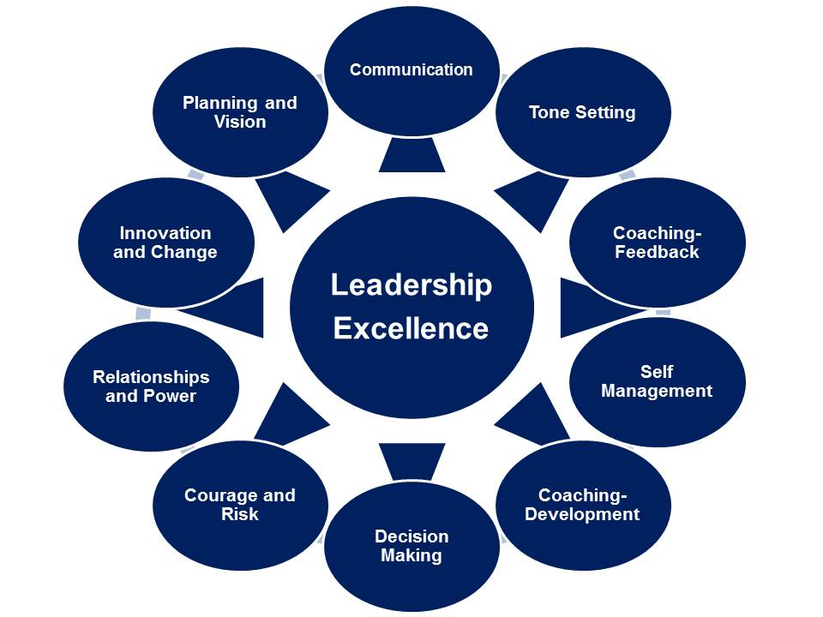
This Photo by Unknown Author is licensed under CC BY

REFERENCES
Baldersheim, H., Bodnárová, B., Horváth, T.M. and Vajdová, Z., 2019. Functions of the Executive: Power, Leadership, and Management. In Local Democracy and The Processes of Transformation in East-central Europe (pp. 197-224). Routledge.
Bencsik, A., Csokas, L. and Seben, Z., 2019, November. What is the role of Ethics in an Ideal Leadership Style?. In Proceedings of the European Conference on Management, Leadership & Governance (pp. 63-72).
Bush, T., 2019. Distinguishing between educational leadership and management: Compatible or incompatible constructs?. Educational Management Administration & Leadership, 47(4), pp.501-503.
Bush, T., Middlewood, D. and Bell, L., 2019. Principles of educational leadership & management. Principles of Educational Leadership & Management, pp.1-408.
Ellis, P. and Abbott, J., 2020. Are leadership and management different?. Journal of Kidney Care, 5(1), pp.45-47.
Hewitt, L., Dahlen, H.G., Hartz, D.L. and Dadich, A., 2021. Leadership and management in midwifery-led continuity of care models: A thematic and lexical analysis of a scoping review. Midwifery, 98, p.102986.
Kouzes, T.K. and Posner, B.Z., 2019. Influence of managers’ mindset on leadership behavior. Leadership & Organization Development Journal, 40(8), pp.829-844.
Kovacevic, M., 2019. Academic leadership skills: Managing teams and conflict management. In University Governance and Academic leadership in the Eu and China (pp. 246-257). IGI Global.
Ramere, D.M. and Laseinde, O.T., 2020. Creating a Physical Bridge Between Management and Leadership as a Strategy to Improve Organization Performance Analysis. In Advances in Human Factors, Business Management and Leadership: Proceedings of the AHFE 2020 Virtual Conferences on Human Factors, Business Management and Society, and Human Factors in Management and Leadership, July 16-20, 2020, USA (pp. 546-552). Springer International Publishing.
Rehman, U.U. and Iqbal, A., 2020. Nexus of knowledge-oriented leadership, knowledge management, innovation, and organizational performance in higher education. Business Process Management Journal, 26(6), pp.1731-1758.
Sharafizad, J., Redmond, J. and Morris, R., 2020. Leadership/management factors impact employee engagement and discretionary effort. International Journal of Organization Theory & Behavior, 23(1), pp.43-64.
Shaturaev, J. and Bekimbetova, G., 2021. The difference between educational management and educational leadership and the importance of educational responsibility. InterConf.
Xu, X., Zhang, Y., Zhou, P. and Zhou, X., 2022. Developing a leadership and management competency framework for nurse champion: A qualitative study from Shanghai, China. Journal of Nursing Management, 30(4), pp.962-972.

