

BA (Hons) International Hotel Management

International Meetings Management for the Hotel Industry
Module Code - BMIH6007

Lecturer Name - Kathryn Flynn

Student Name- Daniela Vartolomeu
Student ID- 2130495
Slide 1

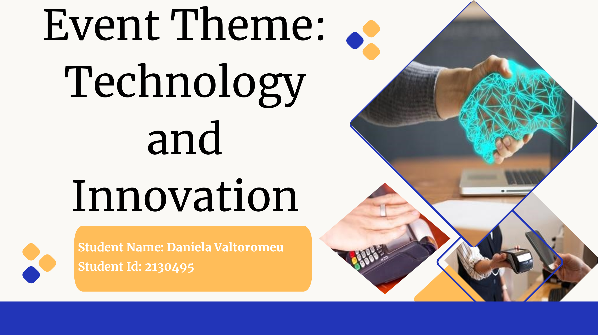
Slide 2
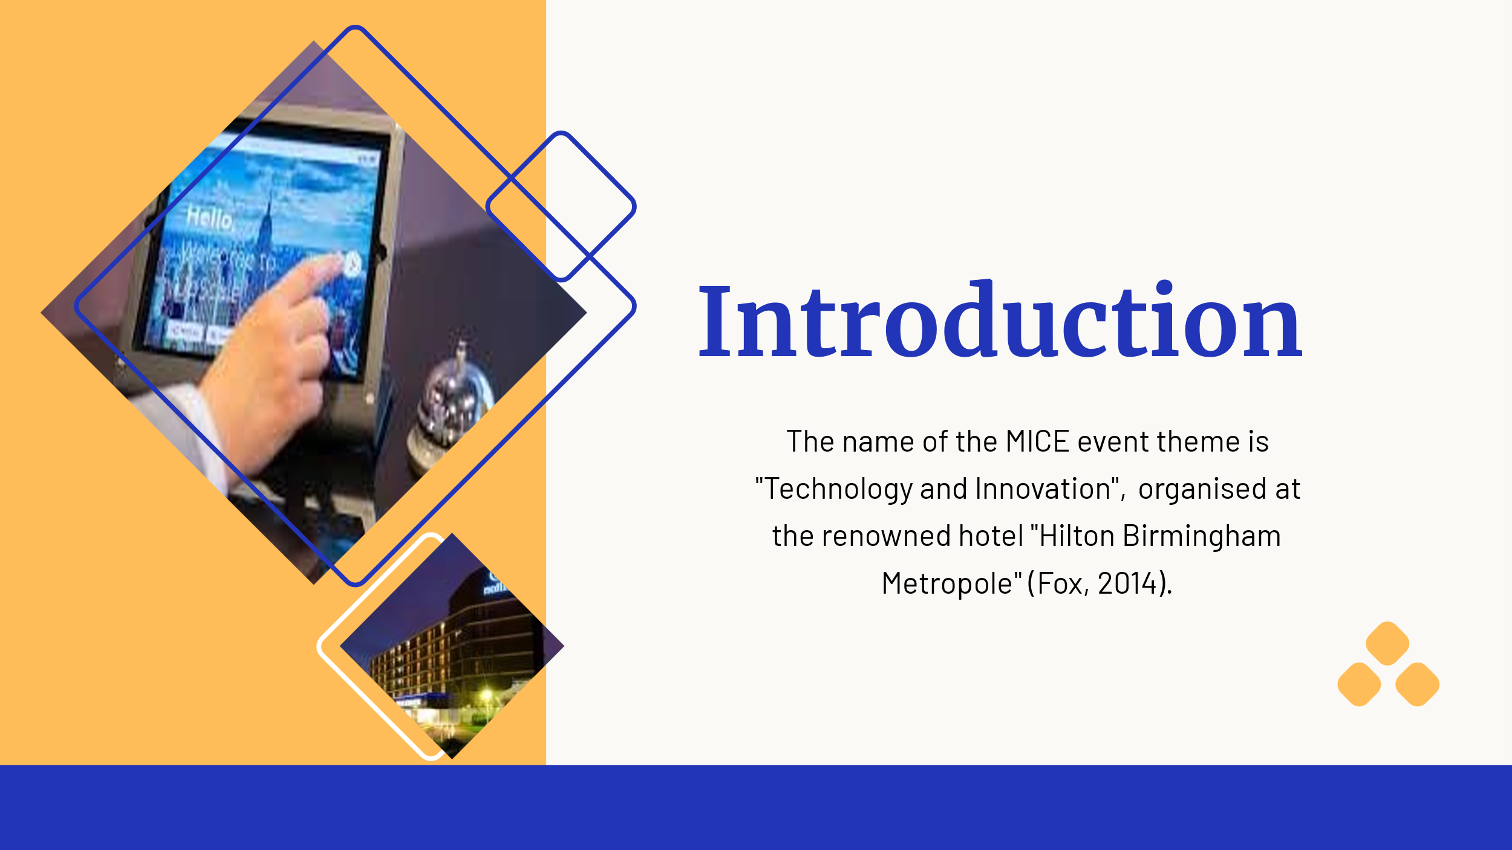
Slide 3
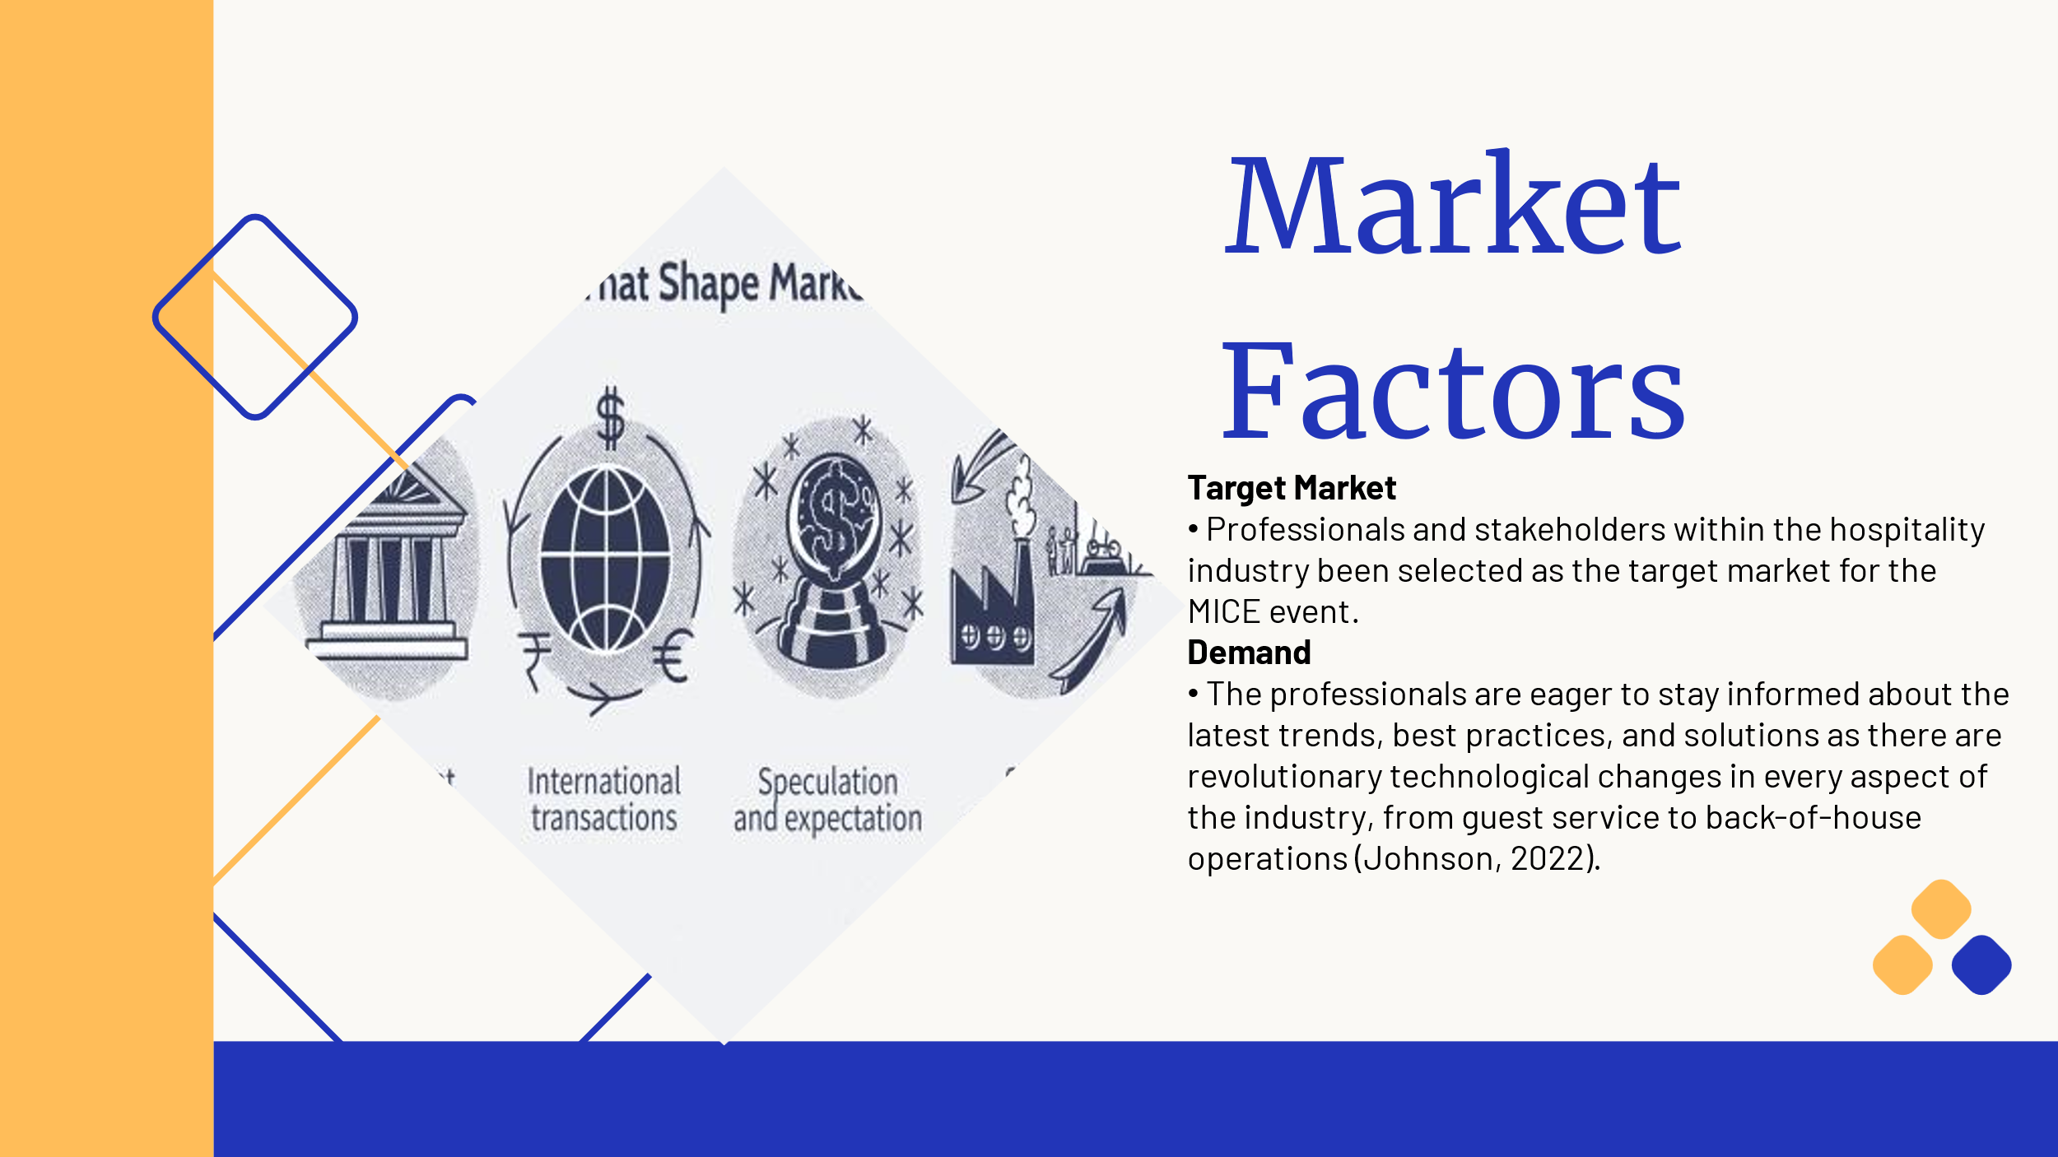

Slide 4
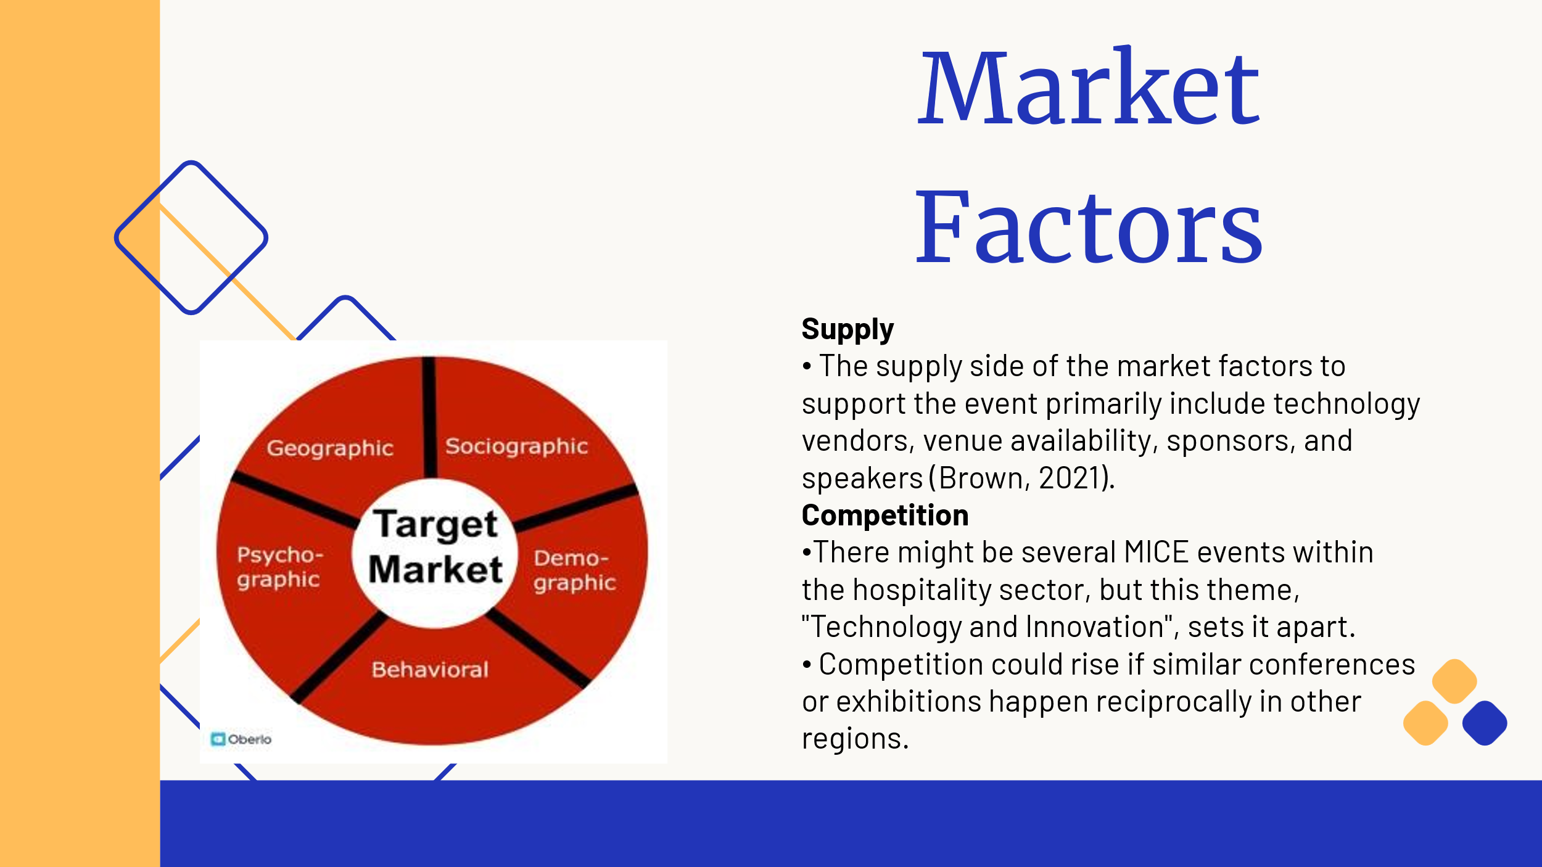
Slide-5
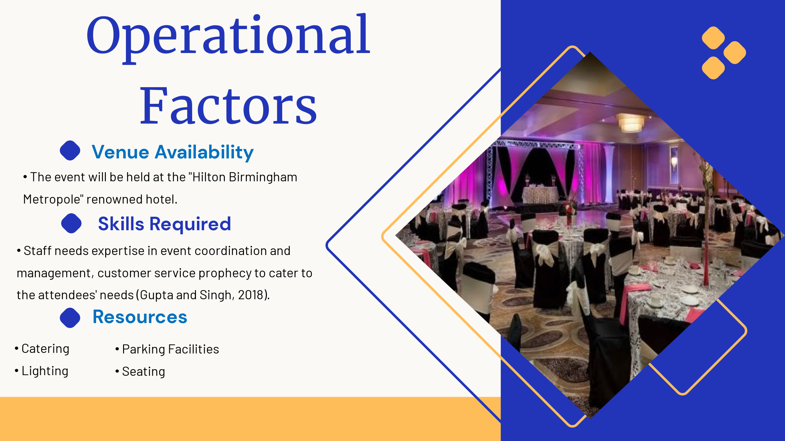

Slide 6
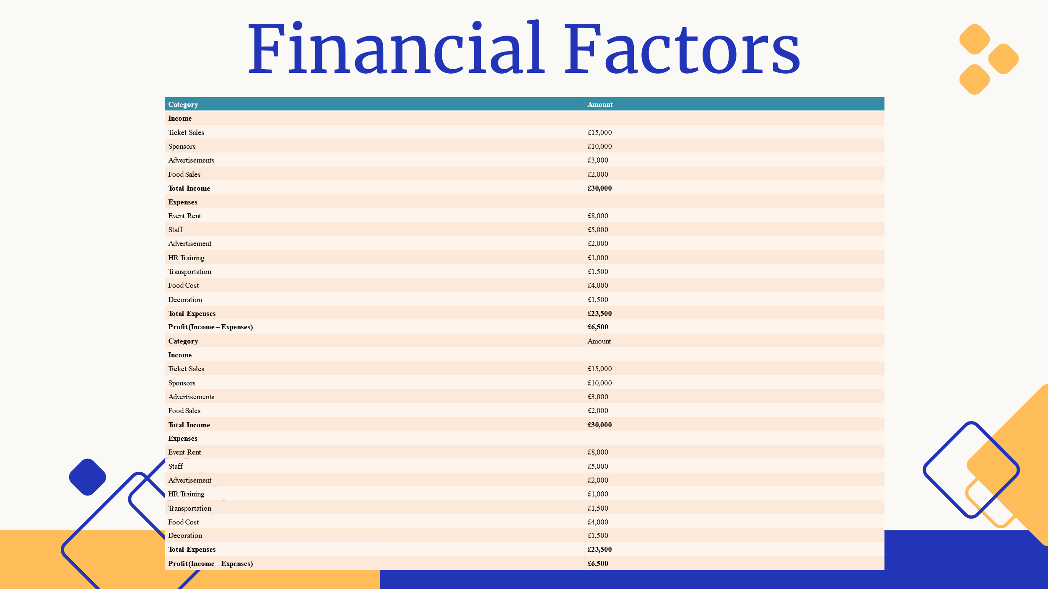
Slide 7

Slide 8
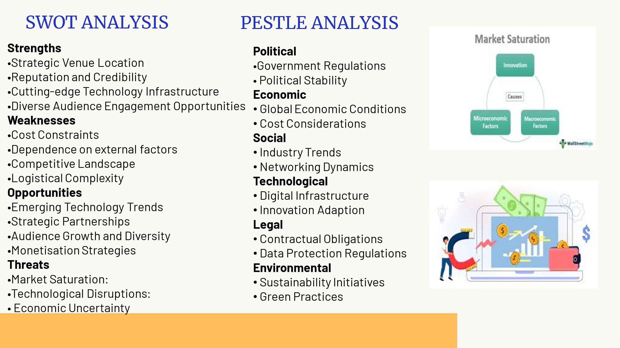

Slide 9
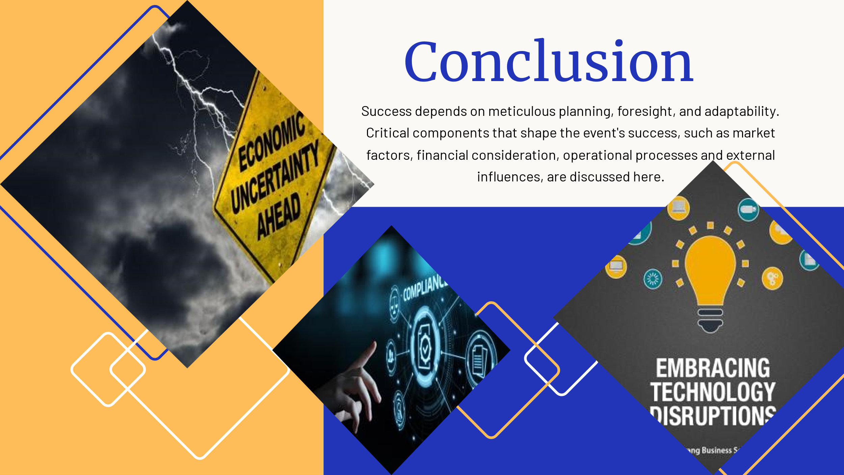
Slide 10
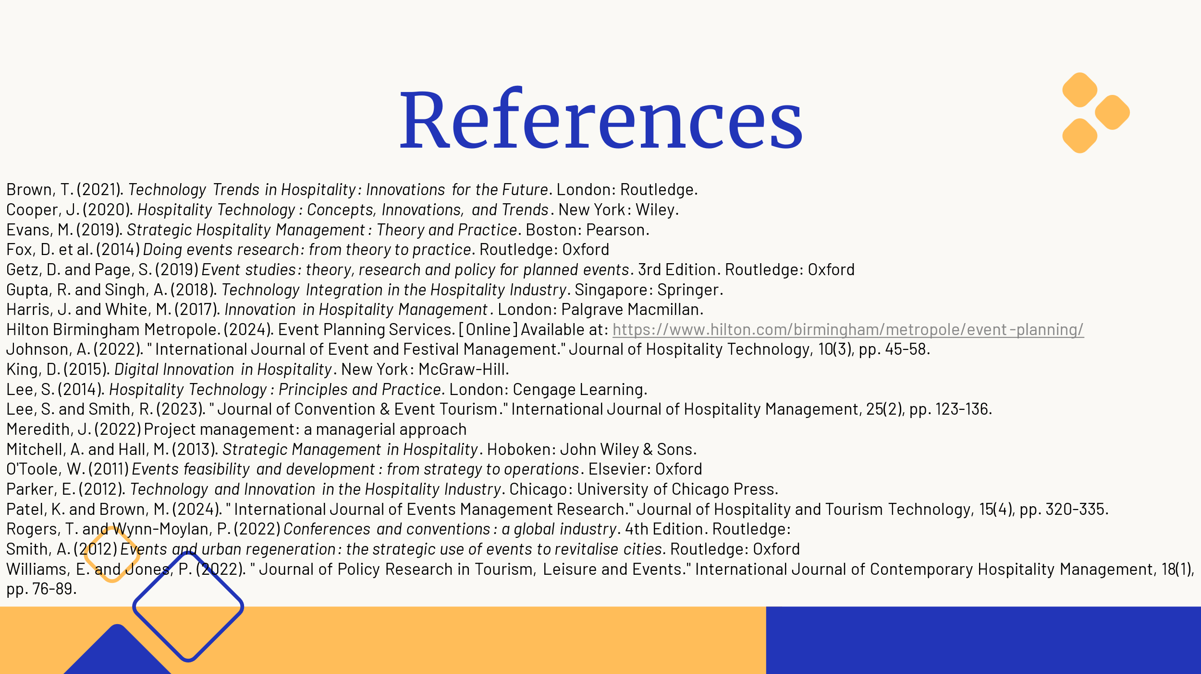

References:
Brown, T. (2021). Technology Trends in Hospitality: Innovations for the Future. London: Routledge.
Cooper, J. (2020). Hospitality Technology: Concepts, Innovations, and Trends. New York: Wiley.
Evans, M. (2019). Strategic Hospitality Management: Theory and Practice. Boston: Pearson.
Fox, D. et al. (2014) Doing events research: from theory to practice. Routledge: Oxford
Getz, D. and Page, S. (2019) Event studies: theory, research and policy for planned events. 3rd Edition. Routledge: Oxford
Gupta, R. and Singh, A. (2018). Technology Integration in the Hospitality Industry. Singapore: Springer.
Harris, J. and White, M. (2017). Innovation in Hospitality Management. London: Palgrave Macmillan.
Hilton Birmingham Metropole. (2024). Event Planning Services. [Online] Available at: https://www.hilton.com/birmingham/metropole/event-planning/
Johnson, A. (2022). " International Journal of Event and Festival Management." Journal of Hospitality Technology, 10(3), pp. 45-58.
King, D. (2015). Digital Innovation in Hospitality. New York: McGraw-Hill.
Lee, S. (2014). Hospitality Technology: Principles and Practice. London: Cengage Learning.
Lee, S. and Smith, R. (2023). " Journal of Convention & Event Tourism." International Journal of Hospitality Management, 25(2), pp. 123-136.
Meredith, J. (2022) Project management: a managerial approach
Mitchell, A. and Hall, M. (2013). Strategic Management in Hospitality. Hoboken: John Wiley & Sons.
O'Toole, W. (2011) Events feasibility and development: from strategy to operations. Elsevier: Oxford
Parker, E. (2012). Technology and Innovation in the Hospitality Industry. Chicago: University of Chicago Press.
Patel, K. and Brown, M. (2024). " International Journal of Events Management Research." Journal of Hospitality and Tourism Technology, 15(4), pp. 320-335.
Rogers, T. and Wynn-Moylan, P. (2022) Conferences and conventions: a global industry. 4th Edition. Routledge:
Smith, A. (2012) Events and urban regeneration: the strategic use of events to revitalise cities. Routledge: Oxford
Williams, E. and Jones, P. (2022). " Journal of Policy Research in Tourism, Leisure and Events." International Journal of Contemporary Hospitality Management, 18(1), pp. 76-89.

