
Personal career development planning
MODUL NAME: PROFESSIONAL CAREER DEVELOPMENT

MODUL ID: BMSW4005

HRVOJE GASPARIC
STUDENT ID: 1917115
LECTURER: WINIFRED SORIBE
SKILLS FOR THE WORKPLACE
UNIVERSITY OF WALES – TRINITY SAINT DAVID

Table of Contents
Reflection on the role play 2
Personal Career Development Planning 3
My roles and responsibilities as a transport manager 3
Planning 3
Organizing 4
Directing 4
Controlling 5
Team leadership 5
Skills and knowledge requirements 6
Legal understanding 6
People skills 6
Technical skills 6
Personal action plan/development plan 7
Goals 7
Most important goal 7
Timelines 7
Strengths and weaknesses 8
Strengths 8
Weaknesses 8
Progress 8
References 9
Appendices 10

Reflection on the role play
My reflection on the role play is almost excellent (on the scale of 1 to 10 I would give myself 8) but there were some gaps that could have been filled up. Talking about role play in general from my own experience is all about preparation and to have a good preparation you must get a good partner which I chose wisely and at the end it was shown as a good choice. Furthermore, talking about things that I would change in the role play would be only to add more my personal experience, to show my future employer that I was not only responsible for given tasks but that I handled with those situations, and if I would not have the situation to describe the given situation in question, I would describe some situation from my own life where I deal with similar problem and how I sorted it. Therefore, if you answer the question with already explained solved situation from your own experience, employer will start looking you as a potential candite for the role you are applying for because in his mind he does not have to invest money in your training but instead put you straight to perform. I messed up with this part as I only explained one situation where I have solved the problem, however that was only practice and I could have prepared myself even better, but you live you learn. It was great experience that we had interview role play for our assessment, as I have not had the real proper interview here in the UK yet, what I mean by that is the type of interview where you get the job by eliminating the other candidates, going through stages with your abilities and experience and not just what is written in your qualifications. My conclusion is that no matter how old you are and no matter how much experience you have had there will be always room for improvements regardless of your qualifications.

Personal Career Development Planning
My position as the transport manager requires me to ensure that the different customers have been supplied with a wide range of services that address their needs. Even though the key role is similar, the smaller duties of transport managers be likely to change from one organization to the other (Simkova, 2012). To carry my tasks effectively and as expected, I need to have exceptional management and planning skills. Trends keep on changing in the transport industry and therefore my position as a transport manager requires me to be flexible and have the ability to adapt when circumstances change. If delivery problems are experienced, for instance, it is my duty as the transport manager to make changes in some schedules in order to resolve the problem in the shortest time possible. During the time working as a transport manager, I have to learn on how to handle pressure at work because goods produced are supposed to be delivered to customers in the shortest time possible. The department of transportation entails linking an organization and its customers through service delivery and therefore it is my role to ensure that I have displayed a good picture of the organization. Understanding the needs of both the customers and transport department employees is very key to achieving this role. Customers come from different geographical areas and so a good understanding of the region’s geography is required (Simkova, 2012).

My roles and responsibilities as a transport manager

Planning
Planning requires the determination of resources that are needed to meet the variable requirement levels and make sure all customers are well satisfied (Simkova, 2012). In the organization, it is my duty to decide the number of vehicles and employees who will be available on a given day. When work increases, I will also increase the number of vehicles and drivers to supply the increasing number of customers. When work is low, the number of vehicles and drivers made available also goes low for the given day. It is also my planning role to define any other related equipment that are required during transportation.

Organizing
After coming up with a plan on how things will be done, it is my role to organize in order to make sure that people are at the right places, and at the required time, in order to make the plan work effectively. Organizational abilities of a manager are required here for the task to be performed as required (Miceski & Tashkov, 2017). Apart from organizing resources, it is my duty to organize the workload for every driver on daily basis and manage to ensure every vehicle has been loaded with the correct goods. At times, I will give this to other staff members and then use the time to handle other issues in the department. The manager is always responsible for the results obtained after achieving the plan and therefore the reason I am always keen to ensure everything has been done in the correct manner. The issue of supplying wrong goods, for instance, will always go back to the manager and so I must be very careful on how things are getting done.

Directing
Directing is another key responsibility for me as a transport manager. It is my duty to make sure that all people involved in have already prepared plan and have a good understanding of what they are required to do, the reasons as to why they are doing so, and the timelines for doing it. Effective guidance helps ensure everything gets done on time and it also helps in execution of the plan. The ability to communicate well with all department members is of importance in the process of coordination (Miceski & Tashkov, 2017). The success of each activity depends on how the rest have been done and so it is my role to establish a good flow of communication among all people involved in executing the plan.

Controlling
Controlling is directly connected to directing employees. In my role of controlling, I will have to make sure that performance against guidelines issued is monitored, and that there is progress made towards achieving the goals. Since the role of transportation works according timelines, it is my duty to make sure that progress is being made at the correct rate. The plan does not have to be fixed and adjustments have to be made whenever the situation allows. Changes can either be made on the plan or on the objectives. To be able to identify the areas where changes are required, the process of controlling is required. In some cases, information obtained from the process of controlling is used to create future plans and hence controlling is required for the various objectives in the transport department to be achieved (Simkova, 2012). Performance monitoring, for instance, is used to ensure that goals are set realistic.

Team leadership
Lastly, team leadership is my other key role as a transport manager. Effective leadership needs the use of an approach that will help bring all employees at a common ground in terms of reasoning and execution of the plan. Employees have differences and therefore the role of team leadership requires the use of an approach that will bring all employees together. Without doubt, there will be weaknesses and strengths across the team that need to be addressed when bringing the team together (Miceski & Tashkov, 2017). At times, I will have to come across employees with special circumstances that to somehow interfere with their compatibility with the team. In my role as the leader, I will always take into account such circumstances and then look for the best approach that will work for them. In addition, I will always take the circumstances into account when assigning duties to ensure that everybody is given a task, he/she will perform excellently.

Skills and knowledge requirements

Legal understanding
Becoming a transport manager requires a certain level of legal understanding. As the top employee in the department, having a good understanding of key legislations relevant to some of the common department issues is very key. Some of these common issues are drivers’ hours, regulations governing the constructions and use of vehicles, operator licensing, employment law, the various health and safety laws, licensing of drivers, and legislation relevant in road traffic (Simkova, 2012). The list is very big and it is an indicator of the many fields I am supposed to have a basic understanding of the relevant legislation. Such an understanding helps ensure that vehicles and drivers are on the correct side of the law at all times.

People skills
Another definition of my role as a manager “is the ability to get activities accomplished through other people.” To achieve some set objectives, we have to rely on the input of other people. In order to accomplish this, my role demands the ability to communicate effectively, maintain working relationships while managing employee performance, and have an effective approach to negotiations with customers. New communication approaches are created from time to time and so I have to learn about them in order to cope with the changing business world. Management of working relationships needs be done in light of these changing approaches.

Technical skills
Having the required technical skills is required for transport managers to achieve the set objectives. Some of the skills I found to be important in the management section are computer skills, knowledge about vehicles and loading, scheduling and routing, and transport costing awareness.

Personal action plan/development plan

Goals
-Get certified to become a professional transport manager.
-Gain experience on how to manage projects that are highly complex.
-Improve public speaking and leadership skills.
-Improve on the core management skills.
-Develop capabilities that will help in the transition towards the management of complex projects and programs that require a high budget input.
-Be able to reach all customers within the required duration of time.
-Identify and work on areas that are limiting effective performance of the transport department.

Most important goal
My most important goal is to improve on core management skills. My success as a transport manager highly relies on my ability to effectively manage all small tasks and coordinate them towards achieving the wished goal. To achieve this, having the core management skills is very important. Achieving this key goal will create a path for achieving the other goals.

Timelines
My target is to achieve this goal within a period of one year. To make improvements on core management skills, the best way is to go through training programs and seminars that are aimed in enhancing the skills. The skills that I am aiming to improve on are communication and motivation, interpersonal skills, mentoring skills, effective decision-making and solving problems, strategic thinking, forward planning, delegation, and organization. I know we covered the most of these subjects and skills last year at the Uni, but having more knowledge is not to be thrown away. For each skill, I will take a training for about one month. Training hours will be in the evening hours after work.

Strengths and weaknesses

Strengths
- I strictly stick to timelines.
- I am flexible and I have the ability to cope easily with changing situations.
- I have good communication skills.
- Ability to bridge diversity together.

Weaknesses
- I am poor at working under high pressure.
- Poor decision-making ability under pressure.
- I have poor interpersonal skills.
The transportation sector requires working with timelines in order to deliver goods within the required time. My strength in sticking to timelines will enable me to achieve this task as required. Due to technological advancements, circumstances at the workplace keep on changing and my ability to be flexible helps me adjust to the changing business world. Being a transport manager and working with different people requires ability to quick adaptation. Through the different training programs, I will be able to improve on my weaknesses.

Progress
I will note down progress after every training program to establish areas where additional improvement is needed.

References
Miceski, T., & Tashkov, T. (2017). The manager and his role in developing a successful transport business. Journal of Economics, 2(1), 40-51.
Simkova, I. (2012). Transport manager responsibilities and risk-based insurance analysis.

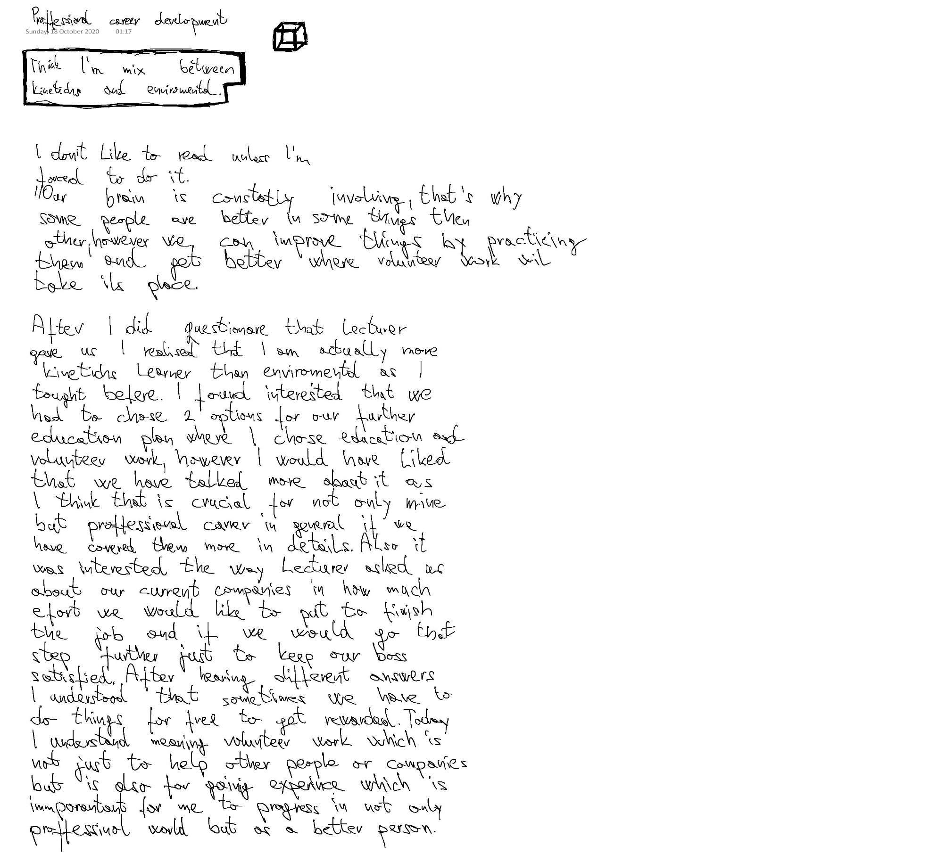
Appendices



