Assessment 2:
Bont Community Centre- Volunteer Tracking System
Contents
Introduction 2
Proposed Entity Relationship Diagram 3
Entity Relationship diagram 4
Creating the tables 5
Inserting information 10
12
Queries and searches 12
Creating forms in access 17

Introduction
This document will report the physical design and implementation of the System development life Cycle of the Bont community centre volunteer tracking system database, the database will be created and implemented using MySQL. The report will contain how the tables were created and the problems occurred while creating them .It will discuss the queries that have been made and how they are relevant and usable in order to extract information from the database.
The physical design has been created using MySQL. The database planning, system definition, requirements collection and analysis, conceptual design and the logical design has all researched and completed before the physical design could start. The ER diagram was given to be used for the physical design at this stage MySQL was chosen as the desired software programme.
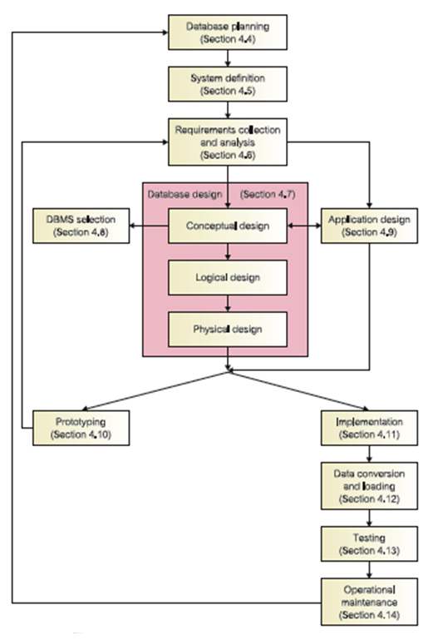

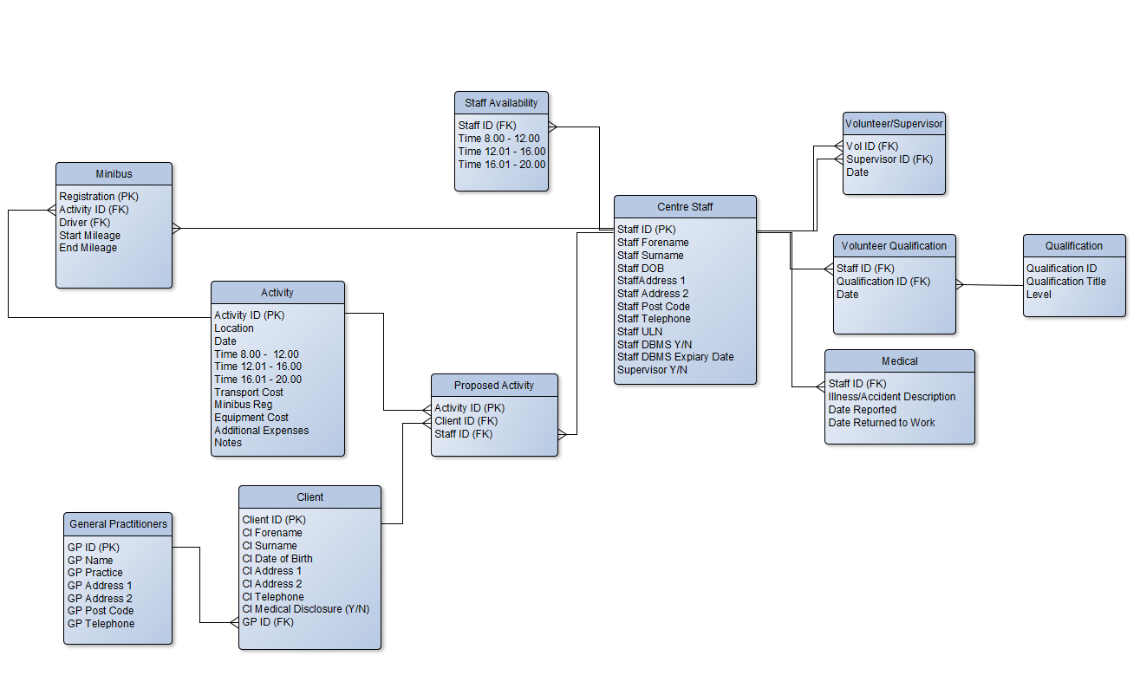
Proposed Entity Relationship Diagram

This was the proposed entity relationship diagram that was given to be created. This ER diagram was given to be created using MySQL.

Entity Relationship diagram
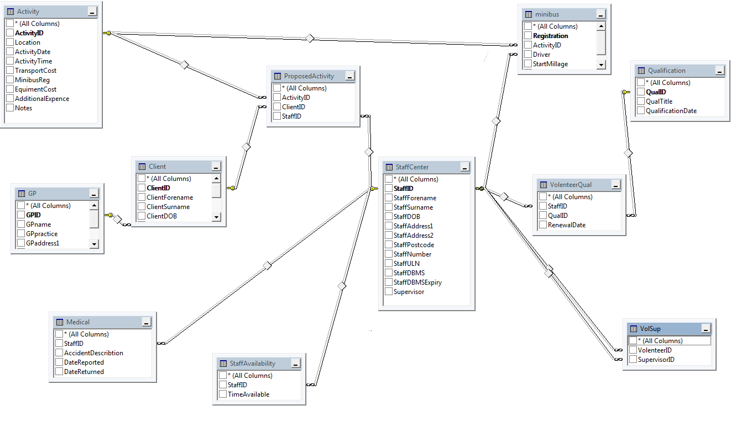

During the implantations of the entity relationship diagram a few errors occurred e.g. in the proposed activity table the activity ID was given a primary key, because of this the table was not able to be linked more than once to the activities, meaning that one activity could only have one staff ID and one Volunteer ID linked.

Creating the tables
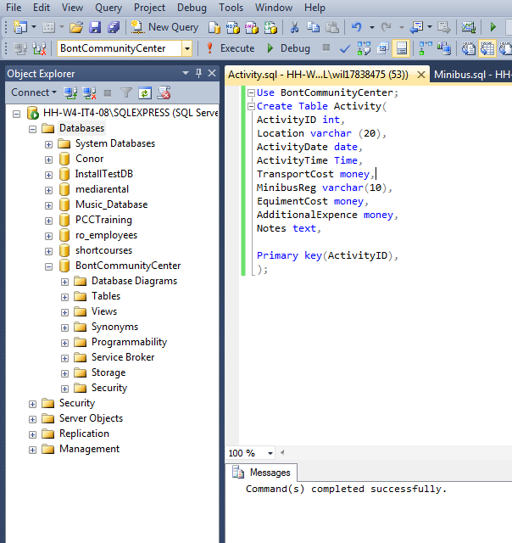
The tables need to be created in a specific order to ensure that there were no missing primary key and that every foreign key was able to connect to a table. The first two table to be created were the ‘StaffCenter’ and ‘Activity’, These two table do not contain any foreign keys.
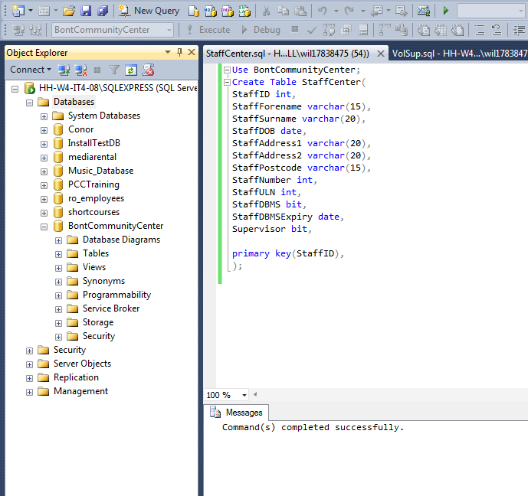

The next table to be created was the ‘minibus’ table, while creating this table an error occurred due to there being a conflict of data types. The foreign key (driver) data type was ‘varchar’ this did not match the primary key (staffID) data type of ‘int’ in the staff center table.
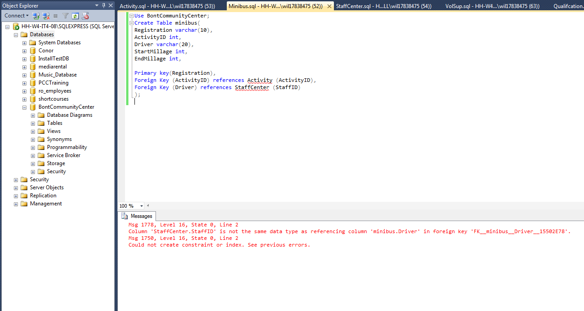
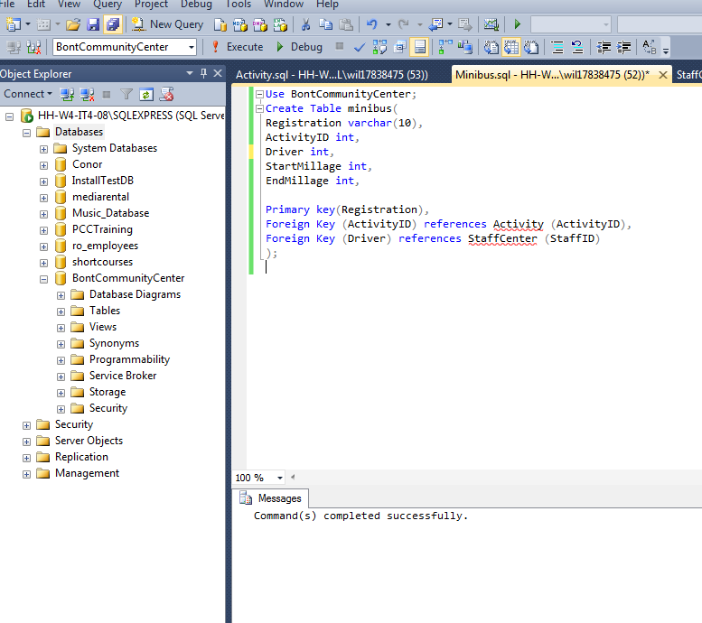
After changing the data type of the field (driver) to ‘int’ the tables successfully got created. In this table there are two foreign keys –ActivityID which links to the activity table, this allows for a minibus to be linked to an activity and also driver which links to staff centre table, this allows for a driver to be link to a minibus.

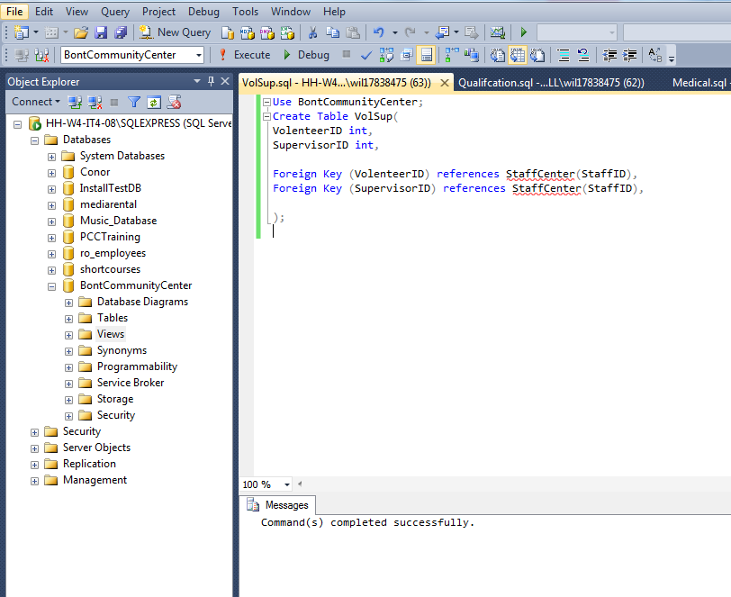
The next two tables that were created were the Volunteer/supervisor table and the volunteer qualification table. The Volunteer/supervisor table has no primary key but has two foreign keys which link with the staff centre table, although the both foreign keys link up to the same primary key (StaffID) they both still need to be linked to see who are supervisors and/or are volunteers. The volunteer qualification also has no primary key but has a relationship through the use of foreign keys with the staff centre table and qualification table; these links ensure that the correct qualification is linked to the correct volunteer.
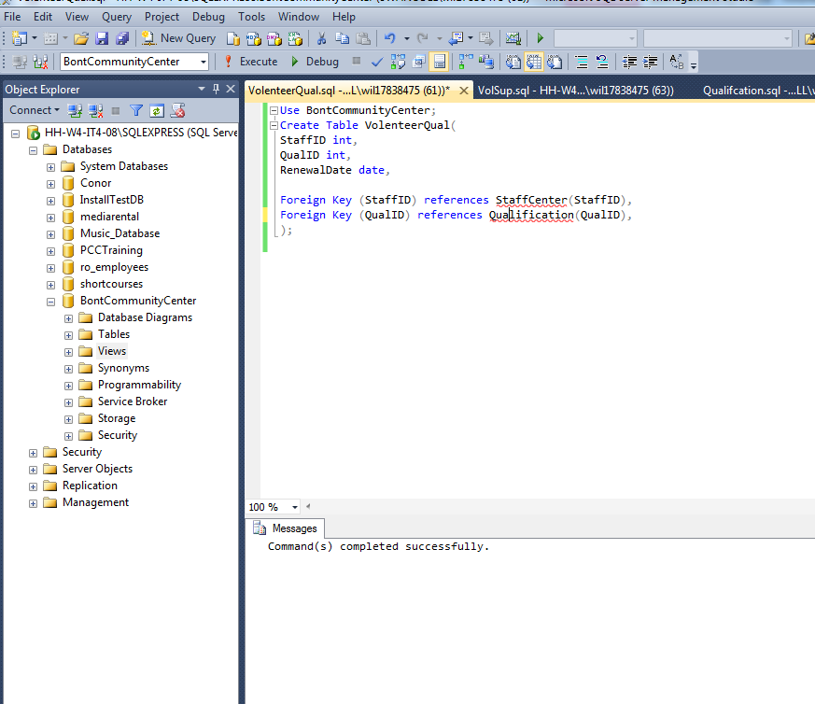
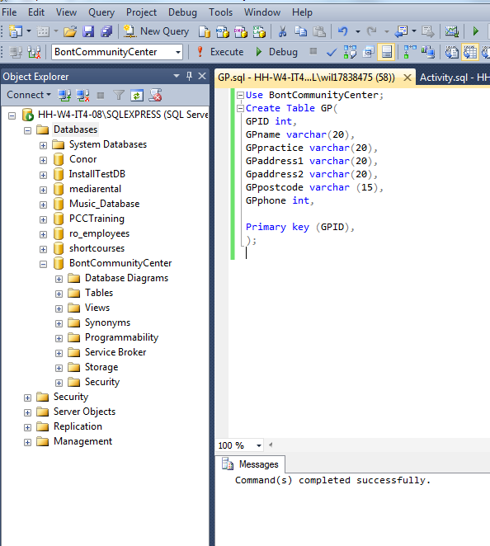
Next to be initialized were the general practitioner and the proposed activity tables. The general practitioner table has no foreign keys but has a primary key which is used to link to the clients table, because this table has a primary key it could also be linked to different tables if so required at a later date, for example to link general practitioners to supervisors and/or volunteers.

The proposed activity table was created but needed to be edited due to a primary key being used and causing the table to be unable to link to many fields in one tables(one to many relationship). When the table first got created the primary key was the activityID, but when trying to connect the three columns to other tables an error occurred ,resulting in the table only being allowed to connect once ,this was a problem as many clients and staff could be connected to more than one proposed activity.
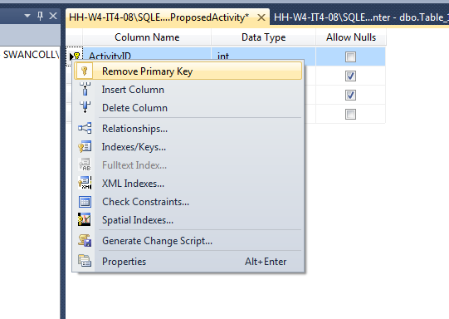
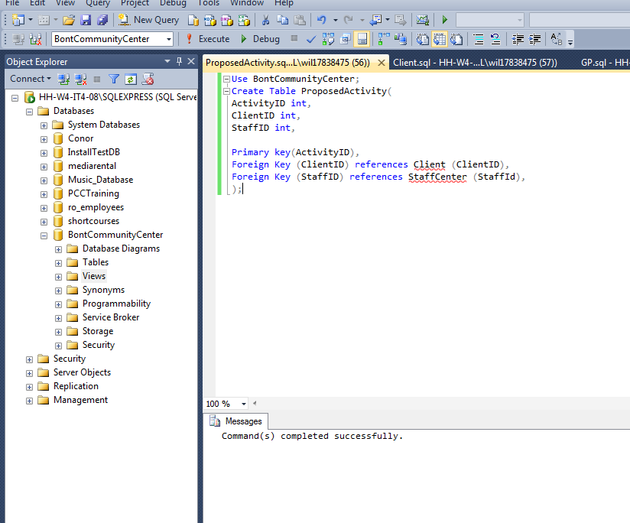

The primary key was removed from the table allowing the activityID to be linked to more than one field in any table and the same table more than once. This is allowed because activityid was altered to be a forgien key . The last two tables to be created were the client table and the staff availability table. The client table contains a primary key and a foreign key, The foreign key is from the general practitioner table and the primary key links up to the proposed activity table.

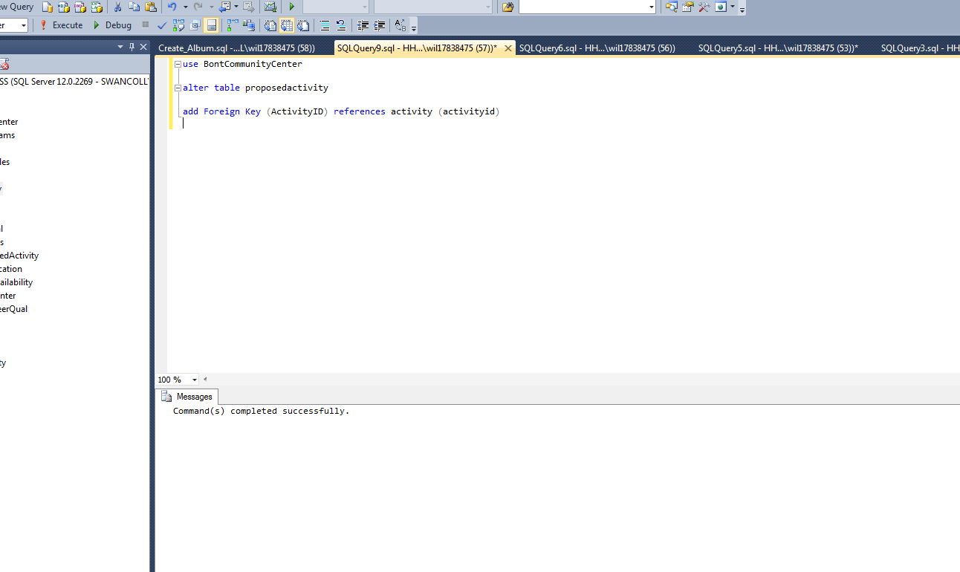

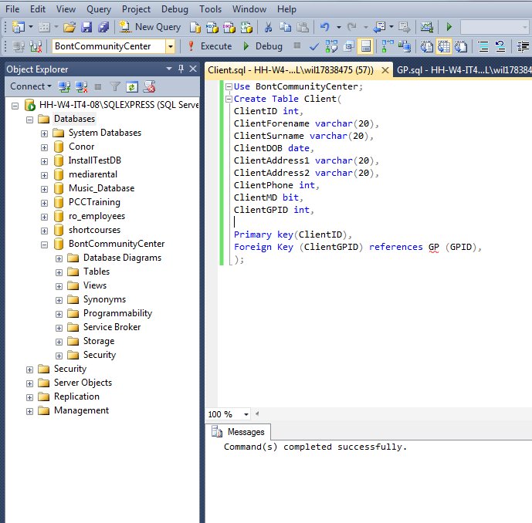

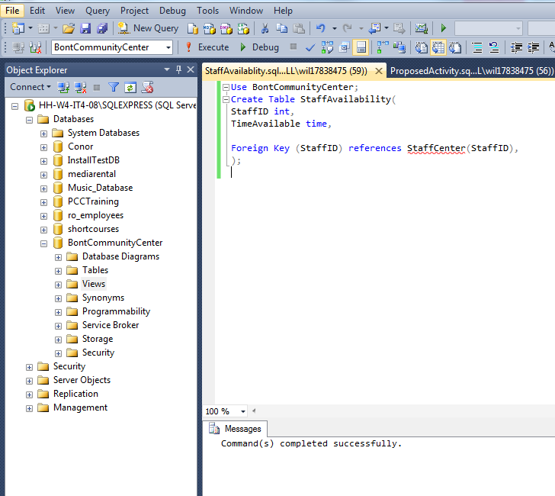
The staff availability has a link to the staff centre table, and is used to determine when a volunteer or a supervisor is available.

Inserting information
After the table were created and linked, the tables needed to be filled with information about Bont community centre e.g. the volunteer and clients they have, the qualifications, the activities that are ongoing and medical information (GP and accident).
The only problem that occurred during filling the tables was that during filling the staff cente table one of the addresses were too long for the field.
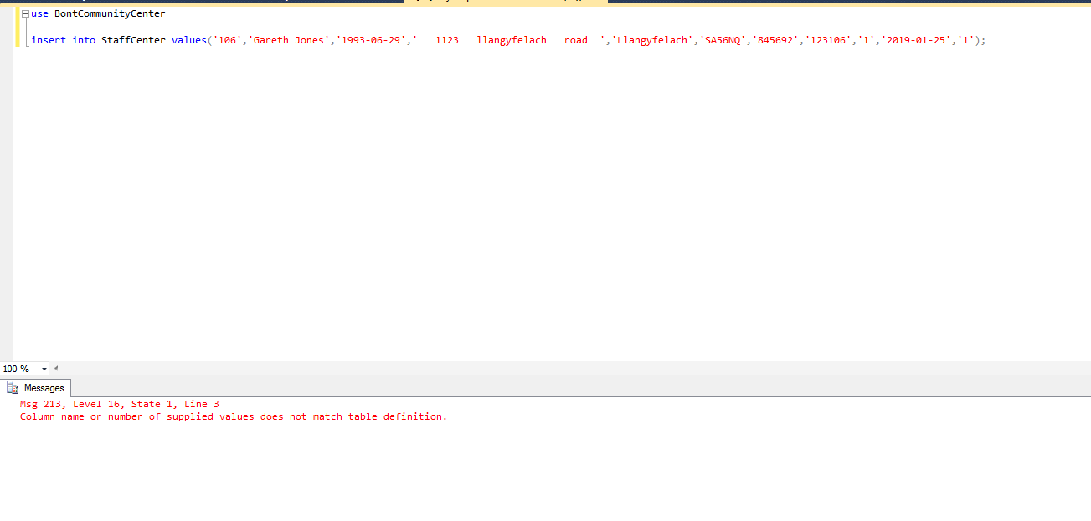
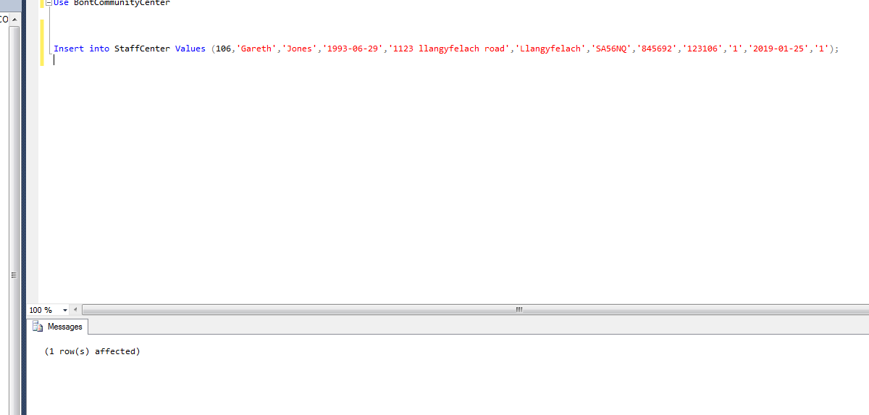
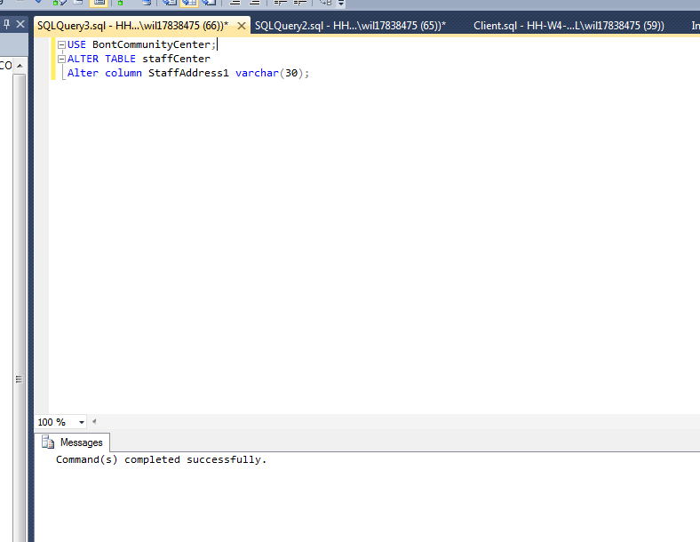
This problem was fixed by using the alter command in SQL. The alter command allows the user to amend how many characters are allowed in each field. The varchar data type allows for up to 30 characters to be entered, as many addresses have various lengths then varchar was the correct data type to use as opposed to char, which would expect to hold the exact number of characters entered e.g. 30. After the alter command was executed the values we entered into the table without any other problems occurring.

Information has been entered using MySQL by using the insert command, using this command can be difficult and time consuming due to have to type the command every time. Access has been used as a front end for easier user input and for a better look to the database. Through access the database can be made in to forms, buttons and can save time on queries and searches.

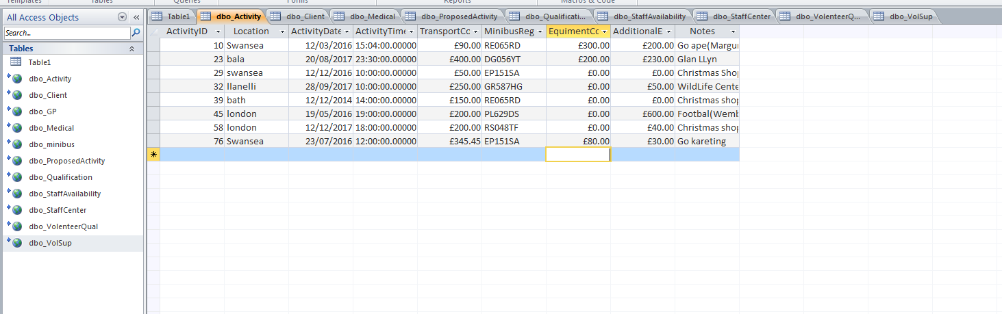
This shows the information being transferred into access.

Queries and searches
In MySQl there is a function whereby the user is enabled to search for various tables, titles and information. Queries are good to search for specific information needed on a particular activity, volunteer, client, medical information or anything that the user need to fins with a search.
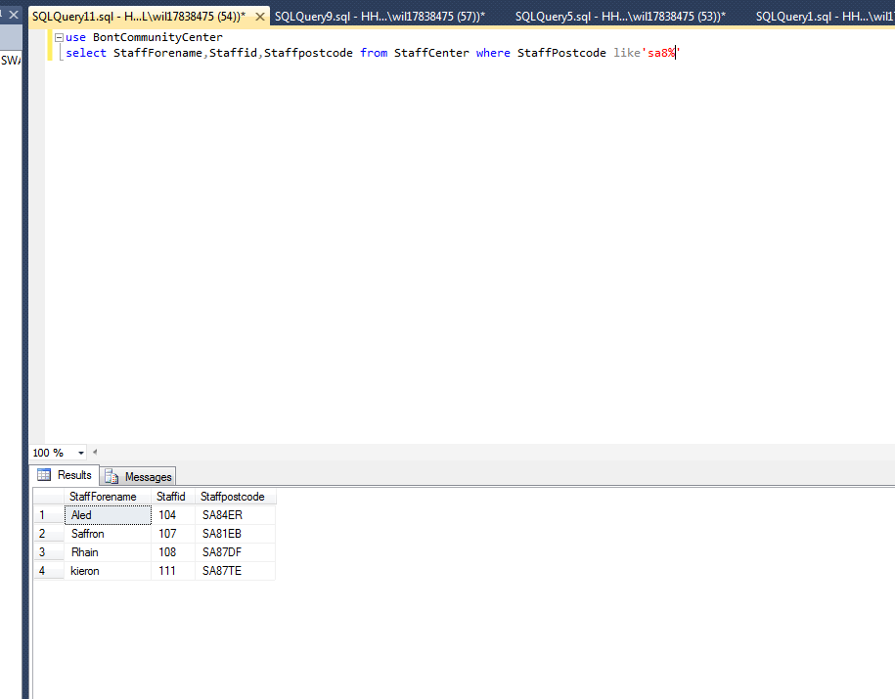
Searches could be carried out to find out where a member of staff (volunteer), might live and if one or more volunteer lives in the same area. This search could be extended to query if one of the staff members living in that area have a particular skill or qualification.

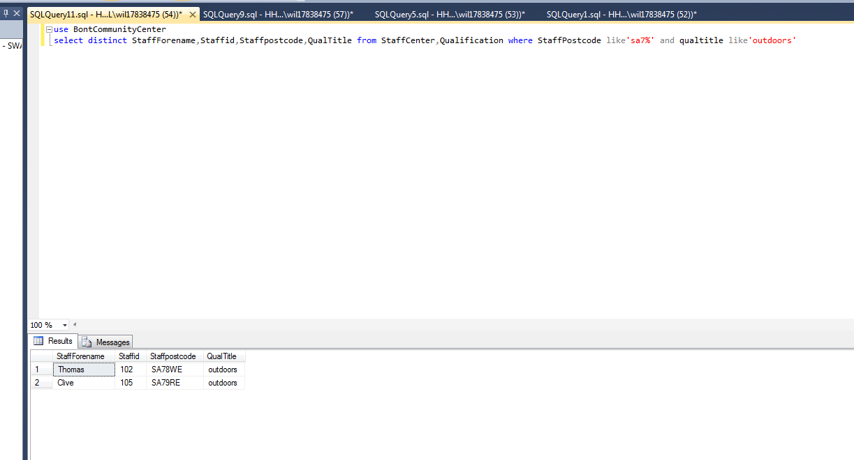
In the two queries above I have used the SELECT, FROM and WHERE functions to gather information from different tables to make a search in to a specific area and a specific skill.
The cost of all trips is important information for any of the Bont community centre leaders to be able to find out, this quire below show the transport cost, additional coast and the equipment cost for all the locations that have been visited. The second quire shows the total amount of money spent by the community centre since its opening and the third quire show the total cost from the year 2017.
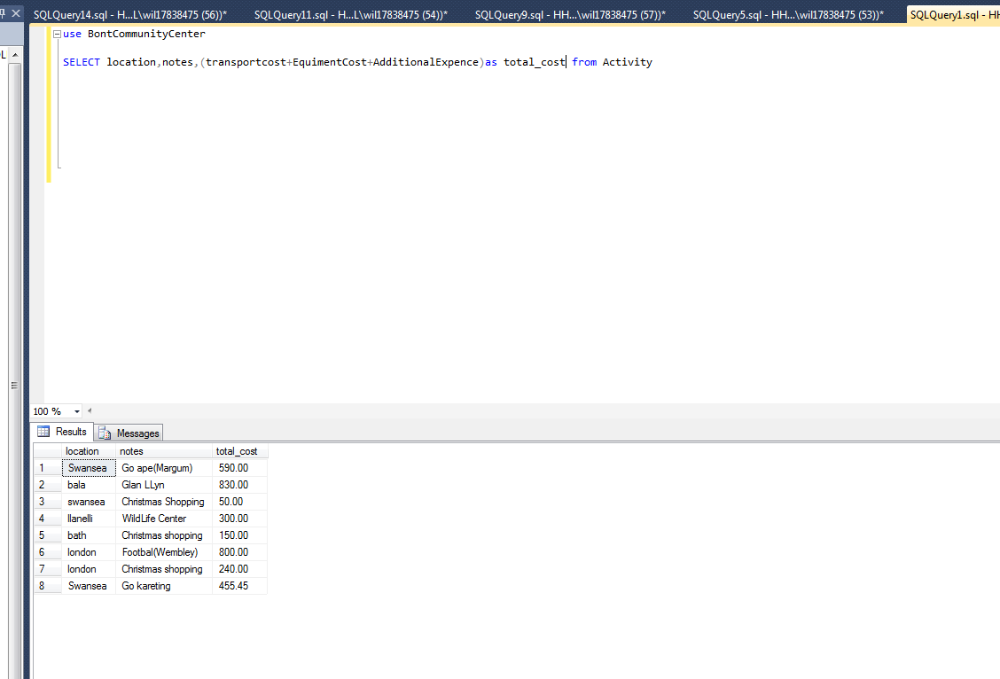

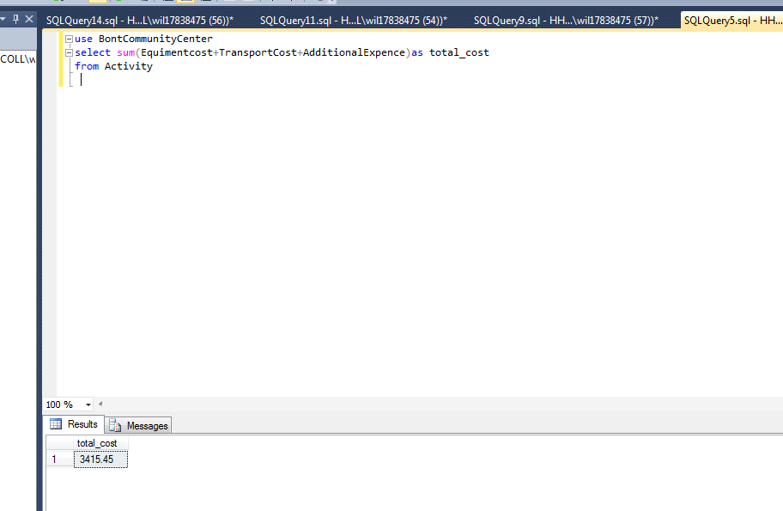
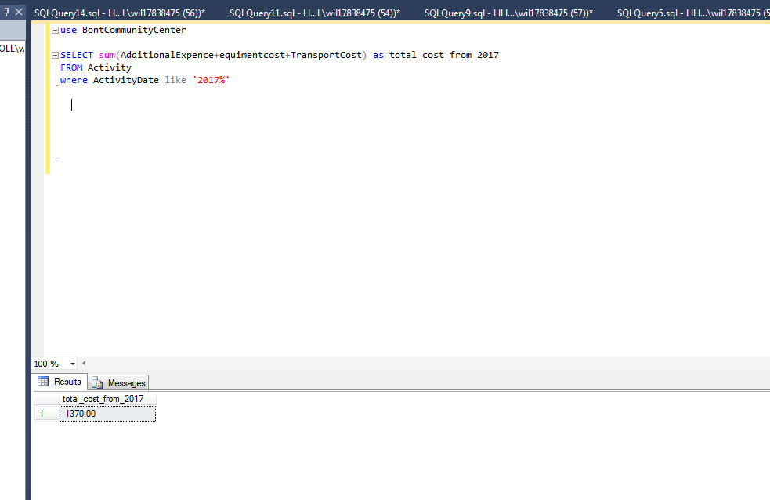
The leaders of the community centre might want to find out which clients have been on some of the trips and if some volunteers have been volunteering more than others. The quire below show how to gather this information.

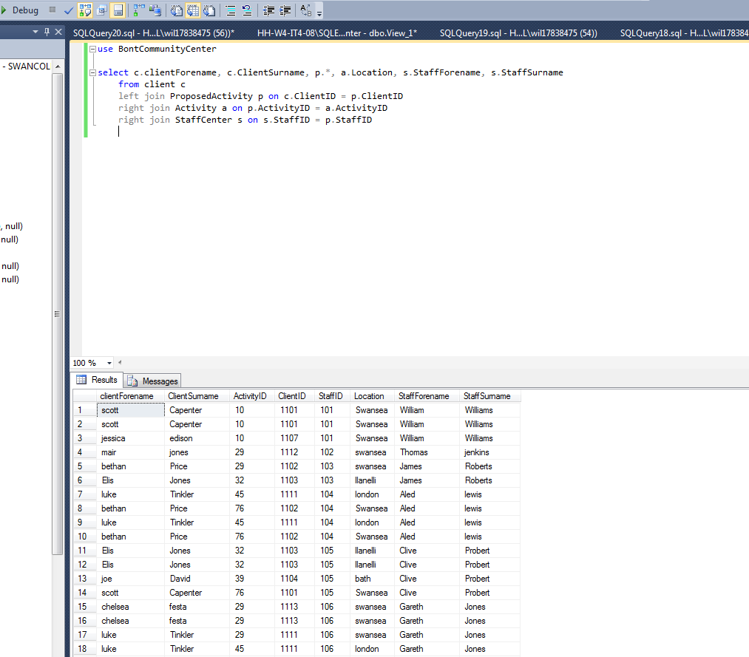
While searching through the database Bont community centre might want to find out what volunteer has been on what trip with what clients, this query below shows how you might search through the database to find this information.

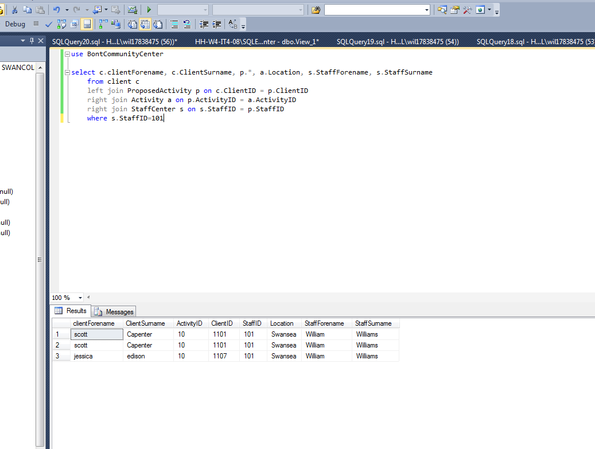
This query below show how to search for one member of staff from the table’s staff centre proposed activity and clients. The left join command/keyword shows all matching records from proposed activity table connecting to the clients table, using the clients ID which is a forging key. The right join command/keyword searches for all records from the clients table and matches them to the activity table using the activity id, if there are no matches for the record then the search will come back with the value of null.

The next query is looking at what staff member is a volunteer and who is a supervisor, this query also searches what staffs are available and how long they are available for. The query links four tables and searches using the inner join command. The inner join command searches for records that match in both tables.

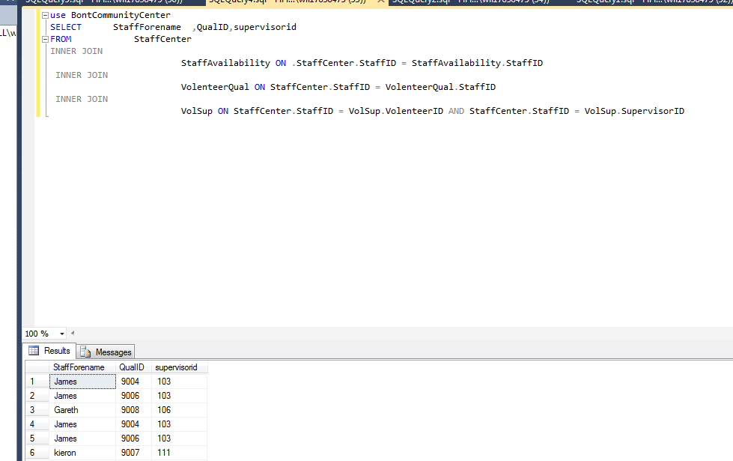

Linking SQL to access
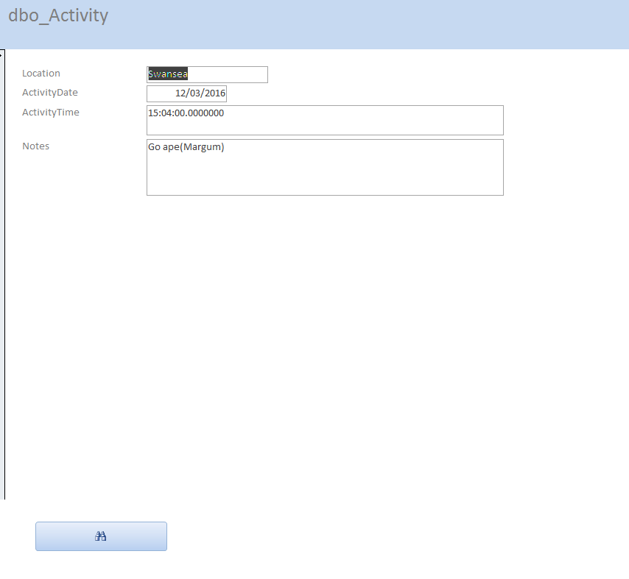
Once the data base has been made in MySQL then it was connected to access for an easier user interface. The access allows for forms to be created and buttons to be added to the forms for easier queries. The first button I added was a search button, this button allows for easier searching through the

There are several button available to on access for different commands ,the next button I have made is go to next record. This button is helpful as you can go to the next record on the form with a click of a button.
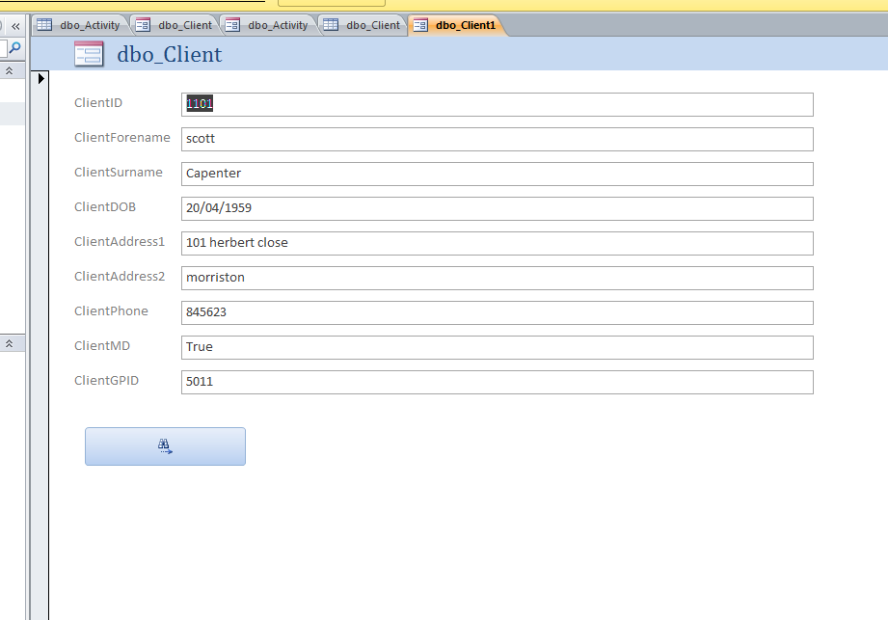
I have also entered a new qualification into access and it has updated in SQL, this proves that the database can be updated from access and SQL.
The qualification I added was ’badminton’ as in the screen shots below it has updatedin acces and SQL.
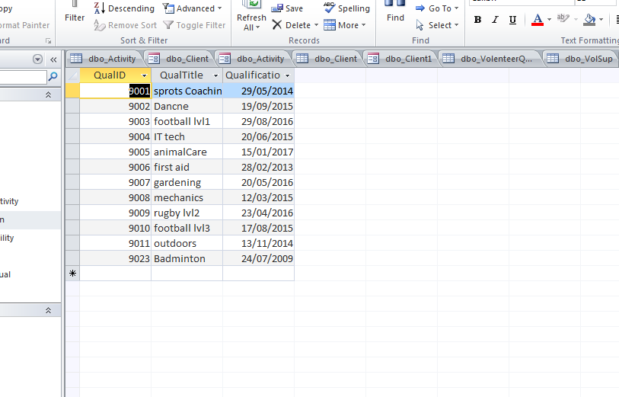

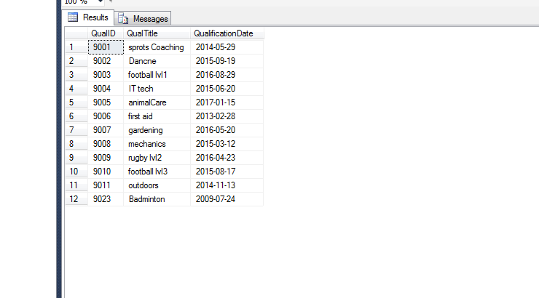

Making a switchboard in access allows for easy navigation around the database.
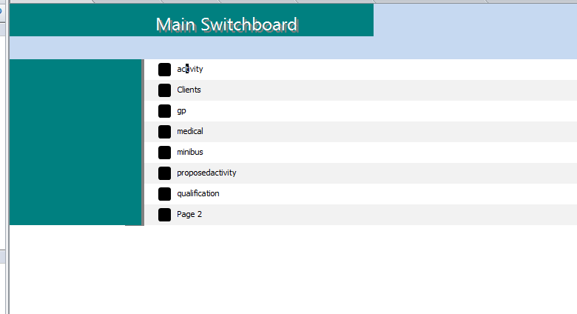
The switchboard contains links to all the forms that are on the database. When you click on a link it will take you to a form, you are able to enter new information or edit information by using the links in the switchboard. The last link on the switchboard takes the user to second switchboard which contains more links to forms.

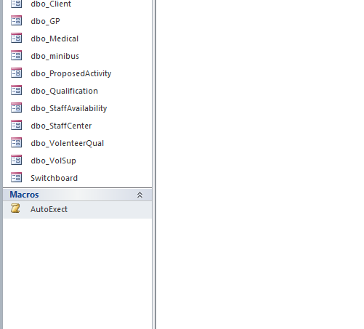
Here I have made an AutoExect file, this allows the switchboard to appear first on the database in access. This makes it easy for the user to get to the forms without any hassle.

I have also made a query in access, the query searches through the qualification tables and the staff centre tables and searches for any one with the address SA7. This is the the report result for the query.
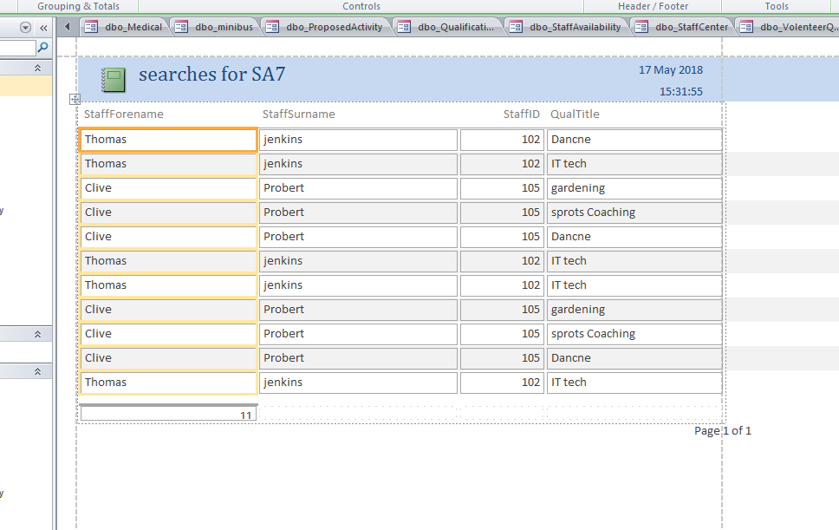

Conclusion
This report has covered how and why a database is created in SQL. The report has talked of datatypes used and how database tables are created. The test information has been entered and the report has shown how it’s been entered and has discussed how to overcome any problem that may occur while inserting information. The report has discussed how to link the SQL database to access for an easier front end user. Forms and report have been made and queried in access with buttons also being created. The system life cycle has been completed by the end of this database creation, the database has been implemented and test data has been entered. There was no older database to link to the new database and the testing has been done by proving the database links to access and contains all the correct tables and information.

