Review paper: Business Intelligence and a critical review of Data Mining in online retail marketing.

Written by: Emma-Siân Davies

Abstract: Data mining is widely used throughout the retail industry. This paper reviews the application of different data mining techniques in marketing used by large and small organisations via online retail and determines if, through critical analysis and research, data mining is conducive to successful marketing for retail organisations trading online.

Keywords: Data mining, Retail Industry, Online, data mining future

- Introduction

Data mining is an analytical tool used by organisations to determine who is buying what, when and how they can best market specific products and cater for consumers by offering a tailored service. Data mining incorporates quantitative methods which can include different algorithms, mathematical equations, clustering, decision trees, association and prediction as well as many others, to determine consumer trends and patterns. For every item put into an online basket or bought in an online shopping trip, data is uploaded into a system of big data which is then analysed, adapted to the individual consumer and implemented in the form of special offers, vouchers and/or offering items which the consumer may be interested in and in turn, increasing revenue.

- Data Mining for retail

The use of data mining has enabled organisations to connect to their consumers on a personal level by creating an uniquely designed algorithm to extract specific information. It aids in the process of predicting accurate sales figures for specific regions and can help an organisation forecast the need for specific products during different seasons and has help adapt to increase sales and revenue.

“The goal …to solve a pressing problem or to explore an emerging business opportunity in order to create a sustainable competitive advantage”[7]

Here we discuss in brief the three main categories of data mining patterns; association, clustering and prediction. Once the organisation has decided on a structured or unstructured route they can begin there are four phases in which an organisation must process Big Data to enable them to condense the data [1]. First it must be cleansed, any incomplete or missing data to be removed to avoid miscalculation, secondly, relevant data mining tasks are run to show patterns. Third, the patterns are analysed in preparation and finally, using the data mined, applications are put in place to assist decision making.
Associated: By finding an affiliation between products one can see what a consumer purchases and can suggest additions by advertising individual promotions on a complementary product or products. For example, an online consumer may purchase cream on a regular basis from a food retail organisation. To promote sales the organisation may send offers to the consumer for strawberries [2]. By making suggestions the organisation can put a suggestion in the mind of the consumer and the next time they buy cream, they are more likely to purchase strawberries. This in turn could then allow further associated products to be suggested.
Clustering: Online organisations are like physical outlets in the way they group similar products together. It may be that some items fall in to different categories. One of the main clustering techniques used is the k-means algorithm Fig 1, a process developed to assign a piece of data to its nearest and most similar counterpart. By grouping similar products organisations make them easy to access for the consumer [4].
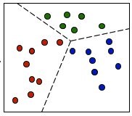
Fig 1 [6].
Predictive: Both large and small organisations use data mining for marketing in similar ways though it is probable that they work on a differing scale; this is predominantly down to company size, turnover and budget. With the increase of digital marketing we see little paper marketing coming through our letterboxes nowadays and more consumer focused emails. Thanks to modern technology and online shopping, we are able to do the majority of our shopping online. Online sales have increased considerably in the last decade and the Office of National Statistics [5] show that at present internet sales in the United Kingdom are 16.3% of the overall retail sales; in comparison to 4.9% in 2008, as seen in Fig 2.

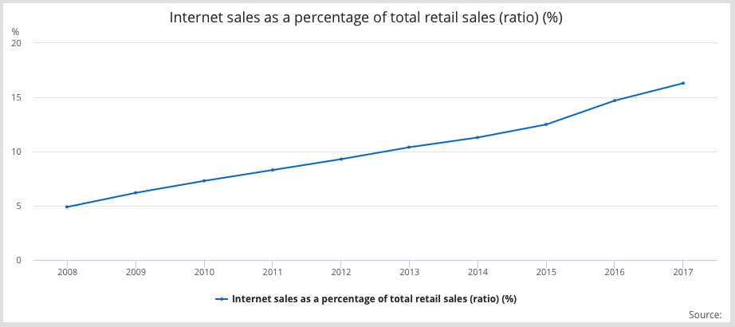
Fig 2.
If this is to continue to grow, then organisations within the retail industry can use a predictive data mining technique to forecast possible % sales in the next five to ten years. They will see fluctuating patterns through the year as some months are busier than others and can adapt their marketing strategy from this big data.
“Retailers who appeal to connected shoppers and meet these new expectations will thrive the most in the next 10 years.”[3]
By making use of one or all of these techniques, both large and small organisations should be able to market their brand or brands effectively, giving the consumer what they need and increasing online sales, creating a more sustainable organisation.
- Conclusion

With the facility of having access to retail organisations on mobile devices, people are able to shop almost anywhere and having online presence allows you to connect with a consumer any time of day and ship items as soon as possible. Based on the evidence shown, we can be sure that online retail will only increase, more and more organisations will begin to sell products online and many may become solely online traders.

- References

[1]Anupama, Y. K., Amutha, S. & Ramesh Babu, D. R., 2017. Survey on Data Mining Techniques for Diagnosis and Prognosis of Breast Cancer. International Journal on Recent Innovation Trends in Computing and Comunication, 1 Feb , 5(2), pp. 33-37.

[2]IBM, 2012. Data mining techniques. [Online]
Available at: https://www.ibm.com/developerworks/library/ba-data-mining-techniques/#fig2
[Accessed 03 Mar 2018].

[3]Linklater, J. & Mulvenna, A., 2016. Future of Retail: In Stores Now , s.l.: SweetIQ Analytics Corp..

[4]Mishra, M. & Behera, H. S., 2012. Kohonen Self Organizing Map with Modified K-means clustering For High Dimensional Data Set. International Journal of Applied Information Systems (IJAIS), May.2(3).

[5]Office for National Statistics, 2018. Internet sales as a percentage of total retail sales (ratio) (%). [Online]
Available at: https://www.ons.gov.uk/businessindustryandtrade/retailindustry/timeseries/j4mc/drsi
[Accessed 2nd March 2018].

[6]Parson Education limited, 2014. Lecture Data Mining. s.l.:s.n.

[7]Sharda, R., Delen, D. & Turban, E., 2014. Business Intelligence and Analytics: Systems for Decision Support. 10th ed. Harlow: Global Edition.

