

University of Wales Trinity Saint David School of Engineering

Passive RC Filter Networks
Technical Report

Electrical & Electronic Principles
(ACDB4002)

Mohamed Rithwan Thangeswaran
2313855
08/03/2024
ABSTRACT
A passive filter is a circuit containing capacitors, inductors, and resistors, which is used for passing a certain range of frequencies while attenuating the other frequencies. In this experiment two passive RC filter circuits were made and analyzed. The low-pass filter circuit was designed using 10KΩ resistor and a 560 pF capacitor, and the high-pass filter was designed using a 10kΩ resistor and a 15 nF capacitor. 5V_{pk-pk} sine wave was supplied to the filters and the outputs respect to various frequencies were observed using an oscilloscope. Results obtained were graphed to display the characteristics of the filter circuits clearly. Analyzing the results show that the LPF has a cutoff frequency of 28421 Hz and therefore, it will pass the signals with frequencies lower than that and attenuate signals with frequencies higher. Similarly, the cutoff frequency of HPF is 1061 Hz, so the signals with lower frequencies than the cutoff frequency were attenuated and the signals with higher frequencies were passed.

Contents
1. INTRODUCTION 5
1.1. CAPACITIVE REACTANCE 6
1.2. PASSIVE LOW PASS FILTER (LPF) 7
1.3. PASSIVE HIGH PASS FILTER (HPF) 8
1.4. CUT-OFF FREQUENCY 9
2. CIRCUIT DESCRIPTIONS 10
2.1. METHODOLOGY - RC LOW-PASS FILTER 10
2.2. METHODOLOGY - RC HIGH-PASS FILTER 11
3. RESULTS 12
3.1. RC LOW-PASS FILTER 12
3.2. RC HIGH-PASS FILTER 17
4. DISCUSSION 23
5. CONCLUSION 25
6. REFERENCES 26

TABLE OF FIGURES
Figure 1-response curves for the above filter types 5
Figure 2-RC LPF circuit 7
Figure 3-Frequency response of a first order LPF 7
Figure 4-RC HPF circuit 8
Figure 5-Frequency response of a first order HPF 8
Figure 6-LPF circuit using a breadboard, a capacitor and a resistor 10
Figure 7-input waveform with 200Hz frequency and 5V amplitude 10
Figure 8-HPF circuit using a breadboard, a capacitor and a resistor 11
Figure 9-Output waveform of LPF at 100Hz frequency (Vout = 5.04V) 12
Figure 10-Output waveform of LPF at 50kHz frequency (Vout = 2.52V) 12
Figure 11-Graph of Xc vs Frequency using theoretical values in LPF 13
Figure 12-Graph of Xc vs Frequency using practical values in LPF 13
Figure 13-Graph of V_{out} vs Frequency using theoretical values in LPF 14
Figure 14-Graph of Vout vs Frequency using practical values in LPF 14
Figure 15-Graph of Gain (A) vs Frequency using theoretical values in LPF 15
Figure 16-Graph of Gain (A) vs Frequency using practical values in LPF 15
Figure 17- Cut-off frequency (-3dB point) of the LPF 16
Figure 18-Output waveform of HPF at 200Hz frequency (Vout = 0.96V) 17
Figure 19-Output waveform of HPF at 299.9 kHz frequency (Vout = 5.12V) 18
Figure 20-Graph of Xc vs Frequency using theoretical values in HPF 18
Figure 21-Graph of Xc vs Frequency using practical values in HPF 19
Figure 22-Graph of Vout vs Frequency using theoretical values in HPF 19
Figure 23-Graph of Vout vs Frequency using practical values in HPF 20
Figure 24-Graph of Gain (A) vs Frequency using theoretical values in HPF 20
Figure 25-Graph of Gain (A) vs Frequency using practical values in HPF 21
Figure 26-Cut-off frequency (-3dB point) of the HPF 22
Figure 27-Capacitive reactance against frequency 23

INTRODUCTION
A filter is used to remove unwanted parts of a signal like random noises, or to extract the necessary parts of a signal contains within a frequency range. An ideal filter allows a certain range of frequencies while attenuating all the other frequencies. According to the elements used to build the filter circuit, the filters can be divided as active filters and passive filters. A passive filters use passive components like resistors, capacitors, and inductors, while the active filters use active components such as op-amps and transistors in addition to resistors and capacitors, but not the inductors. According to the region of the frequencies which are passed and attenuated, the filters are classified as low-pass and high-pass(Davis, 2023) (Kolawole, et al., 2015).
Low pass filters allow low frequency signals up-to its cutoff frequency and block the higher frequencies. These filters are mostly used in audio amplifiers and speaker systems, and they are used to reduce high frequency noise distortions.
High pass filters attenuate the low frequency signals and pass the signals larger than it’s cutoff frequency. These filters are used in audio systems, antenna systems and, also in power supplies, acoustic engineering and signal processing applications.
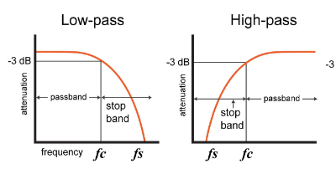
Figure 1-frequency curves for the above filters
In this experiment the characteristics and applications of the two RC passive filters – low pass filers and high pass filters are discussed. A simple first order passive filter can be built by connecting a single capacitor and a resistor in series, opposite to an input signal. The output signal can be taken out from either across the capacitor or the resistor. This determines the type of filter constructed. That is, if the output is taken across the capacitor – it gives a low pass filter, and if the output is taken across the resistor – it gives a high pass filter (Storr, 2022).

CAPACITIVE REACTANCE
The complex impedance value of a capacitor is known as the capacitive reactance. This acts as a variable resistor inside the capacitor which changes with respect to the applied frequency, and limits the current through the capacitor. When the applied frequency increases, the capacitive reactance decreases. This variation is known as the complex impedance of the capacitor. The formula for the capacitive reactance is as follows.
$$X_{C } = \frac{1}{2πfC}$$
Where,
- X_{c} = Capacitive Reactance (Ω)
- π (pi) = 3.142
- ƒ = Frequency (Hz)
- C = Capacitance (F)
According to the above equation, the capacitive reactance is inversely proportional to the supply frequency. In a simple RC filter circuit, the resistor and the capacitor act as a voltage divider. While the impedance of the resistor is constant, the impedance of the capacitor is changed due to its capacitive reactance. Thus, the voltage difference between the resistor and the capacitor is decided by the reactance of the capacitor in a certain frequency. This is the basic principle used in the RC passive filter circuits, specifically the high-pass and low-pass filters (Storr, 2023).
The total impedance of the circuit and the output voltage can be calculated using the below equations.
$$Z = \sqrt{R^{2}+X_{C}^{2}}$$
Where Z is the total impedance of the filter circuit. By substituting this to a voltage divider formula, we can obtain the equations for output voltage of the above filters.
For a Low-pass filter circuit,
$$V_{out} = \frac{X_{C}}{\sqrt{R^{2}+X_{C}^{2}}}$$
For a High-pass filter circuit,
$$V_{out} = \frac{R}{\sqrt{R^{2}+X_{C}^{2}}}$$

PASSIVE LOW PASS FILTER (LPF)
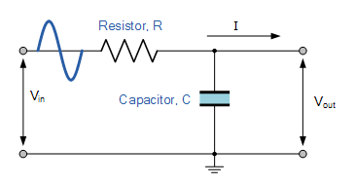
A low-pass filter passes the low frequency signals up to its cut-off frequency and attenuates the higher frequency signals. A simple passive RC LPF can be made by connecting a resistor with a capacitor in series as shown in Figure 2. The input is connected to the two sides of series connection and the output is taken across the capacitor.

Figure 2-RC LPF circuit

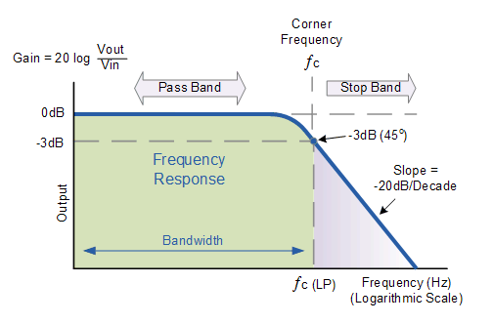
As mentioned above, the resistance R of the resistor remains constant while the capacitive reactance X_{c} of the capacitor changes inversely with the input frequency. So, at lower frequencies the value of X_{c} is very large compared to the R, and therefore the voltage across the capacitor is higher than that of resistor. As the frequency of input signal increases, the voltage across the capacitor decreases gradually due to decreasing X_{c}. The frequency curve for a passive LPF is shown in the Figure 3.
Figure 3-Frequency response of a first order LPF

According to Figure 3, frequency response of the filter is constant / almost equal to the input voltage for the low frequencies, and all of the input signal is passed to the output until it reaches the cutoff frequency. After the cutoff frequency, the response decreases with a -20dB/decade roll-off until it reaches zero. The frequencies above the cutoff value are attenuated (Storr, 2022).

PASSIVE HIGH PASS FILTER (HPF)
A high-pass filter attenuates the low frequency signals and passes the signals with frequencies greater than its cutoff frequency. Similar to the LPF circuit, a simple passive RC HPF can be made by connecting a single resistor with a single capacitor and connecting the input to the sides of the series connection, but the output is taken across the resistor as shown in the Figure 4.
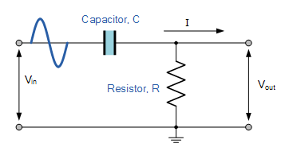
Figure 4-RC HPF circuit

In this arrangement, the capacitor acts as an open circuit (no current is passed) at low frequencies due to its very high reactance, until the cutoff frequency is reached. After the cutoff frequency, the reactance of the capacitor is reduced, so that the input signal passes to the output. The frequency response for a passive HPF is shown in the Figure 5.
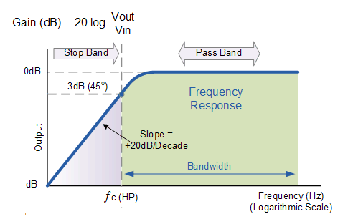
Figure5-Frequency response of a first order HPF
The frequency response of the passive HPF is the exactly opposite to that of LPF circuit. In this configuration the low frequency signals are attenuated and when the frequency approaches the cutoff frequency, it increased at +20dB/decade. (Storr, 2023).

CUT-OFF FREQUENCY
In Figure 3 and Figure 5, the cutoff frequencies of the two filters are marked as fc. In the cutoff frequency, the resistance R of the resistor is equal to the capacitive reactance Xc of the capacitor. In this point the output voltage is 0.707 times the input voltage. This is also known as the -3dB point of the filter response curve, because the gain at this point is equal to -3dB.
The cutoff frequency fc of LPF and HPF can be calculated using the below equation.
$$fc = \frac{1}{2πRC}$$
Where,
- R = Resistance of the resistor (Ω)
- C = Capacitance of the capacitor (F)
The gain of the above-mentioned filters can be calculated using the below equation. These filters do not have any amplifying elements, so their output signal level is always less than the input signal level. Therefore, the gain is always less than 1.
$$Gain (A) in dB = 20 log \left(\frac{V_{out}}{V_{in}}\right)$$
In the next sections of the report the characteristics of passive high pass filters and low pass filters will be discussed extensively using practical and theoretical examples. Changing of capacitive reactance with the frequency, frequency responses, cutoff frequencies and the gains of the above two filter circuits will be explained by analyzing the graphs and calculated values of the practical (Storr, 2023).

CIRCUIT DESCRIPTIONS
In this practical, two simple passive RC filter circuits – a low-pass filter and a high-pass filter were made and the frequency responses were evaluated. The theoretical values for capacitive reactance, output voltage, and the gain are calculated first using the equations given in the previous section, and then the practical values for the above were taken using an oscilloscope connected to the breadboard circuits.

2.1. METHODOLOGY - RC LOW-PASS FILTER
A passive RC filter was built on a breadboard using a capacitor and a resistor as shown in the Figure 6. The capacitance (C) of the capacitor used is 560pF and the resistance (R) of the resistor is 10kΩ.
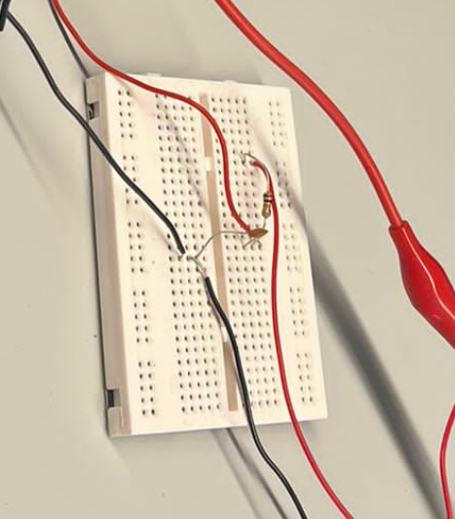
Figure 6-LPF circuit using a breadboard, a capacitor and a resistor
A 5V pk-pk sine wave (offset and phase values are zero) input signal was supplied to the circuit using a function generator, and the frequency of the signal varied from 100Hz to 300kHz. The output voltage was not changed after this is set. Example for the input waveform can be seen in Figure 7.
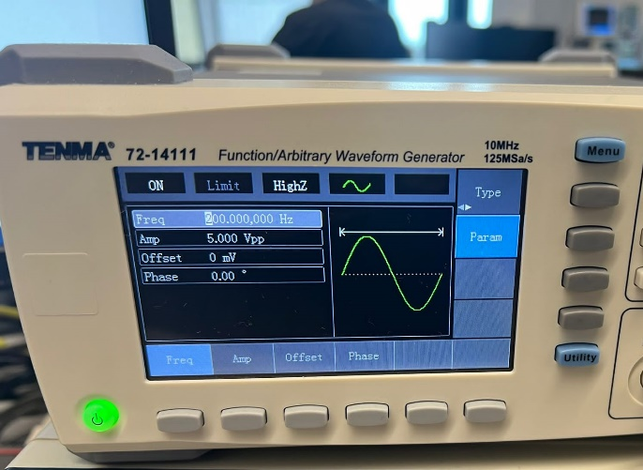
Figure 7-input waveform with 200Hz frequency and 5V amplitude
The output of the circuit was taken across the capacitor and observed through a digital oscilloscope. Output voltage amplitude for each frequency value was recorded and it was plotted as a function of frequency.

2.2. METHODOLOGY - RC HIGH-PASS FILTER
Similar to the low-pass filter circuit, a passive RC filter was built on a breadboard using a capacitor and a resistor as shown in Figure 8. The capacitance (C) of the capacitor used is 15nF and the resistance (R) of the resistor is 10kΩ. A 5V pk-pk sine wave (offset and phase values are zero) input signal was supplied to the circuit using a function generator, and the frequency of the signal varied from 100Hz to 300kHz. Output voltage was not changed after the input is set.
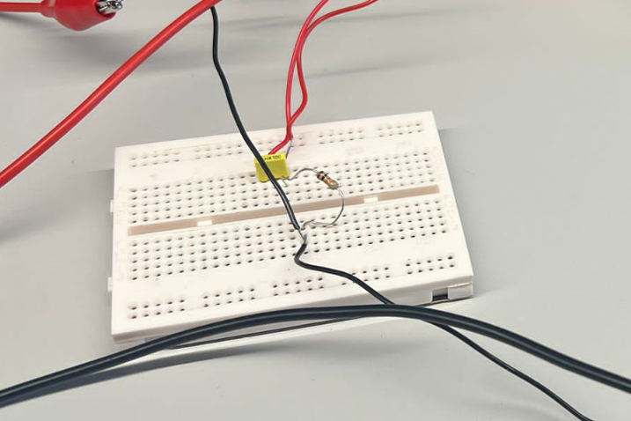
Figure8-HPF circuit using a breadboard, a capacitor and a resistor
The output of the circuit was taken across the resistor and observed through a digital oscilloscope. As similarly to the LPF circuit, the output voltage amplitude for each frequency value was recorded and it was plotted as a function of frequency.

RESULTS

3.1. RC LOW-PASS FILTER
Parameters used in this circuit are as follows. The input signal was given through a function generator as mentioned in the methodology, and the frequency was changed from 100Hz to 300kHz.
- Vin = 5 V
- R = 10 kΩ
- C = 560 pF
The output voltage of the circuit is observed through a digital oscilloscope as shown in the Figure 9 and Figure 10.
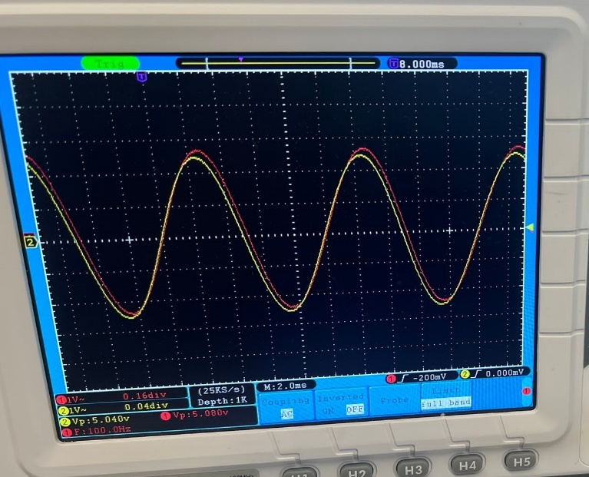
Figure 9-Output waveform of LPF at 100Hz frequency (Vout = 5.04V)

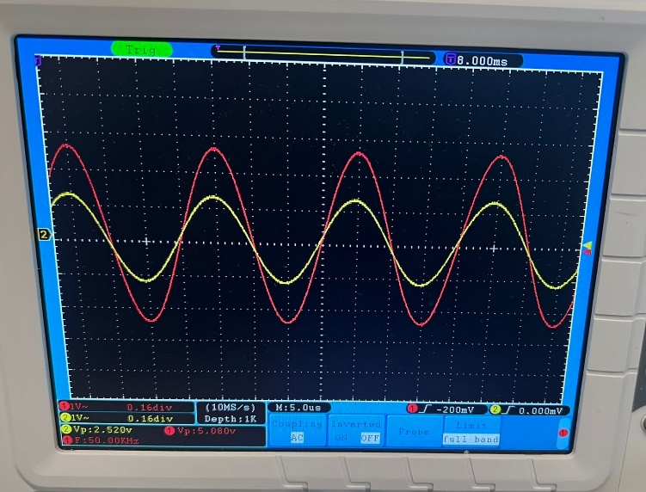
Figure 10-Output waveform of LPF at 50kHz frequency (V_{out} = 2.52V)
As observed in the above Figure 9 and 10, lower frequency signals were passed with full amplitude as the input, and the higher frequency signals get attenuated. All the output voltages with respect to the frequencies were measured, and the graphs of X_{c} vs frequency, V_{out} vs frequency, and Gain (A) vs frequency were plotted using a MS Excel spreadsheet. Following are the graphs plotted using the theoretical/calculated values and using the practical values.

Figure 11-Graph of X_{c} vs Frequency using theoretical values in LPF

Figure 12-Graph of X_{c} vs Frequency using practical values in LPF
In both the graphs value of X_{c} decreases rapidly with the increasing of frequency. Due to the logarithmic scale in X-axis, the graph seems linear.

Figure 13-Graph of V_{out} vs Frequency using theoretical values in LPF

Figure 14-Graph of V_{out} vs Frequency using practical values in LPF

Output voltage (V_{out}) was equal to the input voltage (V_{in}) in the lower frequencies and gradually decreases with the increment of frequency value. Both the theoretical and practical graphs give nearly equal values.

Figure 15-Graph of Gain (A) vs Frequency using theoretical values in LPF

Figure 16-Graph of Gain (A) vs Frequency using practical values in LPF

As mentioned in the above section, the gain of a passive filter circuit is always less than 1. Therefore, the gain in dB is always negative.

Calculating Cut-off frequency (-3dB point) using the equation,
$$fc = \frac{1}{2πRC}$$
Substituting values R = 10kΩ and C = 560 pF,
$$fc = \frac{1}{2π×10×{10}^{3}×560×{10}^{-12}} \\ fc = \frac{1}{2πRC} \\ fc = 28421 Hz$$
Therefore, the cut-off frequency / -3dB frequency is 28.481 kHz. Figure 17 shows the point marked in the Vout vs frequency graph of LPF circuit. The voltage corresponding to the above frequency value is 3.535V.

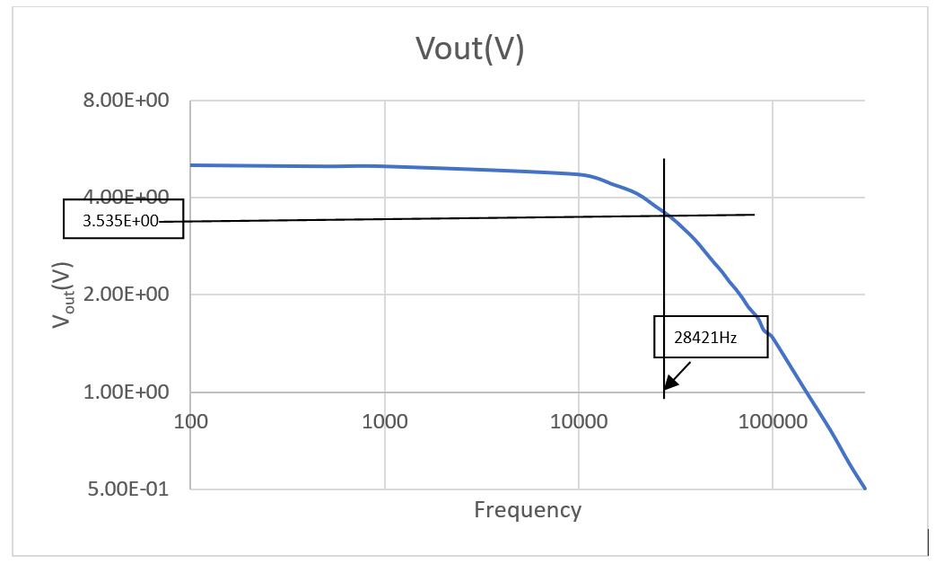
Figure 17- Cut-off frequency (-3dB point) of the LPF

3.2. RC HIGH-PASS FILTER
Parameters used in this circuit are as follows. The input signal was given through a function generator as mentioned in the methodology, and the frequency was changed from 100Hz to 300kHz.
- Vin = 5 V
- R = 10 kΩ
- C = 15 nF
The output voltage of the circuit is observed through a digital oscilloscope as shown in the Figure 18 and Figure 19.
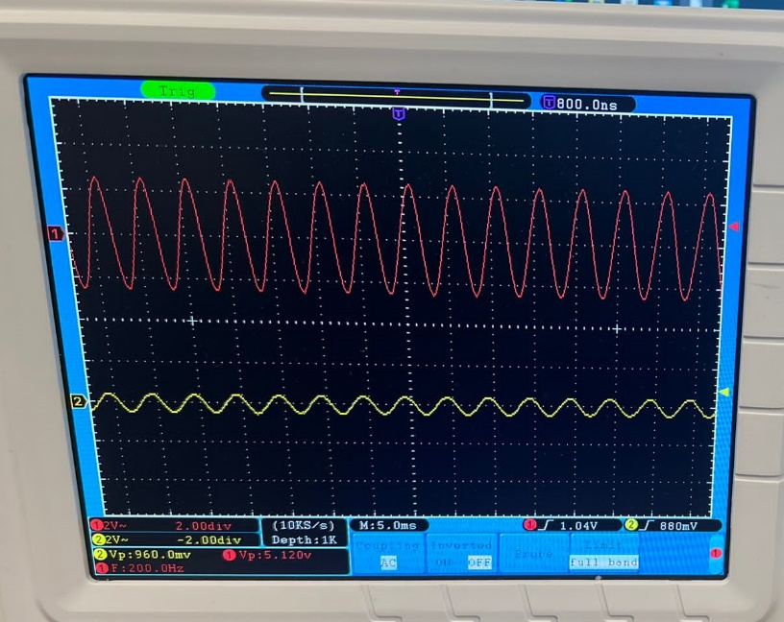
Figure 18-Output waveform of HPF at 200Hz frequency (Vout = 0.96V)
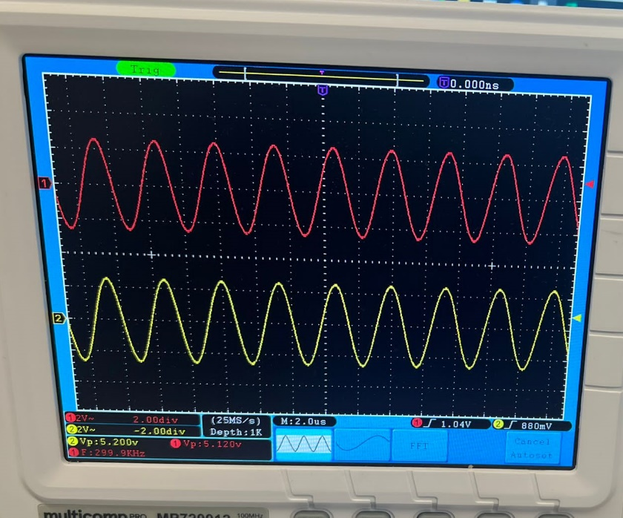
Figure 19-Output waveform of HPF at 299.9 kHz frequency (Vout = 5.12V)

Figure 18 and Figure 19 shows that the lower frequency signals were attenuated and the higher frequency signals were passed with the full amplitude similar to input signal. Similar to the LPF circuit, all the output voltages with respect to the frequencies were measured, and the graphs of Xc vs frequency, Vout vs frequency, and Gain (A) vs frequency were plotted using a MS Excel spreadsheet. The graphs plotted using the theoretical/calculated values and using the practical values are as follows.

Figure 20-Graph of X_{c} vs Frequency using theoretical values in HPF

Figure 21-Graph of X_{c} vs Frequency using practical values in HPF

As observed in Figure 20 and Figure 21, the graphs of X_{c} vs frequency using theoretical values and practical values of the HPF are almost same.

Figure 22-Graph of V_{out} vs Frequency using theoretical values in HPF

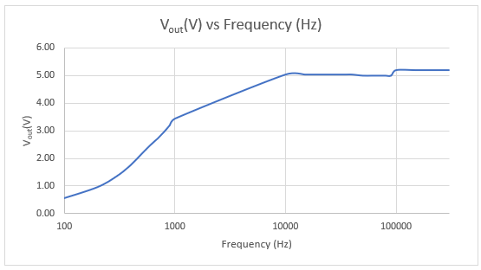
Figure 23-Graph of V_{out} vs Frequency using practical values in HPF
Output voltage (V_{out}) was minimum in the lower frequencies and gradually increases as the frequencies increment. At the higher frequencies the output voltage is almost equal to the input voltage (V_{in}). The curve of the practical value is not smooth due to the losses.

Figure 24-Graph of Gain (A) vs Frequency using theoretical values in HPF

Figure 25-Graph of Gain (A) vs Frequency using practical values in HPF

Similar to LPF circuit, the gain of HPF also always negative because V_{out} is always less than V_{in}. The gain of the HPF circuit increases (decreases the negative value) with increasing frequency.

Calculating Cut-off frequency (-3dB point) using the equation,
$$fc = \frac{1}{2πRC}$$
Substituting values R = 10kΩ and C = 560 pF,
$$fc = \frac{1}{2π×10×{10}^{3}×15×{10}^{-9}} \\ fc = \frac{1}{2πRC} \\ fc = 1061 Hz$$

Therefore, the cut-off frequency / -3dB frequency is 1061 Hz. Figure 26 shows the point marked in the V_{out} vs frequency graph of LPF circuit. The voltage corresponding to the above frequency value is 3.535V.

Figure 26-Cut-off frequency (-3dB point) of the HPF

DISCUSSION
In this practical, the characteristics of passive RC low-pass filter and high-pass filter are discussed using the theoretical values and the practical values of capacitive reactance, output voltage and the gain. The filter circuits were made using capacitors and resistors of given values using a breadboard, and the input signal was supplied using a function generator. The observed results which were graphed are in the previous section.
When considering the LPF circuit, the theoretical X_{c} values are almost same as the practical values. As mentioned before, the impedance across the capacitor is decreased with the increasing of frequency. Figure 11 and Figure 12 shows the change of X_{c} with frequency in a logarithmic scale, and Figure 27 shows the same with a linear scale. The X_{c} values of the HPF circuit also acts in a similar way, and the graphs of X_{c} vs frequency exhibits similar properties.
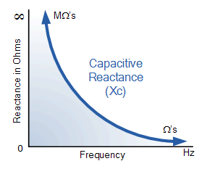
Figure 27-Capacitive reactance against frequency
Using the oscilloscope, the changing of the amplitude of output signal can be observed clearly. Figure 9 and Figure 10 shows two such observations made in LPF circuit. It can be observed that LPF gives an output of 5.04V at 100Hz and the output is reduced to 2.52V when the frequency is increased to 250kHz. All the observations taken using the oscilloscope can be analyzed by using the plotted graphs of V_{out} vs frequency. Figure 13 and 14 shown the graphs of calculated V_{out} and practical V_{out} against frequency of the LPF circuit. It can be observed that the output voltage is equal to the input voltage at the lower frequencies, which is due to the high capacitive reactance of the LPF in lower frequencies. The output voltage starts to decrease rapidly after reaching the cutoff frequency or the -3dB frequency (28421 Hz) which is calculated in the previous section. The angle of the slope or the ‘roll of’ is -20dB, and this value is common for all the RC filter circuits. The higher frequencies show a very low amplitude close to 0 due to the attenuation of the signal.
The amplitude change of the output signal of HPF circuit also can be observed through the oscilloscope. Figure 18 and Figure 19 shows that the HPF gives an output voltage of 0.96V at 200Hz and an output voltage is increased to 5.12V at 299.9kHz frequency. Figure 22 and 23 shows the V_{out} vs frequency graphs plotted using the values taken from oscilloscope observations. The V_{out} is lowest at the minimum frequency used and increased gradually with the increasing of frequency until the cutoff frequency (1061Hz). The reason for this is, at the lower frequencies the resistance is very small with compared to the capacitive reactance, and therefore the voltage across the resistor is very low. But with the frequency, capacitive reactance is reduced and gradually the voltage across the resistor is increases. After reaching the cutoff frequency, the V_{out} was almost equal to the input voltage and didn’t change further although the frequency increased.
When calculating the gain, passive RC filters always shows negative dB values as shown in the Figure 16 (gain of LPF) and Figure 15 (gain of HPF). The reason for this is the output voltages of a passive filter is always less than the input voltage. Unlike the active filters passive filters do not have any amplifying elements, and due to that V_{out}/V_{in} ratio is always less than unity (1). Therefore, when converting to dB values they become negative. In the LPF, the gain decreases when the frequency increases with proportional to the output voltage. And in HPF, the gain increases when the frequency increases with proportional to the output voltage.

CONCLUSION
For the passive RC low pass filter the lower frequency signals (lower than cutoff frequency) are passed through to the output without any attenuation. As the frequency increases beyond the cutoff frequency, capacitive reactance decreases in a slope of -20dB/decade resulting in decreasing of output voltage and thus decreasing the gain of the filter. The cutoff frequency is the point which the output voltage is reduced to 70.7% of the input voltage and it can be determined by using the capacitor and resistor values or using the Vout vs frequency graph.
In the passive RC high pass filter, the lower frequency signals which are less than the cutoff frequency are attenuated. When the frequency increases, the output voltage increases in a slope of 20dB/decade until it reaches the cutoff frequency and become a constant until infinity. With respect to the variation of Vout, the gain also increases and become a constant. The value of gain is negative in this scenario also, similarly to the LPF circuit.
In conclusion, the frequency responses of these two circuits can be used to facilitate the filtering of unnecessary signal components and enabling only the necessary frequencies to pass. And by determining certain values for resistors and capacitors, we can easily adjust the pass band of the filter and the cutoff frequency for any necessary applications.

REFERENCES
Davis, N., 2023. An Introduction to Filters. [Online]
Available at: https://www.allaboutcircuits.com/technical-articles/an-introduction-to-filters/#:~:text=Passive%20and%20Active%20Filters,and%20capacitors%2C%20but%20not%20inductors.
Kolawole, E. S., Ali, W., Cofie, P. & Fuller, J., 2015. Design and Implementation of Low-Pass, High-Pass and Band-Pass Finite Impulse Response (FIR) Filters Using FPGA. Circuits and Systems, 6(2), pp. 30-48.
Storr, W., 2022. Passive Low Pass Filter. [Online]
Available at: https://www.electronics-tutorials.ws/filter/filter_2.html
Storr, W., 2023. Capacitive Reactance. [Online]
Available at: https://www.electronics-tutorials.ws/filter/filter_1.html
Storr, W., 2023. Passive High Pass Filter. [Online]
Available at: https://www.electronics-tutorials.ws/filter/filter_3.html

