

Programme: MBA in International Business
Topic: Impact of Supply Chain Disruption on Product Availability at Boots UK
Supervisor Name: Dr Trinh Nguyen Thi Ngoc
Student Name: Shubham Karanwal
Student ID: 2504766
Submission Date: 28th August 2026
DECLARATION
I, Shubham Karanwal declare that this dissertation has been composed by myself, that the work contained herein is entirely my own except where explicitly stated otherwise in the text, and that this work has not been submitted for any other degree or qualification, in whole or in part, except as specified.

Signature: Shubham karanwal

Date 27th august 2026

Acknowledgement
I would like to thank all the people who helped in the successful completion of this dissertation. First and most important, I want to express my profound gratitude to my supervisor and her priceless guidance, constructive feedback, and active encouragement during the research process. I also want to thank my peers and colleagues, whose thoughts and discussions helped me to gain new views. Lastly, I would like to thank my family and friends as I would not have been able to stay focused and determined in the face of the adversities of this academic journey without their unwavering support and patience, and motivation.

Table of Contents
Table of Contents 3
Chapter 1: Introduction 8
1.1 Research Background 8
1.2 Research Problem 10
1.3 Research Aim, Objectives and Questions 11
1.4 Research Gaps and Motivations 12
1.5 Research contribution 12
1.6 Scope of the Study 13
1.7 Structure of the Dissertation 13
1.8 Summary 14
Chapter 2: Literature Review 15
2.1 External Drivers of Supply Chain Disruption in UK Retail Supply Chains 15
2.3 Operational Sources of Supply Chain Disruption in Retail Supply Chains 16
2.4 Supply Chain Disruptions impacts on Product Availability and Inventory Management 18
2.5 Product Availability and Customer Satisfaction/Reward to Retail Performance 19
2.6 Strategies for Resilience in Supply Chains 20
2.7 Theoretical Framework 21
2.8 Conceptual Framework 22
2.9 Literature Gap 24
2.10 Chapter Summary 25
Chapter 3: Methodology 26
3.1 Introduction 26
3.2 Research Onion 26
3.3 Research Philosophy 27
3.4 Research Approach 28
3.5 Research Design 29
3.6 Research Strategy 30
3.7 Data Collection Method 30
3.8 Data Analysis Method 32
3.9 Reliability and Validity 33
3.10 Ethical Considerations 33
3.11 Summary 33
Chapter 4: Findings, Analysis and Discussion 35
4.1 Introduction 35
4.2 Findings 35
4.2.1 Link Between Questions and Themes 35
4.2.2 Thematic Analysis 37
4.3 Discussion of Findings 43
4.3.1 Understanding the Key Drivers of Supply Chain Vulnerability 43
4.3.2 Evaluating the Consequences for Product Availability and Customer Experience 45
4.3.3 Assessing Strategies for Building Supply Chain Resilience 46
4.3.4 Implications for Boots UK's Future Supply Chain Management 47
4.4 Key Findings 49
4.5 Chapter Summary 49
Chapter 5: Conclusion and Recommendations 50
5.1 Conclusion 50
5.2 Linking with Objectives 52
5.3 Limitations of the Research 53
5.4 Future Scope 53
5.5 Recommendations 54
References 56

List of Figures
Figure 1.1: Logo of Boots 10
Figure 1.2: Boots UK Supply Chain Network 10
Figure 1.3: Structure of the Dissertation 13
Figure 2.1: Conceptual Framework 23
Figure 3.1 Research Onion 26
Figure 4.1: Supplier Dependency 38
Figure 4.2: Challenges in Forecasting 40
Figure 4.3: Supply Chain Integration and Partnerships 42

List of Tables
Table 4.1: Link Between Questions and Themes 36

Chapter 1: Introduction

Disturbances to the supply chain have made it more difficult for retailers to manage inventory because of increasing international uncertainties and operational challenges. In the UK, challenges from globalization, Brexit, the COVID-19 pandemic, inflation and labor shortages have adversely impacted supply chain and stock control issues in the retail industry (Simionescu et al., 2025). Product disruption limits stock available to customers, reduces competitiveness, and negatively impacts operational efficiency. Boots UK, as one of the largest health and beauty retailers in the UK, has the most extensive supply chain network. This ensures availability for each of Boots UK's retail stores and e-commerce (Boots, 2024). Thus, this study is going to analyse how Boots UK is affected by supply chain disruptions and how these disruptions can be made less likely.

1.1 Research Background
The UK Retail Sector is of major importance to the economy, and experiencing rapid growth. Multichannel retailing is changing consumer buying behaviour. Customers are given the option to choose between physical or online buying which has inspired time efficiency and fulfilled expectations towards the retailer. Because of this, businesses have to operate supply chains punctually to hit that demand, or else risk losing out to the competition (Ward, 2025). The rapid changes seen in supply chains have brought increased difficulties to the UK retail sector, and the effects of Brexit have only made it harder to establish cross-border supply chains, and there are more shortages in the workforce and logistics that further disrupt the flow of supply.


Figure 1.1: Logo of Boots
(Source: Boots, 2024)
Heightened inflation and the aftermath of COVID-19 have also created obstacles to establishing supply chains that move goods and manage stock. As a result, companies fail to meet the needs of their clients. Boots UK is a part of The Boots Group, a top independent pharmacy and health retailer (The boots group, 2025). Boots UK is doing well in the financial sector and has reported being in the black by 3.2% for which they have reported £7.5bn in sales as well a 25% increase in pre tax profit to £337m which they report is due to the increase in sales for beauty products and weight loss injections.
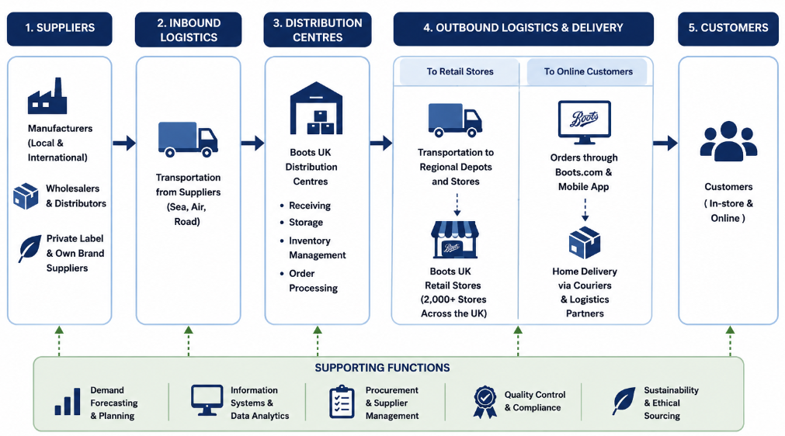

Figure 1.2: Boots UK Supply Chain Network
(Source: The author)
Figure 1.2 illustrates as one of the largest pharmacy chains in the UK, Boots UK sells pharmacy goods and beauty products over their widespread retail network as well as online. Boots UK also has varying and multiple suppliers, and transport and distribution networks to further support their business (Boots, 2024). Some other retail chains are less integrated than Boots UK because an entire supply chain network services Boots UK reflected in above figure. Thus, a disruption in that supply chain will impact Boots UK's stock and hinder the services they can provide. Product availability significantly impacts customer satisfaction, brand loyalty, and purchasing decisions (Khan et al., 2022). Customers will seek other products, and this will not only cost the company the sale of the product, but it will also have a negative effect on the overall performance of the company. To this end, product availability is a requisite to keep the customers and to improve performance and competitive edge.

1.2 Research Problem
The UK supply chain disruptions create significant problems for inventory management and product distribution and service provision for retailers. This includes delays from suppliers, staff shortages, disruptions in transport, and the fluctuating economy (Ovezmyradov, 2026). Because of this, the likelihood of customers creating a negative purchasing behaviour due to product unavailability has increased. For Boots UK, continuous product availability is vital because customers require an almost immediate access to health and personal care products.
Boots UK loses a customer if a product is unavailable. Supply chain delays lead to an inadequate stock and a drop in the quality of service. Operational inefficiencies will always hurt the customer and the business. Although supply chain disruption has become a hot topic for study, most of the studies focus on the manufacturing industry and general retail (Jiang et al., 2023). The studies for the pharmacy and beauty retail industries are almost nonexistent. The studies for Boots UK and general supply chain disruption are almost also nonexistent. Currently, there are no documented studies on the effects that disruptions in the supply chain have on customer satisfaction and product shortages in retail companies, particularly Boots UK.

1.3 Research Aim, Objectives and Questions
Research aim
The main aim of this research is to explore ways that disruption of the supply chain affects product availability at Boots UK. In addition, the study aims to examine critically the impact of operational disruptions on supply chain networks on inventory management, customer satisfaction and retail performance in the UK Pharmacy and Beauty Retail sector. Further, the study seeks to investigate strategic options that could increase organisational resilience and operational efficiency in times of supply chain uncertainty.
Objectives
- To highlight the key issues that are causing disruption of the supply chain to the Boots UK business.
- To investigate the effect that the disruption in the supply chain has had on the availability of the product and customer satisfaction for Boots UK.
- To assess strategies which could enhance the resiliency and efficiencies of the supply chain within Boots UK.
Research Questions
- How does supply chain disruption happen in the operations of Boots UK?
- What impact does the disruption in the supply chain have impact on the availability of products and customer satisfaction at Boots UK?
- What are solutions that can help to make the supply chain more resilient and efficient at Boots UK?

1.4 Research Gaps and Motivations
This research has academic, practical, and policy justification. Increased disturbances along with the increased research opportunities that have been caused by disruptions to global supply chains There have been resilience strategies and operational recovery mechanism studies, but there has been little study on Boots UK and the pharmacy and beauty retail industry (Steen et al., 2024). Moreover, studies have been on the manufacturing and retail literature, leaving studies on the pharmacy retailing space and on the availability of products and customer services. Practically, the research may enable Boots UK managers, retail supply chain specialists, and logistics and inventory planners and managers to explore the disruptions of a retail supply chain, as well as the impacts and the formulation of new strategies to optimize customer satisfaction and services and to cope with disruptions to the supply chain, inventory, and operations (Basu, 2023). For supply chain disruption and inventory management at the policy level, the findings set out the supply strategies, and retail resilience of the UK. Resilience and recovery of the supply chain disruption, and retail of the UK businesses can be improved.

1.5 Research contribution
The importance of this study can be analysed from academic, managerial, and industry frameworks respectively. Theoretically, the study adds to the limited research on supply chain disruptions and retail customer satisfaction in the UK, which is also the main focus of the study. In addition , the study helps identify the key disruptions and offers the necessary frameworks for the development of resilience, improves the quality of operational decisions, and aids effective inventory management. Finally, in the case of the industry framework, the study helps pharmacy and beauty retail sectors that face numerous supply chain issues.

1.6 Scope of the Study
The area of focus for this study is Boots UK as located in the United Kingdom. This study looks at the effect of product and supply chain disruptions on customer satisfaction and company supply chain resilience. In analysing supply chain disruption and its effects on Boots UK, this study uses the following secondary data sources only: academic articles and journals, industry-related reports, government publications, and company-related reports.

1.7 Structure of the Dissertation
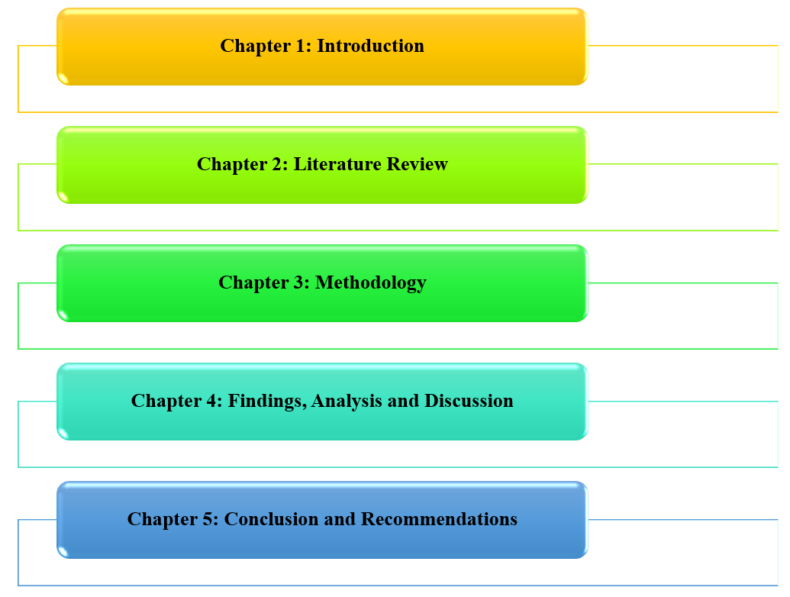

Figure 1.3: Structure of the Dissertation
(Source: The author)
This dissertation has five chapters total reflected in the above figure (figure 1.3). In Chapter 1, this research provides the background to my study, the research problem, aim, and objectives, and this research explains the rationale and significance and defines the scope. Chapter 2 describes the relevant literature and identifies the gaps this research addresses. Chapter 3 describes the research methodology. Findings, analysis and discussion are contained in Chapter 4. Discussion relates findings to pertinent literature and theories. Chapter 5 contains the conclusions of the study and the answers to the research questions. This chapter also contains recommendations.

1.8 Summary
The research topic, background, problem statement, aim, objectives, rationale, significance and scope of the study was introduced in this chapter. It highlighted the significance of researching disruption of the supply chain and product availability at Boots UK and laid out the framework of the dissertation in the subsequent chapters.

Chapter 2: Literature Review
The challenges of disrupted supply chains have become a major issue affecting inventory management, product availability, customer satisfaction, and retail competitiveness in today's retail landscape (Meda, 2023). Existing research and evidence suggest that transportation instability, weakened suppliers and labour shortages are seen as the most important factors that cause disruptions; however, there is no clear consensus regarding the relative importance and how to address the disruptions. Hence, this chapter critically reviews the causes and consequences of supply chain disruptions, considers whether the supply chain is more resilient to improve its operational efficiency and highlights the gaps and future research in the literature in this area that can be explored in the context of Boots UK.

2.1 External Drivers of Supply Chain Disruption in UK Retail Supply Chains
External events have increased in importance as having an impact on the continuity of stock, availability and performance on UK retail supply chains. Not only is the global sourcing process more complex today, but it can also bring a host of macro-economic, political and environmental risks to retailers. This means that the disruptive challenges that retailers like Boots UK have are not merely internal, but are also leaving them with even greater difficulty in managing disruption. Roscoe et al. (2022) stated that geopolitical disruptions have a fundamental impact on the sourcing structure, transportation routes and supplier relationships within the global supply chains. On the other hand, Passarelli et al. (2023) asserted that geopolitical events bring to the fore weaknesses that already exist in the supply chain. But this disparity is an indication of another dimension of disruption – disruption to the way the companies actually function, not only because of the outside developments, but also because of the fact that they are not operating as efficiently as they should. For the companies, Brexit has been one of the contributors to this.
Other uncertainties of the supply chain have increased with the rise in inflation, including the cost of procurement, logistics and inventory costs. Passarelli et al. (2023) asserted that inflationary pressures cause less stability in the supply chain and decrease its response to disruption times. On the other hand, Solanki et al. (2024) argued that inflation could drive innovation and strategic changes that will prompt retailers to build up their resilience. The pandemic of COVID-19 demonstrated how seriously retail companies are affected by external shocks and how it can affect their inventories. The impact was thought to be bigger on the supply side of the economy than on the demand side, with a greater effect on product availability in the UK retail market than on other countries' markets (Khan et al, 2022). Conversely, Mogale et al. (2023) argued that the extent of the disruption is partly due to the level of preparedness and resilience in the organisation, as well as the managerial response.

Compounding geopolitical events can pose system-wide risks that impact sourcing, logistics and inventory management (Roscoe et al., 2022). On the other hand, Solanki et al. (2024) asserted that resilient supply chains have the ability to withstand significant external shocks by being flexible, innovative and adapting to business strategies. In other words, there is a split of opinion regarding the causal factors of vulnerability: one group considers it to be the consequence of the turbulences in the outside world, the other group, as a lack of resiliency of the organisation.
The overall findings from academic studies indicate that Brexit, inflation, geopolitical uncertainty, global uncertainty and post-pandemic disruption, among others, certainly do have an effect on the performance of the retail supply chain. However, academics are still not agreed on how to see their role as the key enablers of vulnerability of the supply chain. For Boots UK, it's a significant debate as it wants to ensure its product is available and that the operations can continue in the event of market uncertainties, especially with all the literature that indicates that external shocks are already present and that there are also future internal weaknesses.

2.2 Operational Sources of Supply Chain Disruption in Retail Supply Chains
The major factors that play a role in the performance of the supply chain are called operational sources of disruption and include factors such as impact on inventory, product availability and service continuity. It is often said that these disruption events are triggered by external shocks, but there is an increasing debate in the literature about whether the shocks are aggravated by internal operations failures. In some academic studies, operational issues have been listed as one of the major factors affecting the performance of retail SCs and organisational resilience, such as unstable transport, supplier dependence, lack of labour, inefficiencies in the distribution system and inventory coordination. The instability problem in transportation still plays a significant role and has an impact on the retail situation. Timotius et al. (2022) attribute transportation disruptions to delays in the delivery of goods along the supply chain, stock-outs and inefficiencies in operation along the supply chain. However, Katsaliaki et al. (2022) argued that the impact of the transportation disruption starts to reach critical levels when there is an insufficient capacity of resilience mechanisms and contingency planning.
Combined, these findings indicate that failure of transport is magnified by organisational weaknesses. But it could be a huge concern for Boots UK, since it is related to the products that are offered in stores and on the website. The dependence on suppliers makes the operation vulnerable because it decreases sourcing flexibility and vulnerability to disruptions. Katsaliaki et al. (2022) stated that relying too much on limited suppliers will limit the ability of the organisation to respond to disruptions. The other study, by Mishra et al. (2022), stated that even with high supplier concentration, collaborative supplier relationships can improve visibility and decrease the impacts of disruption. Labour shortages has re-emerged as a supply chain risk for retail, and productivity and distribution effectiveness of warehouses is affecting product. Timotius et al. (2022) stated that human resource limitations are a major deterrent in maintaining continuity of operations during a crisis.

On the other hand, Ovezmyradov (2026) argued that the disruptions are caused by greater volatility of demand, stockpiling and uncertainty about lead time than labour shortages. These views illustrate how, often, labour shortages are not separate from other operational issues. Thus, the capacity to handle several disruptions at a single time is the key to organisational performance. Ding et al. (2022) claimed that the impact of distribution centre disruptions had the biggest effect on service levels and supply chain performance. In contrast, Katsaliaki et al. (2022) showed that the flexibility of network design and the resilience planning have a significant impact in reducing the impact of disruptions in distribution networks. External and operational drivers come from external forces outside of an organisation's immediate control and internal weaknesses of its operating processes, respectively. This theme became clear in the analysis, as participants and literature generally formulated the situation of supply chain disruption as a series of overlapping external shocks, rather than one event, meaning that one view alone is insufficient to truly explain the reason for the supply chain disruption that has been felt by UK retailers over the last few years and that a combined lens is needed to decipher the evidence.

The debate indicates that operational vulnerability depends on more than just the occurrence of disruption; it is based on the preparedness and adaptability of the organisation. Ovezmyradov (2026) suggested that the problem of lead time uncertainty, panic buying and bullwhip effect greatly disturb the inventory coordination and product availability. However, Mishra et al. (2022) argued that disruptions due to inventory are significantly lowered through effective information sharing and coordinated planning. This conclusion is highly relevant to Boots UK because, after all, they need to be effective in their operations to ensure the availability of products in uncertainty.

2.3 Supply Chain Disruptions impacts on Product Availability and Inventory Management
The product availability and inventory management are hugely affected when the supply chain is disrupted, and a disconnected supply chain can affect the ability to do so effectively, to manage inventories and to provide products to customers. The current literature search shows that disruption leads to stockouts, inventory shortage, inventory lead time, no inventory and issues in omnichannel fulfilment. Continuous research is carried out about why such results are achieved, such as disruption events or the inability to operate effectively within the inventory management process. Inventories are a significant problem, especially during lean periods, and shipping delays and stress in the supply chain play an important role in the problem (Alessandria et al., 2023). However, Tadayonrad and Ndiaye (2023) argued that with careful forecasting and proper safety stock levels, the risks of stockouts can be lowered even with disruption exposure. Resilience proved to be a constant attribute, as secondary evidence both indicated that the response to disruption should not be about getting back to “business as usual”, but about preparing for a transition to a structure that is likely to anticipate and absorb future shocks. It's a sign of the broader grasp by the UK retail community that disruption is not an unusual occurrence, and in fact should be seen as an operating condition that needs to be catered for more regularly, throughout the business’s future, through strategic attention and focus rather than responding to the specific event as an isolated incident.

This is relevant and timely for Boots UK because when they do not have anything in the shop, then they cannot be able to offer the products that their customers want in the Pharmacy or beauty shop. Mohammed and Mandal (2023) suggested that the lead time variability generates an inventory shortage because it adds uncertainty to procurement and replenishment processes. However, Kelka (2024) argued that in times of uncertainty, strategic inventory positioning and inventory management for resilience lower the risk of inventory shortages. Camur et al. (2024) stated that uncertainty of product availability caused by disruptions can cause a loss of confidence in replenishment planning, creating operational inefficiencies. However, Kelka (2024) argued that proactive inventory management measures enhance the continuity of replenishment even with high uncertainty in the supply chain.

All of these results show that delay in replenishment can also be caused by inadequate planning and coordination capacities, as well as disruption events. Therefore, replenishment plays a crucial role in product availability for the Boots UK business as it continues to be effective. According to Camur et al. (2024), the use of predictive technologies enhances the visibility of inventories by offering more precise data on inventory availability and supply chain risks. However, Mohammed and Mandal (2023) stated that improved visibility is not enough to stop the disruption consequences if there is still a high level of lead time variability. The debate points to the fact that visibility enhances decision-making quality, but it is dependent on the operational response that is appropriate. Ovezmyradov (2026) maintained that the fluctuations in demand, inventory building and uncertainty in supply significantly affect omnichannel fulfilment processes and inventory coordination.

Otherwise, Tadayonrad and Ndiaye (2023) stated that the use of advanced forecasting models and inventory optimisation can greatly enhance the fulfilment performance in an uncertain environment. However, Ezeilo et al. (2022), opined that beside advanced forecasting models integration better training for employees to use the technologies can enhance omnichannel fulfilment success along with the ability to coordinate as well. Based on literature review, overall, the disruption of the supply chains has significant impacts on the availability of products and inventory management. However, there is some hope of lower disruption impact in Boots UK with a robust inventory management approach, good forecasting and with collaboration between the operations.

2.5 Product Availability and Customer Satisfaction/Reward to Retail Performance
Availability is one of the key influencers for customer satisfaction and store performance. Customers expect to be able to buy products when they need them and availability will improve purchasing experience and customer loyalty and competitiveness. Therefore, it is still a vital component of a retail business to handle Inventory Management.

According to Ovezmyradov (2026) consumer purchasing behaviour is influenced by a number of factors and product availability is one of these factors because customers often consider stock availability as an indicator of reliability and service quality of retailers. The availability of the product consistently will make the customers more likely to complete their purchases, to have a favourable perception and to have a long-term relationship with retailers. Thus inventory management has a positive impact on customer satisfaction and organisation performance. However, Juhana (2023) states that the product availability is not enough to satisfy the customer as customers also consider the quality of the products, pricing strategy, and brand reputation in their purchasing decisions. Hence, customer satisfaction is considered as a multi-dimensional concept.

Kloth (2025) reported that stock outs lead to lost sales, customer dissatisfaction, and market share erosion as customers can easily switch to other grocery stores. So, it is imperative that the products are always in stock in order to keep the customers and maintain the sustainability of the business. However, according to Johnson (2022) the effects of stock-outs have diminished with digital transformation and omnichannel retailing. However, some customers purchase online, click and collect and/or have products delivered to their homes which reduces the dissatisfaction caused by product shortages to some extent.

Jean (2024) states that with stable levels of inventory, organizations can better adapt to changing customer demands and market conditions. This improves the effectiveness of the operation and the performance of the business. Conversely, Lijuan et al., (2023) suggests that having a surplus of inventory can lead to higher holding costs and financial inefficiencies due to the increased product availability. As a result, retailers are required to effectively maintain the stock on the abis of the demand of their products to gain optimum portability in business and also to stay competitive in markets.

2.6 Strategies for Resilience in Supply Chains
Supply chain resilience is increasingly important because organisations face various economic, political and operational uncertainties. In the last few years, it has been established that supplier diversification is a regular practice and one of the important factors to ensure supply chain resilience and lower the vulnerability of the supply chain against disturbances. Singh et al., (2025) assert that having a small number of suppliers can increase the operational risk of an organisation since any disruption in this supplier can rapidly ripple through the supply chain network. A possible drawback of supplier diversification, however, is the increased coordination complexity, administrative burden and operational cost, as suggested by Lücker et al., (2025). So, it is important for organisations to take care of the benefits of resilience and supplier management challenges.

Technologies like artificial intelligence, predictive analytics and real-time monitoring systems enhance supply chain visibility, aiding quicker decision-making (Nweje and Taiwo, 2025). With such technologies, organisations can monitor supplier performance in real-time, anticipating issues before they arise and acting proactively. They help to improve supply chain visibility, enable timely decision-making, foster coordination between operations and minimize the risk of product shortages, leading to smoother business continuity and increased customer satisfaction. On the other hand, Adebayo et al., (2024) state that investment in such technologies may be costly, and may necessitate technical expertise and organisational change. Thus, for some organisations, digital transformation benefits might be limited due to adoption problems.

Moussawi-Haidar et al., (2022) states that the strategic inventory reserves and safety stock are significant in order to buffer the organisations from temporary disruptions and reduce stock-out risks in uncertain times. Hence, the efficient inventory management will make sure that there is continuity of operations and customer satisfaction. In addition, working together between suppliers, logistics providers and retailers facilitates the exchange of information and coordinated response to disturbances. However, Layode et al., (2024) point out that collaborative arrangements can lead to concerns about data security, confidentiality, and information misuse.

2.7 Theoretical Framework
The theoretical frameworks that form the basis of understanding key concepts and relationships explored in this study are presented. Specifically, the Supply Chain Resilience Theory and Resource-Based View Theory have been chosen as they discuss the ability of organisations to handle disturbances, continuity of product supply and organisational performance via resilience capabilities and strategic resources.

2.7.1 Supply Chain Resilience Theory
Supply Chain Resilience Theory describes what, how and how to predict and act on disruptions to the business, and recover while keeping the business going. The theory focuses on the agility, flexibility, adaptability and risk management as a key ability to manage uncertainty (Hsieh et al., 2023). This implies that the theory can be used in analysing how organisations can optimise their supply chain and guarantee their business continues in uncertain circumstances.
This theory was prioritised over others because it is directly linked with the aim of the research, which is examining how the disruption in the supply chain affects the availability of products in the Boots UK store. It provides information on the use of resilience strategies to minimise disruption impacts and keep operations running (Juan et al., 2022). In addition, the theory was selected to replace Contingency Theory because it more specifically deals with disruption preparedness, response and recovery. The greatest advantage is that it provides a detailed account of the processes of resilience. However, a limitation is its limited focus on the internal resources and capabilities required to develop resilience.

2.7.2 Resource-Based View (RBV) Theory
According to Resource-Based View (RBV) Theory, the effective use of valuable, rare, inimitable and non-substitutable resources, are the ways to create sustainable competitive advantage (Komakecha et al., 2025). The theory implies that the performance of the organisation is related to resources and capabilities that competitors would be reluctant to imitate. For the purposes of SCM these resources are technological infrastructure, supplier relationships, logistics etc., inventory and managerial skills. Thus, RBV can offer a beneficial framework for comprehending how organisations can enhance their operational efficiency, increase product availability and be competitive in progressively demanding business environments (McDougall et al., 2022).
For this reason, RBV was chosen as this study aims to see how Boots UK can strive to make their products more readily available and to ensure that their operations perform better even in the face of disruption within the supply chain. Moreover, RBV was chosen as it reinforces the Supply Chain Resilience Theory by providing further insight into the value of organisational resources and capabilities on supply chain resilience and performance. The primary advantage of RBV is that it keeps explaining the strategic resources as a source for resilience and competitive advantage (Cuthbertson and Furseth, 2022). Furthermore, the integration of “Resource-Based View (RBV)” theory can be helpful for organisations such as Boots organization to achieve long-term success along with maintaining product availability specifically during the supply chain disruptions through leveraging unique, internal assets that are rare, valuable, inimitable as well as non-substitutable

2.8 Conceptual Framework
The conceptual framework reflected in the below figure demonstrated in the relationship between disruption of the supply chain and the product availability and organisational performance at Boots UK. The stability of supply chains, and the efficiency of organisations, has declined due to external factors like Brexit, inflation, economic uncertainty and global disturbances. Furthermore, operational challenges such as supplier deliveries, transportation delays, labor shortages and stock management challenges remain to impact the supply chain performance and business continuity. These challenges directly affect the retail store's product availability in the store and distribution network. Hence, product availability is considered as a key element of the framework as it is the direct consequence of the performance of the supply chain. Good supply chain operations boost the availability of products and the reverse is true.
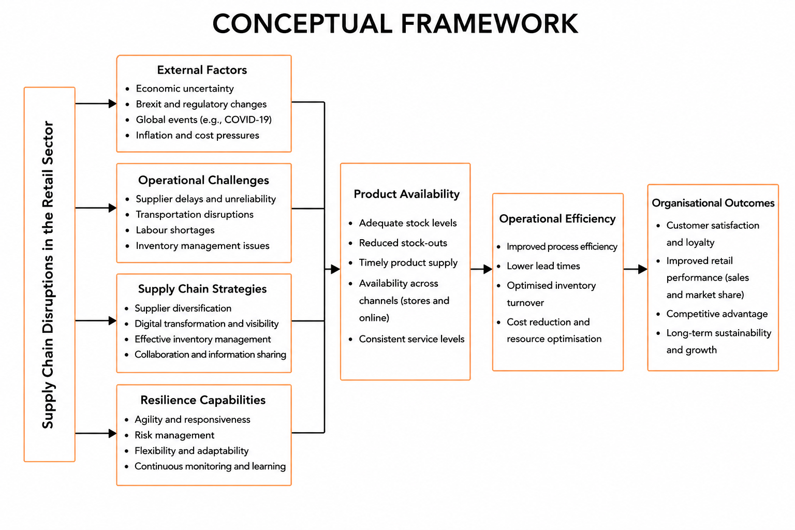

Figure 2.1: Conceptual Framework
(Source: Self-Created)
The figure 2.1 framework has been designed to overcome such challenges, including supply chain resilience strategies and capabilities. In addition, features like agility, flexibility, continuous monitoring and risk management help organisations to deal with disruptions effectively and ensure efficient operations and continuity. Therefore, these strategies can be used to minimize the effects of disruption and enhance the performance of the whole supply chain.
The framework suggests that successful resilience strategies lead to better operational performance, which is linked to inventory management, lead times and efficient allocation of resources. These improvements result in increased product availability, customer satisfaction, competitive advantage and business sustainability. Lastly, improved supply chain resilience enables Boots UK to maintain business continuity and to optimise their operation in a constantly changing business landscape.

2.9 Literature Gap
In various industries, the supply chain disruptions, vulnerabilities, product availability and resilience strategies have been widely studied. Roscoe et al. (2022) examined how structures in the global supply chain were affected by geopolitical disturbances but did not specifically investigate implications for product availability of the UK retail sector. Likewise, Passarelli et al. (2023) studied the impact of inflation and external challenges on supply chain performance and considered customer satisfaction and continuity to be a minor aspect. Moreover, Khan et al. (2022) only examined the COVID-19's impact on retailing supply chains and failed to account for resilience practices outside COVID-19. Similarly, Timotius et al. (2022) studied the transportation disruptions and labour shortage of retail supply chains, while Katsaliaki et al. (2022) presented an extensive literature review on the sources of disruption and approaches to resilience in retail without concentrating on a particular retail organisation. Furthermore, Ovezmyradov (2026) analysed supplier dependency, demand uncertainties and stock disruption but provided limited evidence on the effect of these factors together on the operational performance of Boots UK and the product availability.

Furthermore, product availability, customer satisfaction and inventory management are among the issues studied in detail and have mostly been addressed separately in the current literature. Kloth (2025) reviewed the effects of product availability on customer satisfaction and the competitiveness of the retail sector; however, the author has not discussed much about the operational factors that can lead to product shortages. Likewise, Jean (2024) studied the strategies involved in managing a store's inventory to boost organisational performance but ignored the implications of supply chain disruptions on retail business. Moreover, Juhana (2023) further looked at customer purchasing behaviour and focused less on inventory and supply chain resilience. In the meantime, Mohammed and Mandal (2023) studied variability in lead time and inventory shortages, while Kelka (2024) focused on strategic inventory management for resilience. Yet, neither of these studies explicitly investigated the combined impact of these operational challenges on the availability of products and business continuity in Boots UK.
Most of the literature is based on manufacturing organisations, global supply chains or on the wider retail sector. Singh et al. (2025), Nweje and Taiwo (2025) and Moussawi-Haidar et al. (2022) have explored resilience strategies, but do not offer extensive evidence of their effects on Boots UK's operation. The current study aims to fill this gap by examining the impact of supply chain disruptions on the availability of products and operational performance and customer satisfaction at Boots UK. Moreover, it assesses resilience strategies to enhance the efficiency of supply chains, business continuity and to help organisations adapt to future shocks and uncertainties.

2.10 Chapter Summary
This chapter has conducted a critical literature review of the literature related to supply chain disruption and its impact on product availability in the UK retail sector. In addition, it analysed the external and operational conditions influencing the supply chain performance and the impact of these external and operational conditions on the inventory management and on customer satisfaction and organisational resilience. It can be noted that, availability of products, customer satisfaction as well as inventory management are reflected as the concerning factors that can negatively impact the operations of business in competitive market. Furthermore, the chapter presented resilience strategies and used Supply Chain Resilience Theory and Resource-Based View Theory to develop a theoretical understanding of organisational responses to disruptions. However, the review identified limited research focusing specifically on Boots UK and the pharmacy and beauty retail sector. Hence, this identified gap is addressed in Chapter 3 which presents the research methodology adopted.

Chapter 3: Methodology

3.1 Introduction
The chapter represents methodological approaches selected in terms of identifying impact of supply chain disruption of product available for Boots UK. Use of appropriate philosophies and approaches required in the study in order to gain appropriate data to answer the research questions. Reliability and validity of particular research along with the use of quality findings is accurately derived in the study through providing the best possible choice for collecting data and information.

3.2 Research Onion
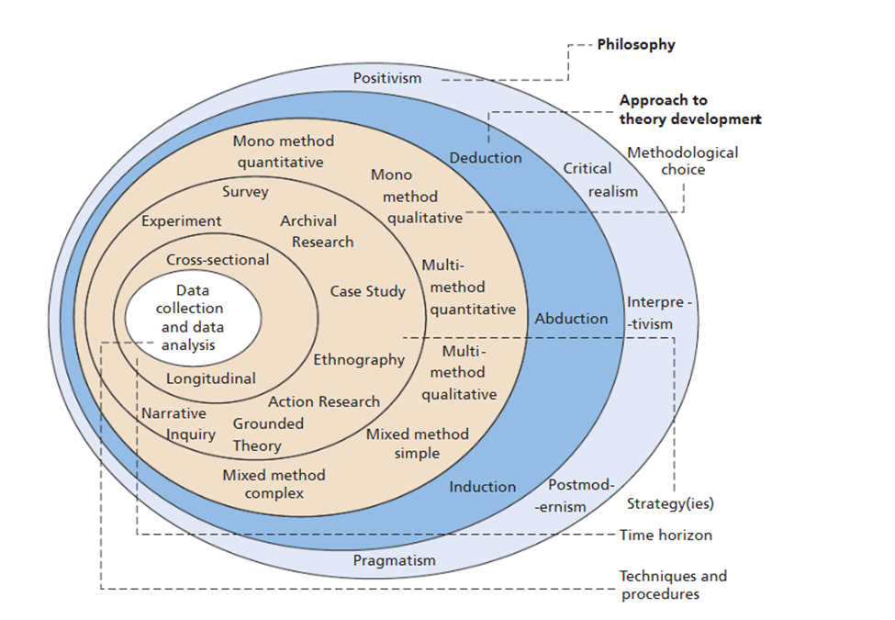

Figure 3.1 Research Onion
(Source: Saunders et al. 2023)
The Research Onion framework plays a crucial role in guiding the selection of appropriate methodological choices from philosophical assumptions to a data collection as well as analysis technique in a logical sequence ( Saunders et al. 2023). The use of research onion helped in the selection of research methods. It can be noted that the outer layer of the research onion reflected in the above figure helped in adopting the “interpretivism research philosophy”. The respective philosophy sheds a positive impact in enabling an in-depth knowledge regarding the supply chain disruptions along with management approaches within the organisation. Besides this, the usage of “inductive research approach” was helpful as it sheds a positive impact in developing insights along with themes from the current evidence instead of testing the predetermined hypotheses.

Apart from this, “descriptive research design” is utilised in this research to provide an in depth explanation of the different causes of supply chain disruptions along with its effects on the availability of products along with its implications for customer satisfaction. Based on the research onion, “qualitative research strategy” is adopted, that plays a crucial role in exploring different organisational issues by rich textual evidence. Apart from this, “Secondary data collection” is implied in which focus was laid on analysing the published industry reports, academic journals, company publications along with credible online sources that can be interpreted and aligned to Boots UK along with supply chain management. In this research “convenience sampling technique” is adopted to select relevant information along with accessible secondary sources that effectively address the objectives of the research. Furthermore, “thematic data analysis” is selected to identify, organise, as well as interpret the recurring patterns followed by themes within the gathered data, that also assists in enabling meaningful conclusions followed by recommendations in regard to supply chain product availability and resilience at Boots UK.

3.3 Research Philosophy
Selecting an appropriate philosophy is an important factor as it provides proper direction of the research to identify the right choice of research philosophy. Moreover, it is a set of beliefs or assumptions related to research data collection and accurate analysis of results. Research philosophy and majorly divided into three types including realism, positivism and interpretivism. Positivism research philosophy is analysed to be appropriate through preparation of statistical views of data from different web sources. According to the study of Ali (2024), under positivism research philosophy, the process focuses on exploring factual variables to obtain accurate answers of research objectives. Moreover, only human participants are valid in terms of collecting appropriate data and information from surveys or interview procedures. Realism, on the other hand, is totally acknowledged with external reality along with the involvement of human participants. Valuable events and underlined structure are properly balanced in order to have a determined combination of qualitative and quantitative results captured from the objective. However, it can be argued from the study of Saliya (2023), implementation of realism can provide a balanced perspective among the comparison between subjective and objective dimension for a particular research topic. Interpretivism research philosophy supports the qualitative nature of study as the process totally helps in understanding that knowledge about a specific topic.

The study mainly determines efficiency of using supply chain management in terms of benefiting business organizations like Boots UK. Use of interpretivism research philosophy is observed to be accurate in terms of examining accurate viewpoints and also develops a comprehensive understanding about product and service to be produced. A proper analysis of the present situation is required to be made for Boots UK to identify efficiency of the supply chain management process. However, it is argued from the study of Sun and Zuo (2024), positivism research philosophy is not considered to be suitable as data determination related to supply chain management is a bit complex. Determination of economic situations along with proper options for resolution can be the right along with the use of interpretivism research philosophy.

3.4 Research Approach
Research approach includes a logical framework in terms of collecting, analysing and interpreting appropriate information. The nature of research problem and objective is totally considered in terms of selecting an appropriate research approach. Research approach is identified to be of two different types including inductive and deductive approach. According to the words of Smela et al. (2023), an inductive approach includes a process of collecting and examining data followed by proper determination of theme, pattern and relationship. Moreover, the inductive approach focuses on determining new view points rather than determining existing information. Accurate conclusion along with theoretical explanation can be provided through the inclusion of inductive approach as it is also closely associated with interpretivism research philosophy. On the other hand, deductive approaches derive from testing theories and hypotheses (Harding-Esch et al. 2023). In the research process proper collection of data is made in other tests of the quality of information.

In deductive research approaches proper tests of existing theories are made in order to identify proper relationships between different variables. Limited investigation along with complex issues can be identified further (Furidha, 2023). In this research process related to investigating impact of supply chain disruption on product availability at Boots UK inclusion of inductive research approach is accurate. Focus on generating new theories can be effectively identified in order to have comprehensive understanding about different supply chain strategies to be implemented to enhance the operation process. Development of proper research is generated for identifying different challenges that can be faced due to the disruption of supply chain options through interpreting the points for further research approaches.

3.5 Research Design
Research design provides an accurate framework for analysing and collecting data for further ensuring accurate achievement of research objectives. Overall planning and structure is determined under research design in order to answer particular research questions generated initially. Based on the words of Che et al. (2023), research design is particularly of three different types including exploratory, explanatory and descriptive. Exploratory research design is included in a research process when new understanding is made for a research to get preliminary insights about key issues. Moreover, exploring accurate understanding along with deeper knowledge about data to be collected is identified under proper exploration of different data of statistics. However, it can be argued from the study of Nwabuko (2024), exploratory research design is identified to be accurate in terms of generating new ideas and different potential areas for further investigation. Hence, description of accurate variables can be effectively explored through different viewpoints and ideas along with the consideration of exploratory research design.
Explanatory research design is identified to be a process that helps in explaining or identifying relationships between different variables from research topics. Answers to different questions like why or how a particular study is introduced in terms of having accurate connection is effectively derived along with the help of explaining it to research design. As per the views of Adeniran and Tayo-Ladega (2024), explanation research design is useful in terms of establishing proper answers like determining cause and effect about the research problem highlighted initially. Complexity in managing organisation data is also highlighted under exploratory design. On the other hand, descriptive research design focuses on discovering new issues or testing relationships to seek accurate answers related to the issues raised initially. In reference to the words of Ebneyamini (2022), descriptive research design provides an accurate presentation in a detailed view for a specific phenomenon. Comprehensive understanding about a particular event can be effectively highlighted along with the use of the shift of reserve design. Selection of descriptive research design is made in terms of highlighting supply in the disruption process as detailed determination about issues are made along with the inclusion of destructive design. Hence, destructive research design helps in providing better understanding for the challenges faced by boots UK in order to maintain accuracy in production availability.

3.6 Research Strategy
Research strategy is identified to be a method that is used during a research process in terms of identifying proper data and information related to the objective and questions set. Identification of a systematic approach is determined in order to collect and interpret data or information derived from different sources. Research strategies are particularly of two different types including quantitative and qualitative. Quantitative research strategy is identified to be an investigation process where proper direct determination is made about a specific real life contact. Quantitative research strategy is focused on collection analysis and interpretation of data that is collected numerically. Inclusion of quantitative research strategy basically depends on selection when positivism research philosophy is used in terms of measuring new trends and establishing a causal relation. Based on the studies of Lavarda and Bellucci (2022), determination of contextual factors that can influence operational phenomena can be effectively identified under quantitative research strategy.
Qualitative research strategy helps in exploring and interpreting non numerical data with deep understanding. According to the study of Oluka (2025), individual and organisational perception for a particular situation is effectively identified along with initiating proper stage for research solution. In the study effective research is identified in order to gain knowledge about qualitative research strategy as disruption can be effectively derived including transportation challenge, supply delay or inventory shortage. Obtaining a rich understanding and experience of the responses helps in determining accurate strategy for future development within the organisation. A qualitative research approach is identified to be an appropriate choice in order to maintain proper flexibility to reduce comprehensive understanding from the challenges faced.

3.7 Data Collection Method
Data collection process is identified to be important as it provides proper information about the research issues highlighted initially. In this research process the impact of supply chain disruption is identified to be the main concern for Boots UK. Data collection is identified to be of two different types including primary and secondary. Appropriate selection of data collection methods is necessary to be determined in order to use proper resources to obtain accurate solutions. Aguas (2022) stated that primary data collection process is referred to as a technique where collection of data and information is made along with interview, survey, focus group questionnaire and observation. Implementation of primary data collection method is accurate as it provides original results with raw viewpoints of individual participants. Moreover, greater control over the quality and scope can be effectively highlighted through inclusion of primary data collection process. However, the primary data collection process also has some drawbacks including cost, difficulty in accessing and news amount of time. Large access of Management personnel within an organisation or employee related data can become a practical challenge along with the inclusion of primary data collection method.

Secondary data collection process is referred to as a technique where collection, interpretation and analysis of information is made from existing sources. Tarisayi (2023) highlighted that a secondary data collection process is derived where collection of information is made through academic journals, company reports, government publications, industry reports, professional databases, websites and others. In the time of making research related to Business and Management, selection of secondary data collection processes is widely used in terms of having proper access to large amounts of data. The secondary research process is identified to be cost effective as existing appearance is properly interpreted along with critical determination of different viewpoints along with proper maintenance of relevance and reliability. However, it can be argued from the study of Chand (2025), peer reviewed journals are determined to be accurate in order to provide theoretical and empirical insight about a specific issue in order to highlight proper justification about the issue raised. In the research process related to having proper knowledge about impact of supply chain description use of secondary data connection method is determined to be accurate in terms of having proper extensive information regarding the issue factors. Existing literature analysis along with meaningful themes and patterns are properly identified which helps in having proper reliability about supplying destruction.

The “convenience sampling technique” is also known as “non-probability sampling method” in which the data sources are gathered considering the relevance, accessibility as well as availability to the researcher (Golzar et al., 2022). In the respective research, “convenience sampling strategy” used as the research notably relies on the “secondary qualitative data” instead of gathering primary data. In addition to this, the relevant sources, incorporating books, peer-reviewed journal articles, government publications, industry reports along with Boots UK corporate reports, as the sources can be helpful for providing reliable information on product availability and supply chain disruption. However, the convenience sampling might introduce selection bias as well as limit generalisability of the research findings, and such limitations might reduce using up-to-date, credible as well as authoritative sources from reputable industry publications and recognised academic databases. The “convenience sampling strategy” assists in enabling the researcher to collect sufficient evidence within ensuring that the selected sources assist to directly addresses the objectives of research (Golzar et al., 2022).

3.8 Data Analysis Method
Data analysis is identified to be a procedure where information collected is properly enterprises along with the determination of the research question and objective set initially. Organising evaluating and interpretation of the raw data into meaningful insights along with the use of data analysis approach. In reference to the study of Im et al. (2023), data analysis techniques help in focusing on the proper pattern of the data set in order to identify and analyse accurate results. In this study, a secondary qualitative data collection process is used in terms of highlighting the impact of supply chain disruption over Boots UK. Inclusion of thematic analysis determined to be accurate as it provides a flexible systematic approach to examine qualitative information and general insight about textual data (Braun and Clarke, 2023). In a research process identification of complex issues is necessary for which proper research analysis is necessary to be made.
Organisational behaviour experience and practice is necessary to be determined through several polluted data available in a pattern of content analysis. Along with the inclusion of thematic analysis, content classification is necessary in order to develop theories in an extensive process to make accurate comparisons. Nicmanis (2024) indicated that under thematic analysis initial key points are necessary to be made in order to signify the piece of information. In this study there are different keywords that can be involved in the time of collecting data including supply delay, transportation disruption, inventory shortage, risk management practice and demand fluctuation. Categorization of accurate themes is necessary in order to highlight the emerging issues. Identification of rich and detailed information is further derived through interpretivism philosophy and deductive research approach to impose detailed information. Development of comprehensive understanding is analysed to be accurate in order to understand proper reason for the supply chain description affecting products available at Boots UK.

3.9 Reliability and Validity
Determination of validity and reliability is an important factor as it ensures quality within a research. According to Cheong et al. (2023), maintenance of reliability is important as it provides consistency within a research process based on its findings. Accurate reliability maintenance is necessary while systematic collection of data and analysis in order to credible information from authentic sources. On the other hand, validity is referred to as maintenance of accuracy in terms of obtaining accurate insights from literature. Use of authoritative sources is determined to be accurate in terms of providing proper reliability and validity of results about product availability in the retail sector.

3.10 Ethical Considerations
Ethical consideration is necessary to be maintained within a research process in terms of having proper integrity and transparency. Ethical consideration is derived to be accurate in order to maintain academic integrity including avoidance of plagiarism and authentic reference pattern. Misinterpretation and manipulation of data can be effectively omitted within a research process along with proper ethical maintenance. In this particular research use of Data Protection Act 2008 and UK general data protection regulation is maintained in order to obtain accurate results about supply chain description and its impact on product availability.

3.11 Summary
This chapter has determined accurate methods to be implemented in order to collect proper data and information for further research. It can be summarised from the chapter that use of interpretivism research philosophy is analysed to be accurate in order to facilitate in depth understanding about the complex nature of supply chain description. Generation of proper patterns can be accurately made by the researcher through addressing the research objective and questions along with accurate statistical and hypothetical testing. “Qualitative research strategy” helps in gaining real knowledge about the issue that is focused initially in order to get a particular solution. This strategy is particularly useful in terms of having proper understanding about organisational factors. However, finding a particular single case study is identified to be time consuming and inaccurate leading to delay in completing the research. On the other hand, the use of an inductive research approach is accurate to drive a proper conclusion about testing pre-determined hypotheses for knowing production viability for Boots UK. Moreover, inclusion of secondary qualitative research and data connection method is identified where different journal articles are included in terms of further integrating factual data. Authentic use of ethical factor is maintained in order to provide appropriate integrity towards research outcome.

Chapter 4: Findings, Analysis and Discussion

4.1 Introduction
The findings, analysis and discussion chapter helps in the effective interpretation of the collected information that enhances understanding. In this chapter 4 themes have been formulated considering the research aim, objectives along with questions. In depot analysis assists in apprehending each theme that are also supported by evidence. The discussion sheds a positive impact in providing a critical interpretation of the findings, mirroring its practical implications for enhancing supply chain management along with organisational performance.

4.2 Findings

4.2.1 Link Between Questions and Themes
Questions | Key Ideas | Themes | Authors or Sources
How does supply chain disruption happen in the operations of Boots UK? | - Supplier shortages and dependency  - Brexit-related trade barriers  - Global supply chain disruptions  - Transportation and logistics delays Inflation and rising costs  - Inventory management issues  - Demand forecasting errors | - External and Operational Drivers of Supply Chain Disruption | Ivanov and Dolgui (2022)  Campling et al., (2022)
What impact does the disruption in the supply chain have impact on the availability of products and customer satisfaction at Boots UK? | - Product stockouts and shortages  - Reduced product variety  - Delayed replenishment  - Declining customer satisfaction  - Loss of customer loyalty  - Reduced sales and profitability  - Customer complaints and negative experiences | - Effects on Product Availability and Customer Satisfaction | Ovezmyradov, 2026  Chowdhury et al., 2025
What are solutions that can help to make the supply chain more resilient and efficient at Boots UK? | - Supplier diversification  - Predictive analytics and demand forecasting  - Digital supply chain technologies  - Inventory optimisation  - Strategic partnerships with suppliers  - Risk management planning | - Supply Chain Resilience Strategies | Qureshi and Ali, 2025  Boonlua et al., 2023
 | - Long-term organisational resilience  - Building sustainable supply chains  - Investment in digital transformation  - Improving operational efficiency  - Strengthening supplier relationships | - Organisational Implications and Future Supply Chain Priorities | Altay and Pal, 2023  Alfaqiyah et al., (2025

Table 4.1: Link Between Questions and Themes
(Source: The author)

4.2.2 Thematic Analysis
Theme 1: External and Operational Drivers of Supply Chain Disruption
This theme examines the complex nature in which supply chain disruptions at Boots UK and in UK retail are driven by multiple external shocks and internal operational faults, but not only by one (Ivanov and Dolgui, 2022). For the UK retail sector, sourced product predictability has declined as a result of externally imposed customs procedures, the impact of the pandemic on manufacturing capacity and logistics employees, inflationary pressures on materials and labour, and broader geopolitical uncertainty. In practice, the limited number of suppliers, especially for specialist and pharmaceutical products, long lead times, distribution issues and unreliable demand forecast only add to such pressures (Campling et al., 2022). But the example of Boots itself provides some evidence of this vulnerability; the interplay of conditions that are constantly changing from the outside and becoming rigid from the inside.

Thinking from the outside, it has been identified that there are several forces that repeatedly figured in the disruption. Post-Brexit customs rules have led to greater customs declaration costs for UK manufacturers. They would incur around £15 billion in extra costs every year for customs declaration costs (UK and EU, 2021). Hence, new trading rules took effect more than a month ago, a majority of UK businesses have seen an increase in their supply chain costs. Unfortunately, the impacts of the COVID-19 are far from over, with restricted manufacturing capacity, raw material scarcity, the ongoing lack of logistics and haulage workers, and inflationary pressures on raw materials, packaging and labour costs adding to the uncertainty across the industry (Ivanov and Dolgui, 2022). In addition, in the days of global supply chain volatility, with geopolitical issues and international routes to shipping brought into disrepute by political events, retailers in the UK with tight replenishment cycles are further lessening their sourcing predictability.
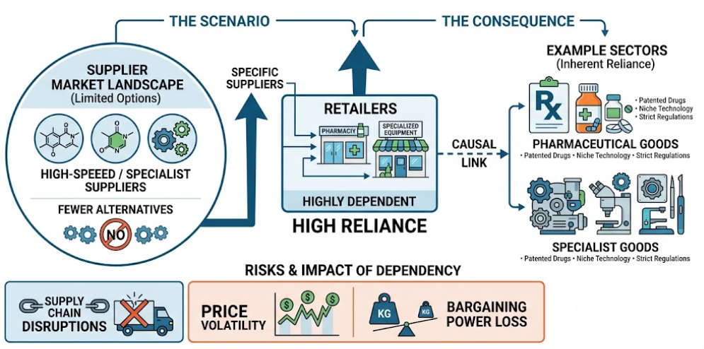

Figure 4.1: Supplier Dependency
(Source: As inspired by Campling et al., 2022)
From an operational standpoint as per figure 4.1, the analysis identified supplier dependency as a constant theme where individual retailers are dependent on specific suppliers with fewer alternatives, such as suppliers for the pharmaceutical or specialist goods sectors on which they place a particular reliance (Campling et al., 2022). Long lead times, particularly for imported products, render it difficult to react in time to demand fluctuations; distribution delays hit the network when shipping is jammed at ports, warehouses or regional distribution centres. Planning for inventories was identified as a problem that exacerbated the effect of external disturbances - and not absorbed them - because of the lack of reliable demand and lack of real-time information (Hodson, 2023).

Theme 2: Effects on Product Availability and Customer Satisfaction
This theme focuses on the effects of how the silence in the upstream supply chain can be observed at the retail end, affecting retail performance as a consequence to what you can actually offer customers. The analysis revealed that the culprit of disruption is not invariably an internal operation issue, but is invariably easily recognised as a dis-available product, or a product availability symptom, in the whole chain (Ovezmyradov, 2026). Thus limiting the chain's ability – level of resilience is directly linked to commercial factors – and retail managers have a visible and measurable symptom of the lack of resilience of upstream issues.

This theme explores the impact that upstream disruption has on product availability at retail outlets, which in turn impacts customers' level of satisfaction and commercial outcomes (Ovezmyradov, 2026). The continuity of supply has a direct impact beyond the regular retail problem, particularly the essential medicines and product categories such as beauty and healthcare products, that are central to Boots UK's commercial success and customer-browse patterns. Forecasting problems and lead-time fluctuations continue to create inventory inaccuracy and cause stock outs and excesses in stores (Chowdhury et al., 2025). Impacts on product availability go beyond simple operational notes as repeated problems compromise brand perception and threaten to prompt permanent switching among a significant number of impacted customers.

As a specific product issue, the results indicate that disruption is highly likely to mean recurrent product stockouts and delayed replenishment orders. This is especially the case with products where continuity of supply has a health consequence, like the supply of essential medicines, as well as with products such as beauty and healthcare products that form an integral part of Boots UK's commercial viability and footfall. These are incredible figures in the context of sector-wide data, which shows that in reality 99% of UK pharmacy professionals are now experiencing medicine supply problems at least once per week (The Pharmaceutical Journal, 2024). Moreover, 72% of pharmacists are experiencing at least three medicine supply problems every day – making availability pressures more commonplace than intermittent occurrences for UK pharmacy-led retailers (The Guardian, 2024).
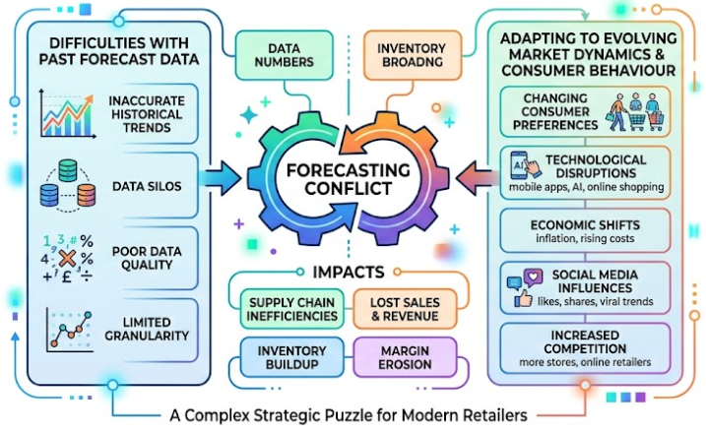

Figure 4.2: Challenges in Forecasting
(Source: As inspired by Chowdhury et al., 2025)
With regards to the performance of inventory, the figure 4.2 noted that challenges in forecasting was a factor, as retailers faced difficulties in dealing with forecast data from the past while adapting to the evolving market dynamics and consumer behaviour (Chowdhury et al., 2025). Further compromising the accuracy of replenishment planning will be lead-time variability, especially for goods from overseas origin, which will leave stores vulnerable to both high demand lines being out and, at times, excess stores in unaffected lines.

The dimension that was imminent as well was the customer satisfaction. Consistently having items out of stock was found to cause customer complaints, and make the brand appear to be less reliable than it actually is. It can lead the shoppers to associate stock-outs increasingly with poor organisational reliability rather than viewing as isolated, forgivable incidents. Industry studies have demonstrated that if stock-outs happen more than once, the majority of consumers switch retailers for good, and a significant number of consumers will buy another brand immediately instead of waiting for better prices and other enticements (Castillo et al., 2022). This switching behaviour is a direct commercial cost, and constitutes the loss of customer value for the duration of the failure, coupled with a loss of future sales.

Theme 3: Supply Chain Resilience Strategies
This theme covers impacts of disruption from the perspective of organisation and strategy beyond the day-to-day operational firefighting. Business continuity, operational efficiency and cost management are increasingly at the forefront of the board's agenda, and disruption, if not managed, can impact materially on overall cost profiles, margins and long term profitability (Altay and Pal, 2023). Strategic trends feature integrating digital transformation and supply chain visibility into the broader organization instead of being pilots for specific departments, and increasing interest in creating resilient and environmentally sustainable supply chains (Alfaqiyah et al., 2025). Organisational agility, risk preparedness and long-term resilience are key strands in future readiness, and Boots UK's competitiveness is rooted in a balance of efficiency, resilience and strategic adaptability.

Issues pertaining to suppliers were a prominent part of the findings with related strategies. Supplier diversification—deliberate efforts to shift away from reliance on a few large predominating suppliers, and in favour of broadening supplier base—was identified as a way to mitigate dependency risk especially in regard to critical pharmaceutical lines (Qureshi and Ali, 2025). Multiple sourcing arrangements, which involve having multiple supply lines for a given product category, were also mentioned, and as were renewed efforts towards sourcing closer to nearer home, to shorten lead times and minimise the risk from cross-border customs disputes and currency volatility.

A second major strand of building resilience was technological approaches. Continuous improvements in forecasting accuracy, achieved through the use of artificial intelligence and predictive analytics, was cited as playing a key role in the enhancement of forecast accuracy repeatedly, with industry research suggesting that using artificial intelligence for forecasting can result in demand forecasting errors being lowered by a factor of 20-50% versus traditional statistical forecasting methods, directly influencing when costly overstocking or damaging stockouts occur (Mckinsey & Company, 2022). Digital supply chains and real-time visibility tools are also shown to pursue a faster time to disrupt identification, allowing retailers to take action and prevent issues before customers feel the impact rather than after they do.
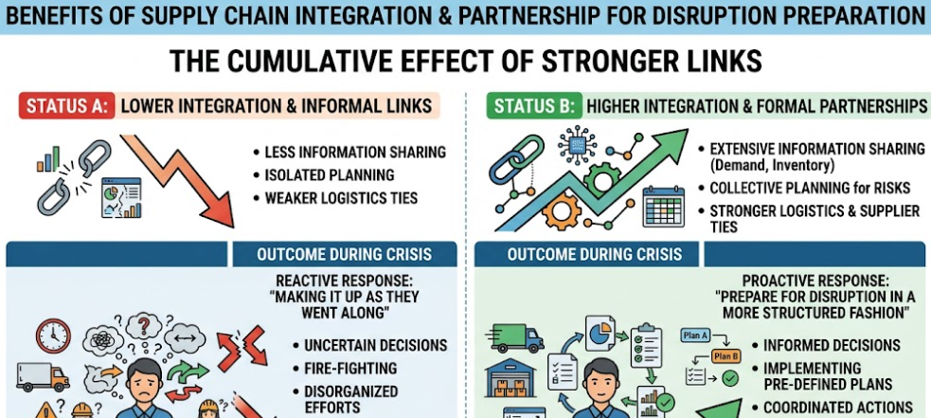

Figure 4.3: Supply Chain Integration and Partnerships
(Source: As inspired by Boonlua et al., 2023)
These technological and suppliers-driven strategies were complemented by operational strategies. The recommendation to inventory optimisation (IO) (dynamic rather than static reorder points) to tackle the challenge of lead-time variability was considered to be a potential solution in practice. Organisations that were better integrated along the supply chain and linked more formally and effectively to logistics partners and suppliers to share information and collectively plan for the risks, found they tended to prepare for disruption in a more structured fashion than make it up as they went along during a crisis (Boonlua et al., 2023).

Theme 4: Organisational Implications and Future Supply Chain Priorities
This final theme emphasizes the importance of recognising that disruption in a supply chain can have consequences beyond day-to-day operational firefighting, impacting an organisation's long-term planning, investment and competition. The analysis revealed an increasing willingness among the organisations studied to question core business goals and change direction in response to disruption, going beyond the view of supply chain management as a back office and operational activity when it comes to business strategy (Altay and Pal, 2023).
The results show, at an organisational performance level, that business continuity is an emerging boardroom agenda, with disruption becoming a direct impact on business continuity at the operational level, on efficiency and cost management processes, as the main result of a disaster scenario. If cost levels are not properly managed, there are currently very real consequences across companies' cost structures, margins and overall profitability with estimates from world-wide research indicating inventory distortion cost of around $1.77 trillion in retail sales in one year, driven by both under and over-fulfilling demand. (BlueYonder, 2026).
The strategic priorities emerging from the analysis focused on the role of digital transformation, as a tool for integrating the various aspects of digital technology into the broader context of the organisation, instead of being seen as separate pilots limited to a single department. The improvement of the supply chain visibility was also described as a strategic objective and not only as a mishandling measure that helps quicker, better-informed organisational decision making at the highest level (Apeji and Sunmola, 2023). Sustainability concern was also caught as a new priority, and as retailers encounter the increasing pressure to create supply chains that aren't just environmentally sound and subject to changing regulations but that are also resilient.
As far as future readiness is concerned, the findings suggest that agility within organizations is becoming a growing driver of competitive positioning, alongside growing risk preparedness, that starts to anticipate and prepare for disruption instead of reacting to it after it happens. The long-term resilience was found to be strongly associated with ongoing competitive edge: According to the views of Alfaqiyah et al., (2025), industries that are integrating adaptive capacity into the structure of their supply chain have a better chance to continue to ensure the availability of their products, safeguard margins and continue to build customer confidence in the face of future volatility.

4.3 Discussion of Findings

4.3.1 Understanding the Key Drivers of Supply Chain Vulnerability
Supply chain vulnerability reflects the exposure of the organizations to internal as well as external disruptions that can threaten revenue, operations as well as reputation. Apart from this, supply chain vulnerability is largely driven by lean inventory targets, globalization as well as outsourcing. The driving factors of supply chain vulnerability can create extended, complex networks that need data-driven, active resilience as well as mitigation strategies. The findings of the research assists in revealing that external and operational are the main drivers of the supply chain disruption. According to Campling et al. (2022), external environmental and macroeconomic drivers are the large-scale disruptions and having direct control of an organisation can be challenging. For instance, Boots can face the challenge of geopolitical instability due to embargoes, trade disputes, regional conflicts and tariff fluctuations that might rapidly close off the trade lanes. In this regard, increasing vulnerability in the supply chain due to geopolitical instability can lead to increased precautionary inventory holding, soaring freight costs as well as compliance complications that can directly impact the revenue segment. Extreme weather and natural disasters is the other attribute that revolves around the external key driver in the supply chain vulnerability. In this regard, climate change as well as natural hazards damage infrastructure frequently, disrupt manufacturing pipelines along with paralyzing transportation hubs. On the contrary, Ivanov and Dolgui (2022) has highlighted that the external vulnerabilities in the supply chain incorporates economic fluctuations such as fluctuating currency exchange rates, rapid inflation as well as broader economic recessions that directly affect labor, fuel along with material costs.

The other key driver in supply chain vulnerability includes sourcing and supplier network as the structural layout of supply base largely dictates the organisation’s risk exposure (Hodson, 2023). The challenging factor can be over dependency on a handful, a single primary supplier or depending on a particular geographic region for the critical parts can lead firms to be highly sensitive to supplier strikes, bankruptcy or factory fires. Apart from this, complexity of outsourcing is the other challenging factor that leads to supply chain vulnerability. Ivanov and Dolgui (2022), stated that increased outsourced operations with multiple hands-off points and long-lead times can dramatically lower transparency along with increasing the hazard of execution or quality failures. In this context, failure in meeting the quality standards can shed a negative impact in manufacturing of products in Boots in meeting the customer expectation rate. Hodson (2023), has opined that consolidating the manufacturing into fewer and highly specialized mega-facilities can reduce agility. The above study also reveals that any single disruption at one facility might halt the entire distribution network globally.

Apart from this, the other challenging factor can be lack of end-to-end visibility. Linking to this, limited transparency and digital tracking across all the supply chain tiers can make it incredibly challenging to forecast accurate demand, pinpoint bottlenecks or evaluate supplier health. The other key driver that leads to supply chain vulnerabilities can be technological and governance drivers. It can be observed that digital as well as procedural weaknesses can expose firms such as Boots to hidden vulnerabilities in the supply chain. In the technological driver, cybersecurity threats can prevail as supply chains can increasingly integrate and digitize through cloud-based software, IoT devices and ERPs the attack surface increases. In addition, breach at the minor third-party vendor might compromise the whole network of supply that can negatively impact in reaching the products to customers and might lead to trust issues.

4.3.2 Evaluating the Consequences for Product Availability and Customer Experience
Presence of vulnerabilities in the supply chain can create a domino effect that might directly degrade customer experience and product availability. In the supply chain disruption, firms such as Boots face shortages of inventory, inflated costs along with fulfilment delays. Furthermore, this forces organisations to navigate a challenging trade-off between raising consumer prices, sacrificing quality or losing customers in the competitive market. The findings of the research assists in illustrating that, whether supply chain vulnerabilities are driven by environmental disasters, geopolitical unrest or software cyber threats it can directly lead to logistical bottlenecks and material scarcity. Based on the perspectives of Ovezmyradov (2026), stated that supply chain vulnerabilities can drastically impact availability of products that can lead to severe order lead time variability, immediate stockouts as well as inflated prices. However, when disruptions prevail, it triggers the bullwhip effect in which minor shifts in demand can cause massive inventory distortions in the retail and manufacturing pipelines that can negatively impact the supply chain of Boots. Besides this, the other consequence can be stockouts and scarcity. Chowdhury et al. (2025), has opined that increasing reliance on a concentrated supplier base or a single geographic region supplier base leaves the production lines vulnerable in regard to the raw material shortages. For instance, when raw materials cannot reach the floor of manufacturing organisations such as Boots can struggle to maintain the baseline in the inventory levels.

However, the other consequence can be the “Bullwhip Effect”. Illustrating this consequence, small fluctuations in demand that are combined with the supply chain breaks can lead to misallocation of the inventory that might lead to issues in manufacturing products and developing products on time to the customers. It can be noted that the logistics-level data might fail to match the proper availability on the retail shelves, which can lead to empty storefronts as well as excess stock in the other warehouses in different areas. The other notable consequence can be operational inefficiencies or logistical chokepoints that can cause the delivery processes to lengthen (Ovezmyradov, 2026). Furthermore, this can lead to products being stuck in the transit that can create temporary yet increasingly disruptive gaps in regional availability.

In the situations where product availability plummets, the experience of the customer suffers immediately. Vulnerability in the supply chain can directly degrade the Customer Experience (CX) by stockouts, fulfilment delays as well as diminished trust (Castillo et al., 2022). In the environment where disruptions occur, proactive transparency, communication as well as flexible problem-solving factors are significant in order to mitigate the negative sentiments, as consumers might mirror higher tolerance for the hurdles if feel valued and informed. The other consequence can be customers who encounter chronic out-of-stock or repeated delays might lose trust in organisations such as Boots' ability to fulfil the needs. The findings of the research assists in revealing that, in order to maintain production in the phases of shortages, firms often pay a premium price for expedited shipping or alternative materials (Chowdhury et al., 2025). In addition to this, such inflated operating expenses are certainly passed down to the customers, that can lead to dissatisfaction as well as resentment.

4.3.3 Assessing Strategies for Building Supply Chain Resilience
The process of building supply chain resilience needs effective balancing cost-efficiency with the adaptability attribute. The core strategies can be using strategic inventory buffers, diversifying supplier bases, adopting digital tracking technologies, performing regular stress testing as well as nearshoring production. In diversifying supplier networks the strategy can be avoiding relying on a single supplier or geographic region for critical components. Illustrating this, increasing dependence on a single source can put an organisation at the mercy of regional or local disruptions, whether from extreme weather or political instability. According to the ideas of Qureshi and Ali (2025), has mentioned that it is significant for the organisations to tier the suppliers as well as establish relationships with tertiary and secondary vendors.

The other strategy for building supply chain resilience can be digital transformation as well as end-to-end visibility. The respective strategy can be increasing investment in advanced digital tools such as the Internet of Things (IoT), Artificial Intelligence (AI) as well as digital twins. The adaptation of advanced technologies can shed a positive impact to track shipments as well as predict risks in real-time. However, it can be noted that the blind spots are the notable cause of failure in the supply chain. Based on the perspectives of Boonlua et al. (2023), has mentioned that organizations that transition to connected ERPs from traditional methods can proactively anticipate the disruptions instead of just reacting. In addition to this, presence of such transparency can shed a positive impact to extend through the entire ecosystem of suppliers that can allow for better demand forecasting as well as quick rerouting. On the contrary to this, the other notable strategy can be strategically maintaining safety stock as well as inventory buffers for the most volatile or critical raw materials. It can be highlighted that the traditional “Just-In-Time (JIT)” approach can shed a positive impact to maximise the short-term profit yet is increasingly vulnerable to shocks. Apart from this, developing inventory buffers can be reflected as insurance policy.

However, the other notable strategy can be to relocate the manufacturing and sourcing facilities closer to the consumer markets that can shed a positive impact to shorten the lead times (Qureshi and Ali, 2025). It can be explained that globalized supply chains are extensively tenuous due to shipping bottlenecks, tariff changes as well as geopolitical risk. In this regard, nearshoring can be fruitful of facilities closer to home that can enhance manufacturing. Furthermore, it can result in lowering the dependency on the global logistics networks along with faster deliveries. On the contrary to this, production or labor costs might be higher, and firms such as Boots often offset through reduced stockholding requirements as well as lower transit costs. The other notable strategy for building supply chain resilience can be cultivating strong supplier relationships. Relied on the findings of the research, it can be illustrated that increasing engagement in joint planning, flexible contracting and transparent communication with key suppliers can be beneficial (Boonlua et al., 2023). However, resilience is not only regarding agreements it also includes trust. Organisations that treat the suppliers as strategic partners instead of merely interchangeable vendors focusing on securing priority in times of the raw material scarcity can be beneficial. Furthermore, maintaining shared risk frameworks along with mutual incentives such as capacity guarantees can shed a positive impact in ensuring that both the parties are aligned on the factor of long-term value creation.

4.3.4 Implications for Boots UK's Future Supply Chain Management
The supply chain management reflects a strategic role that is fruitful in ensuring that Boots UK can maintain the quality, availability as well as safety of the pharmaceutical products. In addition to this improvement in the supply chain management can be fruitful in meeting the expectations of the customers across the retail stores, pharmacies along with digital channels (Altay and Pal, 2023). It can be noted that being a part of an extensively regulated healthcare sector, it is significant for organisations such as Boots UK to continuously adapt the supply chain in order to respond to the rising technological advancements, regulatory requirements, changing consumer behaviour along with sustainability expectations. In regard to the above, reflected factors can aid to create significant organisational implications that can shed a positive impact to influence financial outcomes, operational performance as well as long-term competitiveness.

The noteworthy organisational implications can be the necessity to develop a greater supply chain resilience (Apeji and Sunmola, 2023). However, current disruptions such as the geopolitical tensions, COVID-19 pandemic, transportation challenges as well as inflation are exposed vulnerabilities in the pharmaceutical supply chains globally. Besides this, it is significant for Boots UK to strengthen the supplier diversification with the help of reducing the dependence on a particular source supplier as well as developing strategic partnerships with different qualified manufacturers. Furthermore, the respective approach can be fruitful for improving business continuity as well as lowering the risk of medicine shortages along with ensuring compliance with the pharmaceutical regulations in the UK. Besides this, it is significant for the organisations to continue expanding the usage of technologies such as machine learning, artificial intelligence (AI), Internet of Things (IoT) devices and predictive analytics. In addition the integration of technologies can aid to enhance inventory optimisation, demand forecasting as well as real-time product tracking. The adaptation of advanced technologies can enable proactive decision-making, lower overstocking and stock shortages followed by enhancing the visibility of medicines in the network of distribution (Alfaqiyah et al., 2025).
It can be noted that sustainability is reflected as one of the strategic priorities for the pharmaceutical retailers. For instance, Boots UK can face multiple pressure from investors, regulators as well as consumers in order to reduce its environmental impact along with maintaining better quality healthcare services. Besides this, future supply chain priorities can include initiatives regarding lowering carbon emissions by energy-efficient logistics, increasing biodegradable packaging, use of recyclable as well as optimising the transportation routes followed by sourcing products from the environmentally responsible suppliers. According to Apeji and Sunmola (2023), mentioned that people as well as organisational culture are the ritual factors in improving supply chain performance effectively. Besides this, it is significant for Boots UK to continue investing in cross-functional collaboration, employee training as well as leadership development that can shed a positive impact to create a culture that values continuous improvement, quality along with innovation.

4.4 Key Findings
The key findings from theme 1 and discussion revealed that transportation disruptions, fluctuating customer demand, supplier delays as well as inventory management issues were the notable causes for the rising supply chain interruptions. The respective attributes notably affected the continuity of the supply of products. Apart from this, findings from theme 2 reflected that delayed replenishment and frequent stock shortages lowered the availability of products. Furthermore, it can lead to dissatisfaction among customers, reduce service quality, as well as the loss of customer loyalty and the chances of seeking alternatives among consumers from competitors can be increased. Besides this, theme 3 helps in illustrating the significance of digital supply chain technologies, supplier diversification, real-time inventory monitoring, demand forecasting along with stronger collaboration with the suppliers. However, the key findings from theme 4 reflected that it is significant for Boots UK to prioritise and increase investment in digital transformation, risk management frameworks and others. Furthermore, the findings of the research assists in suggesting that improving supply chain resilience as well as adopting proactive operational strategies are significant for enhancing availability of products, ensuring long-term organisational competitiveness along with maintaining customer satisfaction in the uncertain business environment.

4.5 Chapter Summary
Considering the above factors, it can be summarised that supply chain vulnerability sheds a negative impact on the business environment. Besides this, supply chain disruption can negatively impact the availability of products at Boots UK. Furthermore, the analysis has also mirrored that supply chain disruptions can notably influence the inventory availability as well as customer experience along with this, highlighting the significance of effective risk management, digital technologies and supplier collaboration practices that can aid to operate effectively.

Chapter 5: Conclusion and Recommendations

5.1 Conclusion
Based on the above discussed factors, it can be concluded that supply chain disruption can shed a positive impact in influencing the customer satisfaction as well as product availability attributes at Boots UK. Apart from this, the findings of the research assists in indicating that external factors, incorporating transportation delays, supplier shortages, inflation, demand uncertainty as well as regulatory changes. In addition to this, the internal operational challenges such as forecasting limitations and inventory management, both attributes contribute to rapid disruptions in the supply chain. Besides this, such issues lower product availability that can result in delayed replenishment, stock shortages as well as inconsistent product access for the customers. Furthermore, customer loyalty, satisfaction along with overall shopping experience can negatively impact business operations, and reduced sales along with reputational risks in Boots UK can be challenging.

To summarise, it can be concluded that the disruption in the supply chain at Boots UK and UK retail in general is not due to external shocks or a lack of its internal strength. Instead a disruption occurs due to interaction between volatile external conditions and the lack of flexibility in operational structures, making it clear that changes in both the external and internal dimensions should be taken into account. All of this is illustrated by evidence generated within Boots UK itself. Boots' product offering is complex, with a significant portion sourced from overseas, and are particularly exposed in their supply chain for prescriptions as a small number of manufacturers have been responsible for notification-related shortages in community dispensing in the past. However, its expanding online operation and myriad of stores are vulnerable to delays in the haulage system or congested ports that are associated with the post-Brexit border procedures. The results show that product availability extends beyond being a measure of an organization's operational health; it is a direct measure of customers' satisfaction and performance of an organization. Loss of availability quickly has a reputation and financial cost, making this theme the core of Boots UK's supply chain issues, and not a second rate operating issue.

Overall, the results show that a chain of resilience is not possible—and is not possible to be—without using multiple tools in tandem. Instead, developing a resilient organisation relies on a multi-layered strategy where strategic choices on suppliers, technological investments and disciplined operational practice converge to ensure that Boots UK is able to keep delivering on customer expectations of product consistency and availability, despite disruption. To summarise, the results indicate that it might be important to manage efficiency and resilience alongside strategic adaptability to ensure organisations like Boots UK remain competitive in the future. Therefore disruption in the supply chain is less about a current issue within the operational context and more of a catalyst to drive a change within the long-term organisational context of the UK retail industry as a whole. However, the findings of the research helps in mirroring the logistical and operational drivers that led to supply chain vulnerabilities. Aligning to this, the internal operations as well as distribution strategies can mirror a bottleneck in the supply chain that can negatively impact manufacturing and distribution of the products to the market. However, attempting to optimize cost through maintaining the bare minimum safety stock might eliminate the operational buffer. In addition, it is needed to manage the sudden demand raise or delivery delays.

However, it can be noted that it needs more administrative effort, and such a multi-sourcing model can be fruitful for ensuring that if one of the suppliers goes offline, there is the availability of alternatives that can aid first such as Boots to meet the customer demands on time. Enhancing supply chain resilience can improve availability of products, long-term organisational competitiveness followed by maintaining customer satisfaction in the uncertain business environment. Besides this, the performance measures that can exclusively incentivize the procurement teams for securing the absolute lowest price for purchase instead of prioritizing resilience and reliability can increase organizations such as Boots risk profile. The findings also reflect a notable change that the suppliers in the UK now have to comply with multiple rules. Furthermore, apprehending the drivers can allow organisations to transition to a resilient one from a vulnerable stance. The other notable consequence can be brand switching. It can be noted that in the current highly competitive market, the loyalty attribute is fragile. For instance, if a consumer is not getting products on time, the probability of inevitably switching to the responsive, available competitors is common. On the contrary, inefficiencies in manufacturing and logistics inevitably can lead to extended lead times that can directly negatively impact “On-Time In-Full (OTIF)” metrics. Furthermore, inventory shortages consistently not only lose the immediate sales yet actively drive the customers to switch entirely to the competitors in the markets.

On the contrary to this, digital transformation mirrors another significant organisational priority. Increasing investment in omnichannel retailing as well as online pharmacy services in Boots UK can shed a positive impact in making an efficient digital supply chain management that is significant in supplying the products in time. It is significant for the supply chain professionals to possess the digital competencies with regulatory knowledge that can be fruitful to effectively manage the complex pharmaceutical operations. Furthermore, strong communication between logistics, procurement, quality assurance, suppliers and pharmacy operations improves responsiveness to the changes in the market as well as enables rapid problem-solving.

The analysis also assists in reflecting that enhancing supply chain resilience needs a combination of strategic planning, technological innovation as well as stronger supplier collaboration. It can be observed that measures such as digital technologies, supplier diversification, predictive demand forecasting, proactive risk management and inventory optimisation can improve operational efficiency followed by lowering future disruptions. It can be concluded that the integration of sustainable as well as flexible supply chain practices can shed a positive impact in enabling Boots UK to respond effectively to the rapidly changing market situations.

The research also assists in highlighting that supply chain resilience is crucial for maintaining product availability as well as for ensuring customer trust as well as long-term organisational performance. Furthermore, it can be summarised that increasing investment in resilient supply chain capabilities along with continuously adapting to the emerging risks organisations such as Boots UK can improve competitive position, achieve sustainable business growth and strengthen customer satisfaction in an uncertain retail environment.

5.2 Linking with Objectives
The first objective of the research focuses on key issues that are causing disruption of the supply chain to the Boots UK business that has been met in the chapter 2 literature review section as well as in chapter 4 in theme 1 and in discussion. Besides this, the second objective is related to the effect that the disruption in the supply chain on the availability of the product and customer satisfaction for Boots UK. This objective has been addressed in theme 2 and discussed in the discussion section and also been met in the literature review chapter. Lastly, the third objective of the research has been addressed in theme 3 and 4 in chapter 4 and in-depth discussion is also been done in the discussion section. The third objective has also been met in the chapter 2 literature review section as well as in the chapter 5 recommendations section.

5.3 Limitations of the Research
The limitations of the research include the excessive reliance on the exclusively on “secondary qualitative data” that are obtained from industry reports, published journals, company documents as well as other credible sources. The other limitations of the research include the usage of “convenience sampling” that might restrict the selection of the literature to the accessible sources. In addition, this might introduce the selection bias as well as reduce the comprehensiveness. Apart from this, the findings of the research are specific to the Boots UK as well as might not be fully generalisable that might lead to limitations to the other retail firms operating in the different market contexts. Besides this, the dynamic nature of the supply chain reflects that the external factors such as geopolitical events, economic conditions as well as regulatory changes that might influence the future outcomes. Furthermore, irrespective of having multiple limitations, the research assists in providing valuable insights into product availability, supply chain disruption as well as resilience strategies in the UK retail sector.

5.4 Future Scope
Future researchers can focus on adopting “primary research approach” in order to gather first-hand insights from suppliers, Boots UK employees, managers as well as customers regarding the disruptions in supply chain along with resilience practices. Besides this, the usage of quantitative design or mixed-methods could also be used in the research to measure the relation between product availability, supply chain disruptions as well as customer satisfaction with the usage of statistical analysis. In future focussing on comparative studies involving other UK retailers and Boots UK, will be helpful to provide wider understanding of the industry-wide best practices and challenges. Apart from this, the future research can also examine the long-term impact of the emerging technologies incorporating blockchain, artificial intelligence as well as Internet of Things (IoT), on enhancing operational efficiency and supply chain visibility. Focus can also be laid on investigating the role of circular supply chains, sustainability and environmental regulations in improving supply chain resilience can aid to provide valuable insights. Moreover, such studies will be helpful in contributing to develop adaptable as well as effective supply chain strategies for the organisations operating in the retail sector.

5.5 Recommendations
Investing in the Digital Supply Chain Technologies
Boots UK can focus on strengthening its supply chain through investing in the advanced digital technologies such as Internet of Things (IoT), Artificial Intelligence (AI), blockchain as well as predictive analytics. The usage of advanced technologies can shed a positive impact in improving demand forecasting, provisioning real-time visibility of inventory, identifying potential disruptions along with enhancing decision-making (Nweje and Taiwo, 2025). Besides this, automated inventory management systems can shed a positive impact in lowering stock shortages as well as overstocking with enhancing operational efficiency. Furthermore, digital transformation will be helpful in enabling Boots UK to make the supply chain more resilient and responsive.

Diversifying the Supplier Base
Boots UK can lower its dependence on the limited number of suppliers through developing relationships with different international and domestic suppliers. Celestin and Sujatha (2024), has highlited that supplier diversification can aid to lower the risk of shortages of products that are caused by geopolitical events, supplier failures or transportation disruptions. Boots UK can regularly evaluate the supplier performance considering reliability, quality, compliance along with delivery time to ensure continuity in supply. Developing strategic partnerships with the alternative suppliers can aid to enable Boots UK to respond efficiently in the phase of unexpected disruptions as well as maintain consistency in availability of products.
Improving Inventory and Demand Forecasting and Strengthening Risk Management and Supplier Collaboration
The recommendation can be implementing accurate demand forecasting models through analysing seasonal trends, historical sales data, customer purchasing behaviour along with promotional activities. Demiray Kırmızı et al. (2024), has opined that maintaining appropriate safety stock levels for essential healthcare products as well as high-demand will help to lower stockouts during the periods of uncertainty in supply. Moreover, regular inventory reviews followed by collaboration between logistics, procurement as well as retail departments can be helpful to ensure that the products remain available to the customers as well as enhance stock replenishment. On the contrary, Boots UK can focus on establishing a supply chain risk management framework that can be fruitful in identifying, assessing, and monitoring the potential risks before it disrupts the business operations.

References
Adebayo, V.I., Paul, P.O. and Eyo-Udo, N.L. (2024). Sustainable procurement practices: Balancing compliance, ethics, and cost-effectiveness. GSC Advanced Research and Reviews, 20(1), pp.098-107. https://www.researchgate.net/profile/Nsisong-Eyo-Udo/publication/388075772_Sustainable_procurement_practices_Balancing_compliance_ethics_and_cost-_effectiveness/links/67897d9d98c4e967fa662c52/Sustainable-procurement-practices-Balancing-compliance-ethics-and-cost-effectiveness.pdf
Adeniran, A.O. and Tayo-Ladega, O., (2024). Critical analysis of phenomenological research design in a qualitative research method. Management analytics and social insights, 1(2), pp.186-196. https://www.masi.reapress.com/journal/article/download/47/275
Aguas, P.P., (2022). Fusing approaches in educational research: Data collection and data analysis in phenomenological research. The Qualitative Report, 27(1), pp.1-20. https://pdfs.semanticscholar.org/0388/338903603671bda253de83b9578ecff330f1.pdf
Alessandria, G., Khan, S.Y., Khederlarian, A., Mix, C. and Ruhl, K.J. (2023). The aggregate effects of global and local supply chain disruptions: 2020–2022. Journal of International Economics, 146, p.103788. https://www.sciencedirect.com/science/article/pii/S0022199623000740
Alfaqiyah, E., Alzubi, A., Aljuhmani, H.Y. and Öz, T., 2025. How industry 4.0 technologies enhance supply chain resilience: the interplay of agility, adaptability, and customer integration in manufacturing firms. Sustainability, 17(17), p.7922. https://www.mdpi.com/2071-1050/17/17/7922
Ali, I.M., (2024). A guide for positivist research paradigm: From philosophy to methodology. Idealogy Journal, 9(2). http://www.idealogyjournal.com/ojs/index.php/idealogy/article/download/596/380
Altay, N. and Pal, R., 2023. Coping in supply chains: a conceptual framework for disruption management. The International Journal of Logistics Management, 34(2), pp.261-279. https://www.emerald.com/ijlm/article-pdf/34/2/261/909340/ijlm-05-2021-0305.pdf?casa_token=lHjGJCUCTg8AAAAA:7trVUG1exh89J5NzY7kc8ugjBa-byWgIXQwy03EVNCs19CX3QQ6GU3mLRrZ99Zok0-VJNlp-aUKkhNg
Apeji, U.D. and Sunmola, F.T., 2023. Sustainable supply chain visibility assessment and proposals for improvements using fuzzy logic. Journal of Modelling in Management, 18(3), pp.701-726. https://www.emerald.com/jm2/article-pdf/18/3/701/1628733/jm2-08-2021-0181.pdf?casa_token=Z2pYvT6qpIgAAAAA:zvjd0fC10wMKGFU_KwvdoaPlrufIu-cEXCAVx7fa79m72tAFET9aszmUBh8i8iVbeQM7vTfKCmT0Z3w
Basu, R. (2023) Managing global supply chains: Contemporary global challenges in supply chain management. Routledge. https://www.taylorfrancis.com/books/mono/10.4324/9781003341352/managing-global-supply-chains-ron-basu
BlueYonder, (2026), “Retail Inventory Distortion: The Good, The Bad, and The Ugly”, Available at: https://blueyonder.com/resources/retail-inventory-distortion-report [Accessed on: 7th July, 2026]
Boonlua, S., Supachaiwat, J., Thongchua, K. and Mohamad, B., 2023. Linking supply chain resilience strategies for surviving major disruptions. International Journal of Construction Supply Chain Management, 13(1), pp.154-172. https://ijcscm.com/menu-script/index.php/ijcscm/article/download/205/123
Boots (2024) Boots UK - about Boots UK. Available at: https://www.boots-uk.com/about-boots-uk/ (Accessed: 24 June 2026).
Braun, V. and Clarke, V., (2023). Toward good practice in thematic analysis: Avoiding common problems and be (com) ing a knowing researcher. International journal of transgender health, 24(1), pp.1-6. https://www.tandfonline.com/doi/pdf/10.1080/26895269.2022.2129597
Campling, N., Breen, L., Miller, E., Birtwistle, J., Richardson, A., Bennett, M. and Latter, S., (2022). Issues affecting supply of palliative medicines into community pharmacy: a qualitative study of community pharmacist and pharmaceutical wholesaler/distributor perspectives. Exploratory Research in Clinical and Social Pharmacy, 6, p.100132. https://www.sciencedirect.com/science/article/pii/S2667276622000312
Camur, M.C., Ravi, S.K. and Saleh, S. (2024). Enhancing supply chain resilience: A machine learning approach for predicting product availability dates under disruption. Expert Systems with Applications, 247, p.123226. https://www.sciencedirect.com/science/article/abs/pii/S0957417424000915
Castillo, V.E., Mollenkopf, D.A., Bell, J.E. and Esper, T.L., 2022. Designing technology for on‐demand delivery: The effect of customer tipping on crowdsourced driver behavior and last mile performance. Journal of Operations Management, 68(5), pp.424-453. https://onlinelibrary.wiley.com/doi/pdf/10.1002/joom.1187
Celestin, M. and Sujatha, S., (2024). Impact of global supply chain disruptions on business resilience: Strategies for adapting to pandemics and geopolitical conflicts. International Journal of Advanced Trends in Engineering and Technology, 9(2), pp.44-53. https://www.academia.edu/download/118893249/44_53_1_.pdf
Chand, S.P., (2025). Methods of data collection in qualitative research: Interviews, focus groups, observations, and document analysis. Advances in Educational Research and Evaluation, 6(1), pp.303-317. https://www.academia.edu/download/132488179/Methods_of_data_collection._Chand_S.pdf
Che, W.Q., Li, Y.J., Tsang, C.K., Wang, Y.J., Chen, Z., Wang, X.Y., Xu, A.D. and Lyu, J., (2023). How to use the Surveillance, Epidemiology, and End Results (SEER) data: research design and methodology. Military Medical Research, 10(1), p.50. https://link.springer.com/content/pdf/10.1186/s40779-023-00488-2.pdf
Cheong, H.I., Lyons, A., Houghton, R. and Majumdar, A., (2023). Secondary qualitative research methodology using online data within the context of social sciences. International Journal of Qualitative Methods, 22, p.16094069231180160. https://journals.sagepub.com/doi/pdf/10.1177/16094069231180160
Chowdhury, A.R., Paul, R. and Rozony, F.Z., (2025). A systematic review of demand forecasting models for retail e-commerce enhancing accuracy in inventory and delivery planning. International Journal of Scientific Interdisciplinary Research, 6(1), pp.01-27. https://ijsir.org/index.php/IJSIR/article/download/1/1
Cuthbertson, R.W. and Furseth, P.I. (2022). Digital services and competitive advantage: Strengthening the links between RBV, KBV, and innovation. Journal of Business Research, 152, pp.168-176. https://ora.ox.ac.uk/objects/uuid:63f6668c-7128-4bfe-9119-6163c1d6f831/files/rhh63sw55n
Demiray Kırmızı, S., Ceylan, Z. and Bulkan, S., (2024). Enhancing inventory management through safety-stock strategies—A case study. Systems, 12(7), p.260. https://www.mdpi.com/2079-8954/12/7/260
Ding, C., Liu, L., Zheng, Y., Liao, J. and Huang, W. (2022). Role of distribution centre disruptions in new retail supply chain: An analysis experiment. Sustainability, 14(11), p.6529. https://www.mdpi.com/2071-1050/14/11/6529
Ebneyamini, S., (2022). Towards developing a framework for conducting management studies using design research methodology. International Journal of Qualitative Methods, 21, p.16094069221112245. https://journals.sagepub.com/doi/pdf/10.1177/16094069221112245
Ezeilo, O.J., Ikponmwoba, S.O., Chima, O.K., Ojonugwa, B.M. and Adesuyi, M.O., (2022). Hybrid machine learning models for retail sales forecasting across omnichannel platforms. Shodhshauryam, 5(2), pp.175-190. https://shisrrj.com/paper/SHISRRJ221224.pdf
Furidha, B.W., (2023). Comprehension of the descriptive qualitative research method: A critical assessment of the literature. Acitya Wisesa: Journal Of Multidisciplinary Research, pp.1-8. https://www.journal.jfpublisher.com/index.php/jmr/article/download/443/869
Golzar, J., Noor, S. and Tajik, O., (2022). Convenience sampling. International Journal of Education & Language Studies, 1(2), pp.72-77. https://www.ijels.net/article_162981_06fc448b8914d42316b8d44829c88188.pdf
Harding-Esch, E.M., Burgert-Brucker, C.R., Jimenez, C., Bakhtiari, A., Willis, R., Bejiga, M.D., Mpyet, C., Ngondi, J., Boyd, S., Abdala, M. and Abdou, A., (2023). Tropical Data: approach and methodology as applied to trachoma prevalence surveys. Ophthalmic epidemiology, 30(6), pp.544-560. https://www.tandfonline.com/doi/pdf/10.1080/09286586.2023.2249546
Hodson, E., 2023. Follow the boots: A case study of design and global value chains. Journal of Design History, 36(4), pp.394-410. https://academic.oup.com/jdh/article-pdf/36/4/394/57206350/epad018.pdf?casa_token=Xp6PbL4Gk_kAAAAA:8MFxsl1WOyZpB0-YB7XunibxGbX4_dXqeKLXvUHMNcvwRtuJSZEbL5pEtr14k2TWeAAvBVwH_N14tg
Hsieh, C.C., Chen, S.L. and Huang, C.C. (2023). Investigating the role of supply chain environmental risk in shaping the nexus of supply chain agility, resilience, and performance. Sustainability, 15(20), p.15003. https://www.mdpi.com/2071-1050/15/20/15003
Im, D., Pyo, J., Lee, H., Jung, H. and Ock, M., (2023). Qualitative research in healthcare: data analysis. Journal of Preventive Medicine and Public Health, 56(2), p.100. https://pmc.ncbi.nlm.nih.gov/articles/PMC10111102/pdf/jpmph-22-471.pdf
Ivanov, D. and Dolgui, A., (2022). The shortage economy and its implications for supply chain and operations management. International journal of production research, 60(24), pp.7141-7154. https://www.tandfonline.com/doi/abs/10.1080/00207543.2022.2118889
Jean, G. (2024). Inventory Management Strategies: Balancing Cost, Efficiency, and Customer Satisfaction [online] https://www.researchgate.net/profile/Guillaume-Jean-6/publication/386106872_Inventory_Management_Strategies_Balancing_Cost_Efficiency_and_Customer_Satisfaction/links/6744d201b5bd9d17d606f213/Inventory-Management-Strategies-Balancing-Cost-Efficiency-and-Customer-Satisfaction.pdf
Jiang, S., Yeung, A.C., Han, Z. and Huo, B. (2023) ‘The effect of customer and supplier concentrations on firm resilience during the COVID‐19 pandemic: resource dependence and power balancing’, Journal of Operations Management, 69(3), pp.497-518. https://pure.ulster.ac.uk/files/111599031/The_effect_of_customer_and_supplier_Accepted_Manuscript.pdf
Johnson, S. (2022). Creating seamless omnichannel experiences in eCommerce: Bridging online and offline retail. Note: Add journal/book title and year if available. https://www.researchgate.net/profile/Samuel-Johnson-67/publication/386463706_CREATING_SEAMLESS_OMNICHANNEL_EXPERIENCES_IN_ECOMMERCE_BRIDGING_ONLINE_AND_OFFLINE_RETAIL/links/6752555fb558f41d0fbd24b9/CREATING-SEAMLESS-OMNICHANNEL-EXPERIENCES-IN-ECOMMERCE-BRIDGING-ONLINE-AND-OFFLINE-RETAIL.pdf
Juan, S.J., Li, E.Y. and Hung, W.H. (2022). An integrated model of supply chain resilience and its impact on supply chain performance under disruption. The International Journal of Logistics Management, 33(1), pp.339-364. https://eli.johogo.com/pdf/ijlm-2022.pdf
Juhana, D. (2023). Customer Product Choice: The Effect of Product Quality on Relative price and Price fairness and their implication on Customer Product Choice. Jurnal Computech & Bisnis (e-journal), 17(2), pp.168-177. https://pdfs.semanticscholar.org/64f0/8f8c8b7976fd3a9d4cbd15363e7bf167cb30.pdf
Kanike, U.K. (2023). Factors disrupting supply chain management in manufacturing industries. Journal of Supply Chain Management Science, 4(1-2), pp.1-24. https://journals.open.tudelft.nl/jscms/article/view/6986
Katsaliaki, K., Galetsi, P. and Kumar, S. (2022). Supply chain disruptions and resilience: a major review and future research agenda. Annals of Operations Research, 319(1), pp.965-1002. https://link.springer.com/article/10.1007/s10479-020-03912-1
Kelka, H. (2024). Supply chain resilience: navigating disruptions through strategic inventory management. https://www.theseus.fi/handle/10024/858213
Khan, M., Alroomi, A. and Nikolopoulos, K. (2022), Supply chain disruptions and consumer behavior change from COVID-19: Empirical evidence and long-term implications for supermarkets in the UK. Journal of Humanities, Arts and Social Science, 6(1). http://www.hillpublisher.com/ArticleDetails/849
Khan, M., Alroomi, A. and Nikolopoulos, K. (2022). Supply chain disruptions and consumer behaviour change from COVID-19: Empirical evidence and long-term implications for supermarkets in the UK. Journal of Humanities, Arts and Social Science, 6(1). http://www.hillpublisher.com/ArticleDetails/849
Kloth, S.V. (2025). Balancing Security and Customer Satisfaction: Strategies to Combat Retail Theft. https://commons.nmu.edu/cgi/viewcontent.cgi?article=1007&context=mpa
Komakecha, R.A., Ombatib, T.O., Kikwathab, R.W. and Wainainab, M.G., (2025). Resource-based view theory and its applications in supply chain management: A systematic. Management Science Letters, 15, pp.261-272. https://www.researchgate.net/profile/Robert-Komakech/publication/387946639_Resource-based_view_theory_and_its_applications_in_supply_chain_management_A_systematic_literature_review/links/67ba034a461fb56424e67120/Resource-based-view-theory-and-its-applications-in-supply-chain-management-A-systematic-literature-review.pdf
Lavarda, R. and Bellucci, C.F., (2022). Case study as a suitable method to research strategy as practice perspective. The Qualitative Report, 27(2), pp.539-555. https://www.researchgate.net/profile/Christiane-Bellucci/publication/358711195_Case_Study_as_a_Suitable_Method_to_Research_Strategy_as_Practice_Perspective/links/624b59a921077329f2f210b4/Case-Study-as-a-Suitable-Method-to-Research-Strategy-as-Practice-Perspective.pdf
Layode, O., Naiho, H.N.N., Adeleke, G.S., Udeh, E.O. and Labake, T.T. (2024). Data privacy and security challenges in environmental research: Approaches to safeguarding sensitive information. International Journal of Applied Research in Social Sciences, 6(6), pp.1193-1214. https://www.researchgate.net/profile/Oluwabunmi-Layode/publication/384016781_Data_privacy_and_security_challenges_in_environmental_research_Approaches_to_safeguarding_sensitive_information/links/66e4b95e64f7bf7b19abe62f/Data-privacy-and-security-challenges-in-environmental-research-Approaches-to-safeguarding-sensitive-information.pdf
Lijuan, C., Bhaumik, A., Xinfeng, W. and Jingwen, W. (2023). The effects of inventory management on business efficiency. International Journal For Multidisciplinary Research, 5(4), pp.1-17. https://pdfs.semanticscholar.org/bd22/8e26099cc02797fe92f6afd5243a71f3ef3f.pdf
Lücker, F., Timonina-Farkas, A. and Seifert, R.W. (2025). Balancing resilience and efficiency: A literature review on overcoming supply chain disruptions. Production and Operations Management, 34(6), pp.1495-1511. https://journals.sagepub.com/doi/pdf/10.1177/10591478241302735
McDougall, N., Wagner, B. and MacBryde, J. (2022). Leveraging competitiveness from sustainable operations: frameworks to understand the dynamic capabilities needed to realise NRBV supply chain strategies. Supply Chain Management: An International Journal, 27(1), pp.12-29. https://strathprints.strath.ac.uk/75362/1/McDougall_etal_SCM_2021_Leveraging_competitiveness_sustainable_operations_frameworks_understand_dynamic_capabilities.pdf
Mckinsey & Company, (2022), “AI-driven operations forecasting in data-light environments”, Available at: https://www.mckinsey.com/capabilities/operations/our-insights/ai-driven-operations-forecasting-in-data-light-environments [Accessed on: 7th July, 2026]
Meda, R. (2023). Intelligent Infrastructure for Real-Time Inventory and Logistics in Retail Supply Chains. Educational Administration: Theory and Practice. https://d1wqtxts1xzle7.cloudfront.net/122912007/20250521100647860_10068_2_1-libre.pdf?1748004181=&response-content-disposition=inline%3B+filename%3DIntelligent_Infrastructure_for_Real_Time.pdf&Expires=1782308354&Signature=Irfh6FPOjTXTrfoFtkeEnHgxXQofGNA5SCosuuyZQ425m7jTuEGP9cw5iwL-wlNXY6O0e91eJKySXuxL2vGt2FvEBtYOPsRIy3km~PWy-c9ja4iB0AnKb9fPzBjbe5JohkecLysjR4ZUazBlW0o2hOjuQefApDJdAl8QUAPxbDRU9K2jMQKtU0EOV1eGYVwiGaf87DCJYqT0HKvAkPWo4f67xgLtCAnOQm-DEo2xEfrB~~CTW~aBApFXdF~dvpFUTknubiNNdmRD8fnJxUNtNuO8vkE0z-MwOT7-0VqHgo7qy8A~B3AGEaVTrC5Zl1dWdlpW~emIT7ZlSbeX7s-u2w__&Key-Pair-Id=APKAJLOHF5GGSLRBV4ZA
Mishra, R., Singh, R.K. and Subramanian, N. (2022). Impact of disruptions in the agri-food supply chain due to the COVID-19 pandemic: contextualised resilience framework to achieve operational excellence. The International Journal of Logistics Management, 33(3), pp.926-954. https://www.emerald.com/ijlm/article-abstract/33/3/926/136677/Impact-of-disruptions-in-agri-food-supply-chain?redirectedFrom=fulltext
Mogale, D.G., Wang, X., Demir, E. and Rodrigues, V.S. (2023). Modelling and analysing supply chain disruption: a case of an online grocery retailer. Operations Management Research, 16(4), pp.1901-1924. https://link.springer.com/article/10.1007/s12063-023-00405-9
Mohammed, I.A. and Mandal, J. (2023). The impact of lead time variability on supply chain management. International Journal of Supply Chain Management, 8(2), pp.41-55. https://www.researchgate.net/profile/Irshadullah-Asim-Mohammed/publication/385731018_The_Impact_of_Lead_Time_Variability_on_Supply_Chain_Management/links/673d22c1b903016a31cdb050/The-Impact-of-Lead-Time-Variability-on-Supply-Chain-Management.pdf
Moussawi-Haidar, L., Daou, H. and Khalil, K. (2022). Joint reserve stock and just-in-time inventory under regular preventive maintenance and random disruptions. International Journal of Production Research, 60(5), pp.1666-1687. https://scholarworks.aub.edu.lb/server/api/core/bitstreams/3d6d0da9-da27-4d1e-9156-c2f46270947c/content
Nicmanis, M., (2024). Reflexive content analysis: An approach to qualitative data analysis, reduction, and description. International Journal of Qualitative Methods, 23, p.16094069241236603. https://journals.sagepub.com/doi/pdf/10.1177/16094069241236603
Nwabuko, O., (2024). An overview of research study designs in quantitative research methodology. American Journal of Medical and Clinical Research & Reviews, 3(5), pp.1-6. https://ajmcrr.com/index.php/pub/article/download/185/177
Nweje, U. and Taiwo, M. (2025). Leveraging Artificial Intelligence for predictive supply chain management, focus on how AI-driven tools are revolutionizing demand forecasting and inventory optimization. International Journal of Science and Research Archive, 14(1), pp.230-250. https://www.researchgate.net/profile/Uche-Nweje/publication/387903364_Leveraging_Artificial_Intelligence_for_predictive_supply_chain_management_focus_on_how_AI-driven_tools_are_revolutionizing_demand_forecasting_and_inventory_optimization/links/6781b0ef3e33dd0be9f72b59/Leveraging-Artificial-Intelligence-for-predictive-supply-chain-management-focus-on-how-AI-driven-tools-are-revolutionizing-demand-forecasting-and-inventory-optimization.pdf
Nweje, U. and Taiwo, M., (2025). Leveraging Artificial Intelligence for predictive supply chain management, focus on how AI-driven tools are revolutionizing demand forecasting and inventory optimization. International Journal of Science and Research Archive, 14(1), pp.230-250. https://www.researchgate.net/profile/Uche-Nweje/publication/387903364_Leveraging_Artificial_Intelligence_for_predictive_supply_chain_management_focus_on_how_AI-driven_tools_are_revolutionizing_demand_forecasting_and_inventory_optimization/links/6781b0ef3e33dd0be9f72b59/Leveraging-Artificial-Intelligence-for-predictive-supply-chain-management-focus-on-how-AI-driven-tools-are-revolutionizing-demand-forecasting-and-inventory-optimization.pdf
Olawale, S.R., Chinagozi, O.G. and Joe, O.N., (2023). Exploratory research design in management science: A review of literature on conduct and application. International Journal of Research and Innovation in Social Science, 7(4), pp.1384-1395. https://www.researchgate.net/profile/Rahmon-Saka/publication/370960798_Exploratory_Research_Design_in_Management_Science_A_Review_of_Literature_on_Conduct_and_Application/links/663bc00708aa54017aee05c9/Exploratory-Research-Design-in-Management-Science-A-Review-of-Literature-on-Conduct-and-Application.pdf
Oluka, A., (2025). Phenomenological research strategy: descriptive and interpretive approaches. F1000Research, 14, p.725. https://f1000research.com/articles/14-725/pdf
Ovezmyradov, B. (2026), Product availability and stockpiling in times of pandemic: causes of supply chain disruptions and preventive measures in retailing. Annals of Operations Research, 360(1), pp.15-47. https://link.springer.com/article/10.1007/s10479-022-05091-7
Ovezmyradov, B. (2026). Product availability and stockpiling in times of pandemic: causes of supply chain disruptions and preventive measures in retailing. Annals of Operations Research, 360(1), pp.15-47. https://link.springer.com/article/10.1007/s10479-022-05091-7
Ovezmyradov, B. (2026). Product availability and stockpiling in times of pandemic: causes of supply chain disruptions and preventive measures in retailing. Annals of Operations Research, 360(1), pp.15-47. https://link.springer.com/content/pdf/10.1007/s10479-022-05091-7.pdf
Passarelli, M., Bongiorno, G., Beraldi, P., Musmanno, R. and Filice, L. (2023). Supply chain management in the case of producer disruption between external (unstable) forces and effective models. Procedia Computer Science, 217, pp.1305-1315. https://www.sciencedirect.com/science/article/pii/S1877050922024139
Qureshi, N.A. and Ali, S.A., 2025. The Impact of Supplier Diversification on Supply Chain Resilience in the Post-COVID Era. The Critical Review of Social Sciences Studies, 3(3), pp.2234-2242. http://thecrsss.com/index.php/Journal/article/download/844/858
Roscoe, S., Aktas, E., Petersen, K.J., Skipworth, H.D., Handfield, R.B. and Habib, F. (2022). Redesigning global supply chains during compounding geopolitical disruptions: the role of supply chain logics. International Journal of Operations & Production Management, 42(9), pp.1407-1434. https://www.emerald.com/ijopm/article/42/9/1407/148990
Saliya, C.A., (2023). Research Philosophy: Paradigms, world views, perspectives, and theories. In Social research methodology and publishing results: A guide to non-native English speakers (pp. 35-51). IGI Global Scientific Publishing. https://www.researchgate.net/profile/Candauada-Arachchige-Saliya/publication/369152900_Research_Philosophy_Paradigms_World_Views_Perspectives_and_Theories/links/678e1b3b75d4ab477e51068f/Research-Philosophy-Paradigms-World-Views-Perspectives-and-Theories.pdf
Saunders M., Thornhill, A. and Lewis P. (2023) Methods for Business Students (8th edition). Person Education: London.
Simionescu, M., Horobet, A. and Dalu, M.A. (2025) ‘Navigating uncertainty: the effects of Brexit on foreign direct investment in the United Kingdom’, Journal of Applied Economics, 28(1), p.2484960. https://www.tandfonline.com/doi/pdf/10.1080/15140326.2025.2484960
Singh, N., Arora, R., Arya, P., Dadwal, S. and Upreti, K. (2025, August). Navigating the Ripple Effect: A Risk-Resilient Framework for Supply Chain Optimization. In 2025 World Skills Conference on Universal Data Analytics and Sciences (WorldSUAS) (pp. 1-6). IEEE. https://www.researchgate.net/profile/Kamal-Upreti/publication/396673032_Navigating_the_Ripple_Effect_A_Risk-Resilient_Framework_for_Supply_Chain_Optimization/links/68f484b17d9a4d4e870ad7e7/Navigating-the-Ripple-Effect-A-Risk-Resilient-Framework-for-Supply-Chain-Optimization.pdf
Smela, B., Toumi, M., Świerk, K., Francois, C., Biernikiewicz, M., Clay, E. and Boyer, L., (2023). Rapid literature review: definition and methodology. Journal of market access & health policy, 11(1), p.2241234. https://www.tandfonline.com/doi/pdf/10.1080/20016689.2023.2241234
Solanki, S., Shah, S. and Hasan, S. (2024), November. The Resilience of the UK's Food Retail Supply Chains and Business Strategies. In 2024 IEEE International Conference on Technology Management, Operations and Decisions (ICTMOD) (pp. 1-5). IEEE. https://ieeexplore.ieee.org/abstract/document/10878248/
Steen, R., Haug, O.J. and Patriarca, R. (2024) ‘Business continuity and resilience management: A conceptual framework’, Journal of Contingencies and Crisis Management, 32(1), p.e12501. https://onlinelibrary.wiley.com/doi/pdf/10.1111/1468-5973.12501
Sun, P. and Zuo, X., (2024). Evolution and History of Research Philosophy. Journal of Management Research (09725814), 24(1). https://www.researchgate.net/profile/Mahadih-Kyambade/publication/384320641_The_Impact_of_Motivation_on_Civil_Servants'_Performance_in_Tanzania/links/66f3dd30b753fa724d47babc/The-Impact-of-Motivation-on-Civil-Servants-Performance-in-Tanzania.pdf#page=32
Tadayonrad, Y. and Ndiaye, A.B. (2023). A new key performance indicator model for demand forecasting in inventory management considering supply chain reliability and seasonality. Supply chain analytics, 3, p.100026. https://www.sciencedirect.com/science/article/pii/S2949863523000250
Tarisayi, K.S., (2023). Autoethnography as a qualitative methodology: Conceptual foundations, techniques, benefits and limitations. Encyclopaideia, 27(67), pp.53-63. https://encp.unibo.it/article/download/17815/17242
The boots group. (2025). Financial Information. [online] Available at: https://www.thebootsgroup.co.uk/financial-information.
The Guardian, (2024), “Medicine shortages in England ‘beyond critical’, pharmacists warn”, Available at: https://www.theguardian.com/society/article/2024/may/09/medicine-shortages-in-england-beyond-critical-pharmacists-warn [Accessed on: 7th July, 2026]
The Pharmaceutical Journal, (2024), ‘More than 90% of pharmacies say medicines shortages have got worse over the past year”, Available at: https://pharmaceutical-journal.com/article/news/more-than-90-of-pharmacies-say-medicines-shortages-have-got-worse-over-the-past-year [Accessed on: 7th July, 2026]
Timotius, E., Sunardi, O., Soenandi, I.A., Ginting, M. and Sabini, B. (2022). Supply chain disruption in time of crisis: a case of the Indonesian retail sector. Journal of International Logistics and Trade, 20(2), pp.78-101. https://www.emerald.com/jilt/article/20/2/78/221137
UK and EU, (2021), “The new costs for business post-Brexit”, Available at: https://ukandeu.ac.uk/the-new-costs-for-business-post-brexit/ [Accessed on: 7th July, 2026]
Ward, M. (2025) Retail Sector in the UK. Available at: https://commonslibrary.parliament.uk/research-briefings/sn06186/ (Accessed: 24 June 2026).

