Health, wellbeing and lifestyle
Source: DOWD (2018)

Introduction

This poster looks at the need for health, well-being and a positive lifestyle for children during the early years. It explores the effect of these factors on a child’s development and how an early years practitioner will demonstrate their understanding of the unique child through their practice of supporting these factors.

Key Concepts

Interaction Design Foundation (2021) refers to a prominent concept of health and wellbeing in the early years. This is Maslow’s hierarchy of needs. Maslow identified crucial aspects in a child’s life during their most developmental years which allows them to either thrive or simply survive. Positive factors such as adequate food, shelter and warmth offer a basic environment for psychologically well children. Building on this, children need safety, love and self esteem which will allow them to nurture self actualisation. Self actualisation is the active pursuit of happiness paired with the appreciation and understanding of one's own wants, desires and creativity.
The importance of this theory is that a person can not reach self actualisation without fulfilling the needs first. Demonstrating the importance of fulfilling a child’s need in the early years to lead to long term success in further life.
Source: Sketchplanations (n.d.)

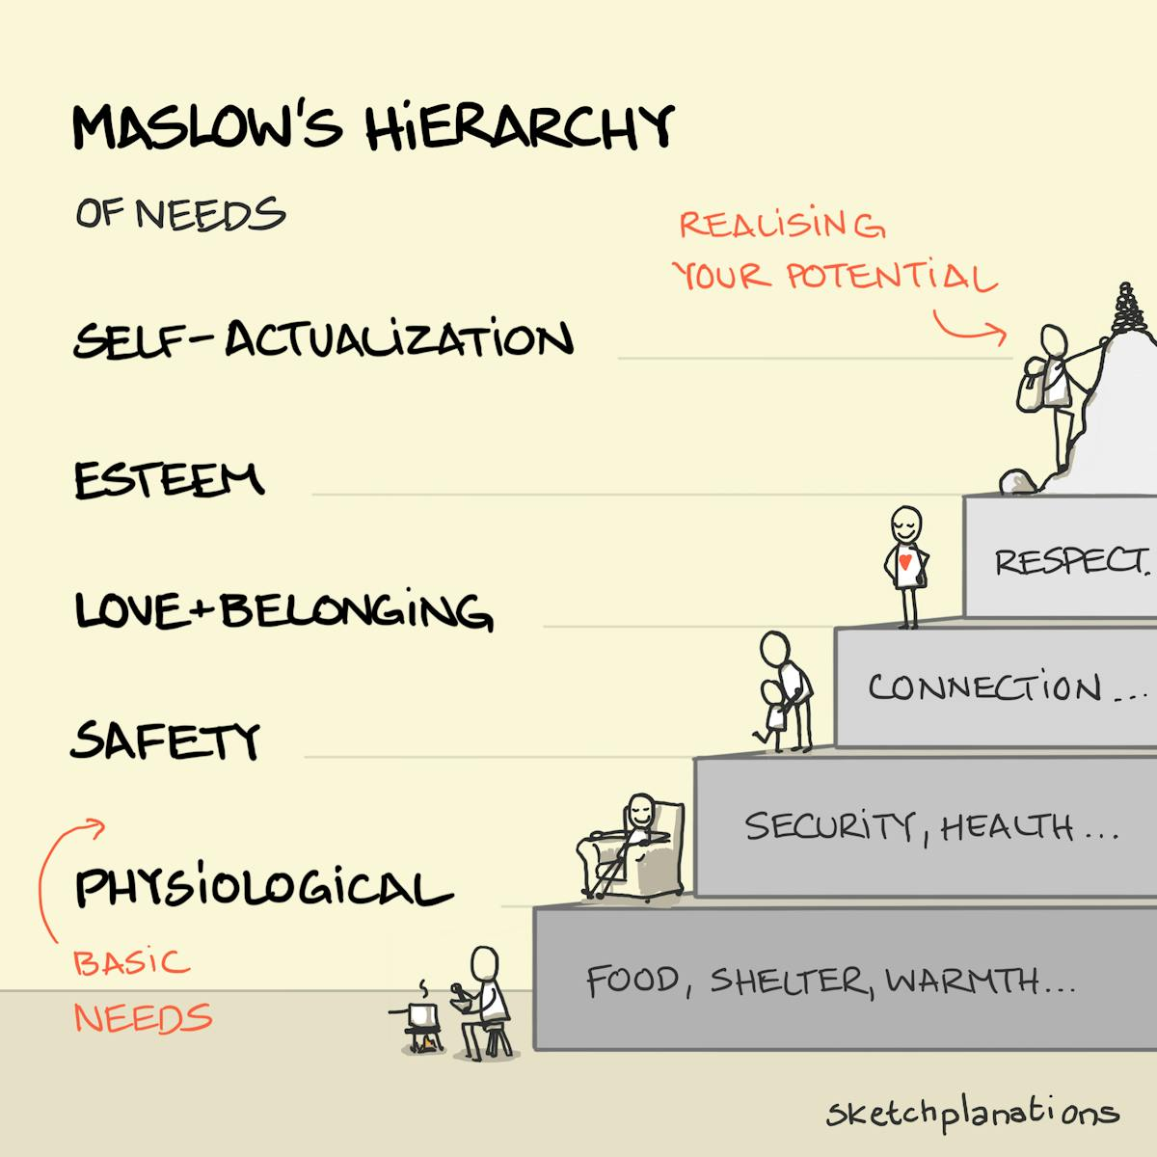

Stirrup, J. (2018) points out the possibility of wealth and class divides in regards to health understanding and perspective. They link this to the EYFS which aims to remove these barriers as both private and state nurseries aim to follow the policies around health to encourage positive development in children. Interestingly, it is also noted that often there are constraints around when and where health is discussed. Mainly around meal times, toilets, or on displays. Sparking ideas of how to integrate health into other areas during the day at the early years setting. This could include during outside play, during story time by reading and discussing books about health, during song time by singing songs about health and actively moving to work the body in a healthy way. Even yoga and meditation times throughout the day.

Health & Lifestyle

The EYFS explains how physical development is important for children to develop healthy and active lives. Physical development contains a varied amount of attributes which will thrive with ample activities tailored to the unique child. Children must have opportunities outside and inside throughout the day which give them chances to develop their core muscles, strength, stability, balance, coordination, gross and fine motor skills. Activities in early years settings can include obstacle courses whilst being resourceful with safe outdoor equipment such as tyres, climbing frames and wooden pallets. Or the use of tunnels and balls to encourage different movement styles. High energy activities which incorporate different movements such as jumping, running, hopping. Physical activity may be more available outside, however an innovative early years setting will use their knowledge to create access to physical development inside the setting.

ECETP (2017) demonstrates the ability to use various resources within the setting to allow for physical development support inside. The use of a hula hoop gives children opportunities to jump through and over. The use of bubbles allows children to run, hop and pop them. As well as navigating spatial awareness and coordination. Throwing balls into a bucket gives children muscle development and coordination as well as an understanding of cause and effect. To build on this further, the early years practitioner could allow children the space to use their divergent thinking and come up with their own uses for these resources, whilst encouraging this behaviour.

Wellbeing

Department for Education (2021) explains how children need environments which thrive from the understanding and support offered to them when dealing with their understanding of and expression of emotions. There is substantial importance of understanding the unique child’s way of expressing and coping with their emotions, the knowledge of each unique child which early years practitioners should strive for will allow for practitioners to tailor their approach to suit each child. Techniques successfully used in settings include creating family books which allow children to have access to pictures and memories from home, in times of emotional dysregulation this technique can offer calm and comfort to the child, offering that missing link between home and nursery. Practitioners can work on reflection techniques where they are able to understand the child’s emotion at one particular time and demonstrate back a safe and healthy way to deal with it. Children need safe space to go away and process their emotions before coming back to address them, again this depends on the unique child. Leading on from this, adults will thrive from an early years setting where they can also have safe space and find comfort in another adult in the setting who is able to help them regulate their own emotions at times. Creating an environment where staff well-being is of equal importance to child well-being will encourage a streamlined effect throughout the setting.

The EYFS explains how the safety, warmth and understanding an early years setting cultivates will support children in their cognitive development, emotional management, positive self esteem and confidence.

Lifestyle
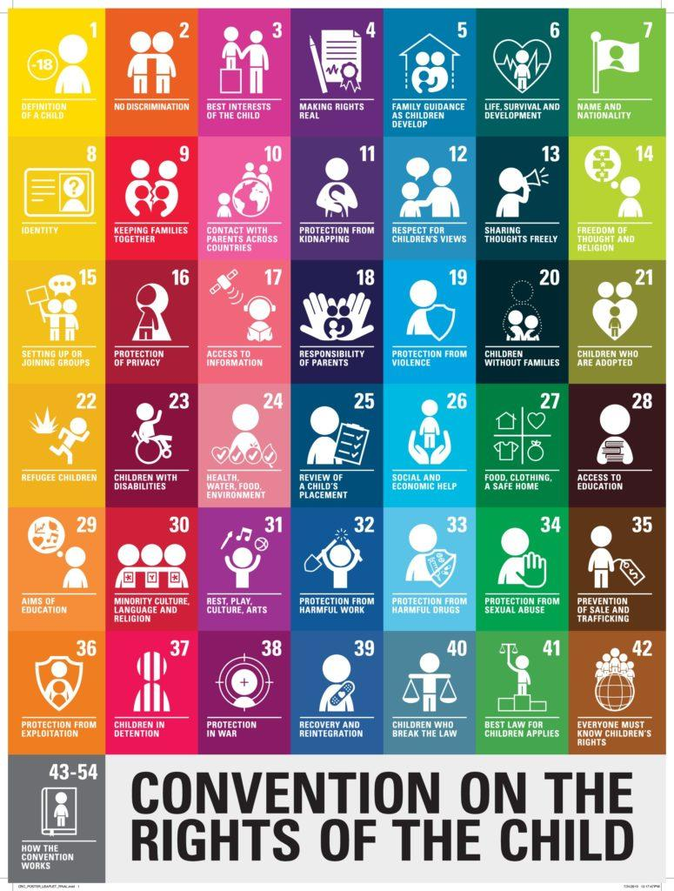
Berlinski et al, (2015) in The Early Years child well-being and the role of public policy, poses interesting points or consideration when looking at the lifestyle of early years children. Children are increasingly being recognised for having their own identities, separate to their parents or caregivers. This identity, inclusive of their own likes, dislikes, ideas and beliefs is understood to deserve respecting and protecting which is a common theme that can be seen throughout The United Nations Convention on the Rights of the Child (UNCRC).

Source: Play Scotland 2024

The book gives insight into how children who thrive in early years settings can contribute to a better society in the future. Becoming ‘productive citizens’, which demonstrates a deep need for investing in the early years sector in terms of health, well-being and lifestyle. As this investment is an investment in all of our futures. There could be an argument for keeping in mind the future when it comes to present day practice. For example, during the COVID pandemic families and early years settings were faced with intense, sudden isolation. Leaving many struggling in terms of health, well-being and lifestyle. Many children who needed socialisation, stability, safe, loving and stress free environments were being raised with factors that meant their needs were not being met. These factors included ill-health, family deaths, instability, fear and stress from parents or caregivers, complete isolation and declining mental health for parents or caregivers. During this time many early years settings were completely focused on assuring settings could stay open, re-open and stay in business. Settings were putting in place procedures to assure the immediate safety of children and to keep a parent partnership throughout the difficult situation everyone seemed to be facing. There was little to no thought about the long term effects the issues would have on children. Early years settings are now seeing a rise in behavioural issues, lack of communication and language in children and developmental issues. Reflecting on this time period, it could be helpful to learn from this experience and understand how supporting children through difficult times should also include plans for future, long term issues.

The Early Years child well-being and the role of public policy also discusses language and communication, mathematics and socioemotional skills in more depth. In regards to language and communication it is important to recognise the variety of factors which allow for development or lack of development of these skills. Children having free access to books, developing a child’s interest in books and interaction with caregivers around language and communication is very important. An example of a positive experience which cultivates an interest in communication and language includes a sleep routine inclusive of reading with the caregiver, tucked in bed, warm and cosy, feeling safe, loved and able to fully relax into the imaginative story-telling. In a negative contrast to this experience, children who grow up in poverty may not have any books, a warm bed, a warm home or even warm pyjamas. They may not have a full stomach to feel warm and relaxed, they may not have a parent or caregiver who is not stressed enough that they can themselves sit with a book and even take the time to give this experience to their child. Leading to a lack of feelings of love, affection and safety.

Solutions in practice

How then, can settings play a role in developing communication and language skills. Department for Education (2021) and the EYFS expresses the need for quality in our support of language development in early years settings. Quality has previously been assessed through the ability of children to ‘sit’ and ‘listen’. Sitting perfectly still whilst an early years educator spoke was a sign that many in the early years sector saw as good listening. However, as research has progressed, a deeper understanding of children’s behaviours has too. Children in the early years are more than likely developmentally unable to sit still for long periods of time. The development of communication and language is now understood as mainly through social interaction. When implementing this in an early years setting, educators are encouraged, especially as mentioned in the EYFS ‘assessment should not involve long breaks or excessive paperwork’, to become responsive play partners, getting involved with children’s play, working alongside the children rather than in a position of overbearing power. Early years educators who can understand a child’s brain development, linking it to the play they see in that very moment, are able to use that to their educational advantage. Such as playing in the role play area, baking a pretend cake and using new words to describe the actions they are doing, “Well done Susie for folding your cake batter!” whilst demonstrating a folding action. This is a positive approach which shows the child respect, understanding and empathy.

An importance on the socioemotional skills children need to thrive is also addressed by Department for Education (2021) and Berlinski et al, (2015). The attachment necessary to develop the safety children need to develop appropriately is especially reliant on the parent’s or caregiver’s ability to make healthy well-being and lifestyle choices. Some of these choices include time and place of birth, nutrition and dietary choices, living circumstances, clothing, whether they access healthcare and follow healthcare advice, family structure, how and when they talk and choice of early years setting. It is evident how poverty effects many of the parent’s or caregivers choices. Many may not be able to afford clothing, a setting, healthcare or quality housing.

In the EYFS practitioners are made aware that they must act on concerns when families or children present with relevant issues. If families are struggling with poverty, a supportive approach can uplift children and develop their health, well-being and lifestyle. The approach could include access to free books through various government schemes such as the free library cards. Library trips can be arranged for children whose parents or caregivers would struggle to access a library, making an educational activity out of this trip is even more of a supportive practice. Which can be built upon to develop many areas of learning. Which is described as ongoing assessment in the EYFS.

Conclusion

In conclusion it is crucial to understand how children really see the world around them. To delve into their brain development and make ample use of resources within the early years setting. Maslow’s hierarchy of needs gives practitioners a basic understanding of the needs which need to be met for children to start their developmental journey into health and well-being. Stirrup, J. (2018) does outline a wealth divide when looking at health, well-being and lifestyle factors in a child’s development. Whereas the EYFS attempts to approach this and bridge any gaps through consistent guidelines for all early years settings. The guidelines underpin good, high quality practice also demonstrated by the UNCRC. Berlinski et al, (2015) approaches different areas of children’s lifestyle which affect their development, concluding that policy makers are moving towards a more child-centred approach, with an encouragement for working in partnership across all sectors of family well-being services. Due to the now widely accepted belief that childcare is a human right.

Reference list
Berlinski, S., Norbert Rüdiger Schady and Inter-American Development Bank (2015). The early years : child well-being and the role of public policy. Houndmills, Basingstocke, Hampshire: Palgrave Macmillan.
Department for Education (2021). EYFS Communication and language – Interactions. [online] www.youtube.com. Available at: https://youtu.be/QHXipia3u-0.
Department for Education (2023). Early Years Foundation Stage Statutory Framework for Group and school-based Providers Setting the Standards for learning, Development and Care for Children from Birth to Five. [online] GOV.UK, p.11. Available at: https://assets.publishing.service.gov.uk/media/65aa5e42ed27ca001327b2c7/EYFS_statutory_framework_for_group_and_school_based_providers.pdf.
Department for Education (2021). EYFS Personal, social and emotional development – Emotions. [online] www.youtube.com. Available at: https://youtu.be/U0W2aejgBaU [Accessed 10 Jun. 2024].
DOWD, K. (2018). The keys to raising a healthy child. [online] The Sun Newspapers. Available at: https://thesunpapers.com/2018/08/20/the-keys-to-raising-a-healthy-child/ [Accessed 11 Jun. 2024].
ECETP (2017). Toddlers - Physical. YouTube. Available at: https://www.youtube.com/watch?v=KCzl-8f-uIE.
Interaction Design Foundation (2021). Maslow’s Hierarchy of Needs. [online] The Interaction Design Foundation. Available at: https://www.interaction-design.org/literature/article/maslow-s-hierarchy-of-needs.
Sketchplanations (n.d.). maslows hierarchy of needs. Available at: https://sketchplanations.com/maslows-hierarchy [Accessed 26 May 2024].
Stirrup, J. (2018) ‘“How Do You Feel? What Is Your Heart Doing?” … “It’s Jumping”: The Body and Health in Early Years Education’, Sport, education and society, 23(6), pp. 547–562. Available at: https://doi.org/10.1080/13573322.2016.1259613.

UNCRC (2024). Child-friendly UNCRC Poster leaflet. [Online image] Play Scotland. Available at: https://www.playscotland.org/resources/crc_poster_leaflet_final-indd_/ [Accessed 10 Jun. 2024].

Script:

Introduction

Hello, my name is Rosalyn Silvers and my student learner number is 2317028 I am studying BA Early Childhood Studies.
Today I am going to be discussing the importance of health, well-being and lifestyle in the early years of a child’s life. With a focus on the struggles many families currently face with poverty.

Joseph Rowntree Foundation (2024) outlines the number of families in poverty currently in the UK, the figure is 4.2 million children. Looking at the graph which is available on their website, it is evident that over the last 29 years, the amount of families struggling with poverty has remained relatively the same. Families with 3 or more children make up 43% of these statistics, with 44% of the overall statistics coming from lone parent families or those whose childcare needs limit their ability to work. The importance of this is crucial. In the Panorama - Surviving the cost of living crisis documentary available online at History Center (2022), we see the real extent of poverty amongst families that we may come across every day at our setting. Understanding their struggles is an important part of family partnership which allows settings to become fully supportive and inclusive which gives children’s health, well-being and lifestyles a chance to flourish. Some of the issues families in poverty face include rising energy costs causing inability to heat the home. Having to receive and live off food parcels, which could be extremely difficult for those with dietary requirements. Struggling to find affordable transport to get to settings, having a detrimental effect on their attendance and ability to learn.

In the truth about child poverty professor green documentary available online at True Lives (2022), we are able to view first hand experiences of life for families in poverty. Some more issues highlighted by this documentary include children experiencing shouting, unhappiness and confusion. Due to the stress parents and carers show with the possibility of debt collectors and eviction notices coming to the door at any time. Eviction and homelessness affects children in a way that may not be evident to the setting unless they are made aware. A child may come to the setting one day with the fear of not knowing if they have a home to go to when they leave, they could show signs of anxiety, stress, undue distress or sadness. If a child in a setting is young enough to not be able to verbalise the issue and parents or carers have not shared the issue, the setting may be completely unaware. This is why family partnership is very important, getting to know the families in the setting and offering trust and support can help build rapport.

Families struggling with poverty may not have the spare income to enrich children’s lives through days out or toys. Steve Zwolak in TEDx Talks (2018) discusses how some families do not have the resources to provide their children with breakfast, let alone enrichment. They then have to attend settings which are seemingly less and less child friendly. With poor lighting, regimented routine, and bland decor. Because of the long term development of this style of setting, there is now a wave of teachers and early years practitioners coming into settings with their own trauma from experiencing these settings first hand. They are then passing down this trauma to the children whilst not dealing with their own. The well-being aspect of children’s lives is being compromised by settings such as these. Developing into dysregulation which causes negative behaviours in settings and further life.

The solution to issues brought to attention in this TEDx talk include investing in the wages of educational staff and investing in children’s early education to create a return on investment in terms of children growing into fully functioning, well rounded, healthy adults who contribute massively to our community. Investing financially is of course important but of equal importance is investing emotionally. Mental well-being of children and staff is paramount. To give children hope, self confidence, professional love and empathy will also give them safety. To give early years educators the same will create a simultaneous environment of empathy within the workforce.

ABC News In-depth (2022) documents issues faced in Australia which cause families with young children to live in poverty. There is the belief that working parents will always have a home however in recent years this belief has become a myth. Working parents are becoming homeless with young babies and children under 5. The reasons behind this include health hazards in inadequate properties such as mould and asbestos. Coupled with rising rent costs which are now unaffordable to the many. Social care in Australia has stepped in but without the ability to tackle housing problems they are left with little choice but to remove children from loving, caring families if they become homeless.

Child Poverty Action group (2017) outlines how children’s health, well-being and lifestyle is damaged through poverty. Including physical development when forced to wear ill-fitting shoes because of unaffordable footwear. Isolation can cause loss of friendships and social interaction due to inability to afford birthday presents and attend birthday outings and nursery trips with friends. The poverty lifestyle limits children in the sense that they will not have opportunities to expand their likes, dislikes and understanding of the world. Which is understood to be crucial by the EYFS. Their experience of the world could be less than those with financial freedom meaning their future is also limited through lack of understanding, opportunity and ability to ‘catch up’ with other children in their class. A part of their childhood may be taken away from them at a young age as they have to deal with the stresses and worry that comes with financial poverty. As also represented by TEDx Talks (2018), Child Poverty Action group (2017) concludes that poverty in the early years directly drains national services of money. The NHS has to cope with greater numbers of mental health issues due to poverty and physical health issues which in turn create less workforce in society.

Understanding the baseline drive amongst all human beings is expressed by Maholmes (2014). Self actualisation in Maslow’s hierarchy of needs is the standard of which many early years practitioners feel children thrive the most. When following this hierarchy they see positive improvement in children’s well-being. The ability to ignore these needs and force a person or child to carry on everyday life without them is possible however it does not last long term, and would be ethically incorrect. This is now coming to fruition as described by Steve Zwolak in TEDx Talks (2018), teachers and early years practitioner passing down that institutionalised trauma to the children in their settings. It is evident from the ethos of the EYFS and resources mentioned in this presentation and my assignment that there is a desperate need for upheaval of ‘old fashioned’ practices in the early years.

In regards to solutions there are a few ethos’s that could be brought in to mainstream settings as research has suggested that they work well in the early years. Franco (2023) looks at Montessori style settings, we see that sensory activities which originated from the Montessori ethos have been widely accepted and implemented throughout early years settings. Even becoming an expected part of daily early years practice. The understanding that children need sensory stimulation to be able to grow and develop their cognitive processes has broadened early years setting opportunities for children. Allowing children safe spaces to express freedom and develop their own play with little adult intervention is one of the main principles of a Montessori education. Another principle is to place value on the every day tasks needed in daily life. The lifestyle of those in poverty should therefore not be completely dismissed, but having strong family partnerships will allow for settings to discuss and come up with solutions to the children’s learning even within the limits of their circumstances. Such as educating parents and carers on how every day tasks can become a free learning activity, giving families the understanding of how to include their children in these tasks educationally. Sometimes offering children ‘unstructured time’ removes some of the pressure from completing tasks by a certain time frame. Removing the feelings of failure and anxiety a child may feel due to this.

Learning and Teaching Scotland (2006) gives importance to reflective practice, as when making changes to early years settings it should be done with consideration to the positive practices that already work well. For example, having a routine for circle time, lunch time, outdoor time and sleep time works well in most settings. Removing this for complete unstructured play time would be detrimental rather than a positive change. Whereas assessing which times of the day may benefit from unstructured play would be a better outcome. The same reflective practice would be beneficial when bringing in other child health, well-being and lifestyle focused philosophies such as Reggio.

In conclusion, the health, well-being and lifestyle of children in poverty is greatly affected by their negative circumstances. This includes food poverty, warmth, and connection to parents and caregivers which is demonstrated by History Center (2022), True Lives (2022) and ABC News In-depth (2022). The effect on children can vary from feelings of stress and anxiety to negative behaviours within the setting environment and later life, which is explored by TEDx Talks (2018) and Child Poverty Action group (2017). Early years settings are encouraged by the EYFS to support the child in these aspects through various solutions, a few of which have been discussed in this presentation with reference to TEDx Talks (2018), Maholmes (2014), Franco (2023) and Learning and Teaching Scotland (2006). Coming to a resounding agreement that settings can offer practical solutions to family poverty within and outside of the setting.

Thank you for listening to my presentation, goodbye.

Reference list
ABC News In-depth (2022). The new face of homelessness in Australia | Four Corners. [online] YouTube. Available at: https://www.youtube.com/watch?v=yk4eWjYVNYg&t=1520s [Accessed 11 Jun. 2024].
Child Poverty Action group (2017). The Effects of Poverty. [online] Child Poverty Action Group. Available at: https://cpag.org.uk/child-poverty/effects-poverty.
Franco, D.R. and A. (2023). Montessori: The world’s most influential school? [online] www.bbc.com. Available at: https://www.bbc.com/future/article/20230131-does-the-montessori-method-actually-work.
History Center (2022). BBC Panorama - Surviving the Cost of Living Crisis. [online] YouTube. Available at: https://www.youtube.com/watch?v=8ulALQapl44&t=128s [Accessed 11 Jun. 2024].
Joseph Rowntree Foundation (2024). UK Poverty 2024: the Essential Guide to Understanding Poverty in the UK | Joseph Rowntree Foundation. [online] JRF. Available at: https://www.jrf.org.uk/uk-poverty-2024-the-essential-guide-to-understanding-poverty-in-the-uk#:~:text=Poverty%202024%20report.-.
Learning and Teaching Scotland (2006). The Reggio Emilia Approach to Early Years Education. [online] Available at: https://education.gov.scot/media/vjtdw2cj/elc35_reggioaug06.pdf.
Maholmes, V. (2014). Fostering resilience and well-being in children and families in poverty : why hope still matters. Oxford, Uk ; New York: Oxford University Press.
TEDx Talks (2018). Early in Life & the Importance of Early Childhood Education | Steve Zwolak | TEDxDelmarLoopED. [online] YouTube. Available at: https://www.youtube.com/watch?v=0xhVGvP4tW4&t=211s [Accessed 11 Jun. 2024].
True Lives (2022). The Truth About Child Poverty (Professor Green Documentary) | Our Life. [online] YouTube. Available at: https://www.youtube.com/watch?v=FRN4c_CDRAg&t=741s [Accessed 11 Jun. 2024].

