BMSW5105_LON
WORKPLACE CULTURE AND ITS IMPACT ON ORGANISATIONAL EFFICIENCY
CASE OF BIOTRADE

Lecturer: Hossein Shokri

Student:
Raya Kardzhieva
Level 5
ID: 1916653
University of Wales Trinity St David
London
28.08.2021

Executive Summary
A European syndicate “Biotrade” that has been privately held and based in the capital of Bulgaria and have been in the business professionally for a quarter of a century envisioned for the expansion and production of dermo-cosmetics. The reason for the selection of "Biotrade" for the case is being the “Director” of management and sales, and realisation of few gaps that persist in the marketing and social media engagement and causing venture to suffer. There are certain PESTEL factors that are currently affecting the business operations at Biotrade. Porter’s five forces are considered the most influencing factors for the companies and their competitive advantage. These include buyer power, supplier power, new entrants, competitors, and substitutes. Cultural Web Model is a framework that is used by the organisations to map the organisational culture in an organisation. Biotrade adheres to ethical standards and ensures that the production of its skincare and cosmetics products is environmentally friendly. The company also believes that its products comply with the expectations of consumers’ safety and do not cause any harm to the skin. The company has established a work culture where employees feel free to discuss ethical dilemmas and to report any unethical attitudes from co-workers and other employees in the organisation.

Table of Contents
1 Introduction 4
2 Overview of the Company 4
3 Business Environment Analysis Tools 4
4 ExternalEnvironment Analysis of Biotrade 6
4.1 PESTEL Analysis 6
4.1.1 Political Factors 6
4.1.2 Economic Factors 6
4.1.3 Social Factors 7
4.1.4 Technological factors 7
4.1.5 Environment Factors 7
4.1.6 Legal Factors 8
5 Industry Analysis of Biotrade 8
5.1 Porter’s Five Forces 8
5.1.1 Bargaining Power of Suppliers 8
5.1.2 Bargaining power of buyers 9
5.1.3 Threats of the New Entrants 9
5.1.4 Threats of Substitute 9
5.1.5 Competitive Rivalries 10
5.1.6 Key Change Driversfor PESTEL and Porter’s Five Forces 10
6 Organisational Culture 11
6.1 Cultural Web Model 11
6.2 Organisational Culture and External Factors 13
6.3 Organisational Culture and Performance 13
7 Ethical Dilemma 14
8 Conclusion and Recommendations 15
9. Reflective Essay 16
9 References 18
10 Appendix 20

Introduction
The workplace culture in the UK portrays the appropriate way for behaving within the organisation as it comprises common values and faiths, which have been established by the organisational leadership. The culture of the organisation defines the implementation of the business activities to be undertaken by the managerial structure and the workforce employed by the organisation. It cannot be proclaimed that dissimilar organisations comprise the identical structure for meeting their naturally distinguishing objectives. The organisational progression can be determined based on the resilience of the workplace culture and the way it influences organisational efficiency. Conversely, the leadership and performance of the business venture can be greatly influenced due to an ineffective culture adopted by the organisation. Most recently, it has been observed that the performance of numerous organisations in the UK has been greatly influenced due to the disruptions in the organisational environment due to the situations of the COVID-19 pandemic.

Overview of the Company
A European syndicate “Biotrade” that has been privately held and based in the capital of Bulgaria and have been in the business professionally for a quarter of a century envisioned for the expansion and production of dermo-cosmetics. The reason for the selection of "Biotrade" for the case is being the “Director” of management and sales, and realisation of few gaps that persist in the marketing and social media engagement and causing venture to suffer (Biotrade, 2021). Although, the organisational structure is very much flexible and provides every single employee with the freedom of expression. The venture has shown its dedication towards dermatology based on continuous innovation in the line of products, which are further perceived as effective and well-suited for beauty, special care, and health. Biotrade proclaims for comprising an interdisciplinary team of specialists commanded by a dermatologist, who are enthusiastic towards the business mission by perceiving that altogether they will be able to successfully achieve their organisation’s aim with devotion and passion (Biotrade, 2021). Being in the successful business development for over 25 years concerning the competitive field of dermo-cosmetics represents that “Biotrade” incorporates strong associations with science and further tracing the outlines for the progressive future.

Business Environment Analysis Tools
It has been observed that the associations among business ventures and organisation’s environments in the UK entail significance as far as business efficiency is concerned. It is obvious that the internal, as well as external environment of the “Biotrade”, influences the companies significantly. Keeping the most recent conditions developed by the epidemic outbreak in the UK has impacted the functionality of the organisation regardless of the nature of the business they are operating in. Hashim et al. (2015) observed that the UK’s economy was flourishing, and the business ventures were opting for the approaches in order to grab chances for the enhancement of their organisational performance since the occurrence of the Covid-19 disrupted the whole thing instantaneously. There are two tools that are used to analyse the business environment. These are the analysis of PESTEL elements such as political, economic, social, environmental, technological, and legal elements. The other analysis tool used is the Porters’ Five Forces. These include analysis of the buyer power, supplier power, competition, substitute threats, and the threats from new entrants.
PESTEL analysis particularly analyses the environmental elements that influence the company externally. There are certain political factors such as taxations, political uncertainties, instabilities and rules, and government regulations that impact the business operations of a company externally (Yüksel, 2012). These are analysed in the PESTEL model. Climate changes, impacts of crisis and disasters, impacts of various religions and cultures, various backgrounds all are analyse using the PESTEL analysis tool. Furthermore, the role of the technology such as equipment and apparatus and social media are analysed with the laws and legal frameworks in the PESTEL analysis.

Figure 1: PESTEL Analysis
Source: Yüksel (2012)
Porter’s five forces analyse some other unique factors that impact the operations of a business. According to Yunna and Yisheng (2014), it assesses the power that the buyers have and the power of the suppliers. Buyers and suppliers ate essential partners for organisations, and they can dictate terms and influence business strategies and objectives as well as key decisions in an organisation. Porter’s Five Forces tool also analyses the threats of the new arrivals in the market. In an attractive market where the demand of the consumers is high threats of the new arrivals to arrive and capture cannot be ignored and using the five forces model, it is analysed. Other factors that are analysed using this tool include threats of substitutes and competitive rivalries.
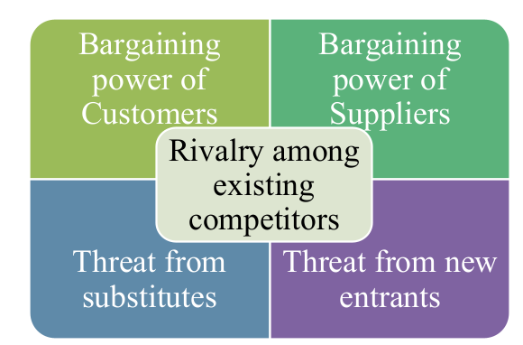
Figure 2: Porter’s Five Forces
Source: Yisheng (2014)

ExternalEnvironment Analysis of Biotrade

PESTEL Analysis
There are certain PESTEL factors that are currently affecting the business operations at Biotrade.

Political Factors
According to Pan et al. (2019), political factors refer to the intervention of politics and government in the business practices of companies. These include political instability, political uncertainty, regularisation, pricing, and taxation. When it comes to Biotrade which is dermocosmetics company and deals in skincare, health, and beauty products, the key change that drives that political impact the company in the UK is European Cosmetics Regulations 1223/2009. This government regulation ensures that the cosmetics industry follows all the rules and regulations for their business operations in the UK marketplace. This regulation involves several things such as scope, production process, ingredients, safety perspectives, and others. In addition to that taxation, and prices imposed and standardised by the government regulations also impact Biotrade.

Economic Factors
Economic factors for Biotrade in the UK influence the purchasing power of the customers. Biotrade deals in products not services and increasing inflation and decreasing income of the customers badly impacts consumer purchasing (Ortega et al., 2019). On the other hand, when the economic situation is stable it increases the demand for the Biotrade products and hence it drives more profit to the company. Significant economic factors influencing Biotrade products in the UK include inflation, income sources, unemployment, interest rates, and others.

Social Factors
The socio-cultural aspects are comprised among the most demanding aspects relating to assessment based on behavioural fluctuations of the individuals, such as values, religion, attitudes, priorities, social changes, and beliefs (Abulibdeh and Zaidan, 2017). Conversely, Adekola and Sergi (2016) argued that understanding the cultural perspective of society is critical for businesses in the UK; they should be continuously monitored by the companies in order to appropriately meet the demands of customers. “Biotrade” can employ a demographic study for the identification of trends, as supporting such trends helps them in decision making. For instance, the way “Reebok” employed such studies for the identification of superior focuses to establish their operations in the UK and beyond (Burke, Dowling and Wei, 2018).

Technological factors
Zafar and Kantola (2019) observed that technology has embraced viability from a macro-environmental perspective that has been presented in numerous products used in daily lives, such as calculators, television, computers, video records, etc. “Biotrade” comprises an important role for engendering further technologies that necessitate them to incorporate their department for research and development for seeking the provision of innovative products. For instance, based on the continuous development of M&S, the company has employed remote operations during the epidemic outbreak for enhancing the sustainability of their international business’s operations. Another significant technological factor that is currently impacting Biotrade is social media. In recent years the use of social media for marketing purposes has become significantly remarkable. However, Biotrade at present lacks a thorough marketing plan through social media that may have negative impacts on the company.

Environment Factors
The aspects concerning ecological sustainability have been observed for constant expansion, particularly for multinational conglomerates; it is due to the demanding fact in relation to social responsibility projects and activities emphasising on the environment and the community (Mkude et al., 2015). “Biotrade” comprises significance in contributing to social development (Biotrade., 2021. The industry of Skincare and Cosmetics is increasingly becoming eco-friendly and green; however, the use of plastic is still heavy in this industry. Another environmental impact is the crisis that has been caused by the recent pandemic of Covid-19. Stores of the company have closed, and the supply chain system has been impacted due to the restriction regarding Covid-19. It has also impacted the delivery system of Biotrade.

Legal Factors
According to Gregoric (2014) legal factors that are influencing Biotrade the product regulations, safety regulations, labour laws, competitive regulations, and laws and regulations regarding mergers and acquisition in the UK. Biotrade deals in cosmetics and beauty products and in UK product regulations laws such as Cosmetics Regulations 1223/2009 significantly impact the company. Other legal factors include consumers’ laws and employment regulations.

Industry Analysis of Biotrade

Porter’s Five Forces
Porter’s five forces are considered to be the most influencing factors for the companies and their competitive advantage. These include buyer power, supplier power, new entrants, competitors, and substitutes.
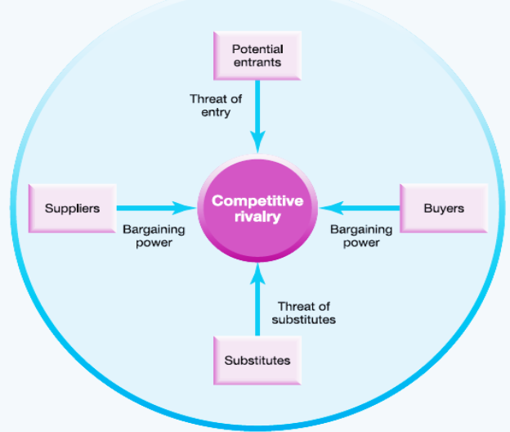
Figure 3: Porter’s Five Forces Model
Source:CISA (2012)

Bargaining Power of Suppliers
Suppliers in the cosmetic and beauty industry are several and the impact of buyer’s power hence is low on Biotrade. In a market where there are fewer suppliers, they dominate the marketplace and dictate terms with their partners (Karagiannopoulos, 2011). However, the supplier market for beauty products includes several manufacturers and the input differentiation is low. Therefore, Biotrade has multiple suppliers’ options that make the impacts of suppliers’ bargaining power less effective on the company. The bargaining power of the Suppliers has further reduced during the pandemic of Covid-19 since the demand for the products decreased due to certain reasons.

Bargaining power of buyers
The buyers are always considered as highly price-sensitive, no matter what the product or service it could be and of what brand. Customer service and reliability have become the significant dynamics, which enables “Biotrade” to deliver products that are known for their reliability and outstanding quality of services offered to their customers (Biotrade., 2021). Such dual factors enable “Biotrade” for creating certain brand royalty, but that will sustain only if the given fact concerning the customer preference would be prioritised by the company while setting their prices as low as to meet the demands of their most loyal customers. It is due to the fact that buyers have developed their bargaining powers as the substitute to the products that are available in the market enabling buyers to develop their higher bargaining powers.

Threats of the New Entrants
The threat of new entrants has always been the worry of business ventures particularly during the pandemic of COVID-19. Numerous ventures have been adapted to the mergers in order to sustain and pass through such turbulent times; whereas, on the other hand, numerous businesses have switched, and several have been thrown out from the global businesses due to product substitutes ensured by numerous other novel entrants (Bressanelli et al., 2019). The magnitude of threat concerning new entrants can be determined based on the nature of the business and type of the products the business is delivering. The industry of skincare and beauty are attractive industries and drive new entrants to capture shares in the industry (CISA, 2012). Thus, the high threats of new entrants lead to a decrease in the sales and profits for Biotrade. There are certain economic and competitive barriers as well for the new arrivals in the market. However, yet threats from the new entrants to Biotrade are inevitable and high in the UK.

Threats of Substitute
The major points highlighting the competitive environment relating to this industry are higher deliberation of prices emerging business concerning lower profit margins, price wars, declining effectiveness, and stumpy diversity (Jain, Aguilera and Jamali, 2017). There are two substitutes used in skincare and beauty products such as home remedies and oil, herbs, etc. threats of the substitutes on Biotrade is low.

Competitive Rivalries
Competition among the rivals in the UK Beauty Industry is high. There are several major players in the industry and product diversification is low (Riky, 2012). Companies such as Charlotte Tilbury, Clarins, Benefit Cosmetics, and Biotrade offer high competition to each other in the UK cosmetic industry.

Bargaining power of Customers | High
Bargaining power of Suppliers | Low
Threat from Substitutes | Low
Threat from new Entrants | High
Competitors’ Rivalry | High

Key Change Driversfor PESTEL and Porter’s Five Forces
Key change drivers for Biotrade are the pandemic of Covid-19, Social media marketing, customers increasing demands, and product development. The recent pandemic of Covid-19 has impacted almost all businesses badly (Khurram et al., 2020). Lockdowns imposed and the rules of social distancing caused companies to close their activities. It has also caused Biotrade to shut down its stores. However, on the other hand, it has offered potential opportunities to companies for change. Particularly the policies regarding remote working have become a popular phenomenon during the pandemic. Biotrade has changed its working policies as well and it has allowed its workers to work from home in order to minimise physical contact.
Another key change driver is the social media. According to Aral et al. (2013) in recent years, use of the social and digital media has increased for marketing. Brands, particularly fashion, beauty and cosmetics brands have been using social networking channels to reach their consumers. Biotrade can use these channels such as Facebook, Instagram, Youtube, and others to approach a global audience for its products online. At present Biotrade lacks comprehensive marketing on social media however, it has the potential to be a key change driver for the company. Technology is also a key change driver for the company. Trends of using the latest technologies for the production and distribution of cosmetics and beauty products are increasing day by day. For instance, in 2016 ModiFace Skin AI was established by dermatologists to observe skin care live. Product development and diversification are also key change drivers for Biotrade in the UK. Finally, the global demand for sustainability also counts to be a key change driver for Biotrade. The company strives to meet these demands and reduce the impacts of its manufacturing and production process on the global climate.

Organisational Culture
Organisational culture refers to the internal environment and the system in an organisation. it involves several key factors and actors such as tools and equipment and employees within an organisation. Hofstede defines culture as “The collective programming of the mind that distinguishes the members of one group or category of people from others” (Zhu, 2015). Organisational culture therefore a collective system of common and shared meaning from the members of an organisation to distinguish it from other organisations.

Cultural Web Model
Cultural Web Model is a framework that is used by the organisations to map the organisational culture in an organisation. According to Ng’ang’a and Wesonga (2012) this mapping tool measures and determines the influence of different cultural aspects on an organisation. It determines the existing culture in the organisation as well as measures the future culture. This model is based on the question that “What does the culture need to look like to make this change happen”. Two web maps are compared with each other to determine that where the change in the organisational culture is required.

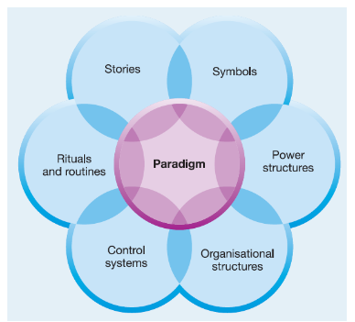
Figure 4: Cultural Web
Source:Wright et al. (2011)

Cultural mapping is useful for companies in three ways. These include surfacing that determines that why and how things and practices are executed in the organisation. Alignments and barriers refer to highlight the supporting factors and sticking points in organisation. The third element is planning where changes for the future are planned and determined. The Cultural web model for Biotrade is illustrated below to assess the organisational culture in the company and to determine and plan future changes. A questionnaire based on the six elements that surround the core of the model Paradigm is created to analyse and map organisational culture of Biotrade (Appendix). Biotrade has a clear mission and vision for their products as well as for the business operation and hence it has a clear story.
Norms and practices at the organisation believe in team practices. Biotrade has accepted the routine of working from home for the individuals who can deliver their work easily from home. During the pandemic, the remote working practices further expanded. For power structure, Biotrade has a few decision-making officials as well, however, decisions are taken by mutual cooperation of teams. Control System for Biotrade emphasises the control of ingredients and substances used in the production of its skincare products which are highly controlled and monitored to enhance customer experience (Biotrade, 2021). The company, however, does not own any physical and artistic symbol. The structure of the organisation follows a formal organisational structure, where a CEO commands and a board of directors is involved in making key decisions.

No. | The theme of Cultural Web | Yes/No
1 | Stories | ☒
2 | Symbol | ☐
3 | Rituals and Routines | ☒
4 | Power | ☒
5 | Control Systems | ☒
6 | Organisational Structure | ☒

Organisational Culture and External Factors
There are several internal and external factors that impact the Organisational Culture. External factors are the forces which impact the practices and model of an organisational. External factors even influence the strategic objectives of an organisation (Zhu, 2015). Elements of the external factors are the same as the earlier discussed for PESTEL analysis and the five forces of Porter. For Biotrade the most significant external factor that recently impacted organisational culture is the recent Pandemic of Covid-19. It has compelled the company to impose a work from home policy for its employees. From the technological perspective social media is influencing the organisational culture of Biotrade. It is although not in control of the company, yet it offers potential opportunities to the company and compels to reconsider the marketing strategy. Social media potentially helps the organisation to present its beauty and skincare products online to its customised audience.
Legal factors also impact the organisational culture for Biotrade and the company has to ensure its compliance with the labour laws within its cultural environment. Environmental factors also influence the internal practices and strategic objectives for Biotrade and it has to ensure that its production process is environmentally friendly. From Porter’s five forces power of the customer or known as the Buyers’ Bargaining Power is the most significant element that influences the internal organisational environment. In a competitive market, customers have the power to dictate the terms and there are several opportunities for the buyers to switch. Company has to strategically ensure that it meets the demands of the consumers with its practices.

Organisational Culture and Performance
Organisational performance refers to the measurements and monitoring of actual organisation outputs to the intended and perceived outputs. According to Sokro (2012), organisational culture impacts the performance and output of an organisation to a great extent. This is because the elements that drive and determine the organisational performance or its business model, structure, strategic objectives, and its workforce are a part of the internal organisational culture. Michael T. Hannan and John Freeman suggested the idea of organizational ecology and argued that the performance and effectiveness of an organisation depend on the operational environment and culture within an organisation (Hannan, 2010). organisations which deliver effective performance in a challenging situation are more efficient than organisations that do not perform in a challenging environment. This model is based on four performance pillars known as constraints, inertia, adaption, and selection.
As for the non-financial performance Biotrade has effectively dealt with the current pandemic of Cold-19. It has adopted the policy of work from home to avoid the suffering that the pandemic could cause to its business operations. Biotrade believes in the freedom to act free and that leads the company to deal with such crisis and challenges (Biotrade, 2021). It offers training and development activities to its employees within the organisation that leads it to perform better. The company also offers a friendly environment to its employees since it’s a family-based business to enhance its performance. Inertia is describing as an obstacle to adaption. Biotrade recognises these obstacles to the use of social media, and it is committed to adapt social media marketing that means high effectiveness in the performance of Biotrade. It offers opportunities to its employees to work freely from home that adds to the perforce of organisation. The selection of remote work policy during the pandemic has effectively contributed to better outputs for the company.
Organisational culture impacts financial performance as well since profits and financial outputs are derived with the help of human capital and management (Hsu et al., 2011). Biotrade manages its financial resources effectively and it has shown great financial performance since its foundation. Key financial performance for the Biotrade is measured in £ million by cash (13.8K), Net worth (3.9 K) total current assets (38.3 K), and total current liabilities (34.4K). The following graph illustrates the financial performance of Biotrade (Biotrade, 2021).
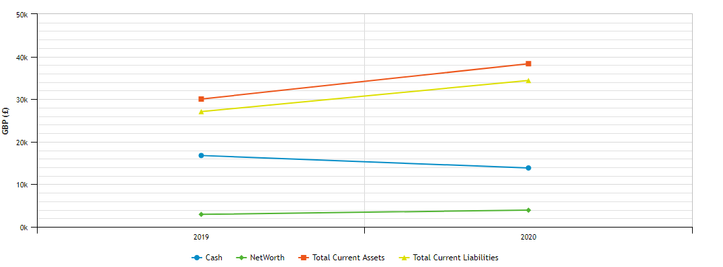
Figure 5: Financial Performance of Biotrade.
Source: Statista (2021)

Ethical Dilemma
Kitson and Campbell (2017) in a study have proposed that in recent years’ ethical considerations have become more important for organisations. Concerns regarding the global environmental, social, and economic compacts that organisations, have created an ethical dilemma for organisations to make their practices social and environmentally friendly. The concept of the Corporate Social Responsibilities demands organisations to comply with the global social, economic, and environmental ethics (Ehrich et al., 2011). To establish ethical culture companies, need to make their business model visible and effectively communicate their ethical expectations to their employees and the consumers (Huhtala et al., 2013). Ethical considerations also demand organisations to offer ethical pieces of training and workshops as well as to establish ethical protective mechanisms. Biotrade adheres to ethical standards and ensures that the production of its skincare and cosmetics products is environmentally friendly. The company also believes that its products comply with the expectations of consumers’ safety and do not cause any harm to the skin. The company has established a work culture where employees feel free to discuss ethical dilemmas and to report any unethical attitudes from co-workers and other employees in the organisation.

Conclusion and Recommendations
Biotrade deals in beauty, skincare, and cosmetic products. It is a family own company, and it adheres to a friendly culture. Tools of PETEL analysis and Porter’s Five forces model have been used to anlyse the external factors for Biotrade. Significant environmental factors are political, environmental, legal, social, economic, and technological elements that impact the business operations of Biotrade. Additional Porter’s Model analyses the bargaining power of buyers and suppliers, threats of new entries in the market of Biotrade, substitute threat, and competitive rivals for the company. These factors are significantly impacting Biotrade.
Organisational culture is the strategy, practices, and employees’ attitude in an organisation. organisational culture is very important for the performance and output of an organisation. Cultural Web model is used for mapping the organisational culture at Biotrade. This model allows to measure and understand the culture in an organisation as well as to adapt to future changes and strategies. External factors that are impacted the organisational culture of Biotrade have been found as the recent pandemic of Covid-19, technology such as social media, customers buying power,and the climate change demands for global sustainability. Finally, the practices and operations of Biotrade are within the ethical standards and it has ensured an ethical environment within the organisation.
There are some recommendations as well for Biotrade to enhance its business performance and to improve an ethical organisational culture. The company should adhere to the needs of global suitability and should appreciate a more ethical work environment. It should eliminate all the discriminative attitudes and should enhance training and development needs. For better performance, it should give freedom and job autonomy to its employees. Most importantly company should consider using social media as a marketing tool. It is recommended since recent years have witnessed that social media marketing is a proven way to enhance organisational performance.

9. Reflective Essay
Gibbs’ reflective cycle could be considered as an effective manner of providing reflection, which allows providing structure to learning from experiences. Gibbs has presented a framework, which is used to examine experiences, allowing learning and planning from things that went good or even bad. The reflective cycle consists of six different steps i.e. description, feelings, evaluation, analysis, conclusion, and action plan (Lia, 2016). Below is a graphical representation of the model:
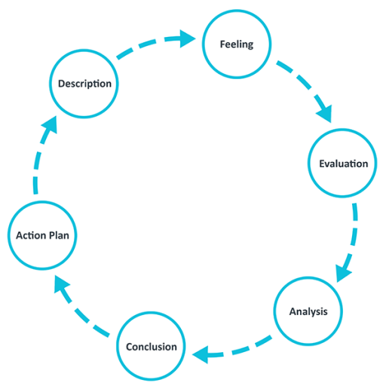
Figure 6: Gibbs Model
Source: Potter (2015)
The whole module has been highly effective and useful for my overall learning and development. Throughout the span, I have gained ample knowledge regarding business management holistically, and I have been provided the opportunity to learn numerous aspects and elements related to my field of education. I was provided an atmosphere and environment with my teachers where I was exposed and introduced to various new concepts of business management, and I was provided ample knowledge related to business internal and external environments, industry analysis, and various other evaluation models.
I was nervous and excited during the span of learning, and I have had the same feeling during learning stages. I was anxious about the new concepts and ideas that were taught to me, and I was excited to learn how the theoretical concepts could be practically applied and implemented. My group members also experience different feelings, but the overall learning environment was positive for me through which I grasped considerable knowledge.
The good things about the experience were that I was able to learn many new concepts, and further understand their implications on a wider level. Also, I was able to assist my fellow peers with the learning procedure and help them to better understand the learning content. Consequently, the bad aspects of the whole experience could be regarded as the level of complexity that sometimes was too high to understand. While most of the learning procedure was effective throughout the project, there were instances where intricacy was too high to grasp.
I believe that the experience was mostly good due to the environment of learning, and the collaborative and assistive environment throughout the project. There were instances where a cumulative effort had to be put in to attain the performance objectives, and these were effectively achieved due to good communication and coordination. On the other hand, certain negative experiences were due to the evolving environment that we were functioning, and access to certain information that made the overall work more difficult.
I was introduced to numerous learning concepts, and I improved my ability to use the concepts practically and augment their usage holistically. My experience throughout the module was positive, and I was permitted to learn in an evolving and progressive environment. For the future, I need to work on my communication and decision-making skills, through which I may be able to enhance my performance even further. To develop the required skills, I would focus on enhancing my learning abilities and enrol myself in programs that may help me improve my overall skills and knowledge.

References
Abulibdeh, A. and Zaidan, E., 2017. Empirical analysis of the cross-cultural information searching and travel behavior of business travelers: A case study of MICE travelers to Qatar in the Middle East. Applied Geography, 85, pp.152-162.
Adekola, A. and Sergi, B.S., 2016. Global business management: A cross-cultural perspective. Routledge.
Aral, S., Dellarocas, C. and Godes, D., 2013. Introduction to the special issue—social media and business transformation: a framework for research. Information systems research, 24(1), pp.3-13.
Biotrade., 2021. A brand of today. https://biotrade.global/our-company/
Burke, P.F., Dowling, G. and Wei, E., 2018. The relative impact of corporate reputation on consumer choice: beyond a halo effect. Journal of Marketing Management, 34(13-14), pp.1227-1257.
CISA, P. and CFE, M.A., 2012. Porter five forces vs resource-based view-a comparison. Available at SSRN 1986725.
Ehrich, L.C., Kimber, M., Millwater, J. and Cranston, N., 2011. Ethical dilemmas: A model to understand teacher practice. Teachers and Teaching: theory and practice, 17(2), pp.173-185.
Gregoric, M., 2014. PESTEL analysis of tourism destinations in the perspective of business tourism (MICE). In Faculty of Tourism and Hospitality Management in Opatija. Biennial International Congress. Tourism & Hospitality Industry (p. 551). University of Rijeka, Faculty of Tourism & Hospitality Management.
Hannan, M.T., 2010. Partiality of memberships in categories and audiences. Annual Review of Sociology, 36, pp.159-181.
Hashim, S.F., Tajuddin, R.M. and Zainol, A.S., 2015. Creating resilient SME through brand identity (Case study of Bumiputera fashion entrepreneurs in Malaysia). International Academic Research of Social Science, 1(2), pp.264-282.
Hsu, G., Hannan, M.T. and Pólos, L., 2011. Typecasting, legitimation, and form emergence: A formal theory. Sociological Theory, 29(2), pp.97-123.
Huhtala, M., Feldt, T., Hyvönen, K. and Mauno, S., 2013. Ethical organisational culture as a context for managers’ personal work goals. Journal of Business Ethics, 114(2), pp.265-282.
Karagiannopoulos, G.D., Georgopoulos, N. and Nikolopoulos, K., 2005. Fathoming Porter's five forces model in the internet era. info.
Khurram, A., Hassan, S. and Khurram, S., 2020. Revisiting Porter Five Forces Model: Influence of Non-Governmental Organizations on Competitive Rivalry in Various Economic Sectors. Pakistan Social Sciences Review, 4.
Kitson, A. and Campbell, R., 2017. The ethical organisation. Palgrave Macmillan.
Lia, P., 2016. Using Gibbs’ Reflective Cycle. Learning Support Tutor.
Mkude, C.G. and Wimmer, M.A., 2015. Studying interdependencies of e-government challenges in Tanzania along a PESTEL analysis.
Ng’ang’a, M.J. and Wesonga, J.N., 2012. The impact of organisational culture on performance of educational institutions.
Ortega, R.G., Rodríguez, M.D.O., Vázquez, M.L., Ricardo, J.E., Figueiredo, J.A.S. and Smarandache, F., 2019. Pestel analysis based on neutrosophic cognitive maps and neutrosophic numbers for the sinos river basin management. Infinite Study.
Pan, W., Chen, L. and Zhan, W., 2019. PESTEL analysis of construction productivity enhancement strategies: A case study of three economies. Journal of Management in Engineering, 35(1), p.05018013.
Potter, C., 2015. Leadership development: an applied comparison of Gibbs’ Reflective Cycle and Scharmer’s Theory U. Industrial and Commercial Training.
Riky, A., 2014. Porter Five Forces Model Pada PT. RUCI GAS. Agora, 2(2), pp.1285-1296.
Sokro, E., 2012. Analysis of the relationship that exists between organisational culture, motivation and performance. Problems of Management in the 21st Century, 3, p.106.
Wright, K.T., Masri, W.E., Osman, A., Chowdhury, J. and Johnson, W.E., 2011. Concise review: bone marrow for the treatment of spinal cord injury: mechanisms and clinical applications. Stem cells, 29(2), pp.169-178.
Yüksel, I., 2012. Developing a multi-criteria decision-making model for PESTEL analysis. International Journal of Business and Management, 7(24), p.52.
Yunna, W. and Yisheng, Y., 2014. The competition situation analysis of shale gas industry in China: Applying Porter’s five forces and scenario model. Renewable and Sustainable Energy Reviews, 40, pp.798-805.
Zafar, A. and Kantola, J., 2019, July. The Effect of Macro Environmental and Firm-Level Factors on Open Innovations in Product Development and Their Impact on Firms’ Performance. In International Conference on Applied Human Factors and Ergonomics (pp. 61-71). Springer, Cham.
Zhu, C., 2015. Organisational culture and technology-enhanced innovation in higher education. Technology, Pedagogy and Education, 24(1), pp.65-79.

Appendix
- Does Biotrade possess any symbol?
- How does the company tell a story?
- What are routine and rituals for Boitrade?
- How is the power distributed among employees in the company?
- What is the control system and which area of the company is most monitored and controlled?
- Which structure Biotrade follows? Formal or any other?

