

Assignment title: Vehicle suspension and steering systems
Student name: Bradley Thomas
Student number: 1901066
Course module: Vehicle systems
Couse code:M4X02198
Lecture: Mark Sandford

Abstract
This report will look at the different suspension data which was gathered during live practical sessions in groups, after this using the Win-Go program, the data will plot a diagram for vehicle suspension. The first practical will look at suspension co-ordinate measurements, this task will include, accurately measuring suspension areas and inputting that set of data into Win-Go. The second practical test will consist of using the software Win-Go to measure and create graphs of the kinetic behaviour of the test car on the program and comparing it with live data gathered. These graphs will look at the difference between the toe steer vs the ride height or the camber vs the right height.
Contents
Abstract 2
Contents page 2
List of figures 2
Introduction 3
Equipment used in test 3
DTI Gauge 3
Vernier calliper 3
Steel ruler 3
Flat square 3
Height gauge 4
Inclinometer 4
Methodology 4
Practical test Lab 1 (suspension hard points) 4
Practical test lab 2 (suspension articulation) 5
Lab 1 Results 5
Lab 2 results 6
Bibliography 6
Appendix 7

List of figures
Fig: 1.1 lab 1 session and Fig 1.2 lab 2 session
Fig 1.3 Win-Go Screenshot.
Fig 1.4 Microsoft Excel table of data.
Fig 1.5 toe data.
Fig 1.6 Camber data.

Introduction
Throughout this report, there will be a series of sections which will cover the tools used during both lab sessions, data gathered from different live tests carried out within the workshop. These data sets will be talked about and analysed, along side this will include a set of graphs representing the different set of data patterns. The area of the vehicle (formula ford) which the data is being collected from is the front right corner.

Equipment used in test
During the live tests, the data that was gathered, was carried out using a series of equipment types. These consisted of Imperial DTI gauge, Vernier calliper, steel rule, flat square, height gauge and inclinometer.

DTI Gauge
The first set of equipment that was used was the DTI gauge, this gauge was in imperial units which meant that all units of data gathered had to be converted to portray accurate data. The way that this piece of equipment is operated is by first setting it on a level surface, once this is done then take the top gauge and make sure that it is set to zero, this can be done using a little adjustment wheel on the gauge its self. Once it is set to zero then to get a reading place the gauge next to the moving component that is being measured. This type of gauge is suitable for use in this practical scenario because it allows for the spring compression travel to be measured. In terms of accuracy the DTI gauge is an accurate tool because its scale is set in 001 to 1.0 of an inch which is a precise measurement, however this needs to be converted when inputting the data. Possible alternative to this piece of equipment would be a digital DTI gauge as this type of gauge has the option of using metric units and zeroing for when needed during measuring.

Vernier calliper
The second tool that was using in the data gathering practical was a Vernier calliper. The Vernier calliper is a tool which can measure the distance between 2 different surfaces. This tool is suitable for use in this practical because it is in metric which allows for data to be gathered in the correct measurement, the scale of this tool is in mm which allows for high accuracy when in use during measuring. An alternative tool that could be used is an electronic Vernier calliper and this could be used as an alternative because it allows for the user to change the units if needed and it allows for zeroing.

Steel ruler
The third tool included is a steel ruler, this tool is a standard metal ruler in metric and imperial units, used for most measurements in the workshop environment. This tool is suitable for application in practical testing as it allows for distances between components over large areas to be measured however it can only be applied to flat surfaces and can’t be used on an uneven surface. In terms off accuracy the ruler is accurate up to 1mm and 1 16th of an inch. There are no alternatives for this tool to be used.

Flat square
The fourth tool on the list is the flat square, this tool is used to measure right angles produced during the practical. The suitability of this tool in this is vital as it allows for the data to be taken at different right angles accurately. In terms of accuracy the flat square allows the user to get best results for right angle measurements. There aren’t any other tools that would be a better alternative for this one.

Height gauge
The fifth tool that was used in gathering data was a height gauge, the function of this tool is to work out the height of a point from the base, it uses an electronic gauge at the top to measure the height from the base of the tool. The suitability of this tool is important as it allows for measurements to be taken at high points on the chassis. Its accuracy is very good as it can be zeroed to measure a gap between two points on the chassis that are high up from the base. Another alternative is not applicable as the suitability of this tool is second to none as it is vital to the accusation of data for the Win-Go program.

Inclinometer
The final tool used on this list was the inclinometer and this tool was used to measure the camber of the wheel hub through the brake disk. The suitability of this tool is applicable to this task as it is needed to complete a vital part of information gathering to build the data. The accuracy of this tool was displayed as it allowed to factor in the level of the table which would have a factor to consider to the results of the data. There would be no other alternative tool to use for this.

Methodology

Practical test Lab 1 (suspension hard points)
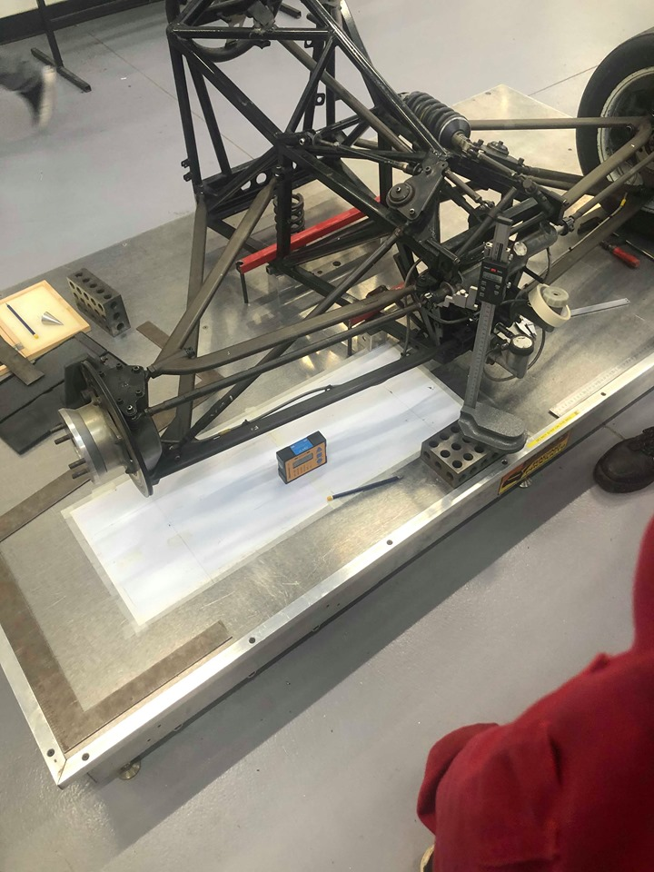
The first lab session covered measuring suspension hard points, this involved taking measurements of different points on the chassis. The methods used in doing this were as follows, first make sure tools are set up correctly and work accordingly. After that then start out the measuring procedures by first locking the steering wheel to give an accurate result, once this has been done, then work out your X axis, to do this you must first look at the base of the table which the chassis is on and draw your X line using a steel ruler. This line must travel through the centre of the wheel hub to the end of the paper base and this line should be in position with your tie rod bolts. This will give you your X axis. Now that the X axis is gathered the Y axis is needed. To get the Y axis first look at your inner tie rod bolts and make a mark using the flat square as to the position of the bolts, carry this out again on the bolts closer to the wheel hub. Once both points have been marked draw a line from the point to the X axis line using a Steel ruler. At this point all axis will have been marked and the next phase of the test can begin. Now the measurements can be taken. Using the height gauge placing it inline with the tie rod bolts measure the distance from the base surface to the centre of the bolt on the tie rod. Once that is measured then do the same for the inner bolt to make sure that it is equal, this will also give the Z axis. Fig: 1.1 below shows the lab 1 practical. The X, Y and Z axis are highlighted below.

Practical test lab 2 (suspension articulation)
Lab 2 was a session which looks at the suspension articulation. This involves measuring different points of the vehicles suspension and taking different sets of data. Theses data sets will include the following, Wheel height, Damper length, camber of the wheel hub, DTI gauge A&B and the spring measurement. The order in which this data is measured is by first setting up the equipment this includes, setting the height gauge and zeroing it at the wheel height, then setting the DTI gauges to the wheel correspondingly against the wheel hub. Once that is carried out, then clamp the inclinometer to the wheel hub using a clamp. After that has been done then adjust the damper by 2 increments and take measurements, accordingly, note to take first measurement before adjusting the damper and the damper measurement using a Vernier gauge at each of the 10 steps.
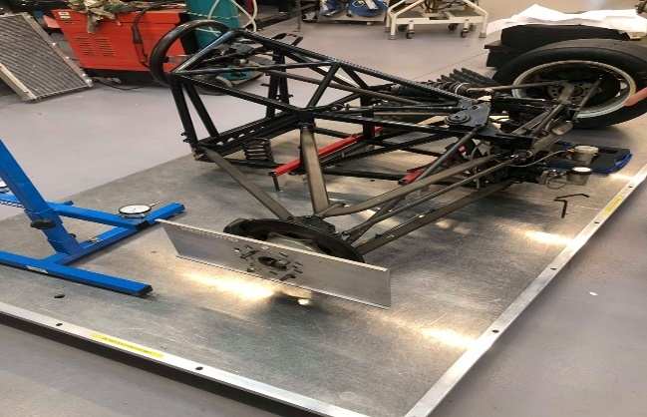
This is a photo of the second lab session, fig: 1.2.

Lab 1 Results
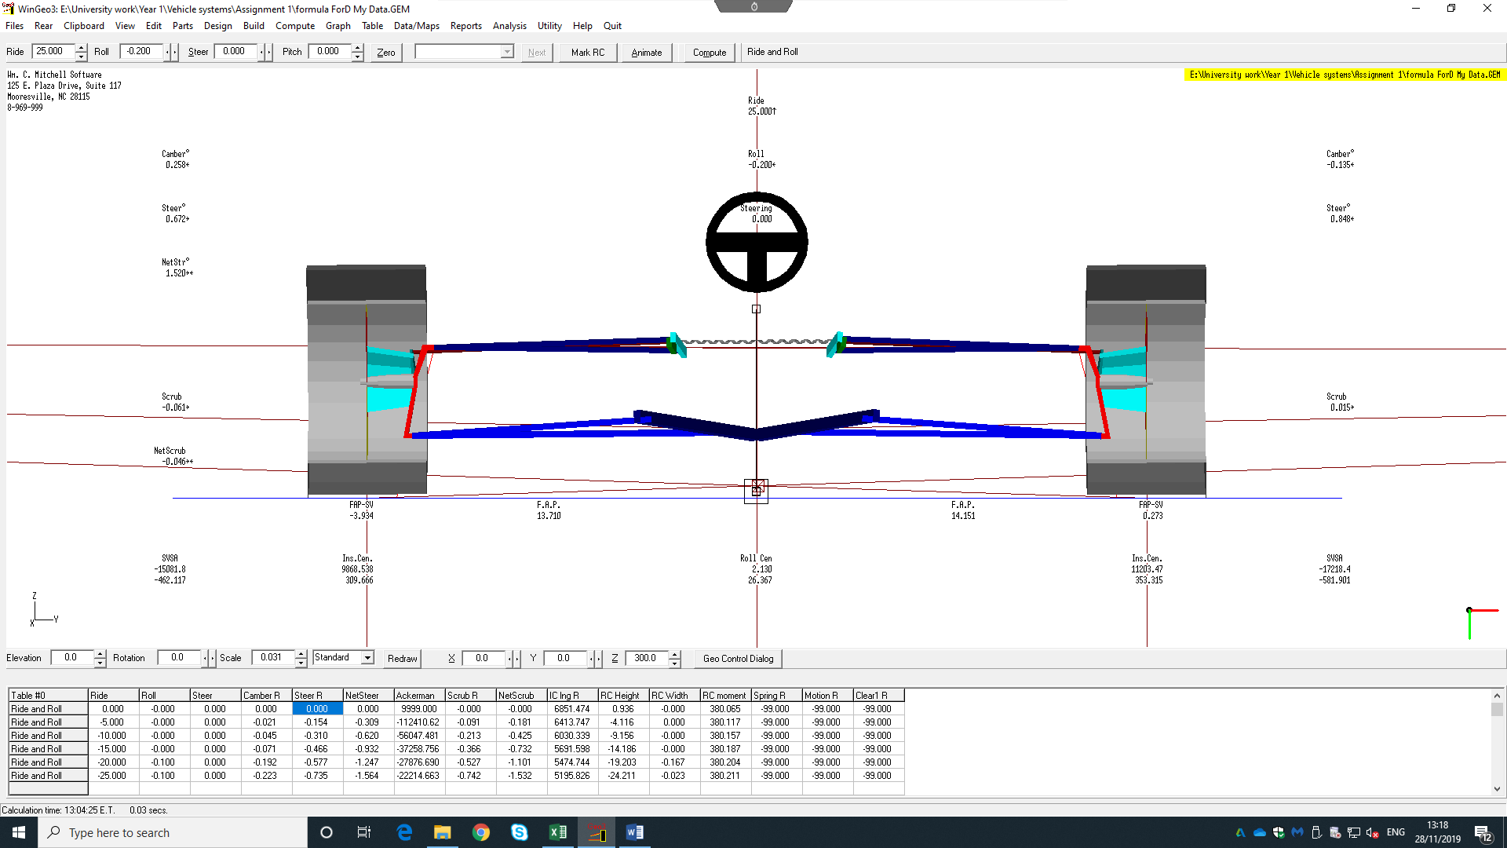
The first lab session that was carried out found that the angle of tolerance was 0.16 this was the number produced by Win-Go. The tolerance was measured over the steering rack arm and the measurement that was gathered was 0.07, this wasn’t accurate, so the measurement was rechecked, and it was discovered that the datum was not flat which resulted in 0.02 of a difference. Taking away the 0.07 from 0.22 leaves 0.15, taking this away for the 0.16 produced by Win-Go it gives 0.01 angle of tolerance. Fig 1.3 shows the set up in Win-Go.

Lab 2 results
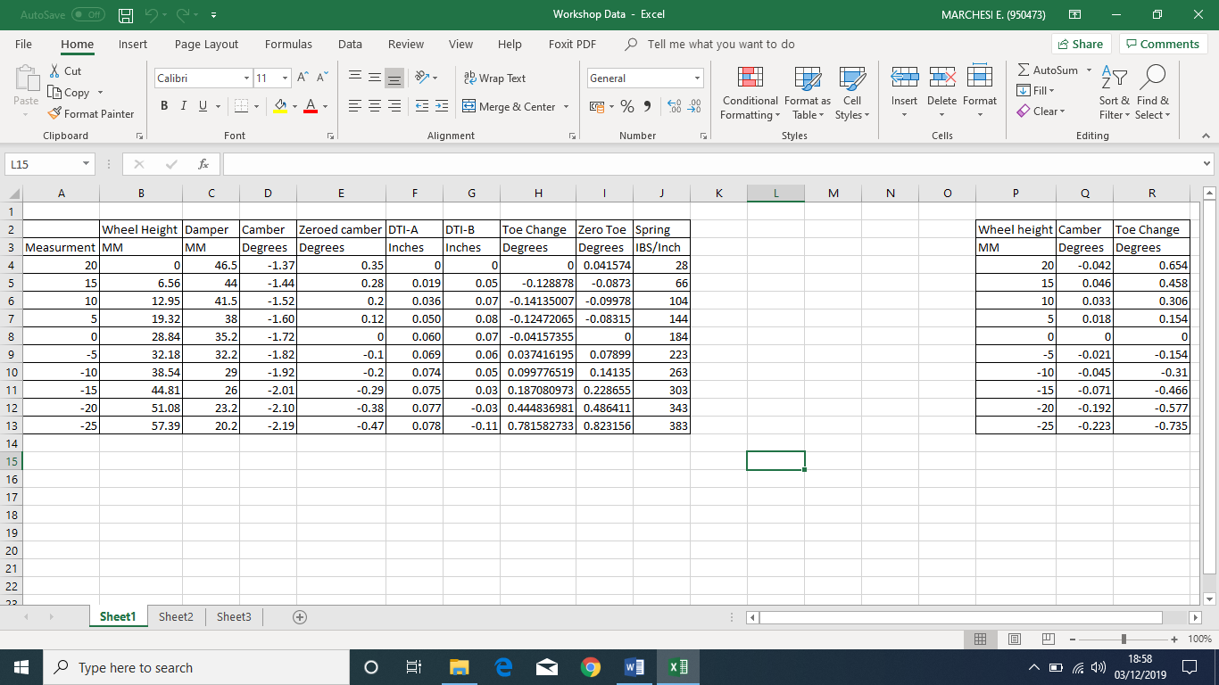
The second lab was a test of vehicle suspension articulation, this is looking at the vehicles unsprung when the ford formulas suspension was both connected and disconnected, before that was carried out, a table of data was procured looking at the different levels of suspension camber. The way in which the data was gathered was by taking 10 measurement while adjusting the suspension dampener. After the table was completed, we then looked at the vehicles unsprung mass, this is any components below the springs, e.g. trailing arms. First tested was the unsprang mass when it was connected to the rest of the ford set up it gave a reading of 21.5kg and when it was disconnected it gave a reading of 24kg. once this data was gathered, it was then put into a excel table which is shown in fig 1.4.
As you can see from the table there where different areas measured these include, wheel height, damper length, vehicle camber, DTI-A, DTI-B and the spring. The data gathered was used to find the zeroed camber, toe change and zero toe, these results would then allow for data to be compared with the simulation data. the graph below fig: 1.5 is showing the comparison of data between live and simulation data for toe, as you can see there is a similar pattern with the positive toe in degrees, however there was an anomaly with the data which caused the negative toe to change dramatically. The second set of data that was compared was the suspension camber. As you can see from the graph below fig: 1.6 the lines for both test data and simulation data are differing on both positive and negative, these lines show a positive correlation with the data.

Conclusion
In conclusion to the report, the data gathered from the live test 1 showed that there hasn’t been much change in the ford formulas suspension hard points. The data displays that the suspension angle of tolerance was only out by 0.01 which is good as it shows the test was carried out correctly and in a professional manner, it also matches up with the data on Win-Go. The second lab test data shows that the suspension articulation has stayed the same in comparison to Win-Go for the most part but there were some anomality’s for example the ford formulas negative toe was completely different to the Win-Go modal toe. It showed a displacement of -0.3 degrees and the positive toe showed a difference of 0.6 degrees, see Fig: 1.5 for graph data. The vehicle camber also has an anomaly, it shows that measured live data of the vehicle camber has a straight and positive correlation, however the simulation camber is displaying 2 differences of the negative camber is not in a straight correlation but is gradual only changing by -0.1 of a degree. It then travels to 0.05 of a degree and then drops to almost 0. The graph in Fig: 1.6 shows this. The overall look at the data shows that it was accurate and there hasn’t been much change with the formula ford data apart from the abnormalities in the data, needless to say that the results are positive and match what is on the Win-Go data.

Bibliography
UWTSD logo - https://mystudentevents.com/events/uwtsd-carmarthen-open-days/
BOSCH, R. (2019). BOSCH AUTOMOTIVE HANDBOOK. 10th ed. WARRENDALE: Wiley; 10 edition (February 19, 2019).
Zammit, S. (1987). Motor vehicle engineering science for technicians, level 2. Harlow: Longman Scientific & Technical.

Appendix
Fig 1.5

Fig 1.6

