

MODULE CODE: Digital Skills for Personal Development and Business Growth BMSW4008

ASSESSMENT COMPONENT: PORTFOLIO

STUDENT NAME: Julio Cesar Phol Rodriguez

STUDENT NUMBER: 2512123

LECTURER: Digital Skills

DATE:
Contents
Task 1 3
Assessment of Digital Skills 3
References 5
Task 2 6
LinkedIn Learning Certificates for Office365 6
Task 3 7
Essay on Relevance of Excel in professional and personal life. 7
Task 4 11
7 Minute Reflective Presentation 11

Task 1

Assessment of Digital Skills
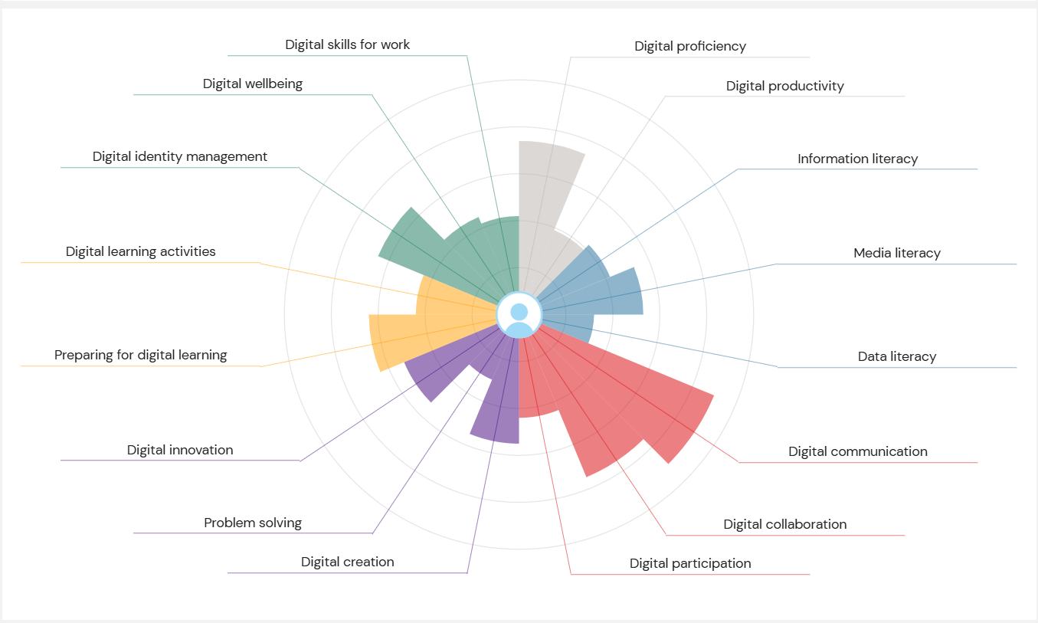
Screen shot of your JISC report

Introduction
Digital skills are basically the stuff you need to get by at university and in most jobs now not just knowing how to open Word, but being able to find good information, present it, protect your online profile and not burn out from screens.

results
My Jisc profile shows I’m solid with practical tools and chatting online, okay at making digital stuff, and weak at finding and evaluating academic info and managing my online identity and wellbeing. In short: I can make a decent PowerPoint and join a Zoom, but I panic a bit when a proper literature search is needed

Strengths
- ICT basics
I can use Word, PowerPoint and Excel without freaking out. I know enough to format essays, make slides that don’t look awful and do basic spreadsheet stuff. It saves time and stress when deadlines are coming.
- Digital communication
I’m comfortable with email, group chats and collaborative docs. I can organise a group project, share files and not be the person who misses every meeting. That’s been handy for teamwork and getting things handed in on time.

Weaknesses
- Information and data literacy
This is the big one. I often just Google and pick the first thing that looks okay. I don’t always know how to use the university library properly, how to judge if a source is academic, or how to manage references without it turning into a nightmare.
- Digital identity and wellbeing
I haven’t sorted a professional online presence (LinkedIn is basically empty) and my privacy settings are a mess. Also, I spend way too much time scrolling, which wrecks focus and make study sessions less productive.

Action plan (SMART goals)
Goal 1 — Improve information and data literacy
- Specific: Do an online short course on academic searching and source evaluation, and practise by creating three annotated bibliographies for different assignments.
- Measurable: Complete the course; produce three bibliographies each with at least 2 credible sources and short notes on why each source is reliable.
- Achievable: Use university library workshops and free modules (e.g., the library, LinkedIn).
- Relevant: better essays and less time wasted.
- Time-bound: Finish the course in the next 6 months.
Goal 2 — Sort digital identity and screen-time habits
- Specific: Build a basic LinkedIn profile, tidy privacy settings on three social accounts, and set a daily limit for recreational screen time.
- Measurable: Publish LinkedIn with photo and summary; update privacy on Facebook/Instagram/Twitter; reduce non-study screen time to 90 minutes per day.
- Achievable: Get feedback from the university careers service and use a screen-time app to track usage.
- Relevant: A cleaner online profile helps with job applications; less screen time improves focus and wellbeing.
- Time-bound: LinkedIn and privacy tweaks done in the next 6 months.

Conclusion
I will waste less time hunting for decent sources, and my essays should be better. Getting my online presence sorted will make me look less amateur to employers and help with networking. Cutting down screen time should make study sessions more effective and reduce stress. I don’t expect to become an expert overnight, but small, realistic steps will turn these weak spots into proper skills that help with university work and future job applications.

References
- Jisc, 2015. Digital capabilities: the 6 elements defined (PDF). Jisc. Available at: https://digitalcapability.jiscinvolve.org/wp/files/2015/06/1.-Digital-capabilities-6-elements.pdf (Accessed: 01December 2025).
- Jisc, 2022. Our digital capabilities framework. Building digital capability. Available at: https://digitalcapability.jisc.ac.uk/what-is-digital-capability/individual-digital-capabilities/our-digital-capabilities-framework/ (Accessed: 03 December 2025).
- Bodleian Libraries, 2025. iSkills workshops and research training. Bodleian Libraries. Available at: https://www.bodleian.ox.ac.uk/ask/workshops (Accessed: 03 December 2025).
- Prospects, 2024. How to improve your LinkedIn profile. Prospects. Available at: https://www.prospects.ac.uk/careers-advice/getting-a-job/how-to-improve-your-linkedin-profile (Accessed: 02 December 2025).
- Department of Health and Social Care, 2019. UK Chief Medical Officers’ commentary on ‘Screen-based activities and children and young people’s mental health and psychosocial wellbeing: a systematic map of reviews’. GOV.UK. Available at: https://www.gov.uk/government/publications/uk-cmo-commentary-on-screen-time-and-social-media-map-of-reviews (Accessed: 02 December 2025).

Task 2

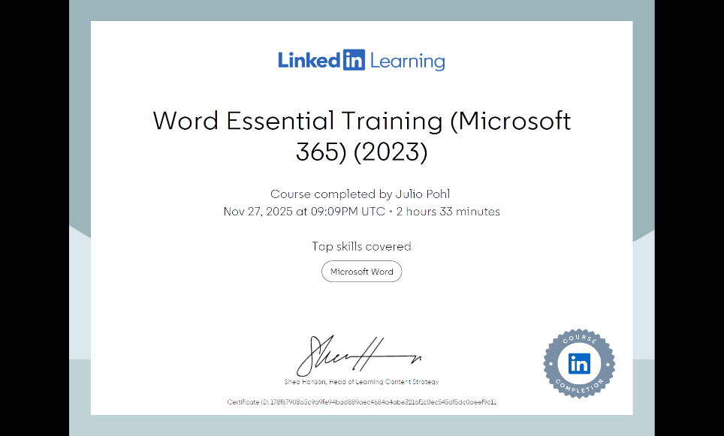
LinkedIn Learning Certificates for Office365

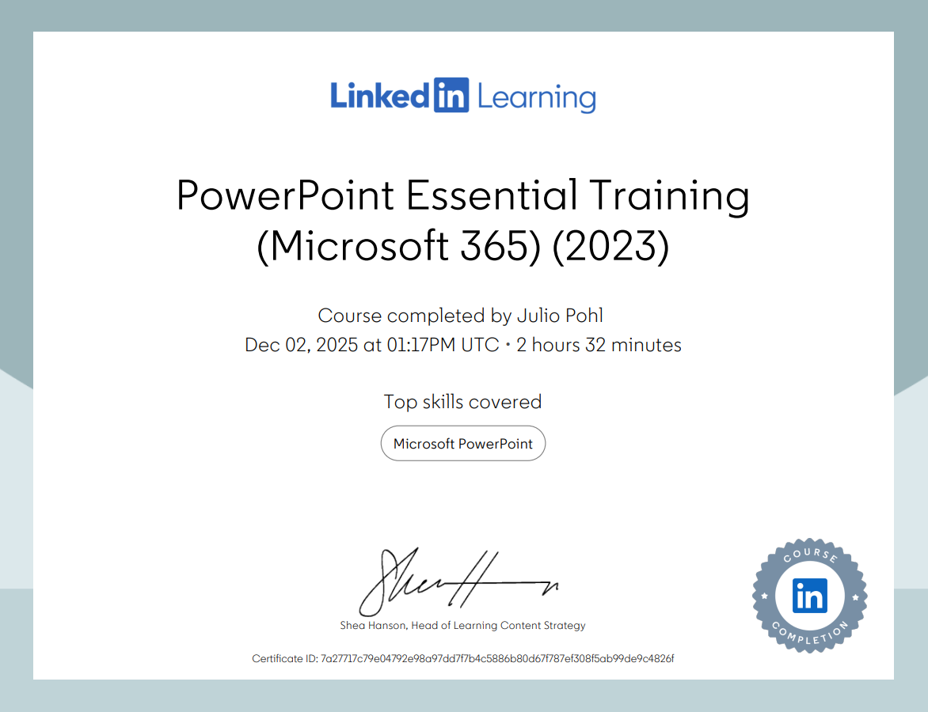

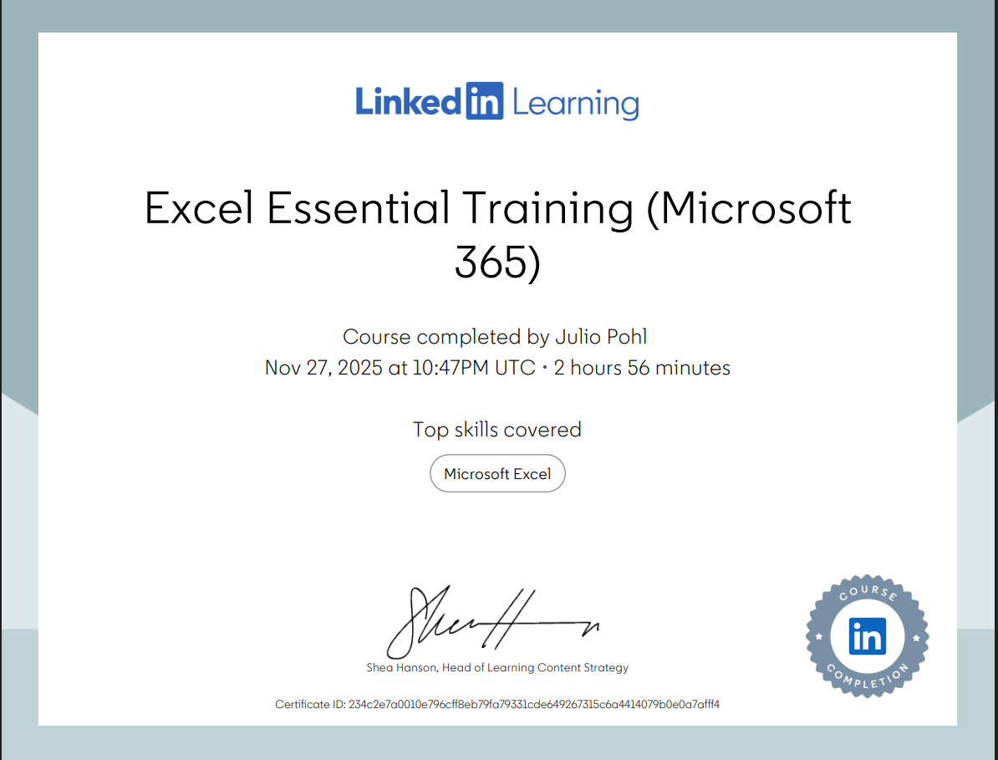

Task 3

Essay on Relevance of Excel in professional and personal life.
Introduction
When I first started university, I thought Microsoft Excel was just for accountants or people working in offices. But after using it for a few assignments and personal stuff like budgeting, I realised it's super useful. Excel is not just about numbers it helps you organise your thoughts and make better decisions. In this essay, I’ll explain why Excel is still important today and how it can help with things like data analysis, budgeting, reporting, and decision-making. I’ll also show a simple spreadsheet I made about household income and expenses to prove how handy it is.

Why Excel Is Still Relevant
Even though there are loads of new apps and tools out there, Excel is still one of the most powerful and flexible ones. It’s used in loads of industries and business, education, healthcare. What makes it stand out is how easy it is to start with, but also how deep you can go if you want to do more advanced stuff. You don’t need to be a technology expert to use it, which is great for students like me who are still learning.

Data Analysis
Excel is great for analysing data because it helps you organise large amounts of information and spot patterns quickly. You can use features like filters, formulas, and charts to break down data and understand what it means. For example, if you have a list of monthly expenses, you can use Excel to calculate totals, averages, or even compare spending across categories. Tools like PivotTables also let you summarise big datasets in just a few clicks, which is super helpful for reports or projects. According to Microsoft (2023), PivotTables are especially useful for quickly analysing and comparing large amounts of data without needing advanced technical skills.

Budgeting
Budgeting is something I never thought I’d use Excel. As a student, money is tight, so keeping track of what I spend is important. I made a simple budget sheet where I list my income (like student loan, part-time job) and my expenses (like rent, food, transport). I used formulas like =SUM() to add things up and =IF() to highlight when I go over budget.

What’s great is that I can update it every week and see where my money is going. It helped me realise I was spending too much on takeaways, so I started cooking more at home.

Decision-Making
Excel isn’t just about showing data it helps you make decisions too. For example, one example can choose between two part-time jobs, made a table comparing the hours, pay, travel time, and flexibility. Give to each factor a score and used Excel to calculate the total. It helps see which job was better overall.

Conclusion
Microsoft Excel is way more than just a boring spreadsheet tool. It’s something that can help students like me with everyday tasks whether it’s analysing data for a project, managing money, writing reports, or making decisions. It’s easy to learn the basics, and once you do, you’ll find loads of ways to use it. I used to think Excel was just for office workers, but now I see it’s a life skill. If you haven’t tried it yet, give it a go you might be surprised how useful it is.

- GeeksforGeeks, 2023. 7 Uses of Excel in Business with Real World Examples. [online] Available at: https://www.geeksforgeeks.org/excel/excel-in-business/ [Accessed 2 Dec. 2025].

- School of Coding UK, 2023. Importance of Microsoft Excel in Business: 10 Reasons. [online] Available at: https://schoolofcodinguk.com/blog/importance-of-microsoft-excel-in-business/ [Accessed 1 Dec. 2025].

- The Knowledge Academy, 2023. Use of Excel in Business Analysis. [online] Available at: https://www.theknowledgeacademy.com/blog/use-of-excel-in-business-analysis/ [Accessed 3 Dec. 2025].

- GeeksforGeeks, 2023. Importance of Microsoft Excel in College and Universities. [online] Available at: https://www.geeksforgeeks.org/excel/importance-microsoft-excel-college/ [Accessed 3 Dec. 2025].

- Microsoft, 2023. Overview of PivotTables and PivotCharts. [online] Available at: https://support.microsoft.com/en-us/office/overview-of-pivottables-and-pivotcharts-527c8fa3-02c0-445a-a2db-7794676bce96 [Accessed 3 Dec. 2025].

- Microsoft, 2023. Personal and Household Budget Templates. [online] Available at: https://excel.cloud.microsoft/create/en/personal-finance/ [Accessed 3 Dec. 2025].

- Examples-of.net, 2023. How Excel Helps Managers Make Decisions Effectively. [online] Available at: https://examples-of.net/how-can-a-spreadsheet-program-such-as-microsoft-office-excel-help-managers-make-decisions/ [Accessed 2 Dec. 2025].

Income | Amount per month £££ | Expenditure | Amount per month £££
Wage 1 |  | Rent/Mortgage
Wage 2 |  | Council tax
Trust Funds |  | Electric
Stocks/Share payouts |  | Gas
Universal credit |  | Water rates
Student Finance |  | Food
Other |  | Car insurance
 |  | Car Tax
 |  | Fuel
 |  | Child Care Costs
 |  | Loans/credit cards
 |  | Other eg Birthdays/savings/holidays

Embed your excel here

Task 4

7 Minute Reflective Presentation




