Reflection on Study Skills

L4 - Study Skills for Electronics
Module Code - ACDA4021

HND/BEng Electronic Engineering/Embedded Electronics

Freddie Wilson
2413880
Contents
1. Presentation Skills 2
1.1 Overview 2
1.2 Presentation Screengrabs 3
1.3 Key Points 4
1.4 Presentation aspects to improve 5
2. Personal research on required skill sets 5
2.1 Skills required for successful learning in a Higher Education environment 5
2.2 Transferrable Skills For Job Candidates 5
3. Self-evaluation and action planning 6
3.1 Self-Evaluation 6
3.2 Goals 8
3.3 Action Plans 9
4. Application 11
4.1 Looking after your data 11
4.2 Time management and self-organisation 12
5. Conclusion & Evaluation 13
6. Referencing 14
7. Appendices 15

Presentation Skills

Overview
The assignment brief details that students must require a brief overview of themselves. Firstly, here is some background information on the presenter:
Name: Freddie Wilson
Age: 18 Years old
From: Pembrokeshire, Wales
For the presentation, it was required that the presenter did a slide on some of their hobbies and interests. Some of these included: travelling; going to the gym; hiking; surfing; the beach and skiing. Furthermore, the author created a slide on his own opinion of his personality traits. These included:
- Persistence
- Ambitious
- Straightforward
- Considerate
- Adventurous
- Confidence
Finally, while creating the PowerPoint, the author did some self-reflection on his strengths and weaknesses. He considers his best attributes to be his problem-solving, attention to detail, his teamwork skills, and his teachability. In contrast, the weaknesses identified were being overly self-critical, extremely competitive nature, and impatience.

Presentation Screengrabs
Attached in Figures 1,2,3 and 4, are some of the PowerPoint slides from the initial presentation.
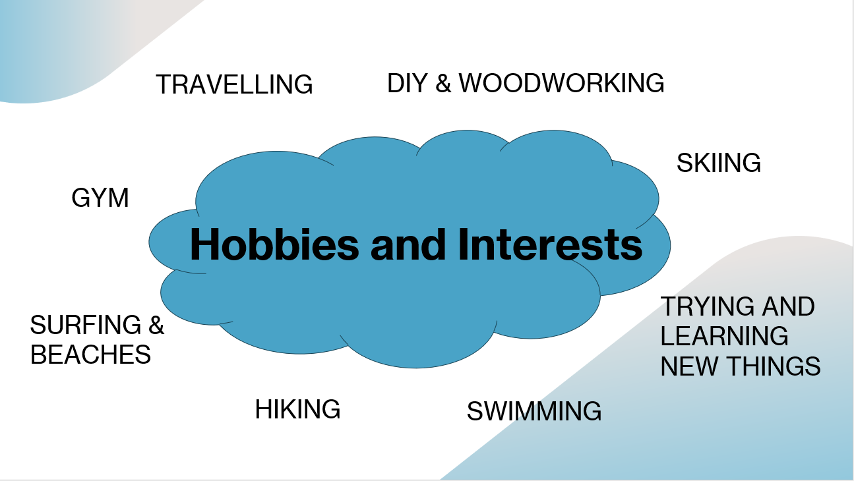
Figure 1: Slide about the authors hobbies and interests.
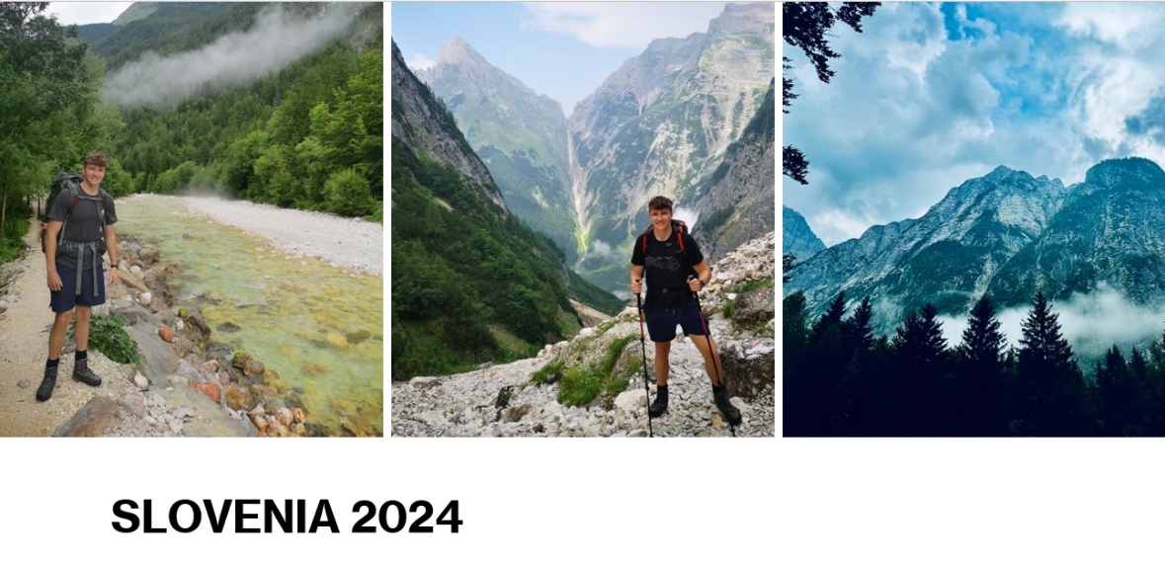
Figure 2: Images from recent travels.
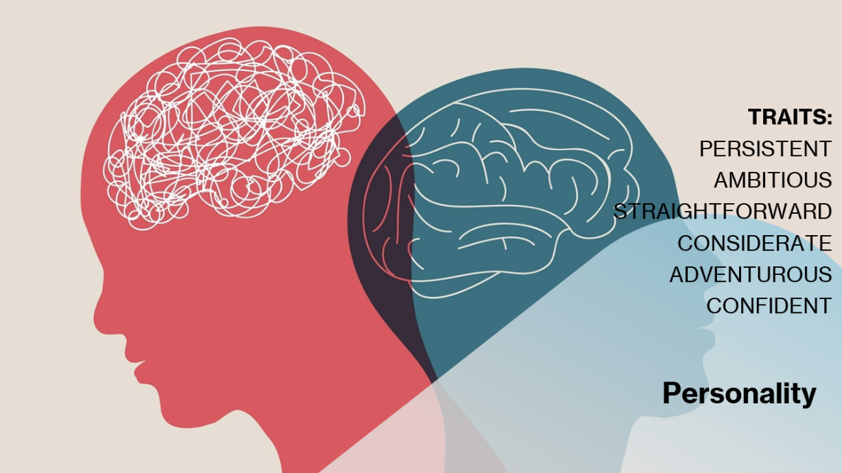
Figure 3: Slide on personality.
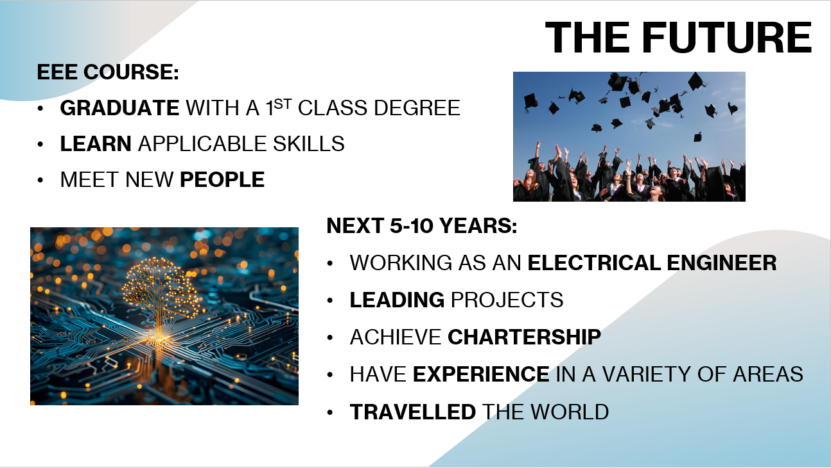
Figure 4: Academic and career goals.

Key Points
During the time spent creating, presenting, and watching peers do their presentations. There were a few key points that determined the success of the creation and delivery of the PowerPoint. The first is projecting your voice and speaking clearly. The reason for this is if the speaker is quiet and mumbling, the audience won’t be able to easily understand the speaker’s words and emotions and will become inattentive. The second key point is making eye contact with the audience and using hand movements and gestures to help with conveying and emphasising important points within the presentation. This ensures that listeners are paying attention to what the speaker is saying and remain engaged. Furthermore, within the PowerPoint itself, the use of visual prompts such as relevant images and bold, large-font titles was an extremely useful tool in retaining the audience’s interest. Moreover, storytelling is a compelling way of engaging listeners. It was discovered during the Presentations of others that ones including this, engrossed the audience far better than those that did not. The final key point was the importance of thoroughly practicing the presentation beforehand. This meant that it was delivered with far more confidence than doing it for the first time in front of an audience.

Presentation aspects to improve
To improve on future presentations, feedback was provided from the lecturer and peers. The main aspect was to look at the screen less and look more at the audience. The presenter agreed that this was fair and would be sure to practice this skill and implement this more effectively into his next presentation, to better engage the audience. Upon reflection, if the presentation was to be done again, the presenter would make sure to add one or two short anecdotes to make it more entertaining.

Personal research on required skill sets

Skills required for successful learning in a Higher Education environment
When studying in Higher Education, a combination of different soft and hard skills is required. Soft skills enable a person to work effectively and cooperatively with others, such as peers and colleagues [1]. In contrast, hard skills are gained through more formal types of training like school or apprenticeships and are often specific job-related skills [2]. To learn successfully while in higher education, Sheffield University [3] says one of the most important soft skills to develop is time management. This is due to the number of different academic deadlines such as exams, assignments, and lab reports as well as other important tasks in your personal and social life that you will have to manage. The second soft skill required is communication, due to the amount of writing and presenting you will do during your time in higher education [4]. Not only this, but you’ll also need to communicate with lecturers and peers in person and through email. As mentioned on the iHasco website [5], effective communication skills are important because they will result in better working relations, trust, productivity, and conflict resolution. The next soft skill needed is problem-solving [4] because of the various challenges faced when studying. Students need to be able to try different methods and think innovatively to resolve these issues. On the contrary, the hard skills required for higher education are developed more specifically due to the work done and content taught during class. For this reason, they change depending on the type of course and study undertaken. Some examples, of generic hard skills necessary are Microsoft Office skills, writing, presenting, research, and technical skills [6].

Transferrable Skills for Job Candidates
When applying for jobs, there are some transferrable skills that employers look for. They can be hard skills that are specific to the job such as software, but they can also be soft skills. According to the Indeed website [7], some examples of many important transferable skills that employers look for are dependability, communication, time management, adaptability, organisation, and problem-solving. All these soft skills are important in the workplace because being competent in conveying your ideas, working through day-to-day problems, ensuring that work you need to complete is done, and even covering and taking over different roles are all things that you may need to do eventually. For an employer, this benefits them by future-proofing the workforce as the organisation progresses and providing them more flexibility during the hiring process as they may be able to match applicants with other job openings, which they might’ve not applied for [8].

Self-evaluation and action planning

Self-Evaluation
As part of the preparation for this assignment. The author performed a variety of online tests to help in the self-evaluation process. The first of these tests was to determine the strengths and weaknesses of the author. This was completed using the 16 Personalities website [9] and the results of the test are attached below:
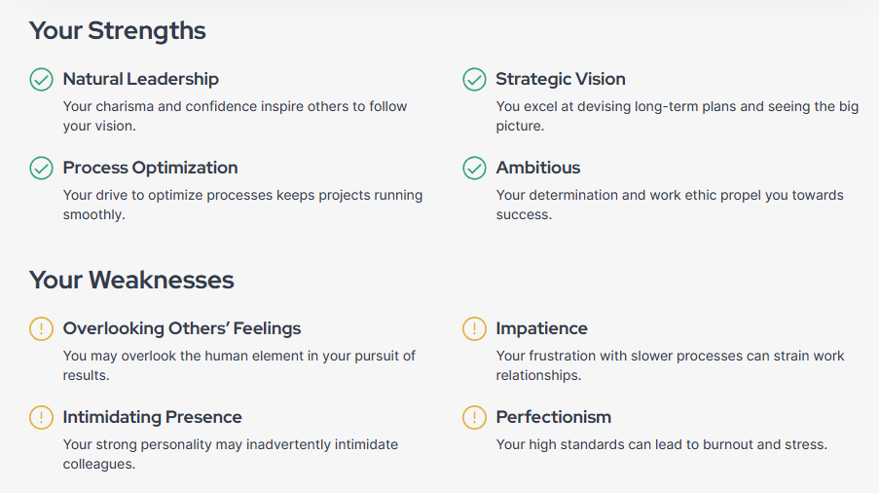
Figure 5: 16 personalities results.
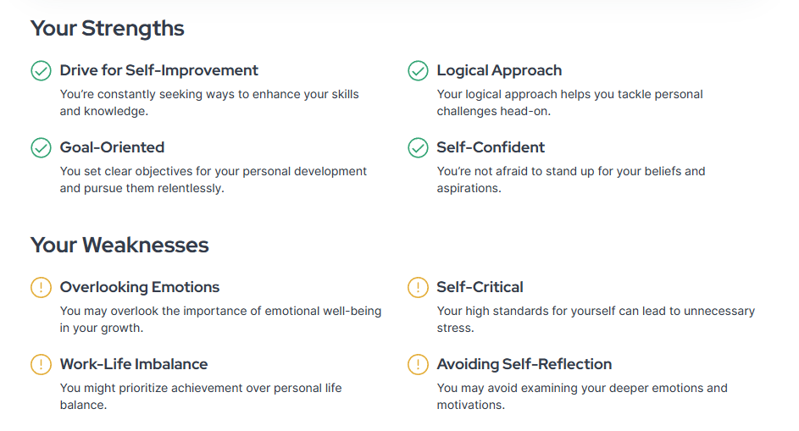
Figure 6: 16 personalities results.
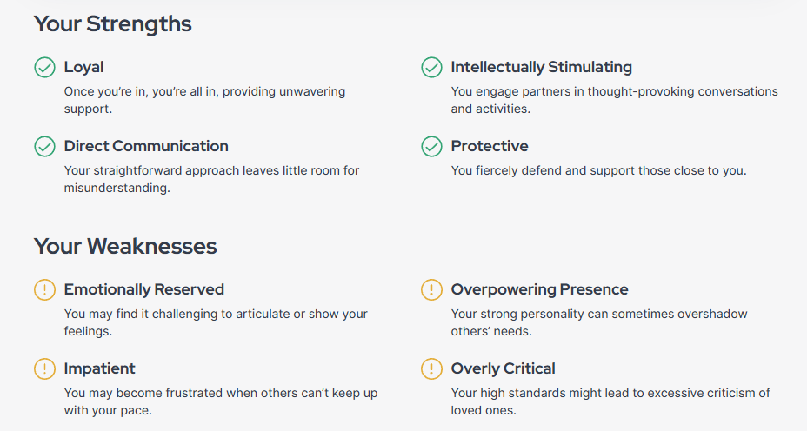
Figure 7: 16 personalities results.
Overall, these results are accurate and similar to how the author perceived himself when making the presentation, before carrying out any official tests. For example, being self-critical, impatient, ambitious, and straightforward were all included in the presentation. However, some weaknesses identified in the test are not believed to be entirely correct which are overlooking other’s feelings, work-life imbalance, and overpowering presence. In contrast, two results went unnoticed, and did not realise that they applied to the author until the test was completed and analysed. These were being emotionally reserved and overlooking emotions. From the results, the main areas that could be improved upon are emotions and perfectionism.
The second type of testing the author undertook was personality testing. Two different tests were completed, and these were the ‘Big Five’ [10] and Jungian [11] tests. The results for both are as follows:
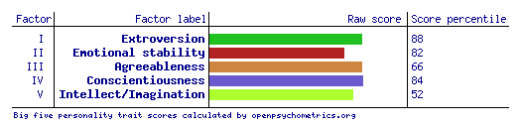
Figure 8: Big five results.
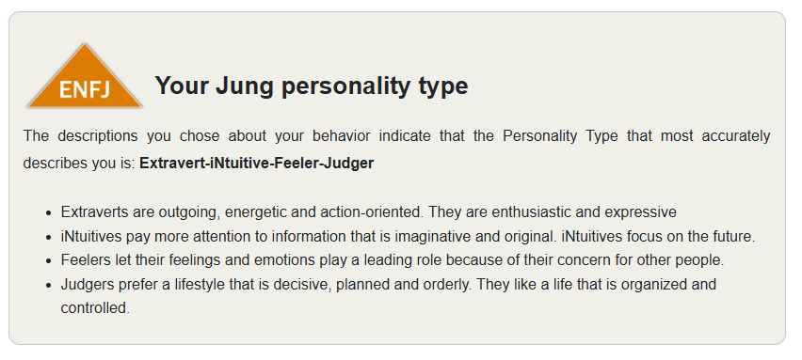
Figure 9: Jungian test results.
The results from the Jungian test were close to what was perceived beforehand. The author described himself as outgoing, future-focused, and conscientious, all of which were outcomes of the tests. From performing this exercise, it was discovered that factor five of the ‘Big Five’ scored lower than expected. This means that familiar experiences are supposedly preferred over new ones, but this is untrue.
The final method of testing undertaken was a career test [12] and the results are as follows.
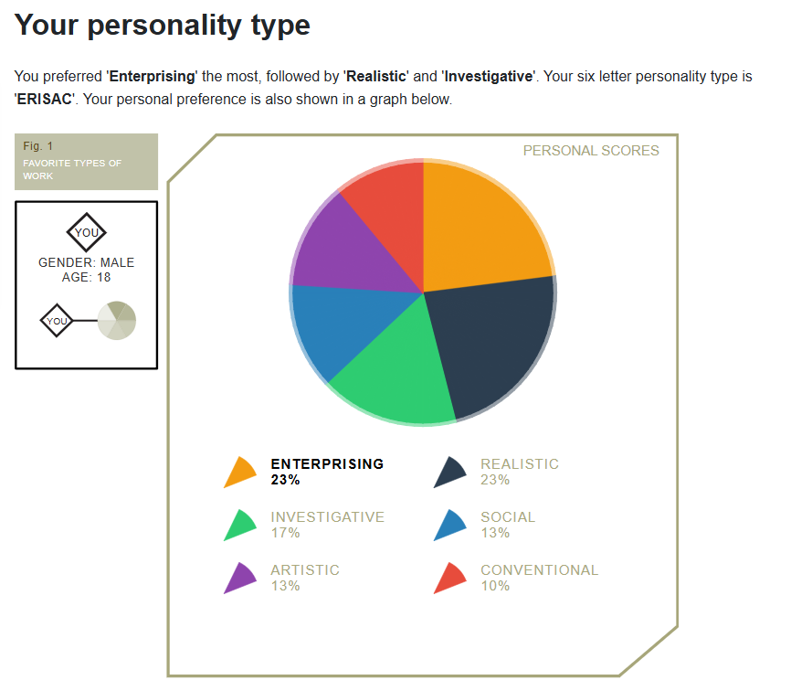
Figure 10: career test results
The top career paths recommended from the results of the test were sales engineer, forestry advisor, construction manager, ICT network admin, and R&D manager. Some of these may be accurate such as sales engineer and R&D manager. However, the other results do not align with the author’s career interests.

Goals
In this section, students are required to list their main goals for the short and long term for their academic studies, personal life, and career. The author’s short-term goals for these are:
Academic – create a refined revision structure and schedule the for upcoming January exam and complete assignments before the due date.
Personal – Run a 5K in under 20 minutes.
Career – Get more experience in a wider variety of projects.
The author’s long-term goals for these areas include:
Academic – Graduate from university with a 1:1 degree.
Personal – Own a house and have a family.
Career – Become a chartered electrical engineer and have a lead/managerial position.

Action Plans
Part of this assignment was to create action plans for the short- and long-term goals listed above. The action plans are found below:
Action Plan: Revision Schedule
Assessment | Type of Assessment | Activities | Date/Duration | Description | Complete By | Exam Date
Electrical & Electronic Principles | Exam | Identify topic weak points  Put together a revision plan  Mock Exam  Marking  Research  Mock exams  Final marking & evaluation | 20th Dec  21st Dec  22nd Dec  22nd Dec  23rd Dec  23rd – 3rd Jan  5th Jan | Find topics that need extra revision.  Prioritise less confident areas.  Complete past paper questions.  Mark answers  Go over topics that were incorrect.  Complete the rest of the past questions on moodle.  Mark answers and go over anymore topics which require more attention before exam. | 5th January | 6th January

Assignment Action Plan: Workshop Skills
Assessment | Type of Assessment | Activities | Date/Duration | Description | Complete By | Due date
Workshop Skills | Logbook | Assignment specification  Look at example logbook  Ensure results and testing is complete  Writing up  Develop  Evaluate  Proofread and references | 2nd Dec  2nd Dec  9th Dec  20th Dec  23rd Dec  27th Dec  27th Dec | Understand what’s required.  Get an idea of layout.  Final lab day to get everything finished ready for report.  Write up results.  Re-read and improve.  Read through and ensure standard.  Ensure grammar, referencing, and layouts are correct. | 31st Jan | 16th Jan

Action Plan: Graduating with a 1:1 degree
Goal | Activities | Date/Duration | Description | End date
Graduate with a first | Achieve HNC  Achieve  HND  Achieve  BEng | December 2025  December 2026  May 2028 | Complete all assignments and pass exams.  Complete all exams and assignments with >70%.  Complete all exams and assignments with >70%. | Summer 2028

Action Plan: Run a 5K in under 20 minutes
Goal | Activities | Date/Duration | Description | End date
Run a 5K in under 20 minutes | Find current 5K time  Start running 2 times per week  Increase to 3 times per week  Increase to 4 times per week  Time 5K | 07/01/2025  31/01/2025  28/02/2025  31/03/2025  01/04/2025 | Run a 5K and record time (22:41).  Do one distance run and one fartlek session.  Do a 5K, fartlek session and long run.  Time 5K’s and continually increase speed/distance in other sessions.  Attempt to run 5K in under 20 minutes. | April 2025

Application

Looking after your data
The author has implemented a backup strategy to look after his data which ensures up-to-date copies of any files and folders are in three separate places simultaneously. These locations include the desktop on a personal PC, a memory stick, and a school PC account. This provides a robust level of security as most of the work is completed on the personal computer, backed up onto a memory stick which is then taken to the university and used to update the relevant folders with the most up-to-date files. This exercise is performed weekly on Monday mornings to ensure that in the event of lost information, a relatively new backup copy is available. A similar strategy is implemented for personal data, however the locations are different. An iPhone local storage, hard drive, and cloud storage backups are used. This ensures personal data such as photos and videos are protected. As part of this module, a report was completed in class on ransomware. In particular, what ransomware is, Cryptowall, the effects, what to do if you are affected, and how to prevent it. The findings of the report were that Cryptowall is a type of ransomware that when it has accessed your device, encrypts different files on your device such as images, music, and documents. In addition, it will affect connected devices such as USB’s. The backup strategies mentioned above will protect against this form of malware as there is a completely independent third location in case a device and connected memory stick are affected and locked down.

Time management and self-organisation
To improve organisation at work to keep on top of tasks and meetings, the electronic Outlook calendar is used. This helps ensure that days are structured and planned to ensure effective use of time and resources. Below is a screengrab of this calendar.
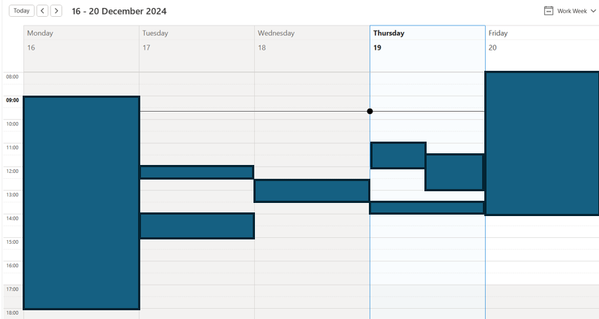
Figure 11: Screengrab of personal work calendar.
In day-to-day personal life, Google Keep is used from his mobile device to keep track of daily activities and ensure productivity. Creating a to-do list every evening for the next day is a step to reduce stress as nothing will be missed or forgotten. Attached below is a screengrab of today’s to-do list.
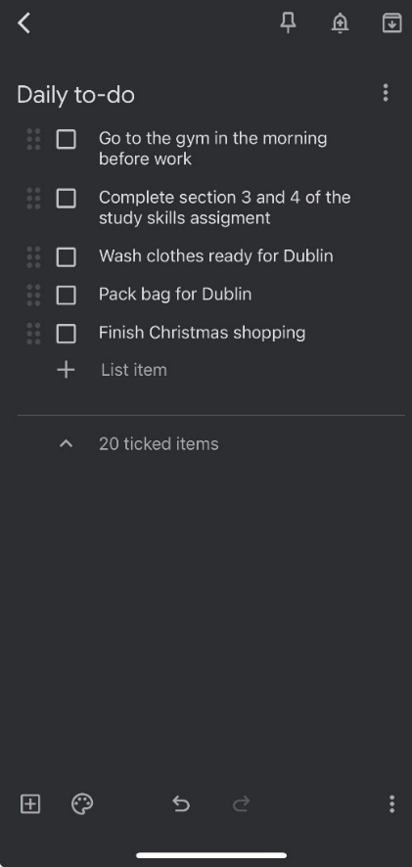
Figure 12: Screengrab of to-do list on Google Keep.
Below is a screenshot of a completed e-portfolio, which includes a variety of different files and folders covering personal and professional development. It is structured in a way so that it is easy to locate and update all the files with information. In particular, the CPD, training & activities folder because every week it can be updated with all the CPD hours achieved which are also booked on the IET website to ensure continual professional development. This method of organisation was chosen due to everything being in one place on the computer and it is easy to update regularly to ensure that information and files are recent. Below is a screengrab of the complex directory structure of the e-Portfolio.
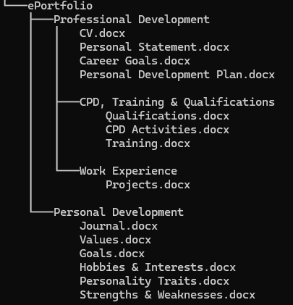

Figure 13: e-Portfolio screengrab.

Conclusion & Evaluation
During this module, it was discovered that there were insufficient measures in place to protect against ransomware. Since then, additional backup procedures have been implemented to prevent this form of malware. In addition, it was realised that there was a lack of a file system for important documents such as a CV, CPD, and qualifications. To fix this, a proper e-portfolio has been put into practice. Furthermore, another key take-away from this module was learning about the required skill sets for university study and employment. Moreover, the various personality tests that were undertaken helped discover areas for future development and self-improvement. Finally, obtaining feedback from the personal presentation exercise was very useful in finding areas to improve when performing similar activities to practice and ensure future presentations are successful.

Referencing

References

[1] | W. Kenton, “Investopedia,” 26 Aug 2024. [Online]. Available: https://www.investopedia.com/terms/s/soft-skills.asp. [Accessed 16 Dec 2024].
[2] | A. S. Gillis, “TechTarget,” [Online]. Available: https://www.techtarget.com/searchcio/definition/hard-skills. [Accessed 16 Dec 2024].
[3] | “University of Sheffield,” [Online]. Available: https://www.sheffield.ac.uk/study-skills/university/independent/manage-time#:~:text=Time%20management%20is%20perhaps%20the,academic%20%E2%80%93%20are%20a%20huge%20benefit.. [Accessed 16 Dec 2024].
[4] | O. Hurcum, “Top Universities,” 15 Dec 2023. [Online]. Available: https://www.topuniversities.com/student-info/careers-advice/five-soft-skills-you-develop-university. [Accessed 16 Dec 2024].
[5] | E. Johnson, “iHasco,” 2020. [Online]. Available: https://www.ihasco.co.uk/blog/what-are-the-benefits-of-effective-communication-skills. [Accessed 16 Dec 2024].
[6] | U. S. Team, “Unmudl,” 12 Mar 2024. [Online]. Available: https://unmudl.com/blog/hard-skills. [Accessed 16 Dec 2024].
[7] | I. E. Team, “Indeed,” 17 May 2024. [Online]. Available: https://uk.indeed.com/career-advice/career-development/transferable-skills. [Accessed 19 Dec 2024].
[8] | A. Vesere, “Equalture,” [Online]. Available: https://www.equalture.com/blog/benefits-transferable-skills/#:~:text=By%20hiring%20candidates%20with%20transferable,or%20changes%20in%20job%20requirements.. [Accessed 19 Dec 2024].
[9] | “16 Personalities,” [Online]. Available: https://www.16personalities.com/. [Accessed 22 Oct 2024].
[10] | “Open Psychometrics,” [Online]. Available: https://openpsychometrics.org/tests/IPIP-BFFM/. [Accessed 22 Oct 2024].
[11] | “123test,” [Online]. Available: https://www.123test.com/jung-personality-test/. [Accessed 22 Oct 2024].
[12] | “123test,” [Online]. Available: https://www.123test.com/career-test/ . [Accessed 19 Dec 2024].
[13] | “openpsychometrics,” [Online]. Available: https://openpsychometrics.org/tests/OEJTS/. [Accessed 19 Dec 2024].

Appendices
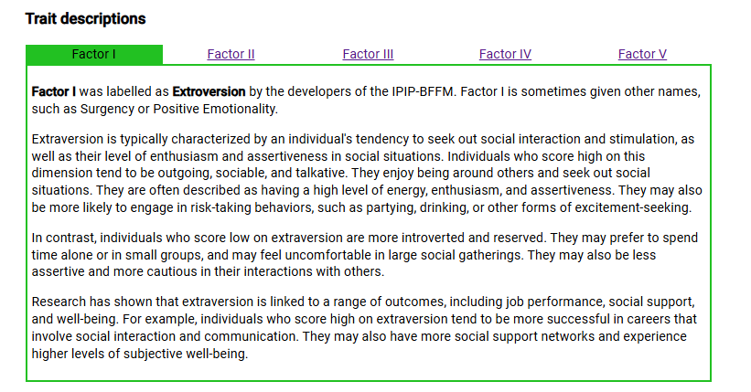
More screenshots from the results of the ‘Big Five’ [10] personality test.

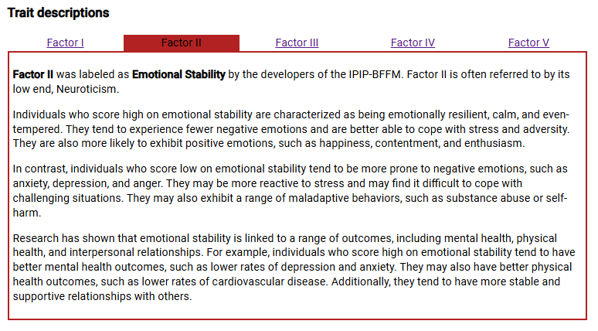
Figure 14: Factor 1 description from the ‘Big Five’ test.

Figure 15: Factor 2 description from the 'Big Five’ test.
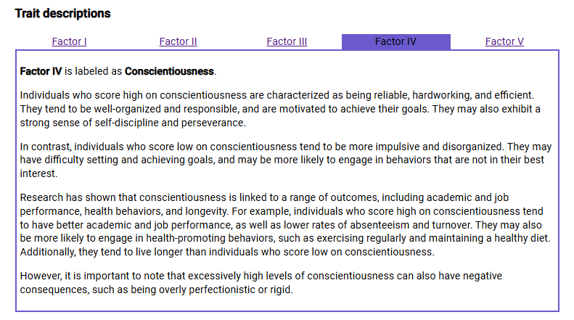
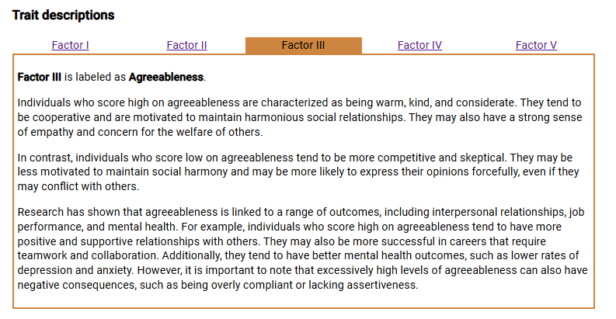
Figure 16: Factor 3 description from the 'Big Five’ test.

Figure 17: Factor 4 description from the 'Big Five’ test.
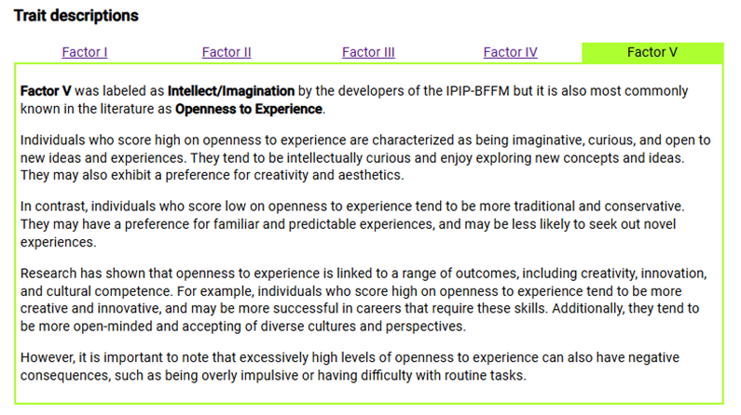

Figure 18: Factor 5 description from the 'Big Five’ test.
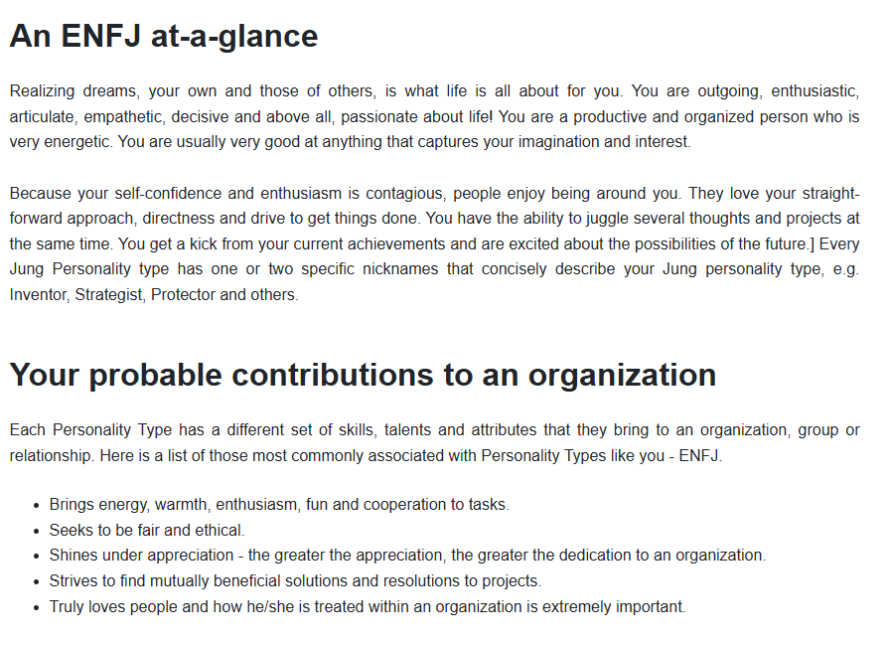
More screenshots from the results of the ‘Jungian’ [11] personality test.
Figure 18: Personality results from Jungian test.
Another Jungian test from the openpsychometrics [13] website.
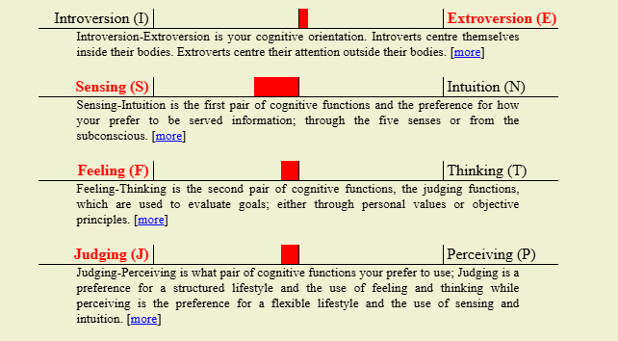

Figure 19: Overall score from the Jungian test on openpsychometrics.
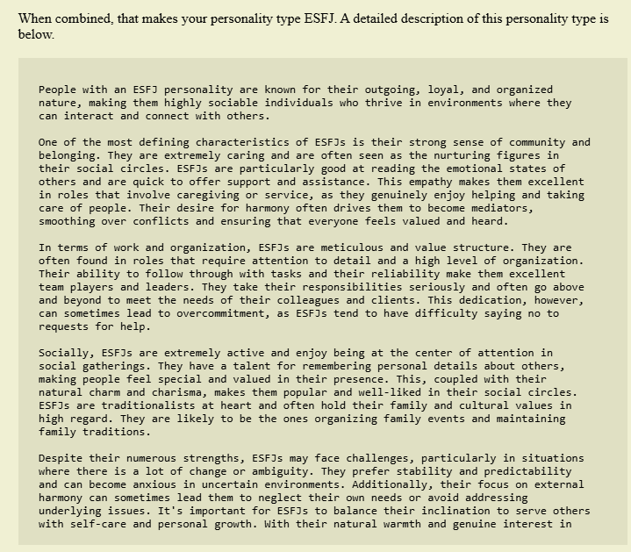
Figure 20: Detailed personality writeup from openpsychometrics.
Screenshots from ransomware report.
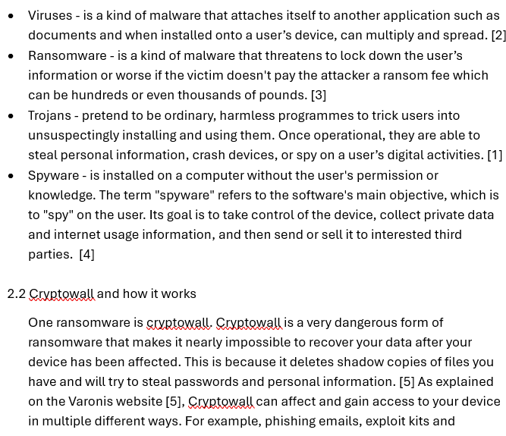
Figure 21: Screengrab of text section from report on ransomware done in class.
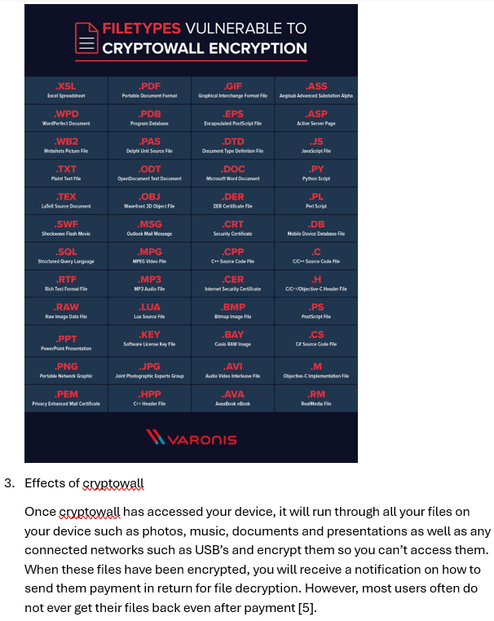
Figure 22: Additional screenshot from in class ransomware report.

