Essential Skills
E-PORTFOLIO
Submitted By: Mirela Stratulat

E-Portfolio Links:
https://sites.google.com/view/mj25/e-portfolio

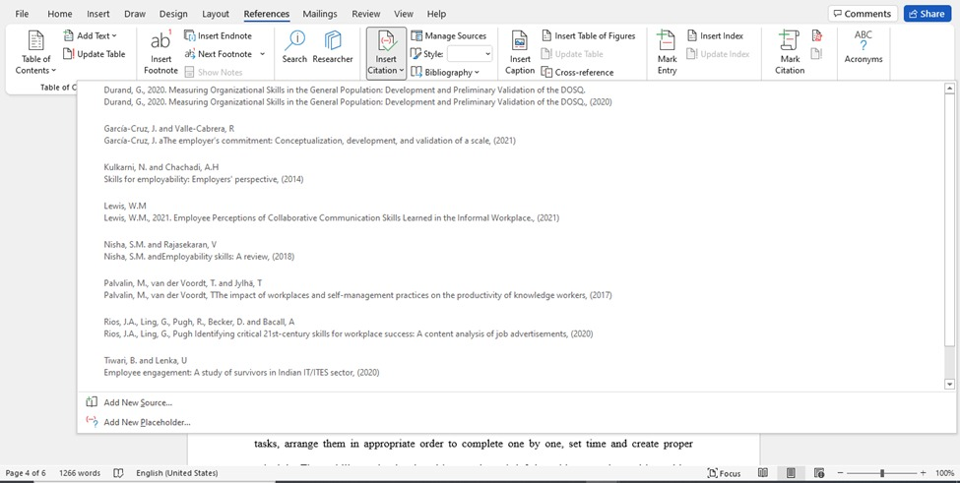

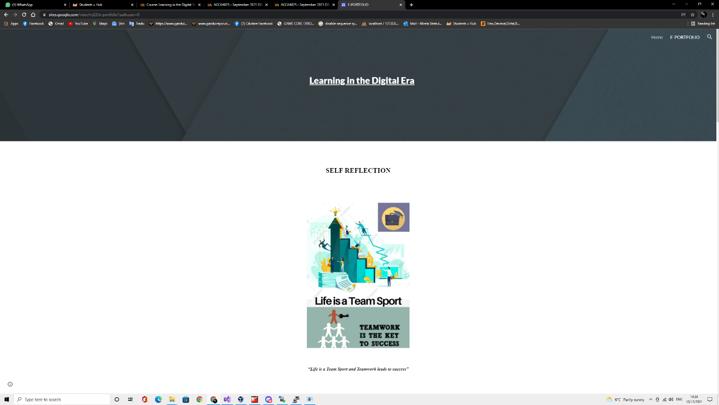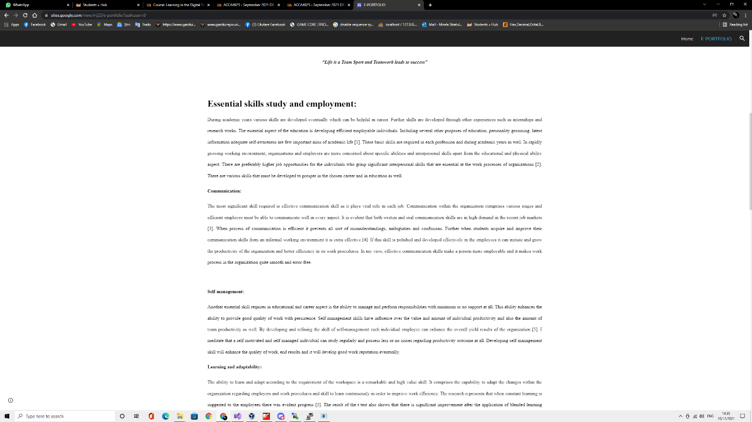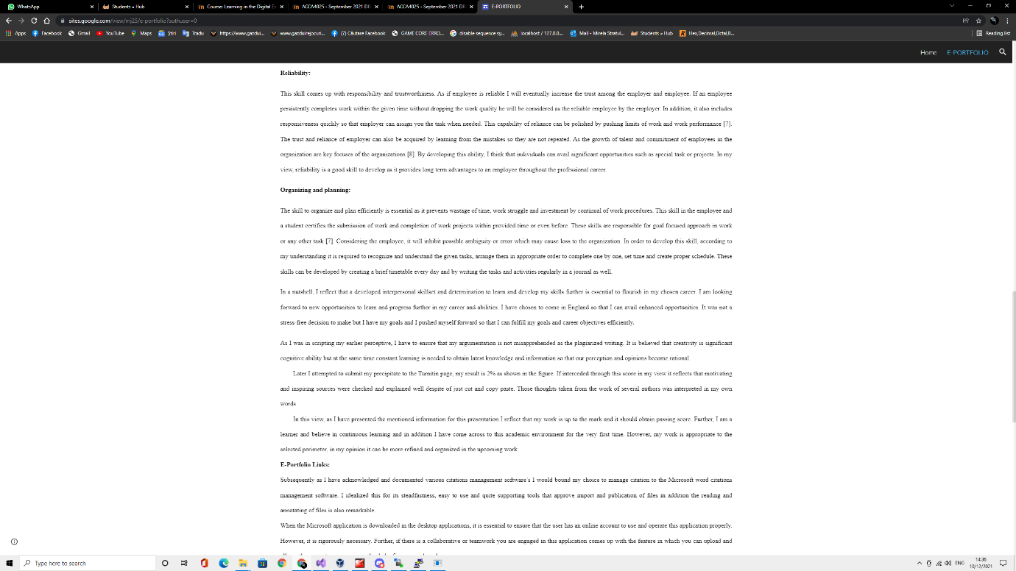

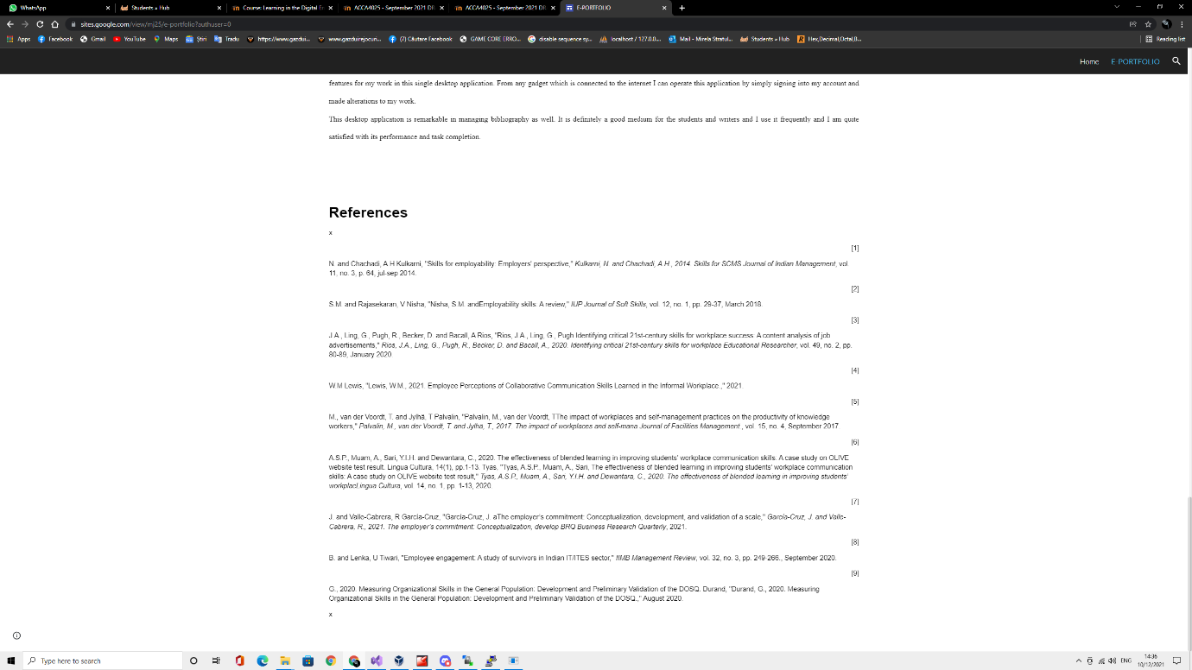

E-Portfolio Link Presentation:
https://sites.google.com/view/mj25/home

https://drive.google.com/file/d/1e5a3X6LXraaPKswC3lOM7Y0Ld6ER_RC_/view


