Programme: International Hotel Management
Module: Marketing Essentials
Module code: BMIH4005 Resit
Name: Oana Girtu
ID: 2209481

Introduction
With the help of this marketing strategy, the Ritz Carlton hotel brand will be better able to target its customers and deal with the current economic climate. It is written with an emphasis on applying frameworks like SOSTAC, Marketing mix, and Bowmans for the Ritz Carlton brand management team.

Situational Analysis

Company-SWOT analysis
Strengths
- The Ritz Carlton has a strong brand image for its high quality of services and excellence.
- Exceptional customer service
Weaknesses
- As a luxury brand, Ritz Carlton is overpriced for the majority of customers, eliminating a larger market segment as a result.
Opportunities
- The Ritz Carlton has a chance to reach out to new clientele and expand its market share by entering economies that are developing.
Threats
- Since there are so many premium hotel brands around, Ritz Carlton faces fierce competition.

Customers- STP
Segmentation: Based on shared traits, the industry is segmented into several groups. This helps the Ritz Carlton in recognising various clienteles.
Targeting: The Ritz Carlton chooses the most appealing and successful categories to concentrate its marketing efforts on after the segments have been identified. Targets in this situation are wealthy individuals who favour luxury. Furthermore, The Ritz Carlton puts greater focus on adults’ travellers. According to Similarweb statistics, youngsters between the age of 25 and 35 are the most visitors of The Ritz Carlton, and individuals above the age of 55 are the least interested.
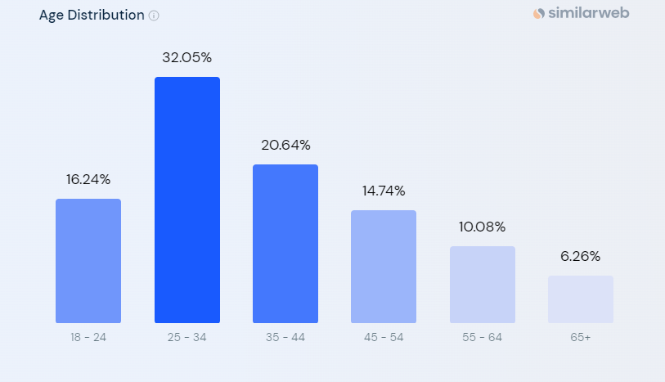
Figure 1: Similar web 2023
Positioning: According to their positioning, the Ritz Carlton is a high-end hotel chain that provides great service, meticulous attention to detail, and exclusivity.

Competitors
There are other luxury and high-end brands that compete with The Ritz Carlton on the market. For instance, the renowned luxury hotel brand Four Seasons Hotels and Resorts is recognised for its superb service and opulent amenities (Mohamed et al., 2018). Another is the Mandarin Oriental Hotel Group, a well-known international hotel chain that specialises on providing upscale guests with individualised service (Araske, 2018). On the other hand, Hilton Garden Inn is competitor to Ritz Carlton in terms of affordability. However, Ritz Carlton provides excellent services.
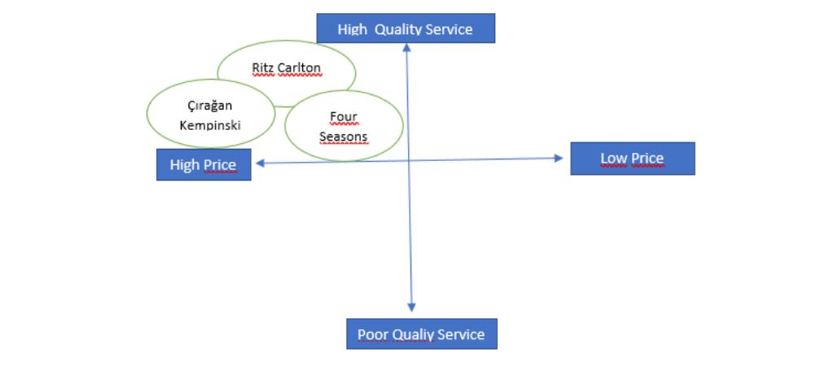
Hilton Garden Inn
Marriott

Collaborators
The Ritz-Carlton keeps business-to-business ties with travel agencies, event planners, and high-end brands to increase awareness and draw affluent customers. Franchises are carefully chosen for international growth. Through their collaboration with Diptyque, the company is bringing their upscale bath products to Ritz-Carlton hotels (Marriott 2022).

Climate-PESTLE
Political: After Brexit, the Ritz Carlton experienced difficulties because of staff shortages brought on by changes to immigration laws. Nevertheless, the hotel business benefits from favourable rules and regulations that support operations (Kuo et al., 2022).
Economic: A solid economic base for the Ritz Carlton can be seen in the UK's GDP of 2.2 trillion British Pounds in 2022 (Statista 2023).
Social: According to Voramontri and Klieb (2019), the increase in social media usage has had an impact on consumer behaviour. The Ritz Carlton must modify its marketing tactics.
Technological: Technological developments have improved the guest experience in the hotel sector, including the widespread use of online reservation systems and the incorporation of artificial intelligence.
Legal: Dunnerlein et al. (2020) underline the importance for the Ritz Carlton of adhering to laws such the Health and Safety Act, Consumer Protection Law, and Employee Safety Law.
Environmental: Given the significance of environmental conservation, sustainability is a major emphasis for the hospitality industry (Duric et al., 2021).

Marketing Mix
Product: The Ritz-Carlton provides a world-class hospitality experience with first-rate service, individualised conveniences, and luxurious lodgings. Unparalleled luxury and individualised experiences for discerning guests are the value proposition.
Price: Premium cost reflecting the brand's exclusivity and excellence.
Place: Global footprint with hotels in prominent locations that are well-located.
Promotions: Integrated marketing efforts that showcase the brand's distinctive products, first-rate support, and exclusive partnership.

Objectives
- To improve website traffic by 15% in the second quarter of 2023, aiming to achieve a higher ranking for the hotel and increase online visibility.
- To establish collaborations with influencers within the next 12 months to drive profits and attract a 30% increase in consumer influx.
- To implement consumer interaction initiatives by the third quarter of 2023 to strengthen brand loyalty and raise customer satisfaction.
- To regularly track and analyze customer engagement metrics, website traffic data, and revenue generated to evaluate the effectiveness of the marketing efforts.

Strategy
Based on the Ansoff matrix, a market development plan will be used by The Ritz Carlton to enter new areas and profit from its well-known brand (Clarissia 2020). The hotel will rethink its value proposition to focus on providing great service, individualised experiences, and a commitment to client happiness. The plan will centre on applying strict quality control procedures, improving employee training, and actively collecting guest input for ongoing improvement in order to resolve any unfavourable reviews and improve the brand's reputation. To support the approach, the previous marketing mix will be modified. Pricing can be changed to stay competitive in new areas while upholding the impression of exclusivity and luxury. To boost efficiency and streamline operations, new procedures like personalised customer communications and online reservation systems will be implemented. In order to efficiently reach new markets, distribution channels will be increased, possibly through collaborations with travel agents and internet booking sites.

Tactics
Digital Marketing: The Ritz Carlton prioritises search engine optimisation (SEO), and social media advertisements in an effort to expand its digital presence (Chaffey, 2019). Such actions will boost internet visibility and increase website traffic, drawing a larger stream of potential customers.
Celebrity Partnerships: The Ritz Carlton will be able to attract a larger audience and increase revenue by teaming up with celebrities and premium lifestyle bloggers. Marketing through the word of mouth and positive feedback from celebrities is considered one of the most effective tools for advertisement. Popular people may share their experiences with the company, promote it, and bring in an aditional number of customers.
Improve customer interaction: Through programmes that promote active consumer participation, The Ritz Carlton is committed to enhancing client engagement and cultivating unshakeable brand loyalty. Companies may increase their profit margins by proactively serving the requests and requirements of their customers (Wang and Kim, 2017). Sales are always increased when existing clients are retained and their pleasure and experience are improved. Custom email marketing, loyalty programmes, and interactive social media material will all be used extensively in this effort. These actions are intended to improve customer satisfaction, encourage repeat business, and create a strong bond between the brand and its audience. The Ritz Carlton strives to create an unforgettable and positive client journey via the delivery of tailored encounters, incentives, and fascinating content, eventually building enduring customer commitment and advocacy.
Incorporating technology: Recognising the importance of incorporating technology, The Ritz Carlton plans to implement customised customer communication frameworks, web-based booking tools, and cutting-edge guest interactions. Utilising information technology (IT) helps businesses run more quickly, spend less money, and nurture better uniformity while reducing mistakes (Neuhofar et al., 2015). IT-enabled innovation enables corporate executives and staff to take on more creative and aggressive projects. By using technology, the hotel hopes to improve efficiency, enhance visitor convenience, and simplify operations. Platforms for online reservations will streamline the booking procedure and provide a pleasant experience. Furthermore, the use of cutting-edge in-room technology will bring forth cutting-edge guest interactions, further enriching the trip. The Ritz Carlton strives to increase client satisfaction and retain a competitive edge in the exciting world of hospitality by embracing the promise of technology.

Action

Control
Key performance indicators (KPIs) and metrics will be used to gauge success in line with marketing goals (Reyes-Menedez et al., 2020). These include,
- Track new client acquisitions made through paid search, referrals, and relationships with influencers.
- Assess customer satisfaction ratings, online reviews, and sentiment analysis to determine positive brand attitudes.
- Track earnings coming in from various sources, like seasonal sales and retargeting ads.
These measures were selected because they provide concrete signs of performance and are directly aligned with intended results. They enable the measurement of the financial impact of marketing initiatives, consumer sentiment, and new customer acquisition (Daller 2019). Making decisions will be aided by regular monitoring and analysis of these metrics.

Conclusion
In a nutshell the expansion into new markets, the redefinition of the value proposition, and increasing customer interaction are the main goals of the marketing strategy for The Ritz Carlton hotel brand. The approach aims to raise brand awareness, promote client acquisition, and boost customer satisfaction through the use of digital media and the adoption of a market development strategy. Additional suggestions include utilising data analytics for ongoing improvement, looking into collaborations with nearby companies, and funding sustainability activities to keep up with shifting consumer tastes.

References
Arsaqe, N., 2018. Internship Report at Mandarin Oriental, Jakarta.
Chaffey, D. and Ellis-Chadwick, F., 2019. Digital marketing. Pearson uk.
Clarissia, S.M.S., 2020. A study on Ansoff Matrix Technique: As a growth strategy and an adaptive learning technique adopted in the leading brand of products. BIMS Journal of Management, p.18.
Daller, N., 2019. The power of key performance indicators: How aligning success metrics to company objectives elevated the importance of digital asset management at Pampered Chef. Journal of Digital Media Management, 7(3), pp.206-213.
Dennerlein, J.T., Burke, L., Sabbath, E.L., Williams, J.A., Peters, S.E., Wallace, L., Karapanos, M. and Sorensen, G., 2020. An integrative total worker health framework for keeping workers safe and healthy during the COVID-19 pandemic. Human factors, 62(5), pp.689-696.
Duric, Z. and Potočnik Topler, J., 2021. The role of performance and environmental sustainability indicators in hotel competitiveness. Sustainability, 13(12), p.6574.
Kuo, F.I., Fang, W.T. and LePage, B.A., 2022. Proactive environmental strategies in the hotel industry: Eco-innovation, green competitive advantage, and green core competence. Journal of Sustainable Tourism, 30(6), pp.1240-1261.
Marriott 2022. The Ritz-Carlton Announces New Partnership with Diptyque. [Online] Available at https://news.marriott.com/news/2022/11/17/the-ritz-carlton-announces-new-partnership-with-diptyque [Accessed on 3 June 2023].
Mohamed, A., Sharef, A., Ali El Oraby, A. and Mokhtar, A., 2018. The effect of creating a competitive employee benefits package on employee performance in multinational organizations in Egypt: A field study on Four Seasons Hotels & Resorts.
Neuhofer, B., Buhalis, D. and Ladkin, A., 2015. Smart technologies for personalized experiences: a case study in the hospitality domain. Electronic Markets, 25, pp.243-254.
Reyes-Menendez, A., Saura, J.R. and Palos-Sanchez, P., 2020. Identifying key performance indicators for marketing strategies in mobile applications: A systematic literature review. International Journal of Electronic Marketing and Retailing, 11(3), pp.259-277.
Similar Web 2023. Ritz Carlton. [Online] Available at https://www.similarweb.com/website/ritzcarlton.com/competitors/ https://www.statista.com/topics/3795/gdp-of-the-uk/#topicOverview [Accessed on 5 June 2023].
Statista 2023. UK GDP. [Online] Available at https://www.statista.com/topics/3795/gdp-of-the-uk/#topicOverview [Accessed on 3 June 2023].
Voramontri, D. and Klieb, L., 2019. Impact of social media on consumer behaviour. International Journal of Information and Decision Sciences, 11(3), pp.209-233.
Wang, Z. and Kim, H.G., 2017. Can social media marketing improve customer relationship capabilities and firm performance? Dynamic capability perspective. Journal of Interactive marketing, 39(1), pp.15-26.

Power Point Presentation



