

Human Capital Management
LCMB7023

Assessment component 1:
The influence of national and international labour markets on HRM and IHRM strategies

Name: Yagnik Bharatbhai Bhakhar
Student ID: 2431085

Lecturer: Hoang Dang Nguyen

Word Count: 2508

Executive Summary
This report critically analysis the influence of technology advancement in reshaping the labour market, while in the following section, the report addresses the key demographic and geopolitical factors and highlights challenges for HR professionals. Finally, the reports include a reflective evaluation of personal competencies in a technology-enabled global business environment.
Table of Contents
1.0 Influence of technological advancement in reshaping Labour markets 4
1.1 Implication of technological advancement for HRM and IHRM strategies 5
2.0 Discussion of key demographic and geopolitical factors 6
2.1 Challenges of demographic and geopolitical factors for HR professionals 8
3.0 Implementation of strategic HRM to address persistent skills gaps and talent shortages 9
4.0 Reflection on Capabilities for Working in an International Context 11
4.1 Relevant Skills 11
4.2 My strengths and weaknesses 12
4.3 Leveraging strength and addressing areas of improvement 13
Reference List 15
Appendices 19

1.0 Influence of technological advancement in reshaping Labour markets
AI and automation
Integration of the advanced technology in the HRM process in business, specifically, which includes AI and automation tool support to transform the labour markets globally by redefining the job structures, altering the demand for skills and enabling new employment models. As per Ericson and Sjöstrand (2024), the inclusion of the technology in HR management supports increasing productivity, but it leads to certain roles displacement specifically in the administrative and manufacturing sectors. In the HRM princess in the global organisation, the emerging technology enhances the opportunities in developing cybersecurity, data analytics, digital marketing and software engineering (Farndale et al., 2025). It can be analysed from the data of the World Economic Forum that the integration of advance technology and digital tools could create 97 million jobs while displacing 85 million jobs by 2025. But the new job opportunities in the current era of business require cognitive skills and advance digital skills.
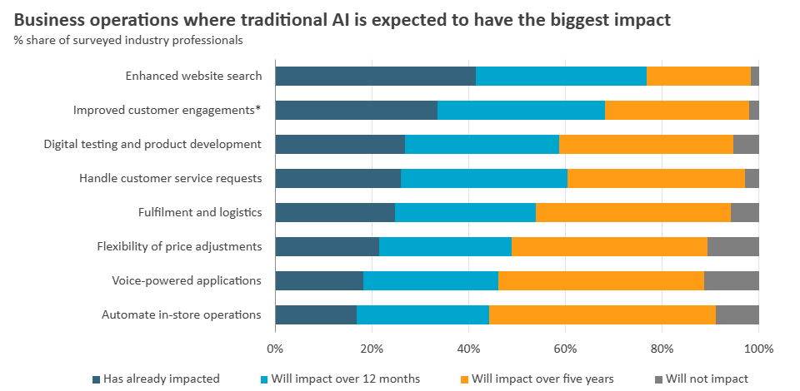
Figure 1: Impact of AI in business
(Source: Aleksandra, 2024)
Digital platforms
The recruitment and selection processes in HRM and HR technology in the current era of business are rapid changing with the inclusion of digital technology in HRM and IHRM strategies. As per Barrah (2022), digital labour platforms such as Fiverr and Upwork have contributed to the rise of the gig economy, which offers flexible job opportunities such as freelancing opportunities across international borders. platform like Naukri, Justdial offers vacancies to candidates globally. The transformation in HRM compels HR professionals to challenge traditional employment relationships to redefine the compensation models and workforce planning.

1.1 Implication of technological advancement for HRM and IHRM strategies
Implications for HRM strategies
At the domestic level in the national labour market. HRM strategies need to address the changing nature of work in the digital era of business and consider the skill requirements. The recruitment and selection process increasingly relies on AI-driven tools in human resource management that support reducing bias in selection and enhancing the efficiency of the overall process (World Economic Forum, 2025). Predictive data analytics tools are being used in HRM to assess workforce trends and support managers at the organisational level to maintain proactive talent management. As per the analysis of He, Zhang and Zhang (2024, May), digital collaboration technologies through the virtual platform support maintaining the organisational culture and enhancing employee productivity with high flexibility.
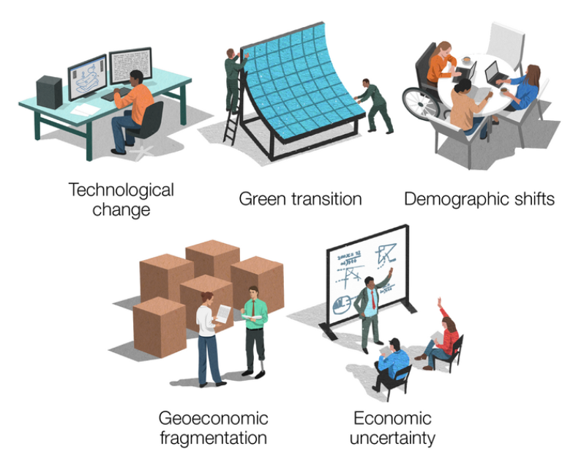
Figure 2: Five Key labour market drivers
(Source: World Economic Forum, 2025)
Implication for IHRM
The implementation of technology in the international business context blurred geographical boundaries from the perspectives of the global MNEs. This allows the HRM to recruit skilled and experience talent from the global market and diverse regions and support to operate of global virtual teams (Ross, McGregor and Swales, 2024). The IHRM prioritises cross-cultural communication, global workforce integration and technology proficiency. AI-driven IHRM strategy supports the organisation to identify and recruit the skill cluster from the emerging markets, supports in mapping international talent and optimises global staffing decisions (Georgieva, 2024). HR professionals in IHRM strategies face challenges such as virtual team dynamics, data protection and addressing inequalities in technological access between the developing and developed countries.

2.0 Discussion of key demographic and geopolitical factors
Key Demographic Factors
Ageing population: In the various developed countries, the labour market is full of the ageing population as the life expectancy in countries like Japan, Northern America has increased and declining birth rates, which increases the working-age population. It creates labour shortages in the global labour market and drives the demand for workers in healthcare.
Youth Bulges: In the developing countries, such as in South Asia and parts of Africa experience youth bulges. As per Barslund et al. (2025), in those emerging markets, a growing young population enhance their skills for the employment opportunities and prepares for the national and international labour markets. HR professionals should manage their strategies to manage intergenerational diversity and ensure continuous learning.
Migration: globally, the workforce diversity is increasing, which is driven by the migration and gender equality movements. Migrant workers transform the organisational cultures (Sikorskyi, 2024). HR professionals have to maintain inclusivity and develop career advancement pathways.
Changing workforce composition: with the increasing demand for a hybrid and remote work culture, employees from different geographical regions are work together, so HR professionals have to consider performance management and communication engagement.
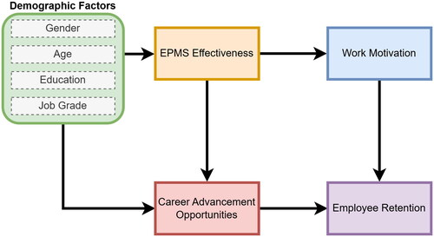
Figure 3: Demographic factors that influence labour market
(Source: Joseph et al., 2025)
Key Geopolitical Factors
Global economic fragmentation: global economic downtrends and inflation, increasing geopolitical tensions, economic nationalism and trade restrictions are disrupting the global labour flow and disrupting the supply chain. HR professionals experience challenges in managing the local workforce during employee migrations.
Government policies and industrial strategy: The protectionist policies and trade tensions between the US-China trade conflicts affect talent migration, global mobility and business investment patterns. As per Budhwar et al. (2022), HR professionals exceeded workforce shortages in several sectors globally, specifically in the logistics and hospitality sectors. Sustainability and climate change policies are reshaping the functions of the HR professional by displacing employment in the carbon-intensive sectors and shifting toward green jobs, and the HR managers are able to address the reskilling needs as part of the industry transformation.
Global Cooperation: Digital interconnectivity and globalisation support to develop of transnational employment markets where the skilled talent experience intense competition but high demand within the industry (Kumar and Saxena, 2025). The HR team address the complexities at the industry level.

2.1 Challenges of demographic and geopolitical factors for HR professionals
Workforce shortages and diversity: globally, HR professionals experience uneven labour supply due to youth unemployment and an ageing population. The HR face challenges to attract diverse and multi-generational talent in the industry while focusing on higher engagement and inclusivity.
Skill Mismatch and Reskilling: Climate transitions, technological change in the global market and industry transformation require continuous upgradation of reskilling strategies (Malik and Budhwar, 2023). HR professionals face challenges in redesigning adaptive learning frameworks across the diverse workforce.
Global mobility: Workforce migration, geopolitical instability, and global inflation affect the cross-border recruitment. HR professionals face challenges in compiling international employment regulations and visa management.

3.0 Implementation of strategic HRM to address persistent skills gaps and talent shortages
Persistent skill gaps in several sectors and talent shortages are one of the pressing challenges in the current labour market globally, specifically in the hospitality, technology and healthcare sectors. As per Adias and Raimi (2025), the technology, hospitality and healthcare industry in the global market face challenges to attract skilled and experienced talent and employee retention due to changing customer demands, rapid digital transformation and post-pandemic workforce shifts and changes in work culture. 60% of the HR professionals from these industries report that they face challenges in finding properly skilled digital and technical expertise. The hospitality industry globally faces challenges due to high employee turnover and workforce shortages, while the healthcare industry experiences shortages of skilled caregivers and nurses. HR managers experience a structural imbalance that aligns with workforce planning, while it directly affects the long-term organisational needs.
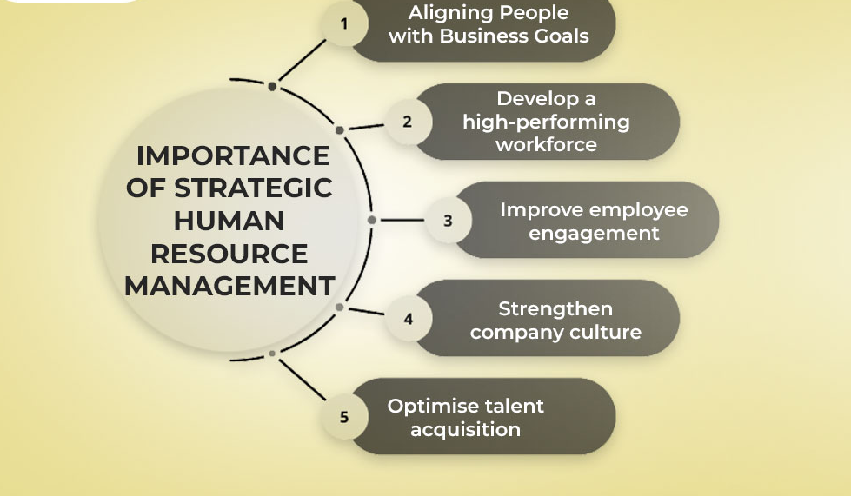
Figure 4: Strategic HRM
(Source: Ashlin, 2025)
Strategic recruitment and employer branding
To address the workforce shortage HR professionals, need to focus on an effective strategic recruitment strategy. In the organisation, HR professionals significantly focus on data-driven talent acquisition, includes AI-based recruitment and attracting global talents with transferable skills (Bristol-Alagbariya et al., 2024). HR have to emphasise strong employer branding where HR highlights the career growth, purpose and work-life balance that supports recruiting the workforce from the young population. For example, tech giants such as Google and Microsoft include employee advocacy programmes and social media campaigns to increase the employer branding that supports global talent retention. Organisations in the healthcare sector emphasised international recruitment initiatives with flexible contracts that support address the workforce shortages.
Learning development and reskilling strategies
To bridge the current and future skill gap, the HR professional has to focus on reskilling initiatives and continuous learning. As per Ogedengbe et al. (2024), strategic HRM should focus on developing HRM initiatives for skill development while partnering with digital learning platforms and educational mentors, and institutions. For example, the tech giant Amazon includes the employee training programme “Career Choice” to enhance employee retention and internal mobility. The hospitality business Marriott International includes structured pipelines to train the entry-level employees and offer career progression (Mukhuty, Upadhyay and Rothwell, 2022). The organisational can deliver customised training through digital platforms such as Coursera and LinkedIn. The technological advancements support arranging both hybrid and remote work environment where HR implement flexible policies for the employees and ensure employee well-being.
Retention, inclusion and workforce flexibility
The HR professional significantly focuses on employee retention strategies to address the workforce shortages. The HR professional includes employee well-being initiatives and flexible working arrangements to enhance job satisfaction and minimise employee turnover. HR professionals focus on enhancing operational efficiency with flexible workforce models, including cross-functional teams and gig workers. The global organisation includes digital collaboration platforms such as Slack, Google and Microsoft Teams to facilitate real-time communication across cross-cultural teams, drive innovation and enhance the overall productivity that effectively response to labour market fluctuation.

4.0 Reflection on Capabilities for Working in an International Context
In the era of globalisation, the dynamic national and international labour markets significantly influence both domestic human resource management (HRM) and International HRM (IHRM) strategies through technological transformation, managing talent supply and demand, addressing cultural requirements and determining costs. The labour market nationally and internationally is undergoing a transformative change driven by geographical change, demographic shift and technological innovation. In the current era of business in global MNCS, to attract skilled and global talent, manage employees and retail talent (Lucio and MacKenzie, 2022). The HRM and IHRM need to adopt more data-driven, inclusive and agile strategies.

4.1 Relevant Skills
Technological Competence: The implementation of advance technologies such as automation, AI and digital tools and platforms make changes in the work process of HRM, while factors such as migration, ageing population and global conflicts reshape the workforce availability and composition. In the modern organisational context, in the national and international market, technological implementation skills are most required. I can enhance my technological competence through active involvement in academic group projects and learn tools like Microsoft Teams, Google Workspace and Miro (Budhwar et al., 2022). enhancing the technical skill support to increase proficiency in project coordination and digital communication. In the HRM process, the integration of AI tools helps minimise the time of repetitive tasks and drives a data-driven recruitment and selection process. Technological implementation presents ethical challenges such as algorithm bias and data privacy concerns.

Communication Skills: Effective communication skills are the most relevant and required skill for teamwork. Effective and professional communication support to mitigate the conflicts in the workplace and promote cross-cultural collaborations. During the academic projects, I get the opportunity to enhance my team communication skills through collaborations and presentations.
Teamwork and Collaboration: During the academic projects, I get the opportunity to learn significant skills like team collaboration skills in multicultural settings and diverse perspectives toward shared goals. During my academics, I significantly contributed to project planning and task distribution fairly.
Leadership Skills: As per Adias and Raimi (2025), in the national and international business context, leveraging leadership skills is crucially important; it demands flexibility, inclusivity and EI. During the group projects, I get the opportunity to demonstrate leadership skills through coordination tasks, initiating discussion and motivating the other team members during group assessments.
Self-Directed Learning: Self-directed learning skill support to enhance my capability through my own study and setting learning goals. With self-directing learning skills, I can engage more with academic journals and online resources and enhance my subject understanding and increase my knowledge. For the training and development program, the learning function has shifted toward a continuous digital learning ecosystem where the talent can be able to access endless resources through the digital platform based on demand and promotes self-learning.

4.2 My strengths and weaknesses
Strength
- I am confident in using the digital platform for communication, design, research and data analytics. With the technological competencies, I have become confident in efficient collaboration across time zones.
- I am confident in my presentation with clear and simple language and expression. My strength is that I am an active listener and have the capability to tailor messages to diverse audiences (Bristol-Alagbariya et al., 2024).
- My strength is that I have the capability to demonstrate adaptability and empathy to improve group cohesion and manage team conflicts. I am highly confident in conflict management through collaboration, and I ensure the team works efficiently together to meet deadlines.
- I am confident in applying transformational leadership during the group projects, which encourages creativity and functional collaboration among the team members.
- I am confident in the reflective exercise, as it supports improving my adaptability and critical thinking.
Weakness
- I lack advanced data analytics and AI applications to address the current technological inclusion in business operations.
- My weakness highlights that I occasionally experience hesitation in assertive communication during group discussions involving strong opinions (Mukhuty, Upadhyay and Rothwell, 2022).
- To meet the deadline and address the conflicts between the team, sometimes during the work feel stressed due to extra burden and excessive responsibility.
- I recognise that I need to develop stronger decision-making confidence, particularly under pressure and high work stress.
- I lack time management skills and managing multiple learning goals effectively.

4.3 Leveraging strength and addressing areas of improvement
- To leverage technology for strategic decision-making in future roles, I plan to complete short online certifications in data visualisation and AI in HRM, enabling me to better cope with technological tools and digital platforms.
- As per the analysis of Mukhuty, Upadhyay and Rothwell (2022), to improve my communication skills, I plan to join a professional communication workshop online and actively seek feedback from the senior and team members to build my confidence in multicultural settings.
- I plan to increase trust-building and delegation skill development through a data-driven, structured team management approach. I learn the implementation of RACI matrices to enhance accountability.
- To enhance leadership skills, I can join an online training institution and grow my leadership. I can increase my participation in cross-cultural management to support enhancing my strategic thinking and adaptability skills.
- I plan to implement structured learning plans with the inclusion of productivity tools such as Notion and Trello to support consistent progress.
The national and international labour markets are significantly reshaped by the demographic transitions, technological innovation and geographical changes. As per Adias and Raimi (2025), to adopt more strategic and adaptive approaches, compelling human resource management at the national and international levels is important. I realised that for effective HRM, organisation should focus on the implementation of digital transformation, continuous learning and inclusivity that support the HR professionals to address evolving workforce demands and employee shortages. I see that for professionals and personal development in the global workplace, I need to focus on developing technology competencies, communication, teamwork, self-directed learning and leadership skills (Ericson and Sjöstrand, 2024). In the competitive global economy, it can be concluded that technical proficiency is a support for building resilience.

Reference List
Books
Ericson, T., and Sjöstrand, G. (2024). Skills shortages and employers’ HRM strategies and practices towards older workers. Department of Economics and Statistics, Linnaeus University.
Lucio, M. M., and MacKenzie, R. (Eds.). (2022). International human resource management: The transformation of work in a global context. Sage.
Journal Articles
Adias, L. T., and Raimi, A. A. G. (2025). Addressing Skills Gaps and Talent Shortages in Nigeria: HRM Strategies for the Future. JMIR Preprints, 11(04), 2025. https://www.researchgate.net/profile/Raimi-Gift/publication/390722022_Addressing_Skills_Gaps_and_Talent_Shortages_in_Nigeria_HRM_Strategies_for_the_Future_Preprint/links/67fada19df0e3f544f40ff77/Addressing-Skills-Gaps-and-Talent-Shortages-in-Nigeria-HRM-Strategies-for-the-Future-Preprint.pdf
Barrah, G. C (2022). International Human Resource Management Trends, Future Challenges and Solution. https://iiardjournals.org/get/JBAE/VOL.%2010%20NO.%201%202024/International%20Human%20Resource%2048-56.pdf
Barslund, M., Lenaerts, K., Perugini, C., Pompei, F., and Thil, L. (2025). LABOUR MARKET MATCHING AND QUALITY OF WORK IN A CHANGING WORLD: the role of labour market regulations, collective bargaining and investments in up-and re-skilling. https://lirias.kuleuven.be/retrieve/805975
Bristol-Alagbariya, B., Ayanponle, O. L., and Ogedengbe, D. E. (2024). Leadership development and talent management in constrained resource settings: A strategic HR perspective. Comprehensive Research and Reviews Journal, 2(02), 013-022. https://crrjournals.com/crrj/sites/default/files/CRRJ-2024-0031.pdf
Budhwar, P., Malik, A., De Silva, M. T., and Thevisuthan, P. (2022). Artificial intelligence–challenges and opportunities for international HRM: a review and research agenda. The InTernaTIonal Journal of human resource managemenT, 33(6), 1065-1097. https://www.tandfonline.com/doi/abs/10.1080/09585192.2022.2035161
Farndale, E., Horak, S., Piyanontalee, R., Puffer, S. M., and Vidović, M. (2025). Looking back to look forward: Disruption, innovation and future trends in international human resource management. International Business Review, 34(1), 102362. https://www.sciencedirect.com/science/article/pii/S0969593124001094
He, W., Zhang, B., and Zhang, J. (2024, May). The impact of technology on the labor market: An analysis of the changing landscape. In 9th international conference on financial innovation and economic development (ICFIED 2024) (pp. 498-504). Atlantis Press. https://www.atlantis-press.com/proceedings/icfied-24/125999567
Kumar, S., and Saxena, S. (2025). THE IMPACT OF GLOBALIZATION, TECHNOLOGY AND WORKFORCE DIVERSITY ON INDUSTRIAL RELATIONS IN THE 21ST CENTURY. International Journal of Humanities Education, 13(1), 1024-1038. https://cm.os-cgrn.org/index.php/ijhe/article/view/115
Malik, A., and Budhwar, P. S. (2023). Artificial Intelligence and International HRM. Challenges, Opportunities and a Research Agenda. https://api.taylorfrancis.com/content/books/mono/download?identifierName=doiandidentifierValue=10.4324/9781003377085andtype=googlepdf
Mukhuty, S., Upadhyay, A., and Rothwell, H. (2022). Strategic sustainable development of Industry 4.0 through the lens of social responsibility: The role of human resource practices. Business Strategy and the Environment, 31(5), 2068-2081. https://onlinelibrary.wiley.com/doi/abs/10.1002/bse.3008
Ogedengbe, D. E., Oladapo, J. O., Elufioye, O. A., Ejairu, E., and Ezeafulukwe, C. (2024). Strategic HRM in the logistics and shipping sector: Challenges and opportunities. International Journal of Science and Research Archive, 11(1), 2000-2011. https://www.researchgate.net/profile/Emuesiri-Ejairu/publication/378403533_Strategic_HRM_in_the_logistics_and_shipping_sector_Challenges_and_opportunities/links/65d891baadf2362b6352daa5/Strategic-HRM-in-the-logistics-and-shipping-sector-Challenges-and-opportunities.pdf
Ross, A. G., McGregor, P. G., and Swales, J. K. (2024). Labour market dynamics in the era of technological advancements: The system-wide impacts of labour augmenting technological change. Technology in Society, 77, 102539. https://www.sciencedirect.com/science/article/pii/S0160791X24000873
Sikorskyi, Y. (2024). Innovative technological solutions and their impact on the global labour market. Аctual Problems of International Relations, 1(159), 146-153. http://apir.iir.edu.ua/index.php/apmv/article/view/3910
Website references
Aleksandra Svidler (2024). “Navigating Changing Labour Markets.” Euromonitor, Euromonitor International, 22 Oct. 2024, www.euromonitor.com/article/navigating-changing-labour-markets.
Ashlin (2025). “What Is Strategic Human Resource Management? | Jones RecruitZo.” Jones RecruitZo, 25 July 2025, www.jonesrecruitzo.com/blog/strategic-human-resource-management/.
Georgieva, Dorina (2024). “What Do Demographic Changes Mean for Labor Supply?” World Bank Blogs, 9 Apr. 2024, https://blogs.worldbank.org/en/developmenttalk/what-do-demographic-changes-mean-for-labor-supply-
Grayling, Sam, and World Economic Forum (2025). “What’s Happening across Global Labour Markets in 2025?” World Economic Forum, 4 Sept. 2025, www.weforum.org/stories/2025/09/global-labour-market-unemployment-wages/.
Joseph Mofokeng, Teboho, et al (2025). “Demographic Influences on Employee Perceptions: Performance Management, Motivation, and Career Advancement.” Cogent Business & Management, vol. 12, no. 1, 21 Mar. 2025, https://doi.org/10.1080/23311975.2025.2480242.
World Economic Forum (2025). “The Future of Jobs Report 2025.” World Economic Forum, 2025, www.weforum.org/publications/the-future-of-jobs-report-2025/in-full/1-drivers-of-labour-market-transformation/.

Appendices
Appendix 1: Strategies to address HR challenges
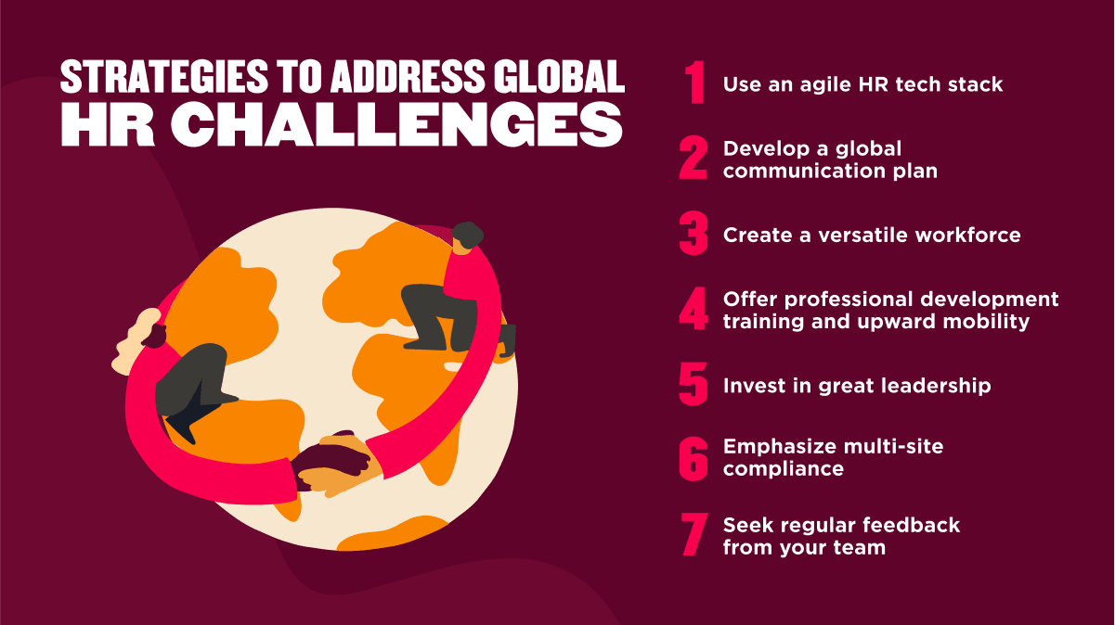
Appendix 2: Implementation of strategic HRM


