Certificate of Higher Education in Business Skills for the Workplace

Module Code: LCLM 4001_Lon
Module Title: Academic Skills
Assignment Number: Task 3
Assignment Title: Reflective Report



Lecturer: Mr Lloyd Beharry
Student name: Mr Noor Miah
Student ID number: 2416058

Table of Contents
Introduction 1
Reflection 2
Conclusion 6
References 7

Introduction
The core purpose of this particular reflective written piece is to explore the ways learning within this module has contributed towards three key academic skills development: research, paraphrasing, and even referencing. In these I have mentioned skills that are highly crucial for academic success and actually enable not only effective sourcing but also interpretation and presentation of valuable information while upholding academic integrity. Here, I have applied Gibbs’ Reflective Cycle to structure this reflection as it is a widely recognised model which facilitates a proper and comprehensive assessment of experiences. This paper now is going to detail specified tasks alongside activities from the module followed by my initial reactions to them, an evaluation regarding their effectiveness, and their impact analysis before reaching a fruitful conclusion to form an action plan for further skill development.

Reflection
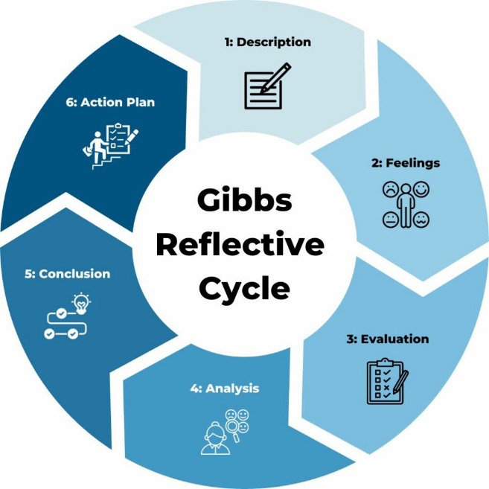
Figure: Gibbs’ reflective cycle.
Source: (Bassot, 2020).
Description
Throughout th span of this module, I have been engaged in several activities that have been designed specifically to strengthen skills like research, paraphrasing, referencing and others. Here, one of the notable tasks has included conducting a literature search via various academic databases like JSTOR, Google Scholar, and others. Besides, I have learned to identify credible sources as well as refine search queries, and similar others. On the other hand, paraphrasing-related exercise has been another focus here where we have practised complicated text summarisation in our own words while retaining their original meaning. Following Dolowitz, Buckler and Sweeney’s (2021) guidelines, it has encompassed key points in identifing alongside ideas rephrasing and others without altering the context. Contrastingly, the respected instructor has also emphasised referencing through activities applying citation styles like Harvard and others. During this, we have practised formating not only in-text citations but also reference lists, along with tools like CiteThisForMe has been introduced to us within the class.

Feelings
At the initial level, I have felt highly overwhelmed by the sheer volume of information to master within this module, particularly about research and referencing. Apparently, academic sources searching during this time seemed highly daunting because I was not been aware of any of the advanced search strategies and felt lost within the abundance of information. As hinted by Arfiani, Mauke and Mukmin (2021), paraphrasing here has brought a mixture of frustration and confidence. Even though I have appreciated its significance in terms of avoiding plagiarism, I have found it mostly challenging to rephrase technical texts without losing original meaning. Here, my confidence level has been lifted during the class discussion where my teachers have helped me to grasp such tasks more promptly. Now to focus on referencing, this surprisingly has been a source of comfort (Bassot, 2020). Despite my initial struggles with formatting, I have felt reassured by all the available tools and templates. Gradually, my confidence has grown as I practised more, and I have begun to enjoy the sense of precision which is required in referencing.
Evaluation
This particular module has offered a well-rounded approach to developing various academic skills, and I have found multiple aspects that have been highly effective. For research, learning to not only utilise academic databases but also refine search queries has been transformative (Dolowitz, Buckler and Sweeney, 2021). Here, the application of Boolean operators has enhanced the relevancy of my outcomes most significantly, and I have even begun to appreciate the depth of all available credible resources. Still, the volume of search results at times has been overwhelming, and I have struggled mostly with prioritising which sources to utilise. Seemingly, exercising paraphrasing has been a turning point for me because it has aided me in sharpening my capability of reading critically and even reframing ideas. Like Jacobs (2021) has suggested, I have found summarising much easier while using various strategies like breaking the texts into smaller sections, but the complexity of paraphrasing technical languages has remained a crucial challenge. Likewise, referencing has been another notable growth area where numerous practical activities like reference list creation have enhanced my understanding of various citation styles. In addition, even though certain online-based tools have been assistive, yet I have noticed they occasionally have made errors. This has taught me the significance of cross-checking each reference manually.
Analysis
Apparently, learning to utilise a vast array of academic databases has been highly transformative. At an initial point, my search strategies yielded irrelevant results, but as I adopted the in-class discussed strategies, my searches began to become more focused (Jacobs, 2021). To clarify this, during a task of finding sources about climate change, I have refined my query from ‘climate change effects’ to ‘climate change impact on agriculture in developing countries’. This here has drastically enhanced my sources quality. Evidently, the paraphrasing-related activities have improved my capability of understanding and synthesising complicated information. In the initial period, I mostly resorted to quoting texts directly, but the in-class activities later motivated me to paraphrase them instead. Afterwards, based on Vardi’s (2022) directions, I practised breaking down lengthy passages into smaller segments while working on a case study and rephrasing each within simpler terms. This seemingly has not only enhanced my comprehension but also increased my academic writing via excessive quotation reduction. Also, referencing has assisted me in appreciating both the ethical and formal aspects of academic writing (Moon, 2020). Here, learning the Harvard style, particularly in detail has allowed me to cite sources accurately while writing essays and other types of assignments. During one exercise, I created an annotated bibliography that later aided me in understanding the nuances of formatting.

Conclusion
From such reflection, I have recognised that even though I have made notable progress, there have been other areas where I could have improved. In addition, familiarising myself with referencing guides earlier here may have minimised potential errors within initial tasks. Now moving forward, I am planning to consolidate such mentioned skills via not only continued application but also reflection. Overall, all the challenges I have experienced have given me valuable lessons, and such experience has made me realise the value of persistence, adaptability and even the continuous pursuit of academic excellence.
Action Plan
Now, I will commit to conducting at least one heavily focused literature search each week while using various academic databases. Here, I will apply advanced search techniques like Boolean operators and even keep a research log to keep track of my progression (Vardi, 2022). Besides, I am going to practice paraphrasing every week by simply summarising each journal article or textbook excerpt. Lastly, I will create a reference list for each academic text I am going to read while adhering to the Harvard style. Taking guidance from Moon (2020), I here will cross-check each reference with their official style guides and even employ tools like Zotero and others to organise my citations systematically.

Conclusion
In my opinion this model has been highly beneficial to strengthen not only my research but also my paraphrasing and referencing skills. All these foundational abilities have crucial value for academic success which will allow me to engage with various academic content both effectively and ethically. Even though certain challenges have arisen, they have offered invaluable growth opportunities to nurture a deeper appreciation for the overall learning procedures.

References
Arfiani, N., Mauke, N. and Mukmin, M. (2021). English Paraphrasing Through Initial Stage Technique to Develop Writing Skills. BABASAL English Education Journal, 2(2), p.1.
Bassot, B. (2020). Reflective Journal. 3rd ed. London: Palgrave Macmillan.
Dolowitz, D.P., Buckler, S. and Sweeney, F. (2021). Researching Online. Basingstoke: Palgrave Macmillan.
Jacobs, S. (2021). Reflective Learning, Reflective Practice. Nursing, 46(5), pp.62–64.
Moon, J.A. (2020). Reflection in Learning and Professional Development. London: Routledge.
Vardi, I. (2022). Developing Students’ Referencing Skills: A Matter of Plagiarism, Punishment and Morality or of Learning to Write Critically? Higher Education Research & Development, 31(6), pp.921–930.

