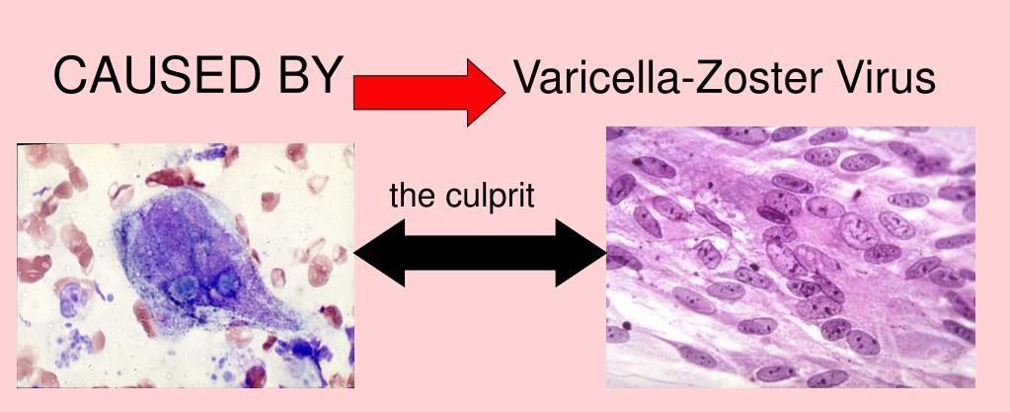

Report
Supporting paper
Saira Arshad
2125447
LCHS4004
Introduction to public health
DR MD Nazmul Hasan

Introduction
in this report I’m going to emphasize the policies and strategies of how to monitor, measure and control of an infectious disease chicken pox. we discussed in the group our findings individually and tried to understand what policies are in place and how many are in action. Further in the essay I will discuss that how I would critically evaluate these points. Also, discussion that took place and some questions that were asked by the lecturer himself will be added in this report and at the end there will be conclusion on what policies are in place and what can be added more to control an infectious disease.
To measure an outbreak of an infectious disease the two common ways are mortality and morbidity. these two data are used as a surrogate of any infectious disease and health. mortality data in medicine is a term that uses to record death rate or the number of deaths in certain areas or certain amount of time. Mortality data is to record usually the estimation of new cases arising. (naidoo j. and wills, 2009)
Mortality and morbidity data are in place as we know but I think to our case study chicken pox there wasn’t any data that I found on this an infectious disease. We discussed in the group about not finding much data about this particular disease.
Monitor
To monitor an infectious disease there’s a system called public health surveillance system. Public health surveillance system is the system that collects, analysis, interoperates and helps spread the information wildly to help guide public health decision making and brings into an action. This surveillance collects data from the equation of mortality and morbidity reports and other health data. surveillance system measures occurrences of new disease in that period of time. (naidoo j. and wills, 2009)
About surveillance system we agreed in the discussion that the data collectors did good job to monitor the disease covid19 but to some point it was a discussion that they could have had better system to monitor of new cases because the app they had to track and trace was a flop.
Control
To control an infectious disease from spreading there’s few ways that are in place in UK which are as follows
- Immunisation
- Lifestyle behavioural changes
- Medication, antibiotics, antivirals and antifungals.
- Modifying the environment: vector control
- Quarantine
Immunisation is the very common way by which a person gets protection against the disease. maintaining proper hygiene is very important in this situation to stop virus to spread more. Further to stop an outbreak avoid travelling in public transport when you are feeling unwell. Also avoid sharing used personal belongings such as razors, glass, toothbrush, comb etc. Extra care needs to be taken while going to hospital such as wearing masks using sanitizers etc (Dembek, et al., 2018)
To control we have seen above how UK government have rules in place. I think these rules above to control were in place when Covid19 was spreading fast but it didn’t help much as it should have like any other infectious disease.
Maintain public health
In England public health policy aims to protect from infectious diseases and environmental hazards. Health security is available in UK to maintain public health. health security means required activates proactive and reactive.to minimise the danger to public health that effects globally then serious cross border threat to health means a life threatening environmental or unknown origin that can spread wildly. (Anon., 2021)
Public health offers a lot of things to maintain good health in England. We discussed about border control in England. tb is an infectious disease and the government doesn’t let anyone across the border to enter the country. But for environmental hazards I think that most of the UK popularity who lives in bad neighbourhood don’t get clean roads or green place to walk etc.

UK government challenged agencies
Yes, in the group we discussed that UK government work along health protection team to challenge of any infectious disease or bring awareness of the outbreak. we have seen how the UK government worked along with the local agencies to bring awareness of covid19 causes and ask for every individual to use masks, wash hands and avoid traveling in public transport.
I think the UK government did not challenged the agencies or contacted the local communities properly and did not bring much awareness. Yes, I agree that rules and regulations were bought into action such as masks, washing hands but that did not help to control the virus.
Conclusion
chicken pox is an infectious disease which is normally common in children up till the age of ten. Its contagious disease that can be easily spreads among children. Normally children start showing symptoms four to five days before the spots appear. When noticed the sudden change in child’s health one should avoid sending the child in public gatherings or to school. As we seen in the case study Roma who’s in year 1. Teacher notices after half the day passes that she has spots on her arm.Teacher takes the measures in control by calling the parents to take the child home but it was too late as further in the study showed that next day few other children were absent due to catching chicken pox. This study showed that it is quite common for children to catch an infectious disease because of their immune system.an infectious disease is to some point is dangerous to elderly people and children. Upon finding the statistics to this particular disease there’s no actual data. We discussed in the group that how local communities or local council should allow child to take day off easily when parent notice a little change in their health so we can prevent it from spreading to more kids. As it was mentioned by group members that sometime child cannot bare the pain the spots cause. Itchiness and sometimes burning sensation are quite strong that their immune system struggles to fight back and very rarely it leads to death.

References
Dembek, Z. F., Chekol, T. & Wu, A., 2018. Best practice assessment of disease modelling for infectious disease outbreaks. [Online]
[Accessed 29 october 2022].
naidoo j. and wills, j., 2009. scientific research an academic publisher. [Online]
[Accessed 29 october 2022].
naidoo j, w. j., 2009. scientific research an acdemic publisher. [Online]
[Accessed 29 october 2022].

- Introduction (100 words)
- Strategies used in the UK to measure the incidence of the disease in your case study and critically evaluate it (250 words)
- Strategies used in the UK to monitor the incidence of the disease in your case study and critically evaluate it (250 words)
- Strategies used in the UK to control the incidence of the disease in your case study and critically evaluate it (300 words)
Conclusion (100 words)

