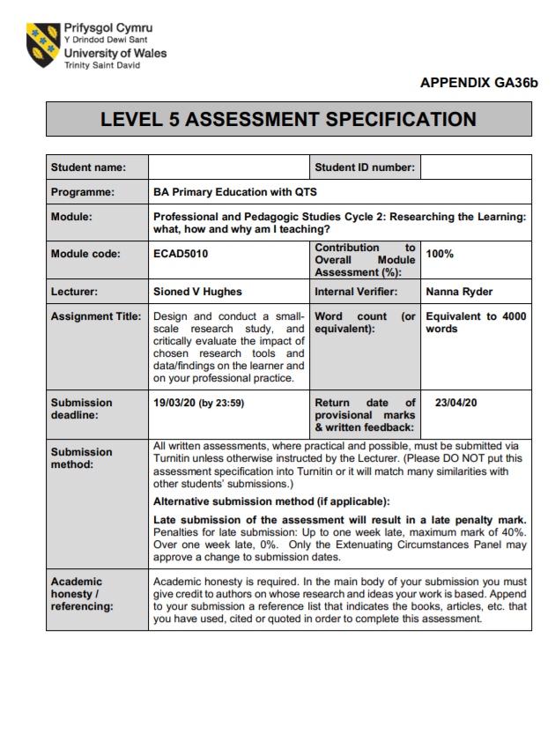

Design and conduct a small-scale research study, and critically evaluate the impact of chosen research tools and data/findings on the learner and on your professional practice.

Many conversations have taken place within education discussing teaching techniques, the pros and cons of certain styles and what can be done to improve the quality of teaching within schools. That is what this document wishes to continue. A discussion on how effective an aspect of teaching is to aid children’s learning. More specifically how ‘Questioning’ can impact children’s learning. A study conducted within a primary school in South Wales to gather findings in order to further understand the chosen focus of ‘Questioning’.
The question that leads the discussion is ‘Can Questioning Have a Positive Impact on Understanding?’. This broad question allows the study to delve deep into all branches of questioning and its links to the overall productivity of the children. ‘Can’ has been chosen specifically as it implies that not all cases always produce positivity from questioning within the classroom. The study looks to focus on whether questioning can stimulate positivity and what different aspects of children’s lives effect the results.
The hypothesis from the study investigates the idea that pupils are affected differently to different styles of questioning. They each have a preferred approach and each show different progression of understanding from their original stance on the topic.
The research tools that were chosen to conduct the study were an observational sheet, where six pupils were observed throughout a two-hour period. An informal interview was conducted with the same six pupils where five general questioning regarding their typical classroom experience. Finally, a questionnaire was sent out the staff of the primary school, providing questions of the different approaches they had to questioning.

During research it is key for the writer to engross themselves in previous studies and research. The more you know about a topics background, the more you can help it thrive to its educational potential.

Research tells a story and the existing literature helps us identify where we are in the story currently. It is up to these writing (a research study) to continue that story with new research and new perspectives but they must first be familiar with the story before they can move forwards.
(Austin, 2016, p.40)

Today’s world, experienced and new teachers alike face a constant pressure on improving children’s learning to a higher standard than before. There is always a need for the styles to be refined, the approaches perfected and delivery effortless. Crowe and Standford (2010) believe that if you do not have a structured plan for questioning, “you miss a powerful opportunity to create the type of dynamic and interactive environment in which students actively analyze and process information to answer good questions”.

A researcher names Michelle Flippione conducted a study where she stated, “Research in classroom behavior indicates cueing and questioning might account for 80% of what occurs in a given classroom on a given day.” (Flippione, 1998). This number equates to the majority of a teaching day, which really highlights the importance of effective questioning to support children’s learning. The aim for this study was to investigate the standard of questioning and what questions are needed to promote critical thinking. It was found that a mix of higher and lower ability level questions were asked throughout the lessons. The number of collated questions asked by 12 teachers in their short reading sessions was “737” questions. The study also found that as the pupils were moving up the school age ladder the percentage difference was increasing as “the percentage of higher-level questions increased in each grade level” (Flippione, 1998). The reliability of this study may be questioned as it was performed by a non-credible source, however the way it was conducted, with quantitative data, we can assume the data is reliable.
These results can be used to enhance the current study. Using the statistics collected will allow the observer to focus on other topics in question. The number of questions and the level have been previously recorded, now the study can focus styles, responses and understanding.

During the study a mixed approach of structured and non-structed observation was used to give the observer a broad chance to collect data based on both a criterion and what they saw of importance to the study. Rolfe and Emmett (2010, p.312) suggest “that ‘if we define observation broadly as one person's perception’ then we could say that all research is based on observation”, allowing observation to have a key role in all forms of research. This approach is accompanied by advantages and disadvantages to both collecting data and the well-being of the children being observed. Observation can provide you with qualitative data.

Observation offers the social researcher a distinct way of collecting data. It does not rely on what people say they do, or what they say they think. It is more direct than that. Instead, it draws on the direct evidence of the eye to witness events first-hand. It is based on the premise that for certain purposes, it is best observe what actually happens.
(Denscombe, 2010, p.196)

NSW suggest, qualitative analyses through classroom observation can support quantitative data, as test scores rise for a pupil you can use qualitive analyses to see what has changed in the classroom helping the pupil achieve higher. This approach is used as “these approaches deal more with the stories of individuals” (Nolan et al, 2013) than the statistics and facts. This can then be applied to other pupils within the class to potentially support their leaning further. However, the way the pupil learns effects this approach as they may learn in a different way to others. Another advantage of qualitative analyses is, it “allows for a detailed examination of thoughts, feelings, opinions and/or experiences of individuals, groups or communities” (NSW, 2019). This links to the research for this study (see appendix A – E) as the observer can note down what the emotional effects of the lesson are for the pupil as well as their general focus. On the other hand, there are disadvantages to this approach that effect the results of the study, the main being due to ‘human error’. Qualitative data may be harder to analyse “as the data collected is not inherently objective, and thus can be open to multiple interpretation” (NSW, 2019). This rings true in many ways as during the study the observer had different opinions of the pupils being observed than the class teacher. This could have a harmful effect on pupils if not carefully approached as the pupil may be seen in a bad light, without completely knowing the pupil. Another barrier facing this approach is time. The primary classroom environment is fast paced, noisy and in somewhat hectic. This does not give the observer much time to conduct a complete observation of the pupils emotional, productivity and response to questioning. A way round this barrier used during this study was to have a structured observational sheet ready with criteria to follow (See appendix A-E). This gave the observer the opportunity to focus primarily on their productivity responses to questioning during the lesson, then further complete the observational sheet post lesson. The disadvantage of this is that each observer may have their own interpretation of events during the lesson. Mukherji and Albon describe observers as different and everyone has different experiences through life and go on to suggest that “all these differences affect what they focus on when they are observing”.

Another research tool used was an informal interview with the chosen pupils. These were conducted individually in a separate classroom with a witness (teaching assistant) in the room as a safeguarding precaution. The topic used for the interview was questioning, more specifically the effect the teachers questioning had on the pupils. The decision to interview the pupils was made primarily due to the observer having complete background knowledge of the pupils, spent time teaching them and had a strong educational relationship with the class. Pupil interviews can be seen as a disadvantage as NSW states that “conducting interviews and focus groups requires strong interpersonal skills, particularly in making people feel comfortable”. This was avoided as the pupils we very comfortable with the one to one interview, keeping it as an informal chat. Another barrier faced was leading pupils down the path of an answer the observer wants. This was a challenging aspect to conquer due to lack of preparation. To improve this aspect of the interview in the future, the study will need to have more closed questions for the pupils with the follow up of ‘why’ to explain their reasoning. This being said, Mukherji and Albon (2018) agree with Robson (2011) when they state that “the interviewer can clarify what the interviewee is trying to say, and can investigate areas of interest as they emerge, probing and teasing out strands of thought”. According to Robson (2011) this is a key advantage of interviewing as a research method. Also, a guide of additional comments will be planned in order to help pupils with the questions if they do not understand. Another challenge that was faced was the reluctancy of one pupil to answer the questions, this pupil has a gypsy traveller background and the pupils personal view to education is that it is unnecessary. This made it a brief interview with little detail or information (see appendix 2). In the future an approach that may work more effectively at getting pupils within this category involved with interviews/feedback is using the Hawthorne effect. Mukherji and Albon (2018) refers to the Hawthorne effect when they state, “when people know they are being studied, they change the way they behave”. This is evident in the differences during classroom activities and the interview. The pupil regularly engages in work and conversations regarding it with teachers but changed to timid, shy and unresponsive during the interview. In the future to tackle this barrier, a careful undisclosed approach will be taken within the classroom environment. However, this infringes on the ethical rights of that child, so in order to do this full disclosure of this will need to be addressed at the start of the lesson. The outline of what a researcher is looking for and doing at the start of the lesson is used to adhere to ethical conformities as Robson (2002, p.65) supports by stating “ethics refers to rules of conduct; typically, to conformity to a code or a set of principles”.

The final form of data collection used is questionnaires. This method is extremely like the interview process as they both share the premise of asking and answering specific topic related questions. It does have the fundamental difference that an interview is “always impersonal in some ways; that is, there is always personal contact between the researcher and the participant” (Mukherji and Albon, 2018). The focus was teacher based and how they perceive questioning in the classroom in relation to its importance of developing understanding from effective questioning. Questionnaires are an effective way to get a set number of questions out to a large group, giving you both open and closed questions to analyse and both quantitative and qualitive data. The disadvantage that Mukherji and Albon (2018, p.261) suggest is that the aspect that provokes a response to a questionnaire is if it important to us, whether that being for work, or to win something. This suggest that the questionnaire used in this study has no value to the participants to complete. Mukherji and Albon (2018, p.261) later state that we “complete questionnaires if they are conducted by colleagues, friends or students (when we have time) as we have a personal and/or professional commitment to them”, which contradicts the previous reason for low engagement with the questionnaire.

The results from the study are both varied and intriguing. The predictions for the result of the study were somewhat correct with some anomalies. The pupil's observation was conducted well and effectively with no engagement with the pupils that were being observed. The pupils who were being observe were chosen through random selection, when they asked the teacher a question and vies versa. He results were as predicted with the pupils who were not engaging with the lesson and the teacher were less productive. This was accompanied by these pupils distracting others and effecting their overall engagement. My observational sheets may give evidence to this behaviour through the comments; however, this does not affect the overall result. Pupils who started the lesson with little engagement were identified by the class teacher and brought onto the teachers focus table. This was not there as a punishment, but to follow the lines of Skinners operant conditioning theory positive reinforcement by giving them positive feedback on their work and encouraging them to continue doing better. When these pupils were on the table their engagement increased due to conversing with the teacher and conveying queries about the task and getting an overall understanding of what to do. The pupils began to increase productivity and could then return to their tables to continue work independently. The teacher then needed to continue questioning them with closed questions such aa ‘are you ok?’ ‘can I help?’ etc.
The interview questions provided the study with a more in depth look on the pupil’s opinions on questioning. The pupils gave an insight on the differences between each teacher questioning styles and what they found more effective. Going against current belief of a brief introduction to the lesson, the pupils preferred it when the teachers take their time to explain the task. The pupils also said that they enjoy when the teachers use real life events as examples of tasks or during explanations. This then limits the amount of questions that the pupils must ask about the task and allows the teacher to ask engaging questions. An aspect of this that is hinders their understanding is the pupil's confidence, every pupil said that they did not want to ask questions regarding understanding in front of the whole class as they were ‘embarrassed’. Finally, the pupils conveyed that they find when they fully understand the task at the start, they do not need to ask questions often and can be more productive with their work.
The questionnaire has had a different result than predicted. Even though the questionnaire responses contain a range of detailed answers with insightful information regarding teaching, the lack of responses hinders the reliability of the results. Due to this hinderance, this part of the study cannot be used to speak for many teachers in South Wales. The overall result of the questionnaire is that many of the participants believe that questioning improves understanding by giving pupils clarity of the task and aims for the session. The combination of open and closed questions is vital for engaging pupils and promoting their understanding further. However, this needs to be monitored closely to utilise the correct style of questioning when it is needed. As Hattie (2009) states “The biggest effects on student learning occur when teachers become learners of their own teaching.” This allows teachers themselves to continuously improve, thus improving the pupils overall learning.

The above is a complete has been summarised with the research question in mind. The research question ‘Can Questioning Have a Positive Impact on Understanding’ is broad and allows the study to use different approaches, angles and perspectives to investigate a similar topic that’s been covered before. For example, the study conducted previously by Filippone 1998 follows the same lines as this current study except for the style of data collected quantitative compared to qualitive. These studies are crucial for the development of questioning within classrooms as it provides future aspiring teachers with a base layer of information, allowing them to correctly ready themselves to be effective teachers in their careers ahead.

The outcome of the study conducted has allowed a new perspective to questioning. Questioning has been proven to have a significant impact on engagement within the classroom. From this study, more specifically the observation we can see that the pupils who lacked engagement were affected through effective questioning, keeping them engaged with the task at hand. Pupils had a steady increase of productivity while working one on one with the teacher using topic specific open and closed questions to assist their learning. This goes to suggest that pupils sometimes are shadowed by a hectic classroom environment and teachers need to be vigilant to see who needs the extra support and when. This is further supported by the interviews with the pupils. The anonymous comments of the lack of confidence in a whole classroom setting backs up the suggestion of teacher's efficient observational skills, scanning to see who may need support.

Another aspect of teaching unveiled during this study is the difference that perspectives have on questioning. Teachers have a different view on how understanding effects pupils during lessons. Pupils deem understanding at a high priority level during lessons whereas teachers see it as average importance. This itself gives an insight into how teachers plan their lessons, with the introduction as brief to begin hands on work. As on the pupil's side, they would prefer extra time for the teachers to explain the premise of the lesson more clearly.

Ethics has a huge card to play when conducting any style of research with young and young minded pupils. This includes verbal and non-verbal consent and at all age ranges, supported as Flewitt (2005) found that “children as young as three years old were competent and confident enough to grant or withdraw consent – with some more outspoken and enquiring than their parents”. It is seen that pupils require “high levels of understanding for a valid consent, however, could operate to exclude research with very young children unless an adult has consented on their behalf” (BERA, 2015). This further adds to the difficulty of conducting research within schools and hinders the advancement of teaching at its roots.

In the future the study could improve by testing new research methods, having more structured research tools in place prepared to enter the classroom. Also, a different approach to the ethical aspect of the observation. The colloquial approach to the interviews worked in some cases, but it is down to the interviewer to get background knowledge of the pupil and how to approach the situation to get the best from the experience.

Word count including appendix and ethics form, excluding title and reference list - 3041

Reference List

Blackburn (2015) researching with young and developmentally young children: ethical considerstions, dilemas and comprosises – BERA bits paper

Rolfe, S. and Emmett, S. (2010) ‘Direct observation’, in G. MacNaughton, S. Rolfe and I. Siraj-Blatchford (eds) Doing Early Childhood Research: International Perspectives on Theory and Practice, 2nd edition. Maidenhead: Open University Press.

Mukherji, P. and Albon, D. (2018) ‘Research Methods in Early Childhood’ , 3rd edition. London. SAGE Publications.

Robson, C. (2011) Real World Research, 3rd edtion. Cinchester: John Wiley.

Education.nsw.gov.au. (2019). Collecting Data. [online] Available at: https://education.nsw.gov.au/teaching-and-learning/professional-learning/evaluation-resource-hub/collecting-data [Accessed 23 March 2020].

Payne, G. and Payne, J., (2004) Key Concepts in Social Research. [online] Google Books. Available at: https://books.google.co.uk/books?id=63GACgAAQBAJ&printsec=frontcover&dq=hawthorne+effect&hl=en&sa=X&ved=0ahUKEwjnitKSmLjoAhULecAKHVaYAQIQ6AEIQjAD#v=onepage&q=hawthorne%20effect&f=false [Accessed 22 March 2020].
Nolan, A. Macfarlane, K. and Cartmel, J., (2013). Research in Early Childhood. London: SAGE Publications.

Filippone, M., (1998). Question at The Elementary Level. Available at:
https://files.eric.ed.gov/fulltext/ED417431.pdf [Accessed 20/02/20]

Flewitt, R., (2005). Conducting research with young children: some ethical considerations. Early Child Development and Care, [online] 175(6). Available at: http://oro.open.ac.uk/2720/2/Flewitt(1).pdf
[Accessed 20 March 2020].

Denscombe, M., (2010). The Good Research Guide: For Small-Scale Social Research Projects. 4th ed. Birkshire: Open University press.

Appendix

Appendix 1a – Child A
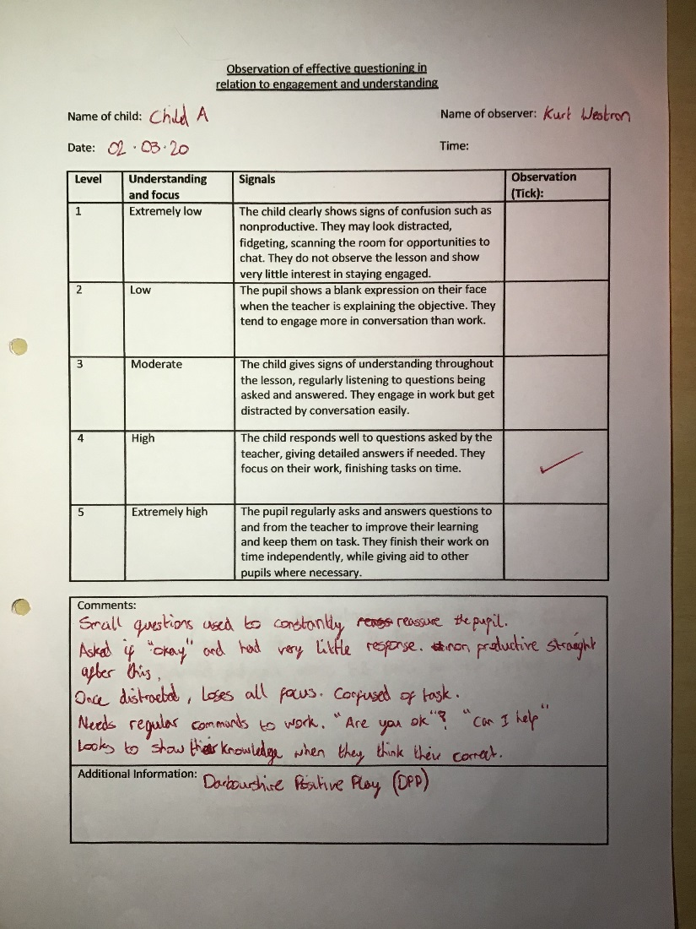

Appendix 1b – Child B
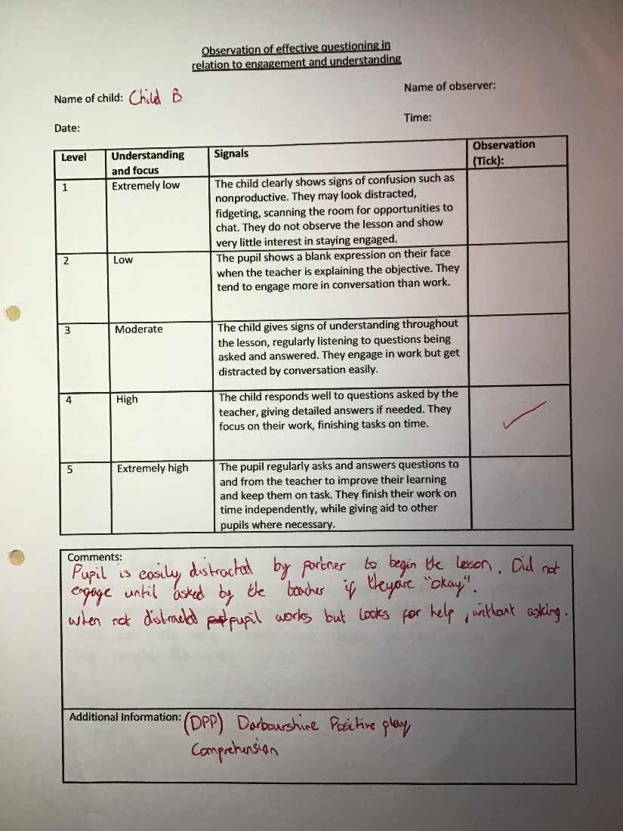

Appendix 1c – Child C
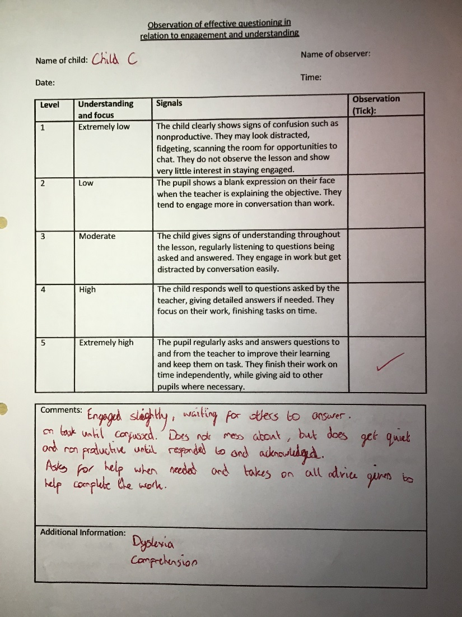

Appendix 1d – Child D
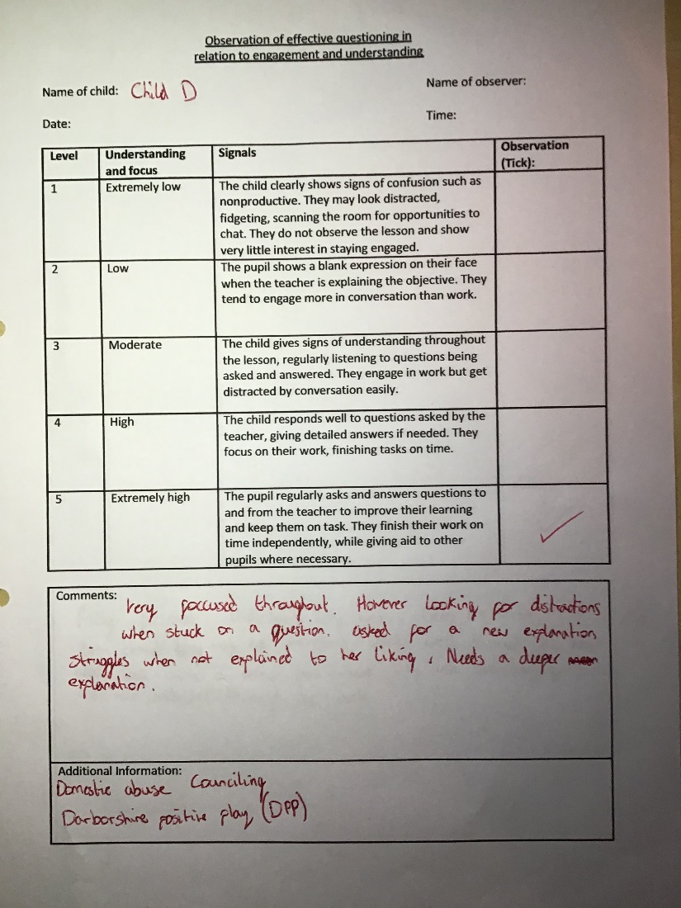

Appendix 1e – Child E
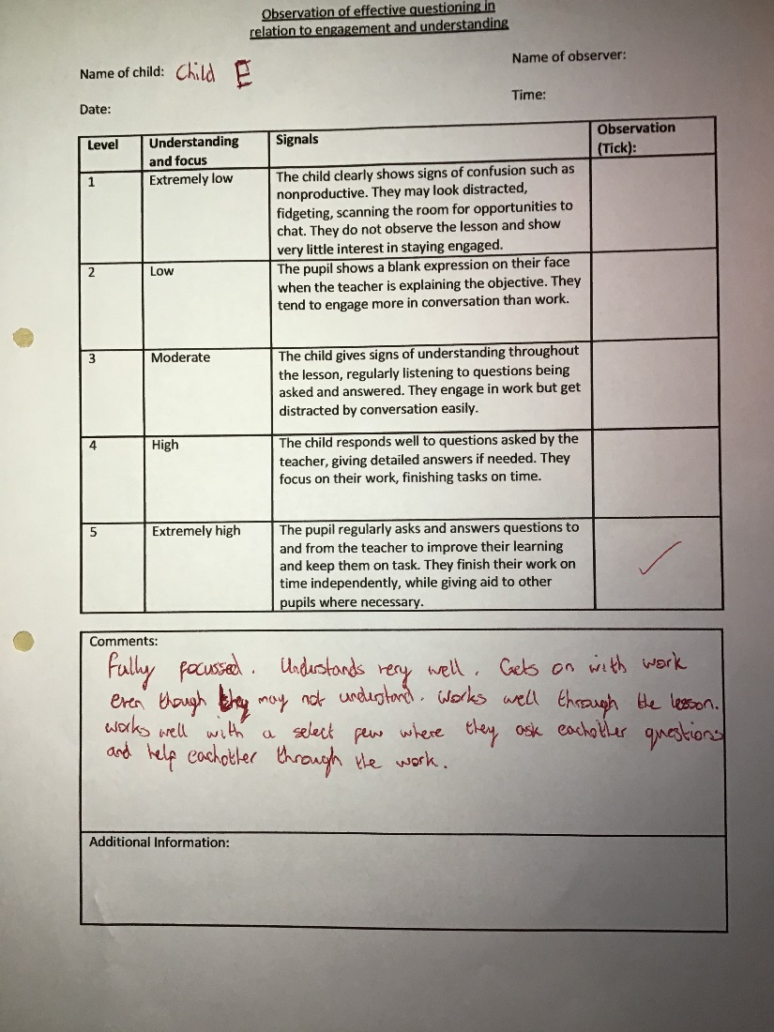

Appendix 2 – Questionnaire

https://forms.office.com/Pages/ResponsePage.aspx?id=-REPTm4EBUWcuNshUjEeIRS3vDn8DpBPoMBRTaZVTrxUNlM2RzVIMjVFSjNKNEo0ODYyNVJCS1pDRS4u

Appendix 3 – Interview Script 1

Interviewer - First one, you know at the start when Mr Bacon was explaining things, we call it an introduction to your lesson, did he or do all the teachers ask you questions as you are going through things? You personally, not the class.
Child - It depends
Interviewer - Go on explain
Child -For example eg, sometimes when we are with Mrs ?????, when she talks about something say for example adjectives she like has anybody heard of it, stuff like that?
Interviewer - So that’s when she asks you a question, do you tend to ask questions just to help you out a bit? If you do not understand something do you think that helps you understand
Child - Yes
Interviewer - On what extent? So how, do you ask the question and then you are like perfect I’m going to get on with it or do you just kind of go, its ok I’m just going to mess about a bit.
Child - the first one
Interviewer - the first one, so focused are you, liar. Right, got one here, are there any times when you want to ask a question but you don’t?
Child - yes
Interviewer - Yes, there are times. Why don’t you ask?
Child - Because its a silly question
Interviewer - So you think its a silly question. What sort of questions?
Child - Silly ones.
Interviewer - So is it things that you are really stuck with or is it something that I really don’t know what that means. Should I ask?
Child - Or like sometimes when you want to ask a question but then all of a sudden the teacher just moves onto something else.
Interviewer - Right ok. So then you’re then stuck and you don’t know what he meant. But they have gone on anyway. Do you ask then afterwards?
Child - Yes
Interviewer - So you go up afterwards when it’s quiet. Oh right, so the reason that you don’t ask is because you are a bit
Child - I raise my hand up but then all of a sudden the teacher goes onto something else.
Interviewer - Oh ok, right, so that’s the teacher not seeing that you have got your hand up, or do you kind of put your hand just slightly up.
Child - Yeah
Interviewer - Ah I know you, you don’t stretch up, you’re just like “excuse me”.
When you fully understand what to do, do you find you work better?
Child - Yea
Interviewer - Easier?
Child - Yea
Interviewer - So you just fly through the work?
Child - I don’t fly through but I’m better than when I don’t get it.
Interviewer - But do you understand it? Because I can go through work really quickly but then I might not understand it
Child yes
Interviewer - So do you find then that when you understand the work fully, you go and ask Sir is this right? and he turns around and says yes, yes, yes
Child - Yes, I like doing that
Interviewer - I bet you walk away and you feel chuffed then
Child - Yeah

Appendix 4 – Interview Script 2

Interviewer - So, this morning, or this afternoon you had Mr Bacon. At the start of the lesson they do what is called an introduction, it's where they explain exactly what they want you to do. Do you find that the teachers ask you a lot of questions when they explain things?
Child - Yea
Interviewer - That was a quick yes. What sort of things do they ask?
Child - They keep on saying the same thing to write down something
Interviewer - Oh ok, so they are not asking you things, they are saying write down this, write down this.
Child - Yea
Interviewer - So when they are explaining the task, so Mr Bendle for example, when he is explaining somethingto do, does he ask the class anything? Does he ask you anything specific, when he’s explaining ?
Child - Well, yea
Interviewer - What sort of things does he ask you?
Child - We do the work on the board ………………………..
Interviewer - What does he ask you when he is explaining things? Does he ask you, do you understand? Are you ok?
Child - Yea
Interviewer - So he is just checking up
Child - Yea
Interviewer - Do you find when he does that, or say for instance now, if I was explaining something about maths, and I said do you know the answer and you said I don’t know the answer and I said why don’t you know the answer ? Because I don’t understand this bit - do you find that because you have explained what you don’t understand that he will then go into it a bit?
Child - Yea
Interviewer - Does that help you understand more?
Child - Yes
Interviewer - So if for instance, I said it was on the board - what does productive mean? And everyone was like I don’t know so he would go through that, do you find then that ah I understand what it means now.
Child - Yea
Interviewer - So questioning does help a bit
Child - Yea
Interviewer - Good, good. Any times that you want to ask a question and you don’t?
Child - Yea, lots
Interviewer - So why don’t you ask?
Child - Don’t like asking
Interviewer - Two people I spoke to before you said yes as well. I do as well in uni and Mr Randall does. Why don’t you ask?
Child - I don’t like it
Interviewer - Is it because its a big group?
Child - Yea, mostly
Interviewer - So do you think now you’ve moved on to that focus table, are you asking questions?
Child - No
Interviewer - Still a bit too big?
Child - Yea
Interviewer - So if it was just me and you in a room, you’d be ah what’s this, what’s that
Child - Yea
Interviewer - Or would you wait for me to explain it?
Child - No
Interviewer - So you would just ask?
Child - Yea
Interviewer - It's a tough one that because in big groups people tend to think it may be a silly question or something like that or is it that you can’t be bothered to ask.
Child - Just don’t want to ask.
Interviewer - So do you find that effects how much you understand? Because if I did not understand something and I did not ask, I wouldn’t understand it after would I
Child - No
Interviewer - When you fully understand the task, when I’ve been here sometimes you were very confused and sometimes you found this is easy, do you find you work better when you completely understand?.
Child - Yea
Interviewer - So you get on with your work a bit better.
Child - Yea
Interviewer - You find as well then once you understand that you will go up to Mr Bendle, myself, Mr Randall and you would show us your work and we would go, like, perfect.
Child - I don’t go up and show anyone my work really
Interviewer - Ok, do you find when you go back to look at it when we’ve marked it, everything is correct?
Child - No
Interviewer - So even though you’re understanding, you’ve got a few things wrong. Do you go back then and with your green pen. Do you correct things or do you go and ask Mr Bendle?
Child - I correct things
Interviewer - Oh good so you’re a bit independent.

Appendix 5 – Ethics form

APPLICATION FOR ETHICAL APPROVAL

In order for research to result in benefit and minimise risk of harm, it must be conducted ethically. A researcher may not be covered by the University’s insurance if ethical approval has not been obtained prior to commencement.

The University follows the OECD Frascati manual definition of research activity: “creative work undertaken on a systematic basis in order to increase the stock of knowledge, including knowledge of man, culture and society, and the use of this stock of knowledge to devise new applications”. As such this covers activities undertaken by members of staff, postgraduate research students, and both taught postgraduate and undergraduate students working on dissertations/projects.

The individual undertaking the research activity is known as the “principal researcher”.

Ethical approval is not required for routine audits, performance reviews, quality assurance studies, testing within normal educational requirements, and literary or artistic criticism.

Please read the notes for guidance before completing ALL sections of the form.

This form must be completed and approved prior to undertaking any research activity. Please see Checklist for details of process for different categories of application.

Delete the Guidance Notes at the end of the form BEFORE submitting your application

SECTION A: About You (Principal Researcher)
Full Name: |  | Kurt Aaron Westron
Tick all boxes which apply: |  | Member of staff: | ☐ | Honorary research fellow: | ☐
Undergraduate Student | ☒ | Taught Postgraduate Student | ☐ | Postgraduate Research Student | ☐

Faculty/School/Centre: | Initial Teacher Education, Yr Athrofa
Campus: | Carmarthen
E-mail address: | 1804645@student.uwtsd.ac.uk
Contact Telephone Number: | 07794098091
For students:
Student Number: | 1804645@student.uwtsd.ac.uk
Programme of Study: | BA Primary Education with QTS
Director of Studies/Supervisor: | Dr. Sioned V. Hughes

SECTION B: Approval for Research Activity
Has the research activity received approval in principle?  (please check the Guidance Notes as to the appropriate approval process for different levels of research by different categories of individual) |  | YES | ☒ | NO | ☐
 |  |  |  | Date
If Yes, please indicate source of approval (and date where known): Approval in principle must be obtained from the relevant source prior to seeking ethical approval | Research Degrees Committee |  | ☐
 | Faculty Research Committee |  | ☐
 | Other (write in) ECAD5010 Module Lead |  | ☒ | 27.02.20

SECTION C: Internal and External Ethical Guidance Materials
Please list the core ethical guidance documents that have been referred to during the completion of this form (including any discipline-specific codes of research ethics, and also any specific ethical guidance relating to the proposed methodology). Please tick to confirm that your research proposal adheres to these codes and guidelines.
UWTSD Research Ethics & Integrity Code of Practice | ☒
UWTSD Research Data Management Policy | ☒
Include references to BERA Guidelines here  BERA https://www.bera.ac.uk/researchers-resources/publications/ethical-guidelines-for- educational-research-2018 | ☒

SECTION D: External Collaborative Research Activity
Does the research activity involve collaborators outside of the University? |  | YES | ☐ | NO | ☒
If Yes, please provide the name of the external organisation and name and contact details for the main contact person and confirmation this person has consented to their personal data being shared.as part of this collaboration.
Institution
Contact person name
Contact person e-mail address

Has this individual consented to sharing their details on this form? |  | YES | ☐ | NO |  |  | ☐
Are you in receipt of a KESS scholarship? |  | YES | ☐ | NO |  |  | ☐
Is your research externally funded |  | YES | ☐ | NO |  |  | ☐
Are you specifically employed to undertake this research in either a paid or voluntary capacity? | Voluntary | YES | ☐ | NO |  | ☐
 | Employed | YES | ☐ | NO |  | ☐
Is the research being undertaken within an existing UWTSD Athrofa Professional Learning Partnership (APLP) | If YES then the permission question below does not need to be answered. | YES | ☒ | NO |  |  | ☐
Permission to undertake the research has been provided by the partner organisation | (If YES attach copy)  If NO the application cannot continue | YES | ☐ | NO |  |  | ☐

Where research activity is carried out in collaboration with an external organisation
Does this organisation have its own ethics approval system? | YES | ☐ | NO | ☒
If Yes, please attach a copy of any final approval (or interim approval) from the organisation

SECTION E: Details of Research Activity
Indicative title: | To explore the impact questioning has on pupils understanding
Proposed start date: | 02.03.20 | Proposed end date: | 01.04.20
Introduction to the Research (maximum 300 words)
Ensure that you write for a Non-Specialist Audience when outlining your response to the three points below:
- Purpose of Research Activity
- Proposed Research Question
- Aims of Research Activity
- Objectives of Research Activity
Demonstrate, briefly, how Existing Research has informed the proposed activity and explain
- What the research activity will add to the body of knowledge
- How it addresses an area of importance.

Purpose of Research Activity

- To gather data on the effect of questioning within the classroom.
- To explore the different styles of questions used.
- To trial 3 different research tools such as, questionnaire, interview and observation recordings to collect data on my research topic.

(this box should expand as you type)
Research Question

Does the use of questioning have a positive impact on understanding in the classroom?

(this box should expand as you type)
Aims of Research Activity

- To observe members of the classroom as they engage in questioning during their daily lessons.
- To explore staff and learners’ perceptions of questioning.
- To critically evaluate the different research tools used, questionnaire, interview, and observation.
- To further develop personal knowledge and understanding of AfL
- To improve professional practice

(this box should expand as you type)
Objectives of Research Activity

- To explore the questioning strategies and approaches used by staff to support and develop pupils’ learning using a questionnaire and observation.
- To interview 5 - 10 / 11 year-olds learners to capture their views about how questioning helps with understanding in the classroom.
- To observe 5 – 10 / 11 year olds responses to questioning in the classroom.
- To critically reflect on the process of using different research tools to collect data

(this box should expand as you type)
Proposed methods (maximum 600 words)
Provide a brief summary of all the methods that may be used in the research activity, making it clear what specific techniques may be used. If methods other than those listed in this section are deemed appropriate later, additional ethical approval for those methods will be needed.
Interviews – 3 pupils of mixed ability will be involved in a semi-structured interview where they will be invited to respond to key questions. For example, do you find questioning helps your understanding? What sort of questions does the teacher normally ask? The interview will be conducted in the style of an informal chat where I will be making short/rough notes and have an audio recording of the interview itself. The children will have the choice to participate and they will at no point during the day be forced to take part in anything they do not want to do. They will also have the option to stop at any time, or not answer a specific question. Pupils will be able to tell me at any point in the interview to tell me how they are feeling during the interview. There will be 3 key points in the interview to stop and ask the pupils if they wish to continue. No names will be recorded, but they will be referred to as child A, child B, and child C.

Questionnaire – 2 members of staff will be given the questionnaire to work through. 1 teacher and 1 teaching assistant. The questionnaire will cover a range of questions encompassing teacher questions, pupil questions and recapping questions. For example, What styles of questioning do you use? Does pupil questioning effect the flow of the lesson? When asked a question do you follow it up afterwards? The questionnaire will have a variety of question styles, giving the members of staff a chance to give reasoning for their answers and give as detailed answers as possible.

Observations – 3 pupils will be chosen to observe, the same pupils as involved in the interview. The key elements that will be observed are questioning from the teacher during the lesson, questioning from the pupils to the the teacher during the lesson, follow up questions throughout the lesson, and productivity of the pupils after conducting questioning. The observations will be chosen at random as the lessons go on.

(this box should expand as you type)

Location of research activity
Identify all locations where research activity will take place.
The research task will take place in a small school in an area of social deprivation. There are approximately 190 pupils within the school. The school has a vast ability range with 2 Special Teaching Facilities.

(this box should expand as you type)
Research activity outside of the UK
If research activity will take place overseas, you are responsible for ensuring that local ethical considerations are complied with and that the relevant permissions are sought. Specify any local guidelines (e.g. from local professional associations/learned societies/universities) that exist and whether these involve any ethical stipulations beyond those usual in the UK (provide details of any licenses or permissions required). Also specify whether there are any specific ethical issues raised by the local context in which the research activity is taking place, for example, particular cultural and/or legal sensitivities or vulnerabilities of participants.
N/A

(this box should expand as you type)
Use of documentation not in the public domain: Are any documents NOT publicly available? | NO | ☒
 | YES | ☐
If Yes, please provide details here of how you will gain access to specific documentation that is not in the public domain and that this is in accordance with prevailing data protection law of the country in question and England and Wales.

(this box should expand as you type)

SECTION F: Scope of Research Activity
Will the research activity include: | YES | NO
Use of a questionnaire or similar research instrument? | ☒ | ☐
Use of interviews? | ☒ | ☐
Use of diaries? | ☐ | ☒
Participant observation with their knowledge? | ☒ | ☐
Participant observation without their knowledge? | ☐ | ☒
Use of video or audio recording? | ☒ | ☐
Access to personal or confidential information without the participants’ specific consent? | ☐ | ☒
Administration of any questions, test stimuli, presentation that may be experienced as physically, mentally or emotionally harmful / offensive? | ☐ | ☒
Performance of any acts which may cause embarrassment or affect self-esteem? | ☐ | ☒
Investigation of participants involved in illegal activities? | ☐ | ☒
Use of procedures that involve deception? | ☐ | ☒
Administration of any substance, agent or placebo? | ☐ | ☒
Working with live vertebrate animals? | ☐ | ☒
Other primary data collection methods, please explain in this box  For example, ‘focus groups’. Please indicate the type of data collection method(s) in this box and tick the accompany box. | ☐ | ☒
Details of any other primary data collection method:

(this box should expand as you type)
If NO to every question, then the research activity is (ethically) low risk and may be exempt from some of the following sections (please refer to Guidance Notes).

If YES to any question, then no research activity should be undertaken until full ethical approval has been obtained.

SECTION G: Intended Participants
Who are the intended participants: | YES | NO
Students or staff at the University? | ☐ | ☒
Adults (over the age of 18 and competent to give consent)? | ☒ | ☐
Vulnerable adults? | ☐ | ☒
Children and Young People under the age of 8? (Consent from Parent, Carer or Guardian will be required) | ☒ | ☐
Prisoners? | ☐ | ☒
Young offenders? | ☐ | ☒
Those who could be considered to have a particularly dependent relationship with the investigator or a gatekeeper? | ☐ | ☒
People engaged in illegal activities? | ☐ | ☒
Others (please identify specifically any group who may be unable to give consent) please indicate here and tick the appropriate box. | ☐ | ☒
Other – please indicate here:

(this box should expand as you type)

Participant numbers and source
How will you identify participants and how will they be recruited?
How many participants are expected? | 20 participants  (this box should expand as you type)
Who will the participants be? | 15 teachers, 5 pupils (year 5/6)  (this box should expand as you type)
How will you identify the participants? | Previous PTE2 experience in the school  (this box should expand as you type)

Information for participants: | YES | NO | N/A
Will you describe the main research procedures to participants in advance, so that they are informed about what to expect? | ☒ | ☐ | ☐
Will you tell participants that their participation is voluntary? | ☒ | ☐ | ☐
Will you obtain written consent for participation? | ☐ | ☐ | ☒
Will you explain to participants that refusal to participate in the research will not affect their treatment or education (if relevant)? | ☒ | ☐ | ☐
If the research is observational, will you ask participants for their consent to being observed? | ☒ | ☐ | ☐
Will you tell participants that they may withdraw from the research at any time and for any reason? | ☒ | ☐ | ☐
With questionnaires, will you give participants the option of omitting questions they do not want to answer? | ☒ | ☐ | ☐
Will you tell participants that their data will be treated with full confidentiality and that, if published, it will not be identifiable as theirs? | ☒ | ☐ | ☐
Will you debrief participants at the end of their participation, in a way appropriate to the type of research undertaken? | ☐ | ☐ | ☒
If NO to any of above questions, please give an explanation
(this box should expand as you type)

Information for participants: | YES | NO | N/A
Will participants be paid? | ☐ | ☒ | ☐
Is specialist electrical or other equipment to be used with participants? | ☐ | ☒ | ☐
Are there any financial or other interests to the investigator or University arising from this study? | ☐ | ☒ | ☐
Will the research activity involve deliberately misleading participants in any way, or the partial or full concealment of the specific study aims? | ☐ | ☒ | ☐
If YES to any question, please provide full details
(this box should expand as you type)

SECTION H: Anticipated Risks

Outline any anticipated risks that may adversely affect any of the participants, the researchers and/or the University, and the steps that will be taken to address them.

If you have completed a full risk assessment (for example as required by a laboratory, or external research collaborator) you may append that to this form.
Full risk assessment completed and appended? |  | Yes | ☐
 |  | No | ☒
Risks to participants
For example: emotional distress, financial disclosure, physical harm, transfer of personal data, sensitive organisational information
Risk to Participant:  - Pupils may feel under pressure to give the correct answer to the questions.  - Breach of confidentiality, due to pupils being worried of referring information to the teacher.  - Teachers may feel under pressure answering questions.  (this box should expand as you type) | How will you mitigate the Risk to Participant  - Pupils will be told that there is no consequence for anything they say. I will make it clear that I want open and honest answers.  - I will make it clear that the answers they give will affect their education in no way and there will be no repercussions for their actions and answers in regard to the research  (this box should expand as you type)
If research activity may include sensitive, embarrassing or upsetting topics (e.g. sexual activity, drug use) or issues likely to disclose information requiring further action (e.g. criminal activity), give details of the procedures to deal with these issues, including any support/advice (e.g. helpline numbers) to be offered to participants. Note that where applicable, consent procedures should make it clear that if something potentially or actually illegal is discovered in the course of a project, it may need to be disclosed to the proper authorities
N/A
(this box should expand as you type)
Risks to investigator
For example: personal safety, physical harm, emotional distress, risk of accusation of harm/impropriety, conflict of interest
Risk to Investigator:  - Allegations from pupils in the classroom while completing the research.  (this box should expand as you type) | How will you mitigate the Risk to Investigator:  - The majority of the research will be during a normal activity in the classroom. There will be another researcher present while interviewing is taking place.  (this box should expand as you type)
University/institutional risks
For example: adverse publicity, financial loss, data protection
Risk to University:  - Not behaving in a way that could impact the relationship between school and university.  (this box should expand as you type) | How will you mitigate the Risk to University:  - I will behave in a professional manner, at all times and adhere to the UWTSD guidelines  (this box should expand as you type)

Disclosure and Barring Service
If the research activity involves children or vulnerable adults, a Disclosure and Barring Service (DBS) certificate must be obtained before any contact with such participants. | YES | NO | N/A
Does your research require you to hold a current DBS Certificate? | ☒ | ☐ | ☐

SECTION I: Feedback, Consent and Confidentiality
Feedback
What de-briefing and feedback will be provided to participants, how will this be done and when?
N/A

(this box should expand as you type)
Informed consent
Describe the arrangements to inform potential participants, before providing consent, of what is involved in participating. Describe the arrangements for participants to provide full consent before data collection begins. If gaining consent in this way is inappropriate, explain how consent will be obtained and recorded in accordance with prevailing data protection legislation.
I will converse with my class teacher and senior mentor and inform them of the research I will be undertaking, providing reason and rational behind the research. The headteacher of the school has been informed through phone call and will be contacted via email with full details of the observational plans. I will be verbally asking the children who are participating whether they wish to participate with another researcher or teacher present. Children will also be informed they can approach me at any time to ask questions and discuss their contribution to the project.

(this box should expand as you type)
Confidentiality / Anonymity
Set out how anonymity of participants and confidentiality will be ensured in any outputs. If anonymity is not being offered, explain why this is the case.
No names will be recorded. Names will not be disclosed to anyone, with the participants remaining anonymous. Individual data (raw scores, individual identifiable performance outcomes) will be available to participants and the school if they wish.

(this box should expand as you type)

SECTION J: Data Protection and Storage
In completing this section refer to the University’s Research Data Management Policy and the extensive resources on the University’s Research Data Management web pages (http://uwtsd.ac.uk/library/research-data-management/).
Does the research activity involve personal data (as defined by the General Data Protection Regulation 2016 “GDPR” and the Data Protection Act 2018 “DPA”)? | YES | NO
“Personal data” means any information relating to an identified or identifiable natural person (‘data subject’). An identifiable natural person is one who can be identified, directly or indirectly, in particular by reference to an identifier such as a name, an identification number, location data, an online identifier or to one or more factors specific to the physical, physiological, genetic, mental, economic, cultural or social identity of that natural person. | ☐ | ☐
If YES, provide a description of the data and explain why this data needs to be collected:
(this box should expand as you type)
Does it involve special category data (as defined by the GDPR)? | YES | NO
“Special category data” means sensitive personal data consisting of information as to the data subjects’ –  (a) racial or ethnic origin,  (b) political opinions,  (c ) religious beliefs or other beliefs of a similar nature,  (d) membership of a trade union (within the meaning of the Trade Union and Labour Relations (Consolidation) Act 1992),  (e) physical or mental health or condition,  (f) sexual life,  (g) genetics,  (h) biometric data (as used for ID purposes), | ☐ | ☐
If YES, provide a description of the special category data and explain why this data needs to be collected:
(this box should expand as you type)
Will the research activity involve storing personal data and/or special category data on one of the following: | YES | NO
Manual files (i.e. in paper form)? | ☐ | ☐
University computers? | ☐ | ☐
Private company computers? | ☐ | ☐
Home or other personal computers? | ☐ | ☐
Laptop computers/ CDs/ Portable disk-drives/ memory sticks? | ☐ | ☐
“Cloud” storage or websites? | ☐ | ☐
Other – specify: | ☐ | ☐
For all stored data, explain the measures in place to ensure the security of the data collected, data confidentiality, including details of password protection, encryption, anonymisation and pseudonymisation:
(this box should expand as you type)
All Data Storage
Will the research activity involve any of the following activities: | YES | NO
Electronic transfer of data in any form? | ☐ | ☐
Sharing of data with others at the University? | ☐ | ☐
Sharing of data with other organisations? | ☐ | ☐
Export of data outside the European Union or importing of data from outside the UK? | ☐ | ☐
Use of personal addresses, postcodes, faxes, emails or telephone numbers? | ☐ | ☐
Publication of data that might allow identification of individuals? | ☐ | ☐
Use of data management system? | ☐ | ☐
Data archiving? | ☐ | ☐
If YES to any question, please provide full details, explaining how this will be conducted in accordance with the GDPR and DPA (and/or any international equivalent):
(this box should expand as you type)
List all who will have access to the data generated by the research activity:
(this box should expand as you type)
List who will have control of, and act as custodian(s) for, data generated by the research activity:
(this box should expand as you type)
Give details of data storage arrangements, including security measures in place to protect the data, where data will be stored, how long for, and in what form. Will data be archived – if so how and if not why not.
(this box should expand as you type)
Please indicate if your data will be stored in the UWTSD Research Data Repository (see https://researchdata.uwtsd.ac.uk/ ). If so please explain. (Most relevant to academic staff)
(this box should expand as you type)
Confirm that you have read the UWTSD guidance on data management (see https://www.uwtsd.ac.uk/library/research-data-management/) | YES | ☐
 | NO | ☐
Confirm that you are aware that you need to keep all data until after your research has completed or the end of your funding | YES | ☐
 | NO | ☐

SECTION K: Declaration
The information which I have provided is correct and complete to the best of my knowledge. I have attempted to identify any risks and issues related to the research activity and acknowledge my obligations and the rights of the participants.

In submitting this application I hereby confirm that I undertake to ensure that the above named research activity will meet the University’s Research Ethics and Integrity Code of Practice
Signature of applicant: | Mr. Kurt A Westron | Date:  27.02.20

For STUDENT Submissions:
Director of Studies/Supervisor: | Dr. Sioned V. Hughes | Date:  27.02.20
Signature: | S.V.Hughes

For STAFF Submissions:
Head of School/Assistant Dean: |  | Date:
Signature:

Checklist: Please complete the checklist below to ensure that you have completed the form according to the guidelines and attached any required documentation:
☒ | I have read the guidance notes supplied before completing the form.
☒ | I have completed ALL RELEVANT sections of the form in full.
☒ | I confirm that the research activity has received approval in principle
☐ | I have attached a copy of final/interim approval from external organisation (where appropriate)
☐ | I have attached a full risk assessment (and have NOT completed Section H of this form) (where appropriate) ONLY TICK IF YOU HAVE ATTACHED A FULL RISK ASSESSMENT
☒ | I understand that it is my responsibility to ensure that the above named research activity will meet the University’s Research Ethics and Integrity Code of Practice.
☒ | I understand that before commencing data collection all documents aimed at respondents (including information sheets, consent forms, questionnaires, interview schedules etc.) must be confirmed by the DoS/Supervisor, module tutor or Head of School.
☒ | I have deleted the guidance notes before submitting the PG2 for consideration

