CHAY
Mohammad Yaqoob (2419891)

Assignment 2: Practical & Professional Development
Changemakers: Creativity and Value Creation

Contents
Task 1: Practical Development / Implementation 2
Q1: Initial Feedback 2
Data Collection Method 2
Summary of Feedback 3
Analysis 3
Changes to be Implemented 4
Q2: Implementation 4
Tools and Technologies Used 4
Key Features Implemented 4
4.Task Input System 7
5. Database Integration 7
Troubleshooting 8
Conclusion 8
Task 2: Enterprise & Innovation 10
T2 – Enterprise 10
Q1: Tech Start-up Concept 10
Q2: PEST Analysis with Legal & Ethical Considerations 11
Conclusion 13
Task 3: Project Feedback & Reflection 14
Q1: Practical Feedback 14
Q2: Project Progress Diary 14
Q3: Skills Development 15
Q4: Positive Social Impact (PSI) 15
Conclusion 15
Appendix 17
References 20

Task 1: Practical Development / Implementation

Q1: Initial Feedback
To evaluate the Smart Study Planner, a structured data collection method was designed using an online questionnaire and short user interviews. The questionnaire was distributed to five university students, representing the target audience of the application. The questions focused on usability, usefulness, design clarity, and feature expectations. A mix of closed ended (Likert scale) and open ended questions was used to gather both quantitative and qualitative data , which is a common approach in user-centred system design [1] [2].

Data Collection Method
- Tool used: Google Forms [3]
- Participants: 5 university students
- Question types:
  - Rating scale (1–5) for usability and design
  - Yes/No questions for feature usefulness
  - Open ended questions for suggestions
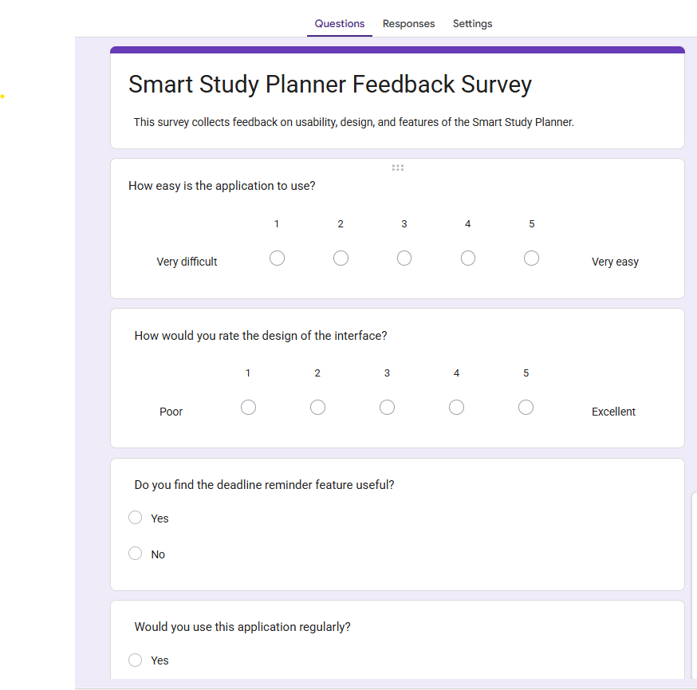
Visual 1: Screenshot of survey form

Summary of Feedback
The feedback highlighted several key findings:
- Ease of Use:
Most participants (4 out of 5) rated the interface as easy to understand (average score: 4.2/5). However, one user suggested clearer navigation between pages.
- Feature Usefulness:
All participants agreed that assignment tracking and deadline reminders were highly useful. The personalised schedule feature was rated slightly lower (3.8/5), as users wanted more flexibility.
- Design Feedback:
Users appreciated the dashboard but suggested improvements such as:
  - Adding colour-coded priorities
  - Including progress bars for visual clarity

- Additional Suggestions:
  - Integration with calendar apps
  - Mobile friendly design
  - Option to edit schedules dynamically

Analysis
The results indicate that the core functionality meets user needs, particularly in task organisation and deadline tracking. However, usability improvements and additional features could enhance the overall experience. The feedback also suggests that visual elements play a significant role in user engagement.
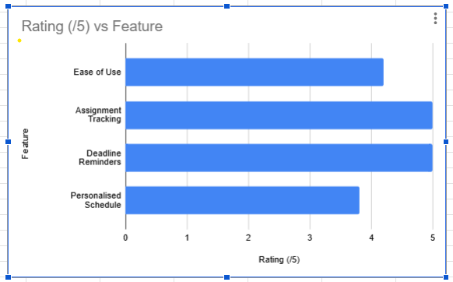
Visual 2: Chart showing feedback ratings – bar chart

Changes to be Implemented
Based on the feedback, the following improvements will be made:
- Improve navigation with clearer menu structure
- Add colour coded task priorities
- Enhance dashboard with progress indicators
- Allow users to edit schedules more flexibly
- Optimise layout for mobile devices

These changes align with the Agile methodology, allowing iterative improvements based on user feedback.

Q2: Implementation
The Smart Study Planner was developed as a web based application using front end and back end technologies. The implementation focused on core features such as task input, deadline management, and schedule generation.

Tools and Technologies Used
- Front end: HTML, CSS, JavaScript [2]
- Back end: The project does not use a traditional back end framework such as Python Flask or Node.js. Instead, it uses JavaScript with browser based local Storage to simulate a lightweight database for storing and managing user tasks.
- Database: Database: Not used. Data is stored using browser based localStorage to simulate a lightweight database system.
- Development environment: Visual Studio Code

Key Features Implemented

1. Login page
Enter correct login credentials.
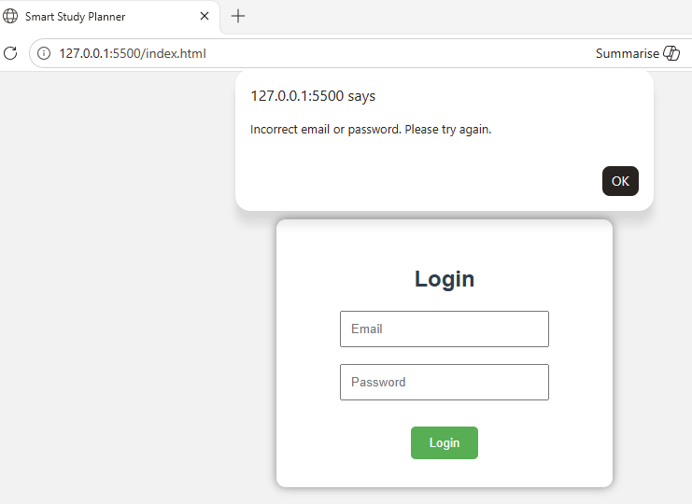Screenshot 1: Wrong credentials entered

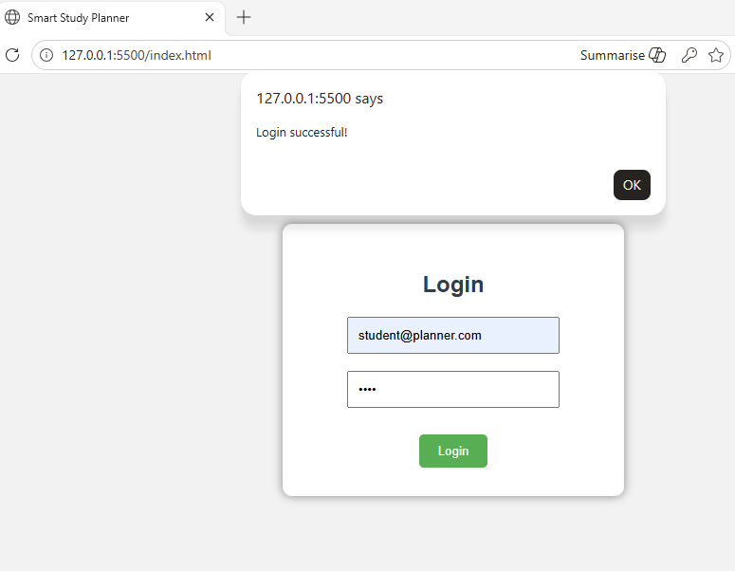Screenshot 2: Correct credentials entered

2. Dashboard Interface
After successful log in planner takes individual to dashboard, where users can input assignments with details such as module name, deadline, and priority level. It also has alerts for assignments due soon.
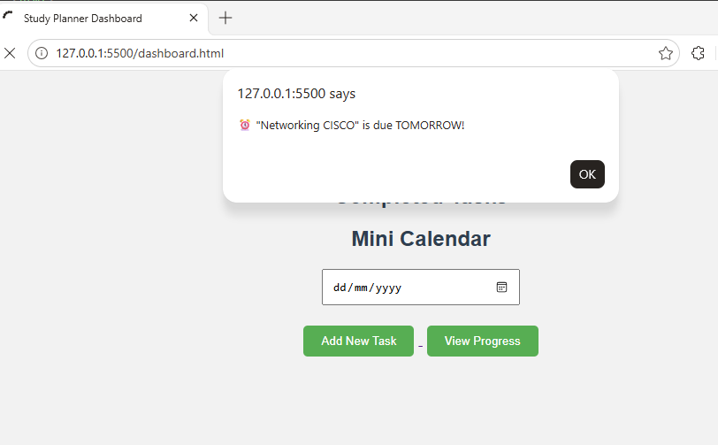
Screenshot 3: Alert showing in dashboard for upcoming task

3. Schedule Generation
The system generates a basic study schedule based on deadlines and priorities. Tasks are automatically organised to optimise study time.
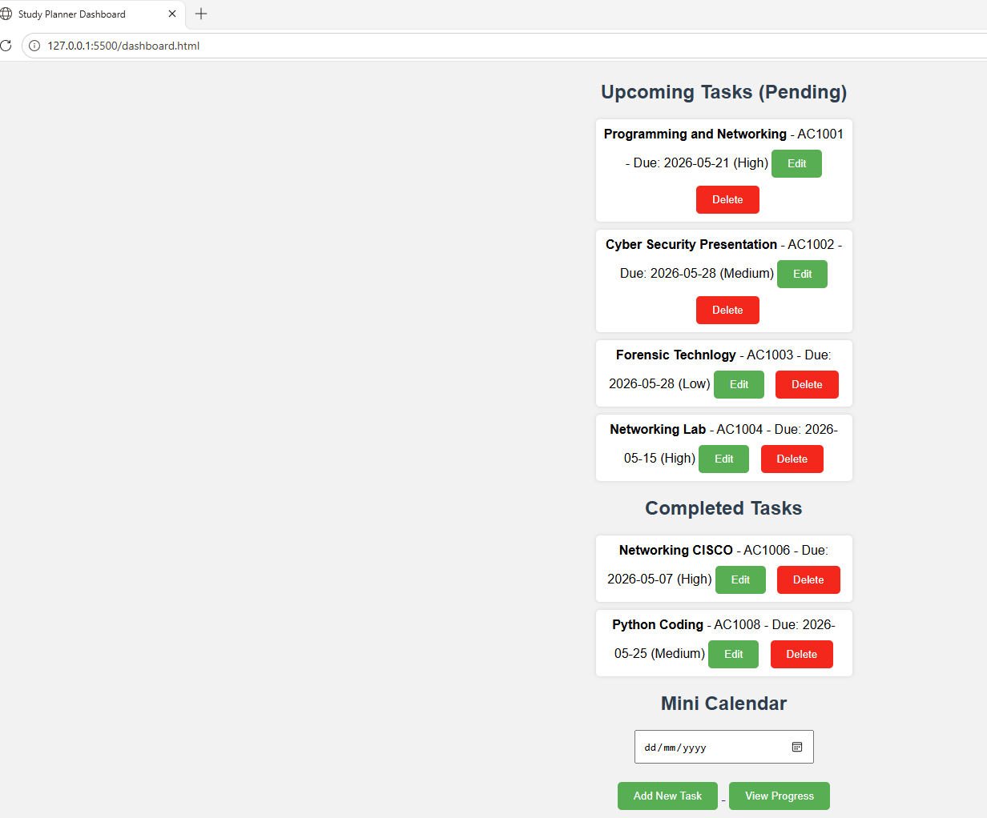
Screenshot 4: Pending and Completed tasks present in dashboard. Options to edit, delete, add new task and view progress present. This screen provides an overview of tasks and helps users track progress.

4.Task Input System
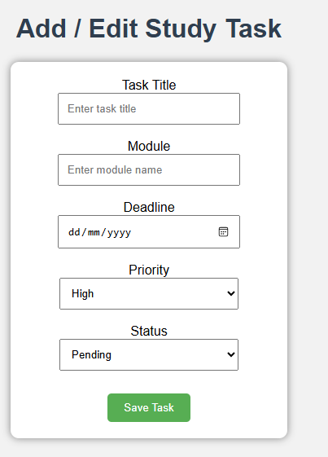
Screenshot 5: Add task , this interface allows users to enter assignment details, which are stored in the database.

5. Database Integration
A browser based storage system (localStorage) was used to store and manage user task data. This simulates basic database functionality by allowing data persistence within the user’s browser without requiring a backend database such as MySQL or SQLite.
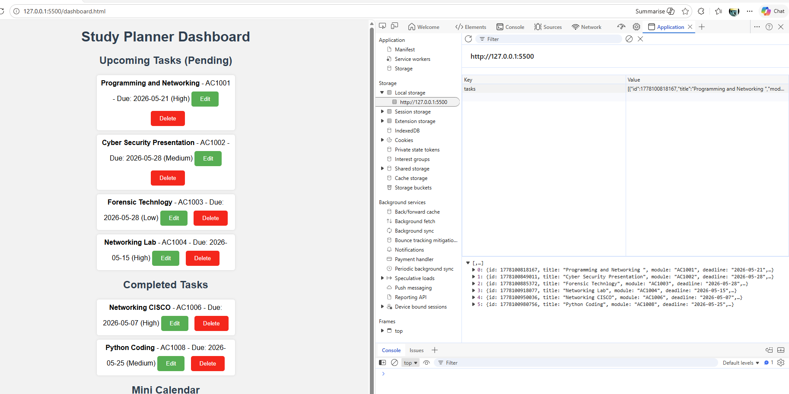Screenshot 6: Screenshot of the study planner dashboard showing dynamically retrieved and displayed task data stored in browser localStorage.

Troubleshooting
During development, several challenges were encountered:
• Data Handling and Storage Issues:
At the beginning, task information was not consistently appearing in the dashboard. This was caused by incorrect handling of browser based storage data. The issue was resolved by correctly converting stored data using JSON.parse() and ensuring tasks were saved in a consistent format within localStorage.
• Editing Functionality Challenges:
Implementing the ability to update existing tasks proved slightly complex, as initial attempts resulted in duplicate entries rather than modifying the correct task. This was addressed by assigning a unique identifier to each task and using it to accurately locate and update the selected entry.
• Interface Display Problems:
Some elements of the task list were not aligning properly when displayed dynamically. These layout issues were corrected through adjustments to the HTML structure and improvements to CSS styling, ensuring a cleaner and more responsive user interface.

Conclusion
The Smart Study Planner project successfully demonstrates how a simple web application can be used to manage academic tasks effectively using front end technologies. Throughout the development process, key features such as task creation, editing, deletion, and progress tracking were implemented using JavaScript and browser based storage.
In addition, building and refining the user interface helped improve awareness of usability and design considerations, particularly in making the system more intuitive and user friendly [4]. Overall, the project strengthened both technical and problem solving skills while demonstrating how basic web technologies can be combined to create a functional productivity tool.

Task 2: Enterprise & Innovation

T2 – Enterprise

Q1: Tech Start-up Concept

Start-up Name and Logo
The proposed start-up is called StudySync Technologies. The name reflects the core purpose of synchronising academic tasks and schedules efficiently for students.
The logo concept includes:
- A calendar merged with a checkmark (task completion)
- A modern blue and green colour scheme representing productivity and growth

Visual 1: generated logo image

Business Type (Legal Classification)
The start-up would operate as a Private Limited Company (Ltd) in the UK [5]. This structure is suitable because:
- It provides limited liability protection for owners
- It allows easier access to investment funding
- It establishes credibility with users and stakeholders

Business Strategy
The business strategy for StudySync Technologies focuses on a freemium SaaS (Software as a Service) model:
- Free Version:
Basic features such as task input, deadlines, and reminders

- Premium Version (Subscription based):
  - Advanced scheduling algorithms
  - AI-based study recommendations
  - Calendar integrations
  - Analytics and performance tracking
This approach helps attract a large user base while generating revenue from premium users [6].

Growth Strategy
- Target university students initially, then expand to schools and professionals
- Partner with universities for institutional adoption
- Develop a mobile application for wider accessibility

Funding Initiatives
Several funding options can support the start-up: [7]
- Seed Funding & Angel Investors:
Early stage investors can provide capital in exchange for equity
- Government Grants:
Support from organisations such as Innovate UK for tech innovation projects
- Crowdfunding Platforms:
Platforms like Kickstarter can help validate the idea and raise funds
- University Incubators:
Many universities offer mentorship and funding for student led start-ups
- Venture Capital:
Once the product scales, firms can invest for growth expansion

Q2: PEST Analysis with Legal & Ethical Considerations
A PEST analysis evaluates Political, Economic, Social, and Technological factors affecting StudySync Technologies. AI tools were used alongside external research sources to support this analysis [1].

Political Factors
- Government support for digital education tools creates opportunities
- Data protection laws such as General Data Protection Regulation (GDPR) must be followed [6]
- Policies on student data usage may restrict how information is stored and processed

Impact:
Compliance with regulations is essential to avoid legal penalties and build user trust.

Economic Factors
- Rising student population increases demand for productivity tools
- Economic constraints may limit students willingness to pay for premium services [8]
- Subscription based models must remain affordable
Impact:
A freemium model helps address financial barriers while maintaining revenue streams.

Social Factors
- Increasing academic pressure creates demand for time management tools [8]
- Growing awareness of mental health encourages use of stress reducing applications
- Students prefer mobile friendly and intuitive applications
Impact:
The application must be user friendly and supportive of student well-being.

Technological Factors
- Advancements in AI enable personalised study recommendations
- Cloud computing supports scalable and accessible systems [1]
- Cybersecurity risks require secure system design
Impact:
Continuous updates and innovation are necessary to remain competitive.

Legal Considerations
- Compliance with GDPR for handling personal data [6]
- Clear privacy policies and user consent mechanisms
- Intellectual property protection for software design [4]
Failure to meet legal requirements could result in fines or reputational damage.

Ethical Considerations
- Ensuring data privacy and confidentiality [6]
- Avoiding over reliance on automation that may reduce student independence
- Designing inclusive systems accessible to all users
Ethical design strengthens trust and promotes responsible technology use.

Factor | Description
Political | Government policies supporting digital education and technology innovation can benefit the platform. However, data protection regulations such as GDPR must be followed when handling user data [6].
Economic | Students may prefer free applications during financial constraints, making a freemium model important. Economic conditions can affect subscription-based revenue.
Social | Increasing demand for productivity tools among students supports the growth of the platform. Users expect simple, easy to use, and accessible digital solutions.
Technological | Advances in web and mobile technologies enable feature expansion such as mobile apps and cloud integration. Continuous updates are required to stay competitive.
Table 1: PEST analysis showing external factors affecting StudySync Technologies

Conclusion
The StudySync Technologies start-up presents a viable business opportunity within the education technology sector. With a strong SaaS strategy, diverse funding options, and awareness of external factors through PEST analysis [8]. Legal compliance and ethical considerations will play a critical role in ensuring long term success and user trust.

Task 3: Project Feedback & Reflection

Q1: Practical Feedback
To evaluate the Smart Study Planner implementation, feedback was collected from four university students using a short online questionnaire and informal discussion. The questionnaire included rating scale questions (1–5) on usability, functionality, and design, along with open ended questions for suggestions.
The feedback indicated that the application was generally easy to use, with an average usability rating of 4/5. Participants found the task input and deadline tracking features particularly useful. However, some users reported that the interface could be more visually engaging, and navigation between sections could be improved.
Additional suggestions included:
- Adding colour coded priorities for tasks
- Improving the dashboard layout
- Including mobile responsiveness

Based on this feedback, several improvements would be implemented. These include enhancing the user interface with better visual elements, simplifying navigation, and optimising the application for mobile devices. This iterative improvement reflects an Agile approach [4], where user feedback directly informs development.

Q2: Project Progress Diary
Throughout the project, weekly progress tracking was used to manage tasks and monitor development. This included setting goals, documenting completed work, and identifying challenges.
Overall, project management was moderately effective Key milestones such as design, database setup, and basic implementation were achieved on time. However, some delays occurred during the development phase due to underestimating the complexity of scheduling logic and debugging [9].
If the project were to be undertaken again, several improvements would be made:
- Break tasks into smaller, more manageable steps
- Allocate more time for testing and debugging
- Use project management tools such as Trello to organise tasks more efficiently [10]
Improved planning and time management would lead to a more structured and less stressful development process.

Q3: Skills Development
This project contributed significantly to the development of both technical and transferable skills.
Technical Skills
- Web development using HTML, CSS, and JavaScript [11]
- Basic database design and integration
- Understanding of backend development concepts

Transferable Skills
- Problem solving and debugging
- Time management and organisation [10]
- Communication skills through feedback collection

Additionally, experience with Agile methodology improved the ability to work iteratively and adapt to changes. These skills are valuable for future academic and professional projects.

Q4: Positive Social Impact (PSI)
The Smart Study Planner has the potential to create a positive social impact, particularly within the student community. By helping students organise their workload and manage deadlines effectively, the system can reduce academic stress and improve productivity.
The application also promotes better time management habits, which are essential for both academic success and future employment. Furthermore, the project encourages the use of digital tools to enhance learning and personal development [10].
From a broader perspective, the skills developed during this project, such as problem solving and software development can contribute to society by enabling the creation of future technological solutions that address real world problems.

Conclusion
In conclusion, the Smart Study Planner project provided valuable insights into both technical development and project management. Feedback from users highlighted strengths in functionality while identifying areas for improvement, particularly in design and usability [1]. Reflecting on the development process emphasised the importance of effective planning, time management, and iterative improvement, which are key principles in software development [2]. The project also supported the development of both technical and transferable skills, which will be beneficial in future work. Overall, the project demonstrates how technology can be used to create practical solutions with a positive impact on individuals and society.

Appendix
Week | Planned Tasks | Work Completed | Challenges Faced | Actions Taken / Reflection
Week 1 | Define project idea and scope | Completed project proposal and selected Smart Study Planner | Difficulty narrowing down features | Focused on core features (tasks, deadlines, schedule)
Week 2 | Create system design (wireframes, flowcharts) | Designed basic wireframes and system flow | Limited design experience | Used online examples to improve layout ideas
Week 3 | Set up development environment | Installed tools and created project structure | Initial setup confusion | Followed tutorials to configure environment
Week 4 | Develop task input feature | Implemented form for adding assignments | Form validation issues | Debugged code and tested inputs thoroughly
Week 5 | Implement database integration | Connected application to database | Connection errors | Fixed configuration and tested queries
Week 6 | Create dashboard interface | Built basic dashboard to display tasks | UI layout issues | Adjusted CSS and improved structure
Week 7 | Develop scheduling feature | Implemented basic task sorting by deadline | Complexity in scheduling logic | Simplified algorithm using priority sorting
Week 8 | Testing and feedback collection | Gathered feedback from users | Limited time for testing | Focused on key features and usability
Week 9 | Final improvements and documentation | Improved UI and completed report | Time pressure | Prioritised essential improvements
Table 1: A summary of weekly progress is shown in Table 1, demonstrating task planning, challenges encountered, and reflective improvements throughout the project lifecycle.

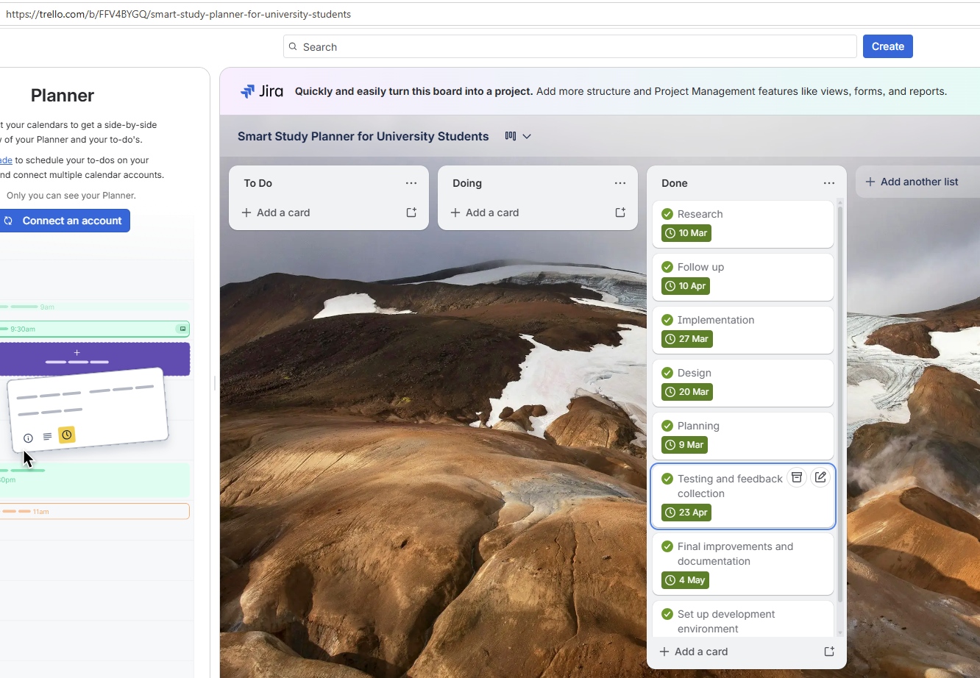
Screenshot 7: Similar chart in Trello: Smart Study Planner for University Students | Trello

Screenshot 8: LinkedIn training: Learn more with learning paths | LinkedIn Learning


Screenshot 9: LinkedIn training certificate on completion Introduction to Wed Design and Development course.

References

[1] | I. Sommerville, Software Engineering, 10 ed., Pearson, 2016.
[2] | R. Pressman and B. Maxim, Software Engineering: A Practitioner’s Approach, 8 ed., McGraw-Hill, 2015.
[3] | Google, “Google Forms,” [Online]. Available: https://forms.google.com.
[4] | M. D. Network, “Web Development Guide,” [Online]. Available: https://developer.mozilla.org.
[5] | U. Government, “Guide to setting up a private limited company,” [Online]. Available: https://www.gov.uk.
[6] | E. Union, “General Data Protection Regulation (GDPR),” 2018.
[7] | I. UK, “Funding opportunities,” [Online]. Available: https://www.ukri.org.
[8] | M. Porter, Competitive Strategy, Free Press, 2008.
[9] | M. D. Network, “Web Security Guidelines,” [Online]. Available: https://developer.mozilla.org.
[10] | Atlassian, “Agile Project Management,” [Online]. Available: https://www.atlassian.com.
[11] | M. D. Network, “Web Development Basics,” [Online]. Available: https://developer.mozilla.org.

