An Assignment
on
Why Psychology is relevant in our Health and Social Care practice?

Module Name: Psychology in Health and Social Care
Module Code: LCHS4006

Submitted by, Submitted to,
Sumi Teresa Ascension Alice Clayton
Student ID: 2130237

Table of Contents

Topic | Page No.
Introduction | 3
Freud’s Psychodynamic Theory | 3
Erikson’s Psycho-social Development Theory | 4
Frustration Aggression Hypothesis | 6
Conclusion | 7
References | 9

Introduction:

Psychology is highly relevant in the health and social care sectors due to its focus on understanding human behaviour and mental processes. A healthcare professional who understands psychological theories of lifespan development behaviour can be more effective in their role for several reasons. Understanding psychological theories of lifespan development behaviour allows healthcare professionals to provide more patient-centred care. By understanding how different developmental stages and life events can impact behaviour, emotions, and coping mechanisms, healthcare professionals can develop personalised care plans that consider the unique needs and circumstances of each patient. This report will outline the theories of Freud’s Psychodynamic Theory, Erikson’s Psycho-social Development Theory and Frustration Aggression Hypothesis (FAH). It will show how these can be used by health and social care professionals in a range of settings in order to argue that knowledge of psychology can be hugely beneficial for the professional and the service user.

Freud’s Psychodynamic Theory:

Sigmund Freud’s psychodynamic theory is a psychological approach that emphasises the role of unconscious thoughts and emotions in human behaviour. Freud’s theory consists of three main components: the id, ego, and superego. The id represents our primal instincts and desires, such as the need for food, sex, and safety. The superego represents our moral and ethical values, while the ego is responsible for mediating between the conflicting demands of the id and superego. (Freud, 1923)

Another important aspect of Freud’s theory is his concept of the psychosexual stages of development. According to Freud, individuals go through several stages of psychosexual development during childhood, each with its own set of psychological conflicts and challenges. These stages include the oral stage, anal stage, phallic stage, latent stage, and genital stage.
Sigmund Freud’s theory of defence mechanisms is a concept in psychodynamic theory that describes how the mind defends itself against unconscious conflicts and anxiety.(Freud,1915).

According to Freud, defence mechanisms are unconscious strategies that the ego uses to cope with the demands of the id and the superego. Repression refers to the unconscious process of pushing unacceptable or threatening thoughts, memories, or emotions out of conscious awareness (Anderson, 2006). Displacement, on the other hand, refers to the redirection of unacceptable or threatening impulses or emotions from peoples original targets onto a less threatening or more socially acceptable target. This is often done unconsciously as a way of avoiding the anxiety or conflict that would arise if the impulses or emotions were directed toward their original target (Di Giuseppe and Perry, 2021).

Example 1:

One real-life example of Freud’s theory in action can be seen in a child who experiences trauma or neglect during their early years. A child who has experienced abuse or neglect may display behaviours that are consistent with Freud's theory on the impact of early childhood experiences on personality development. The child may exhibit signs of oral fixation, such as excessive thumb-sucking or nail-biting, as a way of coping with stress and anxiety. Understanding Freud's theory can aid healthcare and social care providers in developing effective interventions for traumatized or neglected children. Consistent, nurturing care and positive reinforcement from providers can help foster a sense of trust and security in children, mitigating the negative impact of early experiences. Providers can work with parents and caregivers to identify and address any underlying issues that may be contributing to the child's behaviour, such as parental substance abuse or mental health issues.

Although Freud’s theory can help the care providers to understand the child's behaviour however knowledge on Erikson’s development stages (Knight, 2017) and Piaget’s cognitive development is also necessary as Piaget focused on how children's thinking and reasoning abilities develop over time and emphasised the importance of early childhood experiences in shaping cognitive development and overall personality. (Piaget, 1950)

Erikson’s Psycho-social Development Theory:

Erik Erikson's theory of psychosocial development is a developmental theory that focuses on the various stages of psychological and social growth that individuals go through across their lifespan. Erikson believed that individuals go through eight stages of psychosocial development, each with its own unique set of challenges and opportunities for growth. The eight stages of Erikson's theory are listed in diagram below:

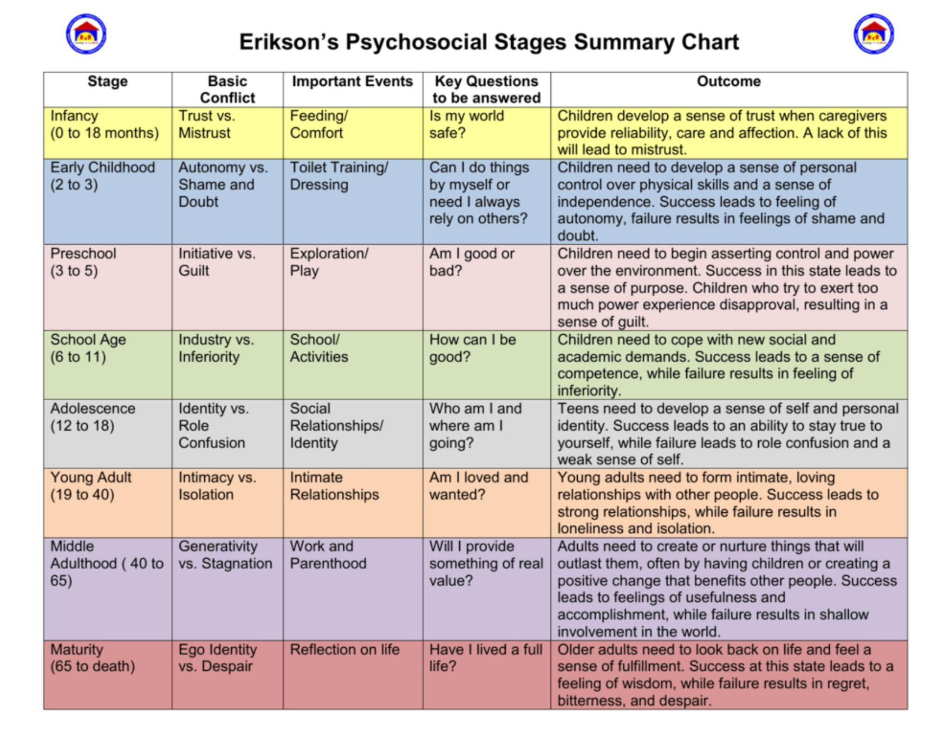
Diagram 1: Erikson’s eight psychosocial stages

Erikson emphasised the social factors that shape development. Erikson described a progression of psychosocial stages that are relevant to people from various cultures and socio-economic groups. In his view, every stage of life is distinguished by a challenge or conflict that the person must face and make an effort to overcome (Erikson, 1950). According to Erikson, successfully resolving each crisis leads to the development of a psychological strength or virtue that helps individuals cope with future challenges and unresolved crises at earlier stages can cause later problems such as mental health issues, identity crisis, depression, anxiety or relationship difficulties.

Example 2:

An example of Erikson’s theory could be a teenager who is struggling with identity issues and experiencing anxiety or depression. According to Erikson's theory, the teenager may be in the stage of "identity versus role confusion," which is associated with the task of developing a sense of self and a clear understanding of one's values and beliefs. (Erikson, 1959) In this scenario, the healthcare provider can help the teenager to work through this developmental task by providing supportive counselling and guidance. The provider can help the teenager to explore their interests and values, and to identify their strengths and weaknesses. They can also help the teenager to develop coping strategies for managing anxiety and depression, such as mindfulness techniques or cognitive behavioural therapy. (Erikson, 1959) By addressing these psychosocial needs, healthcare providers can support the teenager's healthy development and help to prevent long-term mental health issues.

However, at this age as adolescents develop their sense of identity they are also strongly influenced by their peers. Therefore, it might also be important to be familiar with Social Identity Theory which proposes that individuals categorise themselves and others into social groups based on shared characteristics, and group memberships can strongly influence behaviour and attitudes towards others then the service provider can take a proactive and holistic approach to care that considers not just the teenager's physical health but also their psychosocial needs, healthcare providers can help to promote healthy development and well-being during this critical stage of life (Tajfel and Turner, 1979).

Frustration Aggression Hypothesis:

The Frustration-Aggression Hypothesis is a theory that proposes that frustration is the cause of aggression. This theory suggests that aggression is a natural response to frustration and that when individuals are prevented from achieving a goal, they become frustrated and this frustration leads to aggression. According to Dollard et al., frustration occurs when an individual is blocked from achieving a desired goal or objective. This frustration then creates a negative emotional state, which may lead to aggressive behaviour (Dollard et al., 1939). The frustration-aggression hypothesis has been supported by numerous studies. For example, research has shown that individuals who experience frustration are more likely to engage in aggressive behaviour than those who do not (Berkowitz, 1989). Additionally, studies have found that frustration can increase physiological arousal, which can increase the likelihood of aggressive behaviour.

Example 3:

An example of the frustration-aggression hypothesis in a health and social care setting might be a patient who is experiencing long wait times to receive medical treatment. The patient may become increasingly frustrated and angry due to the delay, and this frustration may lead to aggressive behaviour towards healthcare workers, such as yelling or making unreasonable demands. In this scenario, the frustration of unmet needs or goals leads to aggressive behaviour towards others, which can have negative consequences for the individual and the healthcare system as a whole. It highlights the importance of addressing and managing frustrations and stressors in healthcare settings to promote positive patient outcomes and support the well-being of caregivers and healthcare professionals.

To prevent aggressive behaviour in these settings, it is important for healthcare and social care providers to effectively communicate with their patients or clients, provide clear and comprehensive information, and address any concerns or issues that may arise. Also, if a patient becomes angry at a member of staff they should not take it personally rather, they should try to remain calm and professional and work to de-escalate the situation. This may involve acknowledging the patient's feelings, validating their experience, and helping them to identify alternative ways to cope with their frustration that do not involve aggression.

One potential weakness of the frustration-aggression hypothesis is that it may oversimplify the complex process of aggression and frustration does not always lead to aggression. For example, some people may respond to frustration with a sense of humour, while others may channel their frustration into constructive problem-solving or creative endeavours. Thus, while frustration can be an important factor in some instances of aggression, it is not a universal cause, and other individual and situational factors may also play a role (Berkowitz, 1989).

Conclusion:

In conclusion, understanding psychological theories of lifespan development can enhance healthcare professionals' ability to provide optimal care, communicate effectively, identify issues, and manage their emotions. These skills lead to improved patient outcomes and better healthcare quality. Erikson's psychosocial theory, Freud's psychosexual theory, and the frustration-aggression hypothesis all inform our understanding of human behaviour and development. Erikson highlights the significance of social interaction and identity formation, while Freud focuses on the role of sexual desires in shaping personality. The frustration-aggression hypothesis sheds light on the link between frustration and aggression. These theories aid in comprehending human behaviour, and their applications can enhance education, mental health, and health and social care. It can be suggested that all theories need to be used together to enable a true understanding of the complexity of human behaviour. Each theory offers unique insight, but multiple theories enrich our understanding and ability to intervene and promote well-being in individuals and communities.

References:

Anderson, M.C., (2006) ‘Repression: A cognitive neuroscience approach’, Psychoanalysis and neuroscience, pp.327-349.

Bandura, A. (1977) Social learning theory. Englewood Cliffs, NJ: Prentice Hall.

Bandura, A. Ross, D., & Ross, S. A. (1961) ‘Transmission of aggression through the imitation of aggressive models’, Journal of Abnormal and Social Psychology, 63, p.575-582

Berkowitz, L. (1989) ‘Frustration-aggression hypothesis: Examination and reformulation’, Psychological Bulletin, 106(1), pp.59-73. Available at: doi:10.1037/0033-2909.106.1.59

Di Giuseppe, M. and Perry, J.C. (2021) ‘The hierarchy of defence mechanisms: Assessing defensive functioning with the Defense Mechanisms Rating Scales Q-Sort’, Frontiers in Psychology, 12, pp.718440.

Dollard, J., Doob, L. W., Miller, N. E., Mowrer, O. H., & Sears, R. R. (1939). Frustration and aggression. New Haven, CT: Yale University Press.

Erikson, E. H. (1950) Childhood and society. New York: Norton.

Erikson, E. H. (1959) Identity and the life cycle. New York: International Universities Press.

Erikson’s Psychosocial Stages Summary Chart. Available at: https://www.pinterest.co.uk/pin/713820609665421107/ (Accessed on 21 March 2023)
Freud, S. (1915) The unconscious. SE, 14: 159-204.

Freud, S. (1923) The ego and the id. SE, 19: 1-66.

Freud, S. (1900) The Interpretation of Dreams. Vienna: Franz Deuticke.

Knight, Z.G. (2017) ‘A proposed model of psychodynamic psychotherapy linked to Erik Erikson's eight stages of psychosocial development’, Clinical psychology & psychotherapy, 24(5), pp.1047-1058.

Piaget, J. (1929) The Child's Conception of Physical Causality. London: Routledge & Kegan Paul.

Piaget, J. (1950) The Psychology of Intelligence. London: Routledge & Kegan Paul.

Tajfel, H., Turner, J. C., Austin, W. G., & Worchel, S. (1979) ‘An integrative theory of intergroup conflict’, Organisational identity: A reader, p.56-65.

