ECIE5010

Elisa Parry – 2115500

Keeping our Children safe

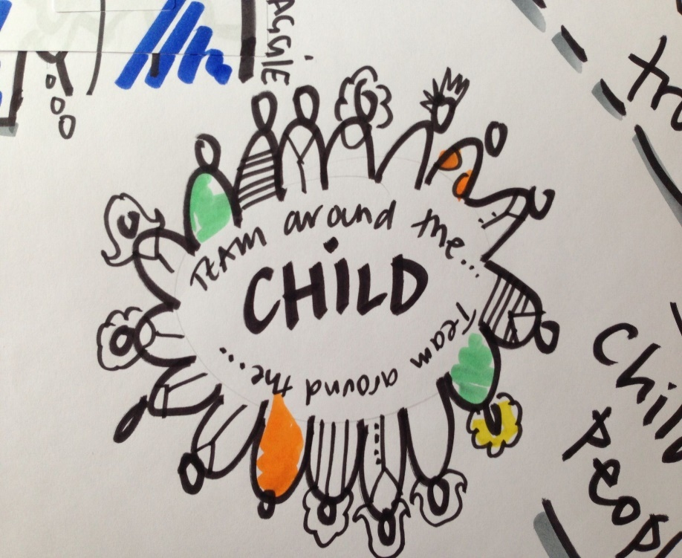

Image source: Pinterest

Critically discuss the limits and benefits of the multi-Agency approach in Wales for Safeguarding children and young people.
In this essay I will explore multi agency looking at the benefits and limitations of multiagency work in Wales for safeguarding children and young people. The situation and sad death of Victoria Climbie will be researched and what came from it as a result of her death. It will look at the theory of Uri Bronfenbrenner and his links to the environment and social factors of life. Also, safeguarding and child protection will be discussed and the difference between the two, how schools deal with both and thinking about being safe online and how important it is that children know the dangers.
What is child protection and safeguarding?
We are ALL responsible for child protection and safeguarding in our roles as practitioners. Safeguarding is keeping our children safe and we all must ensure we are always alert to situations that are of concern or signs of abuse, so that children are free from harm, harassment and abuse (Save the Children, ND). It is essential that we ‘protect’ and ‘prevent’ and ensure they grow up within a safe and harmless environment. Safeguarding also includes safer recruitment, staff training, supervisions, up to date policies and risk assessments. Child protection is part of safeguarding process but the way in which we deal with children that have been identified as being at risk or have been harmed (NSPCC Learning, 2024).

The internet is an excellent resource and especially for individuals to stay connected in this busy world which can also support our health and wellbeing. The internet was an essential commodity during the pandemic as we were able to stay in touch with our friends and relatives. The internet and being online is so beneficial for so many reasons. Learning, communication, banking, bills, shopping, working from home and entertainment (Hope, 2022). Although, it does have its downside. So many are using online banking and High Street banks are closing, purchasing shopping online means that you don’t have that whole experience of seeing what you are actually buying and working from home means you have lost that social experience within the workplace.

Safeguarding children and keeping them safe is exceptionally difficult and especially when they are away from home. Education can come as a result of good parenting but in the 21st century and the world wide web, it can prove even more arduous. So how can we keep children and young people safe online when using the internet? Education is key, and within schools across the country they celebrate Internet Safety Day every year. This is where schools will educate the children regarding Internet safety, including the do’s and don’ts and the school where I work always has a visit from a local police officer who will discuss online safety and especially social media. There are many risks online that children are unaware of and need educating about. The safer internet day has a website with free resources and information regarding the internet and this year’s theme is “Inspiring change?” and is currently celebrated in over 170 countries worldwide (Safer Internet, 2024).

All schools have a safeguarding policy and every school takes safeguarding and child protection extremely seriously. The school where I work ‘fully recognises the contribution it makes to safeguarding’ and concentrates on 3 main elements – Prevention, Identifying and Reporting and Support. All schools will have a Designated Senior Person and also a Deputy Designated Senior Person in their absence for all staff to report to in the event of a disclosure or a problem. But how do we ensure we employ trustworthy staff in our schools? The system is not exactly fool proof but from gaining references from past employers and doing DBS checks (Disclosure and Barring Service which checks your criminal record and will decide whether you are suitable to work with children or adults) goes some way into ensuring the staff are trustworthy to work with children but only really from the time of the check. Regular supervisions and training is also essential to ensure all staff are up to date and have the knowledge of what to do if a child discloses information to them. There is also a ‘flowchart’ displayed giving instructions if needed. All staff must be alert to other staff in ensuring they work within the guidelines following the Wales Safeguarding Procedures (2019) (Llanfaes C P School, 2022).

Multi-agency is a working partnership between various agencies, with the same plan of action to ensure good outcomes for children and to keep them safe. Multi-agency can include representatives from many different organisations like Social Workers, GP’s, Teachers, Police Officers and Health Visitors that come together with their individual level of expertise, skills, ideas and knowledge in their own field, to share information so that these professionals can understand any risks that the child is exposed to and putting processes in place to keep the children safe (NSPCC, 2024).
On 25th February 2000, Victoria Climbie died at the hands of her great aunt and her aunt’s boyfriend having been abused and neglected over time revealing 128 separate injuries on her body. She was made to sleep in a cold bathroom (in the bath) and was deformed and malnourished, living in her own urine and faeces (Laming, 2003).
Many people had met Victoria and had noticed that maybe something wasn’t right – the wig, the cuts on her hand, marks on her face and fingers but none of this was reported or mentioned to the relevant sources. Victoria’s Aunt had asked the childminder to take Victoria in for good as the boyfriend wasn’t happy with Victoria staying with them. These should have all been a massive red flag because why all of a sudden, did she wanted to give her up. Not only that, Victoria looked ill. So many questions to be asked as to why this was allowed to happen. Why was Victoria allowed to leave hospital with noticeable marks on her body and then allowed to return into her aunt’s care. If the nursing staff had visibly seen the marks and bruises on Victoria, then why didn’t they challenge the social workers decision, then it may be a different situation now and Victoria may still be alive (Laming, 2003).
After her death, a serious case review was undertaken and a report was written by Lord Laming, partly in response to her death and the fact that she was let down by the authorities and what could have been done to improve this. Alongside this report, ‘Every Child Matters’ was produced in 2003 brought about by the Children’s Act 2004 to ensure the wellbeing of children is paramount and that multi agencies are working together and sharing all the information they hold on children up to the age of 19 or 24 if the child has a disability. If this was in place before 2003 it might have prevented Victoria’s death (Brendan Fleming, 2024). New systems and 108 recommendations were put in place to ensure that this never happens again. The children’s interest are top priority, they have parental guidance, freedom of expression and have life survival and development, plus many factors as part of the UNCRC (United Nations Convention on the Rights of the Child) (Unicef, 2024).
Multi-agencies should be robust and all agencies with interest in the child should have them at the centre of all discussions. Communication is imperative in ensuring the well being of the child and to ensure that the best outcome is achieved. Sharing the correct information is also important to ensure that all relevant information is discussed (NSPCC, 2023). The Multi-Agency Safeguarding Hub (MASH) in Bridgend will ensure an early, higher quality sharing of information and decision making. Professionals are able to protect the most vulnerable children with additional information with referrals from both the public and professionals too. The MASH team is made up of individuals from:
- Bridgend County Borough Council
- Landlords
- Probation
- Health (Camhs)
- Police Public Protection Unit
- Child Sexual Exploitation
- Voluntary Organisations
- Adult Safeguarding Team

And many more organisations to ensure the wellbeing and safety of the child (Bridgend County Borough Council, 2024).

However, multi-agency working does come with its benefits and challenges as the process is not always straight forward and can be quite complex involving so many people coming together at one time.

Benefits of multi-agency working.
- Single point of contact for all safeguarding concerns where all agencies come together to form a holistic approach
- Different expertise of each agency working together to discuss ideas and the way forward
- Improved outcomes for children where support is accessible on an as and when basis
- All agencies together form a stronger/louder voice, break down boundaries and repel small-minded attitudes
Barriers/challenges to multi-agency working;
- Individuals may not want to share all the information they hold, but this is essential that they do, as each organisation is one piece of the jigsaw
- Cuts to funding and therefore less staff employed within the service and not able to be involved in certain cases as their workload is too great
- Maybe some of the participants of the panel are not able to attend on the day of the meeting, which doesn’t give a true picture if not all the information is shared
- Different ways of working can cause stress within the meetings and may result in the breakdown of communication
(Sage, 2008)

Urie Bronfenbrenner (1977) was an American theorist that researched human development and the different relationships that a child could experience. He believes that teachers are more aware of the importance of positive relationships around that child and therefore the need for those individuals to be vigilant. Bronfenbrenner created the ecological systems theory and stated that children need a support system around them to enable them to thrive and develop. Firstly, from their parents, close family, teachers, then moving onto neighbours and friends of friends, health care professionals and interventions (Guy-Evans, 2024). So many different relationships are involved with a child and it is evident that relationships and environmental factors have a huge part to play in the child’s development (Bates, 2019).

Overall, it is evident that every topic discussed above is absolutely essential in the safeguarding of children at home, school and life in general from abuse, harassment and harm. There are many individuals involved in a child’s life apart from the parents and it is their job to ensure that no harm comes to that child. Also in school, it is everyone’s responsibility for the safeguarding of children to ensure prevention, identifying and reporting and supporting any children who may have made a disclosure, but in general to be vigilant on a daily basis in noticing any changes that might be of concern (Llanfaes C P School, 2022). So many different factors surrounding the child that can have a negative effect on both their development and behaviour. Schools have a vital role to play in demonstrating positive relationships with all children and the adults that the child has contact with. They also play a vital role in safeguarding and child protection (Save the Children, ND) (NSPCC Learning, 2024), following policies and procedures and legislation which will protect the child from harm, harassment and abuse and knowing who to contact in the event of those situations (Department for Education, 2024).
Multi-agencies can work well if all parties are involved 100%,
1) To share information in a timely manner (especially if there is a risk to life)
2) Decision making
3) Interventions (Home Office, 2024)
They all individually can make a huge difference to a child’s life but especially if all parties unite for the benefit of the child, as the child is central in all situations.

We can all make a difference in a child’s life to support them and ensure they are free from harm. We are able to guide them to assist in their development and give advice to parents if needed. Everything we undertake is for the benefit of each and every child in our class and the whole school, following the correct policies and procedures so they are able to live a happy, healthy life.

References
Bates, B., 2019. Urie Bronfenbrenner. In: N. Carrier, ed. Learning Theories Simplified. London: Sage, pp. 194-195.
Brendan Fleming, 2024. Every Child Matters. [Online]
Available at: http://www.brendanfleming.co.uk
[Accessed 10 April 2024].
Bridgend County Borough Council, 2024. Multi-Agency Safeguarding Hub. [Online]
Available at: http:www.bridgend.gov.uk
[Accessed 19 April 2024].
Department for Education, 2024. Children's Act 2004. [Online]
Available at: http://www.legislation.gov.uk
[Accessed 20 April 2024].
Guy-Evans, O., 2024. Bronfenbrenner's Ecological Systems Theory. [Online]
Available at: http://www.simplypsychology.org
[Accessed 18 April 2024].
Home Office, 2024. Multi agency working and information sharing project, London: Home Office.
Hope, C., 2022. What are the advantages of the Internet?. [Online]
Available at: http://www.computerhope.com
[Accessed 17 April 2024].
Laming, L., 2003. The Victoria Climbie Inquiry, Norwich: Licensing Division.
Llanfaes C P School, 2022. Safeguarding Policy. Brecon: Llanfaes C P School.
NSPCC Learning, 2024. Getting Started with Safeguarding and Child Protection. [Online]
Available at: http://www.learning.nspcc.org.uk
[Accessed 10 April 2024].
NSPCC, 2023. Multi agency working. [Online]
Available at: http://www.learning.nspcc.org.uk
[Accessed 3 April 2024].
NSPCC, 2024. Multi-agency working. [Online]
Available at: http://www.learning.nspcc.org.uk
[Accessed 25 March 2024].
Safer Internet, 2024. Inspiring Change? Making a difference, managing influence and navigating change online. [Online]
Available at: http://www.saferinternet.org.uk
[Accessed 19 April 2024].
Sage, 2008. The Benefits and Challenges of Collaborative Multi-Agency Working, London: Sage .
Save the Children, ND. Safeguarding. [Online]
Available at: http://www.savethechildren.org.uk
[Accessed 10 April 2024].
Unicef, 2024. Convention on the Rights of the Child. [Online]
Available at: http://www.unicef.org
[Accessed 3 April 2024].

