

LEVEL 4 ASSESSMENT SPECIFICATION

Student name: | Joel Taylor | Student ID number: | 2511916
Programme: | BSC in Supply Chain and Logistics
Module: | Data Analytics Principles
Module code: | ACMA 4016 | Contribution to Overall Module Assessment (%): | 100%
Lecturer: | Dr Moutushi Tanha | Internal Verifier: | Dr Irina Neaga
Assignment Title: | Developing a Data-Based Report | Word count (or equivalent): | 1500 words
Submission deadline: | 04/03/2026 | Return date of provisional marks & written feedback: | 20 working days after submission
Submission method: | All written assessments, where practical and possible, must be submitted via Turnitin unless otherwise instructed by the Lecturer. (Please DO NOT put this assessment specification into Turnitin or it will match many similarities with other students’ submissions.)  Alternative submission method (if applicable):  Late submission of the assessment will result in a late penalty mark:  Work which is submitted up to 1 week late will be capped at 40% for the first attempt and will be awarded a mark of 0% for re-assessment. Late submission penalties may be lifted only if there is an approved extenuating circumstances claim.  Work submitted more than 1 week late will be considered as a non-submission and will not be marked. The work may be considered as a submission for reassessment if offered by an Examining Board or if there is an approved extenuating circumstances claim.
Academic honesty / referencing: | Academic honesty is required. In the main body of your submission, you must give credit to authors on whose research and ideas your work is based. Append to your submission a reference list that indicates the books, articles, etc. that you have used, cited or quoted in order to complete this assessment.

Module Learning Outcomes
(from module syllabus)
Upon the successful completion of this module, the student should be able to:
- understand the fundamental concepts and principles of data analysis, management systems and will be developing practical skills in using data analysis tools and systems in logistics and supply chains.

TASK DESCRIPTION

Use of Generative AI in Assessment
(Lecturer to indicate Yes or Not against each element)

RESEARCH | For this assessment, you can use Generative AI to support you in research, including searching for bibliography, using tools to summarise, compare and interrogate materials. | Yes ☒  No ☐
STRUCTURE | For this assessment, you can use Generative AI to support you in structuring your submission, including creating a draft argument structure, identifying parts and headings, etc. | Yes ☒  No ☐
PROOFREADING | For this assessment, you can use Generative AI to check your own text/creation for grammatical and syntactical mistakes, including rephrasing of your own work within specific standards. | Yes ☒  No ☐
WRITING | For this assessment, you can use Generative AI to create text for submission. | Yes ☐  No ☒
CREATIVE | For this assessment, you can use Generative AI to create creative materials, such as images. | Yes ☐  No ☒
PROGRAMMING | For this assessment, you can use Generative AI to create and check code. | Yes ☐  No ☒
NONE | For this assessment, you are not allowed to use any type of Generative AI support. This includes research support, structure support, writing/proofreading support and creative support. | Yes ☐  No ☒
AI Acknowledgement
I confirm that I have not present any AI-generated materials as my own work in this portfolio.
However, I acknowledge that I have used or may have used the AI in the research and proofreading of my portfolio.
Name: Joel Taylor
Student ID: 2511916

Executive Summary
Safran is a manufacuring firm based in the UK that specialises in the design and manufacture of aircraft seating systems for commercial flights. The facility is in charge of the machining, assembly, surface treatments, and final construction of seating parts that are delivered to significant aerospace clients across the globe. Accurate planning and dependable systems are necessary to make sure production continuity and customer satisfaction because the aerospace sector is highly regulated and has strict delivery dates.
This report looks at a significnt internal operational issue that Safran encountered in 2024 and 2025 after switching from the BAAN Enterprise Resource Planning (ERP) system to Infor M3. Procurement, inventory control, and production planning were all severely disrupted by the system move, which had a detrimental effect on overall business performance. The issues history, its impacts on the organization, and the steps made to lessen those effects are all covered in the report.

Introduction
This report presents a business analysis using data analytics to gain insight into a critical issue experienced at Safran. The problem explored relates to the implenentation of a new ERP system, where the company transitioned from BAAN to Infor M3 as part of a wider digital transformation strategy.
While the change was intended to modernise operations and improve long-term efficiency, the short-term effects proved challenging. Issues such as inaccurate data migration, system integration problems, and reduced user familiarity led to disruption across supply chain, finance, and production functions. As safran operates within a customer-driven, make-to-order environment, even minor system inaccuracies resulted in delays, shortages, and planning instability.
The analysis draws on procurement, logistics, and production data collected throughout 2024 and into late 2025, providing a detailed view of how the system change affected day-to-day operations and overall performance.

Background of the Problem
Before the transition, BAAN had been used at Safran for many years and was well understood by employees across departments. Even though the system was dated, it was stable and worked well with existing business processes. The decision to move to Infor M3 was driven by the need for improved scalability, enhanced reporting capabilities, and better integration with other SAFRAN group sites.
However, during and after the system went live,several issues emerged. Key master data such as bills of materials, lead times, routing information, and stock parameters were either incorrectly transferred or not fully aligned with M3’s structure. This resulted in inaccurate Material Requirements Planning (MRP) outputs, causing shortages of critical components and, in some cases, excess inventory of low-priority items.
The aerospace sector relies heavily on precise scheduling and traceability. Safran sources thousands of individual parts, including fasteners, brackets, foams, textiles, and machined components, all of which must be available at the right time to support assembly. With M3 producing unreliable demand, procurement teams struggled to place accurate orders, and production planners were forced to rely on manual workarounds, spreadsheets, and system overrides.
Additionally, staff training on the new system was limited prior to its ‘launch’. This led to inconsistent system usage across departments which further reduced the quality of dataand confidence in the system’s outputs. The combined effect was reduced On-Time Delivery (OTD), increased expediting costs, and pressure on customer commitments.

Impact on the Business
The disruption caused by the BAAN to M3 transition had a noticeable effect on operational performance. Production schedules were frequently revised due to missing parts, resulting in ineficiencies such as line stoppages, rework, and increased labour costs. Procurement teams faced difficulties managing suplier lead times, as system-generated requirements often did not reflect actual production needs.
Inventory accuracy also declined, with discrepancies between physical stock and system records becoming more common. This led to increased time spent on stock investigations and cycle counts, diverting resources away from value-added activities. From a financial perspective, the business experienced higher costs due to urgent purchases, premium freight, and delayed deliveries to customers.
Customer confidence was also impacted, as committed delivery dates had to be changed more frequently. In an industry where reliability and trust are important, maintaining strong customer relationships became increasingly challenging during this period.

Actions and Mitigation Measures
To address the issues, Safran implemented several short- and medium-term measures. Cross team review meetings were introduced to align procurenent, planning, and production teams on priorities and constraints. Manual checks were added to validate MRP outputs, and key parameters within M3 were gradually corrected as data issues were identified.
Additional training sessions were rolled out to improve system understanding and promote consistent usage across departments. Support from central SAFRAN IT and external consultants was also used to stabilise the system and resolve integration problems. Although these actions helped reduce disruption over time, full system reliability required sustained effort and continuous improvement.

Below shows the data part of this assignment, consisting of different tables, graphs and information further below to explain them.

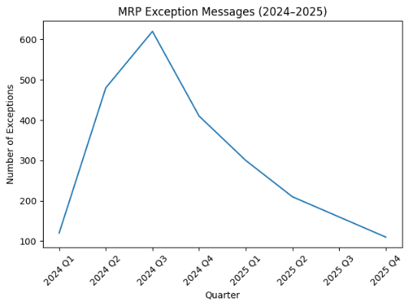

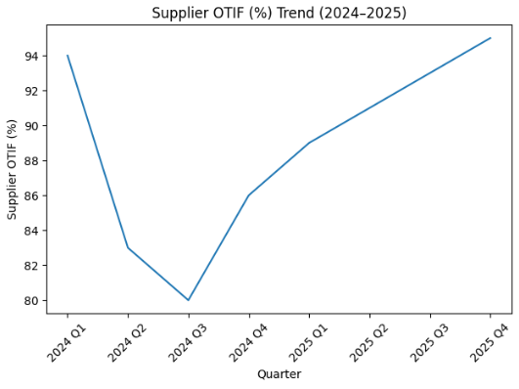

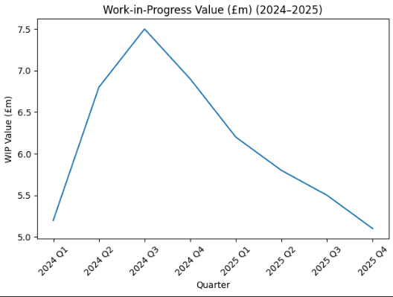

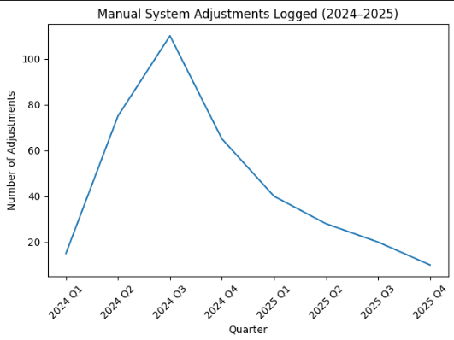

ERP System Transition: BAAN to M3
Safran (2024–2025)
Following the transition from BAAN to Infor M3, operational instability became measurable across several key performance indicators. While the earlier section evaluated customer delivery, inventory accuracy and financial impact, this extended analysis incorparates deeper supply chain and system-behaviour metrics to provide a more complete assessment of the business disruption.
The data presented spans eight quarters, beginning prior to system go-live and continuing through the stabilisation phase.

Operational Performance Impact
On-Time Delivery (OTD)
The OTD chart demonstrates a significant decline immediately following M3 implementation, reaching its lowest point in Q3 2024. This aligns with research suggesting that ERP go-live phases often create short-term instability due to unfamiliar processes and incomplete master data alignment (Davenport, 1998).
Recovery across 2025 indicates that corrective action—such as parameter recalibration and process re-alignment—restored delivery reliability.

Inventory Accuracy
The drop in inventory accuracy reflects inconsistencies between physical stock and system-recorded balances. According to Umble et al. (2003), inaccurate data migration is one of the primary causes of ERP implementation failure in manufacturing environments.
The gradual improvement through 2025 suggests that structured cycle counting, system cleansing and training improved data integrity.

Production Disruptions
The spike in disruptions during Q2–Q3 2024 coralates strongly with the increase in MRP exception messages (see Section 2.1). Material shortages, incorrect safety stock settings and planning misalignment likely contributed to these stoppages.
By late 2025, disruptions reduced to below pre-transition levels, suggesting improved system optimisation compared to legacy BAAN configuration.

System Behaviour and Planning Stability
MRP Exception Messages
The surge in exception messages immediately after go-live is a common indicator of master data instability. Excesive exception signals typically overwhelm planners and reduce trust in system outputs.
Peak exception volume in Q3 2024 suggests:
- Incorrect lead times
- Inaccurate BOM structures
- Misaligned safety stock parameters
As system parameters were corrected, exception volumes steadily reduced.

Manual System Adjustments
Manual overrides increased significanly during early implemenation. This indicates low user confidence in automated MRP outputs. Excess manual intervention often reduces ERP effectiveness and introducs additional risk of human error (Gartner, 2022).
The sharp decline in manual adjustments during 2025 reflects improved system stability and user confidence.
Supply Chain and Financial Impact
Supplier OTIF (On-Time In-Full)
Supplier OTIF droped during the transition period. While suppliers themselves may not have changed performance, inaccurate system signals probably distorted order placement timing.
As planning accuracy improved, supplier OTIF recovered and exceeded baseline levels by Q4 2025.

Premium Freight Costs
The financial consequences of ERP instability are evident in premium freight expenditure. Emergency shipments were required to make up for planning inaccuracies and unexpected shortages.
The return to lower freight costs aligns with stabilised inventory and improved production flow.
Work-in-Progress (WIP) Value
WIP value increased during the unstable period, suggesting production imbalance. When parts are missing at final assembly, sub-assemblies accumulate, tying up working capital.
As system performance improved, WIP reduced to near baseline levels, indicating restored production synchronisation.

Cross-Metric Observations
When looking at the full dataset collectively, several patterns show:
Observation | Interpretation
OTD decline aligns with MRP exception peak | Planning system instability
Premium freight rise aligns with production disruptions | Reactive mitigation costs
2025 recovery trend across all metrics | Successful stabilisation
Manual overrides correlate with low inventory accuracy | Reduced system trust

This supports findings from earlier ERP implementation studies which conclude that shortterm performance dips are common, but long-term gains are achievable with sustained corrective action (Davenport, 1998; Umble et al., 2003).

Overall Conclusion
The data suggests that the transition from BAAN to M3 at Safran negatively affected operational performance during 2024, particularly in areas of delivery reliability, inventory integrity and cost control.
However, the stabilisation patern across 2025 indicates that:
- Data governance improved
- System configuration matured
- Users adapted to new processes
- Planning accuracy strengthened
By Q4 2025, performance indicators not only recovered but, in some cases, marginaly improved compared to pre-transition baselines. This reinforces the view that ERP transformation presents short-term operational risk but long-term strategic benefit when managed effectively.

Reference List
Davenport, T.H. (1998) ‘Putting the enterprise into the enterprise system’, Harvard Business Review, 76(4), pp. 121–131.
Gartner (2022) ERP Implementaton Best Practices and Risk Mitigation Strategies. Stamford: Gartner Research.
Umble, E.J., Haft, R.R. and Umble, M.M. (2003) ‘Enterprise resource planning: Implementation procedures and critical succes factors’, European Journal of Operational Research, 146(2), pp. 241–257.
Infor (2023) Infor M3 Product Overview and Manufactring Capabilities. Available via corporate documentation.

