

Programme: MSc Public Health and Social Care in Practice

Module: Quality Assurance and Service Improvements
Module code: LCHS7006

Assignment Title: Component 2 Service Improvement Report
Mid Staffordshire NHS Foundation Trust (UK)

Student ID: 2433934
Name: Himalaybhai Sureshbhai Mandanaka
Lecturer name:- Dr Fahad Khan

Word count: 3293

Table of Contents
1. Introduction 3
2. Main Body 4
3. Donabedian Model 4
4. Fishbone Diagram – Causes and sub-causes 6
5. SWOT Analysis 9
6. PDSA Cycle 11
7. Kotter’s 8-Step Change Model 13
8. Recommendations 15
9. Benchmarking 16
10. Conclusion 17
Reference List 19

Introduction
High-quality and safe and person-centred care should be offered by the NHS, however, the service is offered under increasing demand, workforce shortages and limited resources, trends noted in comparisons with other high-income systems by Anandaciva (2023) and in analyses of adult social care during and after the pandemic by McHale and Noszlopy (2021), which cause pressure on prioritising short-term measures of performance over daily safety and staff welfare.
The Mid Staffordshire NHS Foundation Trust scandal is largely regarded as the failure of governance, culture and staffing watershed failure. Hughes (2023) demonstrates that, despite the seemingly acceptable headline indicators, public investigations of the situation revealed the extensive neglect, omission of basic care and preventable harm, a situation in which organisational priorities shifted away to finances and targets in a system that claims to be universally-minded.
The contemporary science of safety describes such failures as the outcome of intertwined system vulnerability as opposed to the isolated individual mistake. The Swiss Cheese Model explains that policy, management, clinical processes and front-line practice gaps can converge to allow harm, and the importance of enhancing each defensive layer in realistic manner as described by Larouzee and Le Coze (2020) in their critique. The safety-II thinking prompts organisations to investigate the reasons why care tends to go right and utilize this information to generate resilience and adaptive capacity, which is also pursued in Verhagen et al. (2022) when the authors address the question of how they can make Safety-II work in healthcare practice a reality.
The Patient Safety Strategy 2023-2028 of the NHS has made patient involvement and data and system learning core to improvement, indicating a change to just culture and active risk management, outlined by the national framework of NHS England (2023). Nevertheless, the fact that clinicians in environments with value discrepancies have less compassion capacity, provided by Pavlova et al. (2023), and that unsafe staffing harms outcomes and morale, as explained in the Royal College of Nursing (2023) briefing, suggests that much of the conditions that underlie Mid Staffordshire are still present in the modern practice today.

Main Body
This part critically recommends the Mid Staffordshire NHS Foundation Trust case by using current quality and safety models. It investigates the relationship between organisational culture, staffing, governance, information systems and discharge processes in compromising patient safety. It subsequently correlates these results with the existing NHS policies, integrated care priorities and practical opportunities of quality assurance and service improvement.

Donabedian Model
To reflect on the root causes of delayed discharges at the Mid Staffordshire NHS Foundation Trust, the theoretical framework that may be employed is the Donabedian Model that incorporates Structure, Process, and Outcome. The relationship between the structure of organisation, practice, and patient outcome can be studied with the help of the model and define some of the primary areas of weakness contributing to unnecessary hospitalisation.
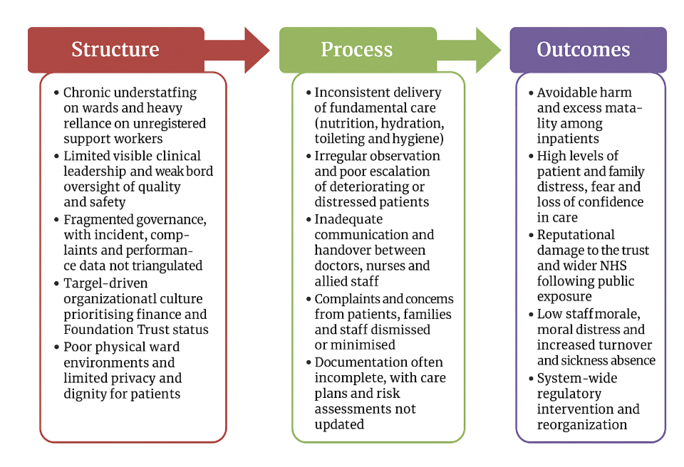
Figure 1: Donabedian Model
(Source: Opele and Adepoju, 2024)
Structure - Capacity of system Resources and Organisational Arrangements.
Donabedian model begins with structure which entails the resources, organisational arrangements and broader system in which care is provided. Opele and Adepoju (2024) demonstrate that the perceived service quality is highly dependent on the structures, including staffing levels, skill mix and supervision. In Mid Staffordshire, small populations of registered nurses, inadequate clinical leadership and board inadequate control of quality were structural weaknesses. The article by Anandaciva (2023) explains how local priorities may be misaligned with the needs of patients, especially because of the larger system pressures such as financial constraint and performance regimes. Miller and colleagues (2021) and Matos and colleagues (2025) note that the disorganized health and social care systems do not allow coordination, which is extremely important when it comes to discharge planning and further assistance of frail patients.
Process- Operational Workflow, Co-ordination and Communication.
The second one is process; this is what the staff does with these resources in day-to-day care. Opele and Adepoju (2024) emphasise the need of clinical pathways that are clear, standardised, and allow the consistency of practice. On the contrary, Mid Staffordshire exhibited lack of basic care, insufficient escalation as well as unstructured multidisciplinary communication. The evidence of Goncalves-Bradley et al. (2022) suggests that the systematic discharge planning enhances the outcomes and decreases readmissions. Like Bechir and Bechir (2025), Fuentes et al. (2023) and Ibrahim et al. (2022), they show that multidisciplinary discharge coordination (at the earliest opportunity) and the use of Lean techniques can help minimize patient flow delays and enable teams to organize themselves around that flow.
Outcome- Patient Safety, Experience, and System Performance.
The last component is outcome, which is the impact of care on the patients, families and staffs. Failure in this level was portrayed by excess mortality, complaints and loss of trust in Mid Staffordshire. The results of Han et al. (2022) support the arguments against delayed discharges by identifying the long duration of stay with worse outcomes. Pavlova et al. (2023) demonstrate that value-discrepant settings are damaging to staff wellbeing, compassion, whereas the Royal College of Nursing (2023) relates unsafe staffing to unfavorable results.

Fishbone Diagram – Causes and sub-causes
The following is a graphical representation as a text of a fishbone (Ishikawa) diagram of Mid Staffordshire NHS Foundation Trust. The "head of the fish" is Impact: Continuous low patient safety and quality of care in Mid Staffordshire NHS Foundation Trust.
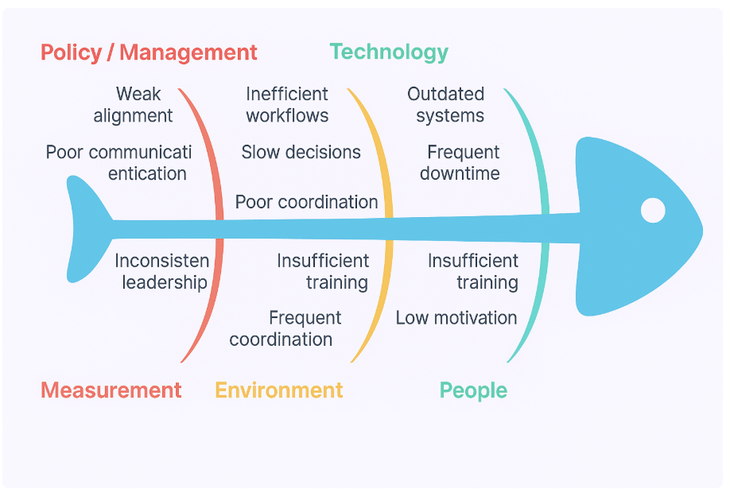
Figure 2: Fishbone Diagram
(Source: Gonçalves-Bradley et al., 2022; Fuentes et al., 2023)
Individuals (workforce, competencies, principles)
According to Majka, fishbone diagrams are ones that prioritize causes into broad categories so that the team can systematically explore contributory factors, and the human factors used as one of the key bones in the structure, which is quite applicable in this context in practice (Majka, 2023). Mid Staffordshire had ongoing shortages of nurses, overuse of healthcare assistants and insufficient senior clinical staff on the wards. The analysis of the Royal College of Nursing correlates the lack of registered nurse staffing with the risks of adverse events and burnout of the staff, which reinforces the interpretation of the fact that the level of workforce was one of the main contributors to this situation (Royal College of Nursing, 2023). Pavlova et al. demonstrate that the ability to feel compassion and wellbeing reduces when clinicians operate in a value-discrepant setting, which can be used to understand why the Mid Staffordshire staff might be unsurprised by becoming desensitised to suffering over a long period (Pavlova et al., 2023).
Practices and procedures (clinical work, communication, discharge)
There is a second bone that enveloped the organisation of work. Opele and Adepoju apply the Donabedian model to demonstrate the impact of weak processes surrounding assessment, communication and escalation on perceived quality but is manifested in the inconsistent provision of the basic care in Mid Staffordshire (Opele and Adepoju, 2024). According to evidence provided by Goncalves-Bradley et al., structured discharge planning decreases readmissions and simplifies outcomes and shows the dangers posed when discharge is uncoordinated and late in the pathway, as it was the case with this trust (Goncalves-Bradley et al., 2022). Bechir and Bechir also state that they should begin discharge planning on day one of admission, whereas Fuentes and colleagues demonstrate the Lean techniques reveal the bottlenecks and delays, and both methods propose the practical alternative processes that were absent locally (Bechir and Bechir, 2025; Fuentes et al., 2023). According to Verhagen and co-authors, Safety-II presupposes the comprehension of how day-to-day work is effective, which was not implied in incident-driven governance in Mid Staffordshire at the moment (Verhagen et al., 2022).
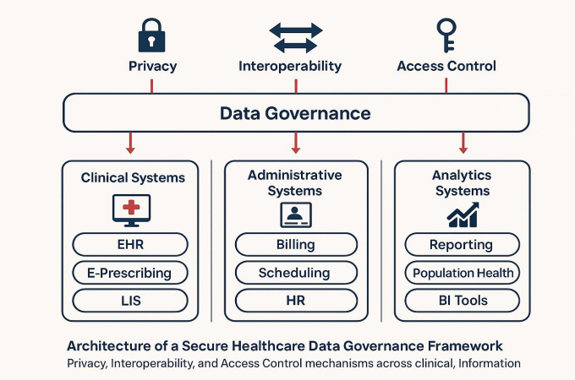
Figure 3: Strong healthcare shared governance structures
(Source: Owhonda, 2024)
Significant digital systems, data, tools (equipment).
The review by Gatiti and co-authors reveals that electronic health records can help improve quality by sustaining information flow, and at the same time, disjointed systems hinder care, a phenomenon also reflected by the fragmented flow of data that surrounds the wards and departments at Mid Staffordshire (Gatiti et al., 2021). Benmessaoud and others show that digital shared-care tools may be used to coordinate chronic disease management, and such a type of technology may have helped frail patients in this organisation to have safer transitions (Benmessaoud et al., 2023).
Environment, Management and Policy (culture, integration, wider system)
The other significant bone is the one that deals with organisational culture and the external environment. According to Hughes, a thorough investigation of boards discovered that they were excessively target- and finance-oriented, and they lacked the level of interest in the lived experience of care, which was highly evident in the course of Mid Staffordshire before the period of the Francis Inquiry (Hughes, 2023). Anandaciva contrasts the NHS and other systems and explains the influence of long-term resource pressure and performance regimes to form local priorities, which aids in understanding why managers might have focused on metrics at the expense of compassion in this trust (Anandaciva, 2023). Miller and others as well as Matos and others demonstrate that an incomplete health and social care integration compromises the patient flow and continuity, which lie at the heart of the discharge and readmission issues, as seen in the case (Miller et al., 2021; Matos et al., 2025).

5. SWOT Analysis
Table 1: SWOT Analysis
Strengths | Weaknesses | Opportunities | Threats
• Universal, tax-funded care mandate • National patient-safety strategy and inquiry culture | • Chronic workforce shortages and unsafe staffing • Target-driven culture prioritising finance and access • Fragmented health–social care interfaces | • Lean flow and structured discharge planning to reduce delays • Better use of digital systems and shared data • Development of integrated care models | • Rising demand, bed pressures and tight funding • Change fatigue and weak change-management capacity • Risk of repeating Mid Staffordshire-type failures

Figure 4: SWOT Analysis
(Source: self-made)
Strengths
NHS has a solid social core of universal tax-funded care which Anandaciva (2023) claims establish a sense of fairness and safety throughout the system. The NHS England (2023) recommends that organisations shift to more proactive risk management by using common language, priorities, and tools of learning, which are provided through national frameworks like the NHS Patient Safety Strategy. Another type of powerful levers of large-scale change and post-failure scrutiny is a tradition of external scrutiny and public inquiries, which Hughes (2023) writes about.
Weaknesses
Hughes (2023) demonstrates that boards have been guilty of prioritising financial balance and access targets, rather than lived care experience, which is evidently the case in Mid Staffordshire. Extensive evidence on the impact of chronic workforce shortages and unsafe staffing on quality is provided by the Royal College of Nursing (2023), whereas Pavlova et al. (2023) show that value-discrepant environments undermine compassion and staff wellbeing. The two articles by Matos et al. (2025) and Miller et al. (2021) point to an overall continued fragmentation of health and social care, which increases lack of discharge coordination and continuity.
Opportunities
According to Fuentes et al. (2023), Lean and process-Mapping methods are feasible means of revealing waste and inefficiencies in hospital processes, which provides useful instruments to redesign inpatient flow and discharge. As demonstrated by Goncalves-Bradley et al. (2022) and Bechir and Bechir (2025), organized early discharge planning positively affects the results and the reduction of readmissions, which leaves a clear area of improvement in trusts with delayed transfers of care. Shippee et al. (2024) and Laig and Abocejo (2021) stress that these redesign efforts can be incorporated more sustainably with the help of formal change-management techniques.
Threats
Anandaciva (2023) cautions that upward demand, limited funding and bed pressures create the threat of repeating the failures of Mid Staffordshire nature in case the momentum of the improvement process stops. Devoid of long-term investment in personnel, integration, and culture, the circumstances that brought about previous scandals can continue to exist in new shapes within the NHS.

6. PDSA Cycle
PDSA (Plan-Do-Study-Act) has been implemented in the following table, considering its contribution to addressing the strategic constraints and improving unit productivity (Manandi et al. 2023).
Table 2: Framework of Plan-Do-Study-Act
PLAN | State the problem as extended length of stay, delayed discharges and poor communication with families. Identify a definite objective, such as: decrease the average length of stay on the pilot ward by 0.5 days in three months and the percentage of patients with a discharge plan documented within the 24 hours of admission. Design change together with ward nurses, physicians, therapists, discharge coordinators and a patient representative. The proposed change is early multidisciplinary discharge planning through daily board rounds because evidence suggests that planned discharge planning and early coordination can enhance results as reported by Goncalves-Bradley et al. (2022), Bechir and Bechir (2025) and NHS England (2019).
DO | Quantitative (e.g., average delays in the discharge process, number of medically fit patients who have stayed in bed) and qualitative feedback using staff surveys and short interviews will be evaluated at the conclusion of six weeks (Abuzied et al., 2021).
STUDY | Simple run charts Simple run charts are used to analyse quantitative data on length of stay, delayed discharges, weekend boarding and early readmissions. Findings interpretation and evidence that the longer a stay, the worse the outcomes are according to the evaluation performed by Han et al. (2022). Assess qualitative comments with staff and patients as to clarity of plans, workload and perceived safety. Compare outcomes with the base performance and expectations based on the literature on structured discharge and Lean flow including the work by Fuentes et al. (2023).
ACT | Decision to adopt, adapt or abandon the change tested. In case the cycle indicates benefit, tighten the board-round script, documentation templates and roles to deal with the problems discovered during the Study phase. Design a new PDSA cycle on a second ward or a more prolonged time, basing on the principles of iterative scaling and stakeholder involvement that Shippee et al. (2024) highlight in their change-management model. In case the outcomes are not consistent, tweak the intervention, such as by introducing more explicit discharge readiness criteria or more social care participation and repeat the process with updated predictions and actions.

7. Kotter’s 8-Step Change Model
Create a sense of urgency
Executives emphasize facts on injury, patient complaints, discharge delays and staff suffering, with local information and patient testimonies proving why business as usual is unsound. This shifts discourse away to the actual effect on patients and personnel.
Build a guiding coalition
It assembles a small, credible team which will consist of senior nurses, doctors, managers, allied health professionals, data staff and a patient representative. This coalition is the promoter of the change, the culture they want to have and eliminate barriers among various departments.
Create a strategic vision and initiatives.
The coalition develops a transparent vision, including, safe, timely and person-centred discharge, and connects it to specific efforts, including early discharge planning, daily board rounds and effective multidisciplinary communication, so the staff can visualize the change.
Communicate the vision
Meetings, handovers and written updates with the vision and rationale are consistent. Leaders relate the vision to the values of the staff so that it is not about the external requirements and necessities but about care pride.
Remove obstacles
Practical obstacles are addressed such as ambiguous roles in discharge planning, absence of social care input or inefficient documentation systems. Managers accommodate employees who formulate issues, as opposed to accusing them of mentioning risks.
Create short-term wins
Minor, noticeable improvements are scheduled and pronounced, including reduced late discharges of a pilot ward or improved patient response of communication. These victories demonstrate that the change can and should happen.
Sustain acceleration
Successful tests are replicated in other wards with the PDSA cycles running, data are provided to the organisations and repeated leadership to ensure that the organisation does not revert to the previous practices.
Establish new practices within the culture.
Lastly, job descriptions, induction, policies and governance construct the new ways of working, which makes safe, coordinated care a norm and not a project.

8. Recommendations
- The organisation must focus on safe staffing and skill mix to enhance quality and safety based on the evidence gathered by the Royal College of Nursing (2023), which could set the minimum nurse-to-patient ratios and guard supervision time of the senior staff. In addition to this, leaders should overcome value-practice discrepancies that discourage compassion and wellbeing, based on the results of Pavlova et al. (2023) to influence culture, Schwartz rounds and restorative support.
- The process of patient flow and discharge should be restructured that the premise should be based on early and multidisciplinary planning beginning during the first day of admission as suggested by Bechir and Bechir (2025). The evidence-based summarised by Goncalves-Bradley et al. (2022) should be structured discharge planning and coordination based on clear criteria and the involvement of carers. As Fuentes et al. (2023) suggest, lean mapping of the discharge journey can help reveal the bottlenecks and implement the required pathways changes in a practical way.
- Digital information systems need to be streamlined in such a way that records, observations and discharge information are precise, timely and disseminated, as well as depicting the quality benefits as discovered by Gatiti et al. (2021). All these alterations must be undertaken as a form of organized change management, which includes the involvement of the stakeholders and repeated testing, aligned with the models outlined by Shippee et al. (2024).

9. Benchmarking
Benchmark / Standard | National Standard | Hospital Performance Before | Hospital Performance After
Safe nurse staffing and skill mix | Safe ratios and skill mix are stressed by Royal College of Nursing (2023) in its evidence on statutory staffing requirements. | Frequent understaffing and high HCA reliance, with limited senior nurse presence on wards. | Rosters increased registered nurses and visible clinical leaders in line with Royal College of Nursing (2023) guidance 95%.
Patient experience and complaints | Dignity, compassion and learning from complaints are emphasised by Hughes (2023) when reviewing public inquiries. | Basic care often missed and complaints informally handled or discounted. | Clear care standards and a formal complaints process now feed into board discussions, reflecting Hughes (2023) recommendations 55%.
Incident reporting and governance | Safety-II ideas in Verhagen et al. (2022) encourage open reporting and system learning across services. | Incidents under-reported and mortality, complaints and audit data rarely triangulated. | Higher reporting rates and regular multidisciplinary review of safety data now support governance as Verhagen et al. (2022) propose 100%
MDT communication and discharge planning | Early, structured discharge planning is supported by Gonçalves-Bradley et al. (2022) and Bechir and Bechir (2025) in their evaluations. | MDT communication fragmented and discharge planning typically late and uncoordinated. | Daily MDT huddles and earlier discharge planning mirror approaches described by Gonçalves-Bradley et al. (2022) and Bechir and Bechir (2025) 40%.

Table 3: Benchmarking and targeted outcome
The above table defines some benchmarking targets that have been planned provided with best practice examples so as to overcome this challenge and minimise delays in discharges.

10. Conclusion
The issue of safety and quality of care in the management of patients in the NHS is a complicated task, but at the same time, it is a primary requirement. There is a natural tension in the service of meeting the expectation of quality, personal care with the lack of resources and growing demand. The high profile failures like those of Mid Staffordshire Experience show that a strong governance and active safety culture is essential, and that systemic problems (not single mistakes) are the chief culprits towards harm.
This realization has since been institutionalized with modern safety science which proposes the process shift to a more systems-based, rather than punitive, blame based, system resilience-oriented approach. The models such as the Swiss Cheese concept and the guidelines of Safety-II influence organizations to comprehend why care is successful and develop resilience. This shift is operationalized in the NHS Patient Safety Strategy 2023-2028 that requires system-wide learning and a just culture. The bottom line is that it is all a matter of fortifying these defensive layers and creating a penalty-free culture where patient and staff safety are mutually reinstated.

Reference List
Allan, S. (2021). Home care market dynamics in England. Policy Social Services Research Unit Discussion Paper. https://ascru.nihr.ac.uk/wp-content/uploads/2024/01/DP2021-01.pdf
Anandaciva, S., (2023). How does the NHS compare to the health care systems of other countries. Retrieved January, 3, p.2023. https://assets.kingsfund.org.uk/f/256914/x/7cdf5ad1de/how_nhs_compares_other_countries_abpi_2023.pdf
Bechir, G., and Bechir, A. (2025). Start With the End: Early Hospital Discharge Planning as a Day-One Priority. Cureus, 17(6). https://www.cureus.com/articles/383207-start-with-the-end-early-hospital-discharge-planning-as-a-day-one-priority.pdf
Benmessaoud, C., Pfisterer, K. J., De Leon, A., Saragadam, A., El-Dassouki, N., Young, K. G., ... and Pham, Q. (2023). Design of a dyadic digital health module for chronic disease shared care: development study. JMIR Human Factors, 10(1), e45035. https://humanfactors.jmir.org/2023/1/e45035/
Choi, S. Y. (2023). Implementation of Daily Goals Tool to Structured Multi-disciplinary Rounds (Doctoral dissertation, University of Maryland). https://archive.hshsl.umaryland.edu/bitstreams/e12a265c-1f7e-471b-8abb-a3c5be5aad5d/download
Fuentes, L.B.E.H., Gardim, L., Silva, T.O.D., Moura, A.A.D. and Bernardes, A., (2023). Applying Lean Healthcare in the hospitalization and patient discharge process: an integrative review. Revista Brasileira de Enfermagem, 76(5), p.e20220751. https://www.scielo.br/j/reben/a/kVjQsYzfK8tXQPsXHTDmpxt/?format=pdf&lang=en
Gatiti, P., Ndirangu, E., Mwangi, J., Mwanzu, A. and Ramadhani, T., (2021). Enhancing healthcare quality in hospitals through electronic health records: a systematic review. Journal of Health Informatics in Developing Countries, 15(2), p.1. https://ecommons.aku.edu/cgi/viewcontent.cgi?article=1063&context=libraries
Godinho, M., Maçães, F., Gonçalves, H., and Silva, F. (2025). Clinical Pathways in Knee and Hip Arthroplasty: Narrative Review on Sustainability, Quality, and Resource Management. JMIR Perioperative Medicine, 8(1), e78174. https://periop.jmir.org/2025/1/e78174/
Gonçalves-Bradley, D.C., Lannin, N.A., Clemson, L., Cameron, I.D. and Shepperd, S., (2022). Discharge planning from hospital. Cochrane database of systematic reviews, (2). https://www.cochranelibrary.com/cdsr/doi/10.1002/14651858.CD000313.pub6/pdf/full
Han, T.S., Murray, P., Robin, J., Wilkinson, P., Fluck, D. and Fry, C.H., (2022). Evaluation of the association of length of stay in hospital and outcomes. International Journal for Quality in Health Care, 34(2), p.mzab160. https://academic.oup.com/intqhc/article-pdf/34/2/mzab160/43523149/mzab160.pdf
Hughes, H., (2023). Public inquiries, patient safety and the implementation gap. Future Healthcare Journal, 10(1), pp.7-9. https://www.sciencedirect.com/science/article/pii/S2514664524003758
Ibrahim, H., Harhara, T., Athar, S., Nair, S.C. and Kamour, A.M., (2022). Multi-disciplinary discharge coordination team to overcome discharge barriers and address the risk of delayed discharges. Risk management and healthcare policy, pp.141-149. https://www.tandfonline.com/doi/pdf/10.2147/RMHP.S347693
Jabeen, K., Khan, M.A., Alhaisoni, M., Tariq, U., Zhang, Y.D., Hamza, A., Mickus, A. and Damaševičius, R., (2022). Breast cancer classification from ultrasound images using probability-based optimal deep learning feature fusion. Sensors, 22(3), p.807. https://www.mdpi.com/1424-8220/22/3/807
Jebeile, H., Kelly, A.S., O'Malley, G. and Baur, L.A., (2022). Obesity in children and adolescents: epidemiology, causes, assessment, and management. The lancet Diabetes & endocrinology, 10(5), pp.351-365. https://www.thelancet.com/pdfs/journals/landia/PIIS2213-8587(22)00047-X.pdf
Laig, R. B. D., and Abocejo, F. T. (2021). Change management process in a mining company: Kotter’s 8-step change model. Journal of Management, Economics, and Industrial Organization, 5(3), 31-50. https://www.researchgate.net/profile/Ferdinand-Abocejo/publication/354614425_Change_Management_Process_in_a_Mining_Company_Kotter's_8-Step_Change_Model/links/615093f2f8c9c51a8af65225/Change-Management-Process-in-a-Mining-Company-Kotters-8-Step-Change-Model.pdf
Larouzee, J. and Le Coze, J.C., (2020). Good and bad reasons: The Swiss cheese model and its critics. Safety science, 126, p.104660. https://www.sciencedirect.com/science/article/am/pii/S0925753520300576
Majka, M. (2023). Fishbone diagram. https://www.researchgate.net/profile/Marcin-Majka-2/publication/385065860_Fishbone_Diagram/links/671361b9069cb92a811b6703/Fishbone-Diagram.pdf
Manandi, D., Tu, Q., Hafiz, N., Raeside, R., Redfern, J., and Hyun, K. (2023). The evaluation of the Plan–Do–Study–Act cycles for a healthcare quality improvement intervention in primary care. Australian Journal of Primary Health, 30(1), NULL-NULL. https://www.publish.csiro.au/PY/PY23123
Matos, R. C. D., Nascimento, G. D., Campos Fernandes, A., and Matos, C. (2025). Health and Social Care Integration: Insights from International Implementation Cases. Journal of Market Access & Health Policy, 13(2), 28. https://www.mdpi.com/2001-6689/13/2/28
Mayo, M.A., (2021). Pandemic Preparation & Response: A Case Study Applying Kotter’s 8 Step Change Management Theory to Improve Pandemic Response in an Acute Care Setting. https://medica-musc.researchcommons.org/cgi/viewcontent.cgi?article=1559&context=theses
McHale, J., & Noszlopy, L. (2021). Adult social care provision under pressure: Lessons from the pandemic. https://research.birmingham.ac.uk/files/154624473/adult_social_care_provision_under_pressure_lessons_from_the_pandemic_november_2021.pdf
Miller, R., Glasby, J. and Dickinson, H., (2021). Integrated health and social care in England: ten years on. International journal of integrated care, 21(4), p.6.https://pmc.ncbi.nlm.nih.gov/articles/PMC8555479/pdf/ijic-21-4-5666.pdf
NHS (2025). The Torbay Model - ‘Mrs Smith’. [online] Torbay and South Devon NHS Foundation Trust. Available at: https://www.torbayandsouthdevon.nhs.uk/about-us/our-vision-and-strategy/the-torbay-model-mrs-smith/ [Accessed 13 Nov. 2025].
NHS England (2019). NHS England» Improving hospital discharge. [online] England.nhs.uk. Available at: https://www.england.nhs.uk/urgent-emergency-care/improving-hospital-discharge/.
NHS England (2023) National Quality Board: NHS Patient Safety Strategy 2023–2028. NHS England Publications.
NHS England (2024). NHS England» Acute discharge situation report: technical specification. [online] www.england.nhs.uk. Available at: https://www.england.nhs.uk/long-read/acute-discharge-situation-report-technical-specification/.
Oliver, D. (2023). David Oliver: Delayed discharges harm patients, staff, and health systems alike. bmj, 380. https://www.bmj.com/content/380/bmj.p459
Opele, J. K., and Adepoju, K. O. (2024). Validation of the Donabedian Model of health service quality in selected States in Nigeria. Nigerian Journal of Clinical Practice, 27(2), 167-173. https://journals.lww.com/njcp/fulltext/2024/02000/validation_of_the_donabedian_model_of_health.2.aspx
Owhonda, K. C. (2024). Enhancing healthcare outcomes via agile IT project management, secure data governance, and informatics-driven workflow optimisation. Int J Eng Technol Res Manag, 8(12), 423. https://ijetrm.com/issues/files/Apr-2024-27-1745729807-DEC202446.pdf
Pavlova, A., Paine, S.J., Sinclair, S., O'Callaghan, A. and Consedine, N.S., (2023). Working in value‐discrepant environments inhibits clinicians’ ability to provide compassion and reduces well‐being: A cross‐sectional study. Journal of Internal Medicine, 293(6), pp.704-723. https://onlinelibrary.wiley.com/doi/pdf/10.1111/joim.13615
Puspita, N.K.H., Sulistianingsih, R., Purwadhi, H. and Widjaja, Y.R., (2025). Hospital organizational transformation towards patient-oriented services: a literature review of organizational change theories. Hospital, 16(2), pp.454-457. https://www.isainsmedis.ejournals.ca/index.php/ism/article/download/2371/1833
Rogers, B., Legaspi, J. P., and Bastiampillai, T. (2023). Hospital congestion: a market solution to address delayed transfers of care from hospital beds. Medical Journal of Australia, 218(7), 298-300. https://www.mja.com.au/system/files/issues/218_07/mja251876.pdf
Royal College of Nursing (2023) Safe Staffing: The Evidence for a Statutory Requirement in England. RCN Policy Briefing Paper.
Shippee, T.P., Davila, H., Ng, W., Bowblis, J.R., Akosionu, O., Skarphol, T., See Thao,
Silvola, S., Restelli, U., Croce, D. and Basu, D., (2024). Change management for services redesign in healthcare: a conceptual framework. Journal of preventive medicine and hygiene, 65(3), p.E410. https://pmc.ncbi.nlm.nih.gov/articles/PMC11698107/
Verhagen, M.J., de Vos, M.S., Sujan, M. and Hamming, J.F., (2022). The problem with making Safety-II work in healthcare. BMJ quality & safety, 31(5), pp.402-408. https://qualitysafety.bmj.com/content/qhc/31/5/402.full.pdf

