UNIVERSITY OF WALES
TRINITY SAINT DAVID

STUDENT NAME: GALUSCA SILVIU GEORGE
STUDENT NUMBER: 1915953

MODULE: THE GLOBAL BUSINESS ENVIRONMENT

ASSIGNMENT: GLOBAL BUSINESS ENVIRONMENT
ASSESSMENT 2

PROGRAMME: BA BUSINESS MANAGEMENT
LEVEL 4/ TERM 2/ GROUP 1

LECTURER : DR.REXON NTING

Table of Contents
1.0 Introduction 3
2.0 Discussion and Findings 3
2.1 Porter's Value Chain Analysis of the electric car industry 3
2.2 Primary Activities 4
2.3 Support Activities 7
2.4 SWOT 7
3.0 PESTEL Analysis of the electric car industry 8
4.0 Advantages and Challenges in the electric automobile industry 9
5.0 Conclusion 12
Reference List 13

1.0 Introduction
The automotive industry has always been an epitome of technological innovation. A showcase of human minds superior intellect and creative designing brilliance and electric cars are a prime reflection of such creative and technological brilliance. Inventor Thomas Parker invented electric cars in 1884, in 1888 Germany started manufacturing ‘Flocken Electrowagen” a prototype electric car. Thomas Edison, Henry Ford, Ferdinand Porsche all tried their hands with the electric car in the early 1900s however due to poor infrastructure, the high cost of manufacturing and limited mass appeal development in the electric car manufacturing sector came to a standstill.
The study will explore in detail the electric car manufacturing industry by using Porter’s value chain analysis framework. In brief, it will be discussed the importance of life cycle and value chain analysis and its relationship with the production and development of electric cars. The objective of the study will be to clearly understand the global business environment in which the sector operates and elucidate the position of the sector, its competencies, competitors using an academic framework. For the study, Nissan Motor Corporations, a Japanese multinational automobile manufacturing firm, is chosen. Along with Tesla and General Motors, Nissan makes up 60% of the market share of the electric automobile industry and is thus a good candidate for the study.

2.0 Discussion and Findings

2.1 Porter's Value Chain Analysis of the electric car industry
Micheal Porter developed the value chain analysis as an entrepreneurship management concept that breaks down business functions to identify value-creating activities. Business organisations rarely function alone and instead maintain a complex web of the supply chain and distribution to manufacture and sell their products (Pelegov and Pontes, 2018). For instance, Nissan Motors Corporation is famous for its SUVs and electric vehicles; however, it does not manufacture all of its components but instead relies on third-party suppliers for raw materials. The purchasing component of the organisation is part of its value chain and contributes to its internal strength. According to Porter, this is a competitive advantage that allows companies to thrive despite stiff competition. It enables them to differentiate their products and market in a way that attracts the attention of the customer without being misleading or dishonest.
In porter's analysis, there are two kinds of activities, primary activities, and support activities. While exploring in detail will reveal nine separate component activities, five primary and four support activities. The details are as follows,

2.2 Primary Activities
Inbound Logistics: Inbound logistics are about procuring building raw materials that are transformed into finished products. It can be vertically integrated into which manufacturers produce the bulk of the components or are horizontally acquired from third-party dealers. For Nissan, the task is completed by the “Renault Nissan Purchasing Organisation” an independent body that integrates the purchasing domain. The relationship with the traders is based on trust and their compliance with the ethical sourcing code of conduct. Further, Nissan has been using the "conquest supply chain planning solutions" in collaboration with Penske Logistics and IBM hardware infrastructure, an integrated software management system that maintains a balanced relationship achieving an equilibrium between the lowest cost in transportation, storage, and inventory management and lean production. Since the adoption of the system supply chain complexity within the organisation has significantly scaled-down, and the car manufacturing giant has become more efficient in acquiring raw materials. Interestingly, Carlos Ghosn, CEO, Nissan Motors, introduced vertically integrated supply chain management to scale up the production of NISSAN LEAF, its flagship electric car model. Ghosn regarded the manufacturing industry as immature and incapable of matching the production capability of Nissan and hence established the "Automotive Energy Supply Corporation" and the Wuxi plant. The Lithium-ion batteries that are incorporated in the electric cars are supplied from this plant (Xinhuanet.com, 2020).
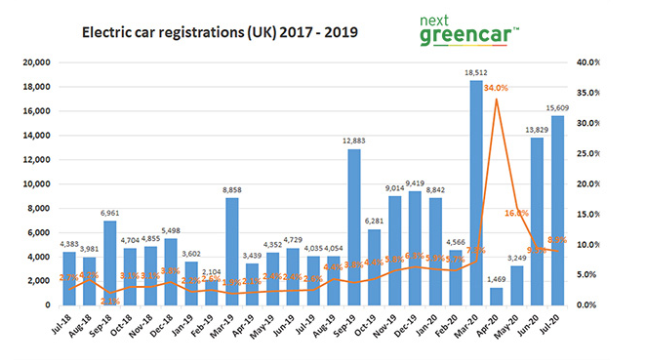
Figure 1: Electric Car Sales Figure in the United Kingdom
(Source: Society of Motor Manufacturers and Traders, 2020)

Production and Operations: Demand forecast analysis predicts that car manufacturer Nissan Motor will likely need to produce 1,330,000 electric cars within 2025 to meet consumer demands. By 2022, Nissan has a plan to launch eight new electric car models. Still, it will only be possible if the production and manufacturing system is in sync with its inventory and delivery system (Zachary Shahan, 2019). Nissan Motors have always relied on lean manufacturing for car production. It extensively uses information technology and detailed planning to complete its operations. It also uses QR-10 Cobots to automate its car production and assembly process, especially to complete mundane, repetitive tasks and carry large components.
Outbound Logistics: Outbound Logistics are post-manufacturing activities that include storing, shipping, and distributing products across the market and to the consumers. Nissan has automated its outbound supply chain logistics to reduce cost and synchronise the process to eliminate wastage and redundancies. In a bid to reduce operation costs, the company has a "distribution dealership" program that empowers individuals to enter into a contractual dealership with Nissan (Nissan-global.com, 2020).
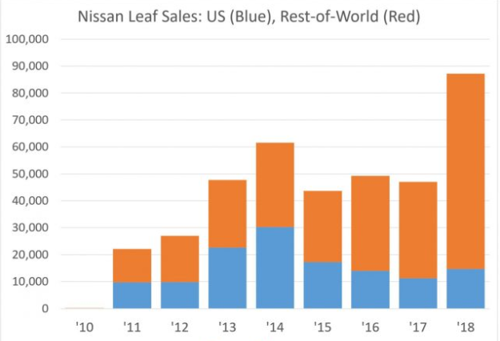
Figure 2: Nissan Sales Figure
(Source: Nissan Annual Report, 2019)
Marketing and Sales: Nissan Motors markets products based on a product differentiation approach. The approach provides clear benefits as it allows the company to identify the consumer niche that would be most likely attracted by the company's offering. Most electric car manufacturers use a similar approach, and it is so because the electric car industry is still at its infancy and lacks the "scale of the economy" that is needed for mass production. The company has been using discount deals and other incentives to promote customers. The automobile manufacturing company also uses interactive social media marketing to reach its customer base.
Services: Customers are at the centre of every activity that Nissan performs. As such customer service forms a core business function of the organisation. It is imperative to note that Nissan has a separate customer service department and a customer support centre that specifically looks into technical issues and complaints and often guides customers through electric car technology. Trained sales representatives look into the matter and address any concerns that might exist within a short time. And then there are charging stations that are meant to charge car batteries, something similar to filling gas at a gas station.

2.3 Support Activities
Infrastructure | Nissan has excellent infrastructure for manufacturing electric cars. The Wuxi plant has 20GWh production capacity and can provide batteries for 400,000 cars globally.
HRM | Nissan has 138,900 employees worldwide. The company believes in providing its employees with a creative environment that lacks any kind of discrimination. The workforce is also diverse, and women make up 30% of the workforce.
Technology | Nissan is a technology-driven company and invests in crafting innovative solutions for mundane problems. Its new offering Ariya will have in-house developed technologies that will allow it to read brain activity.
Procurement | Nissan sold its battery division to Envision and will soon collaborate with the firm to accommodate its battery demands. It also has sustainable, ethical sourcing contracts with suppliers for procurement and distribution that allows it to reduce cost and make the process more carbon efficient.
Table 1: Supporting Activities of the electric car industry
(Source: Self-Created)

2.4 SWOT
Strength  - Developing technology.  - Is environmentally sustainable.  - Is compliant with the UK pledge to reduce carbon dioxide emission to zero by 2050.  - Is cheaper to maintain.  - Has a rapidly growing market. | Weakness  - Expensive.  - Is not completely sustainable.  - Low growth in the car battery manufacturing sector.  - Batteries can heat up.  - Poor customer appeal.  - Spare parts are scarce (Conserve Energy Future, 2019).
Opportunity  - Legislations promote environmentally sustainable technology.  - Conscious consumers.  - Government Incentives, the UK government is promoting the clean energy and automobile manufacturing industry (Milios et al. 2018).  - The rapid growth of technology. | Threats  - Misconceptions and lack of awareness among consumers (Schwanen, 2020.).  - Cutthroat competition from Tesla, BMW, and Toyota.  - The production bottleneck is a concern in the electric vehicle market.
Table 2: SWOT of the electric car industry
(Source: Self-Created)

3.0 PESTEL Analysis of the electric car industry
Political: The United Kingdom has a stable political environment; however, Brexit has indeed created uncertainties in the industrial sector, especially the electric car manufacturing sector since it is so volatile and is still growing. Nevertheless, a silver lining in the form of strongest measures to control pollution and climate change is also encouraging the electric vehicle industry to push boundaries. Nissan has declared to invest 9 Billion Dollars in capturing the electric car market (Masiero et al. 2017).
Economic: The economic impact of the electric industry is yet to be fully realised. It can truly lead to the loss of job opportunities in the oil industry; however, a technology-intensive field like electric car manufacturing will also create jobs, especially skilled jobs. The economic state of the country will also impact the industry. The ongoing CoronaVirus pandemic has leached the economy of the United Kingdom. The economy is, however, expected to recover and replenish itself in the next few months (Singh, 2020).
Social: Society's attitude toward electric cars is changing. No longer are electric cars viewed as a cheap alternative, but instead, cars like Nissan Leaf are prized and valued for its design and simplicity. Also, among the community, the concept of environmental consciousness and eco-sustainability is taking roots, and more and more people are growing conscious of choices. They are making small changes to accommodate the electric car revolution (CNN.com, 2018).
Technology: The electric car industry is technology-driven and is supported by the continual growth in communications technology. Nissan is developing its battery to ensure that it does not heat up and become a safety concern (Narins, 2017).
Environmental: Climate Change and global warming is an issue that has gained traction in recent years and is mostly because of injudicious use of fossil fuels, especially in the automobile sector. There is a drive from the government and the community to develop alternative low-carbon dependent automobiles that will be affordable, sleek, and comfortable. This is an opportunity for the electric car industry that is fuelling interest and investment.
Legal: Several environmental laws such as the "Environmental Protection Act", "Clean Air Act" have been passed to combat air, water, and noise pollution. Also, the United Kingdom is a signatory member of the Kyoto Protocol that aims to reduce carbon emission by 2050 (Bahliuk and Kryzhanivska, 2018).

4.0 Advantages and Challenges in the electric automobile industry
In contemporary society, electric cars have definitive advantages, one, they are cheaper than a conventional SUV, indeed with passing time electric cars are emerging as an affordable alternative to traditional cars. Additionally, electric cars are also easy to maintain and require no expensive mobile. Moreover, producing electricity costs far less than extracting and refining fossil fuels.
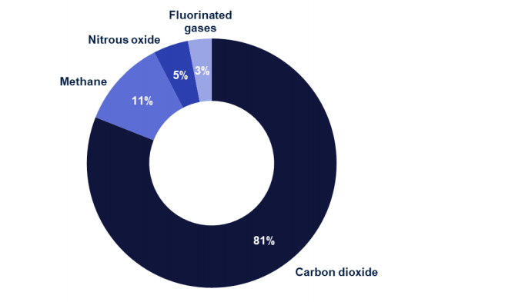
Figure 3: Carbon Dioxide makes the most contribution to the Greenhouse effect.
(Source:assets.publishing.service.gov.uk,2018)
Alternatively, clean sources of electricity production like solar energy, wind energy have caused an abrupt surge in electricity production so much so that the "Agile Octopus Energy Tariff" was forced to pay consumers to use electricity lest it should overload the system. Two, environmental sustainability is pushing the electric manufacturing sector as electric cars using clean fuel cause no emission and little noise. Fossil fuels are non-renewable sources of energy and cause pollution, understandably; thus, the government is striving to reduce its carbon footprint and carbon dioxide emission bypassing stringent legislations. Crude oil production in the United Kingdom has fallen to 51.8 Billion metric tonnes while its import has remained constant by far. The UK consumes 1.55 Billion Barrel petroleum in a day and emits 451.8 Billion tonnes of carbon dioxide (assets.publishing.service.gov.uk,2018). Hybrid electric cars use batteries that can be recycled and can be configured to emit no carbon dioxide and thus can play a crucial role in combating climate change without compromising on transportation comfort and communication.
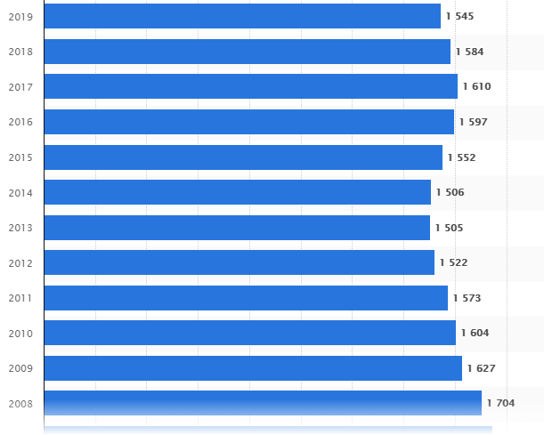
Figure 4: Oil Consumption in the United Kingdom
(Source: Statista.com, 2020)
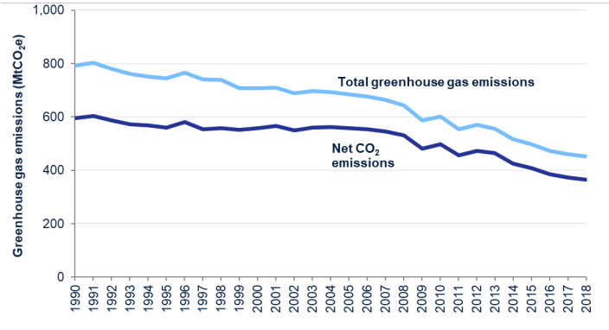
Figure 5: Total Greenhouse Gas Emission in the United Kingdom From 1990-2018
(Source: assets.publishing.service.gov.uk,2018)`

However, electric cars of the present are expensive and not entirely zero-carbon emitters. Also, even though sales in the electric car industry have surged by 57 per cent yet, it accounts for less than 5 per cent of the entire automobile sales. As such, the electric car sector has its struggles and challenges (Mohammadi, 2018).

5.0 Conclusion
The resurgence in the electric car manufacturing industry came after the “oil embargo” that left people looking for alternatives to diesel and petrol-powered cars. General Motors tried first with their Electrovair prototype model, but it never went into mass production and was later picked up by Tesla Motor Inc. and re-developed. It was Elon Musk's venture Tesla that would go on to revolutionise the industry with its sleek design and conveniently utilitarian nature, offering the consumers Model S in 2008. The electric car industry of today is estimated to be worth 162.34 Billion Dollars and is expected to grow at 22.6% to reach 800 Billion Dollars by 2027. The push is coming from several areas, one, there has been an abrupt change in mentality, consumers are increasingly becoming conscious of their environmental impact and are therefore changing their habits to accommodate sustainable environment-friendly transportation. Electric cars are cost-effective, cheaper to maintain, and cause no emission as it burns no fossil fuel. Additionally, charging electric cars costs far less than gasoline whose price fluctuates depending on the state of the international market. Two, electric cars though are a complex system and not easy to assemble 25% fewer components than a conventional ICE("Internal Combustion Engine") vehicle, a convenient feature for manufacturers. Third, the legislation factor, the European Union in 2018 has passed legislation that dictates car manufacturers to reduce their carbon emissions by 40% within 2021. Stringent anti-pollution laws have made car manufacturers re-configure their priorities and have garnered new interest in electric cars.

Reference List
Journals
Bahliuk, Y. and Kryzhanivska, I., 2018. Influence of ecologization tendencies in the world on renewal and development of motor car industry in Ukraine. Економіка і організація управління, [Online] (3), pp.48-56. Available at <http://tesi.luiss.it/24969/1/692331_RICCIARDI_EMANUELE.pdf> [Accessed 4 August 2020]
Masiero, G., Ogasavara, M.H., Jussani, A.C. and Risso, M.L., 2017. The global value chain of electric vehicles: A review of the Japanese, South Korean, and Brazilian cases. Renewable and Sustainable Energy Reviews, 80, pp.290-296. DOI:10.1016/j.rser.2017.05.148
Milios, L., Christensen, L.H., McKinnon, D., Christensen, C., Rasch, M.K., and Eriksen, M.H., 2018. Plastic recycling in the Nordics: A value chain market analysis. Waste Management, 76, pp.180-189. DOI: 10.1016/j.wasman.2018.03.034
Mohammadi, F., 2018. Design, analysis, and electrification of a solar-powered electric vehicle. Journal of Solar Energy Research, [Online] 3(4), pp.293-299. Available at < https://jser.ut.ac.ir/article_68813_c52cc5ab93afa490c2c02ac009e7d439.pdf> [Accessed 4 August 2020]
Narins, T.P., 2017. The battery business: Lithium availability and the growth of the global electric car industry. The Extractive Industries and Society, 4(2), pp.321-328. DOI: 10.1016/j.exis.2017.01.013
Pelegov, D.V., and Pontes, J., 2018. Main drivers of battery industry change: electric vehicles—a market overview. Batteries, 4(4), p.65. DOI: 10.3390/batteries4040065
Online Articles
assets.publishing.service.gov.uk,(2018), Final Greenhouse Gas Emissions Statistical Report, available at https://assets.publishing.service.gov.uk/government/uploads/system/uploads/attachment_data/file/862887/2018_Final_greenhouse_gas_emissions_statistical_release.pdf

Websites
CNN.com, 2018. The Race To The Electric Car Is Just Getting Started. [online] Edition.cnn.com. Available at: <https://edition.cnn.com/interactive/2019/08/business/electric-cars-audi-volkswagen-tesla/> [Accessed 4 August 2020].
Conserve Energy Future, 2019. Various Advantages And Disadvantages Of Electric Cars - Conserve Energy Future. [online] Conserve Energy Future. Available at: <https://www.conserve-energy-future.com/advantages-and-disadvantages-of-electric-cars.php> [Accessed 4 August 2020].
Farrar, B., 2016. Electric Cars SWOT - 5/4/16 - Fusibilities. [online] Available at: <http://www.fusibilities.com/electric-cars-swot/> [Accessed 4 August 2020].
Nissan-global.com, (2020), Nissan Global Supply Chain Management, available at https://www.nissan-global.com/EN/SUSTAINABILITY/REPORT/SOCIAL/SUPPLYCHAIN_MANAGEMENT/[Accessed 4 August 2020].
Schwanen, T., 2020. The Five Major Challenges Facing Electric Vehicles. [online] BBC News. Available at: <https://www.bbc.com/news/uk-49578790> [Accessed 4 August 2020].
Singh, A., 2020. Four Key Areas That Require Government Focus To Accelerate EV Adoption In India. [online] The Financial Express.com. Available at: <https://www.financialexpress.com/auto/industry/fame-ii-electric-vehicle-incentives-ev-adoption-india-electric-cars-hyundao-kona-ev-mg-zs-ev/1994282/> [Accessed 4 August 2020].
Xinhuanet.com, (2020), Niisan to sell its battery division, available at http://www.xinhuanet.com/english/2019-04/02/c_137942498.htm [Accessed 4 August 2020].
Zachary Shahan, (2019), how-many-electric-vehicles-will-tesla-volkswagen-nissan-sell-in-next-5-years, available at: https://cleantechnica.com/2019/09/07/how-many-electric-vehicles-will-tesla-volkswagen-nissan-sell-in-next-5-years/#:~:text=That%20totals%201%2C330%2C000%20Nissan%20electric%20vehicle%20sales%20from%202020%E2%80%932025. [Accessed 4 August 2020].

