NAME: HASEEB KHAN
STUDENT NUMBER: 2505377
COURSE TITLE: ASSIGNMENT 1 E-PORTFOLIO
MODULE NAME: LEARNING IN THE DIGITAL ERA
LECTURER: MASUD SIDDIQUI
DATE: 11/03/26

Contents
E-PORTFOLIO 2
Task 1 – Written summary 3
REFLECTION 4
TASK 2 - AUTOMATIC REFERENCING TOOL 5
TASK 3 – MIND MAP AND ACADEMIC POSTER 6
Task 4 – e-Portfolio creation and review 8

E-PORTFOLIO
https://sites.google.com/view/haseebkhan-portfolio/home
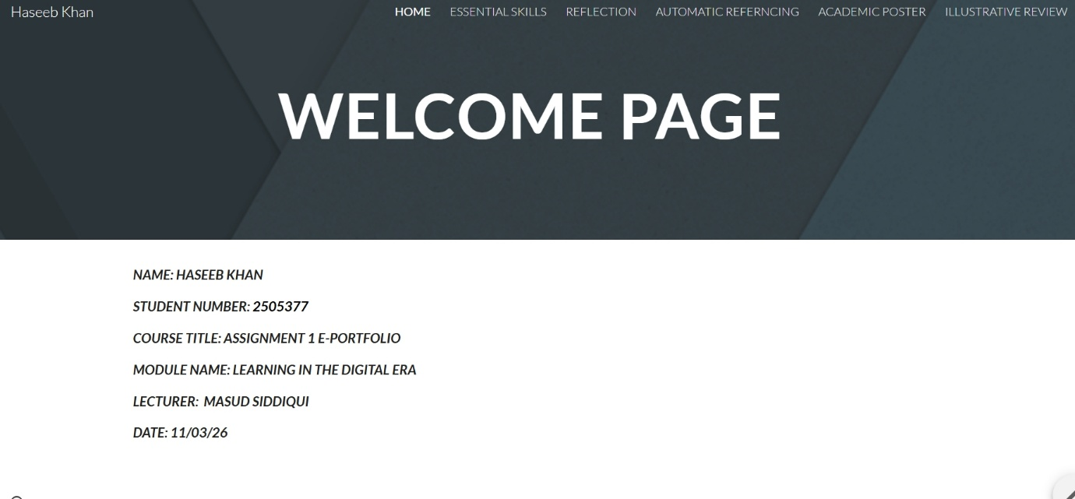

Task 1 – Written summary
Haseeb Khan - ESSENTIAL SKILLS
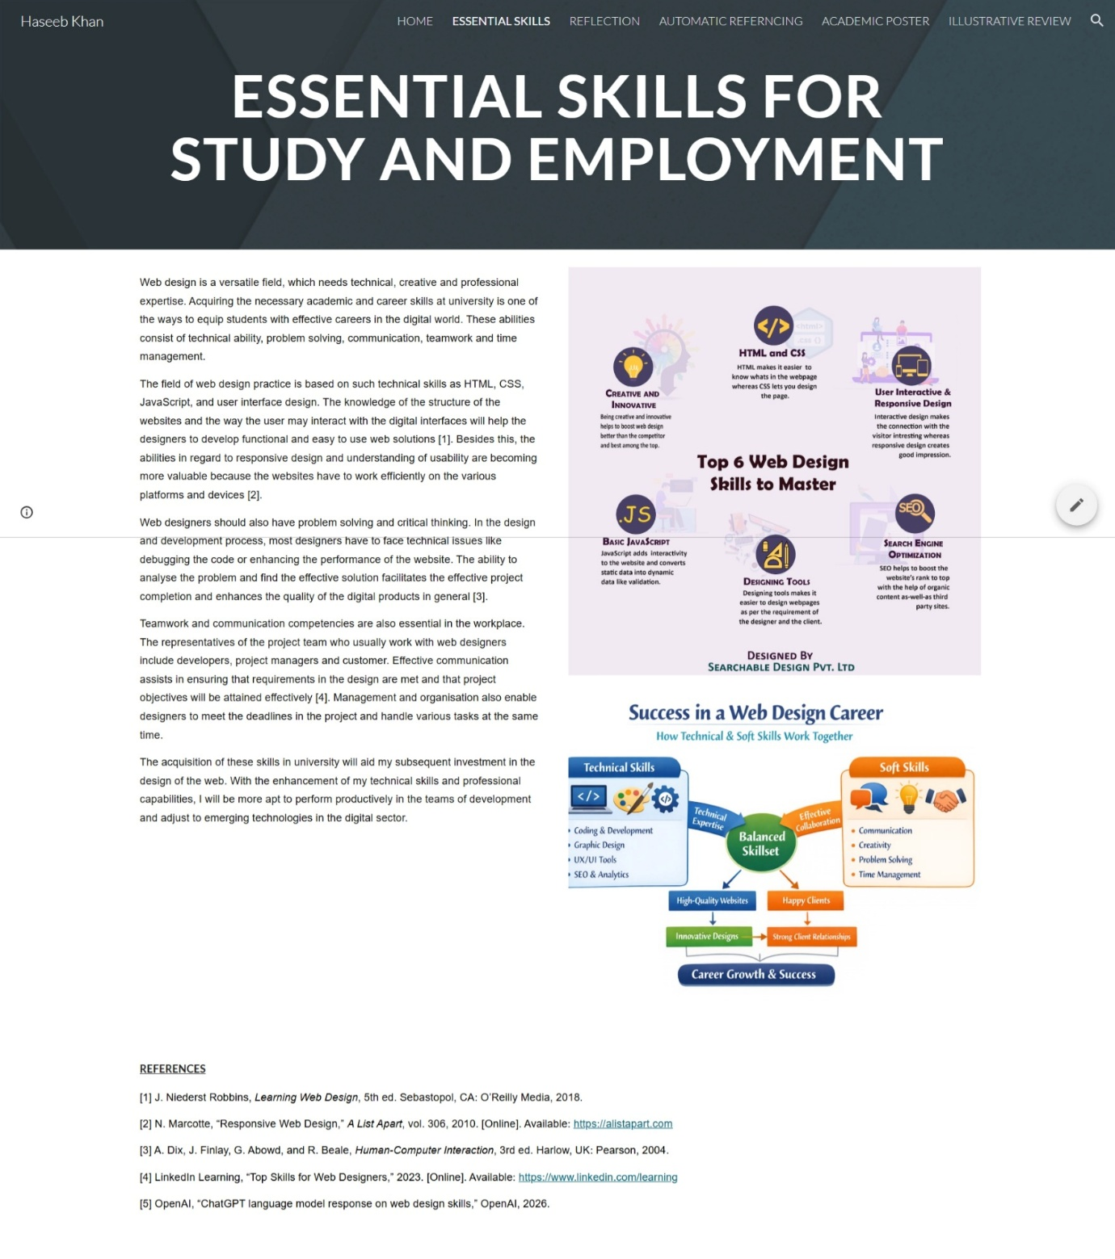

REFLECTION
Haseeb Khan - REFLECTION
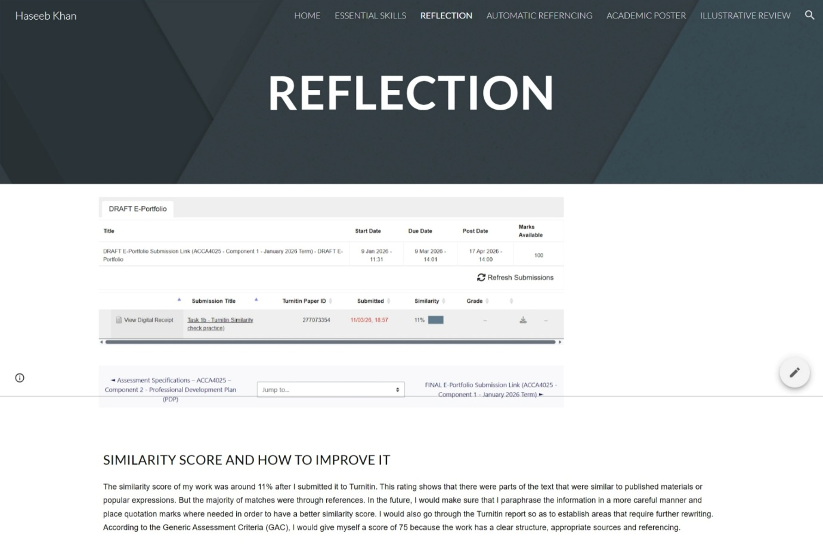

TASK 2 - AUTOMATIC REFERENCING TOOL
Haseeb Khan - AUTOMATIC REFERNCING
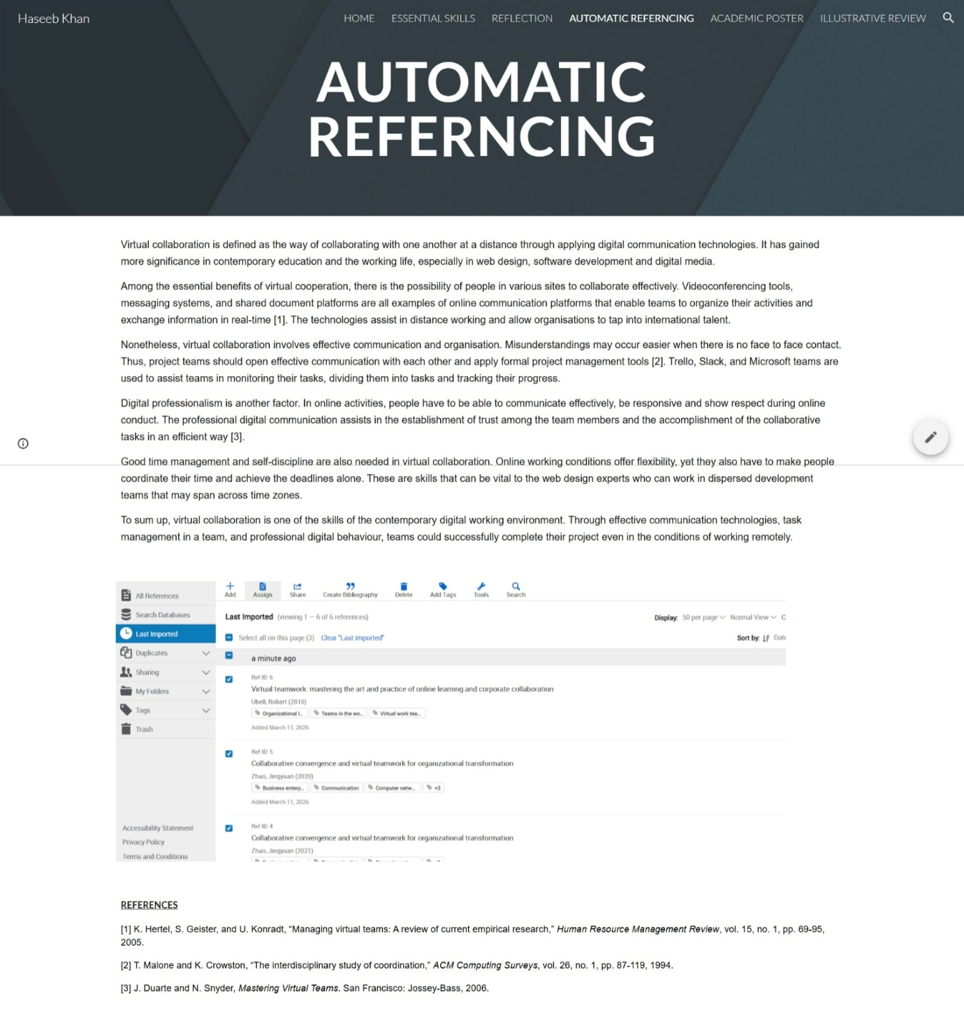

TASK 3 – MIND MAP AND ACADEMIC POSTER
Haseeb Khan - ACADEMIC POSTER
https://mm.tt/map/3960116597?t=SFzhHpiOEA
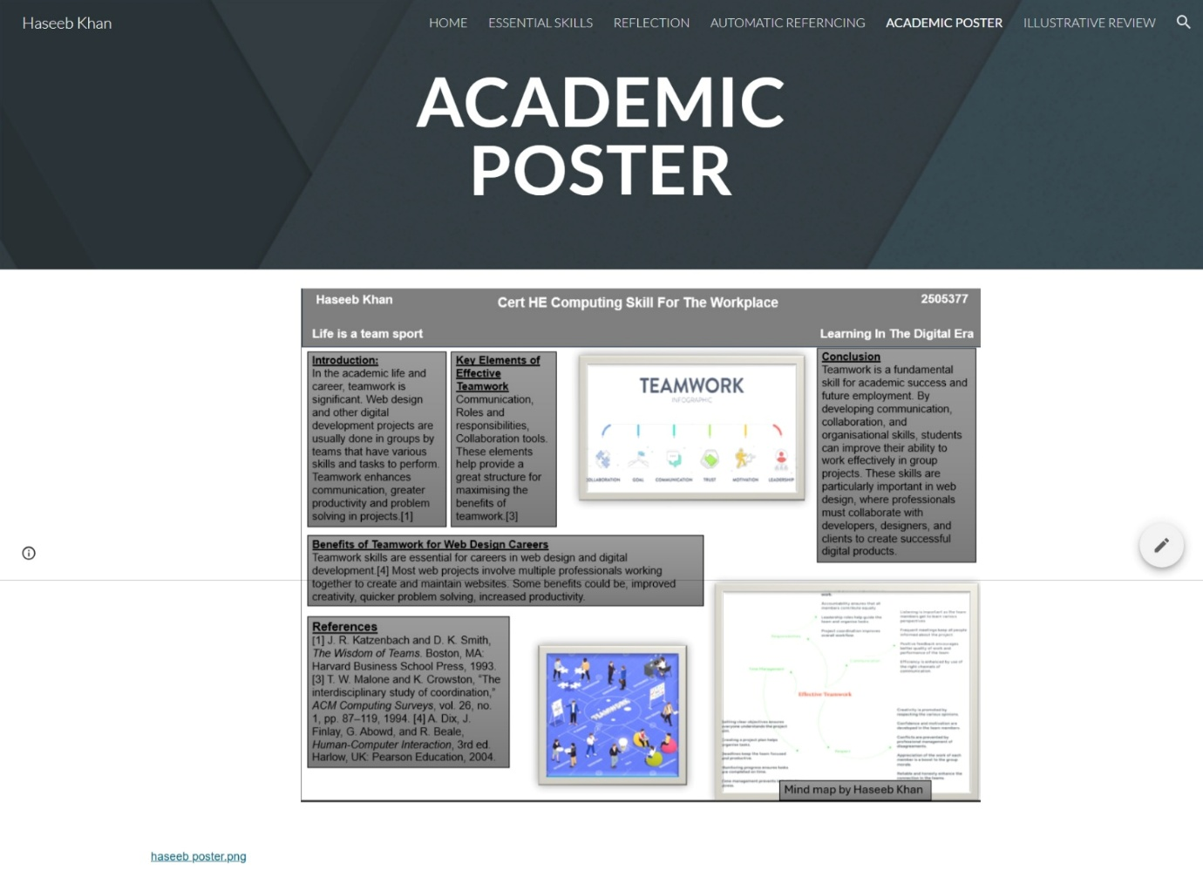
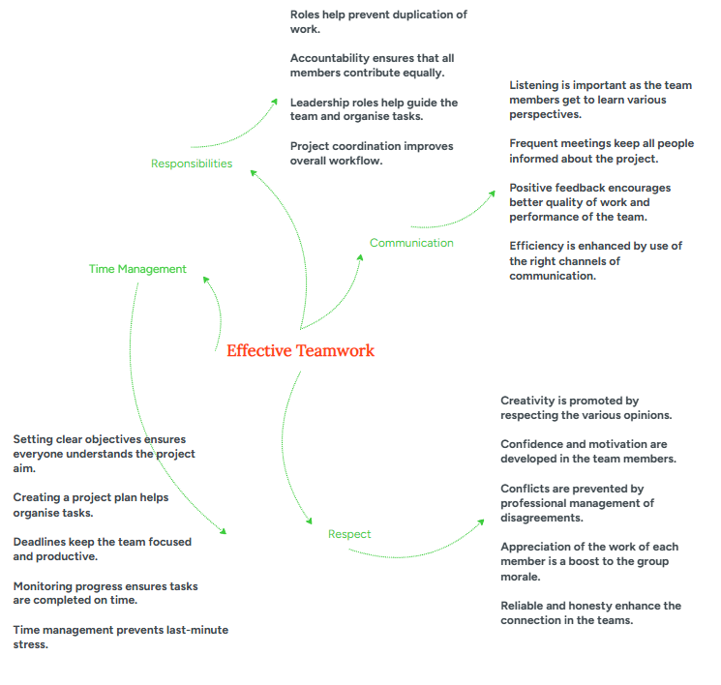

Task 4 – e-Portfolio creation and review
Haseeb Khan - ILLUSTRATIVE REVIEW


