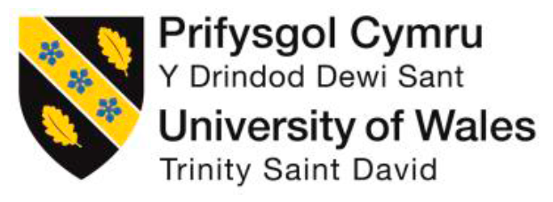

Rebecca Broomfield
Leading Service Improvement
DSAW7058
University of Wales Trinity Saint David

Contents
Clinical leadership within Medical Education: Developing a multi-disciplinary, integrated clinical skills and simulation model within Cardiff and Vale Health Board.
Project proposal:
Background ........................................................................................................ 3
Methods .............................................................................................................. 4
Aim ...................................................................................................................... 5
Project Report:
Aim ...................................................................................................................... 6
Change Management Model ............................................................................... 6
- Establish a sense of urgency ......................................................................... 7
Why use simulation teaching?
- Form a powerful guiding coalition ................................................................... 10
- Create a vision ................................................................................................ 11
- Communicating a vision ................................................................................... 13
- Empower others to act on the vision ............................................................... 15
- Plan for and create short term wins ................................................................. 17
Use within a teaching program: Foundation simulation teaching
Use to address a trainee need: Trauma and Orthopaedics
- Consolidate improvements and produce more change …………………………. 20
Use to address a patient safety problem: Falls project
- Institutionalise new approaches …………………………………………………… 24
References ……………………………………………………………………………….. 26
Appendix 1 – 9 …………………………………………………………………………... 28 – 39
Submission form …………………………………………………………………………………..40

Project Proposal
Clinical leadership within Medical Education: Developing a multi-disciplinary, integrated clinical skills and simulation model within Cardiff and Vale Health Board.
Word Count: 772/750
Background:
The General Medical Council (GMC) (2017) has identified that top drivers for employee satisfaction and the health of an organisation’s culture are learning and development. They call on organisations to invest in professional development of their employees and consider how they can improve on their own techniques for doing this.
Cardiff and Vale University Heath Board (CVUHB) has a strategic vision ‘Caring for People, Keeping People Well’. Within this CVUHB outlines a commitment to the continual education and professional development of multidisciplinary staff members. The department of medical education must reflect an active contribution to quality improvement and patient safety.
There is a strong focus within medical education for increasing the evidence base for the teaching methods used (Jason, 2000). Simulation teaching is an artificial representation of a real world process (McGaghie et al 2006) as well as being used to master clinical skills it can also be utilised to promote multidisciplinary team working focusing on human factors such as communication and leadership (Forsythe 2009). Simulation teaching has a strong evidence base within other fields where safety is paramount, for example in aviation or the military however, it is yet to establish this within healthcare.
One of the main theories used to evaluate the effectiveness of training is the Kirkpatrick model. Kirkpatrick’s purpose was to provide promptly identifiable, easy-to-measure outcomes in learners which could be utilised by management teams. By measuring learners’ behaviour, reactions and learning from technical training and the impact of the training on the organisation he was able to evaluate the impact of the training provided. (Yardley 2012)
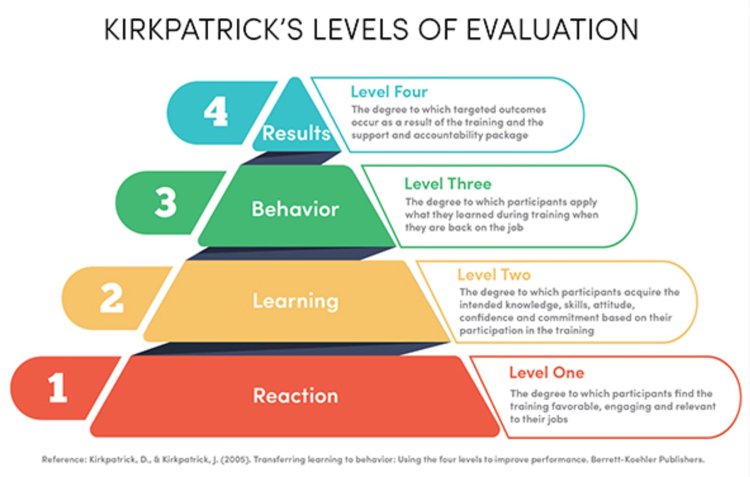
Figure 1: The 4 levels of evaluation proposed by Kirkpatrick.
Methods:
By using the Kirkpatrick evaluation theory we are aiming to strengthen the evidence base for the use of simulation teaching within the healthcare field. Traditionally feedback has focused on reactions, Kirkpatrick level 1 (Kirkpatrick et al 2005). In order to evidence base simulation teaching it is necessary to reach beyond this and evaluate teaching at a higher level. Ideally we would like to prove a teaching intervention has had a level 4 outcomes – that is the teaching alone has directly affected a patient safety outcome. Because improvement is often multi-factorial it has been beyond the reach of the majority of simulation teaching programs (Jason 2000, Aggarwal R et al 2006, McGaghie 2010)) However it is possible to closely evaluate learning, level 2 outcomes. With individual projects we aim to establish measures that will enable a behaviour change (level 3 outcome) to be evaluated (Zendejas B et al 2013).
We aim to prove that the simulation we are delivering within CVUHB is effective at increasing participant’s confidence and knowledge within the subject area that they are being taught. We aim to prove that we can use simulation teaching as a way to promote a culture of open communication and patient safety.
We will redesign the feedback which we are collecting on each simulation session to ensure that we are asking the correct questions to evidence base the use of simulation training. The project also includes the development of teaching programs and courses to address specific needs raised by trainees. We will use the redesigned feedback forms to collect evidence that the teaching offered is effective therefore, enable the value of simulation to be clearly demonstrated.
We also plan to increase engagement within the multidisciplinary teams for simulation training. We will meet with CVUHB patient safety team to identify specific needs, asking them to outline the key areas which CVUHB is focusing on developing. We plan on working with teams in these areas to develop simulation programs to address specific concerns. If we are able to provide evidence of the effectiveness of simulation we will also be looking at addressing complaints and significant incidents through a structured simulation teaching program. To increase engagement we will also meet with directors of each clinical board to encourage participation in simulation. We aim to run simulation courses for multidisciplinary teams and using the evaluation theory above prove that the simulation teaching has value in increasing the knowledge and confidence of participants.
In order to do this I will need to consider my expanding my circle of influence (Covey 1989) and using the science of persuasion to gain momentum for simulation teaching and increase engagement (Cialdine 1993).
Aim: To use educational theory to develop and evaluate the use of simulation sessions and courses within CVUHB. Thus ensuring quality training for the multidisciplinary team and developing an evidence base to prove the effectiveness of simulation teaching in promoting a culture of learning and improving patient safety.

Project report:
Clinical leadership within Medical Education: Developing a multi-disciplinary, integrated clinical skills and simulation model within Cardiff and Vale Health Board.
Word Count: 4453/4500
Aim:
To use educational theory to develop and evaluate the use of simulation sessions and courses within Cardiff and Vale University Health Board (CVUHB).
Change management:
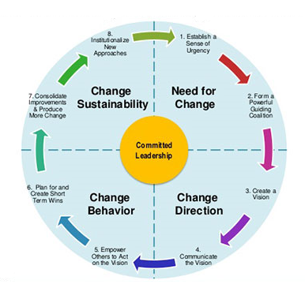
Figure 2 Kotter's Change management model (Eurogeography 2018)
Bringing about change to any organisation is difficult. You need to make sure that the change you are making is accepted and sustainable. Kotter (1996) described an eight step model for management of change with committed leadership at the centre. I have used this model to outline my patient improvement project.

1. Establish a sense of urgency
There is a strong focus within medical education for increasing the evidence base for the teaching methods used (Jason, 2000). Best Evidence Medical Education (Harden et al, 1999) states that education within medicine needs to move from opinion-based to evidence based. Therefore as a group of educators we need to ensure that we are improving the quality and scope of evaluating our medical education (Jason, 2000). We know that in order for education to be effective learners, rather than hearing about or observing others, need to have the ability to practise the capability they are expected to acquire (Westberg et al 1993). Learner’s experiences are improved if trainers give constructive, timely and supportive feedback and they need to be encouraged to evaluate their own performance. By creating an atmosphere of trust within our teaching opportunities we can improve the learning experience.
Why use simulation teaching?
I have focused on simulation teaching as the teaching delivery method of medical education within my improvement project. Simulation teaching is an artificial representation of a real world process (McGaghie et al 2006). As well as being used to master clinical skills it can also be utilised to promote multidisciplinary team working focusing on human factors such as communication and leadership (Forsythe 2009). The difference in the use of simulation between other safety centred industries and medicine was noted by The House of Commons Health Select Committee in their patient safety review 2009. They observed that “the NHS lags unacceptably behind other safety-critical industries, such as aviation, recognising the importance of effective team working and other non-technical skills” (Health of Commons Health Select Committee 2009). Simulation teaching has a strong evidence base within other fields where safety is paramount, for example in aviation or the military however, it is yet to establish this within healthcare. As educators we need to improve on this (Jason 2000). Skills can be defined as “actions and reactions which an individual performs in a competent way in order to achieve a goal” (Issenberg 1999). Simulation teaching ensures that trainees have some exposure to a skill before using it on a human being.
When looking at the differences between an elite performer and an amateur the most important identifiable factor is the amount of deliberate practise they have had the opportunity to perform (Issenberg 1999). A simulation environment takes away the need for deliberate practise to be performed on human beings therefore ensuring the safety of both the patients and the trainee. Matthew Syed notes within ‘Bounce’ (2010) that in order to become an elite performer in any skill from sporting achievements to clinical skills you need an average of ten years productive practise. Simulation can provide a safe environment where skills can be purposely and repetitively practised in order to master them thus shortening the suggested ten year achievement period (McGaghie et al 2006). The data from simulation suggests that skills can be taught which are transferable to patients. (Issenberg 1999)

Figure 3 Simulation-based training has an important role to shorten and flatten the learning curve on real cases (Aggarwal R et al 2006)
The ability to condense the time period to master a skill is particularly important given the changes in rota and workforce structuring, which had to occur following the introduction of the European Working Time Directive (EWTD). Within the Time for Training report (2010) Sir John Temple has noted that “simulation and new technologies can support training and accelerate learning.” Sir John Temple also recognises the other benefits of simulation training. Scenarios can be used to develop teamwork, management skills and leadership (Temple 2010). Alaker et al (2016) noted, in a study on laparoscopic surgery, that the time taken to achieve proficiency on a real case was reduced by 2.3 hours for each hour spent on the simulator. However, importantly it is the quality of training provided, rather than the number of procedures performed which leads to excellence (Alaker 2016).
The GMC are looking to incorporate simulation training in national curricula and are seeking assurance from Local Education Training Boards and deaneries as to the feasibility of implementation (GMC 2017). Simulation training can also be employed to enhance multidisciplinary working (Forsythe 2009). It can be used to encourage breakdown of hierarchy, improved communication and provide an environment which enables deliberate practise of team roles and team working. By providing and evaluating simulation teaching sessions within CVUHB, with relevance to individual curricula for their doctors in training and other postgraduate staff we will be able to provide this assurance.

2. Form a powerful guiding coalition
When starting an improvement project it is often possible to be seen as a ‘lone nut’. In order to be a leader you need to gain followers and create a momentum (Cialdini 1993). But how can you do this? Stephen Covey (1989) suggests that one way you can do this is to increase your own personal circle of influence.
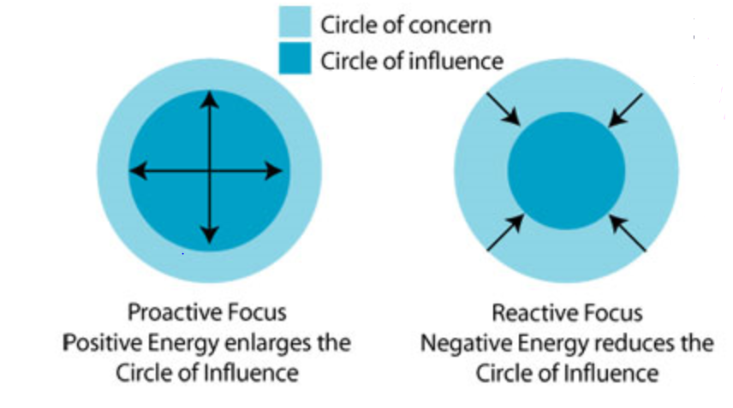
Figure 4 Stephen Covey (1996) Circles of influence: The Circle of Concern is the area that we have no control over. The Circle of Influence is the area that we have control over.

In life our Circle of Influence (COI) is most often smaller than the Circle of Concern (COC), because of this we tend to focus on the COC, which depletes our energy, because we have no control over it. Therefore energy focused on the COC acts as a negative. If you focus on the COC and neglect the COI, eventually the COI will get smaller. As this happens feelings of stress and helplessness will increase, because you cannot change anything in the COC. In order to create momentum and ensure that the improvement project succeeds you need to determine your COI and focus on this rather than your COC. The guiding coalition within this patient improvement project were CVUHB simulation team. As a leader I had to get this team on-board with my vision in order to expand the evaluation of simulation teaching.

3. Create a vision
In order to establish how other teams were evaluating simulation I attended the Association for Simulated Practise in Healthcare (ASPiH) Conference 2017. ASPiH provides a frame work to ensure that simulation delivered reaches a set standard. CVUHB is working towards proving that the standards laid out by ASPiH (Appendix 1) are met in the simulation sessions offered. By developing a reproducible evaluation of simulation sessions we can achieve this.
The Kirkpatrick method of evaluating the educational value of simulation is shown in the figure below.
Figure 5: The 4 levels of evaluation proposed by Kirkpatrick. (Kirkpatrick et al 2005)

Prior to the start of the improvement project feedback was collected post simulation. The feedback forms focused on giving a rating between 1=poor to 4=excellent on the content and presentation. There were also generic questions based on making improvements. (Appendix 1) These generated results which demonstrated a Kirkpatrick level 1 evaluation, shown in appendix 2, and did not focus on the impact and value of the training session.
Our initial work focused on improving the methods which we used to collect feedback in order to establish a Kirkpatrick Level 2 outcome. We chose to focus on knowledge and confidence as our main level 2 outcomes. Evaluation of the programs offered has moved to a pre and post course questionnaire (Appendix 3 and 4) which combines knowledge questions with a self reported confidence level on a likert scale 1-5 (1=Not at all confident, 5=very confident) Therefore data collected in feedback is level 2 data (Kirkpatrick et al 2005).
Generating results:
The data collected can be collated to generate meaningful graphs which through collection pre and post event will demonstrate the impact which the teaching session has achieved.
Pre course Post Course

Figure 6: Results graph from ‘Paediatric Emergency Medicine made easy’ course
We are able to collect more valuable data from our simulation courses. The results generated clearly show the difference between confidence pre simulation session and post simulation session. Likert scales and knowledge questions can be statistically analysed in XLStat 2018, using the Wilcoxon signed-rank test for comparison of 2 non-parametric sets of data.
As well as the quantitative results generation we also generate qualitative information by using questions where participants are asked to reflect on the training provided and its context within their day-to-day jobs. By asking in the precourse questionnaire “Tell us a real life example of when you have personally encountered one of these scenarios within your clinical practice?” following it up in the post course questionnaire with “On the pre-course questionnaire, we asked you to give a real-life example of one of the scenarios. Is there anything now that you would do differently?” We are aiming to focus participant’s minds immediately onto how the training session delivered could impact their behaviour within their day-to-day area of work. This will help us with generation of a Kirkpatrick level 3 outcome. With individual projects it is possible to establish measures that will enable a level 3 outcome, behaviour change to be evaluated (Zendejas B et al 2013). Jason et al (2000) outlines the need to effectively evaluate the teaching given.
4. Communicating a Vision
As a part of gaining momentum and communicating the vision for the use of simulation within medical education we launched the Wood’s Simulation ward within CVUHB.
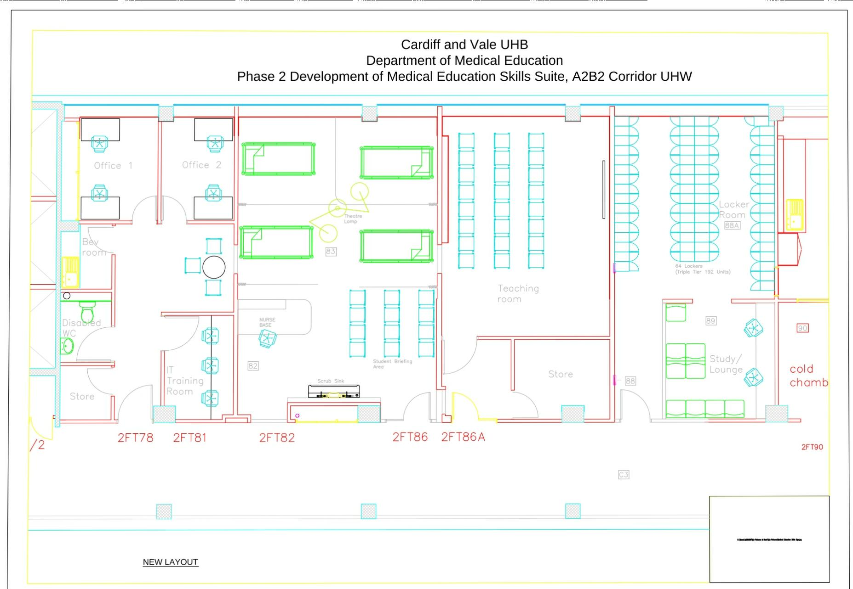
Figure 7 Outline plan for CVUHB Wood's Simulation Ward
The Wood’s Simulation ward is a purpose built simulation facility within CVUHB. This provides a ward environment which can also be manipulated into a surgical environment. The ward is can be set up to mimic the normal working environment and ensures that simulation environment is as close as possible to real life.
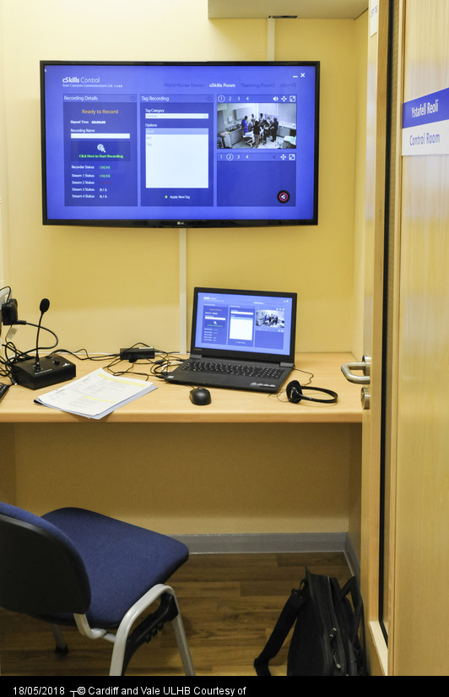
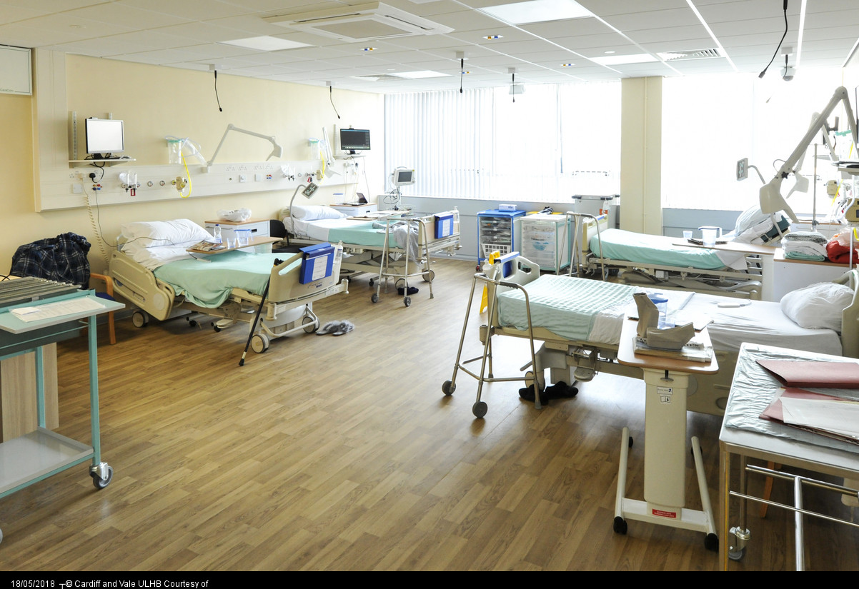
Picture 1 Wood Simulation Ward set up for Fall's simulations and control room to enable recording of simulation sessions and editing
The simulated ward also offers the ability to record visuals and audio’s of the simulation sessions which take place. This means that the sessions can be used immediately in there debriefs thus empowering learners to evaluate their own performance improving the learning environment (Westberg et al 1993). Feedback can also be provided in a timely fashion again improving learning experiences (Jason 2000). The launch event provided a platform for improving engagement.
We also promoted simulation teaching within the Medical Grand Round teaching program. We used this platform to increase our circle of influence further (Covey 1989). We presented the data from the course which we had trialled the feedback forms on to demonstrate the value of simulation.

5. Empower others to act on the vision
Our guiding coalition needed more followers, we needed to expand our circle of influence (Covey 1989). One way of doing this is to use the Science of Persuasion (Caildini et al 2012)
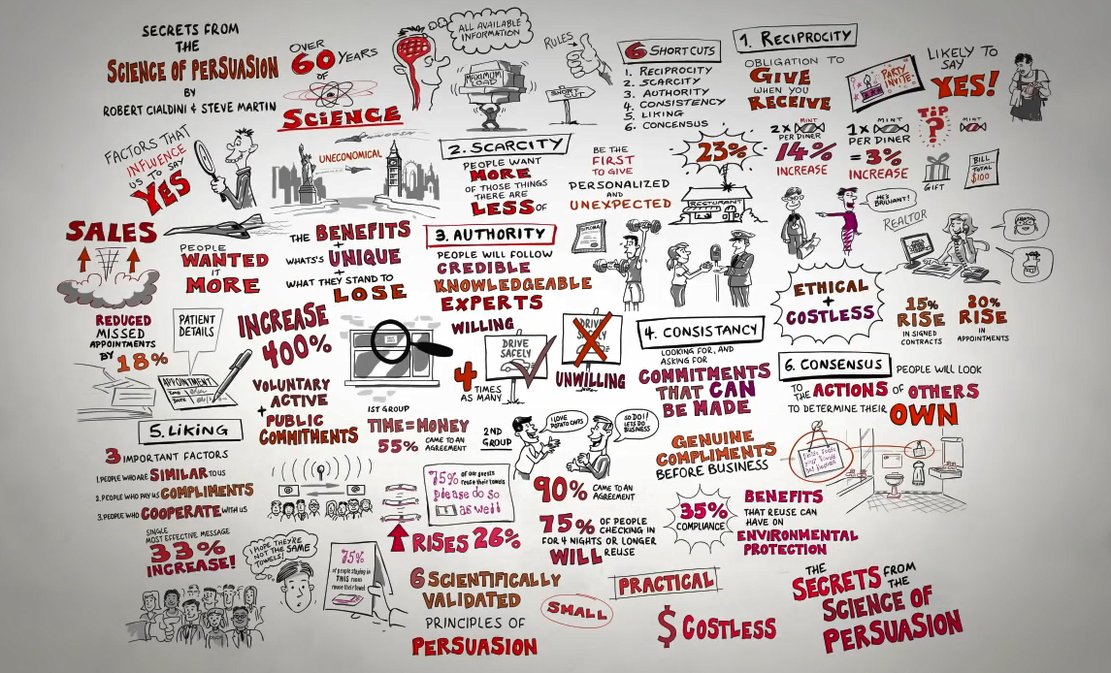
Figure 8 Caildini et al (2012) Secrets from the Science of Persuasion
Within Medical Education we have successfully employed the six shortcuts outlined in the Science of Persuasion (Caildini 1993) I used a personal compassionate leadership style in order to employ the science of persuasion.
- Reciprocity
We have worked with people to develop their own teaching programs, we have encouraged them to bring ideas to us and we can expand them and ensure their effectiveness. We spread the word widely throughout CVUHB and presented in the Grand Round teaching program. The launch of the Wood’s simulation ward was also an opportunity to showcase what we can do. We used a Push technique ‘Percussive reasoning’ in order to achieve reciprocity.
- Scarcity
People want things more if they are scarce. The new area is bookable and we have a limited workforce, time available and space. This makes the simulation teaching more desirable and people give it higher value.
- Authority
The robust evaluation procedures are able to give credibility to the quality of teaching provided and the benefits of simulation teaching. We are able to give faculty statistical evidence that the teaching they provide is having an impact.
- Consistency
Outlined below are the starting commitments we obtained and then how we have already expanded on this.
- Liking
We have positioned ourselves within the overarching vision from CVUHB thus creating the mutual goal to care for people and keep people well. We share a similarity with the people approaching us to run courses because we all what to achieve a high quality teaching environment where participants are safe to learn. We all want to shorten the time it takes to acquire a skill (Syed 2010) and ensure patient safety (Issenberg 1999).
- Social proof
We have used a mixture of push and pull strategies to increase momentum for the use of simulation teaching as an effect method of teaching. We have used previous ideas and evidence of effective courses to bring others within our circle of influence (Covey 1989).
Push influencing is to move the other person into a different viewpoint or position, likened to a carrot and a stick approach. In includes rules and standards and the power of persuasion. A further example of a push influence would be the ASPiH standards (appendix 1). Pull influencing is to motivate a person to see the possibilities that changing their viewpoint can achieve. It includes personal magnetism and joint problem solving. The falls project outlined below would be a good example of a pull style of influencing.

6. Plan for and create short term wins
Using Quality improvement methodology
For each project that I have individually worked on this year I have developed this using a quad of aims.
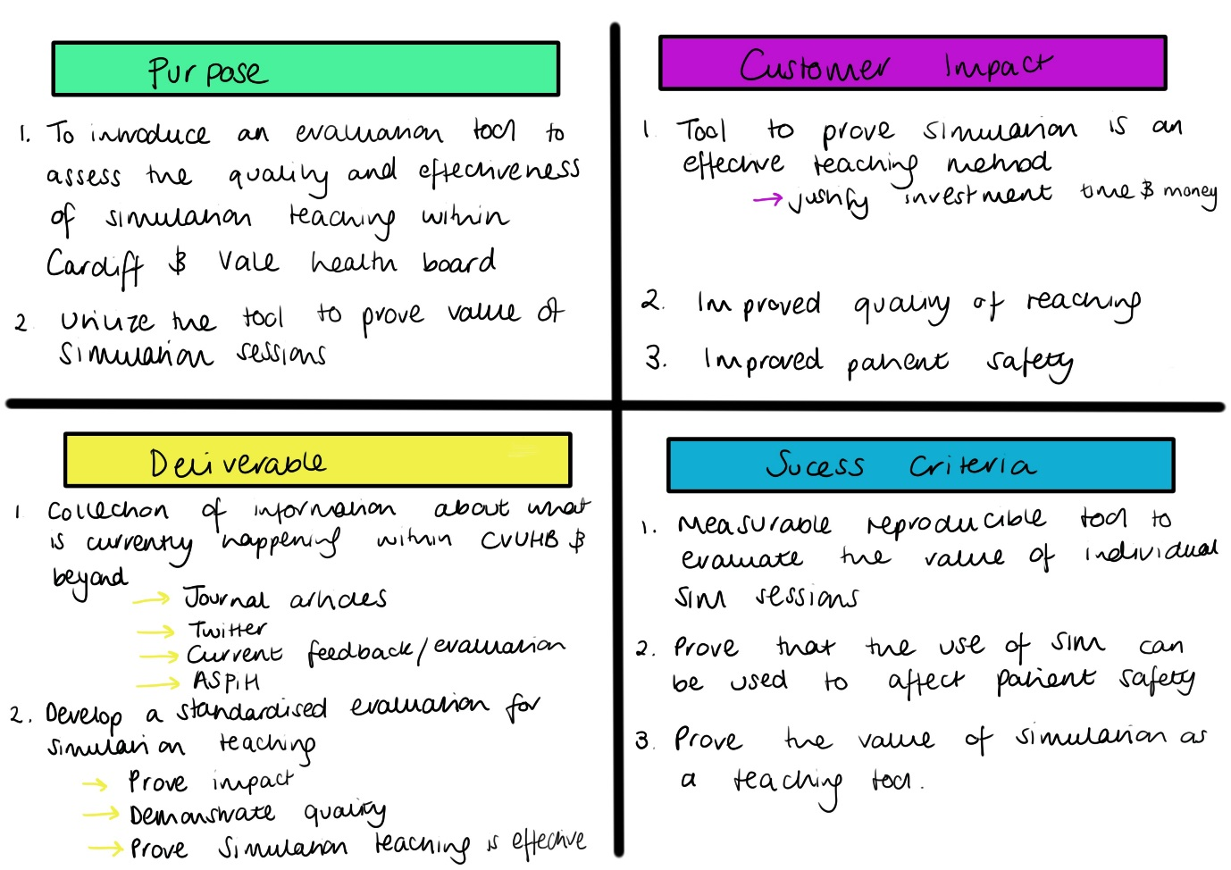
Figure 9: Quad of aims for simulation evaluation project
By utilising small projects initially and focusing on their success I have demonstrated short terms wins to increase momentum and forward drive. I have employed quality improvement skills and utilised the Plan-Do-Study-Act (PDSA) cycles to ensure that the feedback collected from each project is constantly evaluated (NHS Wales 2017).
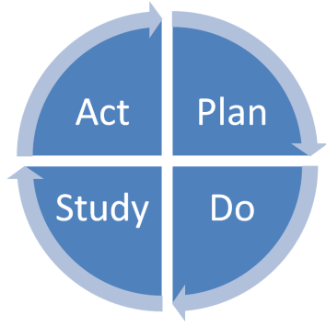
Figure 10 Quality improvement Plan-Do-Study-Act cycle
Each smaller project generated as a result of increased engagement is an individual Quality improvement project which cycles through its own quality improvement methodology. The evaluation of simulation teaching has also progressed through PDSA cycles.
Results: PDSA cycle 1
Use within a teaching program: Foundation simulation teaching
Within CVUHB there are regular teaching programs which take place. One of these programs is for foundation doctors. We utilised the new feedback form for the first time with this group to evaluate a simulation afternoon based on paediatric emergencies. We targeted the questions on the feedback forms to the simulations sessions which took place and were able to demonstrate a significant increase in confidence and knowledge following the simulation session. We presented this information in poster form at the Patient Safety Congress in Manchester 9th-10th July 2018 (Appendix 5). Therefore we have confirmed that the simulation teaching offered as a routine part of medical education within CVUHB is effective. This was cycle 1 as the session was a routine teaching session which ran over an afternoon. There were a limited number of participants and we were easily able to gather feedback from them.
Results: PDSA cycle 2
Use to address a trainee need: Trauma and Orthopaedics
Having proved that the simulation training offered is effective and that our evaluation generated quality data. We moved on to utilise the feedback forms to address trainee concerns. A frequent concern raised within multiple areas of medicine is that when trainees first start they do not feel confident in managing the patients. We were approached by the Trauma and Orthopaedic department because they had concerns raised by their new trainees that they did not feel equipped or confident to manage the Trauma and Orthopaedic patients. We developed a patient story simulation session as a part of their departmental induction in order to: give a basic introduction to approaching trauma, give Foundation Trainees the basic knowledge to deal with a common Orthopaedic emergency and improve trainee’s confidence with patient management. The simulations addressed relevant competencies for the trainees; clinical skills including cast application, the development of leadership skills with a trauma call simulation and the introduction to the theatre environment and etiquette.

We have demonstrated that the use of a simulation program within the Trauma and Orthopaedic induction results in an increase in confidence amongst the trainees. We are equipping the trainees with the day-to-day skills and confidence necessary to fulfil their role within the Trauma and Orthopaedic team thus improving patient safety and experience. 6 of the 8 SIM sessions run throughout the afternoon demonstrated a significant improvement in the confidence of the trainees at handling that particular clinical scenario.

This project was presented in poster form at the Patient Safety Congress in Manchester 9th-10th July 2018 where it won first place in the Education and Training category (Appendix 6, 7).

7. Consolidate improvements and produce more change
Once we established that simulation can be used to meet concerns raised by trainees we moved on to consider health board wide concerns. We met with CVUHB patient safety team to identify specific needs; they outlined the key areas which CVUHB is focusing on developing. Once again increasing momentum, increasing our circle of influence and utilising the science of persuasion to add value and depth to the patient improvement project.
Results: PDSA cycle 3
Use to address a patient safety problem: Falls project
We are working with teams in the areas suggested from meeting the patient safety team to develop simulation programs which address specific concerns; one of these is the prevention and management of inpatient falls.
We used a Pareto diagram to determine where to initiate simulation training.
Figure 11 Pareto Chart: University Hospital of Wales Falls incidence June 2016 – May 2018
From this we approached A4 to engage them with the project. We took a multidisciplinary team from the ward through the quality improvement program run by CVUHB the ‘Leading improvement in patient safety’ (LIPS) program.
Together we developed a project which aimed to increase staff compliance with inpatient CVUHB falls procedures, increase staff confidence in following inpatient CVUHB falls procedures and increase staff knowledge of inpatient CVUHB falls procedures. The process of generating the Falls project also went through its own rounds off PDSA cycles. And employed quality improvement methodology to generate a potential solution. Working with A4 we generated a fishbone diagram in response to the problem statement: There are inconsistencies in staff quality of completion and compliance with the Cardiff and Vale University Health Board inpatient falls procedures, resulting in potential patient harm.
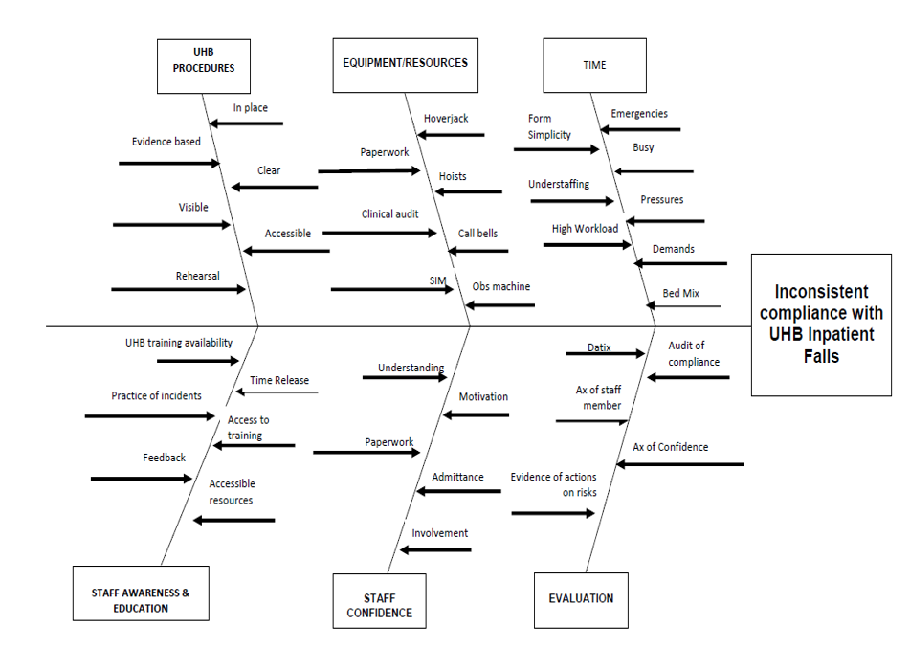
Figure 12 Fishbone diagram for problem statement: There are inconsistencies in staff quality of completion and compliance with the Cardiff and Vale University Health Board inpatient falls procedures, resulting in potential patient harm.
We focused on the staff awareness and education arm of the fishbone diagram. Between May 2018 and August 2018 Staff from Ward A4 undertook falls simulation training on a simulated ward. Three scenarios were used focusing on admission of a patient to the ward, management of a witnessed fall and management of an unwitnessed fall (Picture 2). Following each scenario staff were debriefed on the CVUHB procedure. The multidisciplinary team which undertook LIPS have been trained to conduct simulations thus empowering the ward team to take control of the education program.
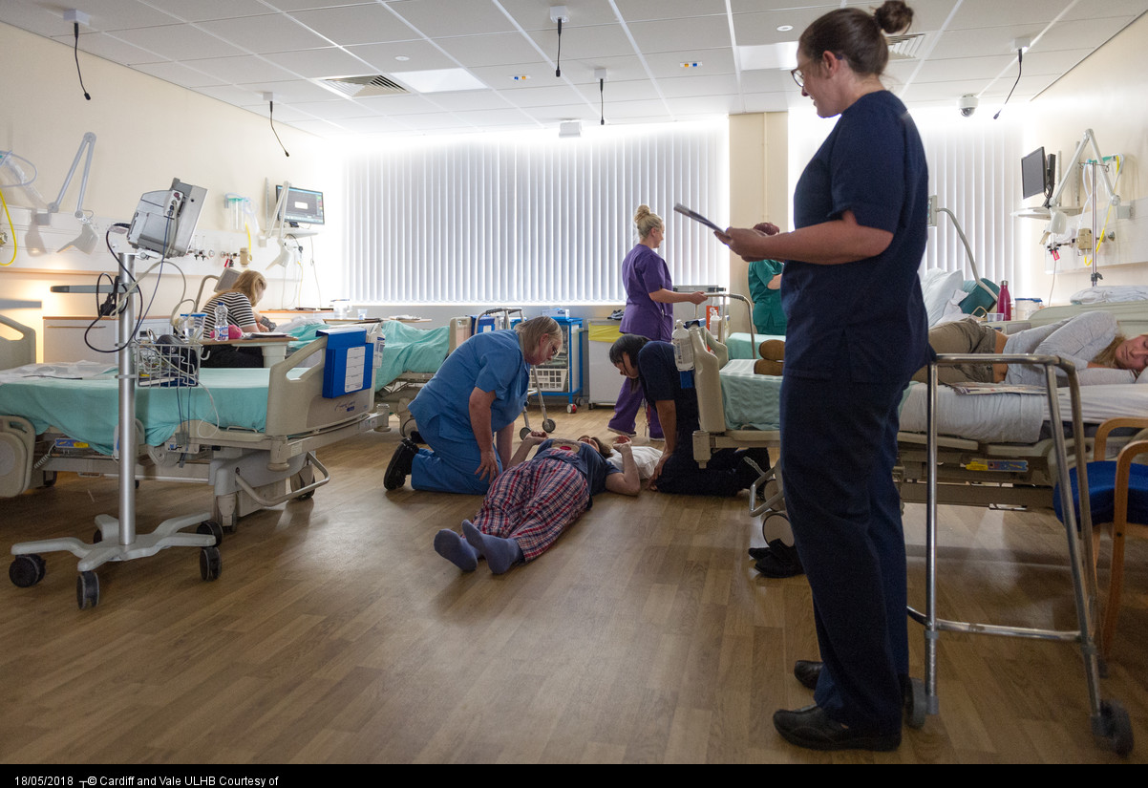
Picture 2: Ward team performing a falls simulation
We utilised the new feedback forms and demonstrated a statistically significant increase in staff confidence post simulation in participant’s knowledge of the CVUHB falls protocol. Other areas demonstrated an increase in confidence but this was not statistically significant. (Appendix 8) We are equipping the multidisciplinary team with the day-to-day skills and confidence necessary to fulfil their role within the management of inpatient falls thus improving patient safety and experience. We have also been generating run diagrams of the absolute number of falls occurring on A4. Currently approximately half of the staff on the ward have undertaken the simulation training and the time period has not been sufficient to demonstrate a change in absolute numbers falls.
These sessions highlighted the benefits of true multidisciplinary working (Forsythe 2009). It highlighted to me personally the value of including the multidisciplinary team. I am a doctor by background and have a strong history of taking part in simulation sessions as a teaching method. This is not shared by the multidisciplinary team and this became apparent during the project. We ran our first simulation session with a small select number of nurses as PDSA cycle one. It became clear that in order for simulation to be effective there first needed to be an induction into how simulation worked and why it was useful. It was necessary to explain the need to suspend reality and act as though this was a real life situation. The small start with a select number of key nurses and healthcare workers (the LIPS team) enabled changes to be made within the scenarios and to the delivery of the teaching thus improving it further for PDSA cycle two. PDSA cycle three took the sessions a step further with senior staff members (the ward manager, the band six nurses and the LIPS team) being taught to teach the simulations themselves. Cycle three was vitally important as in order to ensure sustainability the simulations will all be run in situ by the nursing teams. Cycle four is yet to happen but it will involve the moving of the simulation from the Wood’s simulation ward onto A4, making it in situ.
The future plans are to implement falls simulation training throughout CVUHB, expand the number of available scenarios and embed ward base simulation training into regular practise. We believe that by proving we have embedded a regular program of in-situ simulation training the falls project will represent a level three Kirkpatrick evaluation (Yardy 2012).

8. Institutionalise new approaches
Looking forward
We are in the process of ensuring sustainability of the patient improvement project and continuing its progression. In order to do this we are nurturing and developing mutual relationships with a champion for simulation teaching from each health board directorate. Champions from each board are being utilised with the pull influencing style (Covey 1989) in order to empower them to see the potential for simulation for the staff within their circles of influence.
Ongoing projects:
Midline insertion
Midline insertion is a skill which is performed by few in CVUHB but has a high demand. As a medical education team we were approached by the people who currently place midlines and those whose patients require them to determine if we could help with problem. Midline insertion is a further example of the use of simulation in order to become elite at a skill (Issenberg et al 2005). We have created a business case and this has been put out to tender in order to make a decision which as to which company CVUHB will use to provide the midline equipment. This project was created by momentum generation at the Wood’s simulation launch event.
Wetlab
Again focusing on skill development and the use of simulation to shorten the time needed to achieve a goal (Syed 2010). We were approached by the cardiothoracic team to enable an innovative use of simulation facilities. The Wetlab facility is a simulated operational field where trainees can attend with trainers and be taught on animal organs how to perform specific surgical procedures. This allow cardiothoracic trainees 1:1 quality simulation teaching focusing on their personal development and current learning needs. It will allow the consultant team to rehearse operations with junior members of their team to ensure that exposure to learning events is maximized without compromising patient safety (Westberg et al 1993).
Sepsis
World Sepsis day takes place on 13th September 2018. We were approached following the presentation of this patient improvement project to work with the sepsis team to generate a recorded simulation to be published on World sepsis day and raise awareness. We are in the process of gathering a guiding coalition to take this forward. An ongoing sepsis project will be based on the structure of the Falls project and begin on one ward to generate momentum in order to spread simulation sessions on sepsis throughout CVUHB.
PDSA cycle four – evaluation
Could we take our evaluation process to the next stage? Can we do better than a Kirkpatrick level 2 outcome evaluation (Yardy 2012)? The next step which we are focusing on is the incorporation of measuring situational awareness (Frere et al 2018) Situational awareness is “knowing what is going on in” and in some simulation centres has been measured using situational judgement responses as an evaluation tool for simulation. This is an exciting potential area for future development focusing specifically on this patient improvement project.
Conclusions
Through the use of a thorough evaluation process we have effectively demonstrated the value of simulation within teaching programs at CVUHB.
We have created interest, increased our circle of influence and generated momentum for multidisciplinary staff engagement with simulation.
The falls project is an example of how we can institutionalise simulation within CVUHB but can also be utilised as an example of what can be done therefore enabling the push method of influencing.
Because simulation teaching now has a proven effectiveness and can be evaluated we are able to use it in a larger variety of ways. Simulation can be used as part of regular teaching programs to cover aspects of the curriculum which are difficult to teach in other ways and increasing engagement of trainees. It can also be used to empower teams on wards or in departments to take ownership of their own teaching program and use their valuable time effectively. It can be reactive to events and learning needs brought by a multidisciplinary workforce, reducing the time needed to obtain elite level of a skill (Syed 2010). We can use simulation teaching as a response to significant incidents, creating a simulation based on these. Thus allowing the multidisciplinary team to rehearse good practise and improve on bad. Complaints can be responded to by including a simulation session to address problems with human factors and communication. Together we can change culture and attitude. We aim to run simulation courses for multidisciplinary teams and using the evaluation theory above prove that the simulation teaching has value.

References
Aggarwal R and Darzi AD (2006) Technical-Skills Training in the 21st Century New England Journal of Medicine 355(25), 2695-6
Alaker M, Wynn GR and Arulampalam T (2016) Virtual reality training in laparoscopic surgery; A systemativ review & meta-analysis International Journal of Surgery 29, 85-94
Association for Simulated Practise in Healthcare (ASPiH) (2016) Simulation-based education in healthcare Standards, framework and guidelines. London. Health Education England
Caildini RB (1993) Influence. The Psychology of persuasion Revised Edition. Collins
Caildini RB and Martin S (2012) Influence At Work: https://www.youtube.com/watch?v=cFdCzN7RYbw [Accessed on 1/08/2018]

Commission on Education and Training for Patient Safety (2018) Improving Safety Through Education and Training [online] https://hee.nhs.uk/our-work/education-training-patient-safety [Accessed 19th June 2018]
Cook DA (2012) If you teach them, they will learn: why medical education needs comparative effectiveness research Advances in Health Sciences Education 17, 305-310
Covey S (1989) The 7 Habits of Highly Effective People. Free Press
Davidoff F, Dixon-Woods M, Leviton L and Michie S (2015) Demystifying theory and its use in improvement British Medical Journal Quality and Safety 9, 1-11
Eurogeography (2018) Kotter’s change management model: http://www.eurogeography.eu/SoC/guidelines/changemanagement.html [accessed on 04/09/2018]
Forsythe L (2009) Action Research, Simulation, Team Communication, and Bringing the Tacit Into Voice Society for Simulation in Healthcare Simulation in Healthcare 4 143-149
Frere M, Tepper J, Fischer M, Kennedy K and Kropmans T (2017) Measuring situation awareness in medical education objective structured clinical examination guides. Education for Health 30, 193-7
General Medical Council (2017) The State of medical education and practise in the UK. London. General Medical Council
Grol RPTM, Bosch MC, Hulscher MEJL, Eccles MP and Wensing M (2007) Planning and Studying Improvement in Patient Care: The Use of Theoretical Perspectives The Milbank Quarterly 85, 93-138
Harden RM, Grant J, Buckley G and Hart IR (1999) Best evidence medical education Medical teacher 21, 553-562
Health of Commons Select Committee (2009) Patient Safety: Sixth report of session 2008-2009 Volume 1 House of Commons London: The Stationery Office Limited

Issenberg SB, McGaghie WC, Hart IR,Mayer JW, Felner JM, Petrusa ER, Waugh RA, Brown DD, Safford RR,Gessner IH, Gordon DL and Ewy GA (1999) Simulation Technology for Health Care Professional Skills Training and Assessment Journal of American Medical Association 282(9), 861-866
Issenberg SB, McGaghie WC, Petrusa ER, Gordon DL and Scalese RJ (2005) Features and uses of high-fidelity medical simulation that lead to effective learning a BEME systematic review Medical Teacher 27(1), 10-28
Jason H. (2000) The importance – and limits – of best evidence medical education. Education in Health 13, 9-14
Kotter JP (1996) Leading Change Boston. Harvard Business School Press
Kirkpatrick D and Kirkpatrick J (2005) Transferring learning to behaviour: Using the four levels to improve performance. Berrett-Koehler Publishers.
McGaghie WC, Issenberg SB, Petrusa ER and Scalese RJ (2006) Effect of practise on standardised learning outcomes in simulation-based medical education Medical Education 40, 792-797
NHS Wales (2017) Improving Quality together: Silver level [Teaching delivered on 6th December 2017]
Syed M (2010) Bounce. London. Forth Estate (An impint of HarperCollinsPublishers)
Temple J (2010) Time for Training: A Review of the Impact of the European Working time Directive on the Quality of Training. Medical Education England, London

Westberg J and Jason H (1993) Collaborative clinical education: the foundation of effective health care New York: Springer
Yardley S and Dornan T (2012) Kirkpatrick’s levels and education ‘evidence’ Medical Education 46, 97-106
Zendejas B, Brydges R, Wang AT and Cook DA Patient Outcomes in Simulation-Based
Appendix 1 ASPiH standards

Appendix 1 ASPiH standards

Appendix 1 ASPiH standards
Appendix 2: Original feedback form

Appendix 3: Original feedback results
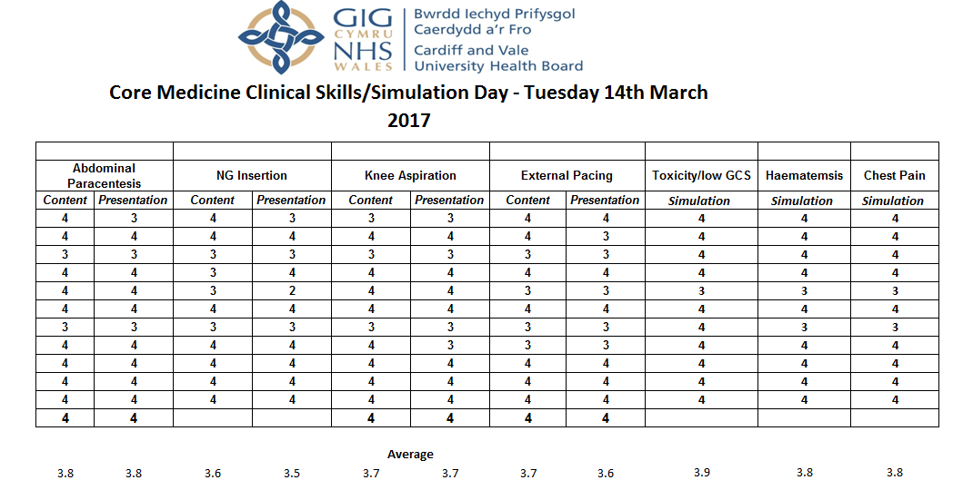
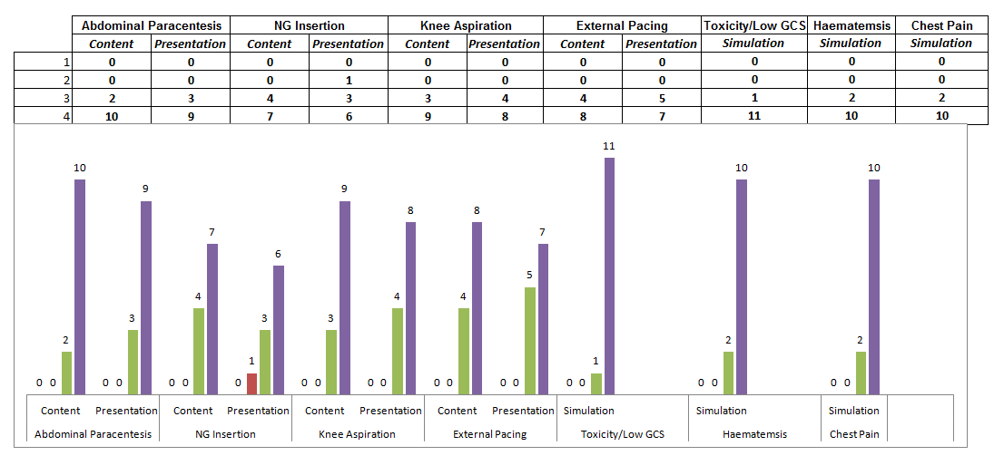
Appendix 4: Generic Pre course feedback form:
Appendix 5: Generic post course evaluation form

Appendix 6: Foundation Simulation Poster

Appendix 7: Trauma and Orthopaedics course poster
Appendix 8: Certificate for first place in the Education and Training category Patient Safety Congress in Manchester 9th-10th July 2018

Appendix 9: Falls Project


