
Software Solutions for Business
Assessment #1
Cristiane Uhlmann Rodrigues 2541760 | 8/7/26 | CERTHE Computing Skills for the Workplace

Contents
Introduction 1
Task 1. e-Commerce Website builders/software solutions 1
1.1 Google Sites 1
1.2 Wix 3
Task 2. Mind-map of contemporary software applications 4
2.1 Describe mind mapping and explain the benefits of using mind mapping 4
2.2 Create a mind map of contemporary software applications 5
Task 3. Office Applications 6
3.1 Four office software solutions for business operations 6
Microsoft Word 6
Microsoft Excel 7
Microsoft PowerPoint 7
Microsoft Access 8
3.2 Test any two features 9
Mail Merge 9
IF Statement 12
Task 4. Communication and Collaboration applications 13
4.1 One contemporary Communication and one Online Collaboration 15
Microsoft Outlook 15
Ms Teams 20
4.2 Test one feature of a freely available Communication (1) and one feature of a Collaboration (1) application 25
WhatsApp – Instant Messaging 25
One feature of a freely available Collaboration app 25
Google Drive – Shared file Storage 25
Microsoft Outlook 25
Team 26
Conclusion 26
References 26

Introduction
Digital tools have changed how businesses run, connect and work together every day. Online sales platforms, office software and communication apps now help teams work more smoothly, save time and make more smoothly, save time and make better decisions.
In this assignment, I will review different software solutions: Google sites and Wix for building websites, office tools for managing documents, and outlook plus team for staying connected. I will also look at mind mapping for planning work. I will explain what each tool does well, its downsides, and how technology helps organisations work better today.

Task 1. e-Commerce Website builders/software solutions

Google Sites

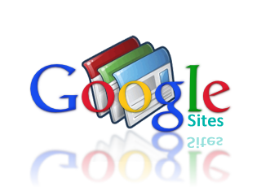
Key Features
Google Sites is a free, user-friendly platform designed for quick and simple website creation. (Nicodemus et al. 2026)It requires no advanced technical skills, letting users build pages through a straightforward interface, with hosting included at no extra cost. It integrates seamlessly with the Google ecosystem Google Docs, Sheets, Drive, Forms, and more can be embedded directly into pages with just a few clicks. It supports basic page layouts, simple navigation, and limited customization of colours, fonts, and structure. It is fully cloud-based, so users can access and edit their work from any device and collaborate in real time with others.

Advantages
The biggest benefit is its simplicity and zero cost ideal for individuals or small teams needing a basic web presence without investment. Setup takes very little time, and anyone familiar with Google tools will feel comfortable right away. Real-time collaboration makes it great for group projects, academic work, or internal team pages. Integration with other Google services removes the need for third-party tools to display documents, spreadsheets, or forms. It is reliable, secure, and requires almost no maintenance Google handles hosting, updates, and security automatically.

Limitations
Google Sites is built for simplicity, not power. Design options are quite limited, offering little control over advanced styling, layout flexibility, or custom code. E-commerce and sales functionality are extremely basic there are no built-in payment systems, inventory tracking, or product management tools. Scalability is poor: it works fine for small informational pages or simple catalogues, but struggles with large sites, complex navigation, or growing businesses. There are almost no marketing, SEO, or analytics tools beyond basic Google Analytics integration. Custom domains are possible but may require extra setup, and the overall look tends to feel generic compared to dedicated builders.

- Free, simple and fast to set up
- Best for basic product catalogues
- Or small info pages
- Very limited built-in sales and payment features
- Integrates an easily with other Google services
- Good for simple online presence, not full stores

1.2 Wix


Key Features

Wix is a powerful all-in-one website builder known for its intuitive drag-and-drop editor that gives users full design freedom. (Hristov 2024)It comes with hundreds of professionally made, ready-to-use templates across every industry, fully customisable to match any brand style. It offers a complete e-commerce suite: secure payment processing, product inventory management, order tracking, discount codes, and multi-channel selling. Users can enhance their site with tools like PhotoScape to easily edit product images and visuals. It also includes built-in SEO, analytics, marketing tools, and a large app marketplace to extend functionality.

Advantages

Wix balances ease of use with professional results you do not need coding skills to build a polished, fully functional website. The e-commerce features are robust right out of the box, making it perfect for launching and growing an online store. Templates are high-quality and mobile-responsive, ensuring your site looks great on every device. You have total creative control over every element on the page. As your business grows, Wix scales with you: you can add more products, features, and marketing tools without switching platforms. Integration with image-editing tools like PhotoScape makes managing visual content simple and efficient.

Limitations
Because Wix hosts your site, you are tied to their platform moving your content elsewhere later can be difficult and time-consuming. The free plan displays Wix branding and has limited features; to remove ads and unlock full e-commerce tools you must subscribe to a paid plan, which can become costly long-term. While flexible, the editor locks you into your chosen template switching to a different design later requires rebuilding your site from scratch. Some advanced customisations still require coding knowledge. Performance can slow down if you add too many apps or heavy media files, and SEO options are less powerful than on dedicated content management systems.

- Intuitive drag-and-drop editor with full design freedom
- Complete e-commerce features: payments, stock, orders and discounts
- Hundreds of professional, ready-made templates
- Works well for growing businesses and custom brand stores
- Easy to edit product images with tools like PhotoScape

Task 2. Mind-map of contemporary software applications

2.1 Describe mind mapping and explain the benefits of using mind mapping

Mind mapping is a visual way to organise ideas. (Arulselvi 2017)You start with one main topic in the centre, then add related ideas, details and connections branching out from it. It uses words, lines, colours and simple images to show different points link together, instead of listing information in straight lines.



- Helps you see the whole picture and small details at the same time
- Make it easier to remember and understand information
- Encourages creativity and new ideas
- Keeps thoughts clear and avoids confusion
- Great for planning studying, solving problems and working in teams

2.2 Create a mind map of contemporary software applications
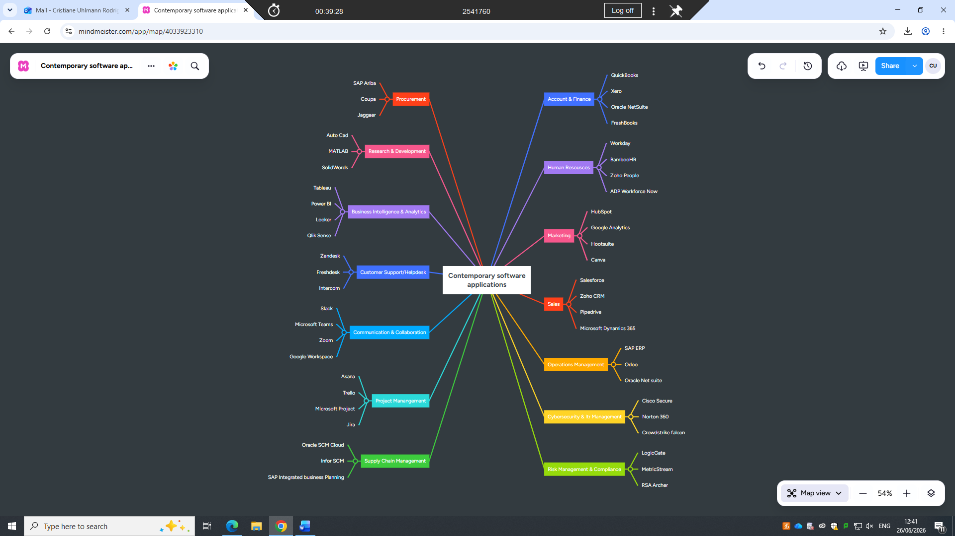

Task 3. Office Applications

3.1 Four office software solutions for business operations


Microsoft Word
Microsoft Word is a powerful word processing tool designed to create, edit, format and share professional written content. (Kruse and Rapp 2023)It is one of the most widely used office applications worldwide, and it plays a central role in almost every type of business operation. You can use it to produce all kinds of documents, such as formal reports, business letters, contracts, proposals, policy manuals, manual, meeting agendas and academic papers. It gives you full control over layout, fonts, images, tables and styles, so your work always looks neat, consistent and easy to read.

Beyond basic typing, Work includes many useful features that save time and improve quality: spell check, grammar correction, templates for standard documents, headers and footers, automatic tables of contents, and tools for reviewing and commenting when working with others. It also works well with programs, so you can easily add Excel data or PowerPoint content into your files. For businesses, Word is essential for creating clear, professional written communication that helps share information, explain ideas and keep accurate records

Microsoft Excel
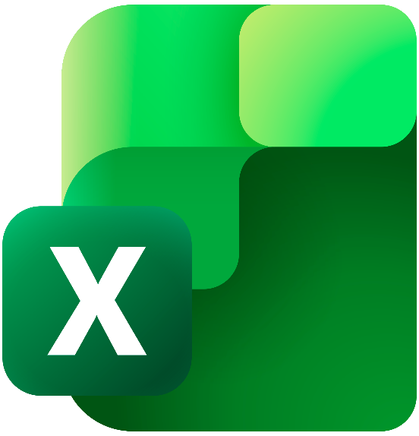
Microsoft Excel is a spreadsheet application built to store. Organise, calculate and analyse data in a clear table format.(Frye 2015) It is an invaluable data in a clear table valuable tool for almost every part of business mat. It is an in management, helping you turn raw numbers into useful insights. You can arrange information in rows and columns, use simples or advanced formulas to work out totals, averages, or graphs to show friends and patterns visually.

Excell is used for task file tracking income and expenses, managing inventory and stock levels, calculating payroll, organising customer lists, and analysing sales performance. It also has powerful extra tools such as data sorting, filtering, conditional formatting, and pivot tables that make it fast to find and understand key details. Because it is flexible and easy to adapt to different needs, tit helps businesses make informed decisions, plan ahead, spot problems early, and keep accurate financial and operational records.

Microsoft PowerPoint

Microsoft PowerPoint is presentation software that helps you turn ideas and information into clear, attractive visual slides. (Kosslyn 2007)It is designed to make communication easier, especially when sharing updates, plans or results with groups of people. You can add text, images charts, diagrams and simple animations to structure your message so it is simple to follow and remember.

In business, PowerPoint is used for meetings, project updates, training sessions, product introductions, and pitching new ideas or plans. It helps you focus on the most important points instead on overwhelming your audience with too much text. You can also use built-in templates to keep a consistent professional look add speaker notes to guide you while presenting and share files or present online for remote teams. It makes complex topics easier to understand, helps keep your audience engaged, and supports you in explaining your work clearly and confidently.

Microsoft Access

Microsoft Access is a database management tool that lets you store, organise, and manage large amounts of related information efficiently. (Dim and Kyaw)Unlike Excel, which works best with simple tables and quick calculations, Access is built to handle structured data that needs to be linked, searched, and updated regularly. It helps you keep information well organised without repeating details unnecessarily, which reduces errors and makes data much easier to work with.
In business, Access is used to build custom databases for tasks such as tracking customer records, managing product inventories, storing employee details, or logging sales and project history. You can create easy to use forms for entering new data, built custom queries to pull out exactly the information you need, and generate clear reports to share results or smoothly with other Microsoft Access, Excel, Word, or Outlook whenever you need to.
For companies that handle large or complex sets of information, Access brings real benefits: it keeps data consistent, makes searching fast, improves security, and lets you adapt the system to match your exact workflow instead of forcing you to fit your work into a fixed format. It is a practical choice for businesses that need more structure than spreadsheets can provide, without the cost or complexity of advanced databases systems.

3.2 Test any two features

Mail Merge

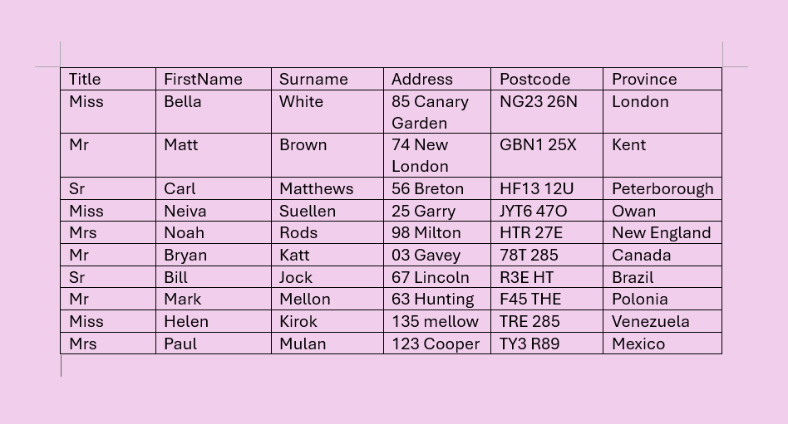

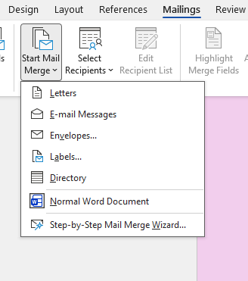
Click on the Start Mail Merge
Click on the Mailings

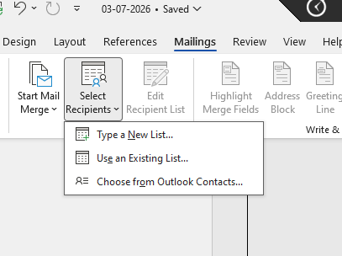
Click on the Select Recipients

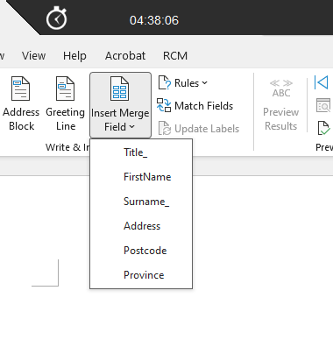
Click on the Insert Merge Field and select any
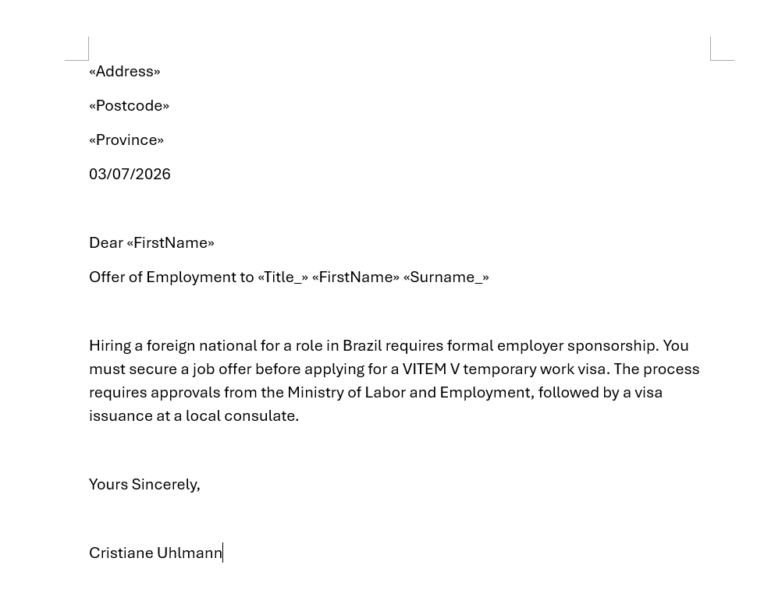
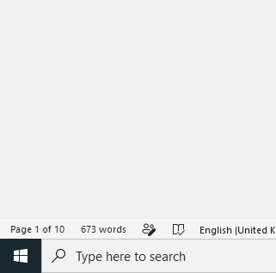

IF Statement

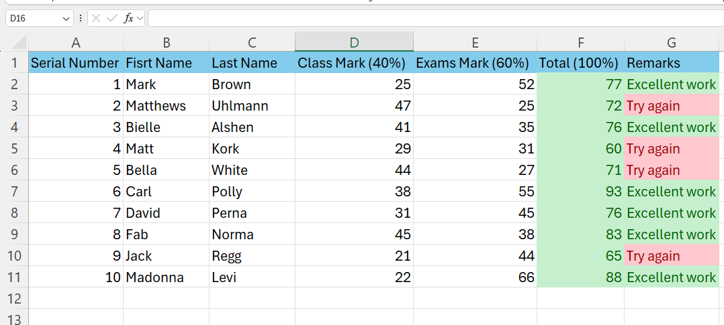

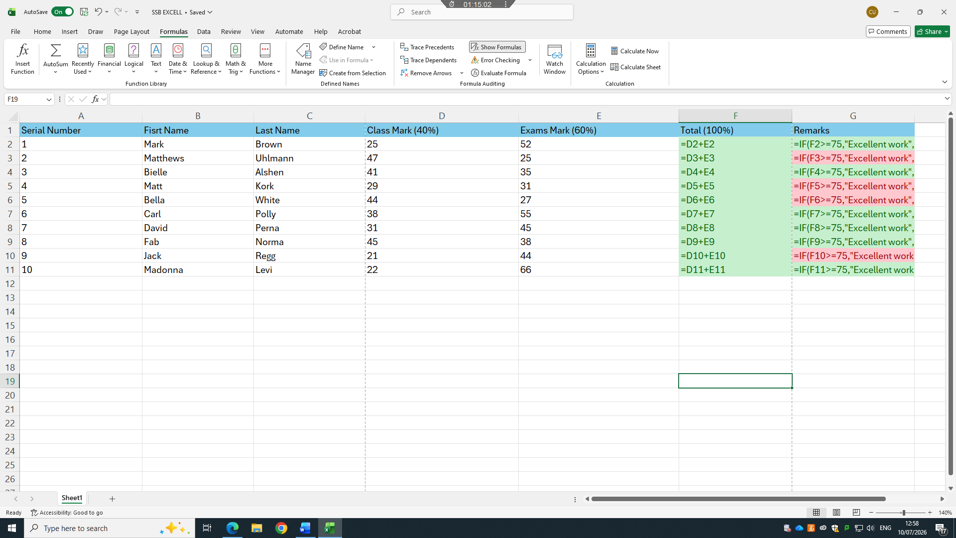

Task 4. Communication and Collaboration applications

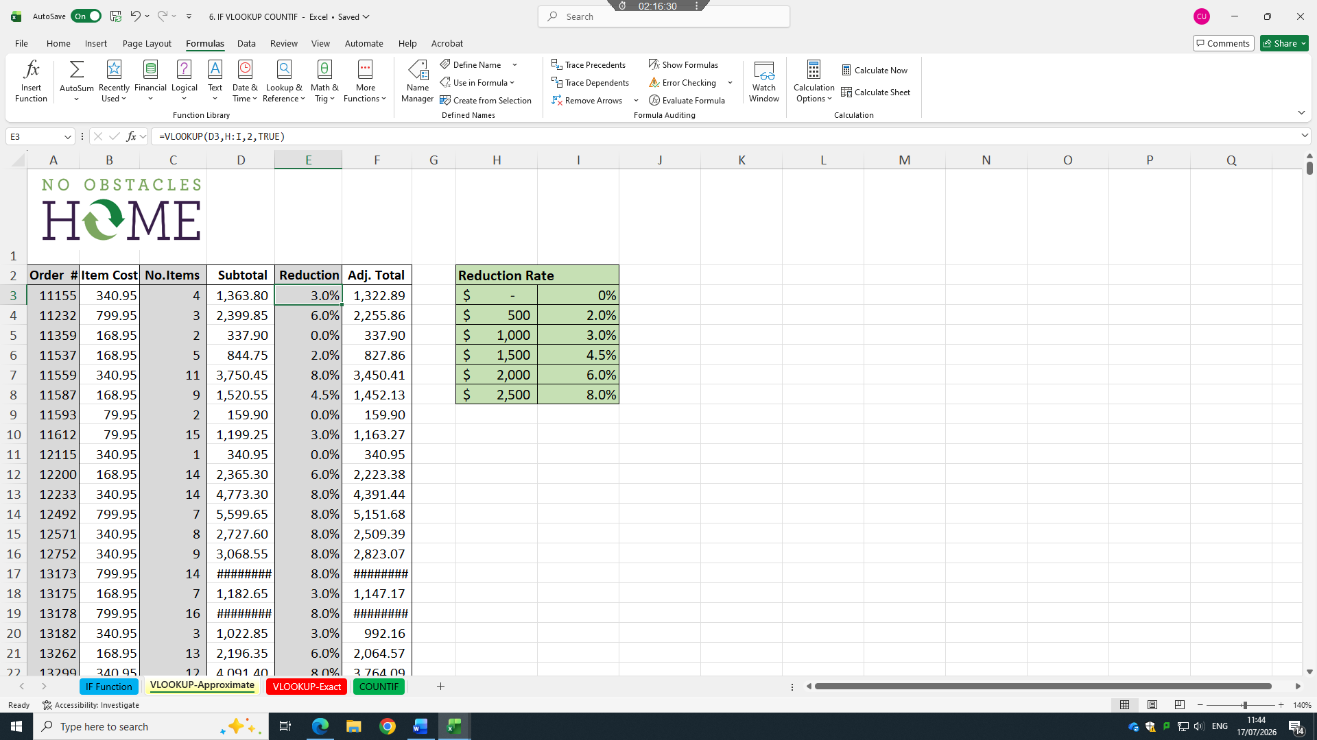
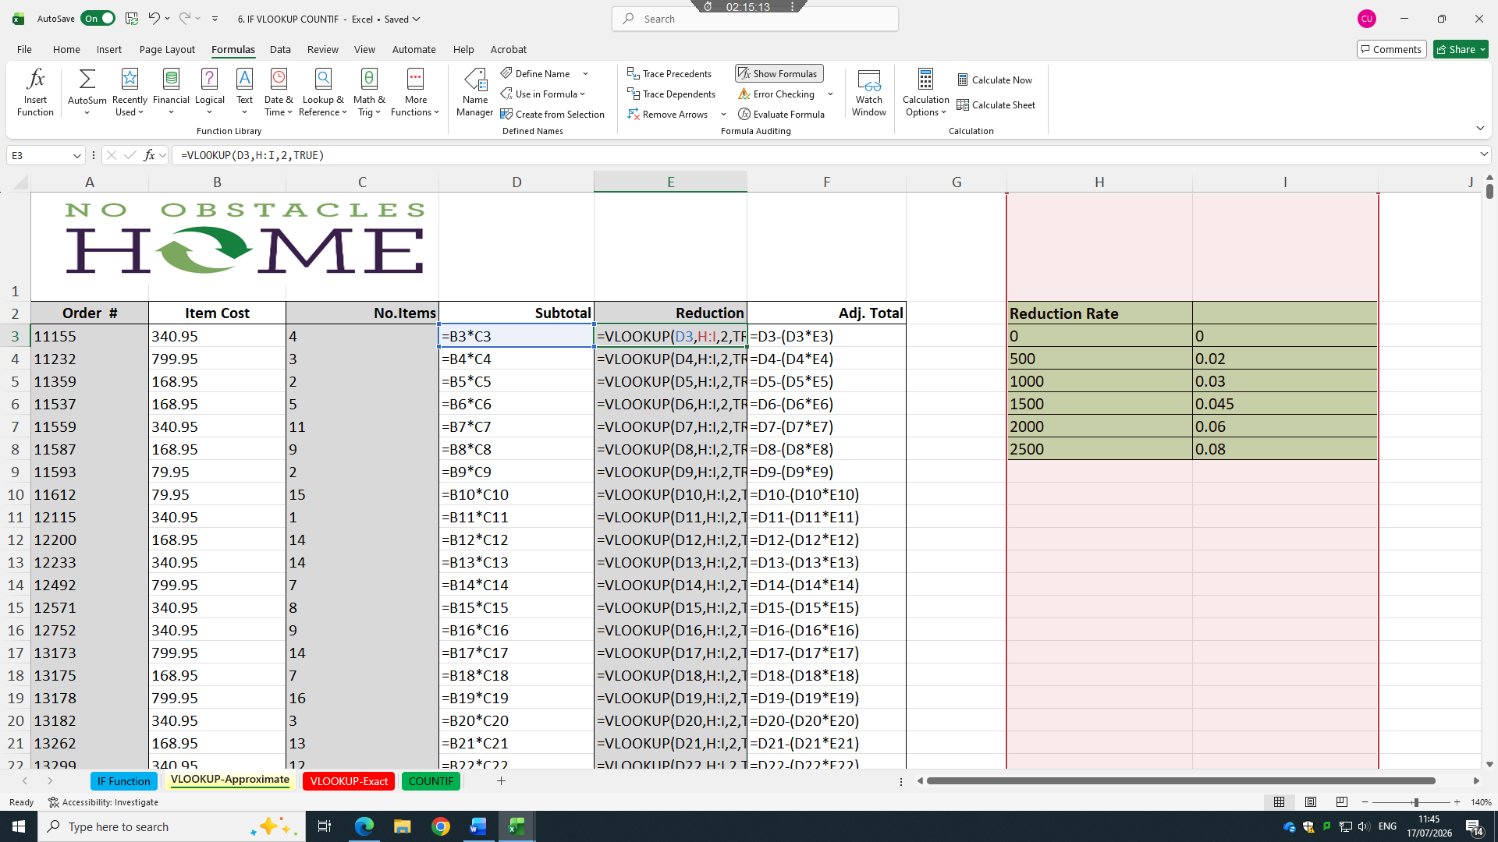
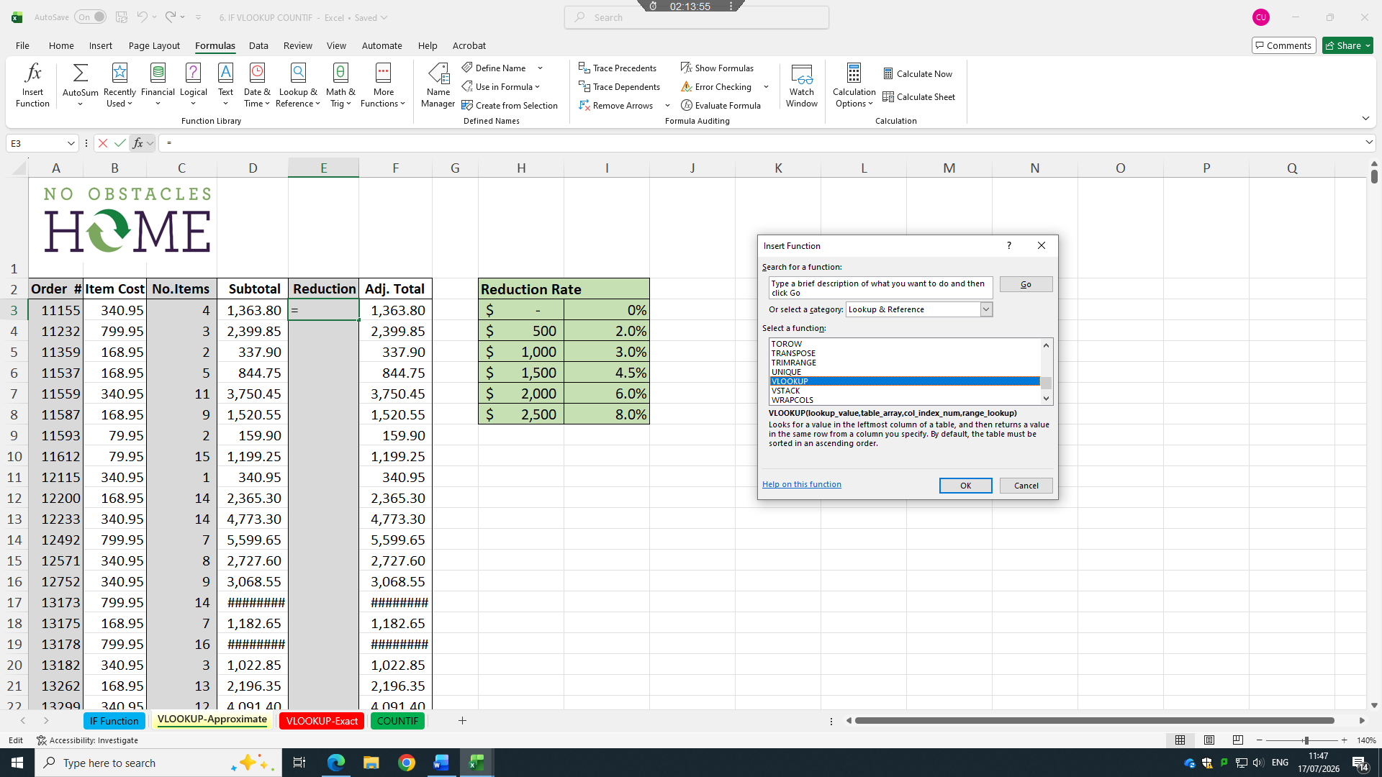
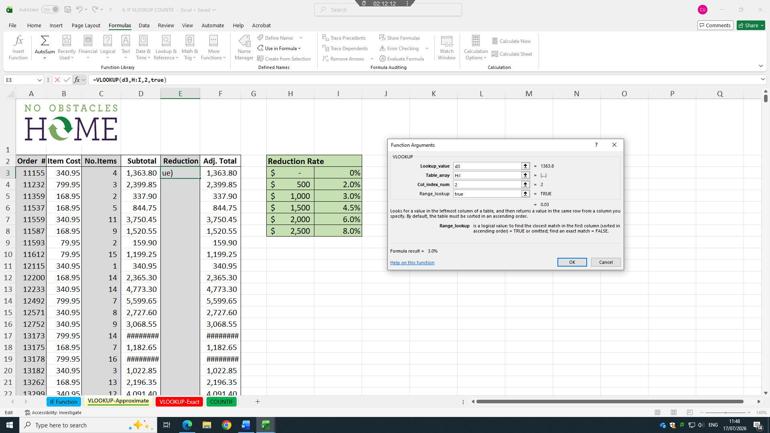
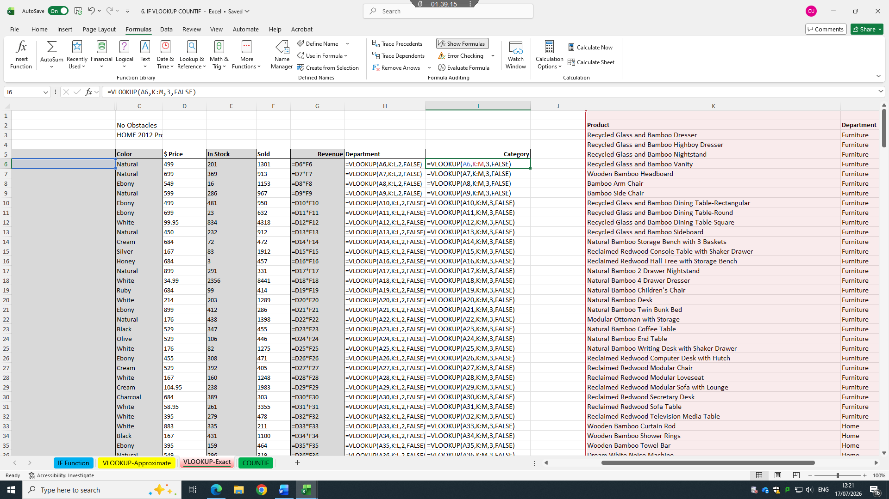

4.1 One contemporary Communication and one Online Collaboration

Microsoft Outlook
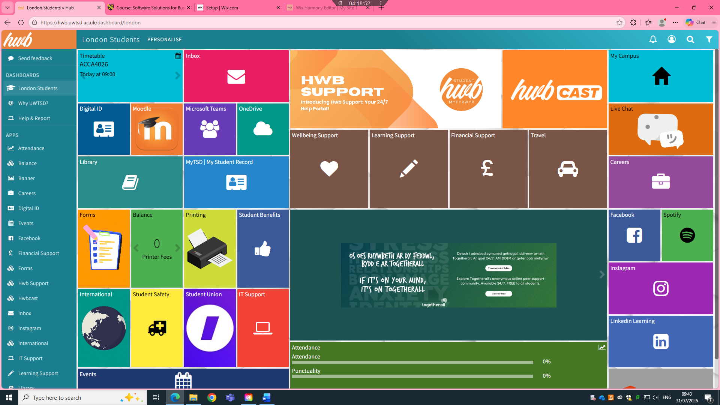

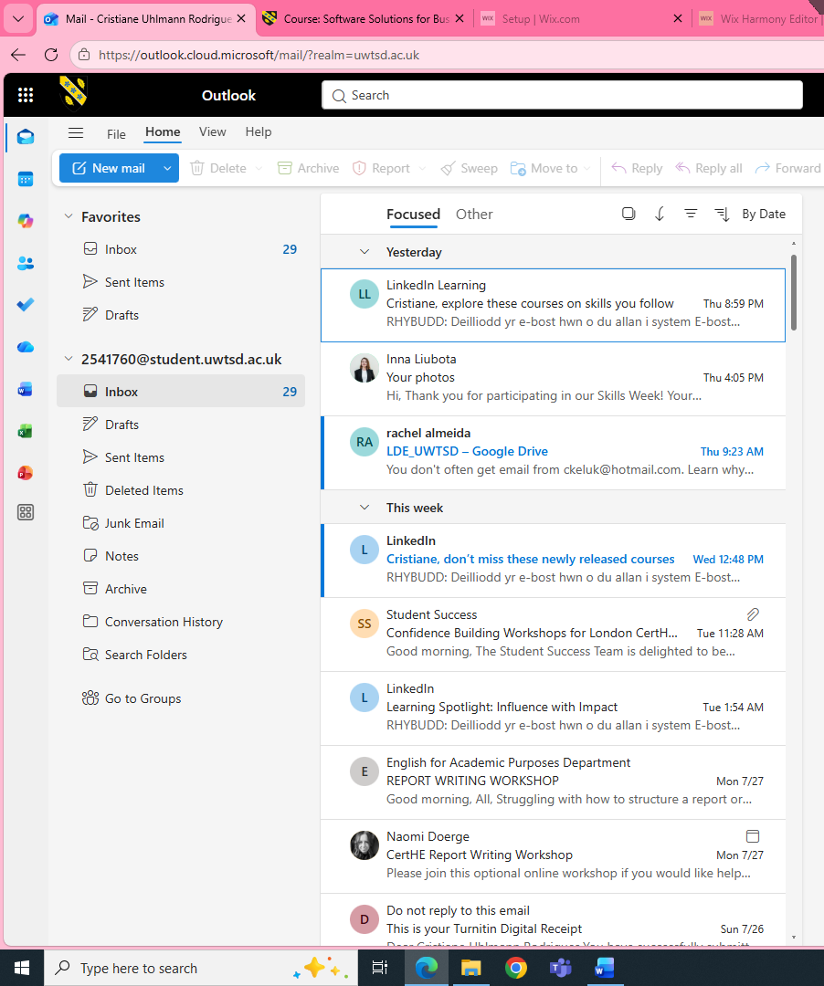

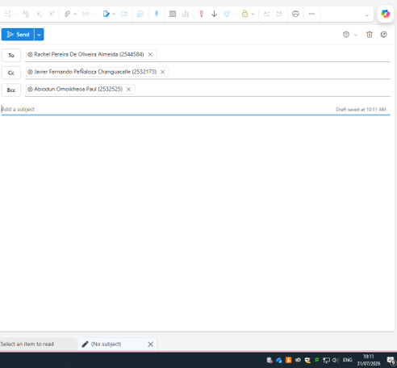

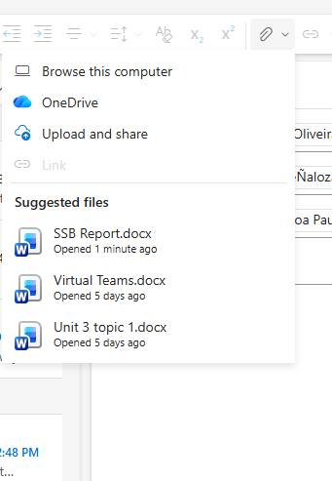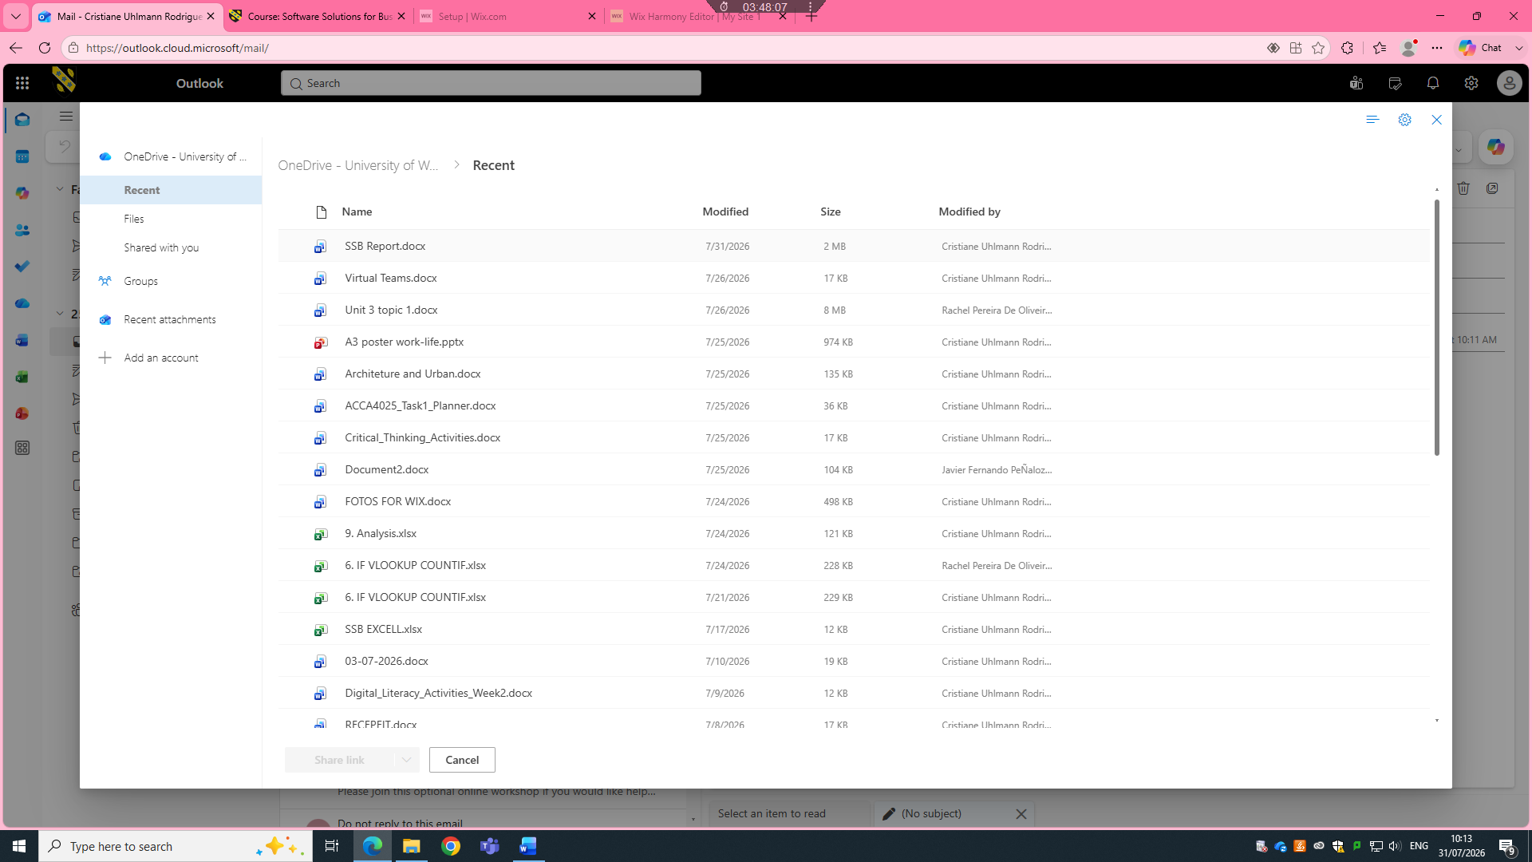
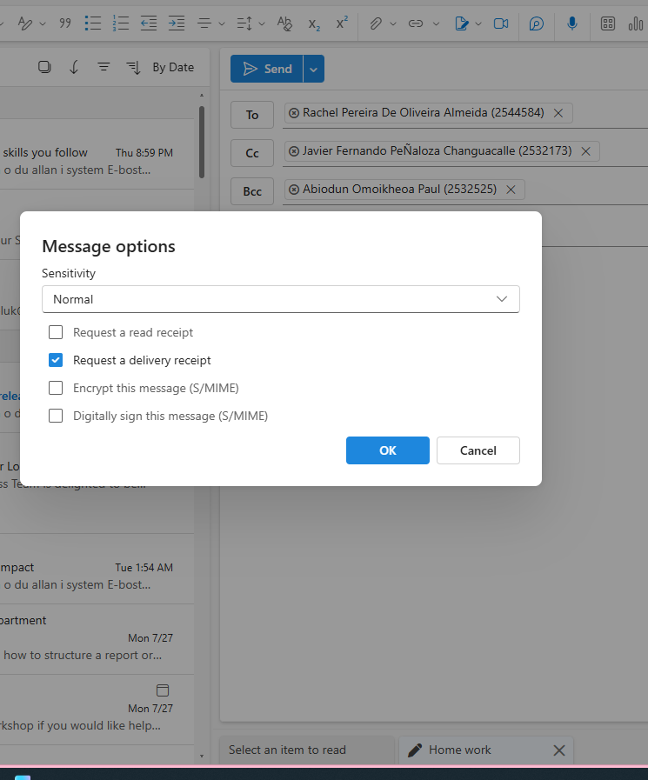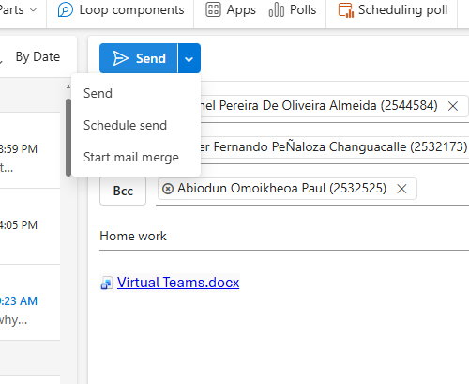

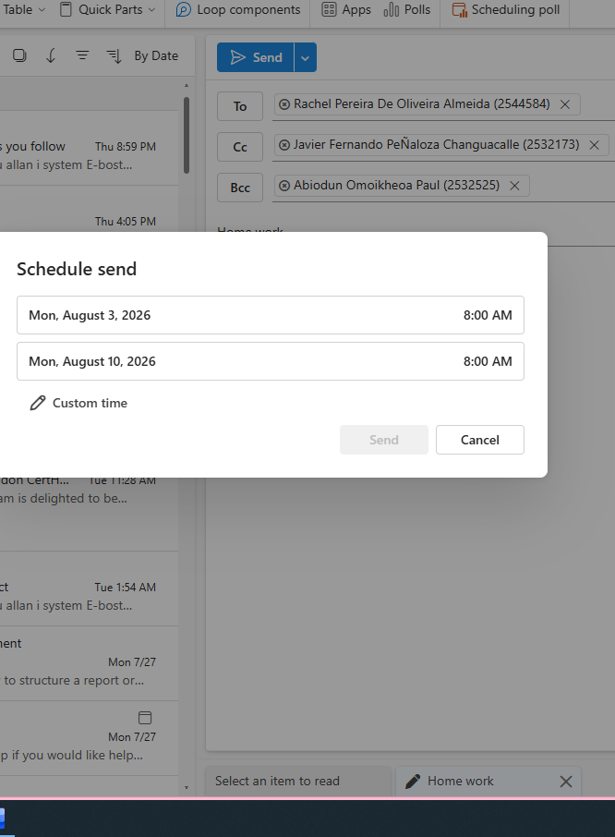
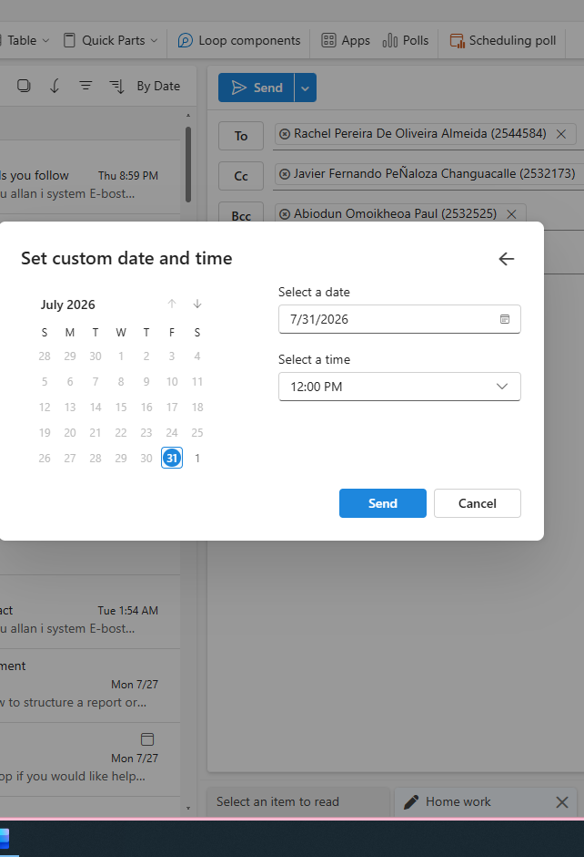
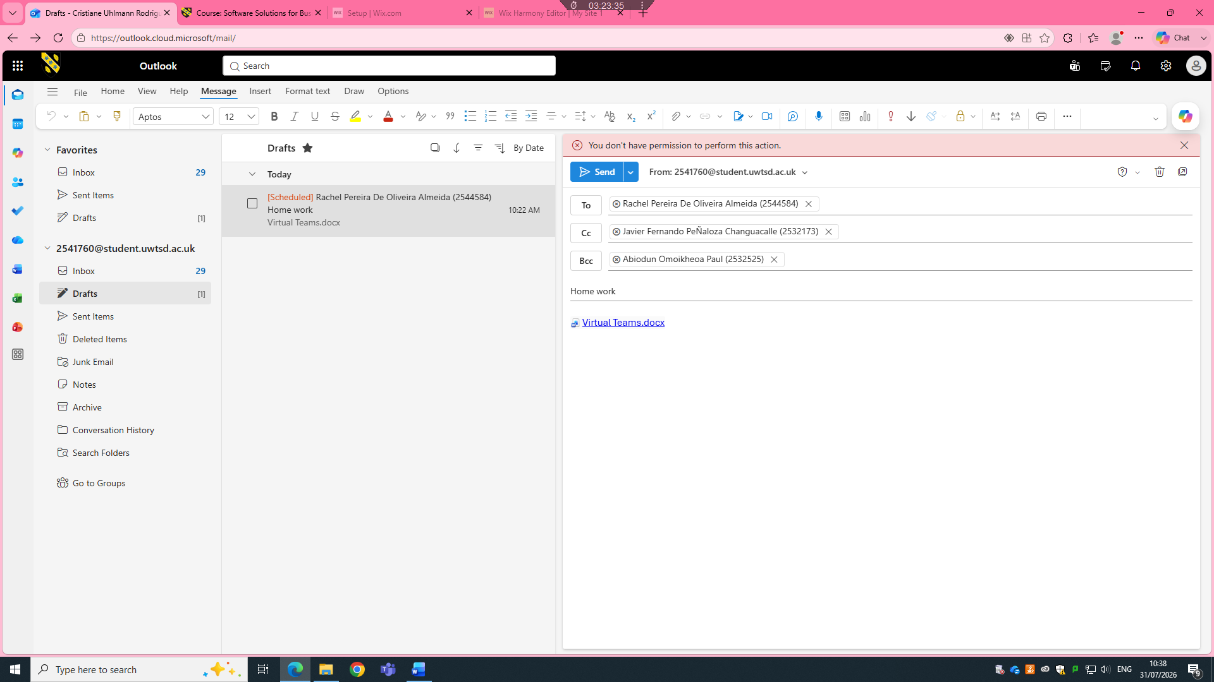
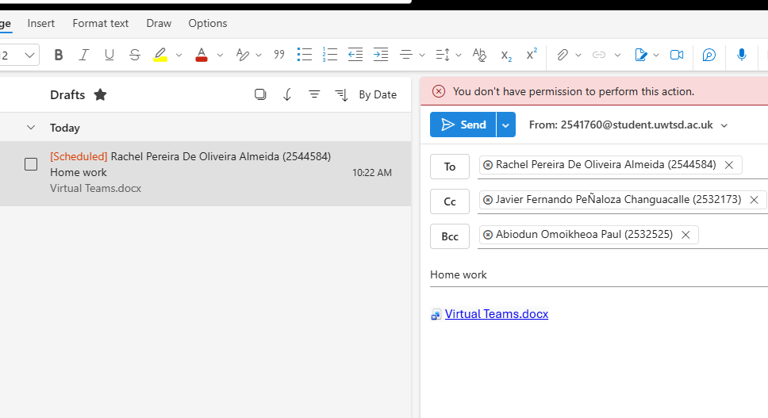

Ms Teams
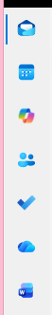
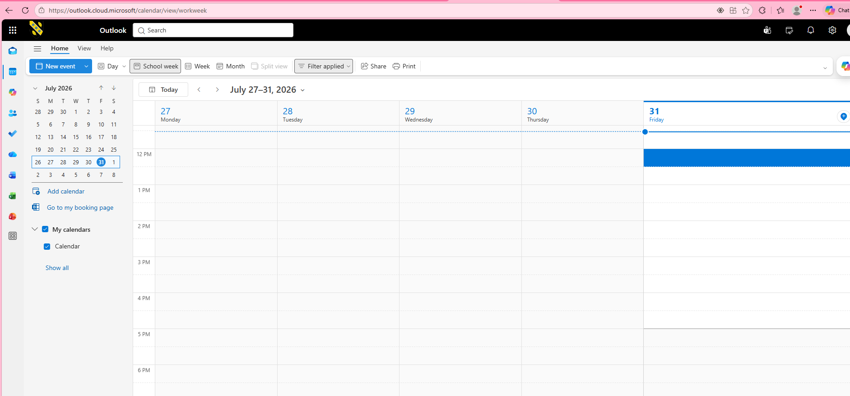

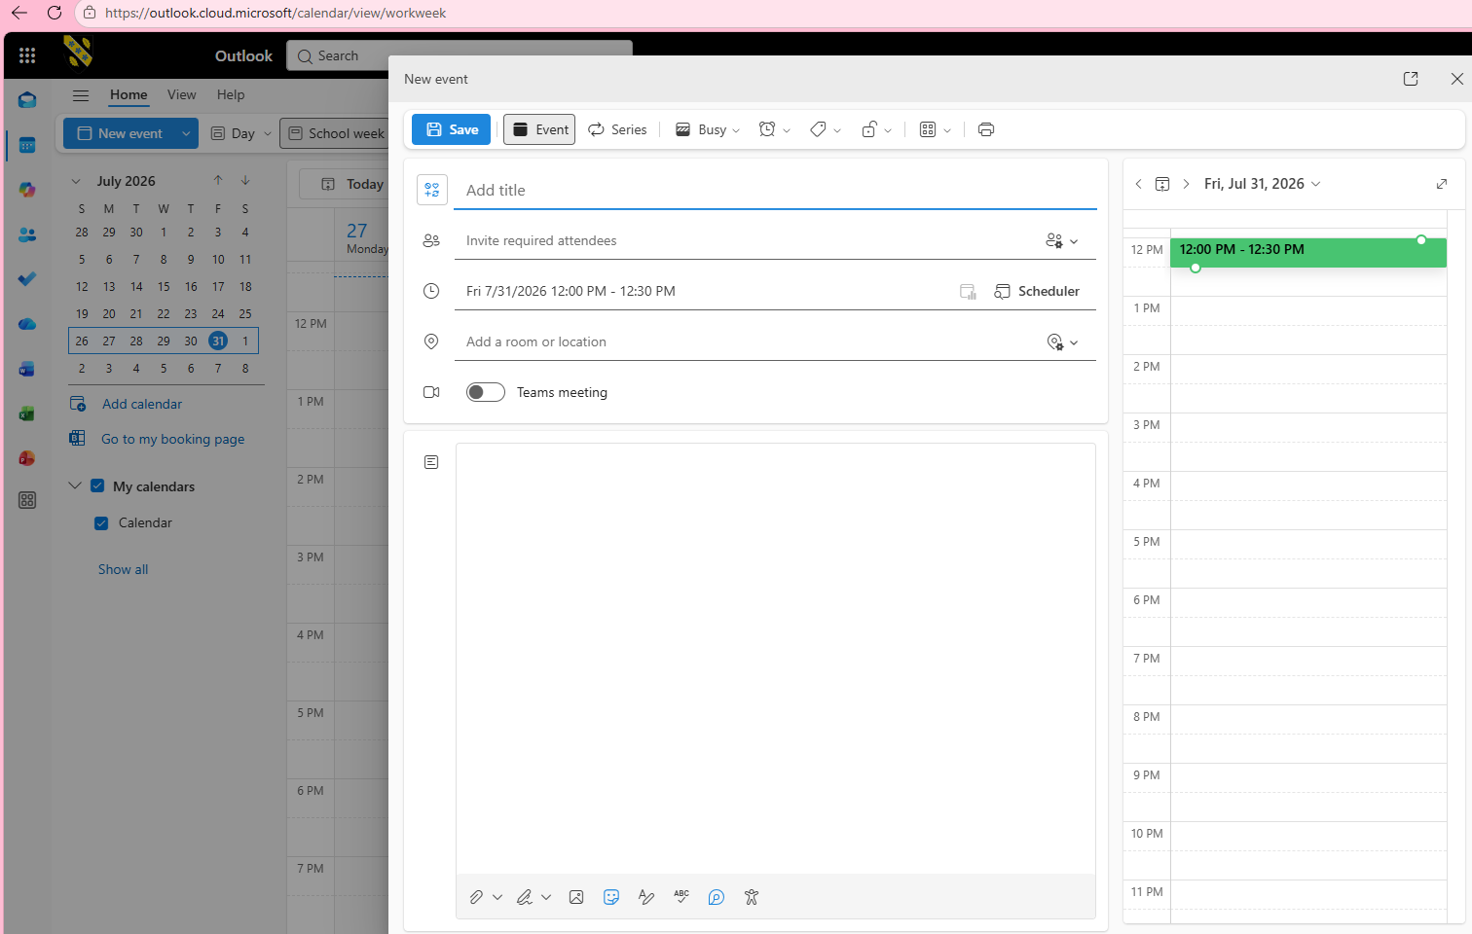

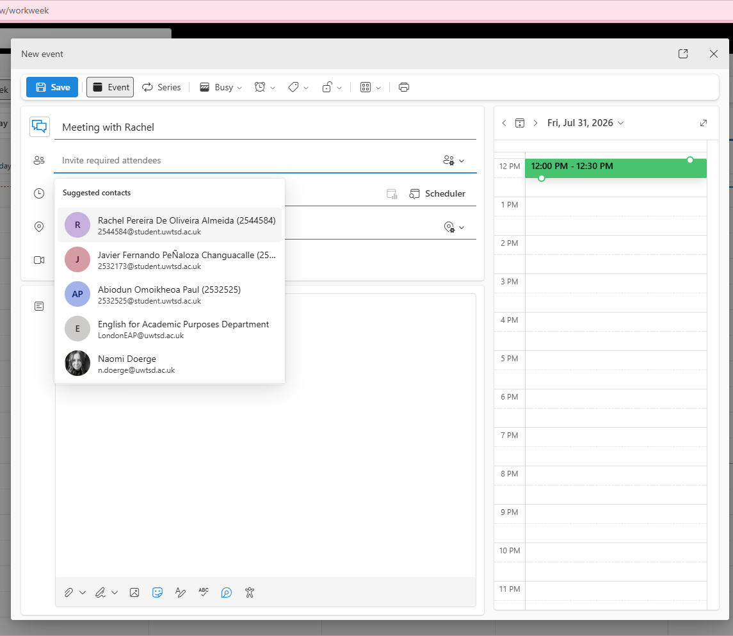
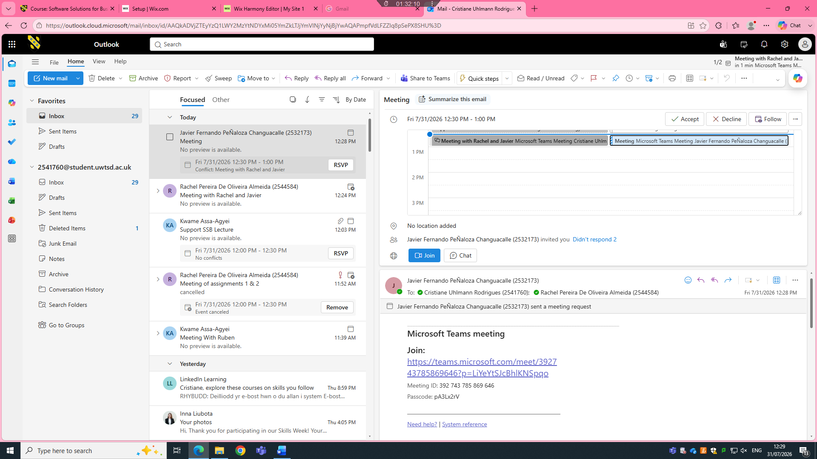


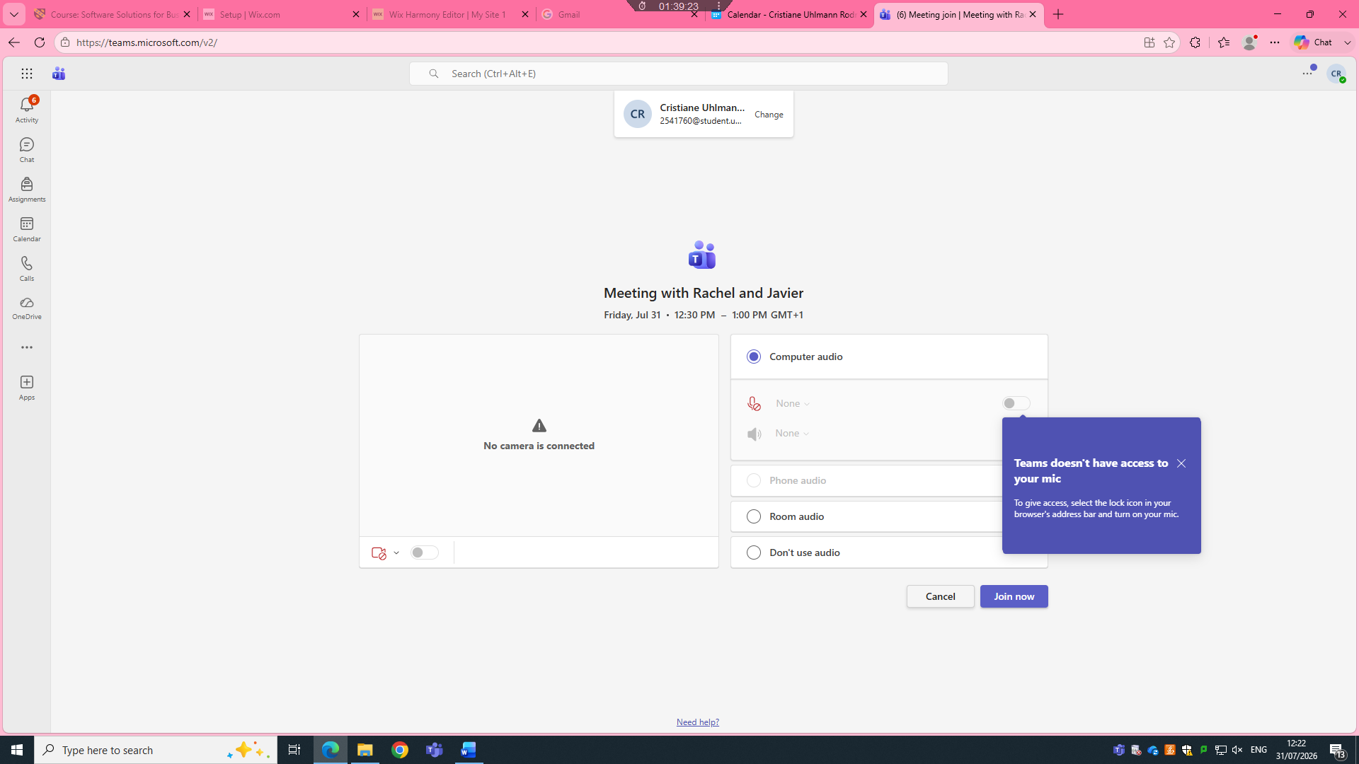
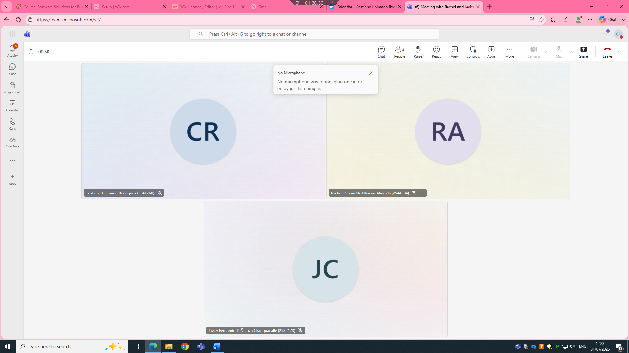

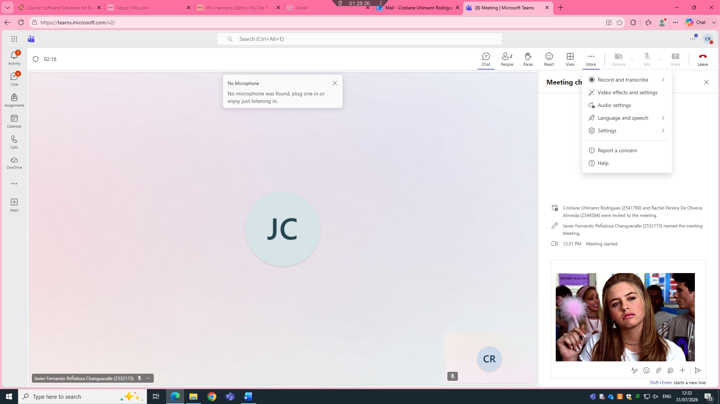

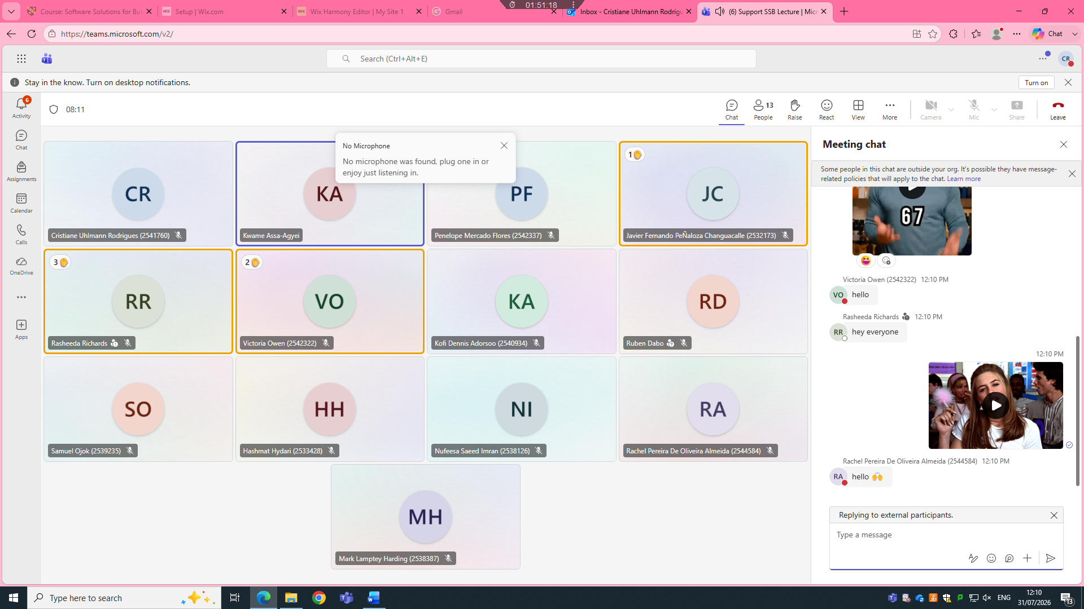

4.2 Test one feature of a freely available Communication (1) and one feature of a Collaboration (1) application

WhatsApp – Instant Messaging

WhatsApp is free to use, and its core communication feature lets you send text, voice or video messages instantly to individuals or groups anywhere in the world. You can also share files, photos and updates without extra cost. This makes it simple and fast to stay connected, whether for quick updates or longer conversations, even across different locations.

One feature of a freely available Collaboration app

Google Drive – Shared file Storage

Google Drive gives you free cloud storage where you can save documents, spreadsheets and presentations, then share them directly with your team. Multiple people can view, edit or leave comments on the same file at the same time, so everyone works from the latest version. It keeps all your shared work organised in one place and easy to access from any device.

Microsoft Outlook

Outlook’s shared calendar feature helps teams organise and coordinate work easily. You can create meetings, check when colleagues are free, send invites and set reminders all in one place. For example, you can schedule a project review, invite all team members, and confirm everyone’s availability without sending multiple messages back and forth. It also links directly to email and tasks, so you can follow up on discussions and track action items right away.

Team

Good communication and collaboration tools are the backbone of any successful team. They help everyone share ideas clearly, work together even when apart, and keep track of progress without confusion. Tools like WhatsApp and Google Drive make every day sharing simple, while Outlook brings structure to schedules and follow‑ups. When a team has the right tools, members can focus on their work instead of wasting time on disorganisation. Trust and openness grow easier when everyone can connect and contribute smoothly, leading to better results and a more positive working environment.

Conclusion

Modern software applications make everyday work much simpler, more organised and more connected. Word, Excel, PowerPoint, Access and Outlook cover all core business needs, from creating documents to managing data and schedules. Free tools like WhatsApp and Google Drive extend these benefits further, letting teams communicate and collaborate without extra cost. Choosing the right tools helps save time, reduce mistakes and support people to work together effectively. Overall, these applications are essential for running operations smoothly and helping teams achieve their goals.

References

References
Arulselvi E (2017) Mind Maps in Classroom Teaching and Learning. 6:50–65.
Dim TL, Kyaw WPP No title.
Frye C (2015) Microsoft Excel 2016 step by step. Microsoft Press, .
Hristov I (2024) Web Design for Small Businesses: Enhancing User Experience.
Kosslyn SM (2007) Clear and to the point: 8 psychological principles for compelling PowerPoint presentations. Oxford University Press, .
Kruse O, Rapp C (2023) Word processing software: The rise of MS Word. In: Anonymous Digital Writing Technologies in Higher Education: Theory, Research, and Practice, Springer, pp 15–32.
Nicodemus E, Kibga E, Rarieya J (2026) Designing a Contextual Google Sites-Based Learning Platform for Environmental Education in Ugandan Teacher Training: A Design-Based Research Study.

