Module Name | Data Analysis and Visualisation
Programme | BSc Cloud Computing
Modul Code | ACCB4002
Lecture | Asim Satti
Student ID | 2121853
Student | Ana-Elena Tocariu

1.Descriptive Statistics
Test score before using app |  | Test score after using app
Mean | 12.75 | Mean | 15.3
Standard Error | 0.648222421 | Standard Error | 0.618310353
Median | 12.5 | Median | 15.5
Mode | 17 | Mode | 20
Standard Deviation | 4.099718564 | Standard Deviation | 3.910538031
Sample Variance | 16.80769231 | Sample Variance | 15.29230769
Kurtosis | -0.992832012 | Kurtosis | 0.208539231
Skewness | -0.208284596 | Skewness | -0.732901282
Range | 15 | Range | 16
Minimum | 5 | Minimum | 4
Maximum | 20 | Maximum | 20
Sum | 510 | Sum | 612
Count | 40 | Count | 40
Largest(1) | 20 | Largest(1) | 20
Smallest(1) | 5 | Smallest(1) | 4
Confidence Level(95.0%) | 1.311153606 | Confidence Level(95.0%) | 1.250650736

Hypothesis Testing

t-Test: Paired Two Sample for Means at 0.05

t-Test: Paired Two Sample for Means
 | Test score before using app | Test score after using app
Mean | 12.75 | 15.3
Variance | 16.80769231 | 15.29230769
Observations | 40 | 40
Pearson Correlation | 0.530985814
Hypothesized Mean Difference | 0
Df | 39
t Stat | -4.153849425
P(T<=t) one-tail | 8.62016E-05
t Critical one-tail | 1.684875122
P(T<=t) two-tail | 0.000172403
t Critical two-tail | 2.02269092

The t-test is less than the t-critical two tailed value hence we fail to reject the null hypothesis and conclude that there is no significance difference between the two means.
t-Test: Paired Two Sample for Means at 0.01
t-Test: Paired Two Sample for Means
 | Test score before using app | Test score after using app
Mean | 12.75 | 15.3
Variance | 16.80769231 | 15.29230769
Observations | 40 | 40
Pearson Correlation | 0.530985814
Hypothesized Mean Difference | 0
Df | 39
t Stat | -4.153849425
P(T<=t) one-tail | 8.62016E-05
t Critical one-tail | 2.42584141
P(T<=t) two-tail | 0.000172403
t Critical two-tail | 2.707913184

The t-test is less than the t-critical two tailed value hence we fail to reject the null hypothesis and conclude that there is no significance difference between the two means.

t-Test: Paired Two Sample for Means at 0.1
t-Test: Paired Two Sample for Means
 | Test score before using app | Test score after using app
Mean | 12.75 | 15.3
Variance | 16.80769231 | 15.29230769
Observations | 40 | 40
Pearson Correlation | 0.530985814
Hypothesized Mean Difference | 0
Df | 39
t Stat | -4.153849425
P(T<=t) one-tail | 8.62016E-05
t Critical one-tail | 1.303638589
P(T<=t) two-tail | 0.000172403
t Critical two-tail | 1.684875122

The t-test is less than the t-critical two tailed value hence we fail to reject the null hypothesis and conclude that there is no significance difference between the two means.

t-Test: Two-Sample Assuming Equal Variances at 0.05

t-Test: Two-Sample Assuming Equal Variances
 | Test score before using app | Test score after using app
Mean | 12.75 | 15.3
Variance | 16.80769231 | 15.29230769
Observations | 40 | 40
Pooled Variance | 16.05
Hypothesized Mean Difference | 0
Df | 78
t Stat | -2.846542418
P(T<=t) one-tail | 0.002822714
t Critical one-tail | 1.664624645
P(T<=t) two-tail | 0.005645427
t Critical two-tail | 1.990847069

The t-test is less than the t-critical two tailed value hence we fail to reject the null hypothesis and conclude that there is no significance difference between the two means.

t-Test: Two-Sample Assuming Equal Variances at 0.01

t-Test: Two-Sample Assuming Equal Variances
 | Test score before using app | Test score after using app
Mean | 12.75 | 15.3
Variance | 16.80769231 | 15.29230769
Observations | 40 | 40
Pooled Variance | 16.05
Hypothesized Mean Difference | 0
Df | 78
t Stat | -2.846542418
P(T<=t) one-tail | 0.002822714
t Critical one-tail | 2.375110958
P(T<=t) two-tail | 0.005645427
t Critical two-tail | 2.640340015

The t-test is less than the t-critical two tailed value hence we fail to reject the null hypothesis and conclude that there is no significance difference between the two means.

t-Test: Two-Sample Assuming Equal Variances at 0.1
t-Test: Two-Sample Assuming Equal Variances
 | Test score before using app | Test score after using app
Mean | 12.75 | 15.3
Variance | 16.80769231 | 15.29230769
Observations | 40 | 40
Pooled Variance | 16.05
Hypothesized Mean Difference | 0
Df | 78
t Stat | -2.846542418
P(T<=t) one-tail | 0.002822714
t Critical one-tail | 1.292499597
P(T<=t) two-tail | 0.005645427
t Critical two-tail | 1.664624645

The t-test is less than the t-critical two tailed value hence we fail to reject the null hypothesis and conclude that there is no significance difference between the two means.

t-Test: Two-Sample Assuming Unequal Variances at 0.05

t-Test: Two-Sample Assuming Unequal Variances
 | Test score before using app | Test score after using app
Mean | 12.75 | 15.3
t-Test: Two-Sample Assuming Unequal Variances
Variance | 16.80769231 | 15.29230769
Observations | 40 | 40
Hypothesized Mean Difference | 0
Df | 78
t Stat | -2.846542418
P(T<=t) one-tail | 0.002822714
t Critical one-tail | 1.664624645
P(T<=t) two-tail | 0.005645427
t Critical two-tail | 1.990847069

The t-test is less than the t-critical two tailed value hence we fail to reject the null hypothesis and conclude that there is no significance difference between the two means.

t-Test: Two-Sample Assuming Unequal Variances at 0.01
t-Test: Two-Sample Assuming Unequal Variances
 | Test score before using app | Test score after using app
Mean | 12.75 | 15.3
Variance | 16.80769231 | 15.29230769
Observations | 40 | 40
Hypothesized Mean Difference | 0
Df | 78
t Stat | -2.846542418
P(T<=t) one-tail | 0.002822714
t Critical one-tail | 2.375110958
P(T<=t) two-tail | 0.005645427
t Critical two-tail | 2.640340015

The t-test is less than the t-critical two tailed value hence we fail to reject the null hypothesis and conclude that there is no significance difference between the two means.

t-Test: Two-Sample Assuming Unequal Variances at 0.1
t-Test: Two-Sample Assuming Unequal Variances
 | Test score before using app | Test score after using app
Mean | 12.75 | 15.3
Variance | 16.80769231 | 15.29230769
Observations | 40 | 40
Hypothesized Mean Difference | 0
Df | 78
t Stat | -2.846542418
P(T<=t) one-tail | 0.002822714
t Critical one-tail | 1.292499597
P(T<=t) two-tail | 0.005645427
t Critical two-tail | 1.664624645

The t-test is less than the t-critical two tailed value hence we fail to reject the null hypothesis and conclude that there is no significance difference between the two means.

z-Test: Two Sample for Means at 0.05

z-Test: Two Sample for Means
 | Variable 1 | Variable 2
Mean | 12.75 | 15.3
Known Variance | 16.8 | 15.29
Observations | 40 | 40
Hypothesized Mean Difference | 0
Z | -2.846985908
P(Z<=z) one-tail | 0.002206766
z Critical one-tail | 1.644853627
P(Z<=z) two-tail | 0.004413532
z Critical two-tail | 1.959963985

The z-test is less than the z-critical two tailed value hence we fail to reject the null hypothesis and conclude that there is no significance difference between the two means.

z-Test: Two Sample for Means at 0.01
z-Test: Two Sample for Means
 | Variable 1 | Variable 2
Mean | 12.75 | 15.3
Known Variance | 16.8 | 15.29
Observations | 40 | 40
Hypothesized Mean Difference | 0
Z | -2.846985908
P(Z<=z) one-tail | 0.002206766
z Critical one-tail | 2.326347874
P(Z<=z) two-tail | 0.004413532
z Critical two-tail | 2.575829304

The z-test is less than the z-critical two tailed value hence we fail to reject the null hypothesis and conclude that there is no significance difference between the two means.

z-Test: Two Sample for Means at 0.1
z-Test: Two Sample for Means
 | Variable 1 | Variable 2
Mean | 12.75 | 15.3
Known Variance | 16.8 | 15.29
Observations | 40 | 40
Hypothesized Mean Difference | 0
Z | -2.846985908
P(Z<=z) one-tail | 0.002206766
z Critical one-tail | 1.281551566
P(Z<=z) two-tail | 0.004413532
z Critical two-tail | 1.644853627

The z-test is less than the z-critical two tailed value hence we fail to reject the null hypothesis and conclude that there is no significance difference between the two means.

Data Visualization to show outliers
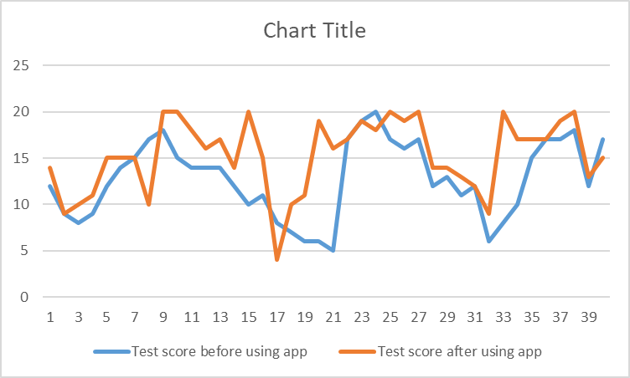

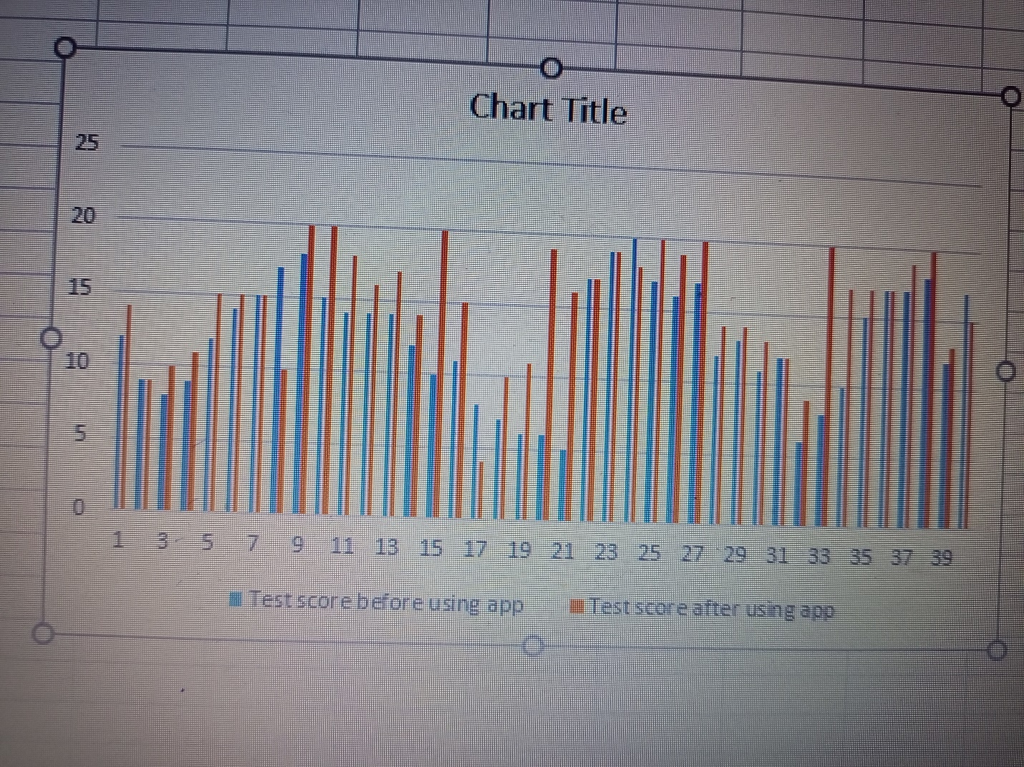
The output shows that there were no outliers since there was no significant difference between the two sample means.
The histogram results show that the marks of most students improved when they were using the app as compared to not using the app. However, there is no big difference between the two performance.
Discussion and Recommendation
The above analysis has proved that the app is a success to the learning of the students in school. This is because there is no significance difference between the two sample means. We have seen an increase in e-learning technologies like smartphone apps over the previous decade. And it appears that the majority of teachers are pleased with it. According to a Statistics survey, roughly 67 percent of instructors embrace open education resources (OER), which is a term for publically available e-learning materials. Is it true that all knowledge apps are made equal?

Presently, will recommend look 5 crucial features that make smartphone math apps successful. All educational applications and games claim to educate kids math by keeping it enjoyable. Much more is promised by the most efficient options:

1. To make lectures and repeated directives a priority, mirroring the classroom's orientation.

2. To keep kids interested
3. Rather of rehashing the very same level of skill, offer training that improve their skills.
4. To share quality metrics that show how well your child is doing.
5.To customize lessons by assessing those data in order to determine each kid's strengths and limitations.

It is no surprise that children require more guidance than adults, whether in the school or through an app. They will never learn new math abilities if they don't comprehend how to enjoy a game. If they could provide training whatsoever, 88 percent of academic apps utilize "drill-and-practice" teaching, according to researchers. To learn more about how pedagogical applications may improve, researchers like the inventor and developer of The Math-stronaut have confirmed this idea (Kay & Kwak, 2018). First via elementary student’s study core mathematical skills by preserving the planetary panels one ability at a go said the founder. The idea is for the kid to take the role of the hero.
To accomplish so, scientists devised a Rubix, a partner who aids the Mathstronaut (also known as the kid) in saving the planetary panels. This implies that instruction is emphasized in a pleasant way at each level. They understood the importance of training that goes beyond a body of norms (Chao & Chang, 2018). To keep kids interested as they focus on playing, we built an immersive tutorial that walks kids through the gameplay in a story-like format, teaching them well how play while introducing them to new innovations and abilities. They will not have to go through one complete lesson until beginning to play. An animated tutorial gives users a hands-on method to learning how to play while remaining unobtrusive to their gameplay experience.
E-learning apps assist students in learning by allowing them to have fun while doing so. And having a good time begins with participation (Outhwaite, Faulder, Gulliford & Pitchford, 2019). That is why apps must be able to capture students' interest and, more importantly, keep it until the lesson is over. They would not buy into their teachings if they do not even buy into the game.
With characteristics like eye-catching visuals, entertaining information, and occasionally pop-ups that allow children get up and running quickly or provide timely data, successful math applications keep youngsters interested. It is indeed worth mentioning that there was a thin border between engrossing visuals and distracting graphics. When evaluating where an app belongs, consider whether the images are helping to achieve the learning goal or if they seem as random as confetti cannons. Is it possible to ask if all of the elements work together from a wonderful novel? Developing an intriguing story is a fantastic method to accomplish this. Learn how to distinguish the difference in a math software and one that improves arithmetic skills. Consider the mathematics game to be the first curriculum. Is there a gameplay for each episode in the app, and does it play Preface over and over?
Search for apps that teach a variety of abilities at different levels. 2nd arithmetic, third-grade conceptual math, and fourth-grade division could all be accommodated in a single program. Furthermore, skills should be built upon one anothe (Kay & Kwak, 2018). Students will learn more as a result of their participation in the game. Furthermore, skills should be built upon one another. Students will learn more as a result of their participation in the game.
This is accomplished in two ways by the Math-stronaut. Firstly, a gaming algorithm identifies whenever a player requires further assistance and modifies specific settings, such as play tempo, in instantaneously. There is an integrated practice section where players can work on poor skills even without added burden of maintaining the solar panels. Students can evaluate and if they have any talents that need some practice it after every stage (Kay, 2020). A Caregivers' Office also provides instructors and parents with more detailed information on their children's progress. We recommend parents to seek out instructional games and apps that not only display performance measures but also allow them to make changes.
References

Chao, W. H., & Chang, R. C. (2018). Using augmented reality to enhance and engage students in learning mathematics. Advances in Social Sciences Research Journal, 5(12), 455-464.
Kay, R. H. (2020). Analyzing the use of mathematics apps in elementary school classrooms. Contemporary Educational Research Journal, 10(2), 68-78.
Kay, R., & Kwak, J. (2018, March). Creating an evidence-based framework for selecting and evaluating mathematics apps. In Society for Information Technology & Teacher Education International Conference (pp. 755-760). Association for the Advancement of Computing in Education (AACE).
Kay, R., & Kwak, J. Y. (2018). Comparing types of mathematics apps used in primary school classrooms: an exploratory analysis. Journal of Computers in Education, 5(3), 349-371.
Outhwaite, L. A., Faulder, M., Gulliford, A., & Pitchford, N. J. (2019). Raising early achievement in math with interactive apps: A randomized control trial. Journal of educational psychology, 111(2), 284.

